Aviral Mehrotra: aviralmehrotra9402@gmail.com
- Technical Assessment Overview:
Project Name: news-frontpage-recreation
Objective: Recreate the front page of the LiveHindustan website using Next.js, following modern frontend development practices and clean component architecture.
  - Wireframe / Sketch
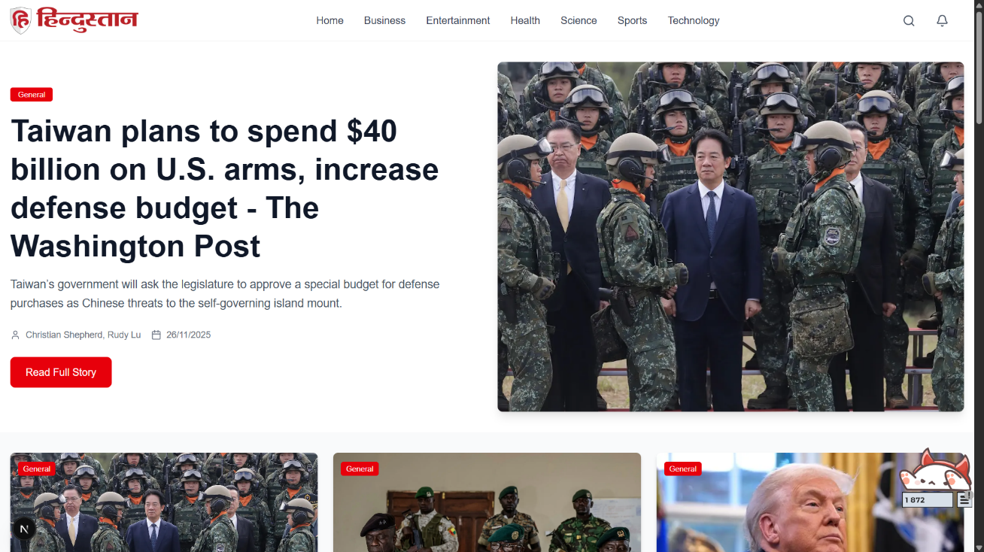
Figure 1: Home Page


Figure 2: Category Page
- Design Documentation
  - Layout Decisions
- Hero Section: Single featured story with large image and CTA button
  - Reasoning: 3-column grid maximizes content density while maintaining readability
- 3-Column Grid: Optimal for desktop readability, collapses to 1-column on mobile
  - Reasoning: Card design provides clear content boundaries and hover interactions
- Card-based Design: Clean, scannable news cards with consistent spacing
  - Reasoning: Hero section creates visual hierarchy and draws attention to breaking news
- Top Story Highlight: Hero section showcases most important/recent news.
  - Reasoning: Responsive design ensures mobile-first approach

  - Data-Fetching Strategy
Method Used: ISR (Incremental Static Regeneration)
export const revalidate = 300; // 5 minutes
Why ISR:
- Performance: Static generation for instant loading
- Freshness: Background revalidation keeps content updated
- SEO: Pre-rendered pages for better search indexing
- Cost-effective: Reduces API calls compared to client-side fetching
Advantages:
- Fast initial page loads
- Good SEO performance
- Reduced server load
Disadvantages:
- Content can be up to 5 minutes stale
- More complex than simple client-side fetching

