data hdfs spark (csv to spark query)/(deltalake to sparkquery(update, delete allowed)) hdfs hive
To implement delta lake (possibel faster updation on data present on delta lake )
spark@439883afcf3d:/opt/spark/bin$ ./pyspark \
> --packages io.delta:delta-spark_2.12:3.1.0 \
> --conf spark.sql.extensions=io.delta.sql.DeltaSparkSessionExtension \
> --conf spark.sql.catalog.spark_catalog=org.apache.spark.sql.delta.catalog.D
eltaCatalog \
> --conf spark.jars.ivy=/tmp/.ivy2
//after disturning from manual data hdfs and spark
import subprocess
import os

# CONFIG
container_name = "namenode"
host_file = os.path.expanduser("~/Downloads/sample_transactions.csv")
container_tmp_path = "/tmp/data.csv"

def run(cmd):
print(f"\nRunning: {cmd}")
result = subprocess.run(cmd, shell=True, capture_output=True, text=True)
if result.returncode != 0:
print("Error:", result.stderr)
exit(1)
else:
print(result.stdout)

# 1. Copy file from host → container
run(f"docker cp {host_file} {container_name}:{container_tmp_path}")

# 2. Create HDFS directory
run(f"docker exec {container_name} hdfs dfs -mkdir -p /data")

# 3. Put file into HDFS
run(f"docker exec {container_name} hdfs dfs -put -f {container_tmp_path} /data/data.csv")
print("\n✅ File successfully copied to HDFS!")
//corresponding docker compose file
services:
namenode:
image: bde2020/hadoop-namenode:2.0.0-hadoop3.2.1-java8
container_name: namenode
environment:
- CLUSTER_NAME=test
- CORE_CONF_fs_defaultFS=hdfs://namenode:9000
- HDFS_CONF_dfs_namenode_rpc_address=0.0.0.0:9000
- HDFS_CONF_dfs_namenode_name_dir=file:///hadoop/dfs/name
ports:
- "9870:9870"
- "9000:9000"
datanode:
image: bde2020/hadoop-datanode:2.0.0-hadoop3.2.1-java8
container_name: datanode
environment:
- CLUSTER_NAME=test
- CORE_CONF_fs_defaultFS=hdfs://namenode:9000
- HDFS_CONF_dfs_datanode_use_datanode_hostname=true
depends_on:
- namenode
ports:
- "9864:9864"
spark:
image: apache/spark:3.5.0
container_name: spark
depends_on:
- namenode
- datanode
tty: true
stdin_open: true
command: tail -f /dev/null
volumes:
- ./jars/:/extrajars
- ./data:/data

// hdfs dfs is set through namenode container ,
// processing is beign done inside spark container inside
/opt/spark/bin – as mentioned the first line of this pdf

// delta lake is further used to store the data so that updation query can be optimised , code is as follows :

/// reading the csv data

>>> df = spark.read \
... .option("header", "true") \
... .option("inferSchema", "true") \
... .csv("hdfs://namenode:9000/data/data.csv")
[Stage 1:> (0 + 4) / 4
>>>
>>> df.show()

/// writing the data into delta lake format
>>> df.write \
... .format("delta") \
... .mode("overwrite") \
... .save("hdfs://namenode:9000/user/spark/delta/transactions")
/// reading the data in the form of delta lake
>>> df_delta = spark.read \
... .format("delta") \
... .load("hdfs://namenode:9000/user/spark/delta/transactions")
>>>
>>> df_delta.show()
/// creating the table from delta lake format

>>> spark.sql("""CREATE TABLE temptrans USING DELTA LOCATION 'hdfs://namenode:9
000/user/spark/delta/transactions'""")
/// now we can query , update the tabel temptrans

>>> spark.sql("SHOW TABLES").show()
>>> spark.sql("SELECT * FROM temptrans").show()
>>> spark.sql("select fraud_type from temptrans group by fraud_type").show()
>>> spark.sql("select fraud_type, count(user_id) from temptrans group by fraud_
type").show()
// update query (imp)
>>> spark.sql("update temptrans set fraud_type='amount_spike' where amount>20")
// deletion

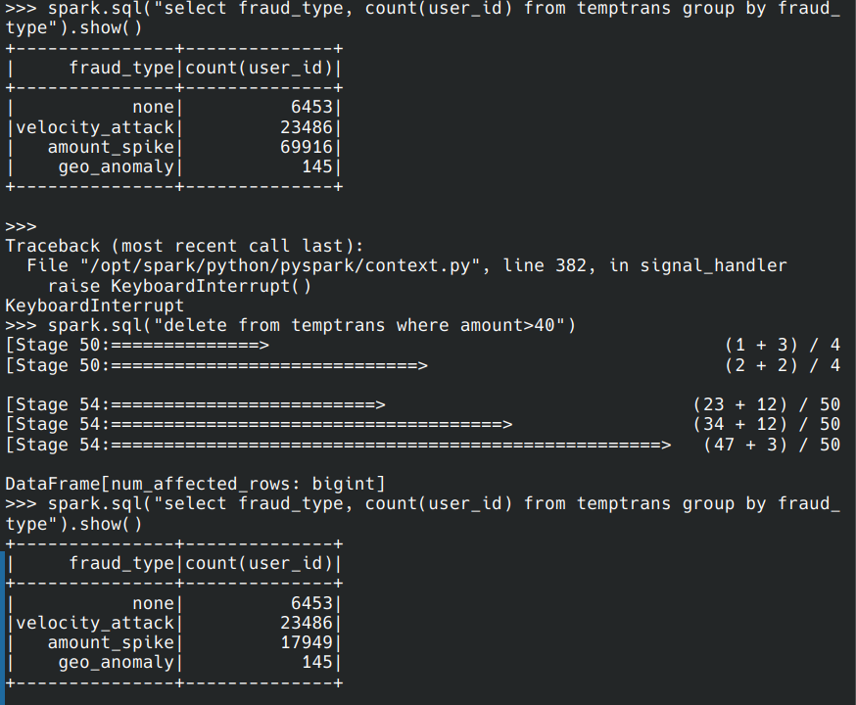
in case of simple csv read with spark without deltalake(layer)
operations not supported :
>>> df=spark.read.option("header" , "true").option("inferSchema" , "true").csv(
"hdfs://namenode:9000/data/data.csv")
[Stage 0:> (0 + 1) / 1
[Stage 1:> (0 + 4) / 4
[Stage 1:==============> (1 + 3) / 4
>>> df.createOrReplaceTempView("t")
>>>
>>>
>>> df.printSchema()
root
|-- transaction_id: string (nullable = true)
|-- user_id: string (nullable = true)
|-- amount: double (nullable = true)
|-- merchant_id: string (nullable = true)
|-- merchant_category: string (nullable = true)
|-- location_lat: double (nullable = true)
|-- location_lon: double (nullable = true)
|-- timestamp: integer (nullable = true)
|-- card_number: string (nullable = true)
|-- ip_address: string (nullable = true)
|-- is_fraud: boolean (nullable = true)
|-- fraud_type: string (nullable = true)
>>>
>>>
>>>
>>> spark.sql("select fraud_type , count(fraud_type) from t group by fraud_type
")
DataFrame[fraud_type: string, count(fraud_type): bigint]
>>> spark.sql("select fraud_type , count(fraud_type) from t group by fraud_type
").show()
[Stage 2:> (0 + 4) / 4
+---------------+-----------------+
| fraud_type|count(fraud_type)|
+---------------+-----------------+
| none| 62801|
|velocity_attack| 32216|
| amount_spike| 3585|
| geo_anomaly| 1398|
+---------------+-----------------+
>>> spark.sql("update t set fraud_type='amount_spike' where amount>40")
Traceback (most recent call last):
File "<stdin>", line 1, in <module>
File "/opt/spark/python/pyspark/sql/session.py", line 1631, in sql
return DataFrame(self._jsparkSession.sql(sqlQuery, litArgs), self)
File "/opt/spark/python/lib/py4j-0.10.9.7-src.zip/py4j/java_gateway.py", line
1322, in __call__
File "/opt/spark/python/pyspark/errors/exceptions/captured.py", line 185, in
deco
raise converted from None
pyspark.errors.exceptions.captured.UnsupportedOperationException: UPDATE TABLE
is not supported temporarily.
>>>
// hive local setup with docker working (spark + hive )

// run the spark with the command in bin folder
spark@439883afcf3d:/opt/spark/bin$ ./pyspark \
> --conf spark.sql.warehouse.dir=/tmp/spark-warehouse \
> --conf spark.sql.catalogImplementation=hive
>>> spark.sql("SHOW DATABASES").show()
>>> spark.sql("use mydb")
if table is not created properly(showing some error )
>>> spark.sql("drop table transactions")

// must know the schema
>>> df.printSchema()
root
|-- transaction_id: string (nullable = true)
|-- user_id: string (nullable = true)
|-- amount: double (nullable = true)
|-- merchant_id: string (nullable = true)
|-- merchant_category: string (nullable = true)
|-- location_lat: double (nullable = true)
|-- location_lon: double (nullable = true)
|-- timestamp: integer (nullable = true)
|-- card_number: string (nullable = true)
|-- ip_address: string (nullable = true)
|-- is_fraud: boolean (nullable = true)
|-- fraud_type: string (nullable = true)

// creating the own loved schema using spark hive method
>>> spark.sql("""
... CREATE TABLE transactions2 (
... user_id STRING,
... merchant_id STRING,
... amount DOUBLE,
... is_fraud boolean
... )
... USING CSV
... OPTIONS (
... path 'hdfs://namenode:9000/data/data.csv',#exact path todata
... header 'true'
... )
... """)
Spark + embedded Hive (local metastore) docker setup

important production level setup (important important )

User SQL
↓
Spark
↓
Hive Metastore Service (contaier)
|
| spark got (table schema ,HDFS location (/data) ,file format info)
|
↓
PostgreSQL (stores metadata of the data) (db run throught container)

Spark (got the requird information)
↓
HDFS NameNode → DataNodes (data)

//// using spark-submit job.py here is the process
job.py::::

#####################################################code 3
from pyspark.sql import SparkSession

# =========================
# START SPARK SESSION
# =========================
print("\n========== STARTING SPARK SESSION ==========\n")

spark = SparkSession.builder \
.appName("Simple_YARN_Job") \
.getOrCreate()

spark.sparkContext.setLogLevel("ERROR")

# =========================
# READ FROM HDFS
# =========================
print("\n========== READING INPUT FROM HDFS ==========\n")

df = spark.read.csv(
"hdfs://namenode:9000/data/data.csv",
header=True,
inferSchema=True
)

df.printSchema()
df.show(5)

# =========================
# TRANSFORMATION
# =========================
print("\n========== APPLYING FILTER ==========\n")

filtered_df = df.filter(df["amount"] > 43)

filtered_df.show()

# =========================
# WRITE TO HDFS
# =========================
print("\n========== WRITING FILTERED DATA TO HDFS ==========\n")

filtered_df.write.mode("overwrite").csv(
"hdfs://namenode:9000/data/output",
header=True
)

# =========================
# READ BACK WRITTEN DATA
# =========================
print("\n========== READING BACK WRITTEN DATA ==========\n")

df_output = spark.read.csv(
"hdfs://namenode:9000/data/output",
header=True,
inferSchema=True
)

df_output.show(5)

# =========================
# CREATE TEMP VIEW
# =========================
print("\n========== CREATING TEMP VIEW ==========\n")

df_output.createOrReplaceTempView("transactions")

# =========================
# RUN SQL QUERY
# =========================
print("\n========== RUNNING SQL QUERY (fraud_type count) ==========\n")

result = spark.sql("""
SELECT fraud_type, COUNT(*) AS count
FROM transactions
GROUP BY fraud_type
ORDER BY count DESC
""")

result.show()

# =========================
# STOP SPARK
# =========================
print("\n========== STOPPING SPARK SESSION ==========\n")

spark.stop()
output for code 3 (working)
spark@318ab7028998:/opt/spak/bin$ ./spark-submit --master local[*] /data/job.py
========== STARTING SPARK SESSION ==========
26/05/03 11:09:45 INFO SparkContext: Running Spark version 3.5.0
26/05/03 11:09:45 INFO SparkContext: OS info Linux, 6.17.0-22-generic, amd64
26/05/03 11:09:45 INFO SparkContext: Java version 11.0.20.1
.
.
.
========== READING INPUT FROM HDFS ==========
root
|-- transaction_id: string (nullable = true)
|-- user_id: string (nullable = true)
|-- amount: double (nullable = true)
|-- merchant_id: strin
.
.
.
+--------------------+----------+------+--------------+-----------------+------------------
+-------------------+----------+-------------------+--------------+--------+---------------
+
| transaction_id| user_id|amount| merchant_id|merchant_category| location_lat
| location_lon| timestamp| card_number| ip_address|is_fraud| fraud_type
|
+--------------------+----------+------+--------------+-----------------+------------------
+-------------------+----------+-------------------+--------------+--------+---------------
+
|393fdb08-4dad-4ed...|USER_10755| 28.83|MERCH_GEN_0107| grocery| 33.755137
|
….
.
.
.
========== APPLYING FILTER ==========
+--------------------+----------+------+--------------------+-----------------+------------
------+-------------------+----------+-------------------+---------------+--------+--------
-------+
| transaction_id| user_id|amount| merchant_id|merchant_category| locati
on_lat| location_lon| timestamp| card_number| ip_address|is_fraud| fra
ud_type|
+--------------------+----------+------+--------------------+-----------------+------------
------+-------------------+----------+-------------------+---------------+--------+--------
-------+
|279c2f4e-27e4-429...|USER_10488| 92.23| MERCH_MACYS| other| 47.36429974
042781|-122.32752747538831|1774253247|4506-1581-4888-1079| 43.6.92.177| true|velocity
_attack|
.
.
.
========== WRITING FILTERED DATA TO HDFS ==========
========== READING BACK WRITTEN DATA ==========
+--------------------+----------+------+--------------+-----------------+------------------
+-------------------+----------+-------------------+---------------+--------+--------------
-+
| transaction_id| user_id|amount| merchant_id|merchant_category| location_lat
| location_lon| timestamp| card_number| ip_address|is_fraud| fraud_typ
e|
+--------------------+----------+------+--------------+-----------------+------------------
+-------------------+----------+-------------------+---------------+--------+--------------
-+
|279c2f4e-27e4-429...|USER_10488| 92.23| MERCH_MACYS| other| 47.36429974042781
|-122.32752747538831|1774253247|4506-1581-4888-1079| 43.6.92.177| true|velocity_attac
k|
|9
.
.
.
.
-+
only showing top 5 rows
========== CREATING TEMP VIEW ==========
========== RUNNING SQL QUERY (fraud_type count) ==========
+---------------+-----+
| fraud_type|count|
+---------------+-----+
| none|38974|
|velocity_attack| 5988|
| amount_spike| 3585|
| geo_anomaly| 847|
+---------------+-----+
output for job2.py
same working

