**OUTPUT**

1.BANK ACCOUNT TABLE

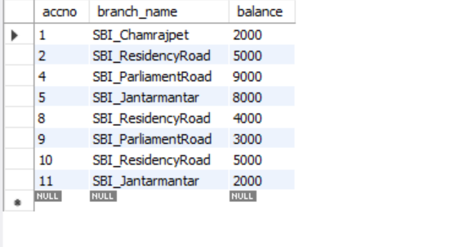

QUERY 4:

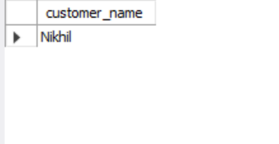

QUERY 3:

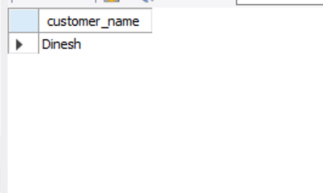

QUERY 5:

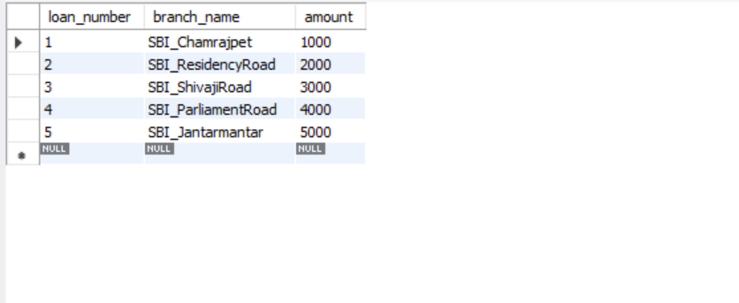

DEPOSITOR TABLE:

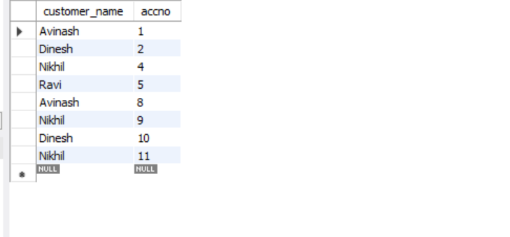

BANK CUSTOMER TABLE

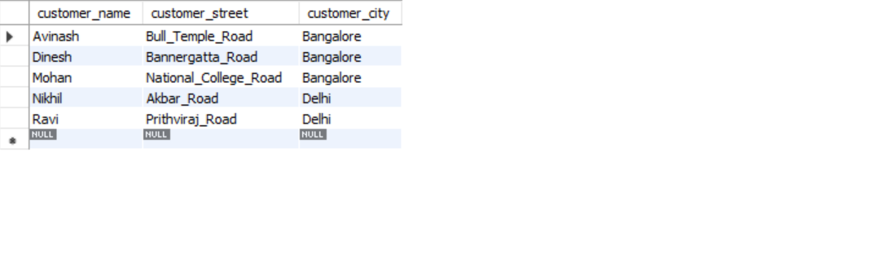

LOAN TABLE

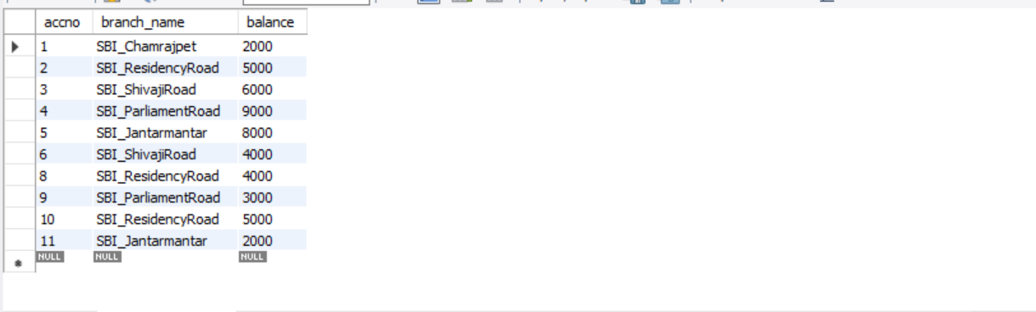

BRANCH TABLE:-

