Game Design Document

Fill up the Following document

1. Write the title of your project.

RUN FOR SURVIVAL 2021

1. What is the goal of the game?

To save over character form dangerous viruses

1. Write a brief story of your game?

There is a boy or girl they want to go for their work but there are many viruses Waiting to kill the boy or girl we have to save the boy and girl we will give mask and santizer to protect boy or girl

1. Which are the playing characters of this game?

* Playing characters are the ones which respond to the user based on the input from the user
* Cars, monkeys, dinos, wizards etc, are the playing characters in the game.

|  |  |  |
| --- | --- | --- |
| Number | Character Name | What can this character do? |
| 1 | SAN | Run , Walk , jump |
| 2 | MIA | Walk , jump |
| 3 |  |  |
| 4 |  |  |
| 5 |  |  |
| 6 |  |  |
| 7 |  |  |
| 8 |  |  |

1. Which are the Non Playing Characters of this game?

* Non Playing characters are the ones which don't have an action or a behaviour when the user interacts with the game.
* Hurdles, stones, bananas, coins, etc are non playing characters in the game.

|  |  |  |
| --- | --- | --- |
| Number | Character Name | What can this character do? |
| 1 | RON | cycling |
| 2 | VIRUSES | can kill san and Mia |
| 3 | machine | Kill san and mia |
| 4 |  |  |
| 5 |  |  |
| 6 |  |  |
| 7 |  |  |
| 8 |  |  |

Draw your imagination of this game. What does this game look like?

* Draw the game either on your computer or on paper,
* Add images of scenes of the game to show each of the playing and non-playing characters at least once.

How do you plan to make your game engaging?

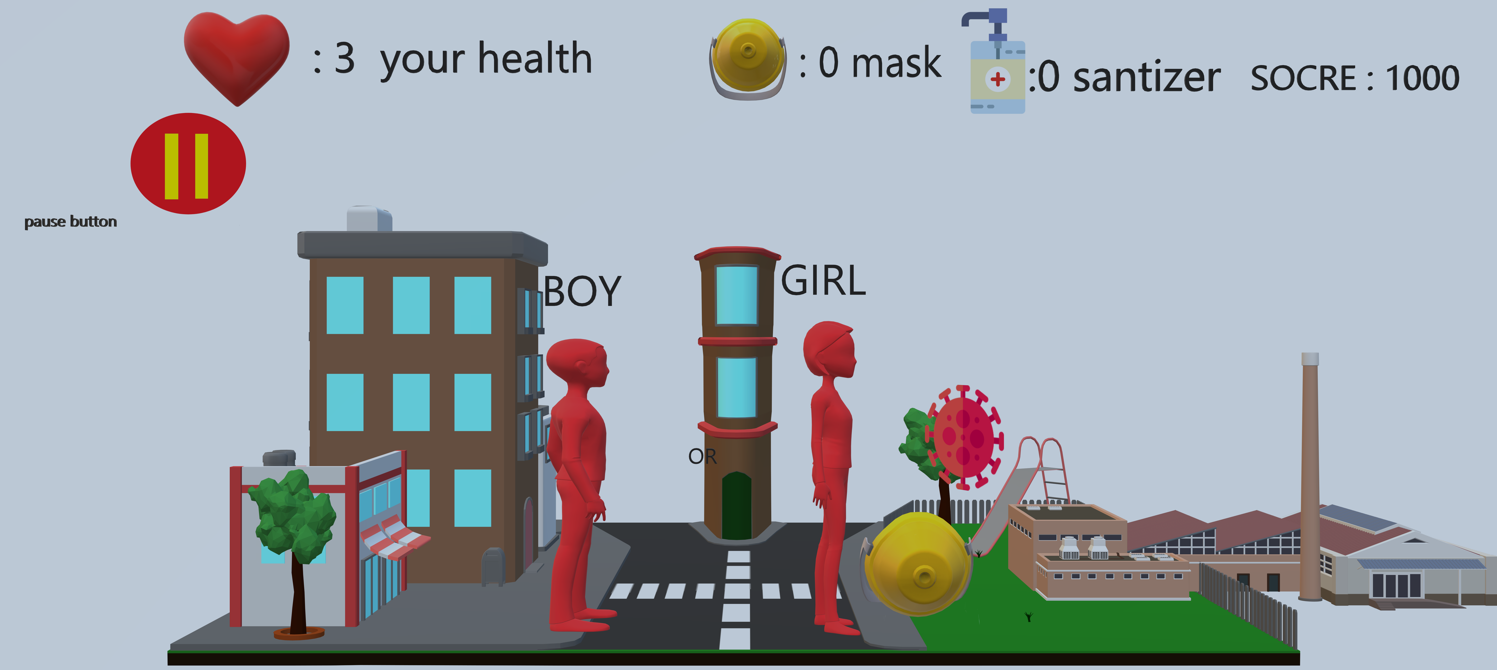

I will try to change the background when the player reach 1500 score

I will bring a factory and after 1800 score I will change the background and

The player will go inside the factory there will be new obstacles like machine and a new viruses and game will end when the player reach the

Score 6000.