[Apache](http://www.apache.org/) Groovy is a **powerful**, **optionally typed** and **dynamic** language, with **static-typing and static compilation** capabilities, for the Java platform aimed at improving developer productivity thanks to a concise, **familiar and easy to learn syntax**. It integrates smoothly with any Java program, and immediately delivers to your application powerful features, including scripting capabilities, **Domain-Specific Language** authoring, runtime and compile-time **meta-programming** and **functional** programming.

<https://stackoverflow.com/questions/1517582/what-is-the-difference-between-statically-typed-and-dynamically-typed-languages>

Add this entry in System Environment Variables if groovy –version check does not work :

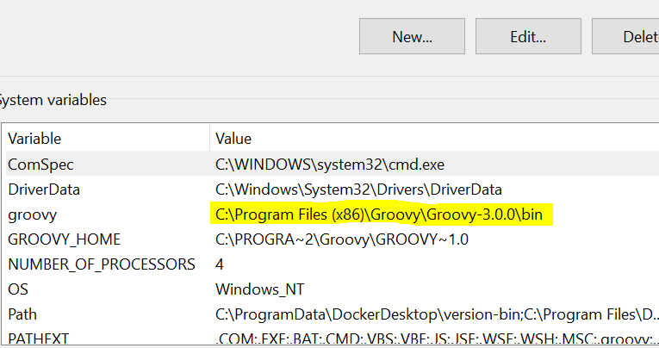

Printing something in groovy

Print “hello”

Running a groovy program from console

Groovy hello.groovy

Defining variables in groovy

Def name = “abc”

Print name

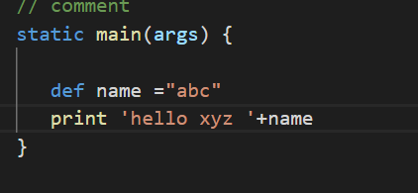

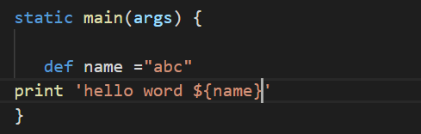

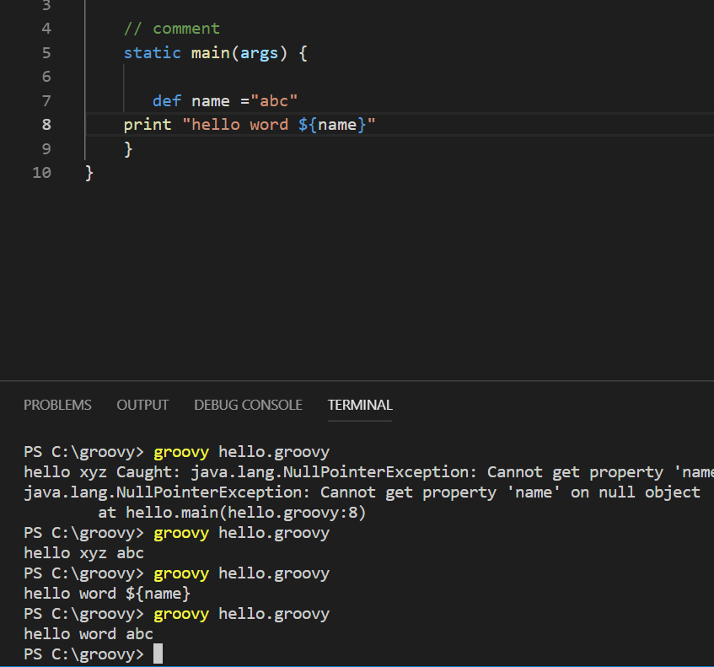

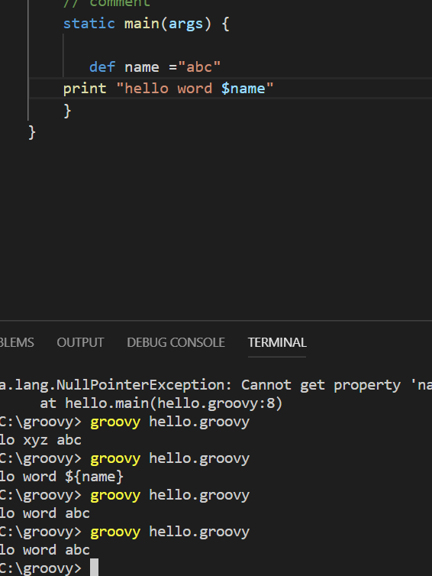

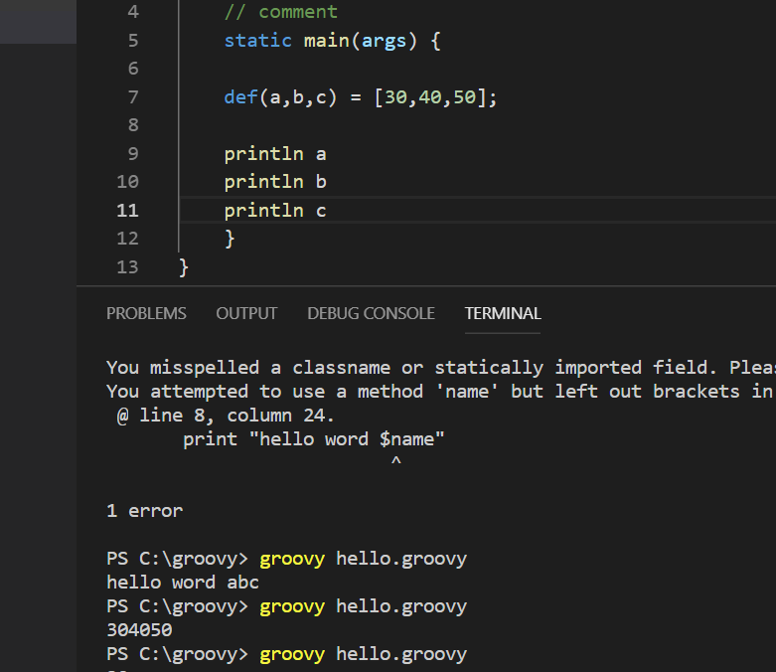

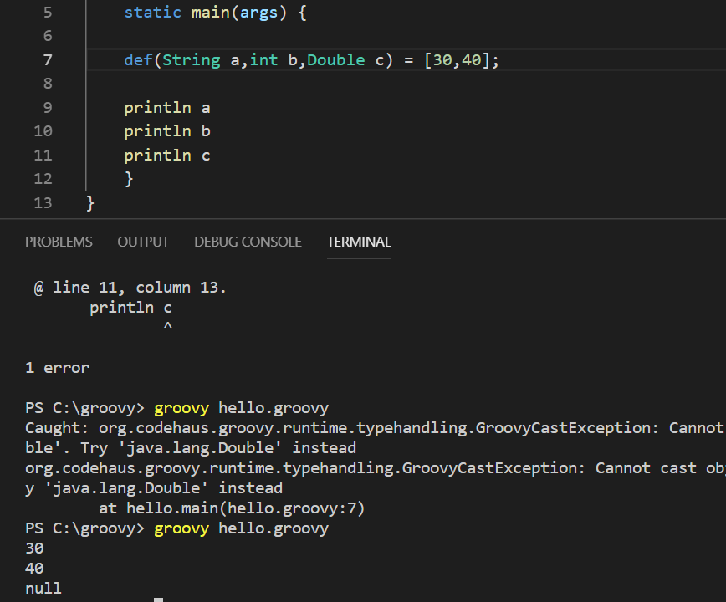

<https://matthewpalmer.net/kubernetes-app-developer/articles/kubernetes-deployment-tutorial-example-yaml.html>

