Spring Cloud Ribbon default algorithm is Round Robin Algorithm .

Other Algorithms for Load Balancing :

1. Least Connections :
2. IP Hash : based on IP Address we want to redirect to our server .

Feign Client : When we are performing load balancing & we are integrating with Eureka Service Registry .

As it implicitly do the Load Implementation .

<http://jsonplaceholder.typicode.com/>

J VISUAL VM

C:\Program Files\Java\jdk1.8.0_221\bin **J VISUAL VM LOCATION**

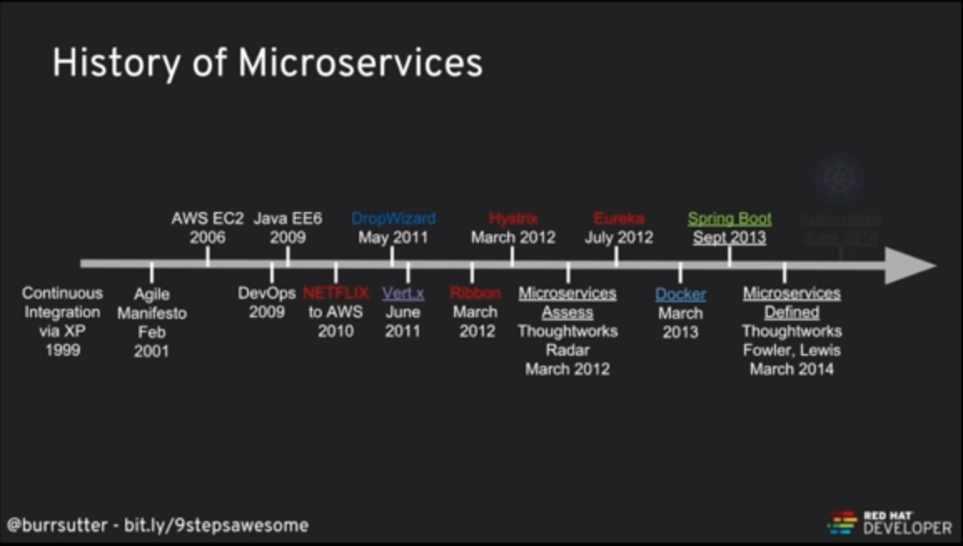

<https://www.hanselman.com/blog/AptGetForWindowsOneGetAndChocolateyOnWindows10.aspx>

<https://www.youtube.com/watch?v=AoDhQt8PtUQ> Docker + Kubernetes + Openshift