AI Logistics & Delivery Automation Platform
Comprehensive System Architecture & Developer Documentation

1. Project Overview & Vision
This project is an enterprise-grade, microservice-based logistics platform. It automates the delivery dispatch process by combining real-time gig-economy features (like Uber/Swiggy) with Machine Learning to predict delivery ETAs and flag potential delays before they happen.

2. System Architecture
The platform operates on a 3-Tier Microservice Architecture.
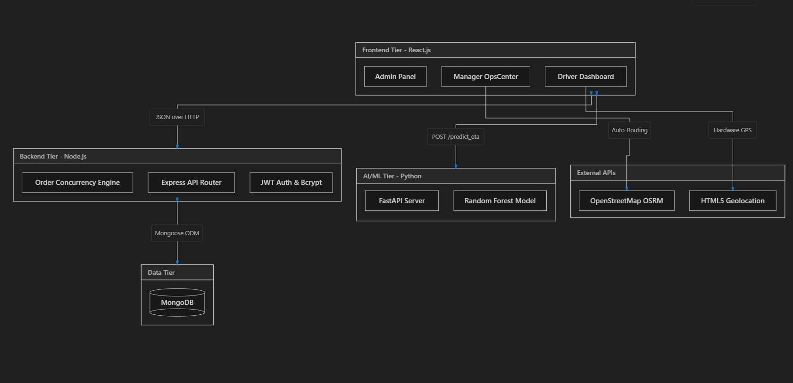

Technology Stack Breakdown:
- Frontend: React.js, TailwindCSS, Vite, React-Leaflet (for maps), Lucide-React (icons).
- Backend: Node.js, Express.js.
- Database: MongoDB, Mongoose ODM.
- Security: JSON Web Tokens (JWT) for session management, Bcrypt for password hashing.
- AI Engine: Python, Pandas, Scikit-Learn (Random Forest Regressor), FastAPI, Uvicorn.
- External Integrations: OpenStreetMap (OSRM) for route distance calculation, HTML5 Geolocation API for hardware GPS tracking.

3. The Lifecycle of an Order (How Data Flows)
Understanding this workflow is crucial for explaining the project. Here is exactly what happens when a order starts occurs:
- Order Creation (Manager):
  - The Manager selects a Pickup Zone and Drop-off Zone.
  - The Magic: The React app instantly pings the OpenStreetMap (OSRM) routing API. It takes the GPS coordinates of those two zones and calculates the exact physical driving distance in kilometers.
- AI Prediction:
  - React sends this distance, along with the Weather and Traffic levels, to the Python FastAPI Microservice.
  - The Random Forest model looks at 50,000 historical deliveries and predicts the ETA in minutes.
  - If the ETA is > 40 minutes, the order is flagged as a "Predicted Delay".
- Database Insertion:
  - The order is saved to MongoDB via the Node.js API with a status of Pending.
- Gig-Economy Broadcast:
  - All online drivers constantly poll the database for Pending orders. The new order pops up on all their screens simultaneously.
- Concurrency Claim (The Race):
  - A driver clicks "Accept Order". The Node.js server uses a locking mechanism: it assigns the driver_id to the order and changes the status to Active. If another driver clicks accept a millisecond later, the server blocks them.
- Live GPS Tracking:
  - The Driver app accesses the phone's physical GPS chip using navigator.geolocation.
  - It sends the driver's exact coordinates to MongoDB every few seconds.
  - The Manager's Leaflet map automatically pulls these coordinates, making the blue pin physically move across the screen.
- Delivery Lifecycle:
  - The driver clicks "Confirm Picked Up" -> The UI switches modes, and the AI calculates the final countdown ETA to the customer.
  - The driver clicks "Mark as Delivered" -> The database status changes to Delivered, clearing the driver's screen so they can accept a new gig.

4. Core Modules & Features Detail

A. The AI Machine Learning Module
- How it works: We trained a RandomForestRegressor on a 50,000-row CSV dataset (localized to Bengaluru).
- Inputs: distance_km, weather, traffic_level, restaurant_prep_time, driver_experience.
- Output: predicted_eta_minutes.
- Why it's smart: Unlike Google Maps, which uses road speed limits, this model uses historical pattern recognition. It knows that 5km in "Rain" + "High Traffic" takes significantly longer than 5km in "Clear" + "Low Traffic".

B. Manager OpsCenter (The Dispatch Hub)
- Real-Time KPIs: Calculates active deliveries and counts how many are mathematically predicted to be delayed.
- React-Leaflet Map: Renders an interactive map of Bengaluru. It filters the MongoDB database for online drivers and plots their live coordinates.
- Hybrid Auto-Routing: Replaces manual distance typing with a dynamic Zone-to-Zone API call (OpenStreetMap) to prevent human error during dispatch.

C. Driver Dashboard (Gig-Economy App)
- Hardware Interfacing: Uses browser-level hardware APIs to read the device's physical GPS location.
- State-Machine UI: The interface is built as a dynamic state machine with three rigid phases:
  - Listening: Displaying the broadcast pool.
  - Active: Navigating to the restaurant.
  - Picked Up: Navigating to the customer (triggers the AI ETA display).

D. System Admin Panel
- Dynamic Provisioning: Allows root admins to create new employee accounts directly into MongoDB.
- Security Middleware: Passwords created here are immediately intercepted by a Mongoose pre('save') hook and hashed via Bcrypt before entering the database, ensuring absolute security.

5. Database Schema

User Collection
- name, email
- password (Encrypted string via Bcrypt)
- role (Admin, Manager, Driver)
- vehicleId
- location (Object containing lat, lng, and updatedAt for live tracking)

Order Collection
- order_id (Unique identifier)
- pickup_area, delivery_area
- distance_km, weather, traffic_level
- status (Enum: Pending, Active, Picked_Up, Delivered)
- late_delivery (Boolean flag determined by the AI)
- driver_id (Relational link to the User collection)

6. How to Run the Project (For Vivas/Demos)
You must run all three microservices simultaneously in three separate terminal windows:
Terminal 1 (Backend Node.js):
cd backend
npm install
npm run dev
# Runs on http://localhost:5000
Terminal 2 (AI FastAPI Python):
cd ai_engine
pip install fastapi uvicorn pandas scikit-learn
uvicorn main:app --host 0.0.0.0 --port 8000
# Runs on http://localhost:8000
Terminal 3 (React Frontend):
cd frontend
npm install
npm run dev
# Runs on http://localhost:5173

