

Cyclistic E-Bike Organisation Business Study

|  |  |  |  |
| --- | --- | --- | --- |
| Avis Massey | Pratik Shetty | Ritik Jain | Viabhav Sonia |
| MSc. Data Analytics | MSc. Data Analytics | MSc. Data Analytics | MSc. Data Analytics |
| National College of Ireland | National College of Ireland | National College of Ireland | National College of Ireland |
| Dublin, Ireland | Dublin, Ireland | Dublin, Ireland | Dublin, Ireland |
| [x21199752@student.ncirl.ie](mailto:x21199752@student.ncirl.ie) | [x 21227578@student.nci.rl.iee](mailto:x%2021227578@student.nci.rl.iee) | [x22119469@student.ncirl.iee](mailto:%20x22119469@student.ncirl.iee) | [x22136860@student.nci.rl.iee](mailto:x22136860@student.nci.rl.iee) |

Contents

1. INTRODUCTION 3
2. BACKGROUND INFORMATION 3
3. BALANCED SCORECARD: 4
   1. Growth Perspective 4
   2. Financial Perspective 4
   3. Customer perspective 4
   4. Internal Process 4
4. GAP ANALYSIS 6
5. SCOPE, INNOVATION, AND WORKFLOW 9
6. DESIGN TOOLS USED: 10

|  |  |  |
| --- | --- | --- |
| **6.1.** | **Local** **Machine** | **10** |
| **6.2.** | **Power** **BI** | **10** |
| **6.3.** | **Monday.com** | **10** |
|  |  |  |

### DASHBOARDS: 11

|  |  |  |
| --- | --- | --- |
| **7.1.** | **Dashboard 1:** | **11** |
| **7.2.** | **Dashboard 2:** | **10** |
|  |  | **10** |
| 7.2.1. | Dashboard 2: | 10 |
| 7.2.2. | Dashboard 2: | 11 |
| **7.3.** | **Dashboard 3:** | **12** |
| 7.3.1. | Dashboard 3: | 12 |
| 7.3.2. | Dashboard 3: | 13 |
| 7.3.3. | Dashboard 3: | 13 |
| **7.1.** | **Dashboard 4:** | **14** |
|  |  |  |

### CRM IMPLEMENTATION 19

|  |  |  |  |
| --- | --- | --- | --- |
| **9.1.** | **Sales** |  | **19** |
| 9.1.1. |  | Step1:Contacts and leads: | 19 |
| 9.1.2. |  | Step2:Cases and solution: | 20 |
| 9.1.3. |  | Step 3:Opportunity: | 22 |

* 1. **Customer Service Request: 26**
     1. Step 1:New Case: 26
     2. Step 2: Working on the case: 27
     3. Step 3 Resolving and Closing the Case: 28

### CONCLUSION AND SOLUTIONS. 29

### REFERENCES 30

### VIDEO PRESENTATION 30

# Introduction

#### We are a group of Business Analysts who provide our clients with end-to-end business support to analyse their business performance, track their growth, and increase their profits by identifying the gaps and downfall points in their business.

#### Cyclistic, a bike-share company based in Chicago, Illinois for which we have been designated as business analysts to oversee the process of selecting and implementing a business intelligence and analytics platform for their development and also to help them increase their profits by identifying and addressing any loopholes and weaknesses in their business operations.

#### As a business analyst, the task is to provide data-driven insights to the Marketing department, in order to develop an effective marketing strategy that converts casual riders into annual members. By understanding the differences in usage patterns between these two customer segments, the goal is to increase the number of annual subscribers and drive company growth.

#### Our team utilizes the Balanced Scorecard framework to assess and monitor organizational performance. By employing this approach, we ensure a comprehensive evaluation of key areas including financial, customer, internal processes, and learning and growth perspectives. It enables us to align business activities with the overall strategic vision, facilitating effective decision-making and goal-setting. Once the Balanced Scorecard is implemented, we proceed to conduct a GAP analysis which involves comparing the current performance levels of the organization across various metrics with the desired targets or benchmarks.

#### To facilitate the technical implementation, we use *Power BI* as the primary tool for creating interactive dashboards and conducting in-depth analytics. Power BI’s visualisation capabilities are robust, allowing us to present data insights in a visually appealing and user-friendly manner. In addition, we will use Monday.com as our customer relationship management (CRM) application of choice. Monday.com, known for its affordability and versatility, provides a comprehensive solution for improving sales processes and customer service. We intend to use these platforms to streamline data analysis and reporting while optimising our interactions with customers in order to drive sales and provide exceptional service.

#### Ultimately, our aim to demonstrate the importance of implementing a business tool to effectively manage the company's operations. We hope to persuade shareholders by emphasising the potential cost savings and the smooth implementation process. Furthermore, we will outline the system and database design, which will provide the company with a scalable business solution. This design will ensure that the tool can grow with the company while still providing optimal performance and efficiency. By presenting these key points, we hope to demonstrate the value and long-term benefits of implementing the proposed business tool for organisational management.

# Background Information

#### Cyclistic, a well-established bike-share platform based in Chicago since mid-2016, has grown significantly over the years. The company has 692 strategically located stations throughout the city and a fleet of 5,824 geotracking bicycles. Their service is notable for the convenience it provides riders, allowing them to unlock bikes from one station and return them to any other station in the system. This adaptability has aided the platform's popularity and established it as a major player in the US bike-share market. As they aim to expand its presence globally, it has identified two distinct user types: casual riders and annual members. Finance analysts have discovered that annual members generate higher profitability compared to casual riders. Recognizing the need for improved sales and customer support management, the company is now considering investing in business intelligence (BI) and customer relationship management (CRM) tools. These investments are crucial to meet the rising demand and ensure future growth. They can improve operational efficiency, provide better customer service, and strategically position itself for continued success in the competitive bike-share industry by leveraging BI and CRM solutions.

#### Our primary objective is to build a large customer database and comprehensive bike usage data. This strategic focus will allow us to use this valuable data for future initiatives while also expanding our client base and increasing our market prominence. By prioritising data collection, we hope to lay a solid foundation for future implementations and foster industry growth.

# Balanced Scorecard:

#### The implementation of a Balanced Scorecard (BSC) framework within Cyclistic's business can significantly contribute to its success and growth. With a focus on aligning activities with the company's overall strategy, the BSC enables a comprehensive evaluation of performance across multiple perspectives which are the Financial, Customer, Internal processes, and Growth perspectives

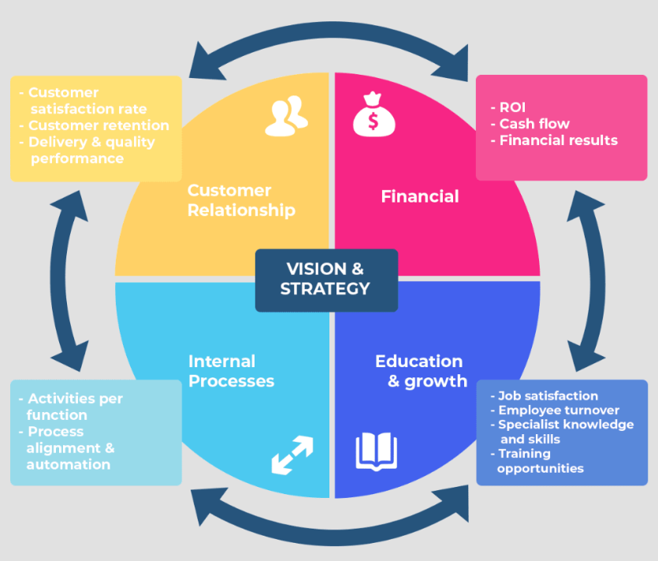

Fig. 1. Balanced scorecard.

## Financial Perspective

Cyclistic can track the three most famous metrics such as revenue growth, profitability, and return on investment. This information will provide insights into the financial health of the business, helping to identify areas for improvement and potential cost-saving measures.

* 1. Customer Perspective

The first and foremost objective of any company is to gauge customer satisfaction, retention, and market share. By understanding customer needs and preferences, the company can enhance its services, improve customer experience, and develop targeted marketing strategies to attract new customers and retain existing ones.

* 1. Internal Process Perspective

To evaluate the efficiency and effectiveness of its operations. Key indicators such as process efficiency, quality control, and innovation can be tracked to identify bottlenecks and streamline operations, ensuring a smooth and seamless bike-sharing experience for customers.

* 1. Growth Perspective

The growth perspective focuses on the development of the organization as a whole. By monitoring metrics such as employee training, knowledge management, and organizational culture, Cyclistic can foster a learning environment, drive innovation, and enhance employee satisfaction, leading to improved overall performance.

The implementation of the Balanced Scorecard in Cyclistic's business will provide a comprehensive view of the company's performance and allow for the identification of areas for improvement. They can make informed decisions, align its activities with strategic objectives, and drive continuous growth and success in the competitive bike-sharing industry by regularly monitoring and analysing data from these perspectives.

# Gap analysis

#### Post conducting brainstorming sessions and utilizing the available data, we performed a comprehensive gap analysis. The analysis was categorized into three sections, and the results are presented in the table provided below.[2]

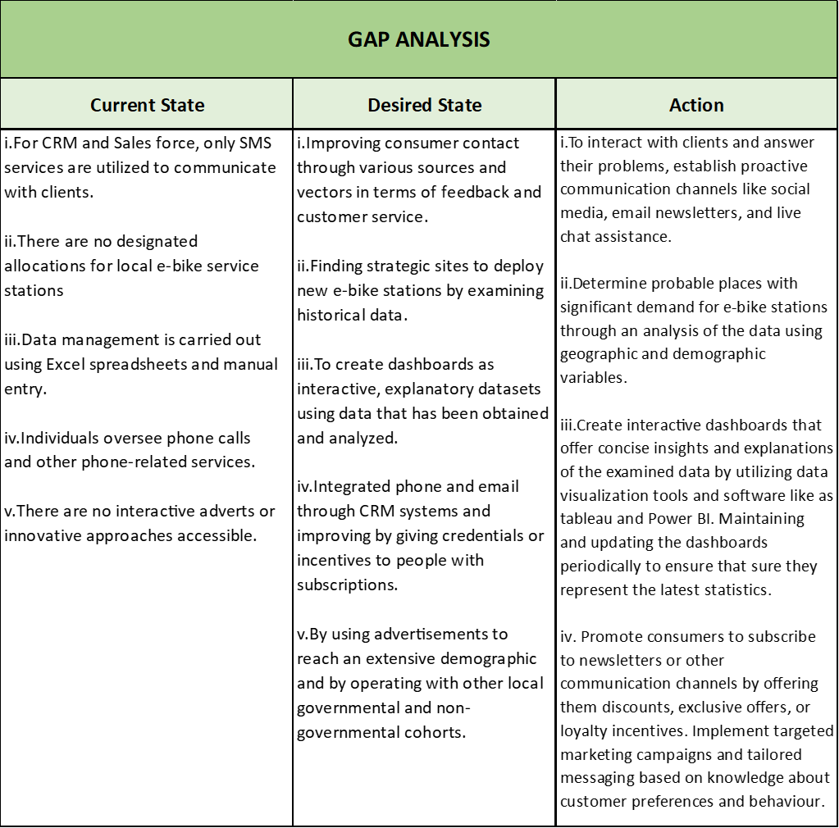

Fig. 2. Gap analysis.

In the aforementioned Fig (2) we have performed GAP analysis on basis of multiple inputs put forth by our team and a detailed explanation of the above is given below:

1. **Current State:** Upon conducting the gap analysis, we identified several areas that require attention and improvement within our current operations.

* In terms of CRM and SalesForce, our communication with clients is solely reliant on SMS services. This limited mode of communication may hinder effective customer engagement and relationship building.
* There is a lack of designated allocations for local e-bike service stations. This absence of clearly defined stations may lead to operational inefficiencies and difficulties in ensuring timely maintenance and servicing of our e-bikes.
* Data management is currently reliant on Excel spreadsheets and manual data entry. This approach poses challenges in terms of data accuracy, scalability, and accessibility for analysis and decision-making processes.
* Individual employees handle phone calls and other phone-related services, which may result in inconsistencies in customer interactions and potentially impact the overall customer experience.
* The absence of interactive advertisements or innovative approaches limits our ability to effectively reach and engage with our target audience. Implementing creative marketing strategies and interactive adverts can help us attract more customers and differentiate ourselves in the competitive market.

Addressing these gaps will be crucial in enhancing our customer communication channels, establishing efficient service stations, implementing robust data management systems, improving customer interactions, and adopting innovative marketing approaches.

1. **Desired State:** To address the identified gaps and enhance our operations, we have outlined several key strategies.

* We aim to improve consumer contact by diversifying our feedback and customer service channels. This includes leveraging various sources and vectors to gather customer feedback and provide prompt and efficient customer support.
* We plan to utilize historical data to identify strategic sites for deploying new e-bike stations. By analyzing the data, we can determine areas with high demand and potential for increased ridership, enabling us to make informed decisions when expanding our station network.
* Our focus is on creating interactive and explanatory dashboards using the data we have collected and analyzed. These dashboards will provide valuable insights and enable stakeholders to make data-driven decisions, contributing to improved operational efficiency and effectiveness.
* We aim to integrate phone and email communication through our CRM systems, enhancing customer interactions and streamlining communication channels. We plan to incentivize customers with subscriptions or provide special credentials to further enhance their experience and foster loyalty.
* We intend to leverage advertisements to reach a broader demographic, expanding our customer base. Collaborating with local governmental and non-governmental cohorts will allow us to tap into additional resources and support, enhancing our marketing efforts and increasing our visibility in the market.

By implementing these strategies, we aim to strengthen customer engagement, optimize station deployment, leverage data for informed decision-making, enhance communication channels, and expand our reach in the market.

1. **Action:** To Based on the identified gaps from the analysis, we have formulated a set of actions to address them.

* We aim to enhance client interaction and problem-solving by establishing proactive communication channels such as social media, email newsletters, and live chat assistance. These channels will allow us to engage with clients in real-time and provide timely support and solutions.
* We will utilize data analysis techniques, considering geographic and demographic variables, to identify potential high-demand locations for e-bike stations. This data-driven approach will help us strategically deploy stations in areas with the greatest potential for usage and ridership.
* We will leverage data visualization tools like Tableau and Power BI to create interactive dashboards that provide concise insights and explanations of the analyzed data. These dashboards will be regularly updated to ensure they reflect the latest statistics, enabling stakeholders to make informed decisions.
* To encourage customer engagement, we will incentivize them to subscribe to newsletters or other communication channels by offering discounts, exclusive offers, or loyalty incentives. Moreover, we will develop targeted marketing campaigns and tailor messaging based on customer preferences and behavior.
* Utilizing CRM capabilities, we will execute targeted advertising campaigns across various channels, encompassing digital platforms, print media, and outdoor advertising. Collaborating with local governmental and non-governmental organizations will allow us to tap into their networks, resources, and community outreach programs, expanding our brand exposure and reach.

By implementing these actions, we aim to enhance client satisfaction, optimize station placement, leverage data visualization for decision-making, boost customer engagement through tailored communication, and broaden our marketing efforts through targeted campaigns and partnerships.

# Scope, Innovation, and workflow

#### To enhance customer service and streamline operations, we have planned the implementation of Customer Relationship Management (CRM) and Business Intelligence (BI) tools. The first step in this process is to replace the existing local database in Excel with a dedicated CRM tool. This transition will enable Cyclistic to manage customer information more efficiently, track interactions, and provide personalized support. Additionally, the CRM tool will enable the company to gather leads from various social media campaigns (Facebook, Instagram etc.) and other sources, allowing for targeted marketing efforts and expansion of the client base. Furthermore, we intend to collect valuable feedback from customers by sending out feedback forms, so that by understanding customer needs and preferences, the company can make informed decisions, tailor its services to meet customer expectations, and continuously improve the overall customer experience.

#### The implementation of CRM and BI tools marks a significant step forward for Cyclistic, empowering the company with the necessary tools and insights to drive growth and deliver exceptional customer service.

#### The primary goals of the business intelligence application are twofold: first, to provide management with comprehensive summary statistics, allowing them to gain valuable insights into the company's performance; and second, to support and facilitate the expansion of bicycle utilisation. Cyclistic intends to provide actionable information to decision-makers via the business intelligence application, allowing them to make informed decisions and drive strategic growth. Furthermore, the application will be critical in identifying opportunities for increasing bicycle utilisation, maximising revenue and improving overall business effectiveness.

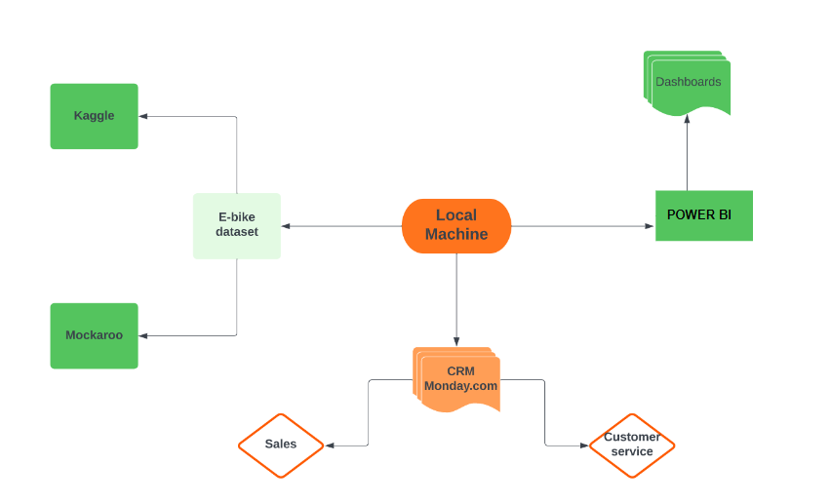

Fig. 3. Process workflow

#### **The process workflow (Figure 3) involves the following steps:**

#### Data Sample: To gather the data, we utilize sources like Kaggle and Mockaroo. We acquire a sample dataset from Kaggle and make necessary modifications using Mockaroo to align it with our requirements.

#### PostgreSQL: The modified data is stored in PostgreSQL, serving as the primary database for the company. This database houses the comprehensive dataset for further analysis and retrieval.

#### Power BI: Data from the PostgreSQL database is extracted and utilized in Power BI. In Power BI, we leverage its features to create insightful financial dashboards and generate other valuable insights. This allows us to visualize and analyze the data effectively.

#### CRM Implementation: SalesForce is implemented as the customer relationship management (CRM) tool. With SalesForce, we establish a robust sales and customer support pipeline. This pipeline enables us to address marketing, sales, and customer-related issues, streamlining our processes and improving overall customer satisfaction.

#### By following this process workflow, we can efficiently gather, store, analyze, and utilize data, leveraging tools like PostgreSQL, Power BI, and SalesForce, to drive informed decision-making, enhance operational efficiency, and strengthen our customer relationships.

# Design Tools used:

Given the size and newness of our company, our focus is on selecting design tools and applications that offer enhanced efficiency, improved management capabilities, and innovative marketing solutions. Due to budget constraints, we prioritize cost-effective options that optimize both time and resources. To support our e-bike processes, we have integrated three key tools:

* 1. Power BI

#### Power BI is a robust business intelligence tool that allows us to gather, analyze, and visualize data effectively. By leveraging Power BI, we gain valuable insights into our operations, enabling data-driven decision-making and enhancing overall business performance.

* 1. Local Machine

#### Our local machine serves as a crucial design tool, providing us with the necessary infrastructure to develop and manage our e-bike processes. This includes data storage, software installations, and local development environments, allowing us to efficiently handle various operational tasks..

* 1. Monday.com

To streamline customer relationship management and enhance our marketing efforts, we utilize Monday.com CRM. This low-cost CRM platform offers comprehensive features for managing sales pipelines, customer interactions, and marketing campaigns. By leveraging Monday.com CRM, we can improve our customer service, sales efficiency, and overall marketing effectiveness.

1. Dashboards:
   1. Dashboard 1:

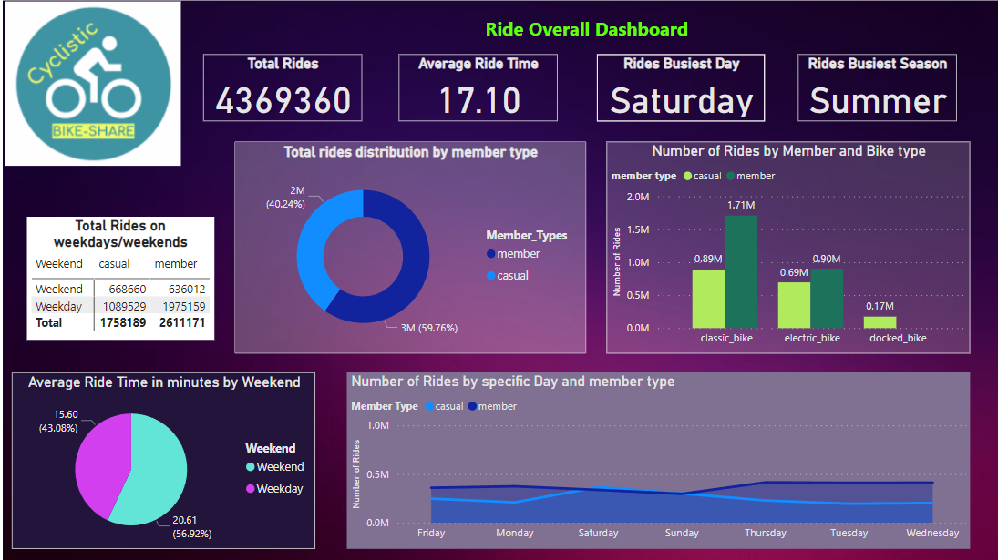

Fig. 6.Overall Ride Dashboard.

* The dashboard in Fig 6. provides an overview of e-bike users, categorizing them into Classic_bike, Electric_bike, and Docked_bike. It presents the count of casual users and members. Among the users, casual users account for 40.24%, while member users make up 59.76% of the total user base, which amounts to 4.3 million users.

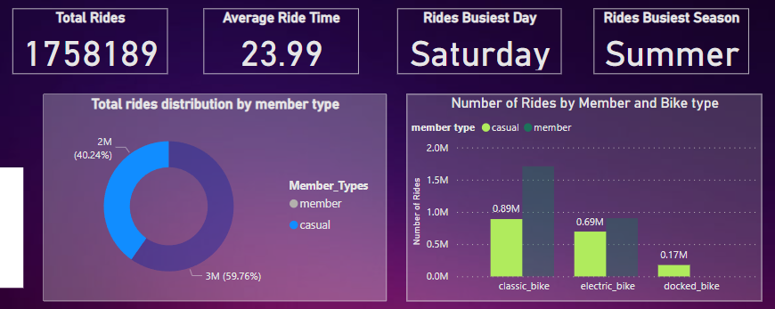

Fig. 7. Average ride distribution for 1.7 mil rides.

* Regarding casual users in fig 7, they have a total of approximately 1.7 million rides. The busiest period for them is Saturday, and the busiest season is summer. The average ride duration for casual users is 23.99 minutes.

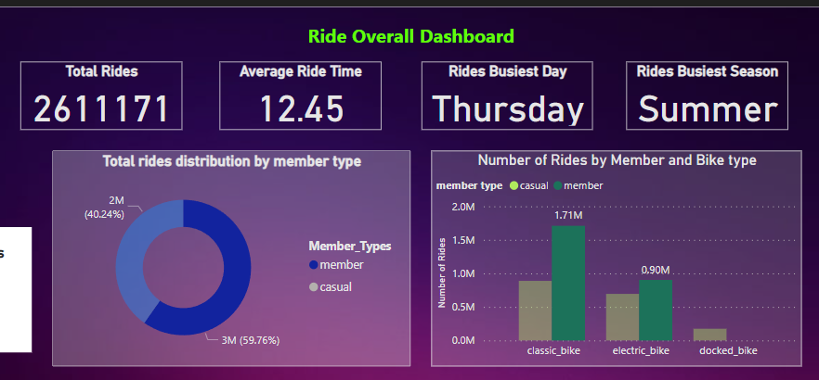

Fig. 8. Average ride distribution for 2.6 mil rides.

* On the other hand, member users have a total of about 2.6 million rides. Their busiest period falls on Thursday, and their busiest season aligns with summer. Member users typically have shorter rides, with an average duration of 12.45 minutes.
* The analysis reveals that casual users tend to have more rides during weekends, while member users are more active on weekdays.

Dashboard 2:

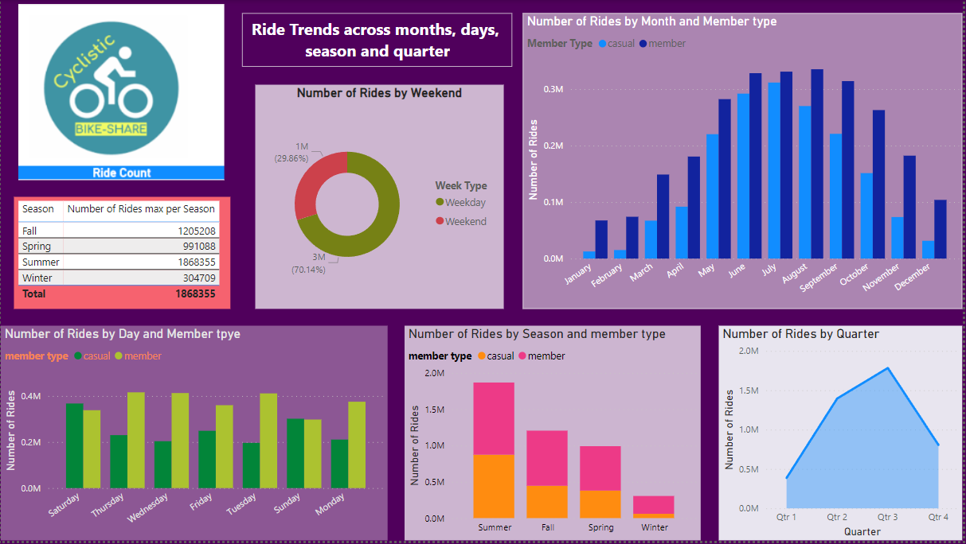

Fig. 9. Ride trends across months, days,season and quater.

#### The aforementioned dashboard provides insights into ride trends across months, days, seasons, and quarters.

#### The graph illustrates the distribution of overall rides throughout the months. It shows a noticeable increase in the user count for both casual users and members starting from April and continuing until November. This surge in users corresponds to the summer season, resulting in heavy traffic on the platform. Conversely, from December to March, there is a decline in the user count for both casual users and members, indicating fewer rides during the winter season.

#### As per the fig 10 mentioned below, we examining the specific days of the week, it is observed that casual users tend to take more rides after Sundays, suggesting a peak in activity during the weekends. In contrast, member users show less variation in their ride patterns across the week, indicating a more consistent usage pattern throughout the weekdays.

#### 

Fig. 10. Number of Rides by month and user type

#### Dashboard 2:

#### 

Fig. 11. Number of Rides by Quater

Analyzing the quarters, it is evident that the third quarter generates higher user engagement compared to other quarters. On the other hand, the first quarter performs relatively less in terms of user activity. This insight highlights the need to expand marketing efforts during the first quarter to attract more users and increase engagement during this period.

Overall, these ride trends provide valuable information for strategic decision-making, allowing for targeted marketing campaigns and resource allocation to optimize user engagement throughout the year.

Dashboard 3:

#### 

Fig. 12. Ebike Station Insights

#### The aforementioned dashboard in Fig 12, it provides valuable insights into the locations of e-bike start stations in the city of Chicago. Through the use of a graph and map, the dashboard displays the number of rides accessed from various e-bike stations across the city. Among the stations, the most frequently used locations are Streeter Dr & Grand Avenue, DuSable Lake Shore Dr & Monroe Street, and DuSable Lake Shore North Blvd. It is interesting to note that the most heavily utilized stations are located near the sea-coast.

#### 

#### Fig. 13. Ebike Station Insights on the Map

#### As shown in Fig 14. In particular, the DuSable Lake Shore North Blvd station stands out as the most popular, with a high number of rides originating from that location. Additionally, the average ride time at the Millennium Park station closely follows the ride time at DuSable Lake Shore North Blvd, indicating a consistent usage pattern between these two stations.

#### 

#### Fig. 14. Breakdown of Station Dashboard.

The data from the dashboard offers valuable insights for planning and optimizing the distribution of e-bike start stations in Chicago. By analyzing the patterns and popularity of specific locations, city planners and bike-sharing companies can make informed decisions about where to strategically place new stations or expand existing ones to cater to the demand.

Further analysis can be conducted to understand the factors contributing to the popularity of these stations near the sea-coast. Is it due to their proximity to popular tourist attractions, residential areas, or transportation hubs? By diving deeper into these aspects, stakeholders can gain a comprehensive understanding of user preferences and usage patterns, ultimately enhancing the efficiency and accessibility of e-bike services throughout the city

Dashboard 4:

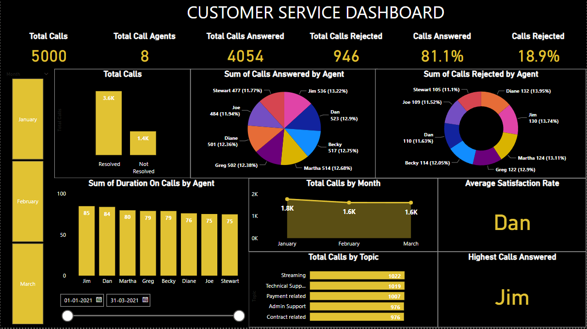

Fig. 15. Customer Service Dashboard

#### The aforementioned fig 15, dashboard represents the performance of the customer service team.

#### During the first quarter, a total of 5,000 queries were received via phone calls. The customer service team consists of 8 members dedicated to providing assistance. Out of the 5,000 calls, 4,054 calls were successfully attended, representing an 81.1% connection rate. However, 946 queries could not be connected, accounting for 18.9% of the total.

#### 

#### Fig. 16. Customer Service Dashboard

#### As shown in Fig 16, it is evident that out of the total 5,000 calls, 3,646 queries were resolved by the team, while 1,354 queries remained unresolved. Among the 8 customer service representatives, Jim handled the highest number of queries that were successfully resolved. However, due to various reasons, some queries were not resolved by the team.

#### Dashboard 4:

#### 

#### Fig. 17. Detailed explanation on Average Sales dashboard

.

#### As shown in fig 17, The queries received covered different categories such as technical support, payment-related issues, administrative support, and contract or membership inquiries. Among these categories, technical support received the highest number of queries, indicating the need for particular attention in addressing technical issues.

#### The dashboard in Fig. 15 provides valuable insights into the performance of the customer service team, highlighting both their successes and areas that require improvement. By analyzing these metrics and identifying the reasons behind unresolved queries, the team can enhance their strategies and processes to ensure better customer satisfaction and more effective query resolution

1. CRM IMPLEMENTATION

CRM is a powerful tool that enables businesses to effectively manage and nurture their existing client relationships while also striving to acquire new ones. For small firms aiming to expand, it is crucial to streamline their sales, marketing, and customer service operations through the implementation of a robust CRM system. This allows them to enhance their overall business performance and create a solid foundation for growth and success.[4]

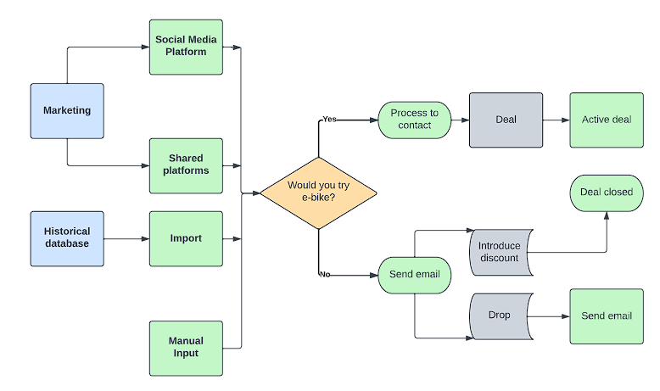

Fig. 18. CRM workflow

While exploring different CRM software options such as Salesforce and Dynamics 365, we specifically targeted a solution that caters to the needs of startups. Hence, we opted for Monday.com as our CRM tool due to its user-friendly interface, automation capabilities, mobile CRM functionality, visually appealing dashboards, scalability, and seamless integration with other software applications. Moreover, Monday.com offers all these features at an affordable cost, making it an ideal choice for our business.

* 1. Sales

**Step1: Contacts:**

In our system, a "contact" refers to an individual who has an active membership with our company. They have already signed up and are actively using our services. However, if their membership expires, they transition from being a contact to a "lead." A lead represents someone who had a previous membership but is currently not an active member.

On our dashboard as shown in fig 19, we have detailed information about each contact, including their email address, gender, phone number, and membership type. These details provide valuable insights that help us personalize our communication and services for each contact. By understanding their preferences and demographics, we can tailor our offerings to better meet their needs and preferences, ultimately enhancing their experience with our company.

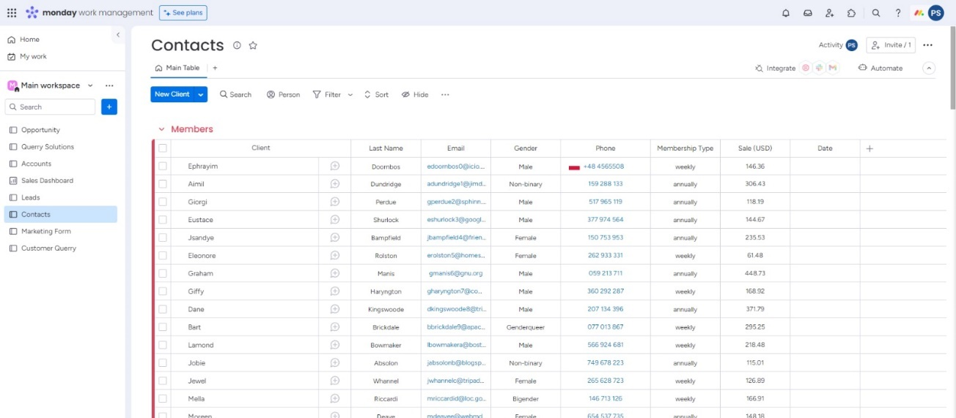

Fig. 19. Contacts Dashboard.

**Step2: Leads:**

A "lead" in our system represents a potential customer who has shown interest in our products or services. There are three primary methods through which we generate leads.

* Firstly, contacts whose membership has expired transition from being active members to becoming leads. This means that even though they were once customers, they currently do not have an active membership with us, indicating an opportunity to re-engage and potentially convert them back into paying customers.
* Secondly, we generate leads through targeted social media marketing campaigns. By leveraging various social media platforms, we create engaging content and advertisements to capture the attention of potential customers who may not be aware of our offerings. Through strategic targeting and compelling messaging, we aim to attract new leads who have expressed an interest in similar products or services.
* Lastly, we generate leads through marketing events. By organizing or participating in events such as trade shows, conferences, or community gatherings, we have the opportunity to connect with a broader audience and showcase our offerings. These events serve as platforms to engage with potential customers, establish relationships, and generate leads through face-to-face interactions and product demonstrations.

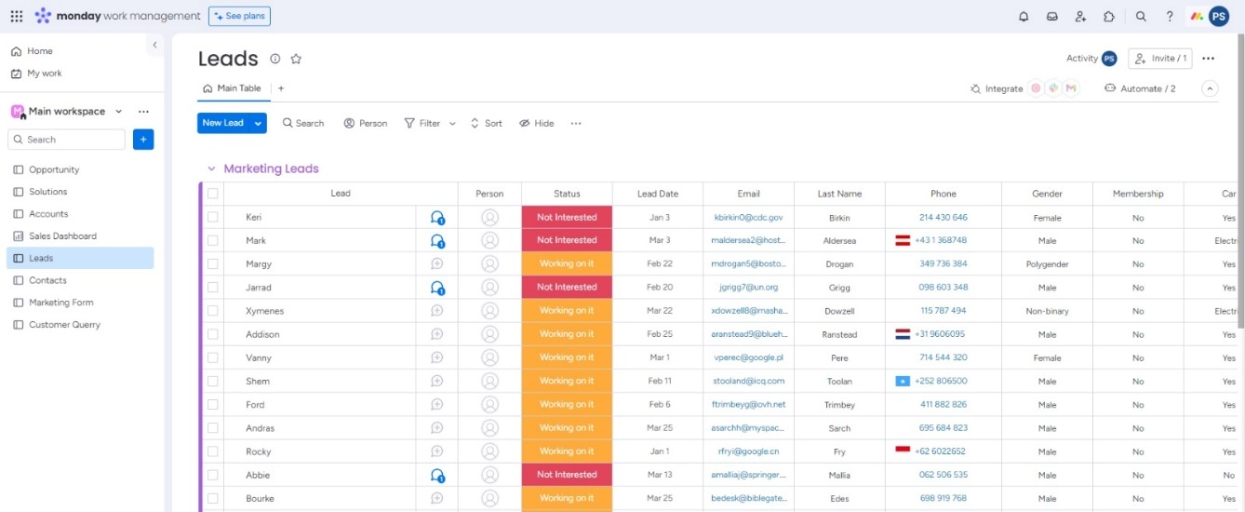

Fig. 20. Leads dashboard

Within the CRM system, we have the flexibility to manually input lead details by creating new lead entries. This can be done by clicking on the "New Lead" option and entering the relevant information. Moreover, we have the capability to import legacy data from our database or Microsoft sheets, as depicted in the figure. This enables us to efficiently populate our CRM with existing lead data, ensuring a comprehensive and accurate database.

Furthermore, automation features within the CRM system allow for streamlined lead management. Tasks such as changing lead status, transitioning leads between different groups, and performing various other actions can be automated.

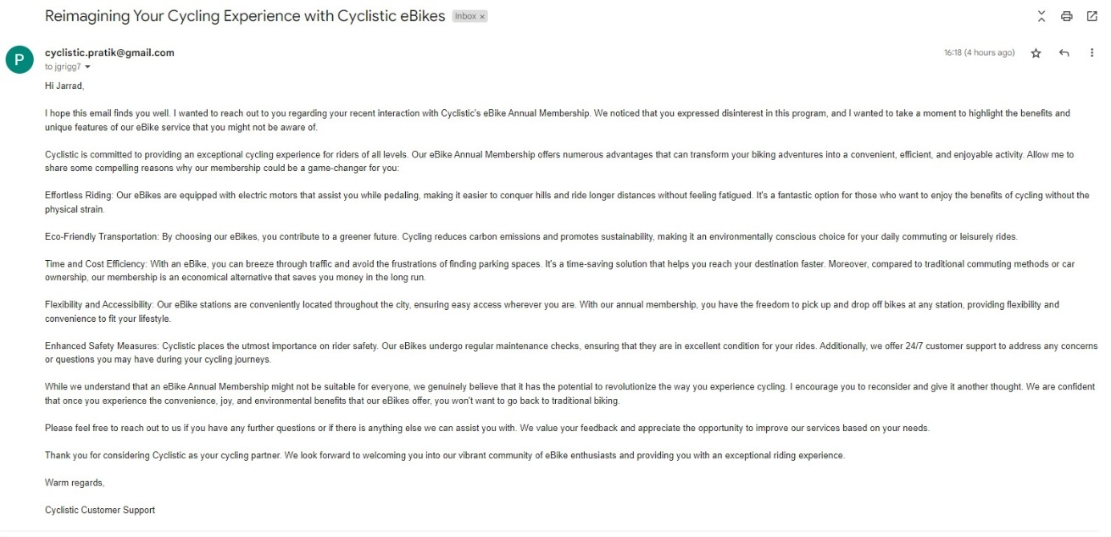

Fig. 21. Email sent to the Leads who are not interested

Once a lead is identified, we initiate contact through the means of a phone call. This direct communication allows us to engage with the lead, understand their needs, and provide them with relevant information about our products or services. If, during the call, it becomes evident that the lead is not interested or requires further nurturing, we proceed with a remarketing step by sending them a follow-up email. This remarketing email as shown in Fig 21. serves as a gentle reminder and provides additional details or incentives to encourage their interest.

On the other hand, if the lead expresses genuine interest and potential for conversion, we shift them to the opportunity dashboard as shown in Fig 22. This dashboard serves as a centralized hub to manage and track potential sales opportunities. It provides a comprehensive view of the lead's progress, allowing us to assign a sales representative, set tasks, schedule follow-ups, and monitor the overall sales pipeline. By transitioning the interested leads to the opportunity dashboard, we ensure a structured and organized approach to convert them into paying customers, maximizing our chances of successful conversions and revenue growth.

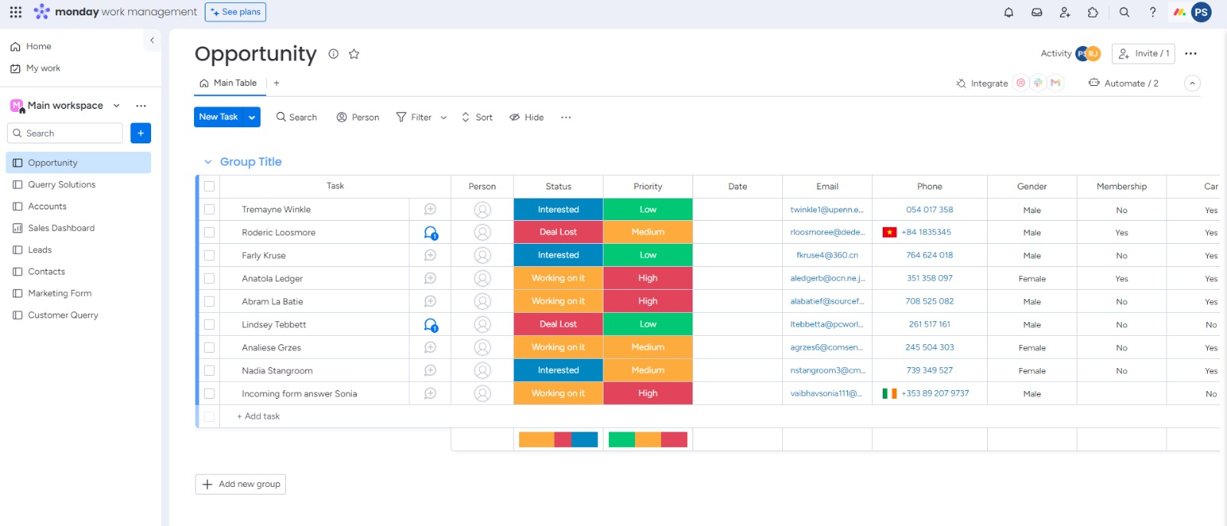

Fig. 21. Opportunity Dashboard

transitioning the interested leads to the opportunity dashboard, we ensure a structured and organized approach to convert them into paying customers, maximizing our chances of successful conversions and revenue growth.

**Step3: Opportunity:**

The opportunity dashboard serves as a vital tool for managing the conversion process from leads to customers. Once a lead has been contacted and engaged, they are categorized into three verticals on the dashboard: Interested, Working on it, and Deal Lost.

The leads categorized as "Interested" are those who have shown a genuine intention to purchase a membership and have successfully made the transition to becoming contacts. These individuals have completed the conversion process and are now considered customers.

Leads categorized as "Working on it" require further follow-up and nurturing to move them towards a final decision. Sales representatives are responsible for contacting and engaging with these leads, addressing any concerns or queries they may have, and guiding them through the process towards a potential membership purchase.

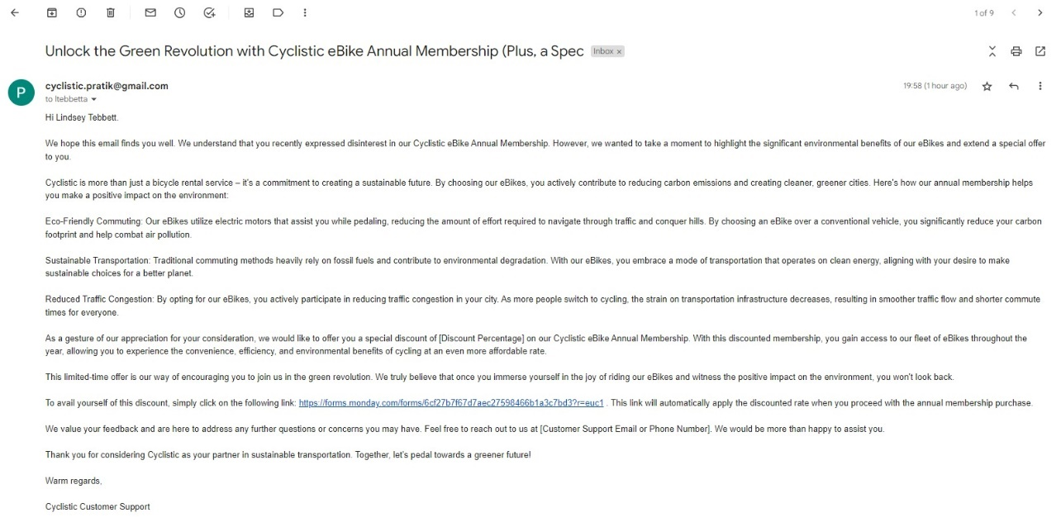

Fig. 22. Remarketing Email sent to Deal Lost customers

**Step4: Remarketing:**

For leads categorized as "Deal Lost," they have indicated a refusal to purchase a membership at the current time. However, we have an opportunity to re-engage them. To entice them further, we resend a tailored email that includes a discount or special offer as shown in Fig 22. Additionally, we provide a link to a marketing form as shown in Fig 23. that allows them to express their interest once again. By completing the form, they are automatically added back into the leads category, providing us with another chance to nurture and convert them into interested prospects and eventually into customers. The opportunity dashboard plays a crucial role in tracking and managing the progress of these leads, ensuring that no potential conversion opportunity is overlooked and maximizing our chances of success in converting leads to customers.

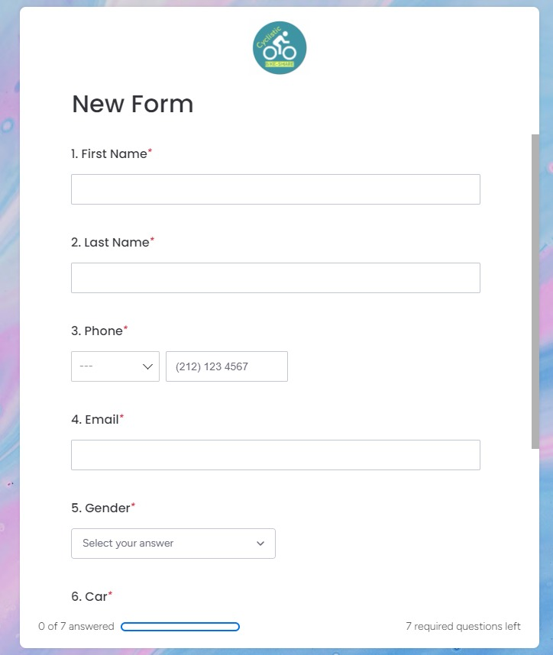

Fig. 23. Form used to remarket the Deal lost leads

**Step5: Sales Dashboard:**

For The sales dashboard provides a comprehensive view of key insights and metrics related to our sales performance. It offers a holistic overview of our overall sales activities and enables us to track important indicators of our business success.

One of the primary metrics displayed on the sales dashboard is the overall sales in USD, which provides a clear understanding of our revenue generation. This metric helps us monitor our financial performance and track our progress towards achieving sales targets.

Another important metric is the average sale per client, which allows us to gauge the average value of each customer transaction. This metric helps us assess the profitability of our sales efforts and identify areas for potential improvement or optimization.

The dashboard also includes information about the number of active leads, which represents the potential customers who have shown interest in our products or services. Tracking this metric helps us understand the size of our potential customer base and evaluate the effectiveness of our lead generation strategies.

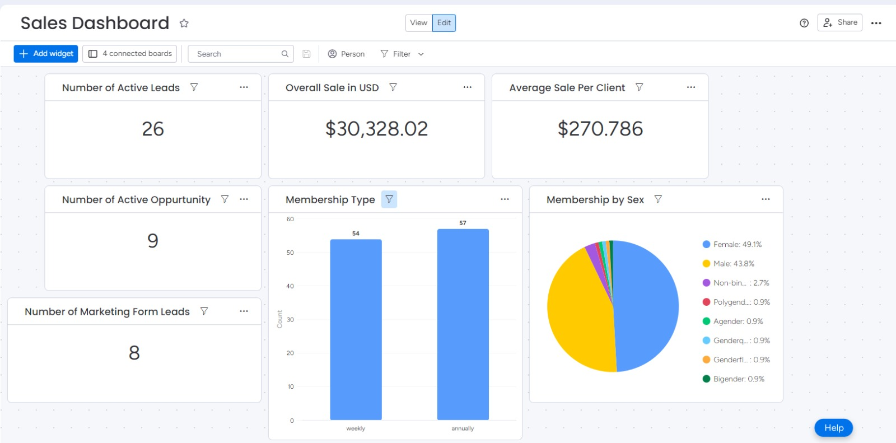

Fig. 24. Sales dashboard

Furthermore, the sales dashboard provides insights into the number of active opportunities, which represent potential sales that are currently being pursued or worked on. This metric helps us prioritize and manage our sales pipeline, ensuring that we focus our efforts on the most promising opportunities.

Additionally, the dashboard presents the number of marketing form leads, which indicates the number of individuals who have expressed interest in our offerings through marketing forms. This metric helps us measure the effectiveness of our marketing campaigns and assess the success of our lead generation initiatives.

The sales dashboard also provides information on membership types, distinguishing between weekly and annual memberships. This allows us to analyze the popularity and uptake of different membership options, enabling us to tailor our sales and marketing strategies accordingly.

Lastly, the dashboard includes insights on membership by gender, offering a breakdown of our customer base by gender. This information helps us understand any gender-based preferences or patterns in our customer demographics, supporting targeted marketing efforts and personalized customer experiences.

Overall, the sales dashboard provides a comprehensive and insightful overview of our sales performance, helping us make data-driven decisions, identify trends, and optimize our sales strategies for continued growth and success. form

* 1. Customer Service Request:

The customer support system plays a crucial role in addressing and resolving various queries and issues raised by our customers. We categorize the queries into different types, including battery problems, tire problems, and damaged bicycle parts. Each query is assigned a priority status based on its severity, categorized as low, medium, or high. As shown in Fig 25

#### Customer Querry Dashboard:

Within the customer support dashboard, there is an "Issue" section that helps us track the status of each query. The status can be marked as resolved, unanswered, unsolvable, or needing further assistance. This enables us to effectively manage and monitor the progress of each customer issue, ensuring that it is addressed in a timely manner. Priority is given to tire problems or damaged bicycle parts, as these issues directly impact the customer's ability to use the bike. Such queries are assigned a high priority, ensuring that they are promptly addressed and resolved to minimize any inconvenience caused to the customer. Queries categorized as medium priority require assistance but may not have an immediate impact on the customer's ability to use the bike. These queries are attended to in a timely manner, ensuring that the customer receives the necessary support and guidance. Queries with a low priority are typically related to issues that can be easily resolved. These queries are given the lowest priority as they are considered to have a minimal impact on the customer experience.

However, we still ensure that these queries are addressed and resolved efficiently to provide comprehensive customer support. By categorizing and prioritizing customer queries, our customer support system enables us to efficiently allocate resources and prioritize our efforts based on the urgency and impact of each issue. This approach ensures that we can provide timely and effective assistance to our customers, enhancing their overall experience with our e-bike service.

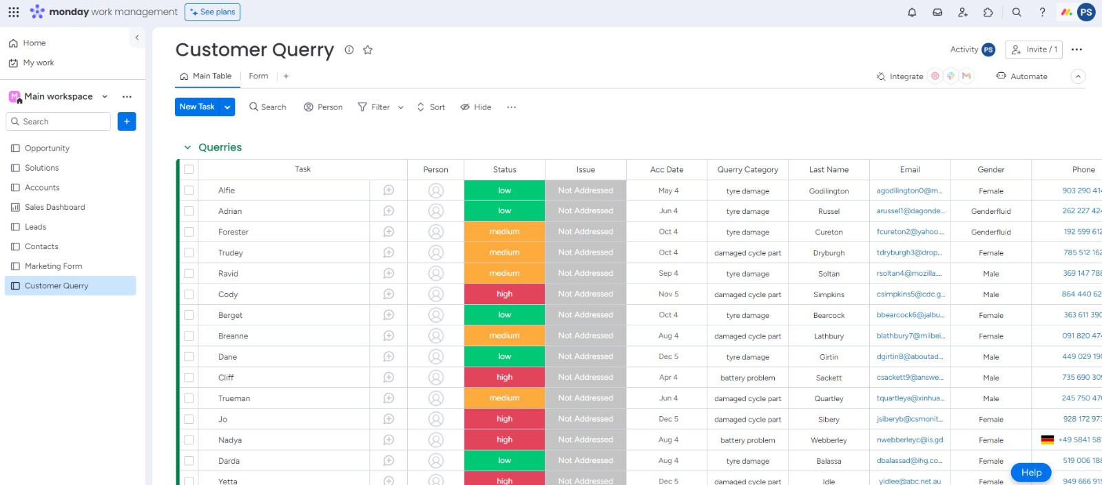

Fig. 25. Customer querry dashboard

#### Resolving and Closing the Case:

We have a dedicated dashboard that provides us with an overview of resolved customer issues. This dashboard contains several columns that help us track and analyze the resolution process. The columns include customer name, the specific issue related to the bicycle, the type of query, detailed information about the query, and the date when the issue was resolved.

Having this dashboard allows us to maintain a comprehensive record of customer issues and their resolutions. It helps us track the progress of each query, ensuring that no customer concern goes unnoticed or unresolved. By capturing important details such as the customer's name, we can provide personalized support and maintain a strong customer relationship.

The "Issue Resolved" dashboard also assists us in identifying recurring problems or patterns in customer queries. By analyzing the types of issues reported and the associated details, we can identify any underlying trends and take proactive measures to address them. This proactive approach helps us enhance the overall customer experience and minimize the occurrence of similar issues in the future.

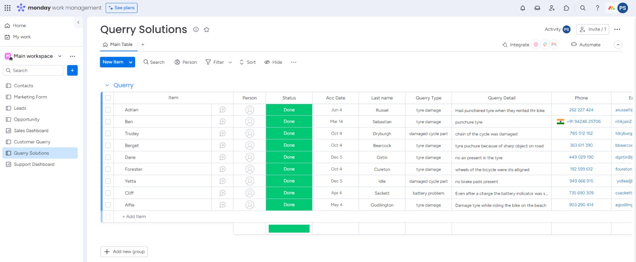

Fig. 28. Querry solutions dashboard

Additionally, the dashboard provides us with valuable insights into the efficiency and effectiveness of our customer support team. We can track the resolution time for each query and evaluate the performance of our team in addressing customer concerns promptly. This data allows us to continuously improve our support processes and ensure that we meet or exceed customer expectations.

Overall, the "Issue Resolved" dashboard serves as a vital tool in monitoring and managing customer queries and their resolutions. It helps us maintain a high level of customer satisfaction by promptly addressing and resolving any issues that may arise during their experience with our e-bike service.

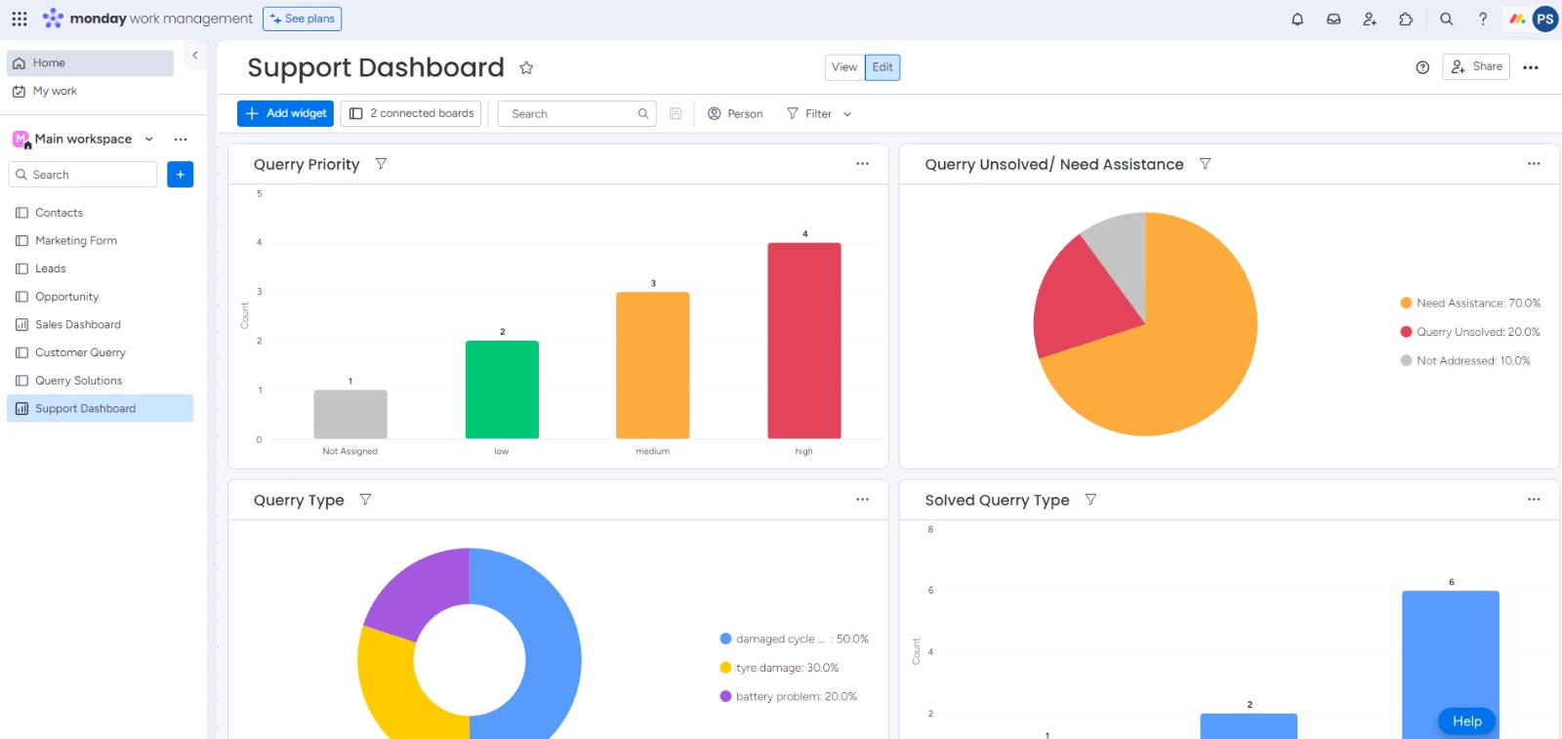

Fig. 29. Customer service dashboard

#### Customer Service Dashboard:

The customer support dashboard provides a comprehensive overview of the queries received by our customer support team. It allows us to track and manage the status of these queries based on their priority levels. The dashboard displays the resolution status of each query, indicating whether it has been resolved or remains unresolved. Additionally, it provides insights into the different types of queries received, allowing us to identify trends and patterns. By monitoring the number of resolved queries for each query type, we can assess the efficiency and effectiveness of our customer support operations. The customer support dashboard plays a crucial role in ensuring timely and satisfactory resolution of customer queries, enhancing overall customer satisfaction.

1. Conclusion and Solutions.

Hotspots: Stations with high ride start frequencies should be supplied with additional cycles to prevent ride scarcity.

Service Centers: More service centers, specifically for end stations, should be established to cater to battery and tire repair needs.

Targeting Female Shoppers: Additional promotional efforts are required to attract more female customers, which can be facilitated through CRM segmentation.

Offers and Feedback: Introducing offers and soliciting feedback from customers will help gain valuable insights and improve customer satisfaction, with CRM playing a crucial role.

Marketing for Classic Bike Pro: Increased advertising efforts are needed to address declining sales for the Classic Bike Pro, utilizing customer feedback to guide improvements.

Converting Casual Customers: Focus on converting casual customers into annual subscribers, leveraging CRM functionalities to nurture leads and drive conversions.

Expanding Clientele: Attracting more customers in the northern part of the city is necessary to improve service effectiveness and expand the user base.

In summary, implementing Power BI dashboards and Monday.com CRM has provided valuable insights and actionable recommendations for the E-bike Sharing startup. These tools have helped manage marketing campaigns, drive sales, enhance customer support, and streamline internal operations. The sales dashboard demonstrates impressive growth potential, attracting potential investors. Investing in business intelligence tools is crucial to stay competitive in the expanding bicycle industry, optimizing processes and achieving cost-effectiveness.

1. References
2. *Monday.com*, 2022. [Online]. Available: https://monday.com/blog/task-management/balanced- scorecard-template/. [Accessed: 13- May- 2022].
3. "Gap Analysis Template Download", *Project Management Templates*, 2022. [Online]. Available: https://[www.techno-pm.com/2018/04/Gap-Analysis-Template.html.](http://www.techno-pm.com/2018/04/Gap-Analysis-Template.html) [Accessed: 13- May- 2022].
4. *Monday.com*, 2022. [Online]. Available: https://monday.com/blog/project-management/monday- com-tutorial/. [Accessed: 13- May- 2022].
5. "Tutorial: Get Started with Tableau Desktop", *Help.tableau.com*, 2022. [Online]. Available: https://help.tableau.com/current/guides/get-started-tutorial/en-us/get-started-tutorial-home.htm. [Accessed: 13- May- 2022].
6. Video Presentation