Dear all,

Please use this checklist when finalising your poster:

Cohesion: Check if the elements in the poster, such as colours, fonts, images, and text, are cohesive and complement each other. The overall poster should convey a consistent message.

Clarity: Ensure that the message is clear and concise and can be understood at a glance. Avoid cluttering the poster with too much text or images.

Branding: Ensure that the poster reflects the branding of the company. Use the company logo and colours to make it recognisable.

Include a tagline: Create a catchy tagline that sums up your business model and makes your poster memorable.

Incorporate interactive elements: When creating your BMC, consider including interactive elements such as QR codes that viewers can use to get more information about your business model. However, be careful not to make these elements too distracting and keep in mind the importance of simplicity and conciseness in the overall design of the BMC.

Appeal: The poster should be visually appealing and draw the viewer's attention. Use high-quality images and graphics to create an attractive visual message.

Hierarchy: Check if the important elements are given more visual prominence than less important elements. For example, the value proposition and customer segments should be more prominent than the key resources.

Testing: Finally, you can test the effectiveness of the visual message by getting feedback from colleagues. This can help you identify areas needing improvement and fine-tune the poster for maximum impact.

Assessment brief/s:
Students will be asked to prepare:
- Summative: Assessment 1 - An academic poster featuring business canvas model for own business proposal OR a given case study (based on the live project).

Your poster has to be submitted via Turnitin by the.

Please remember that use of the business model canvas is crucial for planning a business as it presents a visual depiction of a company's strategy, the assumptions it is based on, and its revenue generation process. This tool allows business owners and entrepreneurs to: communicate their ideas, valuate and iterate on their strategy, identify essential resources and partnerships, align team members, make informed decisions.
You must complete all 9 building blocks:

1. Value Proposition: The unique benefits a business offers to its customers.
2. Customer Segments: The groups of customers a business is targeting.
3. Channels: How a business reaches and interacts with its customers, how do you get this product/service to your customer, such as through a website, sales teams, or brick-and-mortar stores.
4. Customer Relationships: The types of relationships a business has with its customers, such as self-service or personal assistance.
5. Revenue Streams: The ways a business generates revenue, such as through sales of products or services, subscriptions, or advertising.
6. Key Activities: The most important activities a business must perform to create and deliver value to its customers.
7. Key Resources: The resources a business needs to execute its key activities, such as employees, technology, or physical assets.
8. Key Partnerships: A business's relationships with suppliers, distributors, or other businesses that help it bring its value proposition to market.
9. Cost Structure: The costs a business incurs to operate, including fixed costs, variable costs, and economies of scale.

Please remember the best practices for creating the Business Canvas Model as per guidance during your practical workshops:
- Involve key stakeholders
- Start with a clear understanding of your business
- Be specific and concrete
- Regularly review and update
- Use visual aids
- Consider different scenarios

Here is a visual guide to help you!
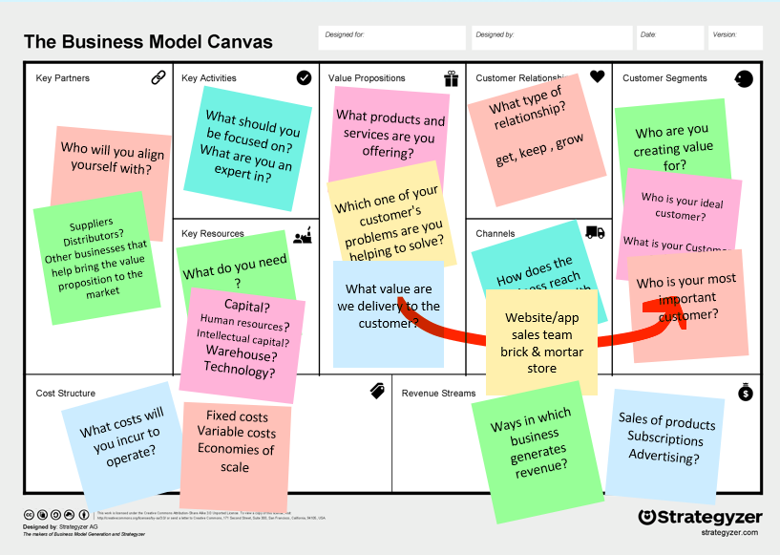
(slide 6 – Business Canvas model Seminar available on BB)

Assessment 1 Criteria:

Assessment 1 - Individual Poster (40%),

Criterion:
Presentation and Style (including language, spelling and grammar) | 10%
Conforming to Instructions | 15%
Content and Knowledge | 35%
Thinking/Analysis/ Conclusions | 30%
Practical/Interpersonal Skills | 10%

