**Xenon Stack- A Stack Innovator**

**Round -2**

**Name** - Avish Arora **College**- Chandigarh University

**PROJECT ON:**

**“CAR REPAIRING WEBSITE”**



**“A simple to use Website for all**

**Services of CARS”**

**-Avish Arora**

**(OWNER)**

**I Created A Simple “*Car Repairing Website* ” Using**

**Technologies Like**

**For Front-End Part :-** HTML,CSS,JAVASCRIPT,BOOTSTRAP

**For Back-End Part :-** JAVA,JDBC,SERVLET

**For DataBase Part** :- SQL(sqlite)

**SOFTWARE USED:**

1. Eclipse IDE
2. SQLite
3. SQLite-JDBC Connector
4. Google Chrome
5. Apache Tomcat 9.0

**SCREENSHOTS**

1. **WELCOME PAGE**

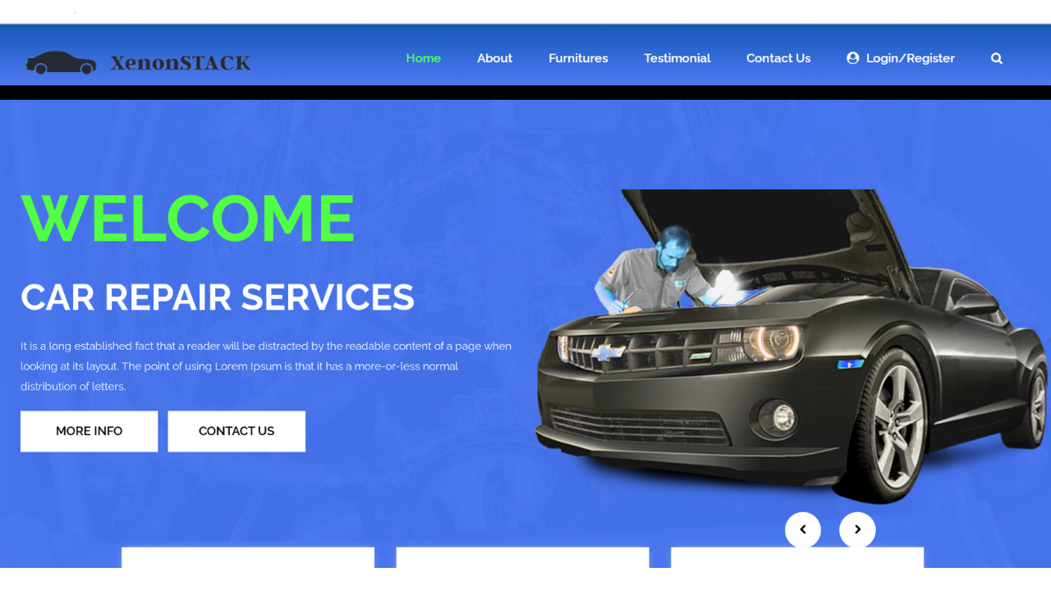

1. **Registration Page**

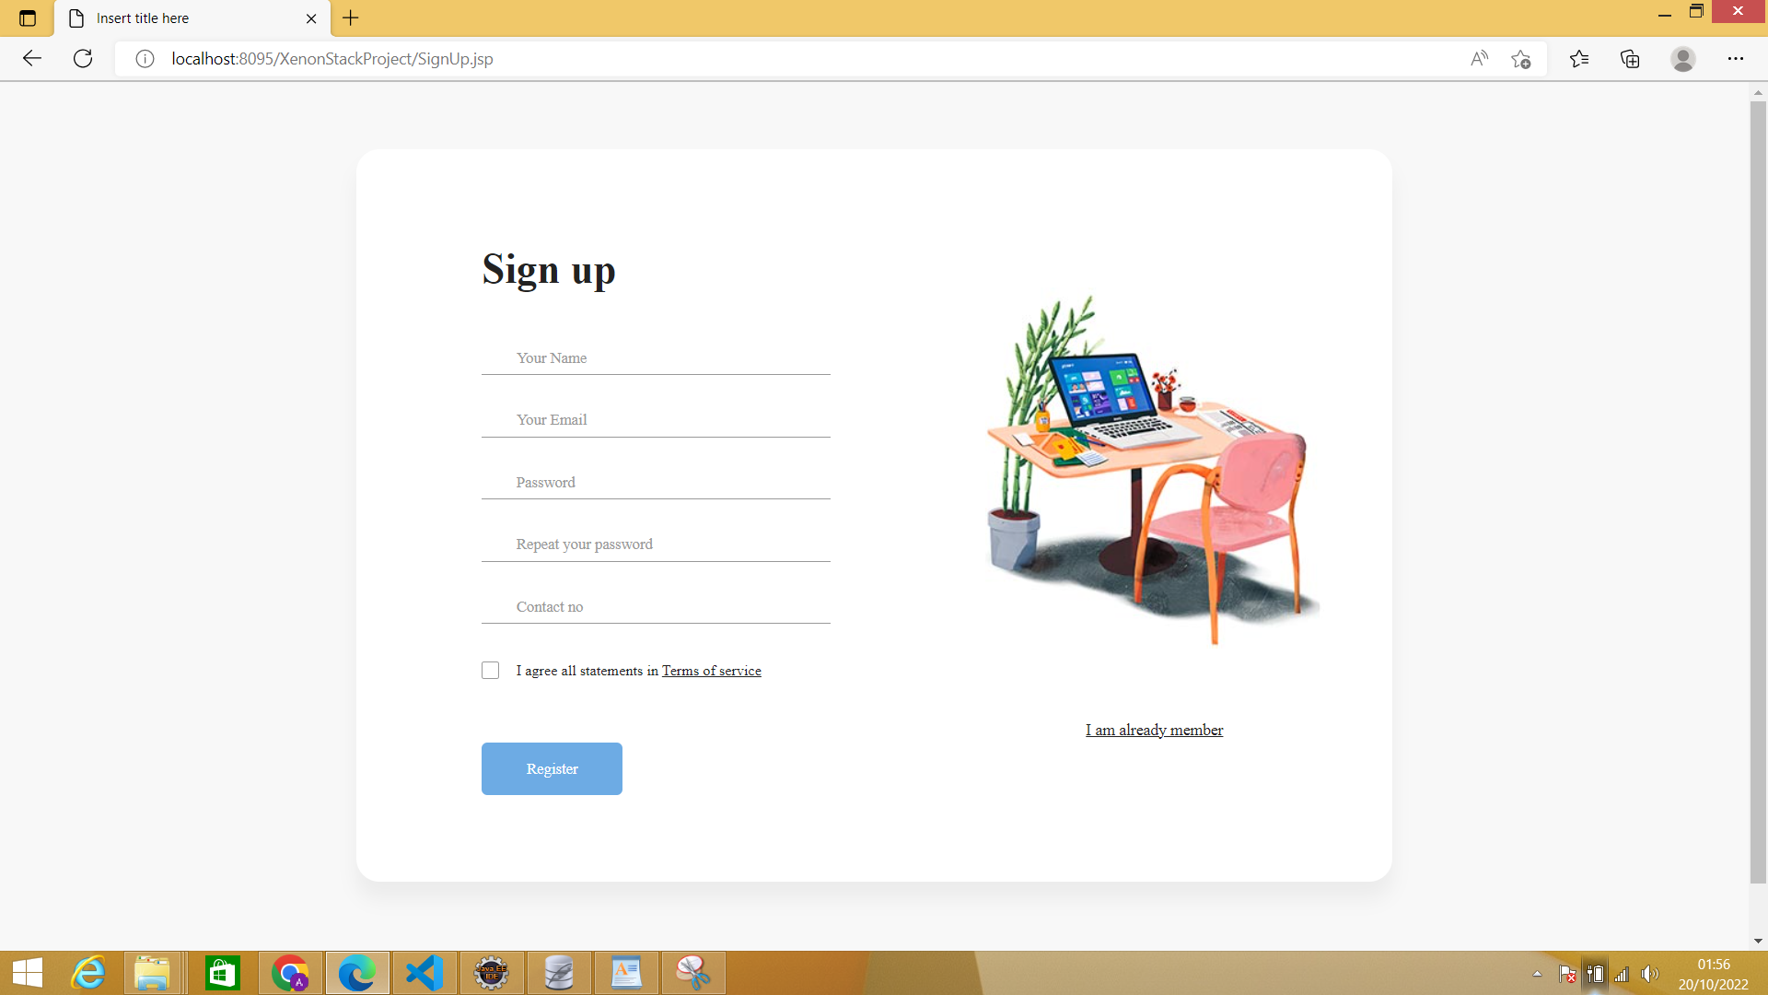

**WITH DETAILS**

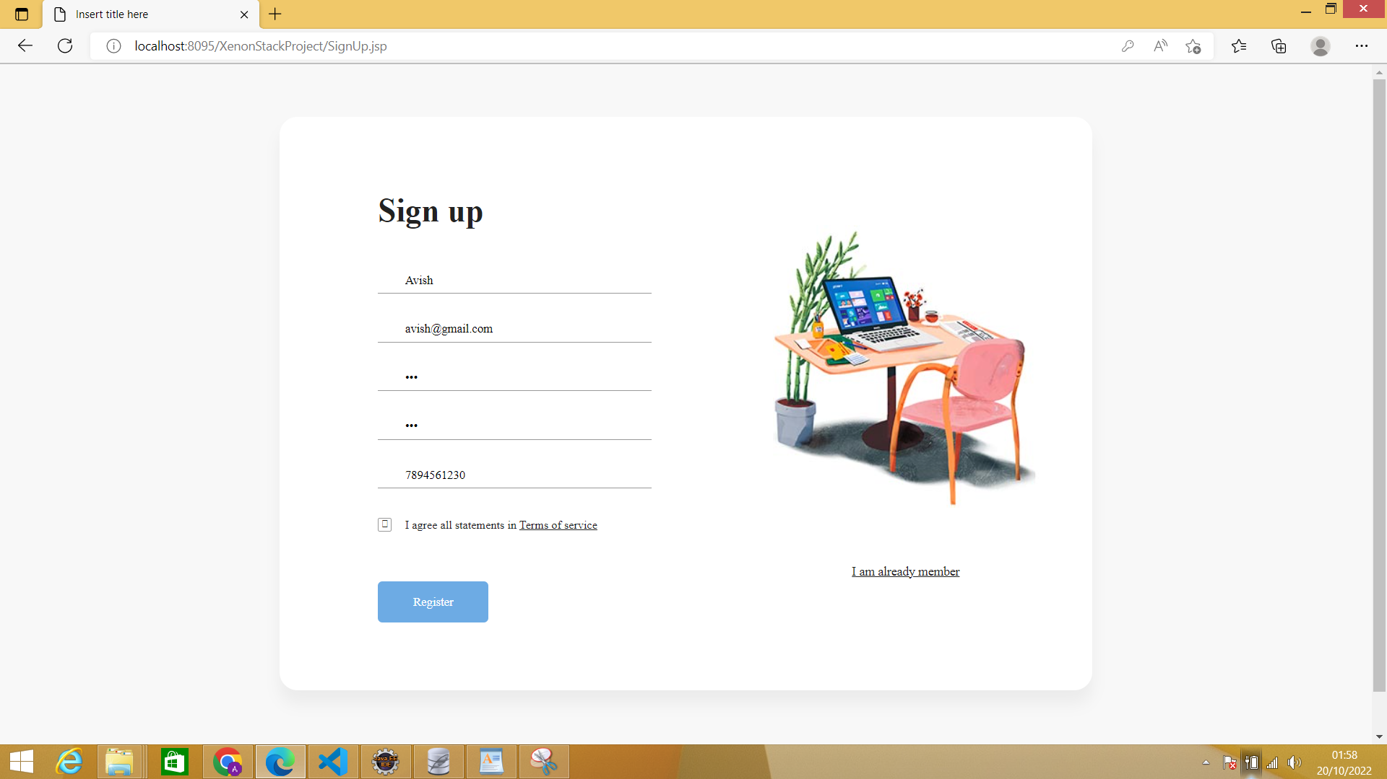

**CONGRATS Message**

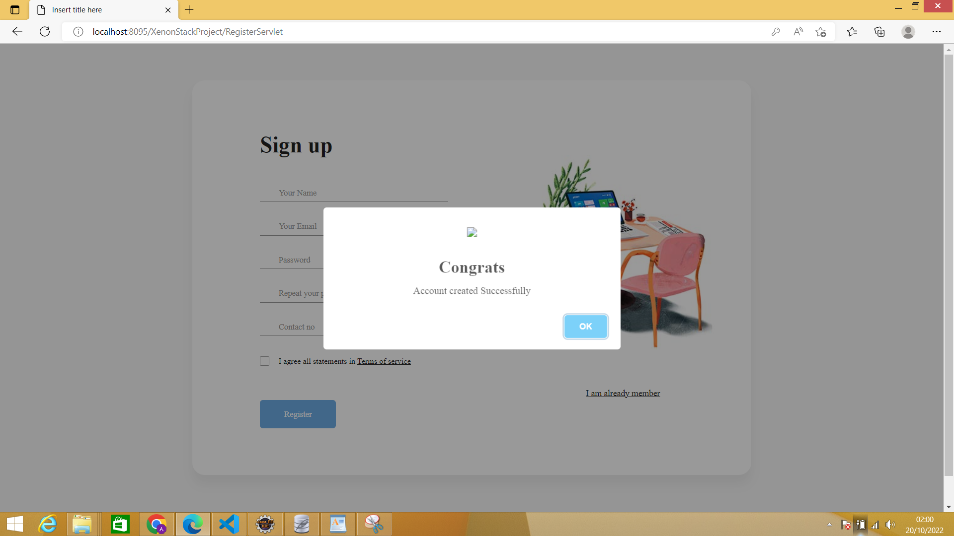

**DATABASE**

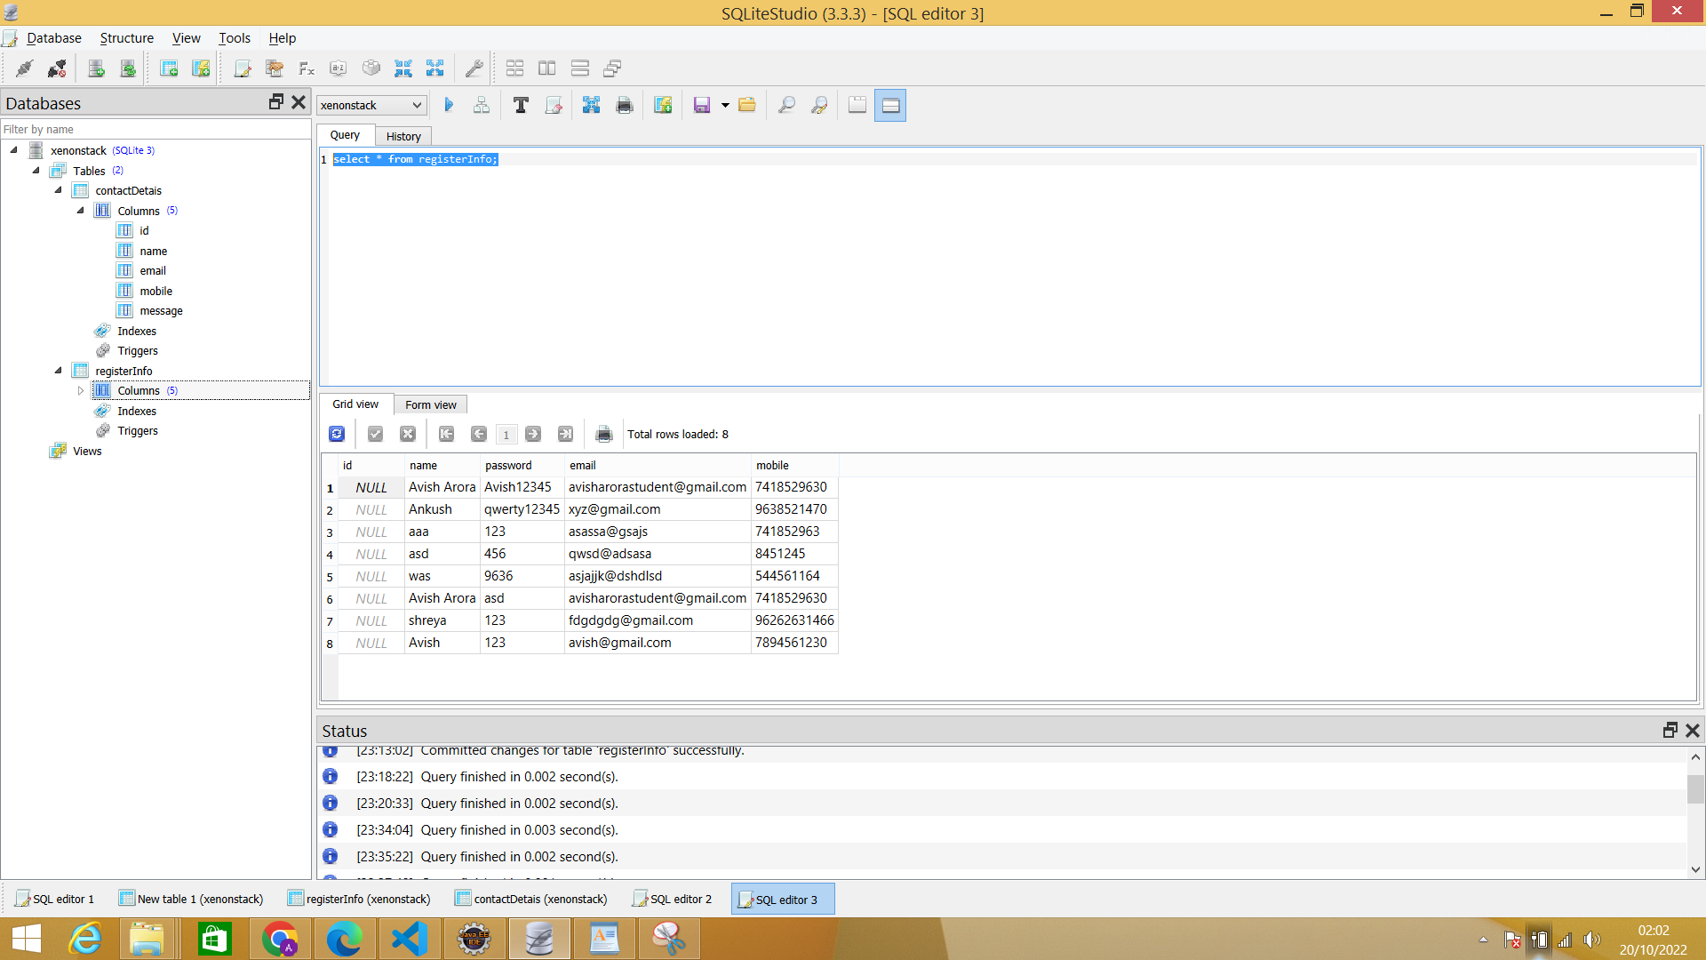

**3 LOGIN PAGE**

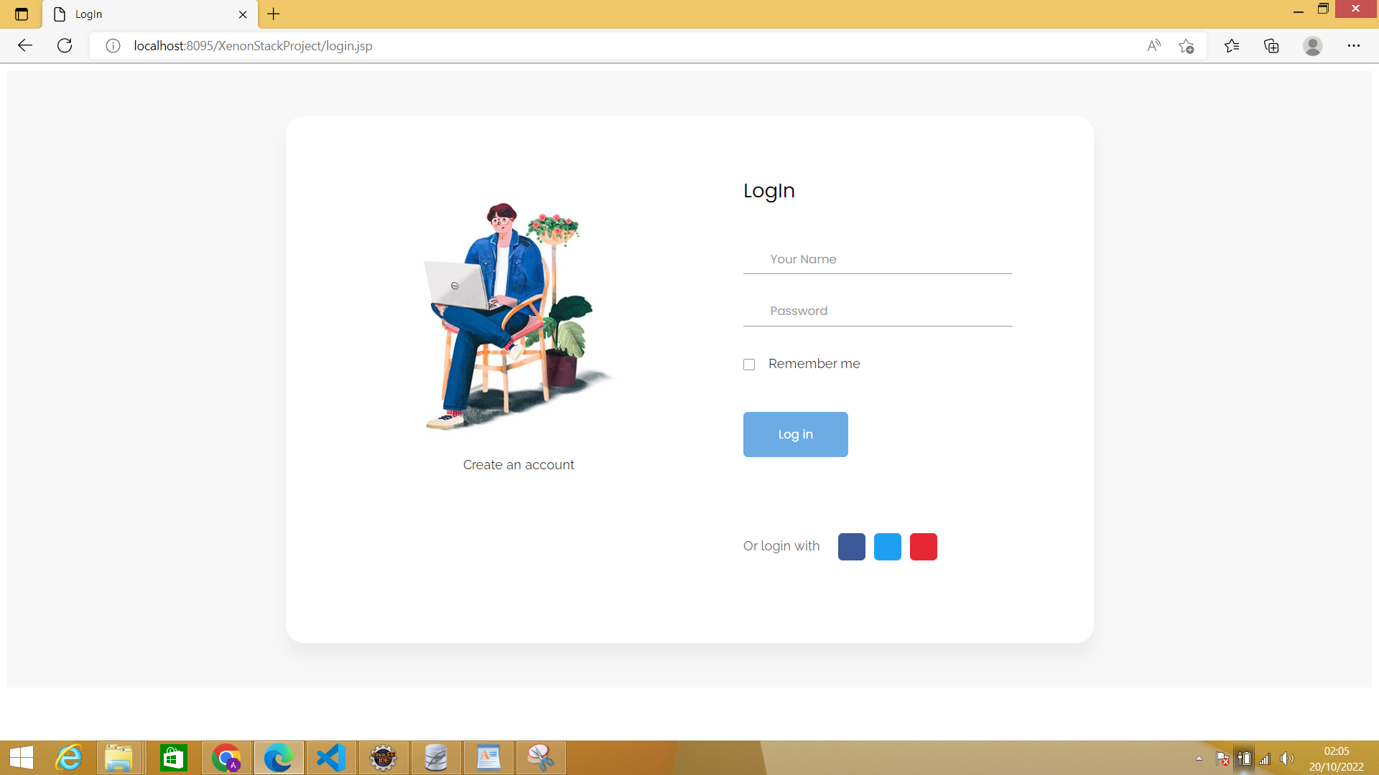

**IF DETAILS DOES NOT MATCH**

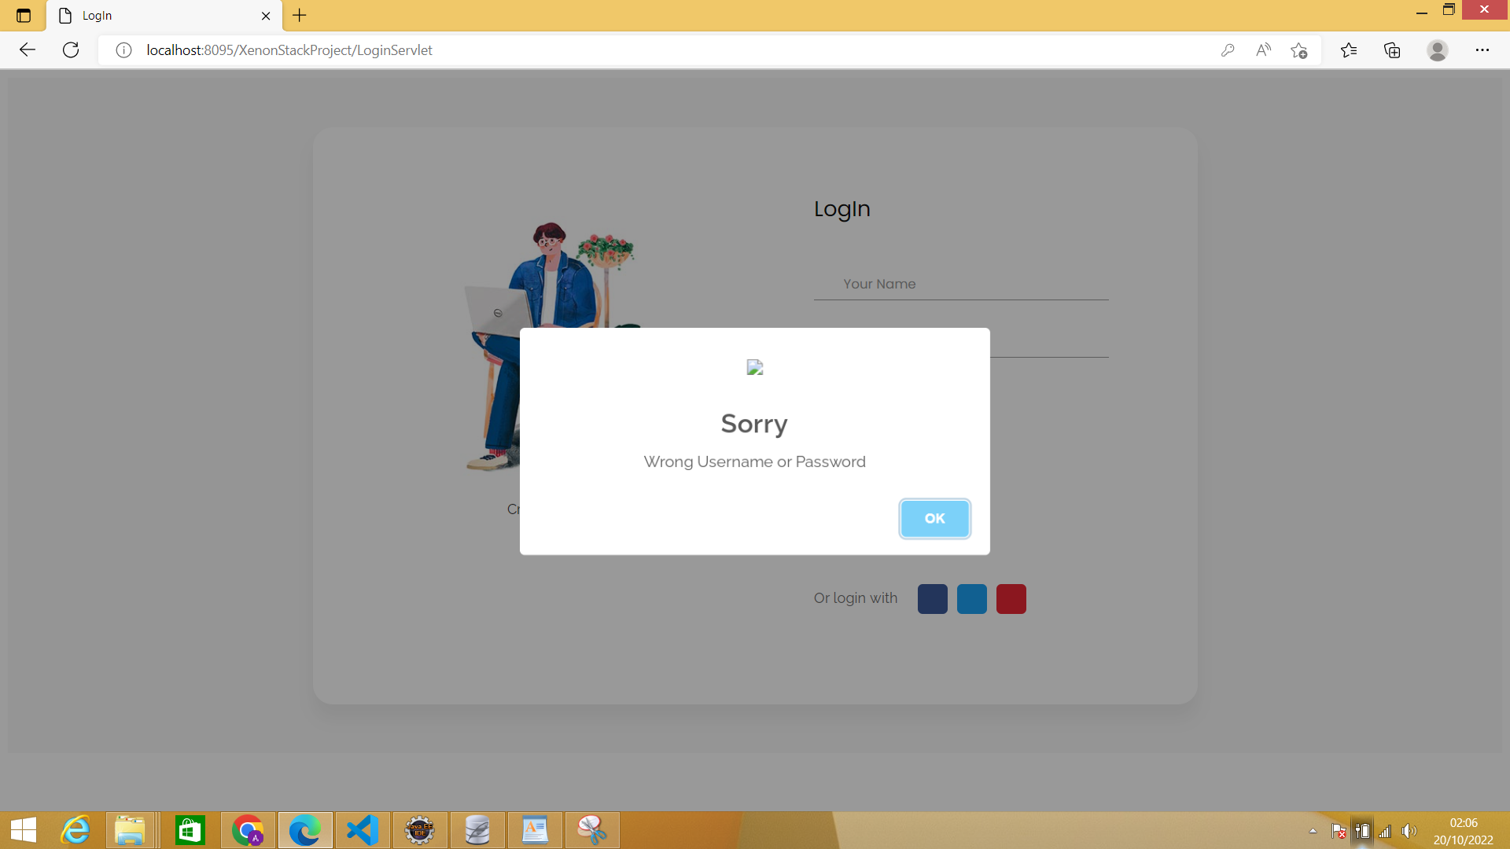

**DATABASE**



**4. CONTACT US PAGE**

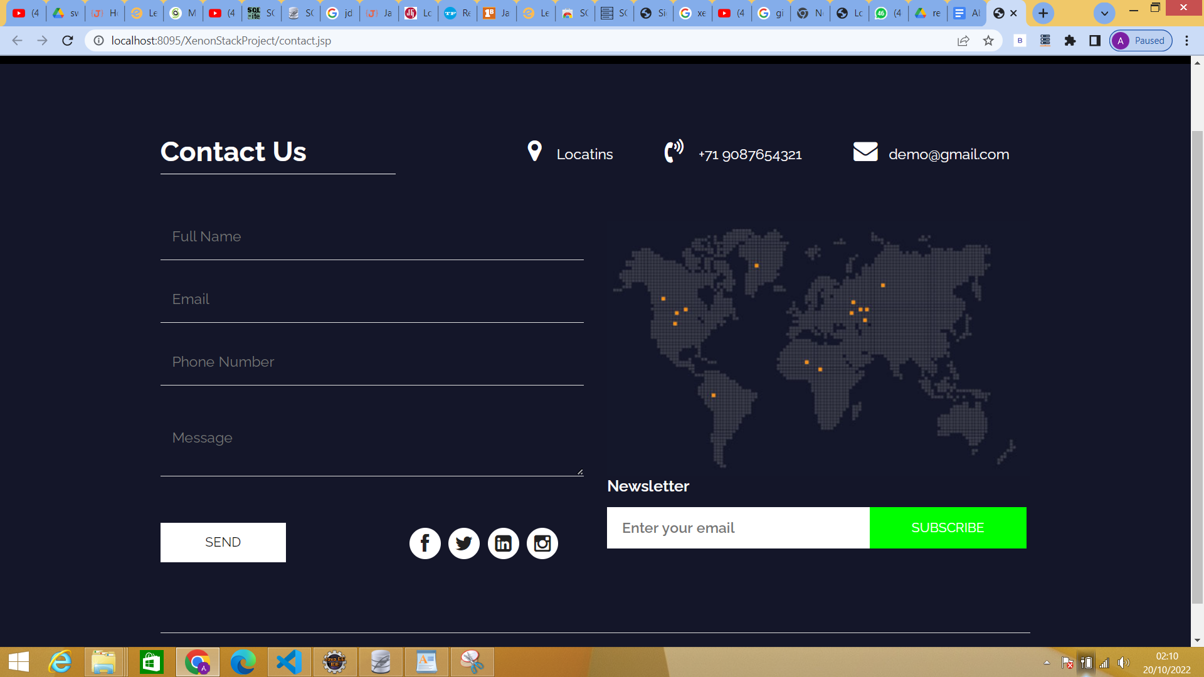

**DATABASE**



**____________________THE END______________________**