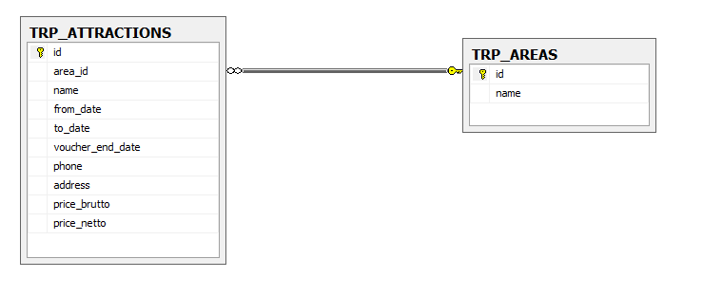TRP_ATTRACTIONS

** Id is incremental int (1, 1)

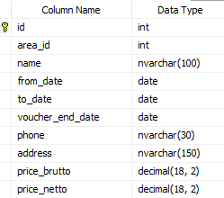

TRP_AREAS



Queries

* Get all the attractions which contains the char 'a'.

SELECT * FROM TRP_ATTRACTIONS WHERE name|| phone|| address LIKE '%a%'

* Get all the attractions that from date in year 2019.

SELECT * FROM TRP_ATTRACTIONS WHERE from_date BETWEEN 2019-01-01 00:00:00' AND 2020-12-31 23:59:59'

* Get all the attractions in area Eilat. (The area name is in table TRP_AREAS)

SELECT TRP_ATTRACTIONS .* FROM TRP_ATTRACTIONS INNER JOIN TRP_AREAS ON area_id = TRP_AREAS .id WHERE TRP_AREAS.name ="Eilat"

* Get all **areas IDs** (area_id) which has more than 1 attraction in. (at least 2 attraction in area_id)

SELECT area_id FROM (SELECT area_id, count(*) FROM TRP_ATTRACTIONS INNER JOIN TRP_AREAS ON area_id = TRP_AREAS .id GROUP BY area_id having count(*)>1)

* Get all areas Names which has more than 1 attraction in. (at least 2 attraction in area_id)
* SELECT nameArea FROM (SELECT TRP_AREAS.name as nameArea, count(*) FROM TRP_ATTRACTIONS INNER JOIN TRP_AREAS ON area_id = TRP_AREAS .id GROUP BY area_id having count(*)>1)
* Get all the attractions that the address in not in the area.   
  (Example: Kayaks is connected to Tel-Aviv area_id and the address contains 'Eilat')
* SELECT * FROM (SELECT TRP_ATTRACTIONS .* FROM TRP_ATTRACTIONS INNER JOIN TRP_AREAS ON area_id = TRP_AREAS .id WHERE address NOT LIKE '%'+ TRP_AREAS.name+'%'
* Get the most profitable attraction. (brutto minus netto = profit)
* SELECT table1 FROM (SELECT TRP_ ATTRACTIONS.* as table1 MAX(brutto - netto) FROM TRP_ATTRACTIONS )