# 1. Introduction

Routing is the process of forwarding packets from one network to the destination address in another network. Routes are based on the destination network. Routing is to find the best path for the network from one network to another. Routing is performed by routers. There are three types routing protocol which are given below:-

1. Static Routing
2. Default Routing
3. Dynamic Routing
4. Static Routing

* It is configured by Administrator manually.
* Mandatory need of Destination Network ID
* It is Secure & fast
* Used for Small organizations with a network of

10-15 Routers.

1. Default Routing

* A Default routing protocol is configured for

unknown destinations.

* Generally used in the internet where the destinations

are unknown.

* Configured at end points.
* It is the last preferred routing.

1. Dynamic Routing

* Dynamic Routing Dynamic routing, describes the capability of a system through which routes are dynamically changed according to change in network.
* In dynamic routing, routing protocols are used to find networks and update routing tables on routers.

## 1.1 Static Routing Topology

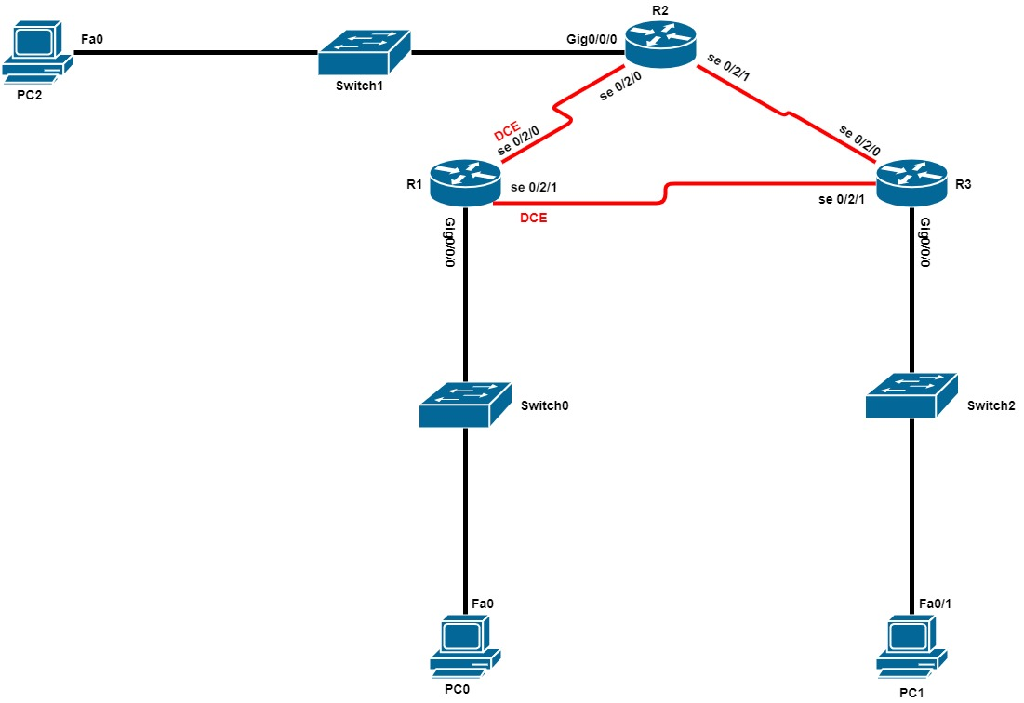

## Static Routing Addressing Table

|  |  |  |  |  |
| --- | --- | --- | --- | --- |
| Device | Interface | IP Address | Subnet Mask | Default Gateway |
| R2 | Gig 0/0/0 | 192.168.1.1 | 255.255.255.0 | None |
|  | Se 0/2/0 | 192.168.30.2 | 255.255.255.0 | None |
|  | Se 0/2/1 | 192.168.20.1 | 255.255.255.0 | None |
| R1 | Gig 0/0/0 | 192.168.2.1 | 255.255.255.0 | None |
|  | Se 0/1/0 (DCE) | 192.168.30.1 | 255.255.255.0 | None |
|  | Se 0/1/1 (DCE) | 192.168.10.1 | 255.255.255.0 | None |
| R3 | Gig 0/0/0 | 192.168.3.1 | 255.255.255.0 | None |
|  | Se 0/2/1 | 192.168.10.2 | 255.255.255.0 | None |
|  | Se 0/2/0 | 192.168.20.2 | 255.255.255.0 | None |
| PC 0 | NIC | 192.168.2.2 | 255.255.255.0 | 192.168.2.1 |
| PC 1 | NIC | 192.168.3.2 | 255.255.255.0 | 192.168.3.1 |
| PC 2 | NIC | 192.168.1.2 | 255.255.255.0 | 192.168.1.1 |

# Testing

## Static Routing Testing Screenshot

* PC 0 success connection to PC 1 and PC 2

## C:\Users\Lenovo\Pictures\Screenshots\Screenshot (3).png

* PC 1 success connection to PC 2 and PC 0

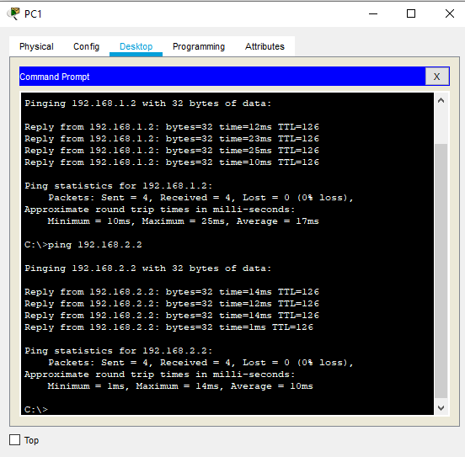

* PC 2 success connection to PC 0 and PC 1

