Data Model : ERD

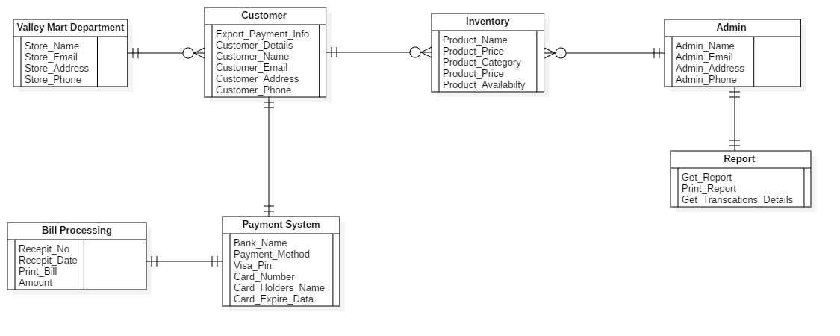

Payment System Use Case

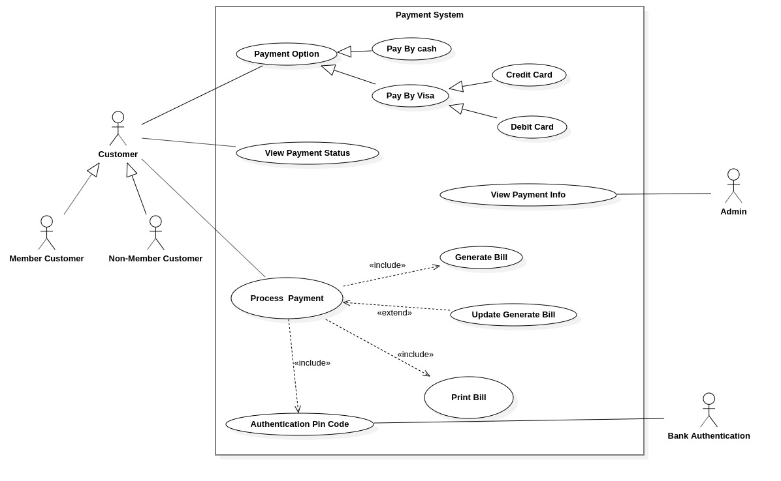

Payment System Context Diagram

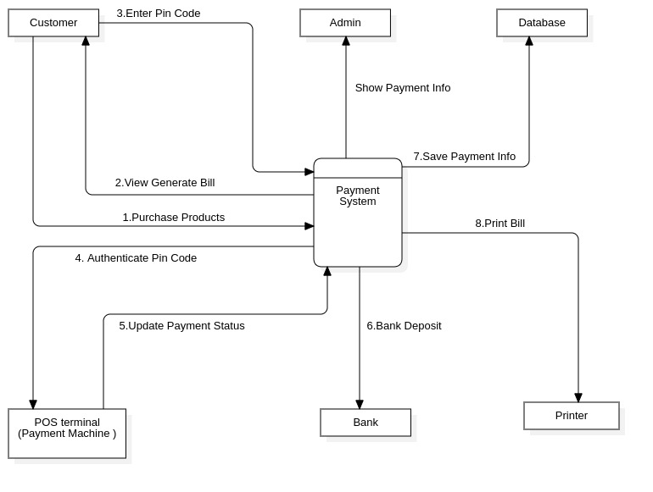

USE CASE DIAGRAM OF BILLING MANAGEMENT:

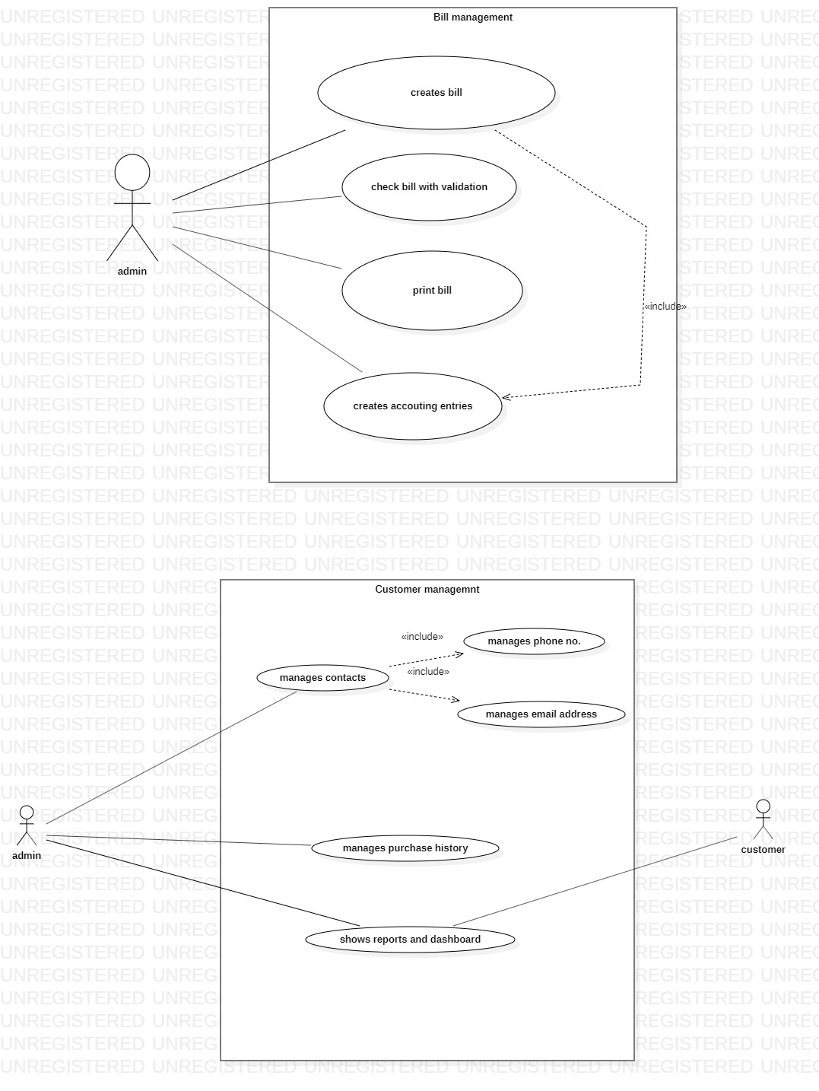

USE CASE OF CUSTOMER MANAGEMENT:



CONTEXT DIAGRAM OF BILLING MANAGEMENT SYSTEM

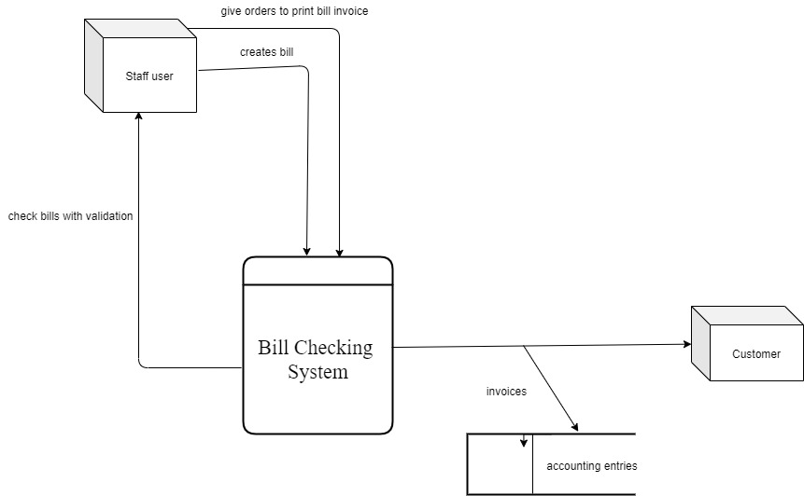

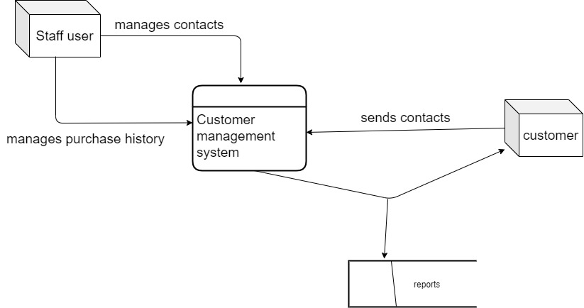

CONTEXT DIAGRAM OF CUSTOMER MANAGEMENT SYSTEM



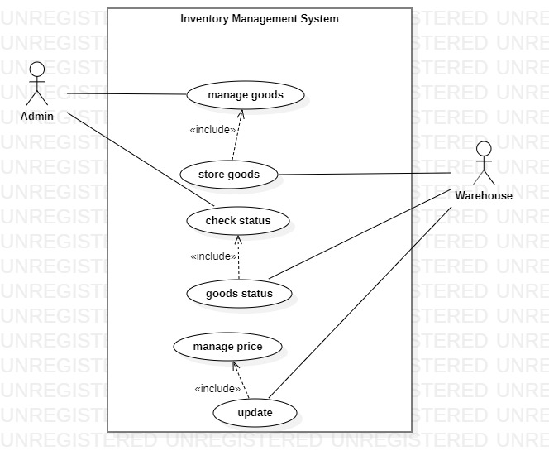

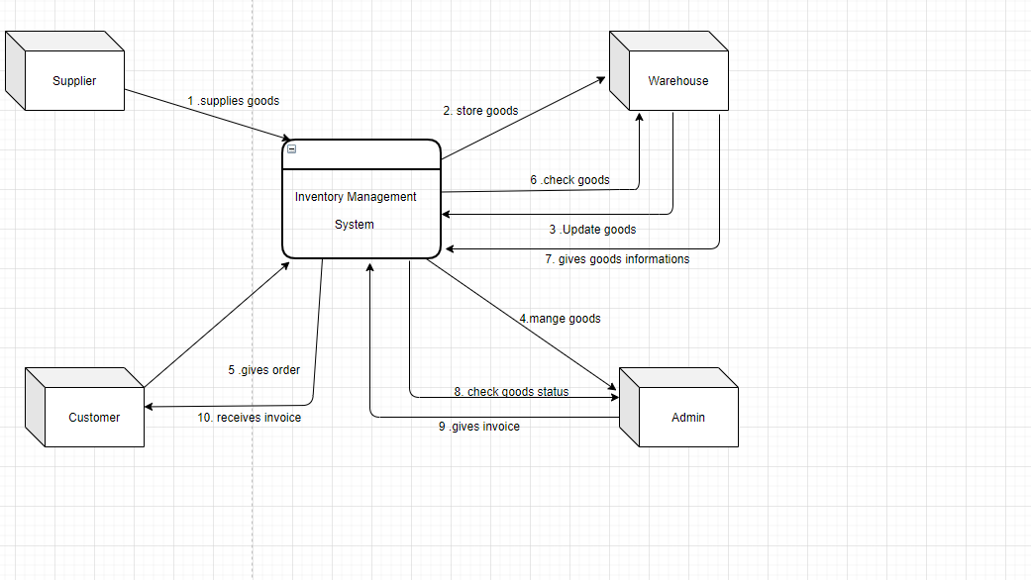

Admin Management System:

Use case Diagram:

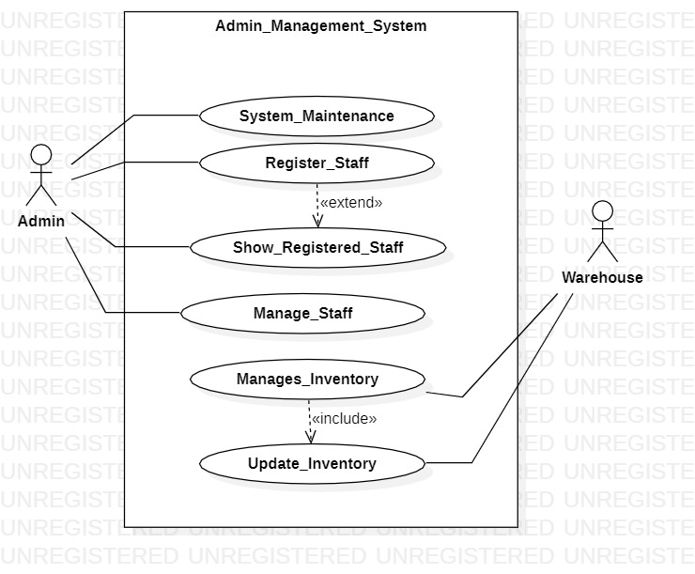

Context Diagram:

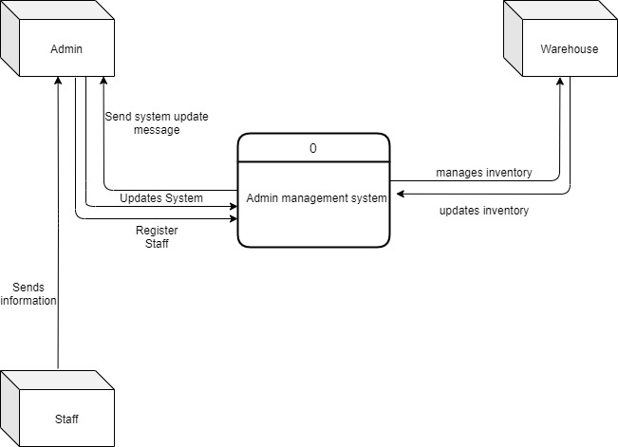

Report Management System:

Use case diagram:

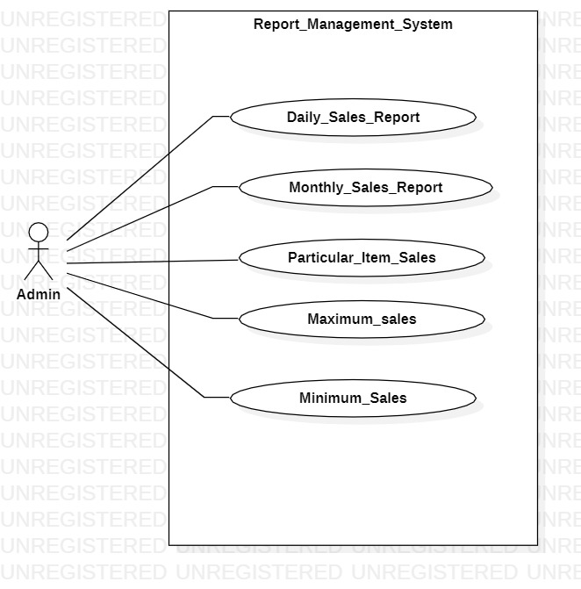

Context diagram:

