1. Build conceptual data model

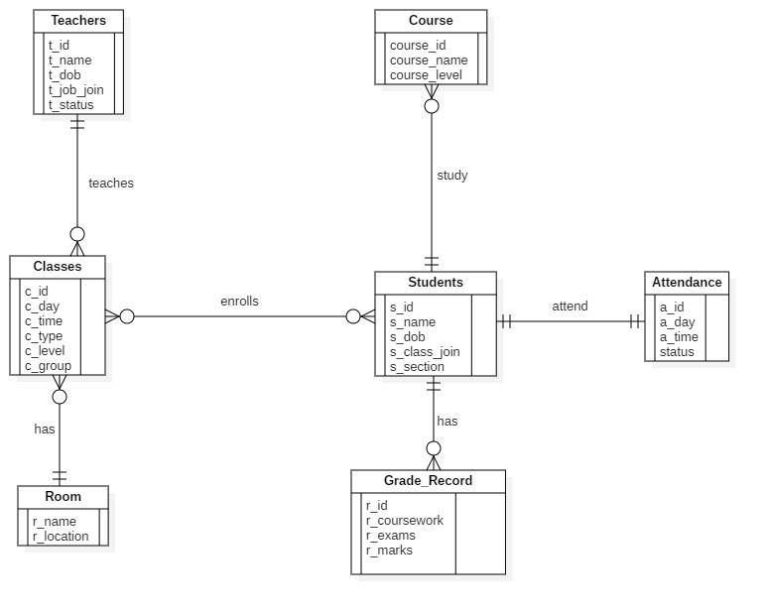

Questions:-

1. How to add part-time and full time job in erd?
2. How to keep track of teachers attendance?

c. Identify and associate attributes with entity or relationship

types [5 marks]

d. Determine attribute domains [5 marks]

e. Determine candidate, primary, and alternate key attributes

Teachers: -

Candidate key:-{t_id, t_name, t_dob}

Primary key :- t_id

Alternate key: {t_name,t_dob}

Students: -

Candidate key:-{s_id, s_name, s_dob}

Primary key :- s_id

Alternate key: {s_name,s_dob}

Course: -

Candidate key:-{course_id, course_name}

Primary key :- course_id

Alternate key: course_name

Classes: -

Primary key :- c_id

Room: -

Candidate key:-{room_name, room_location}

Primary key :- room_name

Alternate key: room_location

Grade_record: -

Primary key :- r_id

Attendance: -

Primary key :- attendance_id