MEDWASTE AI
Initiation & Software Requirements Specification (SRS)
AI-Assisted Medical Waste Management Platform

1. Project Initiation
MedWaste AI is a startup-oriented digital platform designed to manage the lifecycle of medical waste from generation and reporting to collection, transportation, treatment, recycling, and final disposal. The platform connects hospitals with verified waste collectors, treatment facilities, and recycling companies while maintaining digital records and traceability.

2. Problem Statement
Medical waste requires appropriate segregation, collection, transportation, treatment, and disposal. Poor coordination can lead to unsafe handling, environmental pollution, missing records, inefficient pickup planning, and difficulty verifying the final destination of waste. MedWaste AI aims to provide one centralized platform for managing this workflow digitally.

3. Scope
The initial scope includes:
- Hospital registration and profile management.
- Medical waste reporting and record management.
- Waste category and risk assessment.
- Pickup request and scheduling management.
- Vehicle and collector assignment.
- Treatment facility and recycling company management.
- Matching waste with suitable treatment/recycling destinations.
- Digital chain-of-custody tracking.
- Disposal and recycling proof/records.
- Notifications, incidents, and discrepancy detection.
- Analytics and environmental-impact indicators.
- Admin verification and monitoring.
- Future integration of local AI for image-assisted classification, risk assessment, recyclability analysis, anomaly detection, and recommendations.
.

4. Project Objectives
- Digitize and standardize the medical waste reporting and tracking process for hospitals.
- Provide a transparent, auditable chain of custody for every waste batch, from generation to final disposal or recycling.
- Automate classification, risk assessment, and facility/recycler matching using rule-based systems, with AI assistance introduced later.
- Reduce manual coordination overhead between hospitals, collectors, and processing facilities.
- Detect operational discrepancies and incidents (e.g., weight mismatches, missed pickups) automatically.
- Provide analytics and environmental impact reporting for hospitals, facilities, and administrators.
- Deliver a professional, production-quality SaaS user experience.

5. Stakeholders and User Roles
Role | Primary Responsibility | Key Functions
Hospital | Generate/report waste | Report waste, request pickup, track waste, view records and analytics
Waste Collector | Collect and transport waste | View assignments, pickup confirmation, transport updates, delivery confirmation
Treatment Facility | Treat regulated waste | Manage capabilities/capacity, receive waste, record treatment, provide proof
Recycling Company | Recycle eligible waste | Manage recyclable materials, accept requests, record recycling, provide proof
Administrator | Platform governance | Verify organizations, manage users/rules, monitor incidents, audit and analytics

6. Functional Requirements

6.1 Authentication & User Management
ID | Requirement | Description
FR-1.1 | User Registration | The system shall allow users to register under supported organizational roles (Hospital, Collector, Facility, or Recycler). Admin accounts shall be created or assigned through controlled administrative procedures.
FR-1.2 | User Authentication | The system shall authenticate users using securely hashed passwords and session/JWT tokens.
FR-1.3 | Role-Based Access Control | The system shall enforce role-based access control on all protected endpoints and resources.
FR-1.4 | Organization Verification | Administrators shall be able to verify or reject hospital, collector, facility, and recycler accounts.

6.2 Waste Reporting & Classification
ID | Requirement | Description
FR-2.1 | Waste Reporting | Hospitals shall be able to create a waste record with category, quantity, unit, description, date/time, and an optional image or document.
FR-2.2 | Waste Batch Identification | The system shall assign each waste batch a unique, human-readable ID (e.g., MW-2026-000001).
FR-2.3 | Waste Classification | The system shall classify waste using configurable rule-based logic and present a suggested classification with the applicable rule or reasoning.
FR-2.4 | Classification Verification | Authorized users shall be able to manually correct or verify a suggested waste classification.

6.3 Risk Assessment & Recycling Decision
ID | Requirement | Description
FR-3.1 | Risk Assessment | The system shall compute a risk level for each waste batch using a configurable rule engine.
FR-3.2 | Recyclability Assessment | The system shall determine recyclability eligibility based on waste category, configured rules, and available recycling capabilities.
FR-3.3 | Safety Verification | Safety-critical outcomes shall require rule-based validation and human verification before the waste proceeds to the next applicable stage.

6.4 Pickup, Vehicle & Matching
ID | Requirement | Description
FR-4.1 | Pickup Requests | Hospitals shall be able to request Normal, Urgent, or Emergency pickups.
FR-4.2 | Vehicle & Collector Assignment | The system shall assign an appropriate collector and vehicle using local scheduling logic, subject to availability and capacity.
FR-4.3 | Facility/Recycler Matching | The system shall rank candidate treatment facilities or recycling companies using compatibility, capacity, verification status, availability, and location data.
FR-4.4 | Match Recommendation | The system shall display the recommended match, available alternatives, and a match score with an understandable explanation.

6.5 Chain of Custody, Tracking & Proof
ID | Requirement | Description
FR-5.1 | Chain of Custody | The system shall record every important lifecycle event for each waste batch, including status, responsible user, timestamp, quantity where applicable, and notes.
FR-5.2 | Waste Tracking | The system shall present a visual timeline showing the chain of custody and current status of a waste batch.
FR-5.3 | Processing & Proof Records | Authorized treatment facilities and recycling companies shall be able to record processing completion and maintain digital references to treatment, recycling, or disposal proof documents.
FR-5.4 | Incident Detection | The system shall automatically detect defined discrepancies, such as reported versus received weight, and raise an incident for review.

6.6 Analytics & Administration
ID | Requirement | Description
FR-6.1 | Analytics | The system shall provide dashboards showing waste volume, category distribution, recycling rate, processing statistics, and other relevant operational indicators.
FR-6.2 | Administration | Administrators shall be able to manage waste categories, system rules, verified organizations, and view audit logs.
FR-6.3 | Notifications | The system shall provide in-app notifications for important status changes, incidents, assignments, and workflow events. No external SMS or email API shall be required for the initial system.

6.7 AI Assistance
ID | Requirement | Description
FR-7.1 | Local AI Assistance | The system shall optionally use locally hosted AI models to suggest waste classification, risk level, recyclability, anomaly detection, predictions, and recommendations.
FR-7.2 | AI Validation | All AI outputs shall be clearly labeled (e.g., “AI Assessment — Requires Verification”) and validated against configured rules before being finalized.
FR-7.3 | Human Oversight | AI shall not make final safety-critical decisions without appropriate rule-based confirmation and/or authorized human verification.

7. Non-Functional Requirements
Category | ID | Requirement
Usability | NFR-01 | The interface shall follow a consistent design system and support desktop, tablet, and mobile devices.
Performance | NFR-02 | Core dashboard and CRUD operations should normally return within 2 seconds under the expected prototype workload, excluding large file uploads and local AI processing. Large datasets shall use pagination.
Security | NFR-03 | Passwords shall be securely hashed; role-based authorization shall be enforced on every protected endpoint; input and file validation shall be applied; sensitive actions shall be audited.
Reliability | NFR-04 | The system shall prevent loss of recorded waste-lifecycle events, and every valid state transition shall be logged.
Maintainability | NFR-05 | The backend shall follow a layered architecture (API → Service → Repository → Database), with business logic kept out of route handlers.
Portability | NFR-06 | The initial system shall run in a standard local development environment without mandatory dependence on paid cloud services.
Scalability | NFR-07 | The database schema and module boundaries shall support additional hospitals, facilities, recyclers, users, and waste records as the platform grows.
Accessibility | NFR-08 | Forms, navigation, status indicators, typography, and color contrast shall follow practical accessibility principles.
Auditability | NFR-09 | Important lifecycle changes and sensitive administrative actions shall record the responsible user and timestamp.
AI Compatibility | NFR-10 | The database architecture should remain compatible with future pgvector-based AI/RAG features without requiring major restructuring.

8. Proposed System Workflow
Not every waste category passes through every state; the state machine below represents the general/maximal path:
Hospital → Waste Report → Classification → Risk Assessment → Segregation → Pickup Request → Collector/Vehicle Assignment → Collection → Transport → Treatment Facility or Recycling Company → Processing → Proof → Verified Completion → Analytics
Core Entities (Preliminary — created incrementally per phase)
users, hospitals, hospital_staff, waste_categories, waste_records, waste_assessments, pickup_requests, vehicles, drivers, pickup_assignments, treatment_facilities, facility_capabilities, recycling_companies, recycling_capabilities, matching_records, transport_events, processing_records, disposal_records, recycling_records, proof_documents, incidents, notifications, audit_logs.
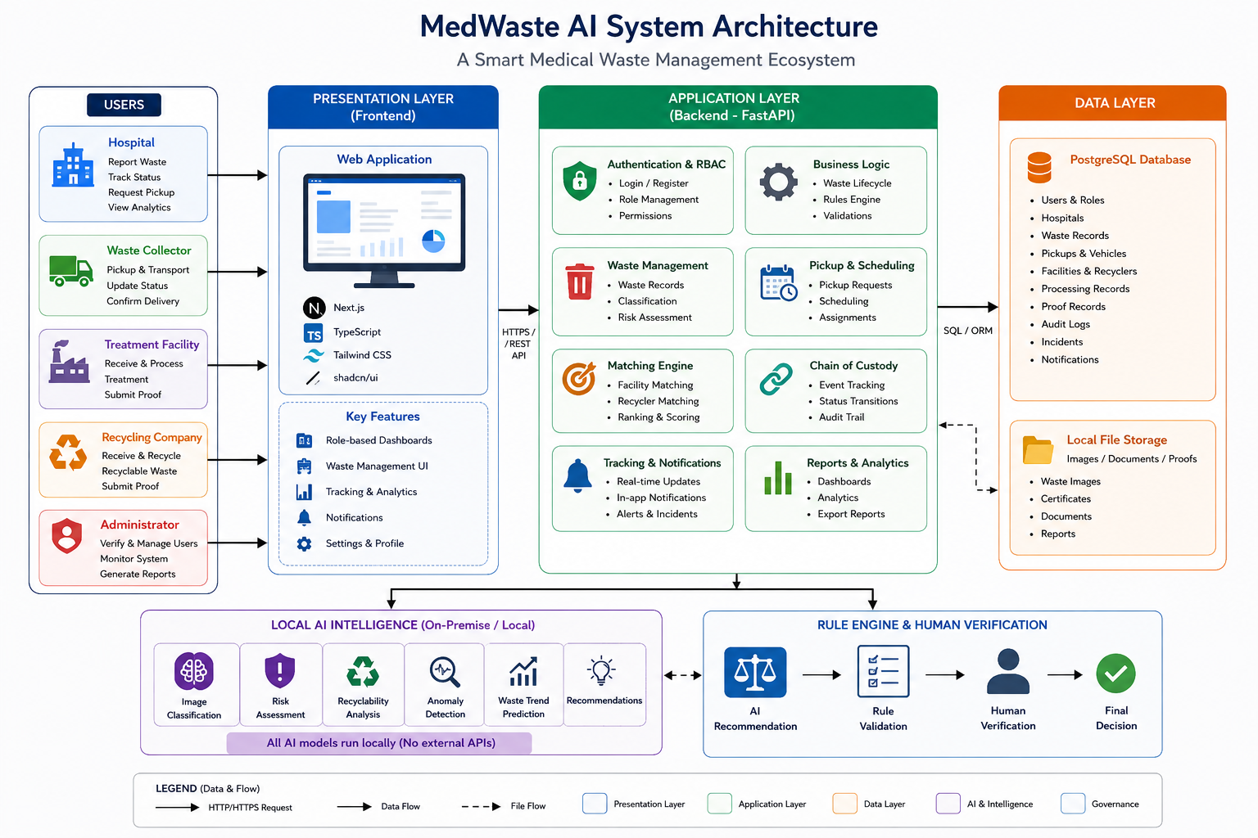

9. Proposed Technology Stack
- Frontend: Next.js + TypeScript + Tailwind CSS + shadcn/ui.
- Backend: Python + FastAPI.
- Database: PostgreSQL.
- ORM/Migrations: SQLAlchemy + Alembic.
- Validation: Pydantic and Zod.
- Local storage during development: local filesystem.
- Local AI in later phase: compatible local model/runtime such as Ollama, depending on available hardware.

10. GitHub Repository Plan
Recommended repository name:
medwaste-ai
Recommended initial repository structure:
- frontend/
- backend/
- docs/
- scripts/
- .env.example
- .gitignore
- README.md

11. Conclusion
MedWaste AI is proposed as a startup-oriented platform rather than a basic CRUD application. Its distinguishing concept is the integration of hospitals, collectors, treatment facilities and recycling companies into one traceable medical waste lifecycle. The Week 1 work establishes the project scope, requirements, stakeholders, repository plan and initial development backlog required for the subsequent implementation phases.

