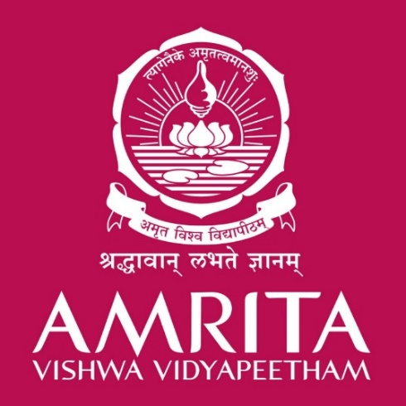

THE

ECO-SENSE-(AI)NATOR

**SDG Addressed: 1) SDG 13(CLIMATE ACTION) 2)SDG 15(LIFE ON LAND)**

Project expo and poster presentation on

**UNLEASHING THE IMPACT OF SDG IN REAL WORLD APPLICATION OF ENERGY AND AI**

**AMRITA VISHWA VIDYAPEETHAM, AMRITAPURI, KOLLAM, KERALA, INDIA**

STUDENT MEMBERS: AVISHEK RAUNIYAR, CH. NIKHILESH KRISHNA, SUJAY BHARATH RAJ, N. KIREETI SAI BHARADWAJ.

Project Group No: 12 Class: S2 B.Tech – AIE – A Batch

Date : 17/08/2023