Block Diagram:

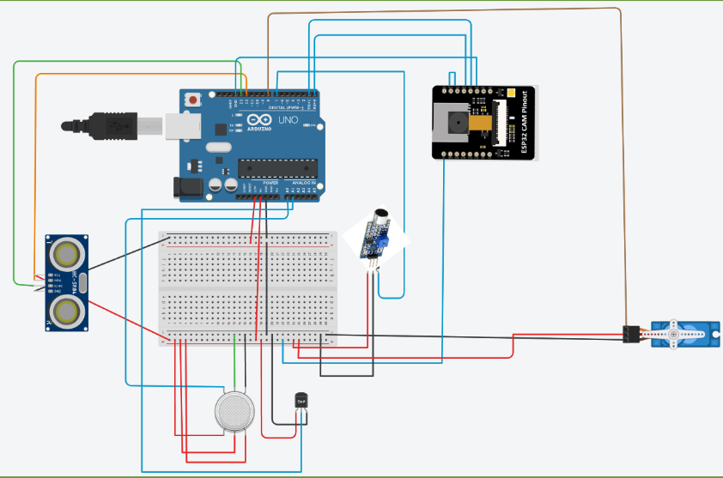

Abstract:

* The convergence of Artificial Intelligence (AI) and the Internet of Things (IoT) has catalyzed a transformative impact on both surveillance and tourism sectors worldwide, revolutionizing traditional approaches and enhancing the promotion of tourism.
* The project focuses on integration of AI and IoT technologies in modernizing surveillance and tourism practices, their applications in remote surveillance, tourist guidance, and environmental conservation.