The

Eco-Sense(AI)Nator

*Ch. Nikhilesh Krishna*

*Department of Computer Science*

*Amrita School of Engineering  
Amrita Vishwa Vidyapeetham,*

*Amritapuri, Kollam, India*

*am.en.u4aie22015@am.students.amrita.edu*

*Sujay Bharath Raj*

*Department of Computer Science*

*Amrita School of Engineering  
Amrita Vishwa Vidyapeetham,*

*Amritapuri, Kollam, India*

*am.en.u4aie22015@am.students.amrita.edu*

*N.Kireeti Sai Bharadwaj*

*Department of Computer Science*

*Amrita School of Engineering  
Amrita Vishwa Vidyapeetham,*

*Amritapuri, Kollam, India*

*am.en.u4aie22015@am.students.amrita.edu*

*Avishek Rauniyar*

*Department of Computer Science*

*Amrita School of Engineering  
Amrita Vishwa Vidyapeetham,*

*Amritapuri, Kollam, India*

*am.en.u4aie22062@am.students.amrita.edu*

*Abstract*— The Eco-Sense (AI)Nator is an intelligent device which uses various sensors and machine learning models with various algorithms that supports and promotes forest monitoring and tourist guidance in forest areas.

The device is used for forest surveillance. Together with cameras and several sensors, the proper monitoring of forests together with automatic alarm systems can be done. The warnings can be given to prevent loss. Also, it provides data for the forest rangers, organizations, and figures about that forest. Using the networks of multiple devices, tourist guidance can further be implemented for effective tourism.

This report highlights the information about the Eco-Sense (AI)Nator regarding various strategies, algorithms, networks, AI, etc. by integrating various hardware and software components

Keywords—sensors, machine learning models, tourist, forest surveillance, automatic alarming systems, data analysis, organizations, networks, strategies

# Introduction

The destruction of the world’s forests is accelerating precipitously, both due to intensive cultivation and fires. Also, due to unmanaged wildlife, there is a problem for the animals to survive in their natural habitat. Not only wildlife and the forest are affected, the people living around the area are also widely affected. On average, there has been a large decline across tens of thousands of wildlife populations since 1970. The Living Planet Index compiles data from tens of thousands of animal communities on population size changes and other related indicators. Its 2022 report contained statistics for 30,000 different wildlife communities. This includes every creature on Earth, from frogs to various kinds of elephants, rhinos, and owls. But even 30,000 populations are a tiny portion of all animals on the planet. In the previous 14 years, 723,924 hectares of land burned down in Italy (Europe-Mediterranean region), and more than as 159,437 hectares of woodland were destroyed by fires in 2021 alone, an alarming trend for a planet that is being used ever more strongly each year.

Between 1950 and 2019, data gathered on 5,440 large carnivores (Felidae, Canidae, and Ursidae; 12 species) attacks globally. Over time, additional incidents were documented, particularly in lower-income nations. 32% of attacks were fatal, while 68% left victims injured. The factors that lead to large carnivore attacks on humans vary depending on the socioeconomic context, with people at risk mostly during leisurely activities in high-income countries and during livelihood activities in low-income countries, even though attack scenarios differ within and among species as well as in various parts of the world. Also, when a tourist enters a forest, then he/she might get lost, unable to find their way out of the forest.

The project overall tries to address these various problems with a solution to try to minimize these problems.

# Literature survey

[1] The article titled "Real-Time IoT Camel Vehicle Collision Shirking Framework in Saudi Arabia" centers on collision evasion advancement utilizing Web of Things (IoT) innovations. The framework was created to fathom the special issue of activity mischances within the nation of Saudi Arabia (KSA (Kingdom of Saudi Arabia)). Camel-vehicle collisions are a major issue in zones where urban streets cross camel-prone ranges. This article gives an arrangement to construct a collision evasion framework utilizing real-time information transmission of IoT. The framework points to distinguish roadside tables utilizing sensors and communication innovation, and to caution drivers in an opportune way, to assist them take the fundamental safety measures and to avoid accidents. This think about appears the significance of understanding territorial issues with innovative arrangements. The proposed IoT-based framework illustrates the potential of IoT in moving forward street security, but too illustrates the effect of street mindfulness applications in avoiding collisions with vehicles and animals. In common, this article leads to a common talk around the use of IoT innovation to illuminate issues in several areas to move forward the security and effectiveness of the transportation framework.

[2]. The author displayed a thought about centering on question discovery and following utilizing the YOLO calculation. This inquiry is based on the profound learning YOLO calculation to distinguish real-time objects in pictures and recordings. The creators investigate YOLO's capacity to distinguish and track objects in numerous areas. They examined its potential applications in regions such as reconnaissance, independent driving, and visual analytics where real-time confirmation is required. The article will go into subtle elements of how the YOLO calculation works, its plan, and how it works for look assignments. It will incorporate challenges and progressions in following objects in energetic situations.

[3]. This article talks about the importance of rapidly spreading fire discovery by association. The most center of this research may be the improvement of relapse strategies for fierce blaze location employing an assortment of methods and strategies. The significance of this work is that it can progress the exactness and execution of electrical hardware within the timberland. Exact estimating, convenient reaction and relief of fierce blazes is fundamental to assist moderate common assets and avoid obliterating damage.

[4]. The article focuses on a modern concept of real-time detached remote arrange location target. Authors can investigate strategies and strategies for following the development and area of targets utilizing wireless signals. Detached WIFI observing includes observing changes within the quality of Wi-Fi signals from diverse get to focus as the target moves and utilizing these changes to assess its location. This investigation will address the complex handle of this observation counting how the vitality information of the flag is collected, handled, and translated. The creators too talk about issues with inactive Wi-Fi checking, such as signal-to-noise, precision, and security considerations. The significance of this inquiry lies in its commitment to the mobile phone and location-based administrations industry. The article "Single Target Real-Time Inactive Wi-Fi Following" presents an unused strategy to track the development of a single target utilizing inactive Wi-Fi signals. His sees contribute to advancements in space innovation and portable applications.

[5]. This article centers on the advancement of an unused framework called the "Progressed Natural life Location and Caution Framework" utilizing the YOLO V5 model. The framework can illuminate location and caution issues of the nearness of wild creatures in extraordinary situations such as ranges with human-wildlife interaction. Model. YOLO V5 could be a well-known profound learning system planned for real-time question location and classification in pictures and recordings. The creators investigate how the demonstration can be utilized to recognize and classify natural life in their habitat.

[6]. The paper discusses a comprehensive research guide to develop a ML-based intelligent tourism system. The article uses machine learning techniques to improve the tourist experience. Provide insight into the design and implementation of systems that use ML to deliver intelligent recommendations and services to travelers. The goal is to create a system that helps travelers make informed decisions and explore destinations more efficiently.

[7]. The paper presents a study focusing on wild animal detection using a machine learning approach, along with alerting through LoRa communication. This paper discusses the application of machine learning techniques to effectively identify wild animals in their natural habitats. Also, the study highlights the integration of LoRa communication for timely alerts on these animals' presence. This research contributes to enhancing wildlife conservation efforts and reducing potential human-animal conflict.

[8]. The paper depicts the plan and execution of smoke discovery and caution frameworks based on LoRa innovation. The point of this inquiry is to form a framework that can detect the nearness of smoke within the environment. Utilizing LoRa communication, the framework gives prompt transmission of caution signals to the open, empowering fast reaction to serious fires. This investigation makes a difference move forward fire security measures by combining remote communication and smoke location.

[9]. This article depicts cloud-based observation utilizing the ESP32 CAM module. The reason of this think about is to make an overview with cloud administrations utilizing this innovation. This permits support to be monitored and controlled remotely through a web stage. This inquiries about points to utilize ESP32 CAM capacities and cloud network to make strides checking. This investigation contributes to the field of farther observing and detecting innovation and has potential applications in numerous areas, counting security and farther detecting.

[10]. This article presents a comprehensive ponder of timberland fire location and forecast. This think about investigates different strategies and innovations for recognizing and foreseeing fires. By analyzing current ponders and strategies, this article points to supply a diagram of advance in this critical region. These studies contribute to distant a much better understanding of the procedures utilized to control woodland fires, which are vital for lessening the harm caused by these occasions to the environment and individuals.

[11]. This article examines the development and implementation of an IoT framework for forest analysis. The aim of this study is to create a framework that can analyze forest lands from different perspectives by using Internet of Things (IoT) technology. This includes collecting data on natural events, fires, and other unrelated events. The framework aims to improve the monitoring and management of forest land biological systems by leveraging IoT capabilities. This research contributes to innovations that improve care and protection, and practices for forest health and protection.

[12]. The paper presents a comprehensive study of the integration of 2023 biological analysis with biological research and taxonomy. The review covers various perspectives, computational models, applications, applications, and problems with these models. By reviewing these elements, this article provides a better understanding of the progress, potential, and disadvantages of using image-based techniques in the application of biological analysis.

[13]. The paper presents an early warning system that recommends using computer imagery to reduce wildlife problems. In this study, the use of a framework called ICSMDI, which uses advanced image processing techniques, is discussed. The purpose of the framework is to provide early warning and warning of the proximity of wild animals, which can help improve security in areas with an impact on livelihoods. The findings of the study, presented at the 3rd International Data Science Conference, recommend using computer imaging to improve human-wildlife interactions, quality, and safety measures.

[14]. The point of view here is to generate reports based on where wild animals are moving. To achieve this, the researchers used the deep nerve permutation method. The opinion published in IEEE Get present findings with important implications for survival and safety monitoring. Using advanced neural network techniques, the research aims to increase the accuracy of identifying wildlife movements as a basis for creating early warnings. Amrita Vishwa Vidyapeetham's work highlights the importance of innovation in solving human-wildlife coexistence and security problems.

[15]. Research by WARSE (World Organization for Science and Design) forms the basis for exploring and analyzing natural life from negative films using computer visual techniques. The idea, published in the Global Design Research Model Ascension Diary in 2019, involves using computer vision to identify and recognize life in the air in video clips. This work, done in collaboration with Amrita Vishwa Vidyapeetham, highlights the importance of using advanced technology for life research and conservation. This exposure can help develop appropriate strategies for identifying and monitoring wildlife in habitats.

[16]. This project uses the YOLO (You Only See One) innovation to detect problems in real time. This theory explores the application of YOLO to a real-time problem. This study by Amrita Vishwa Vidyapeetham discusses how YOLO simplifies intrusion detection planning by predicting both the location of the problem and the process that will occur in a single pass. This paper highlights the importance of computer vision for real-time applications and simplifies the troubleshooting process.

[17]. The investigation includes checking the strength and color of the fire scene and sounding an alarm via video surveillance. The findings were presented at the 3rd International Conference on Vision and Bionic Computing held at Amrita Vishwa Vidyapeetham 2019. The lab uses real-time video analytics for fire detection lights and alert’s locations based on energy and key colors. This project supports the development of electricity in the field of innovation and demonstrates the role of creativity in the development of safety measures.

[18]. The study explores the use of deep learning algorithms for public space surveillance camera-based fire detection. The project, conducted at Amritapuri, the use of deep learning to detect fires using surveillance cameras. By utilizing innovative technology to detect fire events and conduct the proper responses, the research helps to improve safety measures in public environments.

[19]. The study examines the use of machine learning and remote sensing methods in locations with a lack of data to monitor forest-related Sustainable Development Goal (SDG) issues. The case study in the paper focuses on the Japanese city, Ena. The study highlights the difficulty of keeping up with SDG-related issues in areas with limited data resources. The paper demonstrates a technique for accurately identifying and addressing issues linked to forests by integrating machine learning with sensor data. This work highlights the importance of modern technology in addressing environmental issues and makes contributions to the field of sustainable development.

[20]. The utilization of visual simulation technology for establishing forest management plans at the unit level using Watershed Forest (WF) data is the main topic of the study article. The study examines the use of visual modeling methods to help create carry-out strategies for managing forests, particularly for watershed forests. The study aims to improve forest management planning and decision-making through visual representation. By using modern visualization techniques to create effective management plans for natural resources, this work contributes to forestry management.

# Classification of users

1. Inhabitant: The system can provide vital information about their surroundings, including weather updates, wildlife sightings, and potential dangers like forest fires. It could also serve as a communication tool for local updates and emergencies.

2. Traveler: Travelers in remote areas can use the system for navigation and safety. It can guide them through unfamiliar terrain, detect wildlife for a unique experience, and provide weather forecasts for their journey.

3. Tourist: Tourists can benefit from guided tours and wildlife spotting through the system. They can also use it to share their experiences on social media or with friends and family.

4. Visitors: Like tourists, visitors can use the system for guided experiences and safety. They can receive real-time information about the environment and wildlife.

5. Passerby: Even those passing through remote areas can receive safety information, weather updates, and alerts about nearby wildlife or potential hazards.

6. Personnel: Personnel working in remote areas, such as park rangers or conservationists, can use the system for tracking wildlife, monitoring environmental conditions, and ensuring their safety.

7. Workers: Workers on large farms or in remote industrial settings can benefit from the system's ability to detect potential dangers, such as fires or gas leaks, and receive assistance with navigation.

8. Researcher: Researchers can use the system to collect data on wildlife and environmental conditions. It can help them gather valuable information for their studies.

9. Caretakers: Caretakers of animals in reserves can use the system to monitor wildlife and respond to potential threats like forest fires or intruders.

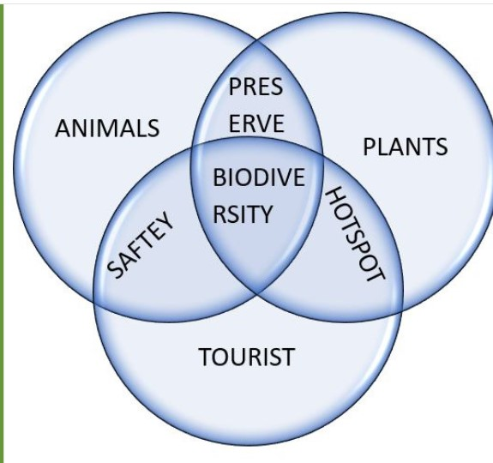

1. Venn Diagram of Eco-Sense(AI)Nator

# Problem explanation

As already mentioned, because of unmanaged forests in the present time, there has been a trend of decline of forest resources with the increasing illegal activities in forests. Many accidents are occurring at a time in various parts of the world because of the various unplanned reserves. The following are some cases where the problems are faced by the forestry department.

## Wild Animals coming too Close to Humans :

At present, natural habitats habituating wild animals and human settlements increasingly overlap, and the rate of unexpected interactions has been and is becoming a monumental concern. For instance, a hiker encounters a bear or other potentially dangerous animal in proximity.

## Early Detection of Wild Animals for Saving Lives:

The uncharted territories within nature reserves can lead individuals with poor navigation skills to venture into danger zones. For example, a hiker losing their way in a dense forest.

*Poor Navigation Leading to Unauthorized Exploration:*

The uncharted territories within nature reserves can lead individuals with poor navigation skills to venture into danger zones. For example, a hiker losing their way in a dense forest.

## Combating Illegal Activities in Vast Forests:

The expanse of large forests can sometimes facilitate illegal activities scooped up undetected by official personnel. There is a high urgency of real-time information available to forest officials to respond promptly and prevent unauthorized activities.

## Risk-Taking Despite Warning Signs:

Despite prominent warning signs, some individuals continue to enter restricted forest areas, disregarding potential hazards. By employing cameras, we could be able to capture instances where people breach restricted zones. For instance, if a camera records a person crossing a boundary despite warning signage, it highlights the need for enforcement measures to deter risky behavior.

*Rise of the Need for Studying Animals:*

As human impact on ecosystems grows, there is a pressing need to understand animal behavior and habitats and incorporate them into present technology. For example, a network of cameras can help scientists reveal the elusive movements of nocturnal creatures like owls.

## Better Understanding of Animals for Forest Rangers:

Forest rangers play a vital role in preserving wilderness areas. To enhance their effectiveness, our project equips them with advanced tools such as image recognition cameras. Imagine a situation where a ranger captures images of rare or endangered species through camera traps. This visual data assists rangers in making informed decisions for better wildlife management.

## Wild Animal Attacks and Preventive Measures:

The harmony between humans and wildlife is occasionally disrupted by untimely encounters. These attacks pose significant risks to both humans and animals. Our system employs image recognition technology to identify signs of animal aggression.

*Addressing Low Connectivity in Forests:*

Remote forests often shroud themselves in limited connectivity, posing challenges to communication and emergency response. This absence of reliable communication networks in remote forests can hinder emergency response efforts. Effective communication can transmit connectivity even in areas with limited connection.

## Preventing Unauthorized Fires:

Unauthorized activities like starting fires can have catastrophic consequences for ecosystems. Our project uses sensors to detect smoke or sudden temperature spikes. If a camera identifies smoke rising from a restricted area, it can send immediate alerts to fire services, helping them swiftly contain the fire and prevent its spread.

## Halting the Escalation of Forest Fires:

The rapid escalation of forest fires poses severe threats so there should be techniques for early indication of potential fire outbreaks. Imagine a scenario where the is a sensing process for rise in temperature and smoke concentration in a remote forest region. This data then could trigger an alert to the firefighting crew, enabling them to respond prior to any big escalations of fire.

*Rise of the Need for Studying Animals:*

As human impact on ecosystems grows, there is a pressing need to understand animal behavior and habitats and incorporate them into present technology. For example, a network of cameras can help scientists reveal the elusive movements of nocturnal creatures like owls.

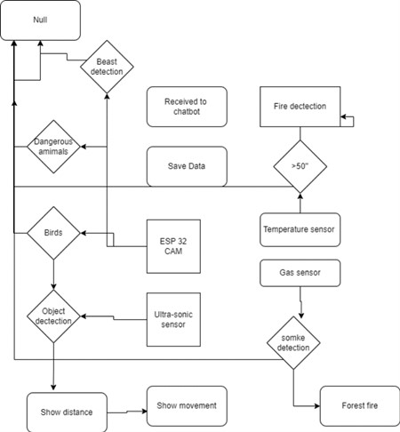

1. Flow Chart of Working of Eco-Sense(AI)Nator

# Beast Detection And Communication

The device uses a camera module which captures real-time images using open-cv library and the machine learning model (YOLO) is applied to detect the presence of animals and various objects in the area.

YOLO is a machine learning based CNN ML model which classifies the objects present in the image by separating and framing the pixels of a picture and then it shows us the object with the label as shown in the above picture. Also, with this, the model can be trained to detect fire in the forest and any unusual activities in the forest. The warnings are shown according to various grouping of various objects such as

'beasts': ['bear', 'elephant', 'zebra', 'giraffe','lion','tiger','cheetah'],

'domestic':['dog', 'cat','cow','sheep']

'birds': ['bird'],

'person': ['person'],

'vehicle': ['bicycle','car','motorcycle','bus','truck','train','boat'],

'signs':['street sign','stop sign'],

'cutting_objects':['knife','fork'],

'danger': ['snake', 'spider'].

This means that whenever lion or cheetah is encountered in cam then the data is transmitted in the same ways as of giraffe or elephant is sent to set some warning of some priority order. Similarly, all the grouping characteristics work as a part of algorithm.

The network of various devices is created and divided into certain areas for pinpointing of various devices. A unique id element is assigned to all devices and a mesh like transmission media is created to transfer the data from places to another i.e., to a device that will transmit the data through web services to be used by all the entities. Each device implanted will have a unique id and an area location assigned to it.

Whenever the device camera detects an unusual moment in forest or any wildlife or any harmful object groups then the data of the event with the device id and area data will be transmitted to a telegram bot. The area and id of device will be pre-fitted with the device. This gives the location of place where the event occurred through some mesh topology structure via Bluetooth technology or Wi-fi to a device that can send the data online. The whole data is sent to the server or forest department to analyze the vulnerability of the event. The data that the department wants to be displayed to the server will be transmitted to a telegram channel by the bot itself to get the entities informed about the event by providing minimal data to the other entities.

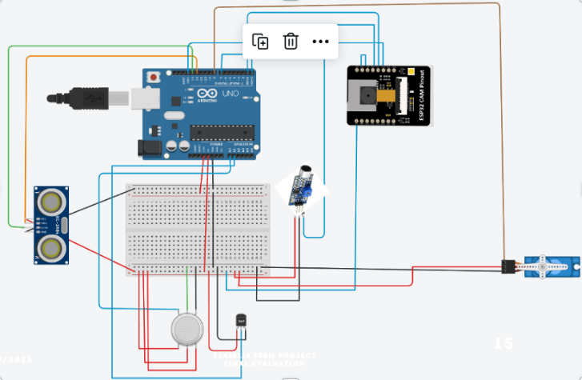

1. Block diagram of Eco-Sense(AI)Nator

V. I Collection of biodata

By strategically positioning environmental sensors, the system captures and analyzes the precise routes and rhythms of wildlife motion. These tracked motion patterns range from daily routines to the very seasonal migrations. Augmented with a mesh type architecture any specific beast could be hand tracked and position could be under radar.

The project capability extends benefits in informed policy design wherein any of policies are taken in interests of the exact habits and requirements of wild and wildlife. For instance, areas which witness high concentrations of seasonal bird migrations can be designated as protected zones during the critical migration periods could made sure no habitat degradation and regrowth of vegetation if exploited any during post migratory period.

Researchers possess the flexibility to tailor capture points according to their research objectives, catering to specific interests such as vegetation or wildlife, whether investigating plant life or observing wildlife behaviors.

V. II Navigating methods of biodata

The project encompasses the study of wildlife behavioral intricacies through efficient tracking facilitated by a 180-degree servo motor, ensuring comprehensive monitoring and motif of movement. Utilizing sophisticated algorithms akin to flight radar systems, the project meticulously could capture every movement. Through continuous data assessment, this approach could become more prominent in research data collection.

The immense threat of losing track of the way is common to users especially in areas of wild or to put even in the villages. The working of our model could be extended in surveillance by the will of the user if they feel the risk of getting lost.

The network of the devices could facilitate navigation which could provide the user with their area location by using the information of the nearest device implanted. The device could also work as a helping hand if the user intends to be directed to a targeted location which our project taking in the ids of their current location and destination and by using in the smallest path algorithm could provide the destination route.

V. III Case study of classification of various objects

Case 1: Person and Cutting Objects

When the YOLO model identifies a person in the forest area and detects cutting objects like a knife or a fork, it might suggest illicit activities. This scenario could involve someone engaging in dangerous or harmful actions, such as unauthorized hunting or other harmful actions.

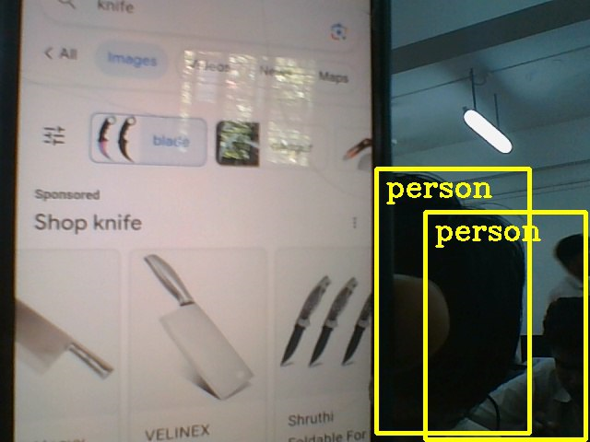

1. Sharp object showed to Eco-Sense(AI)Nator

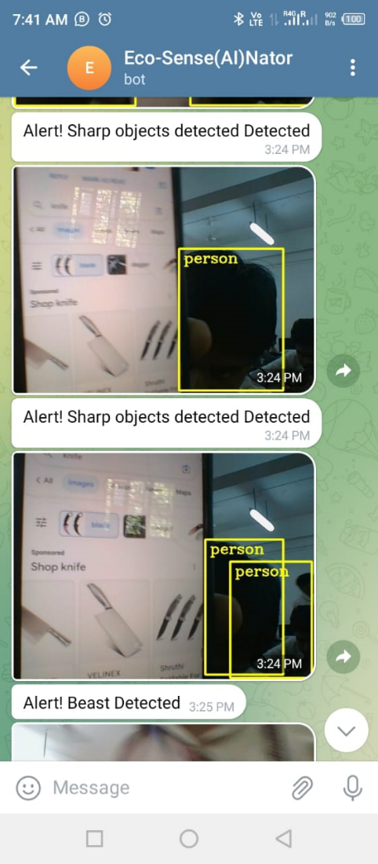

1. Sharp object detected by Eco-Sense(AI)Nator

Case 2: Person, Cutting Objects, and Beasts

If the YOLO model detects a person, cutting objects (like a knife or fork), and wild animals from the "beasts" category (e.g., bear, lion, tiger), it could imply a potentially alarming situation. This combination could indicate illegal activities involving hunting or harm to wildlife, which could pose a threat to the forest ecosystem and the animals living within it.

Case 3: Person and Domestic Animals

If the YOLO model detects a person alongside domestic animals like dogs, cats, cows, or sheep, it is likely a common scenario in which humans are present in the forest with their pets or livestock. This might not necessarily imply illegal activities, but rather a common interaction between humans and animals.

Case 4: Person and Beasts

When the YOLO model recognizes both a person and wild animals from the "beasts" category (such as lion, tiger, etc.), it could indicate risky behavior. This could imply that the person is dangerously close to these animals, potentially leading to dangerous situations for both humans and animals. Moreover, if the person is attempting to interact with or provoke these creatures, it could be illegal and unsafe.

Case 5: Person, Beasts, and Domestic Animals

When the YOLO model identifies a person along with both wild animals from the "beasts" category and domestic animals, it could suggest an atypical situation. This combination might indicate human interference with wildlife or unusual animal interactions, which could have legal or safety implications.

Case 6: Person and Birds

If the YOLO model detects a person alongside birds, it's likely a typical scenario in a forest environment. Humans often coexist with various bird species in natural habitats, so this combination might not raise any immediate concerns about illegal activities.

Case 7: Person, Signs, and Beasts

When the YOLO model recognizes a person, signs (such as warning signs), and wild animals from the "beasts" category (e.g., bear, lion), it could indicate that individuals are being cautious and informed about potential wildlife encounters. This combination could suggest that they are taking appropriate safety measures while navigating the forest.

Case 8: Person, Birds, and Signs

When the YOLO model identifies a person alongside both birds and signs (e.g., street signs), it might suggest a scenario where individuals are engaging in recreational activities while also being aware of designated areas or information conveyed by the signs. This combination could indicate responsible behavior and adherence to guidelines in the forest.

Case 9: Person and Danger

If the YOLO model detects a person alongside dangerous animals from the "danger" category (e.g., snake, spider), it could imply that individuals are in close proximity to potentially harmful creatures. Alternatively, it could signify awareness of the presence of dangerous animals and the need for caution.

Case 10: Signs and Vehicles

If the YOLO model detects signs (such as navigation signs) along with vehicles like bicycles, cars, or motorcycles, near a trespassing sign it could suggest that individuals are in an unauthorized part of the forest area.

Case 11: Person, Vehicles, and Domestic Animals

When the YOLO model identifies a person with vehicles and domestic animals, it suggests that individuals are engaged in recreational activities or using vehicles for transportation while accompanied by their pets. This combination signifies a human-centric engagement with the environment.

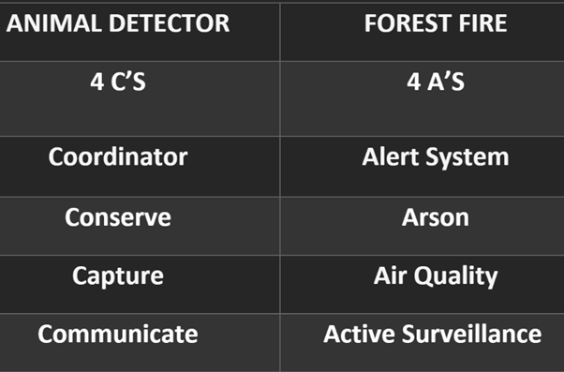

1. 4 C’s And 4 A’s of Eco-Sense(AI)Nator

VI. Forest fire Alerting and Premature Stopping System

Smoke Measurement (MQ2 Gas Sensor): Smoke sensors are vital components in environmental monitoring systems. The MQ2 gas sensor functions by detecting the presence of smoke particles and combustion byproducts in the air. When smoke levels exceed predefined thresholds, these sensors trigger alarms or notifications. Integrating the MQ2 gas sensor can help in the early detection of forest fires, allowing for rapid response and mitigation.

Temperature Measurement (LM35 Sensor): Temperature sensors, such as the LM35 sensor, are essential for monitoring temperature variations in different regions. LM35 sensors provide precise temperature data, which can be used to identify temperature anomalies or trends over time. With it we could monitor temperature fluctuations throughout the year in various areas, which is majorly crucial for understanding climate patterns, identifying potential environmental issues, and ensuring tourist safety in extreme weather conditions.

Cross-Limit Triggering: Coworking system where both the MQ2 gas sensor for smoke and the LM35 sensor for temperature trigger alerts when they simultaneously exceed predefined limits is a proactive approach to environmental monitoring. This dual sensor triggering mechanism can detect forest fires more accurately and rapidly. It minimizes false alarms by requiring both conditions to be met before an alert is generated, increasing the system's reliability and compatibility.

Year-round Temperature Sensing (LM35 Sensor): Continuous temperature sensing throughout the year using LM35 sensors is essential for capturing seasonal variations and long-term climate trends. Implementing robust LM35 temperature sensors in remote areas can provide valuable insights into climate change's impact on ecosystems.

Smoke Content Monitoring in Villages (MQ2 Gas Sensor): Monitoring smoke content in villages, especially near industrial facilities, is crucial for public health and environmental protection. Air quality sensors, including the MQ2 gas sensor for particulate matter and gas detection, can measure the concentration of pollutants like smoke particles and harmful gases. By collecting this data and allocating resources accordingly, it is possible to address pollution issues, assess health risks, and implement measures to improve air quality in affected communities.

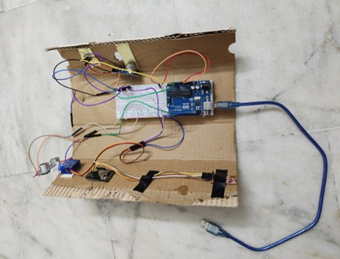

1. Hardware of Eco-Sense(AI)Nator

VII. RESULT

The device was able to collect various information like smoke value, temperature value, distance and identify and classify the objects in real-time and send the data to the entities through telegram service. So, the project overall facilitates all the authorities who are in concern with the area by means of telegram service. Field tests conducted in diverse environments highlighted the system's adaptability and effectiveness, even in challenging lighting and weather conditions. The system's performance exhibited promising potential in mitigating human-wildlife conflicts, enhancing safety for both humans and animals. These results underscore the value of integrating innovative deep learning techniques with practical applications in wildlife conservation and human safety.

##### VIII. CONCLUSION

In conclusion, this project presents a comprehensive system that combines sensor technologies, wireless communication, and AI models to revolutionize tourism, wildlife conservation, and environmental monitoring. By integrating devices carried by tourists with environmental sensor nodes, real-time data on wildlife movements, population densities, tree cutting, earthquakes, and forest fires can be collected and analyzed. The use of AI models enhances data processing and enables informed decision-making. This project contributes to the Sustainable Development Goals, promoting responsible consumption and production, climate action, and the preservation of life on land. Through its innovative approach, it can transform the way we experience tourism while fostering a greater understanding and conservation of our natural resources and endangered species.

##### Acknowledgments

We are deeply grateful to Amrita Vishwa Vidyapeetham, Amritapuri Campus for providing us the opportunity and facilities to explore the core concepts of Electrical and Electronics Engineering and conduct research based upon AI-based applications related to Electrical Engineering.

##### References

1. W. Saad and A. S. Alsayyari, "Real Time IoT Based Camel-Vehicle Collision Avoidance System for KSA," 2020 3rd International Conference on Computer Applications & Information Security (ICCAIS), Riyadh, Saudi Arabia, 2020, pp. 1-4, doi: 10.1109/ICCAIS48893.2020.9096714
2. N. M. Krishna, R. Y. Reddy, M. S. C. Reddy, K. P. Madhav and G. Sudham, "Object Detection and Tracking Using Yolo," 2021 Third International Conference on Inventive Research in Computing Applications (ICIRCA), Coimbatore, India, 2021, pp. 1-7, doi: 10.1109/ICIRCA51532.2021.9544598.
3. I. S. Sineva and M. D. Molovtsev, "An Integrated Approach to the Regression Problem in Forest Fires Detection," 2020 Systems of Signals Generating and Processing in the Field of on Board Communications, Moscow, Russia, 2020, pp. 1-4, doi: 10.1109/IEEECONF48371.2020.9078645.
4. Z. Wang, J. A. Zhang, M. Xu and Y. J. Guo, "Single-Target Real-Time Passive WiFi Tracking," in IEEE Transactions on Mobile Computing, vol. 22, no. 6, pp. 3724-3742, 1 June 2023, doi: 10.1109/TMC.2022.3141115.
5. C. S. Madhumathi, V. Naveen, N. Akshay, M. S. Kumar and M. M. Aslam, "Advanced Wild Animal Detection and Alert System using YOLO V5 Model," 2023 7th International Conference on Trends in Electronics and Informatics (ICOEI), Tirunelveli, India, 2023, pp. 365-371, doi: 10.1109/ICOEI56765.2023.10126065.
6. A. Gehlot and R. Singh, "Research Guide for ML based Smart Tourist System," 2022 International Interdisciplinary Humanitarian Conference for Sustainability (IIHC), Bengaluru, India, 2022, pp. 1427-1434, doi: 10.1109/IIHC55949.2022.10059630.
7. G. Bandari, P. L. Nirmala Devi and P. Srividya, "Wild Animal Detection using a Machine Learning Approach and Alerting using LoRa Communication," 2022 International Conference on Smart Generation Computing, Communication and Networking (SMART GENCON), Bangalore, India, 2022, pp. 1-5, doi: 10.1109/SMARTGENCON56628.2022.10083577.
8. Z. Li, J. Liu, C. Guo, S. Li, L. Li and L. Xu, "Design of Smoke Detection and Alarm System Based on LoRa," 2020 Chinese Automation Congress (CAC), Shanghai, China, 2020, pp. 5086-5090, doi: 10.1109/CAC51589.2020.9326322.
9. A. Kaur, A. Jadli, A. Sadhu, S. Goyal, A. Mehra and Rahul, "Cloud Based Surveillance using ESP32 CAM," 2021 International Conference on Intelligent Technology, System and Service for Internet of Everything (ITSS-IoE), Sana'a, Yemen, 2021, pp. 1-5, doi: 10.1109/ITSS-IoE53029.2021.9615334.
10. P. Thirumal and L. Shylu Dafni Agnus, "Forest Fire Detection and Prediction – Survey," 2022 International Conference on Inventive Computation Technologies (ICICT), Nepal, 2022, pp. 1295-1302, doi: 10.1109/ICICT54344.2022.9850518.
11. A. -E. Marcu, G. Suciu, E. Olteanu, D. Miu, A. Drosu and I. Marcu, "IoT System for Forest Monitoring," 2019 42nd International Conference on Telecommunications and Signal Processing (TSP), Budapest, Hungary, 2019, pp. 629-632, doi: 10.1109/TSP.2019.8768835.
12. N. Sundaram, S. Divya Meena. (2023) Integrated animal monitoring system with animal detection and classification capabilities: a review on image modality, techniques, applications, and challenges. Artificial Intelligence Review 52.
13. Raji C.G, Fathima Safa, Jishana P, Mohammed Adhil. (2023) Early Warning System from Threat of Wild Animals using Digital Image Intelligence (ICSMDI), pages 322-326.Processing. 2023 3rd International Conference on Smart Data
14. B. Natarajan, R. Elakkiya, R. Bhuvaneswari, K. Saleem, D. Chaudhary and S. H. Samsudeen, "Creating Alert Messages Based on Wild Animal Activity Detection Using Hybrid Deep Neural Networks," in IEEE Access, vol. 11, pp. 67308-67321, 2023, doi: 10.1109/ACCESS.2023.3289586, Amrita Vishwa Vidyapeetham
15. WARSE The World Academy, and Engineering. “Wild Animal Detection and Recognition from Aerial Videos Using Computer Vision Technique.” International Journal of Emerging Trends in Engineering Research (2019): n. pag. Web, Amrita Vishwa Vidyapeetham,
16. Geethapriya. S, N. Duraimurugan, SP. Chokkalingam “Real-Time Object Detection with Yolo”, International Journal of Engineering and Advanced Technology (IJEAT) ISSN: 2249 -8958, Volume-8, Issue-3S, February 2019, Amrita Vishwa Vidyapeetham
17. P. S. Srishilesh, Parameswaran, L., Tharagesh, R. S. Sanjay, Dr. Senthil Kumar T., and Sridhar, P., “Dynamic and Chromatic Analysis for Fire Detection and Alarm Raising Using Real-Time Video Analysis”, in Proceedings of 3rd International Conference On Computational Vision and Bio Inspired Computing, Cham, 2019, Amrita Vishwa Vidyapeetham
18. S. S, A. Premkumar, S. C. K, J. Sony and G. M, "Deep Learning Models for Fire Detection using Surveillance Cameras in Public Places," 2022 13th International Conference on Computing Communication and Networking Technologies (ICCCNT), Kharagpur, India, 2022, pp. 1-7, doi: 10.1109/ICCCNT54827.2022.9984601., Amrita Vishwa Vidyapeetham, Department of Computer Science and Engineering, Amritapuri, India
19. A. Phan, K. Takejima, T. Hirakawa and H. Fukui, "Forest-Related SDG Issues Monitoring for Data-Scarce Regions Employing Machine Learning and Remote Sensing - A Case Study for Ena City, Japan," IGARSS 2022 - 2022 IEEE International Geoscience and Remote Sensing Symposium, Kuala Lumpur, Malaysia, 2022, pp. 4343-4346, doi: 10.1109/IGARSS46834.2022.9883037.
20. T. Yang, H. Zhang, Y. Li, Zaiyang Ma, Ruirong Huang and Sijia Li, "The visual simulation technology in formatting forest management plan at unit level based on WF," 2017 2nd International Conference on Image, Vision and Computing (ICIVC), Chengdu, China, 2017, pp. 739-745, doi: 10.1109/ICIVC.2017.7984654.

**Contributions**

