GoLang: A comprehensive document for learning and documenting Go programming language
A high level agent-based programming language developed by Google in 2003. Go (programming language) - Wikipedia
Why is Go an agent based programming language?
With concurrency, performance and efficiency, Type Safety(Go type system catches errors at compile times that would be runtime failures in python), Simplicity, Built for Microservices. These all features Go suitable for agent-based programming. Ref: The Future of AI Agents: Why Go is the Perfect Language for the Agent Era - Rafiul Alam

Features
- Fast, statically typed, strongly typed(unlike JS), compiled language. Supports both type assignment and automatically type assignment.
- General purpose language(for various things)
- Built-in testing support(standard libraries)
- OOP(in its own way, similar to OOP)

Setting up the Environment
Download Go compiler and add the extension in vscode. The path should be automatically updated while using .msi file.

First code
For the first time, we are going to print “Hello World” in the console.
For this define the package main in the top followed by importing fmt which helps in formatting string and printing the messages in Go. Once done, we create the entry point i.e. main function and print the message.
Note: In Go, we can’t left a variable declared or package imported and unused. It must be used somewhere in the code.
Note: Go uses Curly braces like as of Java or C.
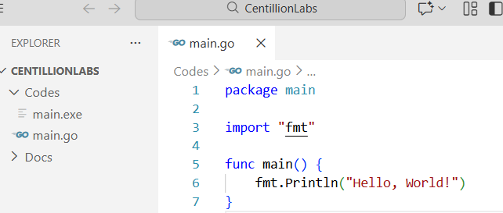

To compile the code, we use go build filename.go
To run the .exe file, run the .\filename.exe
To compile and run together. We would use go run filename.go
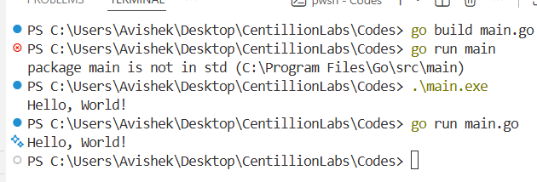
Now, as we have successfully run the first program,
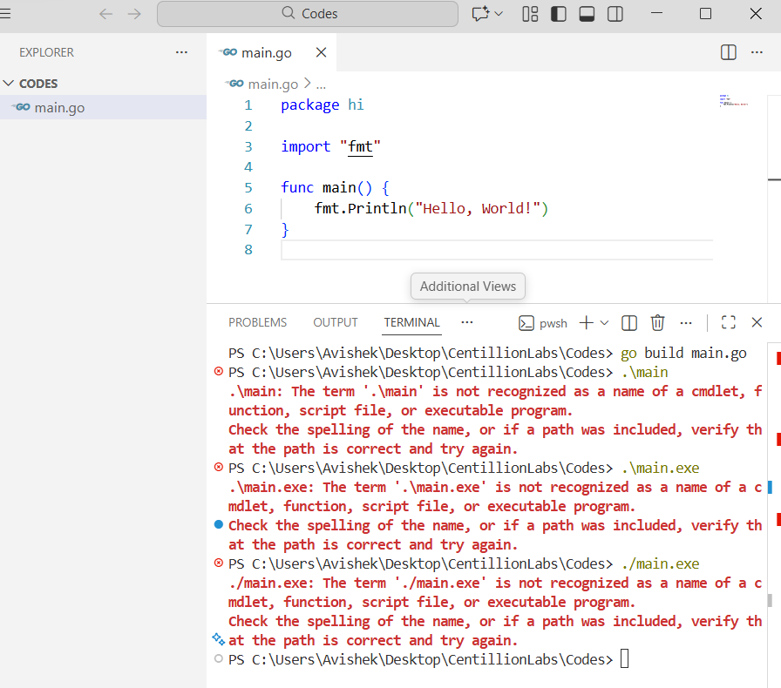
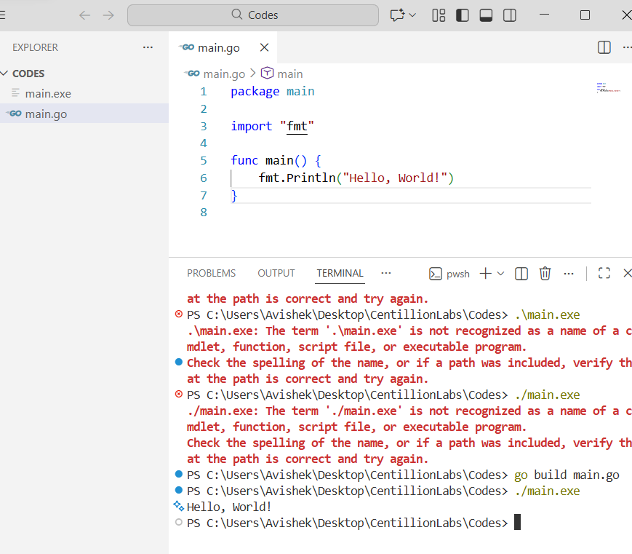
Same as Java, the filename seems to be the package name. We can’t change it according to our wish.

Comments in Go
In Golang, we use ‘//’ to comment a line.

Variables in Go
Use “(double quotes) for declaring strings in the Go lang. Don’t use ‘ unlike python.
By default, the empty defined variable’s value is 0 or NULL.
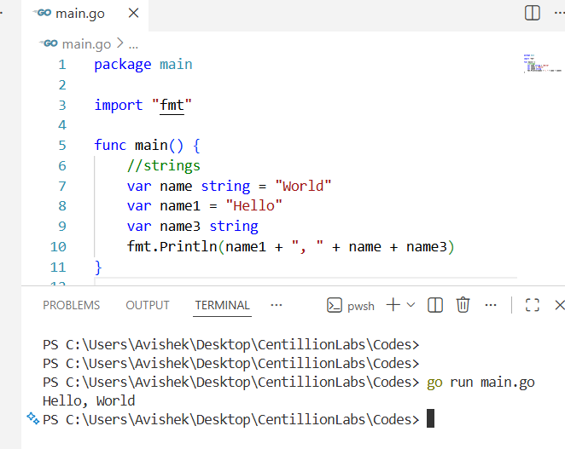
Variables can be declared by using
var varname datatype = value
var varname = value
var varname datatype (NULL)
varname := value

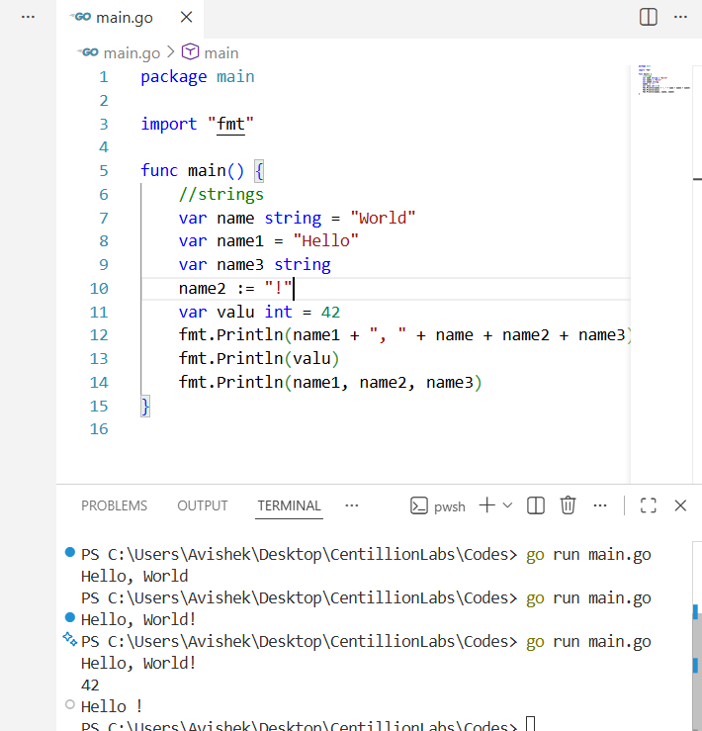
Int also works as same as string works.
- Int8: Int 8 bits -128 to 127
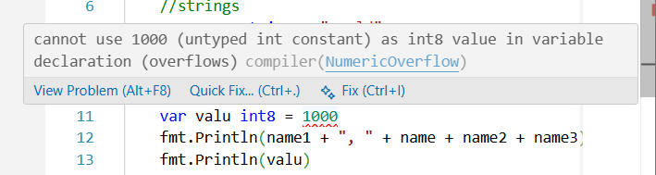
If not using value range value specified, it throws an error.
- Supports newline and other escape characters such as \n.
- To print various datatypes together use a ‘,’ in between.
- To run with format specifier use printf and %v(format specifier) as in c.
- Printf doesn’t adds newline automatically.
- %q : Adds ‘#’ in int and double quotes in strings.
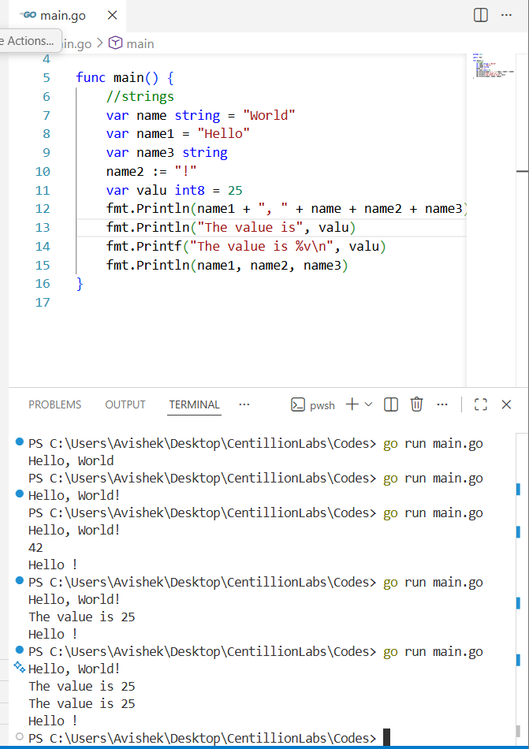

FMT package:
- Print: doesn’t add a new line
- Println: adds a new line automatically
- Printf: Formatted string. Uses formatted strings like %v for the variables by default.
- %q : formatted string that adds double quotes to string
- %T: format specifier for printing the type of the data structure
- %f: format specifier for float
Two main things: package command-line-arguments is not a main package
- While declaring other packages and running them,
Reason is Go compiler expects an executable program to belong to the main package. Fixing the "package command-line-arguments is not a main package" Error in Golang - Go language Tutorial
- In same package declaring 2 go seems overwrite other.
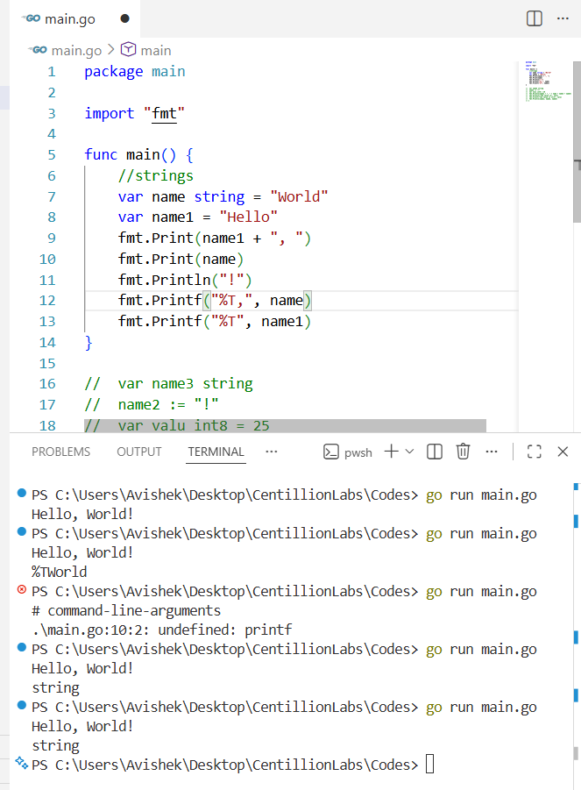
.Sprintf: used to format strings without printing them directly to the console

Arrays:
For arrays we declare a variable and use [] like as in java.
Var array[len] datatype = [len[int{val1, val2}
Array has a fixed length. Like python we have built in functions like len() to find length of the array.
Slices: Same as array but length changes. 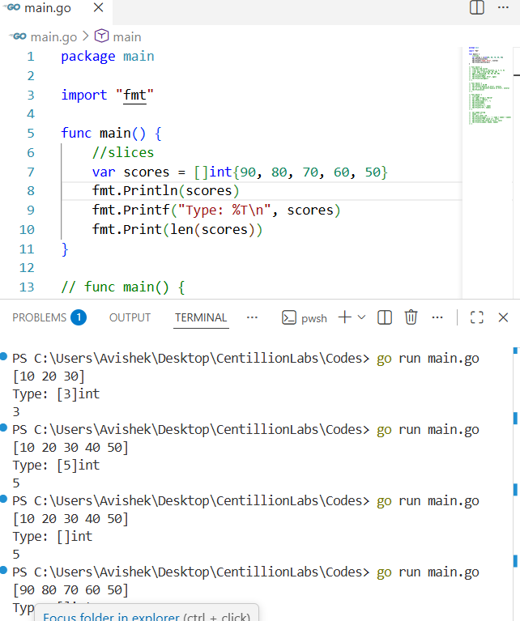
- Change an element like as python. Scores[1] =85
- For appending to a slice use scores=append(scores, 40,30). Here appending only returns a new slice. Doesn’t append it.
- Array slicing: Go has 0 based index slicing. It also excludes the last element in the list like python.
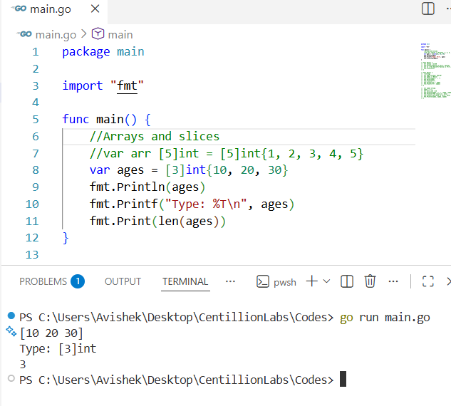
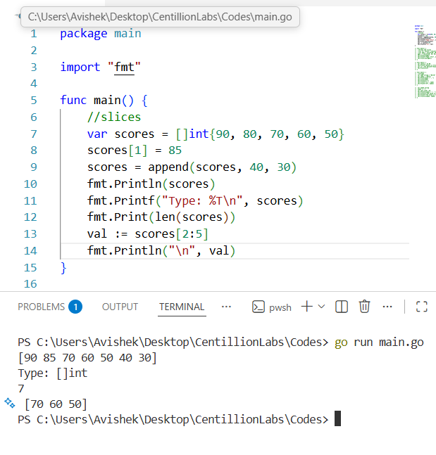

The Standard Library
To import multiple libraries together use import (“package1”, “Package2”).
First, we will be using the string package. All of them returns a new string, doesn’t modify them.

Strings:
- Strings.contains(var, substring) := Returns Boolean value(true, false)
- .ReplaceAll() : Replace all specific values with another specified value.
- .ToUpper() : Convert the string to uppercase.
- .Index : to get index of a substring where it is starting from. If not found -1.
- .ToLower : to convert string to lowercase.
- .Split() : to split the string. Like in Python. Returns a slice.
- HasPrefix: check whether prefix matches or not
- HasSuffix: check whether suffix matches or not.
- .TrimSpace: to get rid of any whitespace
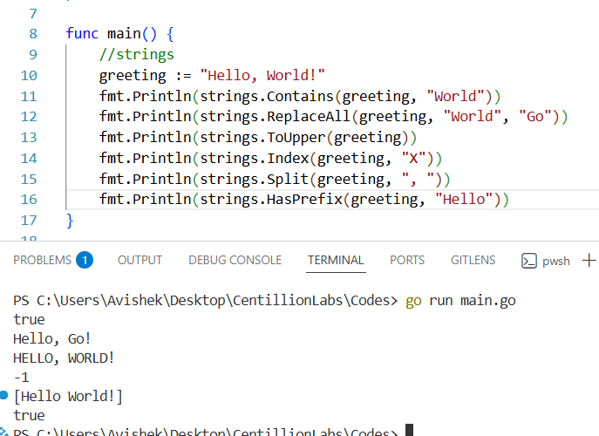

Sort:
It modifies the original list.
Sort packages helps in sorting elements in an array.
- Sort.Ints(variable)
- .SearchInts() : search a value in the array. Will search the element in sorted array. If not found will return the length of list. Actually returns the element upto it searched for.
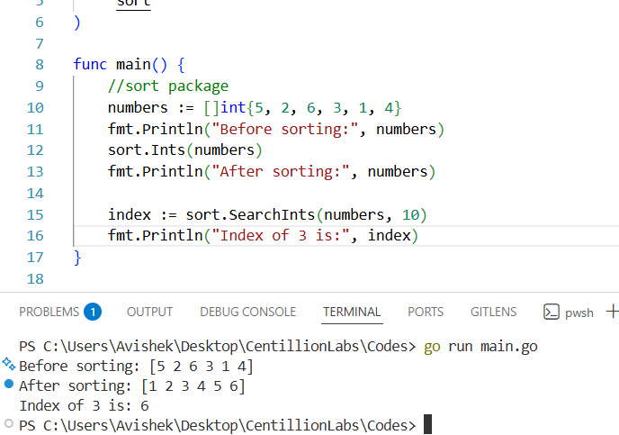
- .Strings(): Sorts the strings lexicographically.
- .SearchStrings() : Search a substring in the sorted array.
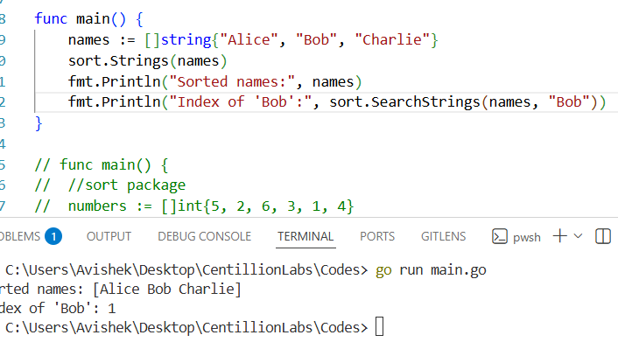
- .Reverse: Reverses the sorting but doesn’t directly work in a array. Needs to slice it first.
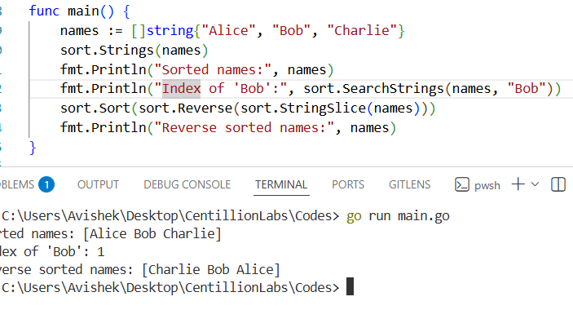

Loops
For for loop, we don’t seem to have auto assignment, increment like python. It seems we have to define it externally. The loop variables can be defined as C i.e. initialization, condition, increment.
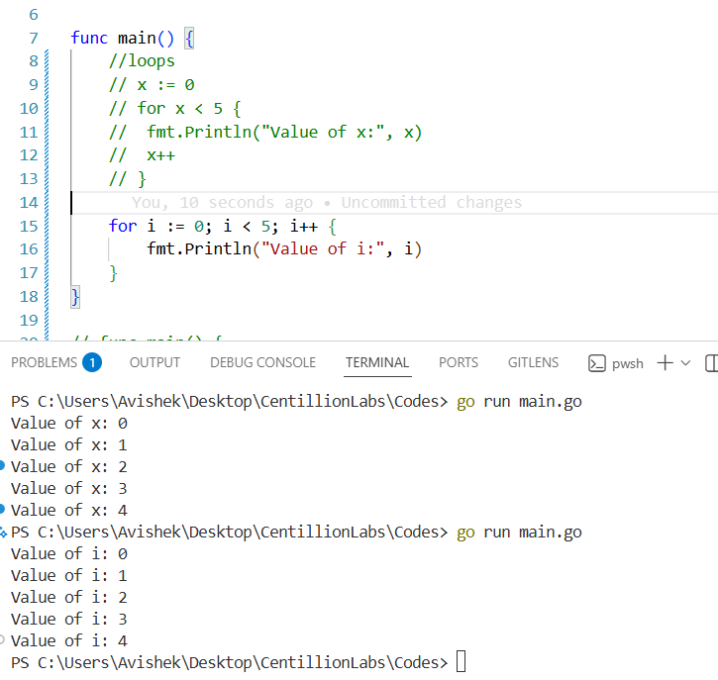
- ++ : Increases value by 1. Same like as C.
We can also loop in like dictionary key and value pairs as shown below. Here, we have index and value.
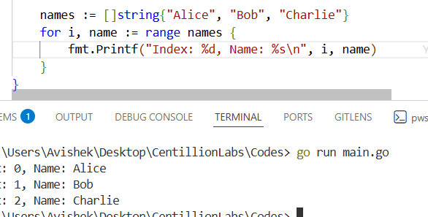
Note: We can also use _ as placeholder for index if not needed.

Boolean and Conditionals
Boolean are those data types with only 2 values true or false.
Conditionals in Go:
>, <, >=, <=, !=, ==
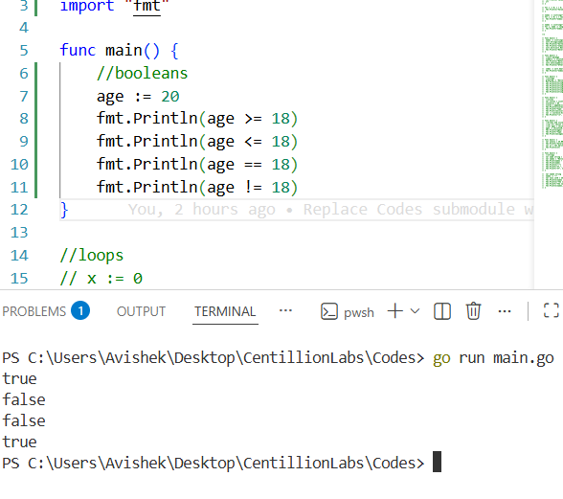
Conational Structure:
If{
…
} Else if{
…
} Else{
…
}
Make sure to keep the else and else if statement like this } else if {.
Error: syntax error: unexpected keyword else, expected }

Same like as python continue and break are there to control the flow of program.
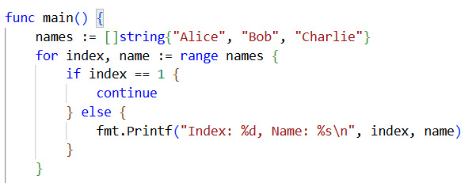

Using Functions
Functions can be defined by using func keyword.
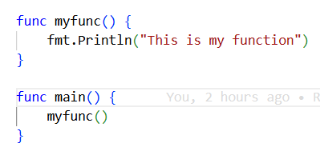
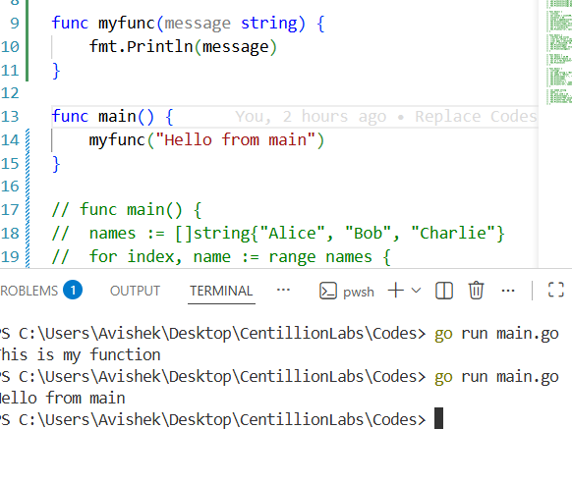
Functions in Go support the function as a parameter.
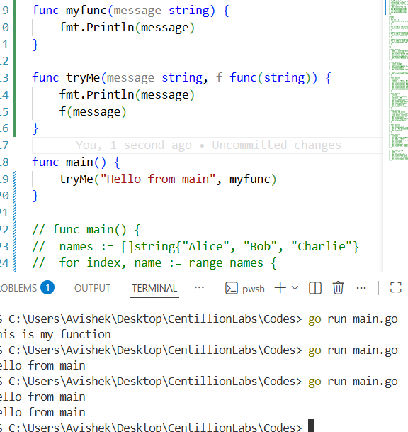

Also, we can call one function from another function.
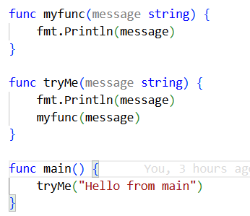
For returning multiple values we have to define return types along with function definition same as in Scala.
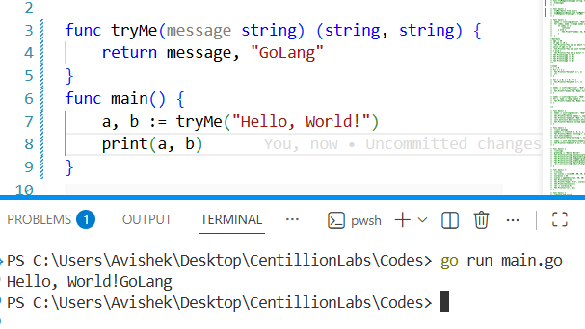

Scopes (Package)
Functions can be accessed anywhere inside the package. But need to consider that we need to compile all the files to get the output. Not only one.
Also, variables can be accessed within the package.
Short variable declaration (:=) is not allowed outside functions
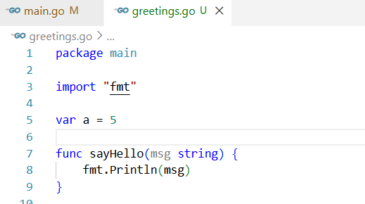
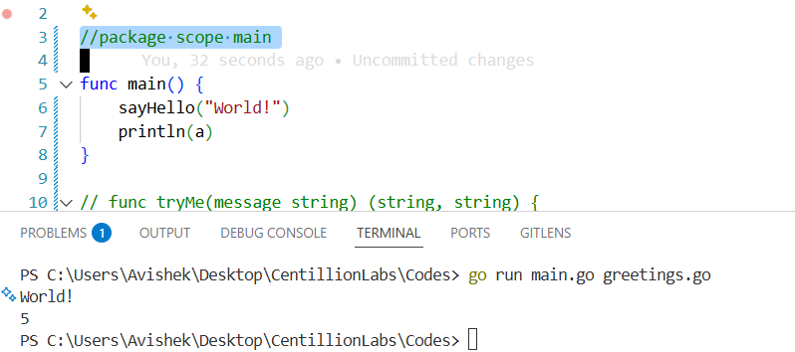

Maps (Dictionary in Go)
Keys can be of multiple types. But a single map should have a key of same type and all values in a single map must have same type too.
Definition:
Menu := map[string]int
1st datatype is for key and 2nd is for the value.
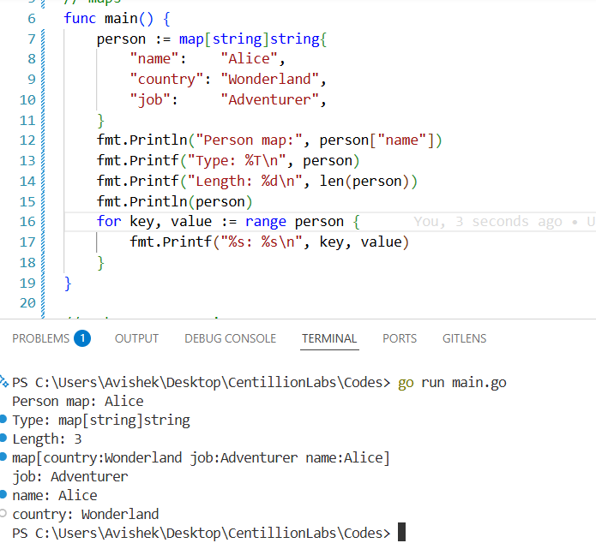

GO as a Pass By Language
- Go makes copies of values when passes into functions.
For slices, maps and functions, the pointer reference works. So, the values here will be updated when updated in the function. For rest we have to return the function.
Same as like C, we have structs in Go.
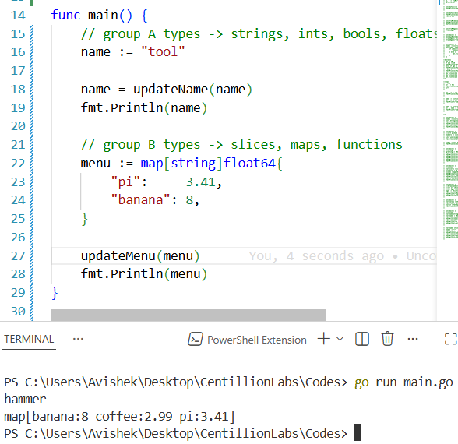

Pointers
Same as C, we can use & to get memory address as well as * to get the value in the particular memory address in Go.
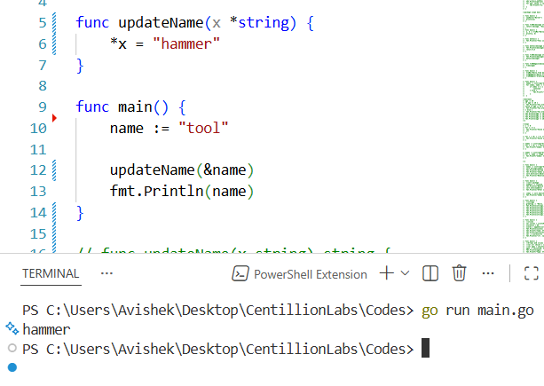

Struct in GO
Similar to C, Struct is a custom build type
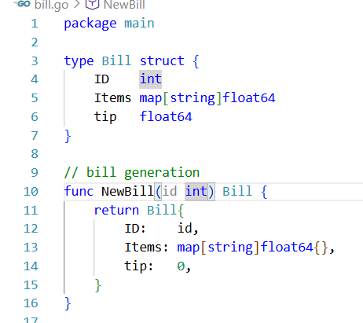
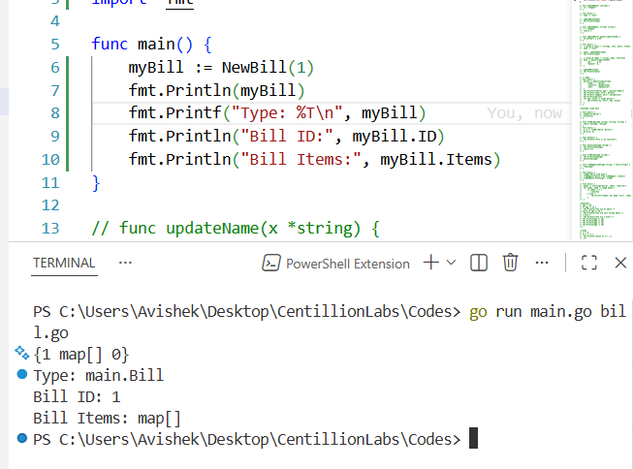
We just created an empty bill with bill id 1.

Receiver Functions
To a function, we want to associate another function. This is where receiver function comes into play.
Func{b bill) format() string
To add some space to make output aligned we can use %v to %25v. It makes the right thing -25 spaces to right. +25 makes it to the left.
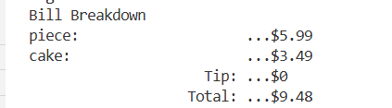
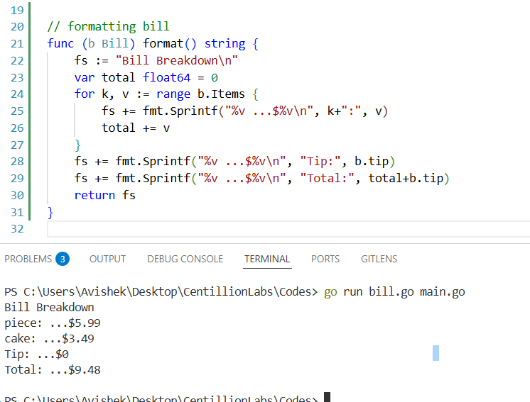

Passing pointer of receiver functions helps us to pass the same memory address to modify the values.
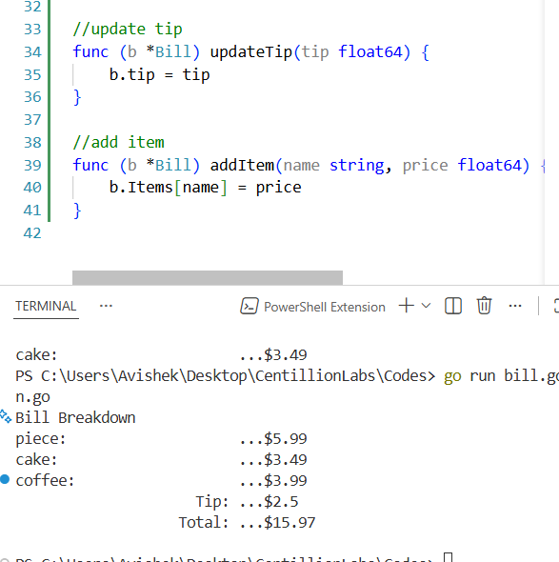
If we are taking a pointer, go will automatically deference it to do changes in same memory location. So *b is not required.

User Input in GO
reader:= bufio.NewReader(os.Stdin)
Create an object for reader as same like in java. Import bufio for that.
idInput, _ := reader.ReadString('\n')
Here we have two things, one is id as input and error which is not required so _. We are reading string until user prints enter i.e. \n.

As input can be anything. We need to trimspaces and then clean to get working with user input to avoid runtime issues.
Conversions in GoLang are: Atoi (string to int) and Itoa (int to string). These functions are present in strconv. strconv package - strconv - Go Packages
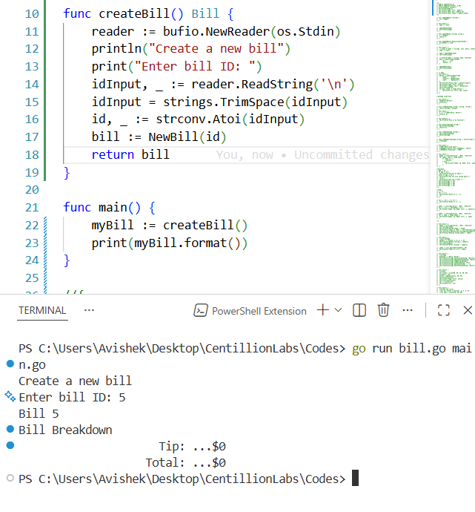
For reuse, create a function initialized with this reader like this.
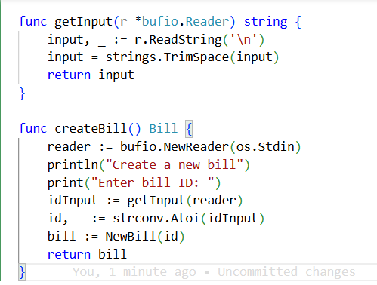
We have switch case statement as same in c.
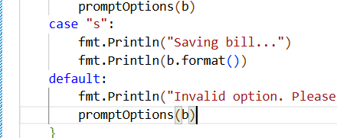
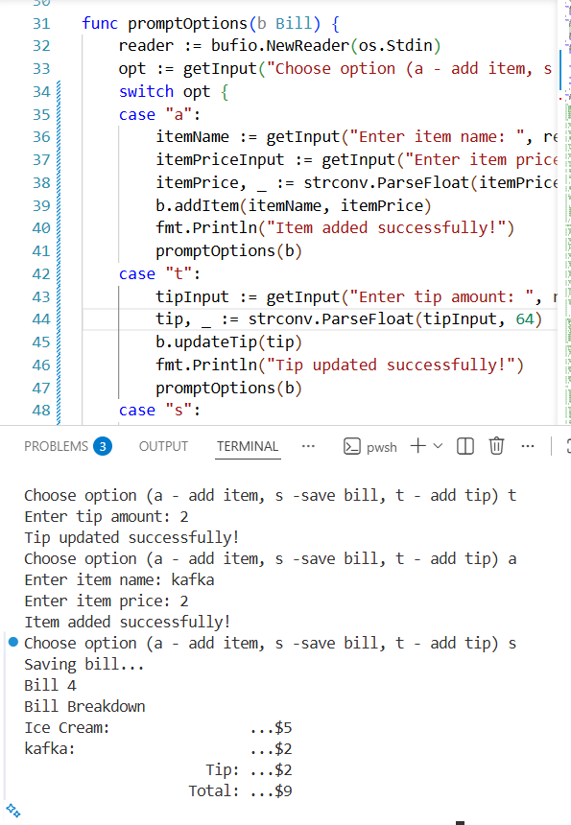

References
Go (Golang) Tutorial #1 - Introduction & Setup
https://stackoverflow.com/

