A Project Proposal

For

Online Hostel Room Reservation System

Submitted in partial fulfillment of the requirement of

Project – I(CACS 256)

Of

Bachelor of Computer Application

**Submitted To**



Tribhuvan University

Kathmandu, Nepal

**Submitted By**

Avishek Khatiwada

Symbol No: 20003

TU-Reg-no: 6-2-0002-0023-2018

Yubraj Adhikari

Symbol No: 20035

TU-Reg-no: 6-2-0002-0080-2018

**MECHI MULTIPLE CAMPUS**

Bhadrapur, Jhapa

14 February 2021

A Project Proposal

For

Online Hostel Room Reservation System

Submitted in partial fulfillment of the requirement of

Project – II (CAPJ 356)

Of

Bachelor of Computer Application

**Submitted To**

Tribhuvan University

Kathmandu, Nepal

**Submitted By**

Avishek Khatiwada

Symbol No: 20003

TU-Reg-no: 6-2-0002-0014-2017

Yubraj Adhikari

Symbol No: 20035

TU-Reg-no: 6-2-0002-0014-2017

**Project Supervisor**

………………………………………….

**MECHI MULTIPLE CAMPUS**

Bhadrapur, Jhapa

14 February 2021

Acknowledgement:

Foremost, the project team would like to express our sincere thanks of gratitude to our adviser, Sir. Raaju Poudel for all his continuous support and help in this project. We cannot thank him enough for all his patience, motivation, and immense knowledge. His guidance helped us in all the time of this project. We could not have imagined having such an adviser and mentor for this project.

Beside our adviser, we would like to thank our Program Director Krishna Prashad Acharya and Deputy Director Sunil Sharma who allowed us this project topic and gave us this opportunity to work on this wonderful project on the topic of ‘Hostel Management System’. Without them we would miss such a life-changing experience and a golden chance to grow our knowledge. They also helped us in doing a lot of Research and we came to know about so many new things that regular academics would have never taught. We are really thankful to them for all their support, helps, guidance, motivations and corrections. We appreciate all the technical support and motivation given by BCA program Mechi Multiple Campus and all the helps provided in order to keep this project aligned with its actual objectives.

Lastly, we would also like to thank our parents and friends who helped us a lot in finalizing this project within the limited time frame. Without all their help, we would never have stepped into this project.

We have tried to mention and give credit to everyone who helped us in this project, along with the sources from where we collected required data and information which supported this project. Yet, there may be some unintended errors and some sources or individuals may have been missed to mention. We shall feel obligated if they are brought to our notice.

14 February 2021

The Project Team

Online Hostel Room Reservation System

Abstract:

‘Online Hostel Room Reservation System’ is a online web application targeted for the College Hostel which is used by students to book the room in the Hostel like online Hotel Booking. This System provides a detailed view of how students records, room allocation and courses. The admin is provided with better control over the transactions like adding details of new students in the hostel, modifying the details of the students, deleting the students, viewing the students details in the Hostel.

This system deals with the problem on managing a Hostel and avoids the problems which occurs when carried out manually such as duplicate entries. Thus this system will helps College in better utilization of resources. The main objective of this system is to provide a facility to user to book room in hostel and view notice provided. System is able to see the check-in and check-out of the students.

The purpose of this system is to automate the existing manual system by the help of computerized equipment and full-fledged computer software, storing all details of students so that their valuable data/information can be stored in a Database for a longer period with easy accessing and modification.

**Table of Contents**

Acknowledgement i

Abstract: ii

Table of Contents iii

List of Figures v

Abbreviations vi

1.Introduction ……………………………………………………………………………….1

* 1. Project Introduction and motivation 1
  2. Overview of Problem…………………………………………………………..……..…2

1.3 Objectives 2

1.4 Audience 2

1.5 Significance 2

1.6. Features 3

1.7. Scope 3

2.Existing system Overview 4

2.1.Pros ……………………………………………………………………….…4

2.1.Cons ……………………………………………………………………….…4

3.System analysis 5

3.1.Software Development Methodology 5

3.2.Requirement specification 5

3.2.1.Functional Requirements 5

3.2.2.Non-Functional Requirements 5

3.3.Feasibility Study 6

3.3.1.Technical Feasibility Study 6

3.3.2.Operational Feasibility Study 6

3.3.3.Economic Feasibility Study 6

3.3.5.Schedule Feasibility Study 6

4.System Design 8

4.2.Context Diagram 8

4.3.Data Flow Diagram 9

4.3.1.Data Flow Diagram (Level-1) 9

4.3.2.Data Flow Diagram (Level-2) 10

4.4.Database Design 11

4.4.1.Entity Relationship Diagram 11

4.5.UI UX mechanism 12

5.Software Development and Implementation 15

5.1.Programming Platform 15

5.1.1.Front End ……………………………………………………………….………..15

5.1.2.Back End ………………………………………………………………………..15

5.2.Programming Technique 15

5.3.Operating Environment 16

6.Future Enhancement 17

6.1.Limitation …………………………………………………………………………17

7.Conclusion ………………………………………………………………………………18

References 19

**List of Figures**

Figure 1 : Project Gantt Chart 7

Figure 2 : Context Diagram 7

Figure 3 : DFD Level 1 8

Figure 4 : DFD LEVEL 2 For Process 1 9

Figure 5 : DFD LEVEL 2 For Process 2 9

Figure 6 : DFD LEVEL 2 For Process 3 9

Figure 7 : DFD LEVEL 2 For Process 4 10

Figure 8 : ER Diagram 10

Figure 9 : Login(Admin) 11

Figure 10 :Dashboard(Admin) 11

Figure 11 : User(Login) 12

Figure 12 : User(Dashboard) 12

Figure 13 : User Registration Form 13

Figure 14 : Student Table 13

**Abbreviations:**

1. DFD: Data Flow Diagram
2. ERD: Entity Relationship Diagram
3. MVC: Model View Controller
4. RAM: Random Access Memory
5. CPU: Central Processing Unit
6. GB: Gigabyte
7. HDD: Hard Disk Drive
8. SQL: Structure query language
9. UI: User Interface
10. UX: User Experience
11. JS: JavaScript
12. CSS: Cascade style sheet
13. HTML: Hypertext markup language
14. **Introduction**

**1.1. Project Introduction and Motivation**

With the advancement of technology, application areas of computer are rising day by day. Every sector desires the use of computer for fast accurate and automated operations. Therefore many programs are developed to meet the requirement of various type of users as related to their field. In context of college, we see few web based application for managing the activities. Specially, observing the Hostel sector nowadays student registration, room allotment activities are performed online without physical interaction.

This project entitled “**Online Hostel Room Reservation System**” is team work of BCA IVth semester student Avishek Khatiwada and Yubraj Adhikari. It is an online web based application which is helpful in the areas of Hostel. In context there are many Hostel accommodation available for college student to live. But it lacks the digitalization process and we find most of the activities are done manually with physical interaction. As now there are few Hostel System online which mostly are inbuilt with college software which lacks many features. Generally students have to visit the hostel and checks for availability of room that expense both time and money. This motivates our project team to develop a separate web based application that facilitate students to book room in a hostel easily through online. The project team has been motivated to complete this project so that no one would suffer from booking rooms in the student that contain full facility and saves time of the student.

* 1. **Overview of Problem**

Quality educational institute are not available on every part of the country. It is not possible for every student to carry out their academic carrier by home only. So student prefer to live in a hostel for comfort and easy environment where he\she can access to many resources of college easily. For any student to live in a hostel it is a long process which consumes a lot of time. Student firstly have to register their name on hostel and visit the desired room where they can live. This process is done manually with physical interaction. Hence, it seems essential to adopt the technology for solving these problems.

Thus project team has decided to make an effort to develop such a system that is capable of solving problems discussed above and provide more functionality and make it easy to book room in a hostel by students through online.

**1.3. Objectives**

To allow Students to book room in hostel.

To automate Students, Rooms and course records.

To allow student to view information regarding room’s availability.

**1.4. Audience**

The Primary Audience of this project are the Students of BCA, Mechi Multiple Campus. Other People that the project team want to reach are those students who are searching for or trying to find hostel details and book room in our hostel. Students can get service comfortably from their their home.

**1.5. Significance**

By the end of this project, in general tongue, this project will benefit its users by saving their time and resources. In another words, this project will prove itself to be a better option for the students who wants to view hostel details and then book a room in the hostel. This is very essential project to save the time and money of the students.

**1.6. Features**

* Status of Rooms
* Reservation management
* Manage Check-in / Check-out
* Long-term storage of records
* Data redundancy can be avoided
* Easy to handle, update and keep records
* High security
* Backup data can be easily generate

**1.7. Scope**

The proposed ‘Online Hostel Room Reservation System’ project is a computerized system. The use of this project in the hostel can reduce all the problems that exist in manual hostel management system. The main objective of developing ‘Online Hostel Room Reservation System’ is to save time and money of students. The project will be covering following areas :

* + Modules for registration, login and password recovery.
  + Platform for Admin to add and remove rooms, course and notice.
  + Platform for Admin to view students by block-wise.
  + Platform for students to view details and book rooms.

1. **Existing system Overview**

Traditionally, booking of rooms in the hostel is done manually with physical interaction with students which leads huge cost consumption and takes lot of time. Hostel used to store rooms, students and course detail in the register or paper where there is maximum chance of duplicate entry and difficult in accessing those data. Students have to personally visit the hostel and have a overview of it. For solution of this problem , system can be used to store students details, provides online platform for registration and booking rooms.

The existing system in the context of this project includes traditional method and few web portals. There are few existing web portals which are offer Hostel Booking. Some of them are **YASKO Boys Hostel**(<https://www.yaksohostel.com>), **Hostel Bookers** ([www.hostelbookers.com/hostels/nepal/](http://www.hostelbookers.com/hostels/nepal/)) which provide info only about availability of rooms .

**2.1.1. Pros**

1. Easy to operate.
2. Easy to book room through online.

**2.1.2. Cons**

1. Time Consuming.
2. Appears maximum and unnecessary Ads.
3. Inaccuracy of data.
4. Costly.
5. **System Analysis**

**3.1. Software Development Methodology**

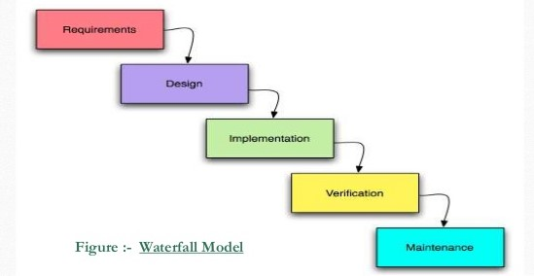The system’s initial requirements are well known, the features are quiet clear and the system is expected to inherit properties of e-commerce website, along with specific focus in hostel management. Furthermore, the project timeline is fixed. The project team believes that the best approach in this environment is going sequentially. As the project is constrained by cost and time, and the requirements and scope are well understood, it seems feasible to use traditional waterfall model of software development.

**3.2. Requirement specification**

**3.2.1. Functional Requirements**

1. System should allow users to login and register their user account.
2. System should be able to keep records students, rooms and course.
3. System should allow student who are willing to book room in hostel.

**3.2.2. Non-Functional Requirements**

1. User Interface
2. Availability
3. Usability
4. Reliability
5. Performance
6. Security

**3.3. Feasibility Study**

**3.3.1. Technical Feasibility Study**

System is technically feasible as the requirement for development of system is easily accessible. Necessary hardware and software required for development is available. The system will be easy to maintain the technical staff. So, the system is technically feasible.

**3.3.2. Operational Feasibility Study**

System is easy to operate with the basic knowledge of computation and internet. Well trained manpower is not necessary. User can easily access the system as it is user friendly in many aspects with good UI. It will overcome many problems as it was faced in manual system.

**3.3.3. Economic Feasibility Study**

The development of this system in general case have no cost, since no components or team members are getting paid or purchased. The project is the part of academic qualification for Bachelors Degree in Computer Application - Tribhuvan University and there are no monetary factor involved. So the project is economically feasible.

**3.3.4. Schedule Feasibility Study**

The deadline of project is set to 15 April 2021. The time frame provided is tough and is immovable yet the project requirement and technology being used are compatible and the project can be done with proper planning. The project team planned to accomplish the project within the time frame following the plan which is listed in the table below and is shown in Gantt chart. The project team concluded that following the schedule as planned, the project is Schedule feasible.

Figure 1:Gantt Chart

|  |  |  |  |  |
| --- | --- | --- | --- | --- |
| **Title** | **Start date** | **End date** | **Duration** |  |
| **(in days)** |  |
|  |  |  |  |
|  |  |  |  |  |
| Project Kickoff | 01/15/2021 | 01/17/2021 | 2 |  |
|  |  |  |  |  |
| Development | 01/15/2021 | 04/15/2021 | 90 |  |
|  |  |  |  |  |
| Requirements gathering | 01/15/2021 | 01/31/2021 | 16 |  |
|  |  |  |  |  |
| Front end Prototype | 01/20/2021 | 01/31/2021 | 11 |  |
|  |  |  |  |  |
| Front-end Design | 01/20/2021 | 04/01/2021 | 71 |  |
|  |  |  |  |  |
| Back-end Design | 01/25/2021 | 04/10/2021 | 75 |  |
|  |  |  |  |  |
| User manual and documentation | 01/28/2021 | 04/10/2021 | 72 |  |
|  |  |  |  |  |
| Database Implementation | 03/01/2021 | 04/15/2021 | 45 |  |
|  |  |  |  |  |
| System Testing | 03/15/2021 | 04/14/2021 | 30 |  |
|  |  |  |  |  |
| Final Project Report | 01/10/2021 | 04/10/2021 | 90 |  |
|  |  |  |  |  |
| System implementation | 04/10/2021 | 04/15/2021 | 5 |  |
|  |  |  |  |  |

Table 1:Project Timeline

1. **System Design**
   * 1. **4.1Context Diagram**

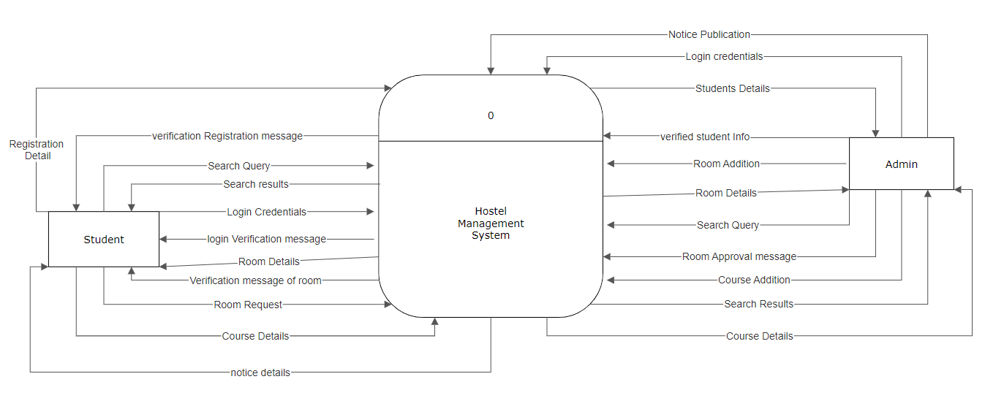

Figure 2:Context Diagram

**4.3. Data Flow Diagram**

DFD shows the flow of data from the end user through the process to the data store or database. Data flow diagram for up to second level for the proposed system are shown below:

**4.3.1. Data Flow Diagram (Level-1)**

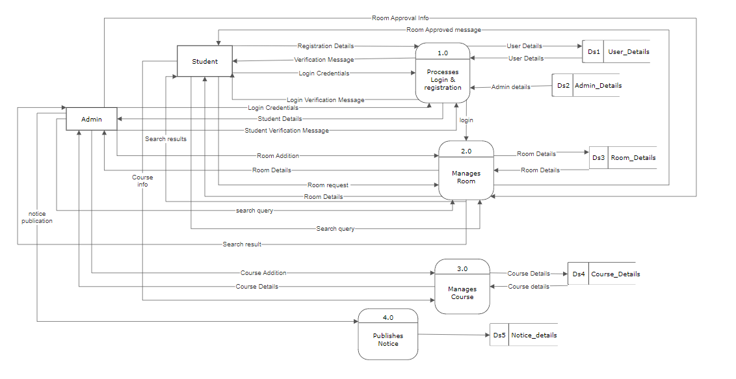

Figure 3: Top-Level DFD

**4.3.2. Data Flow Diagram (Level-2)**

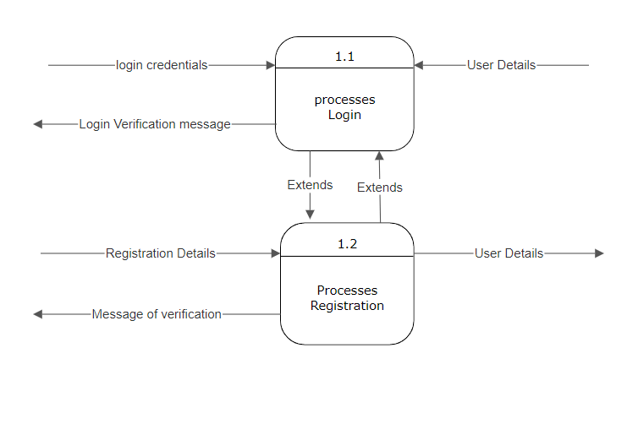

Figure 4: Level 2 DFD of Process 1

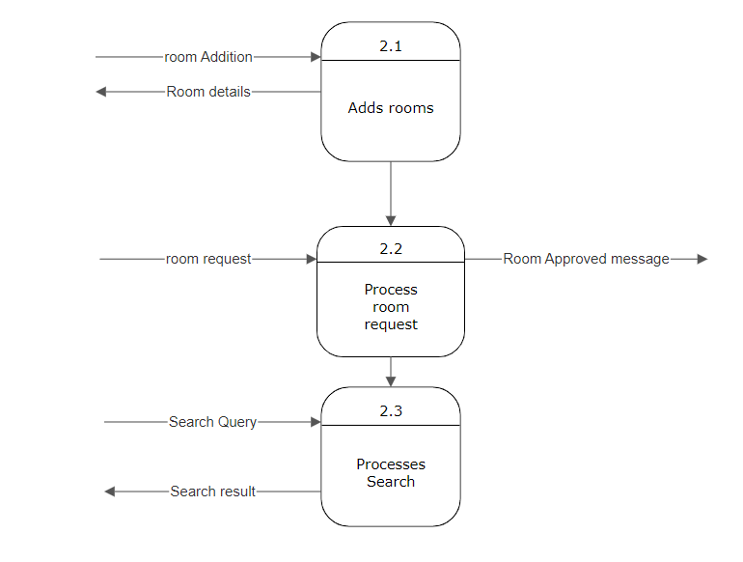

Figure 5:Level 2 DFD of Process 2

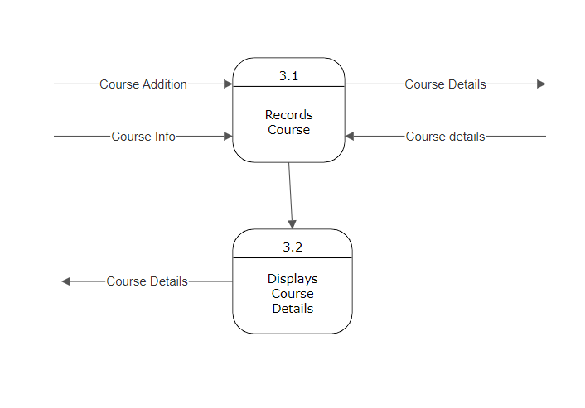

Figure 6: Level 2 DFD of process 3

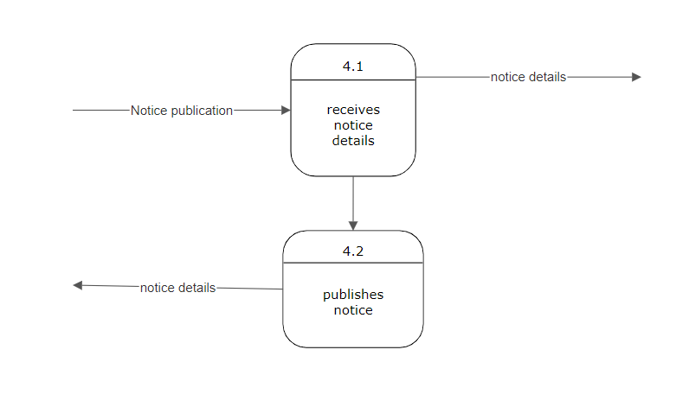

Figure 7:Level 2 DFD of process 4

**4.4. Database Design**

**4.4.1. Entity Relationship Diagram**

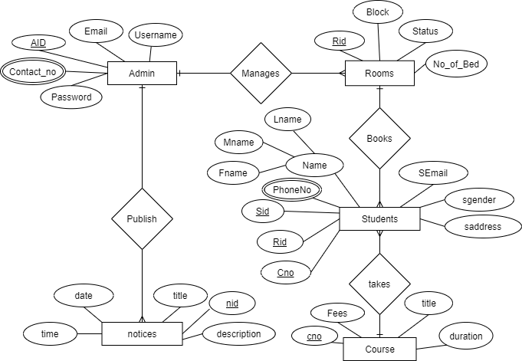

Figure 8:ER-Diagram

**4.5 UI/UX Mechanism**

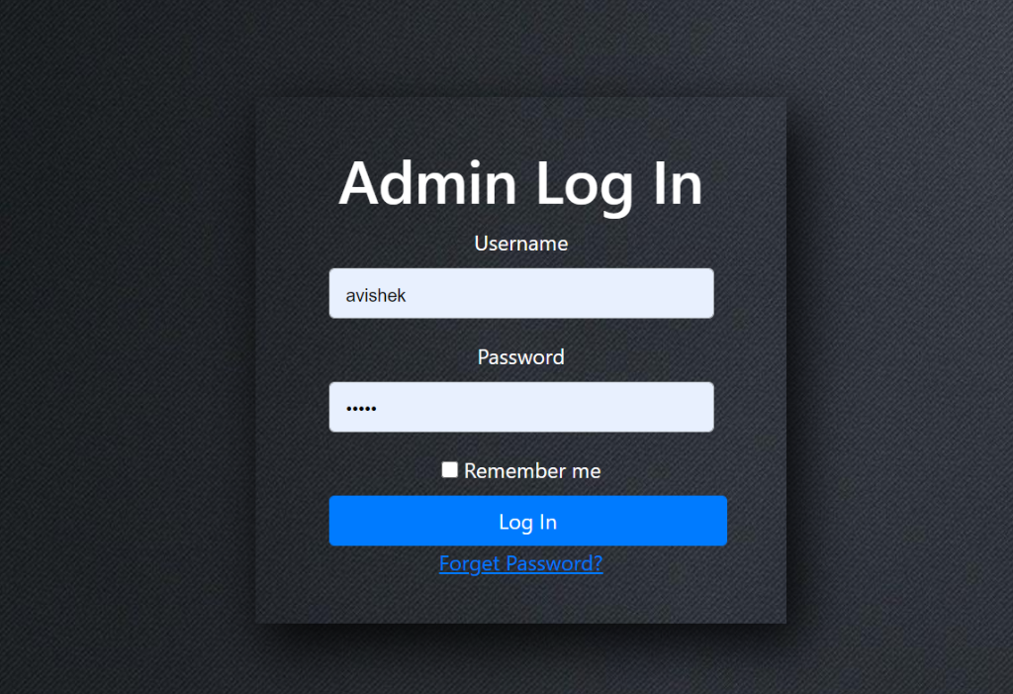

Figure 9: Login (Admin)

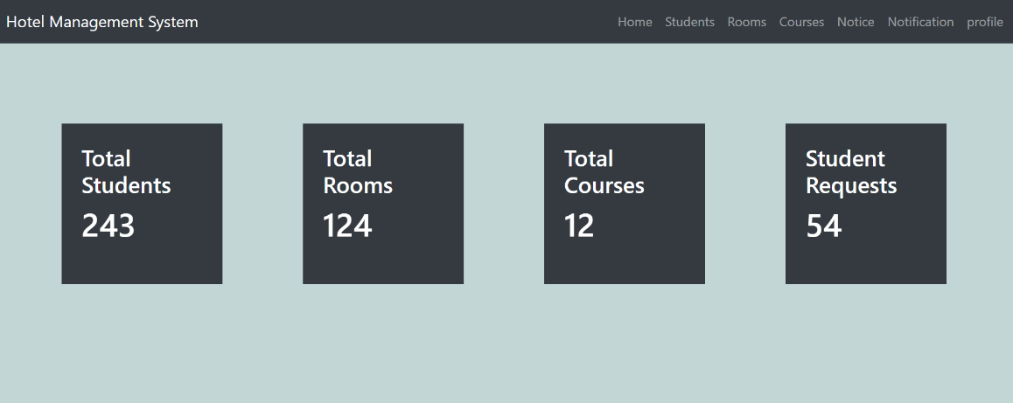

Figure 10: Dashboard(Admin)

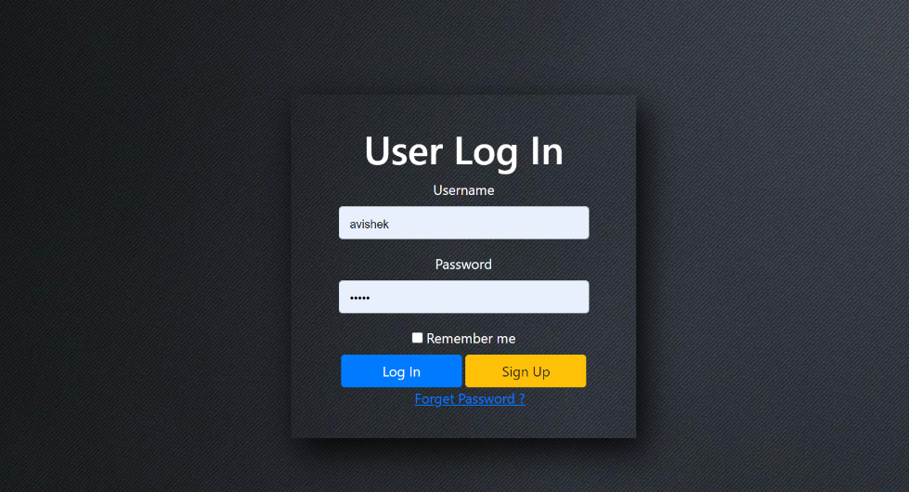

Figure 11: User(Login)

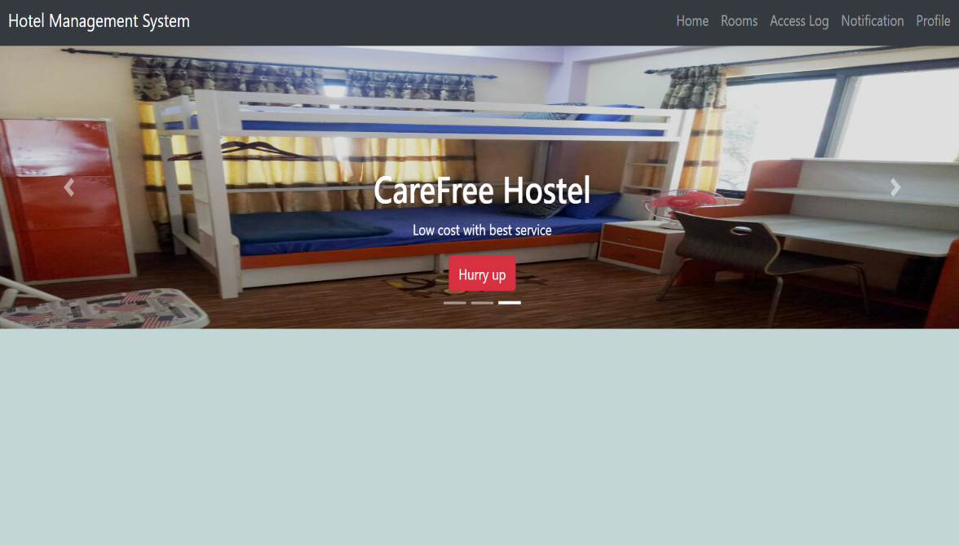

Figure 12:User(Dashboard)

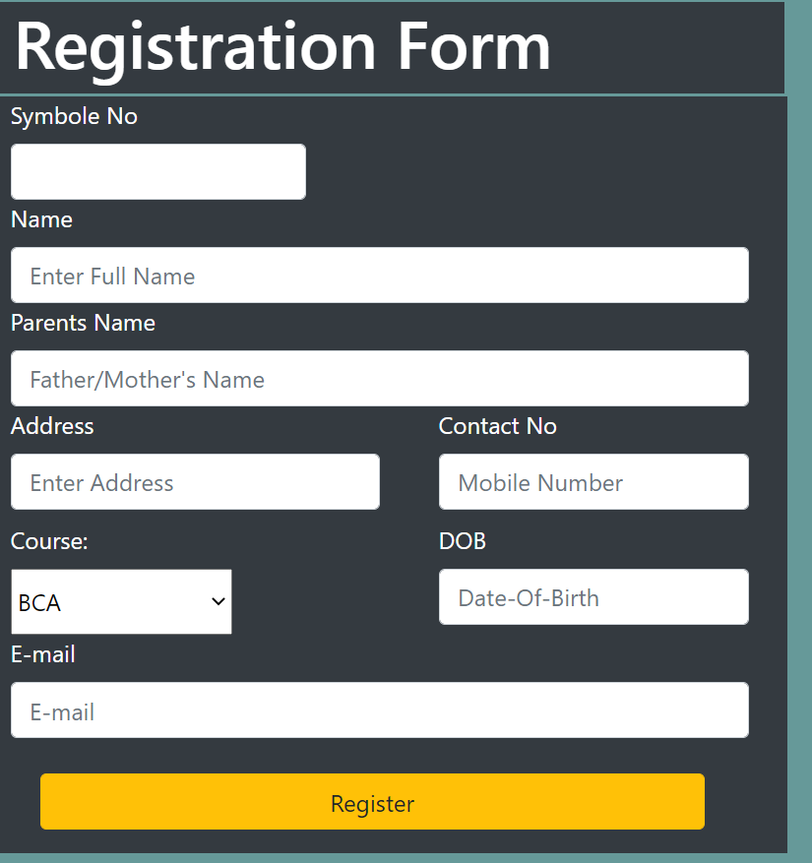

Figure 13: User Registration Form

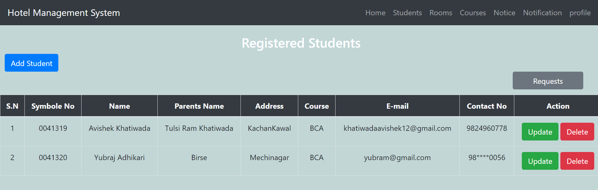

Figure 14: Student Table

**5. Software Development and Implementation**

**5.1. Programming Platform**

**5.1.1. Front End**

Front end of this application is designed using HTML CSS and JS in the core. Bootstrap framework is used as front end framework to speed up development process. The web page designs are mobile first so are compatible with device with any screen size. JQuery is also used as JavaScript library.

**5.1.2. Back End**

Preliminary design of Database may undergo many changes in future, for preliminary implementation, Php & MySql is used as SQL. Cloud servers or any other SQL may also be used in future responding to challenges that might occur.

**5.2. Programming Technique**

This project is made with MVC model, which stands for Model-View-Controller. The data are stored in database and ‘Model’ communicates with database and handles all actions related to database, While ‘View’ connects the data derived from model and display data to the user. ‘Controller’ controls all software code that control the interaction between model and view.

**5.3. Operating Environment**

The following are the minimum hardware requirements needed to run our system.

1. Minimum of 512 MB RAM
2. Minimum of 1GB storage
3. Dual core processor

On user’s end:

* 1. Internet connection
  2. Internet and web enabled device
  3. Basic operating knowledge of device and web

1. **Future Enhancement**

Online Hostel Room Reservation system .This hostel management software is designed for college which owns hostel. This project is small package which includes different categories as well as having all possible features. We have expected that it will be helpful to the, students as well as college.

Following are the possible future enhancements:

* 1. User interface upgrades
  2. Privilege of adding multiple records at same time.
  3. Improvement in performance.
  4. Online Payments.
  5. Bug fixes.
  6. **Limitations**
* Needs active internet connectivity.
* Needs web enabled device.
* Payment still needs to be physical.

**7. Conclusion**

“Online Hostel Room Reservation System” is a online web application that allows student to book room in a hostel online. It avoids the problem which occur while booking room in a hostel manually. This project will automate records of student, rooms and courses. After the completion of this project student can check information about room’s availability and book room among it.

**References**

**Date: 01/02/2021**

1. <https://getbootstrap.com/docs/4.1/getting-started/introduction/>
2. <https://api.jquery.com/>
3. <https://www.w3schools.com/icons/fontawesome5_intro.asp>
4. <https://wowjs.uk/>
5. <https://www.w3schools.com/css/>
6. <https://www.w3schools.com/js/DEFAULT.asp>
7. <https://www.w3schools.com/html/>
8. <https://httpd.apache.org/>