A Project Report

For

Hostel Room Reservation System

Submitted in partial fulfillment of the requirement of

Project – I(CACS 256)

Of

Bachelor of Computer Application

**Submitted To**



Tribhuvan University

Kathmandu, Nepal

**Submitted By**

Avishek Khatiwada

Symbol No: 18020003

TU-Reg-no: 6-2-0002-0080-2018

Yubraj Adhikari

Symbol No: 18020035

TU-Reg-no: 6-2-0002-0049-2018

**MECHI MULTIPLE CAMPUS**

Bhadrapur, Jhapa

20 September 2021

A Project Report

For

Hostel Room Reservation System

Submitted in partial fulfillment of the requirement of

Project – II (CAPJ 356)

Of

Bachelor of Computer Application

**Submitted To**

Tribhuvan University

Biratnagar, Nepal

**Submitted By**

Avishek Khatiwada

Symbol No: 18020003

Yubraj Adhikari

Symbol No: 18020035

**Project Supervisor**

………………………………………….

**MECHI MULTIPLE CAMPUS**

Bhadrapur, Jhapa

20 September 2021 

**LETTER OF APPROVAL**

This is to certify that the project entitled “Hostel Room Reservation System” has been submitted by Avishek Khatiwada and Yubraj Adhikari in the partial fulfillment of the requirements for the degree of bachelor in computer application(BCA) of Tribhuvan University.

|  |
| --- |
| ………………………………….  (External Examiner) |

Approved By

|  |
| --- |
| ………………………………….  Raju Poudel  (supervisor) |

|  |
| --- |
| ………………………  Krishna pd. Acharya  Director BCA program  Mechi Multiple Campus |

|  |
| --- |
| …………………………  Sunil Sharma  Deputy Director BCA program  Mechi Multiple Campus |

**CERTIFICATE**

This is to state that Mr. Avishek Khatiwada & Mr. Yubraj Adhikari has completed this project entitled “**Hostel Room Reservation System** ” under my supervision and I recommended the same for acceptance and approval by the University.

.......................................

Raaju Poudel

(Supervisor)

# Acknowledgement

Foremost, the project team would like to express our sincere thanks of gratitude to our adviser, Sir. **Raaju Poudel** for all his continuous support and help in this project. We cannot thank him enough for all his patience, motivation, and immense knowledge. His guidance helped us in all the time of this project. We could not have imagined having such an adviser and mentor for this project.

Beside our adviser, we would like to thank our Program Director **Krishna Prashad Acharya** and Deputy Director **Sunil Sharma** who allowed this project topic and gave us this opportunity to work on this wonderful project on the topic **‘Hostel Room Reservation System’**. Without them we would miss such a life-changing experience and a golden chance to grow our knowledge. They also helped us in doing a lot of Research and we came to know about so many new things that regular academics would have never taught. We are really thankful to them for all their support, helps, guidance, motivations and corrections. We appreciate all the technical support and motivation given by BCA program **Mechi Multiple Campus** and all the helps provided in order to keep this project aligned with its actual objectives.

Lastly, we would also like to thank our parents and friends who helped us a lot in finalizing this project within the limited time frame. Without all their help, we would never have stepped into this project.

16 September 2021

The Project Team

Hostel Room Reservation System

# Abstract

‘Hostel Room Reservation System’ is a online web application targeted for the College Hostel which is used by students to book the room in the Hostel like online Hotel Booking. This System provides a detailed view of how students records, room allocation and courses. The admin is provided with better control over the transactions like adding details of new students in the hostel, modifying the details of the students, deleting the students, viewing the students details in the Hostel.

This system deals with the problem on managing a Hostel and avoids the problems which occurs when carried out manually such as duplicate entries. Thus this system will helps College in better utilization of resources. The main objective of this system is to provide a facility to user to book room in hostel and view notice provided. System is able to see the check-in and check-out of the students.

The purpose of this system is to automate the existing manual system by the help of computerized equipment and full-fledged computer software, storing all details of students so that their valuable data/information can be stored in a Database for a longer period with easy accessing and modification.

# Table of Content

Contents

Acknowledgement i

Abstract ii

Table of Content iii

List of Figures vi

List of Tables vii

Abbreviations : viii

1. Introduction 1

1.1. Background 1

1.2. Overview of Problem 1

1.3. Introduction To Hostel Room Reservation System 2

1.4. Motivation 2

1.5. Objective 3

1.6. Audience 3

1.7. Significance 3

1.8. Features : 4

1.9. Scope 4

2. Existing System Overview 5

2.1. Pros 5

2.2. Cons 5

3. System Design 6

3.1. Software Development Methodology 6

3.2. Software Requirement Specification 7

3.3. Requirement Analysis 8

3.3.1. Functional Requirement 9

3.3.2. Non-Functional Requirement 9

3.4. Feasibility Study 10

3.4.1. Technical Feasibility Study 10

3.4.2. Operational Feasibility Study 10

3.4.3. Economic Feasibility Study 10

3.4.4. Schedule Feasibility Study 11

4. System Design 12

4.1. Context Diagram 12

4.2. Data Flow Diagram 13

4.2.1. Data Flow Diagram (Level-1) 13

4.2.2. Data Flow Diagram (Level-2) 14

4.3. System Architecture 16

4.4. Use Case Diagram 17

4.5. Class Diagram 18

4.6. Schema Diagram 19

4.7. Activity Diagram 20

4.8. Database Design 21

4.8.1. Entity Relationship Diagram 21

5. Software Development, Testing & Implementation 22

5.1. Programming Platform 22

5.1.1. Front End 22

5.1.2. Back End 22

5.2. Programming Technique 22

5.3. Operating Environment 23

5.4. Implementation 24

5.4.1. Tools Used 24

5.5. Testing 25

5.5.1. Cases For Unit Testing 25

6. Project Management 27

6.1. Member Roles 27

7. Future Enhancement 28

7.1. Limitations 28

8. Conclusion 29

References 30

Appendix-I : System Screenshots 31

Appendix-II : Source Code 32

# List of Figures

**Figure 1: Software Development Technology** 6

**Figure 2 : Gantt Chart** 11

**Figure 3 : Context Diagram** 12

**Figure 4 : Data Flow Diagram(Level-1)** 13

**Figure 5 : DFD For Process 1** 14

Figure 6 : DFD For Process 2 14

**Figure 7 : System Architecture** 16

**Figure 8 : Use Case Diagram** 17

**Figure 9 : Class Diagram** 18

**Figure 10: Schema diagram for model………………………………….………………19**

**Figure 11 : Schema diagram for controller………………………………………………19**

# List of Tables

Table 1 : Software Requirrement Specification 8

Table 2 : Testing 26

# Abbreviations :

1. DFD: Data Flow Diagram
2. ERD: Entity Relationship Diagram
3. MVC: Model View Controller
4. RAM: Random Access Memory
5. CPU: Central Processing Unit
6. GB: Gigabyte
7. HDD: Hard Disk Drive
8. SQL: Structure query language
9. UI: User Interface
10. UX: User Experience
11. JS: JavaScript
12. CSS: Cascade style sheet
13. HTML: Hypertext markup language

# Introduction

## Background

With the advancement of technology, application areas of computer are rising day by day. Every sector desires the use of computer for fast accurate and automated operations. Therefore many programs are developed to meet the requirement of various type of users as related to their field. In context of college, we see few web based application for managing the activities. Specially, observing the Hostel sector nowadays student registration, room allotment activities are performed online without physical interaction.

The project aimed to build a fully functional system in order to achieve the efficiency in the hostel room reservation system. The overall mission of system development is to make online hostel room reservation system easy.

## Overview of Problem

Quality educational institute are not available on every part of the country. It is not possible for every student to carry out their academic carrier by home only. So student prefer to live in a hostel for comfort and easy environment where he\she can access to many resources of college easily. For any student to live in a hostel it is a long process which consumes a lot of time. Student firstly have to register their name on hostel and visit the desired room where they can live. This process is done manually with physical interaction. Hence, it seems essential to adopt the technology for solving these problems.

Thus project team has decided to make an effort to develop such a system that is capable of solving problems discussed above and provide more functionality and make it easy to book room in a hostel by students through online.

## Introduction To Hostel Room Reservation System

Even though the rate of development of technology is increasing day by day, the section of medical Information Management is mostly excluded from using the computerized technology. Although business information management systems are being used from about decades, it looks like hotels are bit abandoned by tech growth. Banks, Colleges, Libraries and even small businesses are using technology to enhance their performance and reduce the risk. Those records can be lost or get damaged which is not good in terms of recording details.

Along with such paper file recording, Admin and customer are facing issue due to unknown history of hotel information which may be recorded in some sheet of paper and lost.

## Motivation

In context there are many Hostel accommodation available for college student to live. But it lacks the digitalization process and we find most of the activities are done manually with physical interaction. As now there are few Hostel System online which mostly are inbuilt with college software which lacks many features. Generally students have to visit the hostel and checks for availability of room that expense both time and money. This motivates our project team to develop a separate web based application that facilitate students to book room in a hostel easily through online. The project team has been motivated to complete this project so that no one would suffer from booking rooms in the student that contain full facility and saves time of the student.

## Objective

To allow Students to book room in hostel.

To allow student to view information regarding room’s availability.

Admin can add/update/delete student and rooms

## Audience

The Primary Audience of this project are the Students of BCA, Mechi Multiple Campus. Other People that the project team want to reach are those students who are searching for or trying to find hostel details and book room in our hostel. Students can get service comfortably from their their home.

## Significance

By the end of this project, in general tongue, this project will benefit its users by saving their time and resources. In another words, this project will prove itself to be a better option for the students who wants to view hostel details and then book a room in the hostel. This is very essential project to save the time and money of the students.

## Features :

* Status of Rooms
* Reservation management
* Manage Check-in / Check-out
* Long-term storage of records
* Data redundancy can be avoided
* Easy to handle, update and keep records
* High security

## Scope

The proposed ‘Hostel Room Reservation System’ project is a computerized system. The use of this project in the hostel can reduce all the problems that exist in manual hostel room reservation system. The main objective of developing ‘Online Hostel Room Reservation System’ is to save time and money of students. The project will be covering following areas :

* + Modules for registration, login and password recovery.
  + Platform for Admin to add and remove rooms, course and notice.
  + Platform for Admin to view students by block-wise.
  + Platform for students to view details and book rooms

# Existing System Overview

Traditionally, booking of rooms in the hostel is done manually with physical interaction with students which leads huge cost consumption and takes lot of time. Hostel used to store rooms, students and course detail in the register or paper where there is maximum chance of duplicate entry and difficult in accessing those data. Students have to personally visit the hostel and have a overview of it. For solution of this problem , system can be used to store students details, provides online platform for registration and booking rooms.

The existing system in the context of this project includes traditional method and few web portals. There are few existing web portals which are offer Hostel Booking. Some of them are **YASKO Boys Hostel**([https://www.yaksohostel.com),](https://www.yaksohostel.com),Hostel)**[Hostel](https://www.yaksohostel.com),Hostel) Bookers** ([www.hostelbookers.com/hostels/nepal/](http://www.hostelbookers.com/hostels/nepal/)) which provide info only about availability of rooms .

## Pros

1. Easy to operate.
2. Easy to book room through online.

## Cons

1. Time Consuming.
2. Appears maximum and unnecessary Ads.
3. Inaccuracy of data.
4. Costly.

# System Design

## Software Development Methodology

The system’s initial requirements are well known, the features are quiet clear and the system is expected to inherit properties of e-commerce website, along with specific focus in hostel management. Furthermore, the project timeline is fixed. The project team believes that the best approach in this environment is going sequentially. As the project is constrained by cost and time, and the requirements and scope are well understood, it seems feasible to use traditional waterfall model of software development.

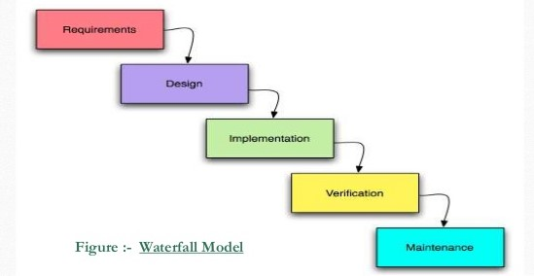

**Figure 1: Software Development Technology**

## Software Requirement Specification

|  |  |  |
| --- | --- | --- |
| SN | Description | Type |
| 1 | Operating system | * windows |
| 2 | Language | * **HTML**: page layout to be designed in **HTML**. * **CSS** : **CSS** to be used for all the designing part. * **BOOTSTRAP** : Bootstrap is the free and open source css framework directed at responsive, mobile first front-end web development. * **JS**: **JS** is lightweight and most used as a part of web pages, whose implementations allow client-side script to interact with the user and make dynamic pages. * **PHP** : all the business and front-end logic will be implemented in **PHP**.. |
| 3 | Server | **XAMPP**   * Apache: project will be running over apache server. * **MySQL**: (localhost/phpMyAdmin)   **MySQL** database will be used as database for the project. |
| 4 | IDE | Visual Studio Code |
| 5 | Browser | Chrome |

Table 1 : Software Requirrement Specification

## Requirement Analysis

The primary goal of the system analyst is to improve the efficiency to the existing system. For the study of specification of the requirements is very essential. For the development of the new system, a preliminary survey of the existing system will be conducted. Investigation where done to improve the current system and ensure all the component of the new system is working efficiently to accomplish their purpose. In this system user will be able to login to the web application. User will be able to add and update their daily expenses. Admin will maintain all the account of the user and to run the system efficiently. The web application has centralized control over all the record of the user.

### Functional Requirement

1. System should allow users to login and register their user account.
2. System should be able to keep records students, rooms and course.
3. System should allow student who are willing to book room in hostel.

### Non-Functional Requirement

1. User Interface
2. Availability
3. Usability
4. Reliability
5. Performance
6. Security

## Feasibility Study

### Technical Feasibility Study

System is technically feasible as the requirement for development of system is easily accessible. Necessary hardware and software required for development is available. The system will be easy to maintain the technical staff. So, the system is technically feasible.

### Operational Feasibility Study

System is easy to operate with the basic knowledge of computation and internet. Well trained manpower is not necessary. User can easily access the system as it is user friendly in many aspects with good UI. It will overcome many problems as it was faced in manual system.

### Economic Feasibility Study

The development of this system in general case have no cost, since no components or team members are getting paid or purchased. The project is the part of academic qualification for Bachelors Degree in Computer Application - Tribhuvan University and there are no monetary factor involved. So the project is economically feasible.

### Schedule Feasibility Study

The deadline of project is set to 15 April 2021. The time frame provided is tough and is immovable yet the project requirement and technology being used are compatible and the project can be done with proper planning. The project team planned to accomplish the project within the time frame following the plan which is listed in the table below and is shown in Gantt chart. The project team concluded that following the schedule as planned, the project is Schedule feasible.

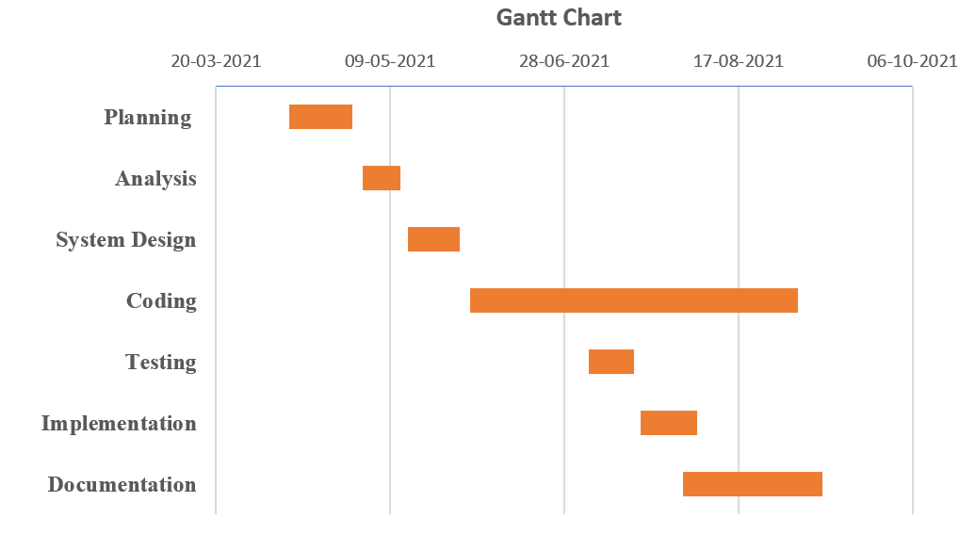

**Figure 2 : Gantt Chart**

# System Design

## Context Diagram

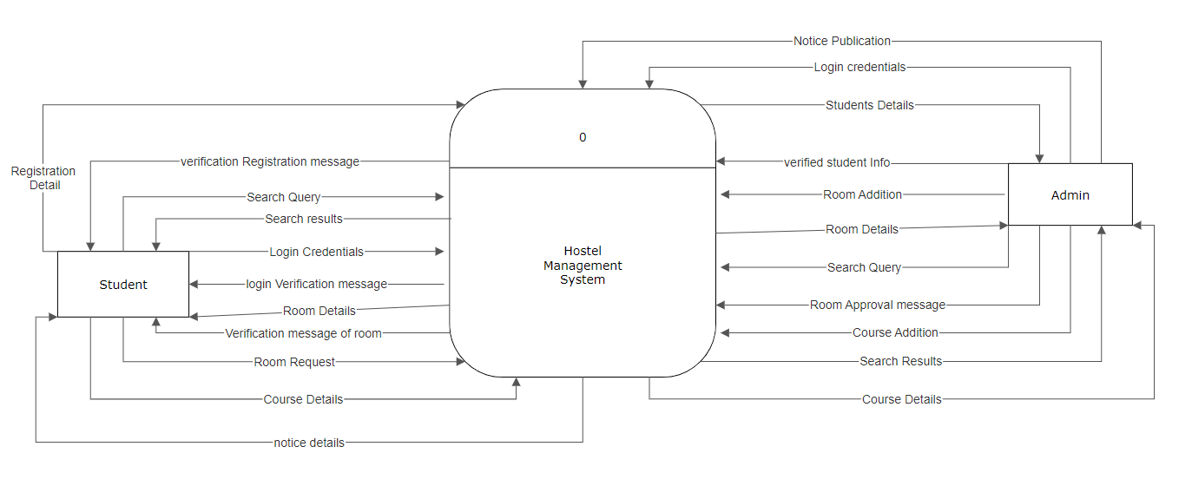

**Figure 3 : Context Diagram**

## Data Flow Diagram

DFD shows the flow of data from the end user through the process to the data store or database. Data flow diagram for up to second level for the proposed system are shown below:

### Data Flow Diagram (Level-1)

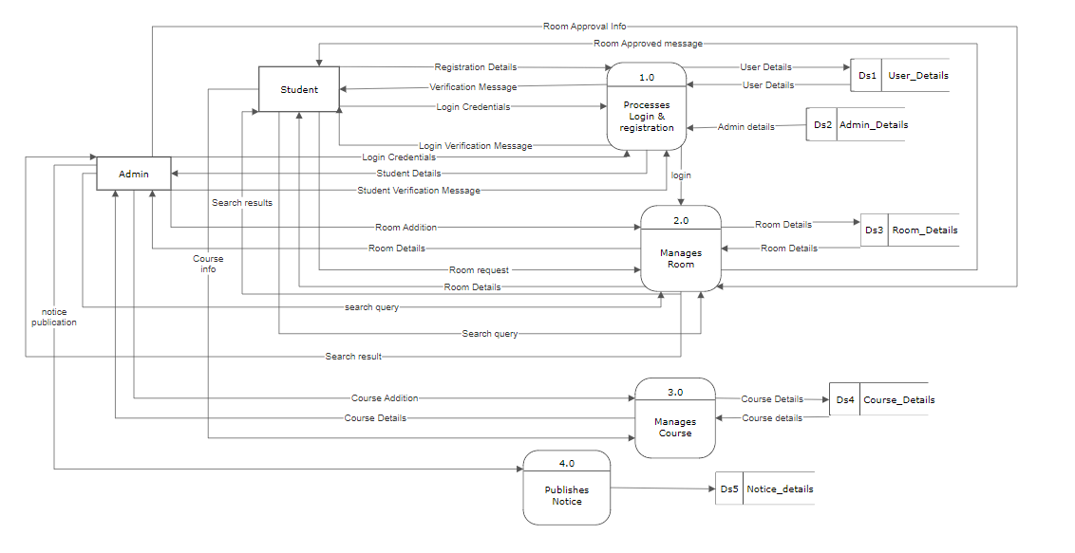

**Figure 4 : Data Flow Diagram(Level-1)**

### Data Flow Diagram (Level-2)

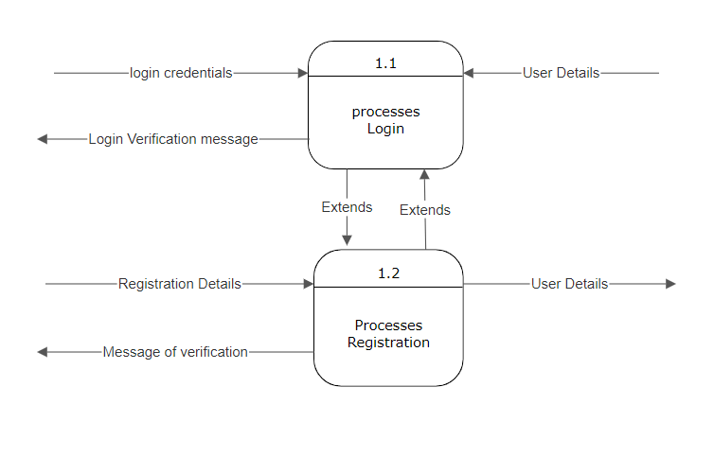

**Figure 5 : DFD For Process 1**

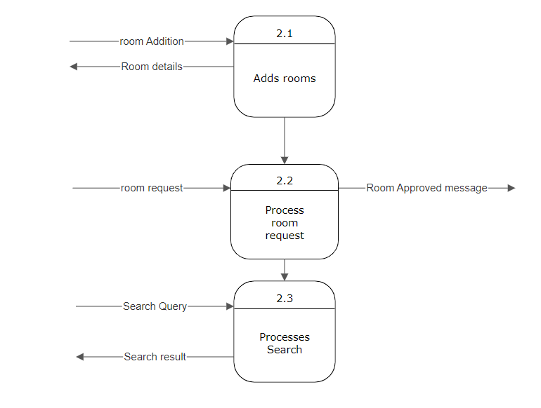

Figure 6 : DFD For Process 2

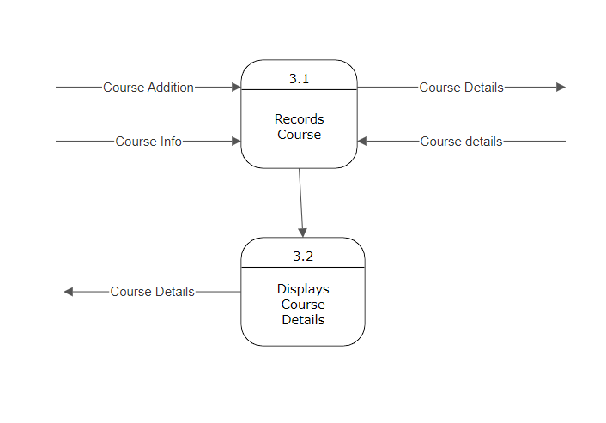

Figure 6: Level 2 DFD of process 3

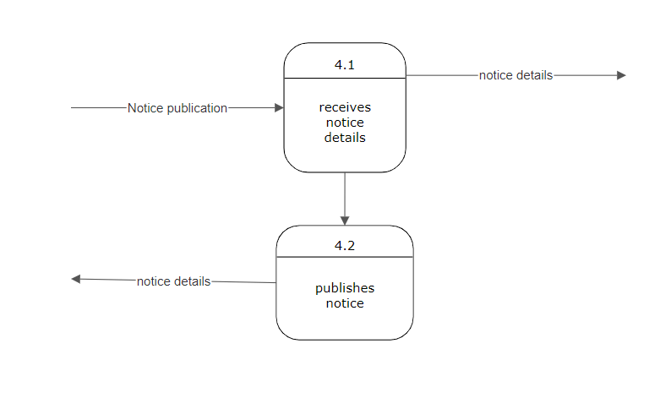

## System Architecture

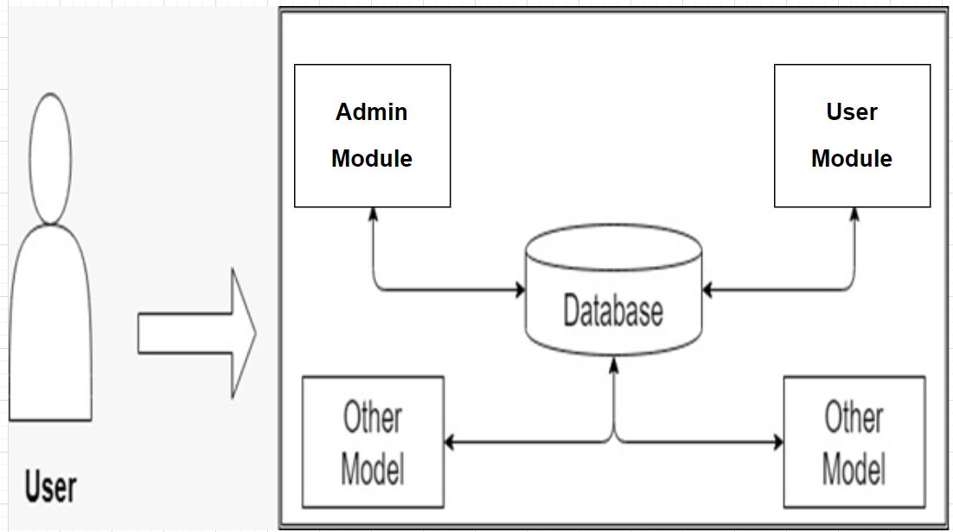

**Figure 7 : System Architecture**

## Use Case Diagram

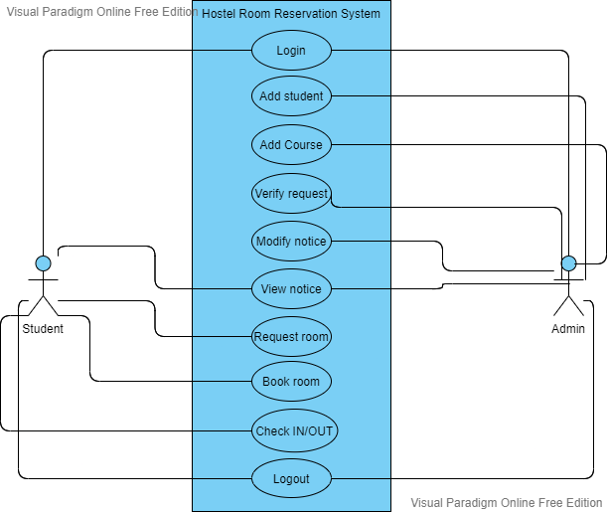

**Figure 8 : Use Case Diagram**

## Class Diagram

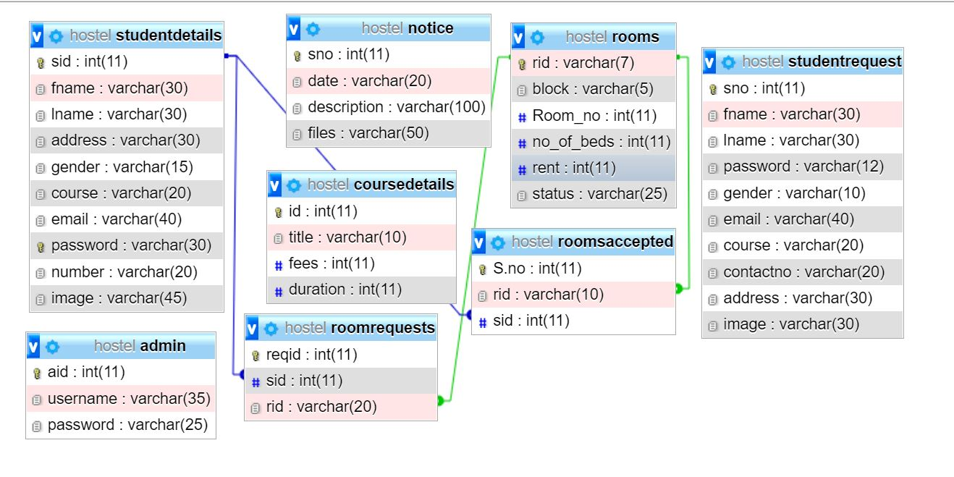

**Figure 9 : Class Diagram**

## Schema Diagrams

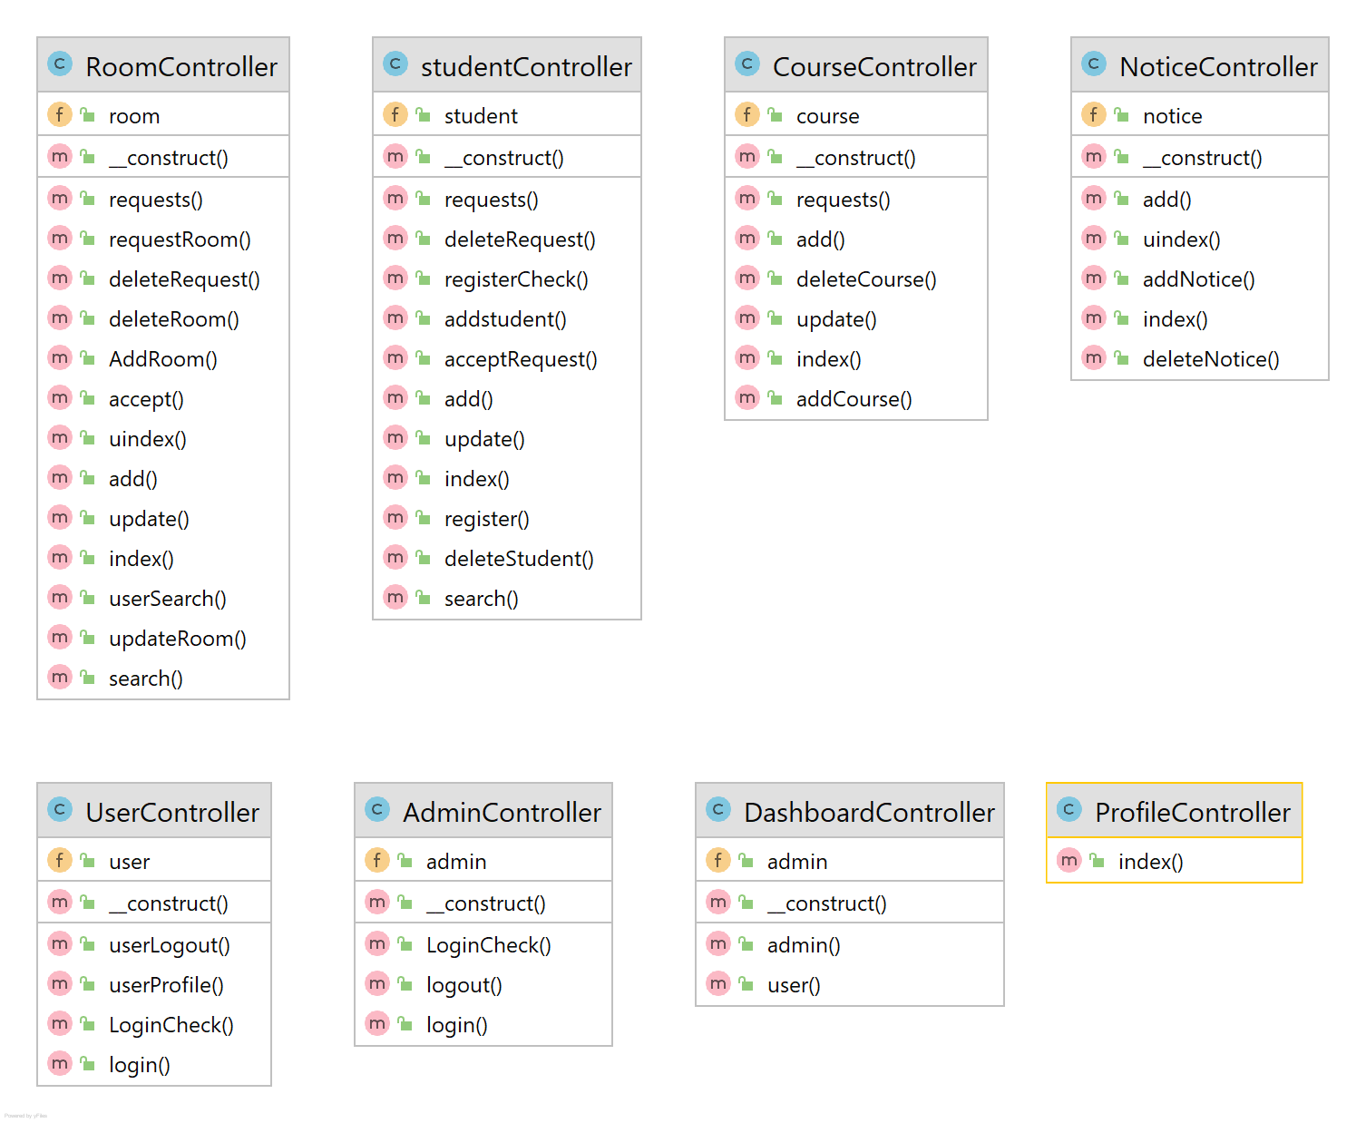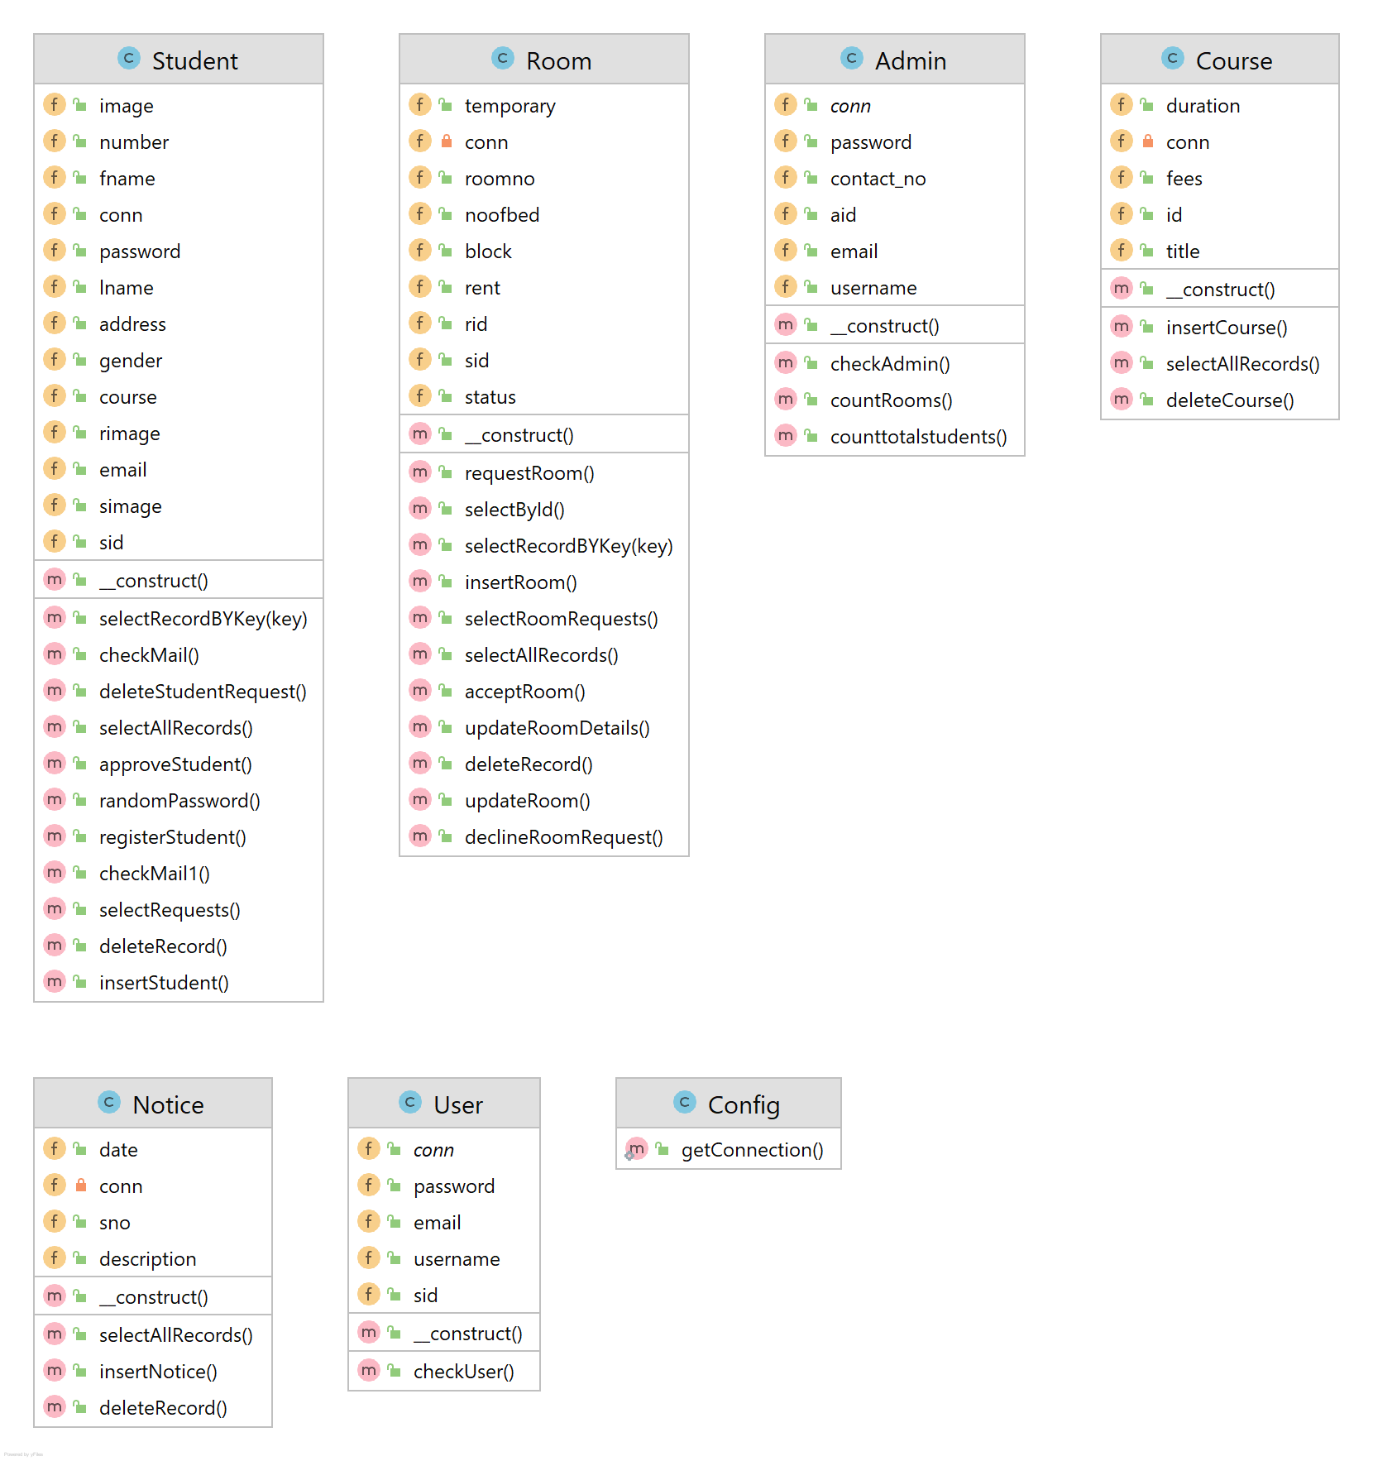

**Figure 11 : Schema Diagram For Controller**

**Figure 10 : Schema Diagram For Model**

## Activity Diagram

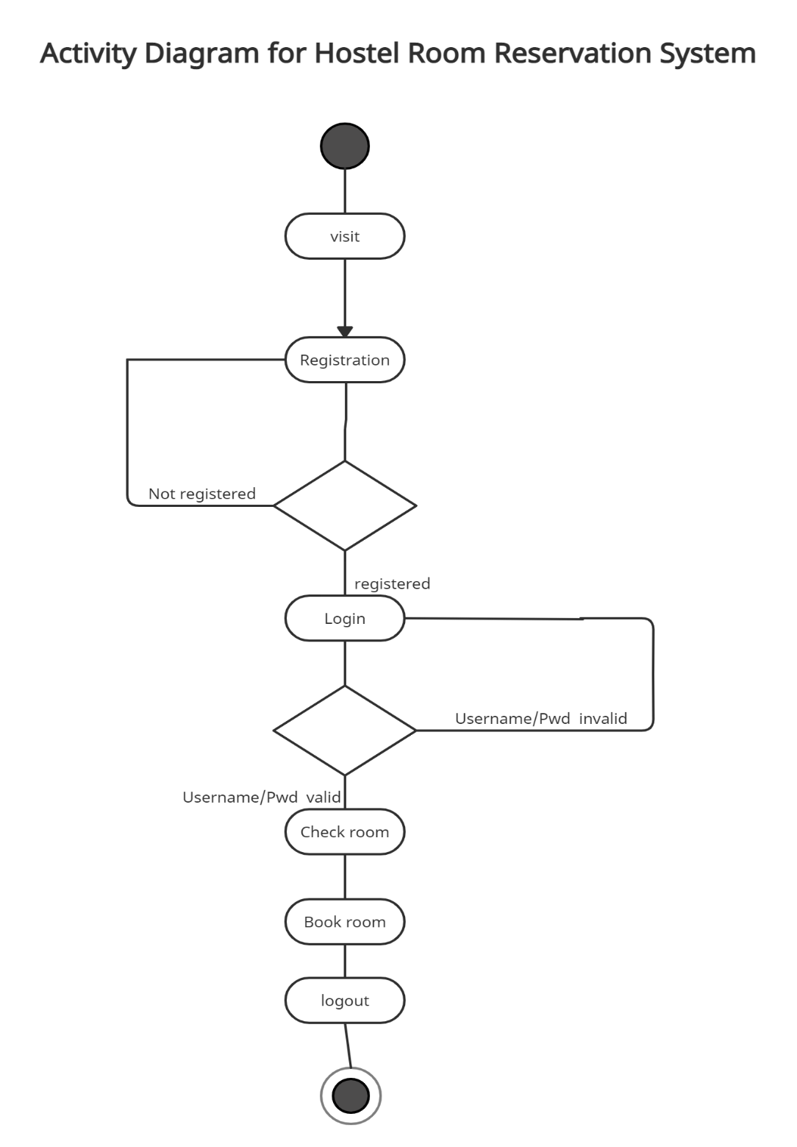

**Figure 12 : Activity Diagram**

## Database Design

### Entity Relationship Diagram of hostel room reservation system

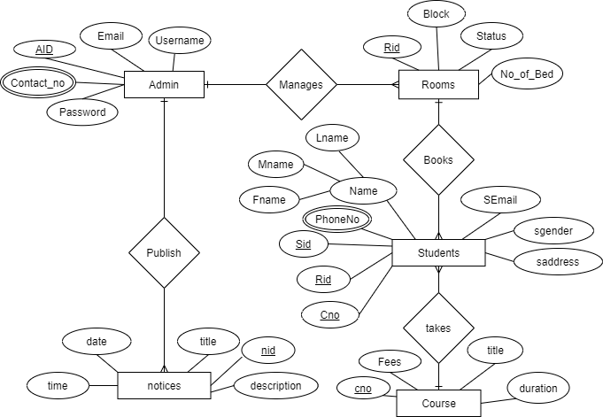

**Figure 13 : ER-Diagram**

# Software Development, Testing & Implementation

## Programming Platform

### Front End

Front end of this application is designed using HTML CSS and JS in the core. Bootstrap framework is used as front end framework to speed up development process. The web page designs are mobile first so are compatible with device with any screen size. JQuery is also used as JavaScript library.

### Back End

Preliminary design of Database may undergo many changes in future, for preliminary implementation, Php & MySql is used as SQL. Cloud servers or any other SQL may also be used in future responding to challenges that might occur.

## Programming Technique

This project is made with MVC model, which stands for Model-View-Controller. The data are stored in database and ‘Model’ communicates with database and handles all actions related to database, While ‘View’ connects the data derived from model and display data to the user. ‘Controller’ controls all software code that control the interaction between model and view.

## Operating Environment

The following are the minimum hardware requirements needed to run our system.

1. Minimum of 512 MB RAM
2. Minimum of 1GB storage
3. Dual core processor

On user’s end:

* 1. Internet connection
  2. Internet and web enabled device
  3. Basic operating knowledge of device and web

## Implementation

### Tools Used

**Visual Studio Code** : Visual Studio Code text editor is used to implement the system i.e. for cooding the system. The IDE interface makes it easy to debug the code and find out problematic porson of code for enhancement. It has also built-in plug-in that allows live testing of code and beautifying the code for easy understanding.

**HTML, CSS and Bootstrap**: HTML primarily used to design the UI and provide support to Bootstrap elements by proving containers for Bootstrap. CSS used to add additional detailed design to the portal and Bootstrap used to overall design the portal by extending tags from existing library.

**JavaScript**: JS used to add events and triggers to the web portal, the web portal uses JS for date and time purposes by directly getting the system time.

**PHP with MySQL**: PHP used for server side scripting purpose to add connectivity to the database. Since CRUD operations need to perform to extract, edit, delete and search news PHP is used with MySQL database where database tables are stored.

**XAMPP Server**: XAMPP is one of the widely used cross-platform web servers, which helps developers to create and test their programs on a local web server. It is used in the project development to locally host the portal and store its database centrally.

**Visual Paradigm Online (Software Design Tool):** Visual Paradigm used to generate various UML diagrams for system analysis and design. Diagrams were created using this tool in order to save time since all components are available with drag and drop functions and it also allows backup the diagrams by syncing with Google account.

## Testing

### Cases For Unit Testing

|  |  |  |  |  |  |  |
| --- | --- | --- | --- | --- | --- | --- |
| SN | Test Case | Test Step | Test Data | Expected Result | Actual Result | Pass/Fail |
| 1 | Check admin | 1. Enter URL 2. Enter username and password | Username: admin@gmail.com  Password: abhi | Admin pannel should be opened. | As expected. | Pass. |

|  |  |  |  |  |  |  |
| --- | --- | --- | --- | --- | --- | --- |
| SN | Test case | Test step | Test data | Expected result | Actual result | Pass / fail |
| 2 | Check admin login with valid data | 1. Enter URL 2. Enter user name and password. 3. Check login button | Username: [roman@gmail.com](mailto:roman@gmail.com)  Password: rom | Admin should be logged in and directed to dashboard | As expected | pass |
| 3 | Check admin login with invalid data | 1. Enter URL 2. Enter username and password. 3. Check login button. | Username: [abc@gmail.com](mailto:abc@gmail.com)  Password: 1234 | Error message should be displayed and stay in same page. | As expected | pass |
| 4 | Add room | 1. Enter url 2. Click add new room button. 3. Enter room details 4. Click add button. | Room id :  block:  room number:  no of beds: | Success message should be appear, new room display in product info page | As expected | pass |

|  |  |  |  |  |  |  |
| --- | --- | --- | --- | --- | --- | --- |
| 5 | Delete room | 1. Enter URL 2. Click delete button on table. | Press delete button | Success message should appear, room should be removed from table | As expected | pass |
| 6 | Update room | 1. Enter URL 2. Click update button on table | Press update button | Update table should be displayed and data should be updated from table. | As expected | pass |

Table 2 : Testing

# Project Management

This project requires frequent interaction and problem discussion among the project members. In order to achieve this goal, we will setup daily meetings to update each member on the progress of the project and ensure coordinated understanding of each member's tasks and responsibilities. The responsibilities of this program contain tasks like research, coding, documentation, presentation, implementation of database, etc. However, the responsibilities of each member can be changed, increased or reduced along with time.

## Member Roles

Brief profiles of each team member and their general duties follow below. Many of the responsibilities will be shared among team members to ensure the overall success of the project.

**Yubraj Adhikari** - will be involved in interactions with the users for requirement determinations. He will help in Physical design of pages and contents. He will design schemas for database of the system. He will also help in coding and testing of the system. He will collect the facts and figures required for improvement of the system.

**Avishek Khatiwada** - will mostly be involved writing codes for the program. He will analyze the requirements; facts and figures collected by her team member and implement them in the system. He will design the required prototypes of the system. He will implement the database into programs using various programming languages. He plays main role while designing a user interfaces.

Both members show equal involvement in this project and carries equal performance regarding this project.

# Future Enhancement

Online Hostel Room Reservation system .This hostel management software is designed for college which owns hostel. This project is small package which includes different categories as well as having all possible features. We have expected that it will be helpful to the, students as well as college.

Following are the possible future enhancements:

* 1. User interface upgrades
  2. Privilege of adding multiple records at same time.
  3. Improvement in performance.
  4. User can change password.
  5. Online Payments.
  6. Bug fixes.

## Limitations

* Needs active internet connectivity.
* Needs web enabled device.
* Payment still needs to be physical.

# Conclusion

“Online Hostel Room Reservation System” is a online web application that allows student to book room in a hostel online. It avoids the problem which occur while booking room in a hostel manually. This project will automate records of student, rooms and courses. After the completion of this project student can check information about room’s availability and book room among it.

# References

**Date: 01/04/2021**

1. <https://getbootstrap.com/docs/4.1/getting-started/introduction/>
2. <https://api.jquery.com/>
3. <https://www.w3schools.com/icons/fontawesome5_intro.asp>
4. <https://wowjs.uk/>
5. <https://www.w3schools.com/css/>
6. <https://www.w3schools.com/js/DEFAULT.asp>
7. <https://www.w3schools.com/html/>
8. <https://httpd.apache.org/>

# Appendix-I : System Screenshots

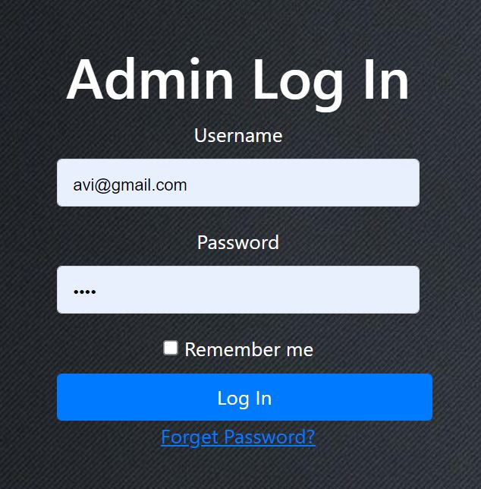

**Figure 14 : Admin Login**

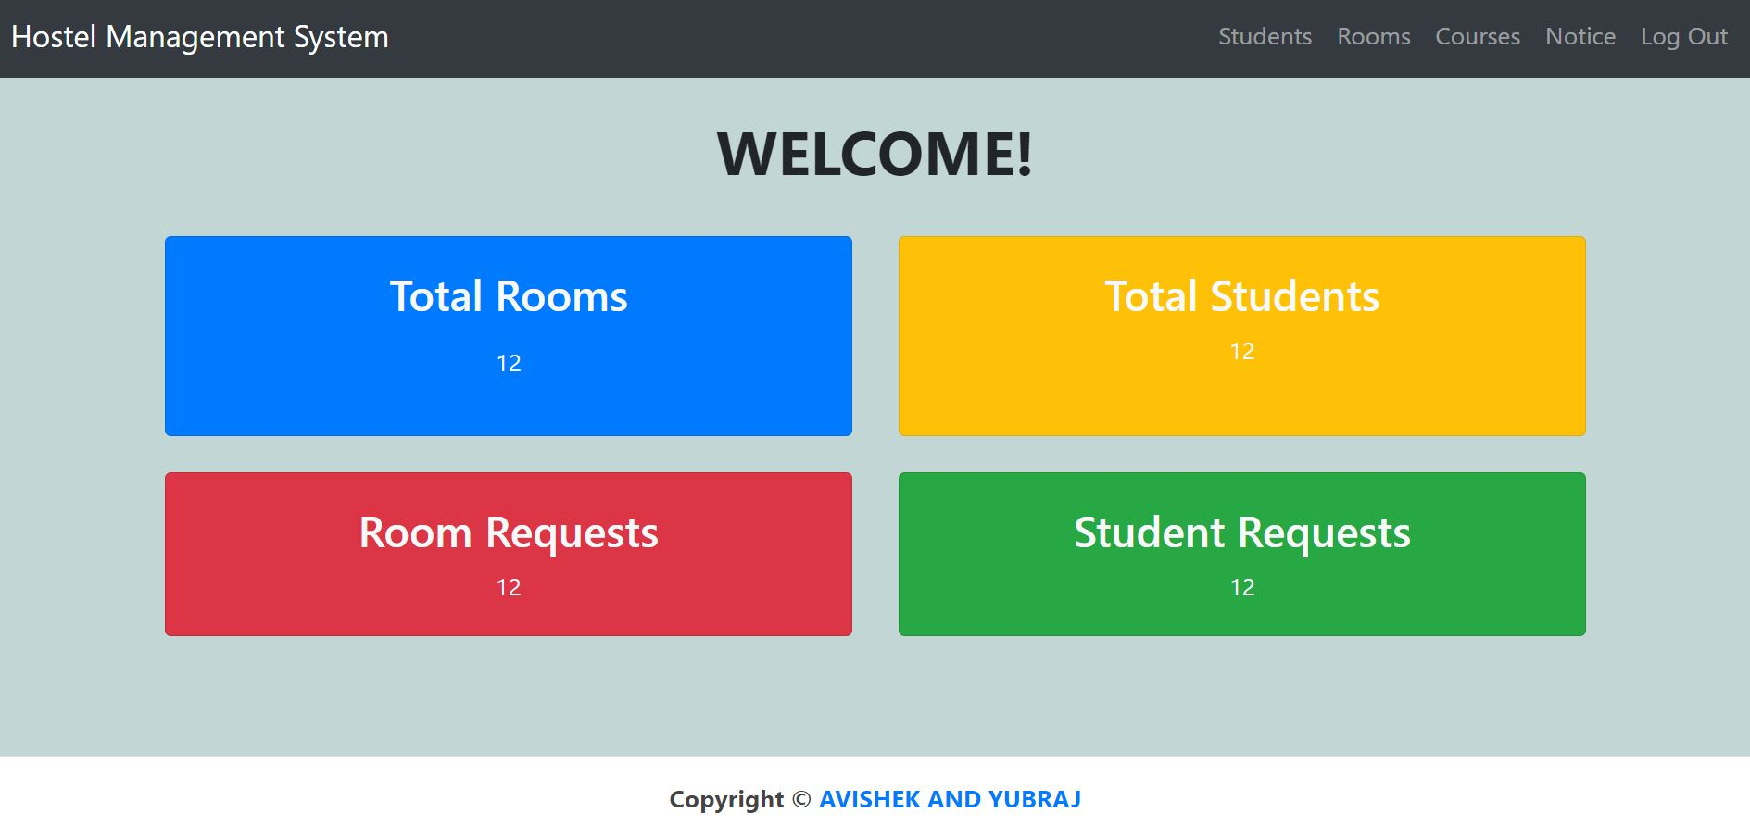

**Figure 15 : Admin Dashboard**

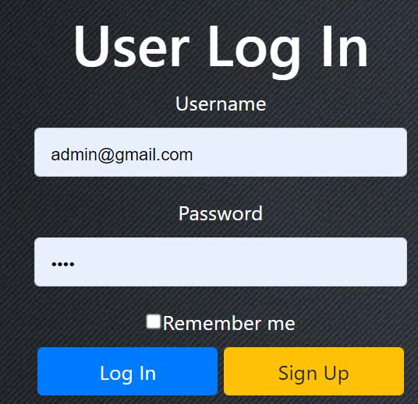

**Figure 16 : User Login**

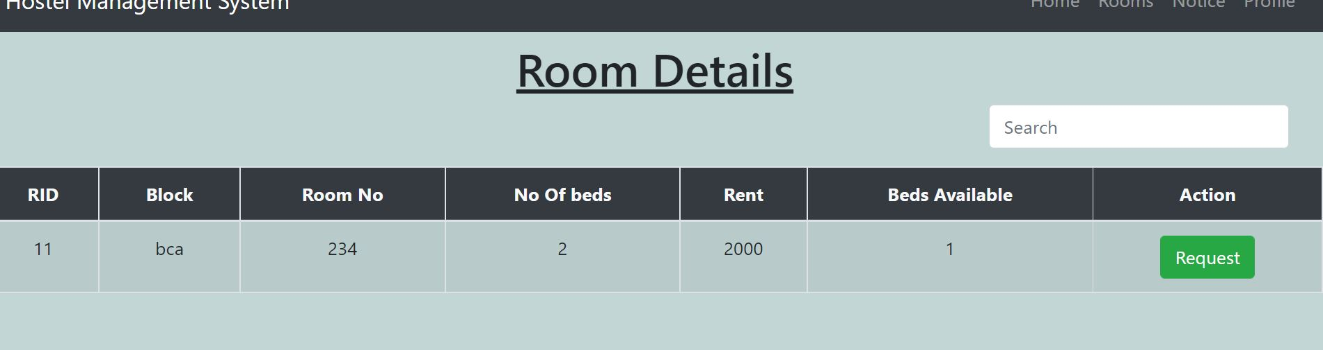

**Figure 17 : Room Details**

# Appendix-II : Source Code

<?php

session_start();

class studentController{

public $student;

function __construct(){

require_once "model/student.php";

$this->student=new Student();

}

function index(){

if(isset($_SESSION['id'])){

//call function to select all records

$result=$this->student->selectAllRecords();

include "./view/student/index.php";

}

}

function add(){

if(isset($_SESSION['id'])){

include "./view/student/add.php";

}

}

function requests(){

if(isset($_SESSION['id'])){

//call function to select all records

$result=$this->student->selectRequests();

include "./view/student/requests.php";

}

}

function register() {

include "./view/user/signup.php";

}

function update(){

//receive bid here

$sid=$_GET["sid"];

//send data to model

$this->book->bid=$bid;

//calling delete function

$result=$this->book->selectById();

include "./view/student/update.php";

}

function addstudent(){

if(isset($_SESSION['id'])){

if(isset($_POST["addstudent"]))

{

$fname=$_POST["fname"];

$lname=$_POST["lname"];

$email=$_POST["email"];

$gender=$_POST["gender"];

$course=$_POST["course"];

$number=$_POST["number"];

$address=$_POST["address"];

$simage=$_FILES["simage"];

if(empty($_POST["fname"]) || empty($_POST["lname"]) || empty($_POST["email"])

|| empty($_POST["number"]) || empty($_POST["course"]) || empty($_POST["address"]))

{

echo "Enter data in all field";

}

else{

// if($simage['size'] == 0 || $simage['error'] > 0) {

// echo "<script> alert ('Please upload a photo.') </script>";

// }

//validate here

//check email existance

$this->student->email=$email;

if(!($this->student->checkMail())){

echo "<script> alert('email already exist!')</script>";

// // die;

}

$imageExtension="";

if($simage['type']=="image/jpeg"){

$imageExtension=".jpeg";

}elseif($simage['type']=="image/jpg"){

$imageExtension=".jpg";

}elseif($simage['type']=="image/png"){

$imageExtension=".png";

}else{

$imageExtension=".svg";

}

$simage['name']=$_POST['email'].$imageExtension;

$imageDestination="photos/student/".$simage['name'];

if(move_uploaded_file($_FILES['simage']['tmp_name'],$imageDestination)){

echo "<script>console.log('Image Moved')</script>";

} else{

echo "<script>console.log('image cannot be moved')</script>";

}

//send data to model

$this->student->fname=$fname;

$this->student->lname=$lname;

$this->student->email=$email;

$this->student->gender=$gender;

$this->student->course=$course;

$this->student->number=$number;

$this->student->address=$address;

//$this->student->image=$simage;

$this->student->image=$imageDestination;

if($this->student->insertStudent()){

echo "<script>alert ('Student added successfully!')

location= 'index';

</script>";

}else{

echo "<script> alert('Unable to insert record!');

location= 'register'

</script>";

}

}

}

}

}

<?php

class Room{

public $rid;

public $block;

public $roomno;

public $noofbed;

public $status;

public $rent;

public $sid;

public $temporary;

private $conn="";

// public static function getConnection(){

// $conn=new mysqli("localhost","root","","hostel");

// return $conn;

// }

function __construct(){

require_once "service/Cofig.php";

$this->conn=Config::getConnection();

}

function updateRoom(){

$sql="UPDATE rooms set '$this->rid','$this->block','$this->roomnumber','$this->no_of_bed','$this->rent' where rid='$this->rid'";

$result=$this->conn->query($sql);

return $result;

}

public function insertRoom(){

//query to insert book

$sql="INSERT INTO rooms(`rid`,`block`,`Room_no`,`no_of_beds`,`rent`,`status`) VALUES

('$this->rid','$this->block','$this->roomnumber','$this->no_of_bed','$this->rent',

'$this->status')";

try{

$result=$this->conn->query($sql);

return $result;

}catch(exception $e) {

}

}

//displaying records

public function selectAllRecords(){

$sql="SELECT * FROM rooms ORDER BY rid ASC";

// $sql="select * from roomsaccepted INNER JOIN rooms INNER JOIN

// studentdetails ON roomsaccepted.rid=rooms.rid AND roomsaccepted.sid = studentdetails.sid";

try{

$result=$this->conn->query($sql);

return $result;

}catch(exception $e){

}

}

public function selectRoomRequests(){

$sql="select * from roomrequests INNER JOIN rooms INNER JOIN studentdetails

ON roomrequests.rid=rooms.rid AND

roomrequests.sid = studentdetails.sid";

// echo $sql;

$result=$this->conn->query($sql);

return $result;

}

//deleting records

public function deleteRecord(){

$sql="DELETE FROM rooms WHERE rid='$this->rid'";

$sql1="DELETE FROM roomrequests WHERE rid='$this->rid'";

$sql2="DELETE FROM roomaccepted WHERE rid='$this->rid'";

$this->conn->query("START TRANSACTION");

$r1= $this->conn->query($sql);

$r2= $this->conn->query($sql1);

$r3= $this->conn->query($sql2);

if($r1 && $r2 &r3) {

$this->conn->query("COMMIT");

return true;

} else {

$this->conn->query("ROLLBACK");

return false;

}

return false;

$result = $this->conn->query($sql);

return $result;

}

public function updateRoomDetails(){

$sql="UPDATE rooms Set `rid`='$this->rid',`block`='$this->block',

'room_no'='$this->roomnumber','no_of_beds'='$this->no_of_bed',

'rent'='$this->rent' WHERE rid='$this->rid'";

$result=$this->conn->query($sql);

return $result;

}

function selectRecordBYKey($key) {

$sql = "SELECT * FROM rooms WHERE `block` LIKE "."'$key"."%' OR rent LIKE "."'$key"."%'";

$result = $this->conn->query($sql);

return $result;

}

public function selectById(){

$sql="SELECT * FROM rooms WHERE rid='$this->rid'";

$result=$this->conn->query($sql);

return $result;

}