Performance Optimization & Interactive Feature Enhancement
A Strategic Guide for Faster, More Usable Tableau Dashboards
Dataset: Tableau Sample – Superstore (scaled-up scenario)
Week 5 Report | Author: [Your Name] | Date: [Date]

Contents

Tip: right-click the table above in Word and choose Update Field to refresh page numbers.

1. Introduction and Scope
Weeks 2 to 4 designed a Superstore dashboard with advanced charts and calculations. A dashboard that is insightful but slow, or interactive but confusing, will not be used. This report assesses a hypothetical version of that dashboard for performance risks, lists optimisation strategies, proposes interactive enhancements, and sets out how to test the result.
✎ Important: Sample – Superstore holds only about ten thousand rows and performs well as-is. To make the exercise realistic, the report assumes a scaled-up scenario of the same design running on a much larger table. The baseline below is a described assumption, not a measurement. Where a figure is needed, the document provides blank "Baseline" and "After" columns for you to fill in from your own Performance Recorder results; no timings have been invented.

2. Hypothetical Baseline Dashboard

2.1 Assumed design
Aspect | Assumed baseline (the "before" state)
Data | Order-line table scaled to tens of millions of rows, joined to customer and product tables, on a live connection to a shared database
Sheets | Ten worksheets on one dashboard: KPI cards, dual-axis trend, heat map, Pareto, waterfall, map, scatter, and three tables
Filters | Twelve quick filters (Year, Region, State, City, Customer, Segment, Category, Sub-Category, Product, Ship Mode, Discount, Order ID), all set to "All values in database", applied to all sheets
Calculations | String-based Discount Bin, FIXED LODs per customer, COUNTD for orders and customers, several table calculations, and a RANK over customers
Layout | Automatic dashboard size, deeply nested containers, viz-in-tooltip on every chart, a map at city level
Interactivity | Quick filters only; no actions, no navigation, no guidance text

2.2 Where time goes when a dashboard opens
Understanding the stages of a dashboard load shows where each design choice costs time. The figure maps the five stages to typical bottlenecks and to the remedy planned for each.
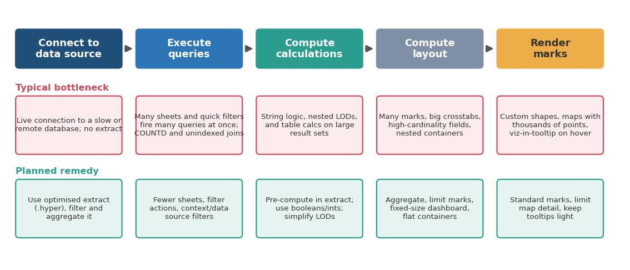
Figure 1: Stages of dashboard loading, typical bottlenecks and planned remedies

3. Performance Assessment Method

3.1 Measuring: Performance Recorder
- Open the workbook in Tableau Desktop and choose Help > Settings and Performance > Start Performance Recording.
- Perform a fixed, scripted set of actions: open the dashboard, change the Year filter, click a state on the map, click a sub-category, switch the Metric parameter.
- Stop recording (Help > Settings and Performance > Stop Performance Recording). Tableau opens a performance workbook.
- In the summary dashboard, sort events by duration and note the slowest, usually Executing Query, Computing Layouts, Computing Table Calculations or Geocoding.
- Repeat on the published version, because Tableau Server or Cloud adds its own caching and network effects.
Keep the script identical for every test so before and after results are comparable.

3.2 Metrics to record
Metric | How to capture | Suggested target | Baseline | After
Initial dashboard load | Performance Recorder, or stopwatch on published view | A few seconds (team-defined) | [record] | [record]
Filter or action response | Recorder events per interaction | Under about 2–3 seconds | [record] | [record]
Number of queries on load | Count "Executing Query" events | As few as possible | [record] | [record]
Slowest single event | Sorted event list | No dominant outlier | [record] | [record]
Extract size and refresh time | Data source properties, server logs | Within refresh window | [record] | [record]
Marks per sheet | Status bar count | Hundreds to low thousands | [record] | [record]

Targets are suggestions and should be agreed with the audience; an executive summary page needs to be quicker than an analyst workbench.

3.3 Improvement cycle
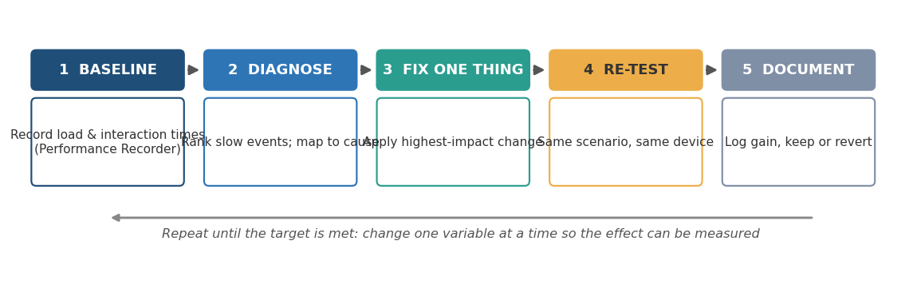
Figure 2: Measure, diagnose, change one thing, re-test, document

4. Bottleneck Analysis
Area | Likely symptom | Cause in the baseline | Severity | How to detect
Data volume | Slow every time; long "Executing Query" | Live connection to a very large table with all fields available | High | Recorder: query time dominates
Joins and blends | Slow loading even with few marks | Joins to wide tables; unneeded fields pulled into the query | Medium | Data Source tab; check fields in use
Quick filters | Slow filter menus and many queries on load | Twelve filters on "All values"; high-cardinality fields such as Customer and Order ID | High | Count queries when the dashboard opens
Calculations | Long compute time after the query | String logic, nested LODs, COUNTD, table calcs over large results | High | Recorder: calculation events; test by removing fields
Dashboard design | Slow layout and render | Ten sheets, large crosstabs, automatic size, nested containers | Medium | Recorder: Computing Layouts
Marks | Slow or sluggish interaction | Map at city level, scatter of every order line | Medium | Marks count in status bar
Tooltips | Delay on hover | Viz in Tooltip queries on every hover | Low–Medium | Hover test; Recorder
Publishing | Fine on desktop, slow on server | No caching strategy, refreshes at peak hours, large workbook | Medium | Compare desktop with published times

5. Optimization Strategies
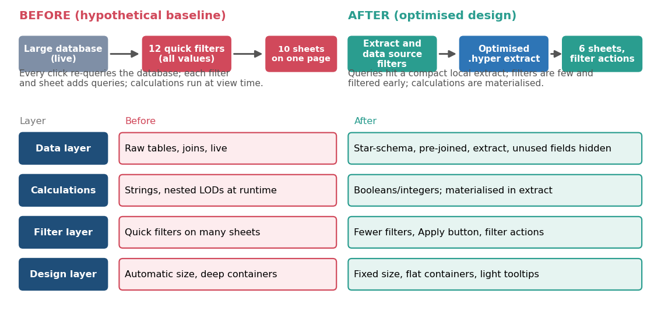
Figure 3: Baseline versus optimised architecture, layer by layer

5.1 Data layer
Action | How | Expected outcome
Use an extract instead of a live connection | Data > Extract Data; save as .hyper; schedule refresh outside peak hours | Queries run against a compact local file; much less dependence on database speed
Reduce the extract | Apply extract filters (for example recent years only); tick "Aggregate data for visible dimensions" when the dashboard does not need order-line detail; hide unused fields before extracting | Smaller file, faster queries, faster refresh
Materialise calculations | Data > Extract > Compute Calculations Now (or build the field in the source/ETL) | Row-level calculations are stored rather than recalculated on every view
Simplify the model | Join only needed tables; prefer a star schema; use Tableau relationships or joins rather than blends where possible; pivot or reshape data in preparation, not in the view | Fewer and cheaper queries
Use incremental refresh where suitable | Choose an incremental refresh on a reliable date or ID column | Shorter refresh times as data grows
Index or optimise source tables (if live is unavoidable) | Work with the database team on indexes and views | Lower query latency

5.2 Calculation layer
- Prefer numbers and booleans to strings: replace string comparisons with integer or boolean tests where possible (for example, a numeric Discount Bin code with an alias, or a boolean Is Loss Line).
- Use native features first: groups, bins and sets are generally cheaper than equivalent calculated fields.
- Limit COUNTD: it is one of the costlier aggregations. Compute it once in the extract or use a pre-aggregated measure where an exact distinct count is not essential.
- Reduce LOD complexity: avoid nested LODs; use FIXED sparingly and keep the dimensions few; consider pre-computing customer-level totals in the data.
- Keep table calculations on small result sets: compute them after filtering to the Top N or to the time range in view.
- Choose efficient logic: use CASE over long nested IF chains; avoid unnecessary type conversions; avoid RAWSQL unless needed.
- Remove unused calculations and hidden fields: they add clutter even when unused.

5.3 Filter layer
Action | How | Expected outcome
Cut the number of quick filters | Keep four to five global filters (Year, Region, Segment, Category). Replace the rest with dashboard filter actions (click a state, click a bar) | Fewer queries on load and a cleaner interface
Avoid high-cardinality quick filters | Replace Customer and Order ID lists with a search-enabled single-value dropdown or a Top N parameter | Quick filters that do not need to fetch very long lists
Use the Apply button | Filter menu > Show Apply Button on multi-select filters | Queries run once after the user finishes selecting, not after each click
Use "All values" and limit "Only relevant values" | Set only the necessary filters to relevant-values mode | Avoids a query to refresh each filter after every selection
Filter early | Use extract filters and data source filters for permanent restrictions; context filters only where a Top N or FIXED LOD must respect a filter | Smaller data reaches the view; context filters add a cost, so use sparingly
Use sheet-level scope | Apply a filter to only the worksheets that need it | Fewer sheets re-query on each change

✎ Order of operations matters: extract and data source filters apply first, then context filters, then FIXED LODs, then dimension and measure filters, then table calculations. A filter placed in the wrong layer can silently change an LOD or a Top N result; test after every change.

5.4 Design layer
- Fewer sheets: aim for about six on the main dashboard; move the rest to a second dashboard reached by navigation buttons.
- Fixed dashboard size: avoids recalculating layout for every screen size; add a Phone layout for mobile.
- Flat container structure: remove unnecessary nested containers; they slow layout and make maintenance harder.
- Limit marks: aggregate to state or region instead of city on the map; bin or sample the scatter; avoid very wide crosstabs.
- Standard marks: avoid custom shapes and large background images.
- Use viz-in-tooltip selectively: reserve it for the two or three charts where detail on hover is valuable.
- Pause automatic updates while building and use "Run Update" when ready.

5.5 Publishing and server practices
- Schedule extract refreshes outside business hours and stagger them.
- Keep one certified published data source, so many workbooks share the same optimised extract.
- Remove unused data sources and sheets from published workbooks to reduce size.
- Monitor usage and load times through the server or cloud administrative views and review them regularly.

6. Interactive Enhancements
Performance and interactivity are linked: well-designed interaction can replace many quick filters, and so improves both usability and speed. The proposals below are intended to make the dashboard more intuitive while remaining light on the data source.
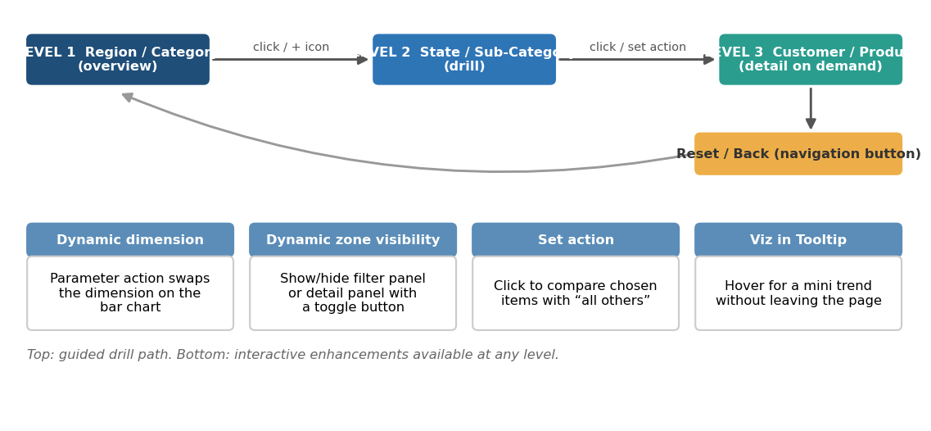
Figure 4: Guided drill path and interactive enhancements at each level
Enhancement | How to build it | Usability benefit | Performance note
Drill-down hierarchy | Create Region > State > City and Category > Sub-Category > Product hierarchies; use the + icon, or use a parameter-driven or set-driven drill | Starts simple, goes deeper only when wanted | Starts with few marks; detail loads only on request
Filter actions replacing quick filters | Dashboard > Actions > Add Action > Filter, Select trigger | Users click the chart instead of managing menus | Removes several filter queries
Dynamic dimension (parameter action) | Parameter holds the dimension name; a calculated field uses CASE to return that dimension; clicking a header updates the parameter | One chart can show by Region, Segment or Category | Replaces multiple duplicate sheets
Dynamic metric selector | Parameter with Sales, Profit, Profit Ratio, as in Week 4 | One chart, three questions | Replaces extra sheets
Show/hide panels (dynamic zone visibility) | Boolean parameter plus a button; set the container to show when the parameter is true | Filters and detail panels appear only on request, keeping the screen clean | Hidden sheets are not queried until shown
Set action for comparison | Create a set on Sub-Category; clicking adds items to it; compare "selected" with "other" | Compare chosen items with the rest | Computed on the aggregated view
Top N control | Integer parameter and rank filter or set | Focus on the largest items without scrolling a long list | Limits marks and rows
Search-enabled dropdown for customers | Single-value dropdown with search; Customer filter set to apply only to relevant sheets | Fast lookup without a huge list | Avoids loading a very long list
Navigation buttons and breadcrumbs | Navigation objects between Overview and Detail dashboards; a Reset button | Users always know where they are and can go back | Splits load across two lighter dashboards
Guidance text and tooltips | Short hints ("Click a state to filter"), information icons and consistent legends | Lower learning curve | No cost
Highlighter and search on a dimension | Dashboard > Highlighter on Sub-Category | Quickly locate an item without filtering | Highlight does not re-query data

6.1 Interaction design principles
- Show the simple view first; reveal detail on demand.
- Use Select, not Hover, for actions so charts do not flicker or query repeatedly.
- Make the interactive state visible: highlighted marks, filter summaries or captions that say what is selected.
- Always provide an undo: Reset button and clear-selection behaviour set to "Show all values".
- Give feedback for slow actions: keep the number of simultaneous queries low so actions feel immediate; where a delay is unavoidable, say so in the guidance text.
- Test with someone who has not seen the dashboard.

6.2 Accessibility and mobile
- Keep text readable and contrast sufficient; do not use colour as the only signal.
- Provide alt text and descriptive titles for each sheet.
- Create a Phone layout with a reduced set of views (KPIs, trend, one drill-down).

7. Optimised Dashboard Specification
Element | Baseline | Optimised design
Data source | Live connection, wide joins | Published extract, filtered and aggregated; star schema
Global filters | Twelve on All values | Four to five, Apply button, set to relevant sheets
Other filtering | None | Filter actions, highlighter, Top N parameter, search dropdown
Sheets on main page | Ten | Six; the rest on a Detail dashboard
Calculations | Strings, nested LODs, COUNTD | Numeric/boolean fields materialised in extract; simplified LODs
Map | City level | State level with drill-down
Tooltips | Viz-in-tooltip on all | Viz-in-tooltip on two or three charts; text tooltips elsewhere
Navigation | None | Buttons to Detail dashboard, Reset, Back
Size | Automatic | Fixed desktop plus Phone layout

8. Implementation Roadmap and Prioritisation
Changes are ordered by expected impact against effort. Apply them one at a time and re-test after each, so the gain from every change is known.
# | Change | Expected impact | Effort | Depends on
1 | Move to an extract; hide unused fields; apply extract filters | High | Low | Access to publish extract
2 | Reduce quick filters; add Apply button; use filter actions | High | Low | Interaction design agreed
3 | Simplify calculations; materialise in extract | High | Medium | Calculation review (Week 4)
4 | Cut sheets to six; fixed size; flatten containers | Medium | Medium | Layout from Week 2
5 | Aggregate map and scatter marks | Medium | Low | None
6 | Add drill-down, parameter actions, dynamic zones | Medium (usability) | Medium | Steps 1–4 complete
7 | Selective viz-in-tooltip | Low–Medium | Low | None
8 | Server scheduling and monitoring | Medium | Low | Publishing access

9. Testing and Validation Plan

9.1 Performance tests
- Run the scripted Performance Recorder session before and after each change.
- Test on desktop and on the published dashboard, at a quiet time and a busy time.
- Test with the least favourable filter selection (for example, all years, all regions).

9.2 Correctness tests
- Reconcile KPI totals before and after extract aggregation; they must match.
- Confirm Top N and LOD results still respect the filters as intended after changing filter scope or order of operations.
- Verify that actions filter the intended sheets and that Reset restores the default view.

9.3 Usability tests
- Ask three users, one for each audience from Week 2, to complete three tasks: find the weakest sub-category, see a state’s trend, compare two sub-categories.
- Record time to completion, wrong clicks and comments; revise the guidance text and layout accordingly.

10. Expected Outcomes
Area | Expected outcome (to be confirmed by measurement)
Load time | Fewer queries and a smaller dataset should shorten initial load; the main gains are expected from the extract, filter reduction and calculation simplification
Interaction speed | Filter actions and Apply buttons should reduce waiting and unnecessary queries
Scalability | An aggregated, filtered extract should tolerate data growth better than a live connection to the full table
Maintainability | Fewer sheets, flat containers and documented calculations make future changes safer
Usability | Drill-down, dynamic controls and guidance text should reduce the effort needed to find an answer

11. Risks and Trade-offs
Risk / trade-off | Mitigation
Aggregated extract loses order-line detail | Keep a separate detail extract for the analyst dashboard; link by navigation
Extract data goes stale | Schedule refresh based on how fresh the data must be; show the last-refresh time on the dashboard
Removing filters frustrates analysts | Offer them on a hidden panel (dynamic zone visibility) or on the Detail dashboard
Context filters or filter scope change results | Document the order of operations and test totals after changes
Over-optimising reduces insight | Optimise only where measurement shows a problem; keep the analytical value of each view
Features depend on Tableau version | Check that dynamic zone visibility, parameter actions and set actions are available in the version in use

12. Conclusion
This report assessed a hypothetical, scaled-up version of the Superstore dashboard, identified the likely bottlenecks in data, calculations, filters and design, and set out a layered optimisation strategy together with usability-focused interactive enhancements. The recommendations are ordered by impact and effort, and every claim of improvement is tied to a measurement plan, so results can be verified rather than assumed. Applied step by step, the plan should deliver a dashboard that responds quickly, scales with the data and guides users from overview to detail with minimal effort.

Appendix: Optimisation checklist
- Extract used; unused fields hidden; extract filters applied
- Calculations simplified and materialised where possible
- No more than four to five global quick filters; Apply button on multi-select
- Filter actions replace redundant quick filters
- About six sheets on main dashboard; fixed size; flat containers
- Marks limited on map and scatter
- Viz-in-tooltip used sparingly
- Drill-down, Reset and navigation tested
- Before/after Performance Recorder results logged
- Published version tested at busy and quiet times

