Dashboard Planning & Design Strategy
Interactive Tableau Dashboard Blueprint
Dataset: Tableau Sample – Superstore
Week 2 Report | Author: [Your Name] | Date: [Date]

Contents

Tip: right-click the table above in Word and choose Update Field to refresh page numbers.

1. Introduction and Purpose
Week 1 explored the Superstore dataset and produced hypotheses about sales, profit and discounting. This document turns that exploration into a blueprint for a single interactive Tableau dashboard. It records what the dashboard is for, who it serves, which metrics and charts it contains, where each element sits, how the elements interact, and why each decision was made. No dashboard is built this week; the aim is that Week 3 can start building directly from this plan.
The mock-ups in this document use placeholder values. They show structure, not results.

2. Conceptualization

2.1 Dashboard objective
Primary objective: let a business user see in under 30 seconds whether the business is profitable, then find where and why profit is being lost.
Supporting objectives:
- Monitor headline performance (sales, profit, margin, orders) against the prior year.
- Reveal seasonal and trend patterns over time.
- Locate profitable and loss-making products and regions.
- Test the Week 1 hypothesis that deep discounting drives losses.

2.2 Target audience
Audience | Main question | What they need | Interaction level
Executive / Owner | Are we making money? | KPIs and trend at a glance | Low: reads top rows, uses Year filter
Regional / Sales Manager | Which regions and segments underperform? | Map, segment and region filters | Medium: filters and clicks the map
Merchandising / Pricing Analyst | Which products and discounts cause losses? | Sub-category and discount views, tooltips | High: drills down, hovers, exports

The design serves all three by placing the executive view at the top and detail underneath, so each reader can stop scrolling when they have their answer.

2.3 Key metrics
Metric | Definition | Why it matters
Sales | SUM([Sales]) | Scale of the business
Profit | SUM([Profit]) | Bottom-line outcome; can be negative
Profit Ratio | SUM([Profit]) / SUM([Sales]) | Fair comparison across segments of different size
Orders | COUNTD([Order ID]) | Volume and customer activity
YoY change | Year-over-year table calculation | Shows direction, not just level
Discount Bin | Calculated grouping of Discount (0%, 1–20%, 21–40%, >40%) | Makes the discount effect readable

2.4 Data story
The dashboard is organised as a story that moves from broad to specific, answering five questions in order. Each question maps to one visual, and the layout follows the same order from top to bottom.
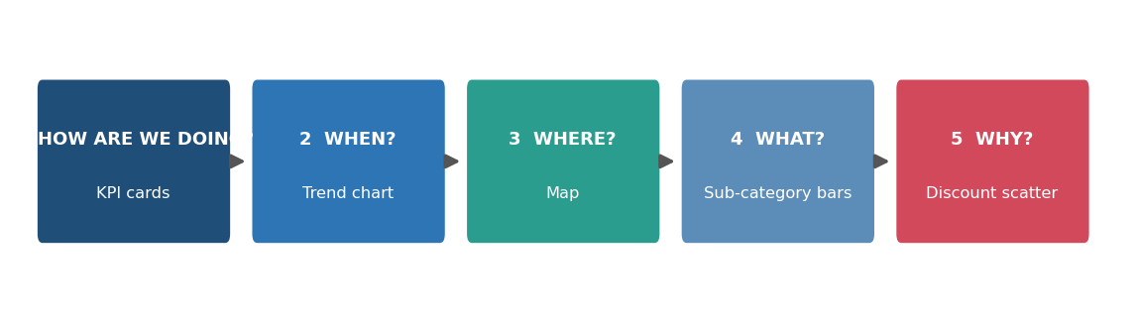
Figure 1: Storyline from overview to explanation

3. Layout Strategy

3.1 Canvas
- Size: fixed 1200 × 840 px for desktop (Tableau Dashboard > Size > Fixed). A fixed size keeps the layout predictable and is easy to publish; a Phone layout is added as a secondary device layout.
- Structure: nested horizontal and vertical containers, so the tiles resize cleanly and align exactly.
- Reading pattern: Z-pattern. The eye goes to the title and filters, then to the KPIs, then down through the charts.

3.2 Wireframe
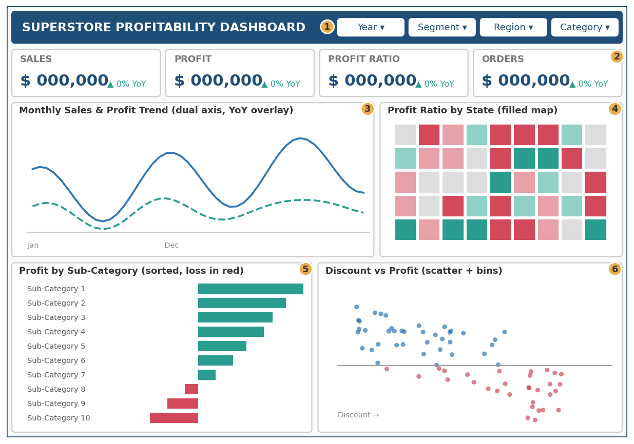
Figure 2: Desktop dashboard wireframe (numbered callouts explained in Table 1)
Table 1: Component specification
# | Component | Visual type | Position | Specification
1 | Header and filters | Title banner, 4 dropdown filters | Top, full width, 60 px | Year, Segment, Region, Category applied to all sheets; single-value dropdowns for compactness
2 | KPI cards | Text tables / BANs | Row 2, 4 equal cards, 90 px | Value with ▲▼ YoY indicator coloured teal (good) or red (bad)
3 | Trend | Dual-axis line chart | Row 3 left, 60% width | Monthly sales (solid) and profit (dashed); year colour overlay on toggle; trend line
4 | Geography | Filled map by State | Row 3 right, 40% width | Diverging colour on Profit Ratio, centred at 0; tooltip shows sales and profit
5 | Product | Horizontal sorted bar | Row 4 left, 50% | Profit by Sub-Category, red for negative; click to filter
6 | Discount | Scatter plus bar by Discount Bin | Row 4 right, 50% | Points coloured by profit sign; trend line; Discount Bin bar via sheet swap or tooltip

3.3 Placement rationale
- KPIs sit directly under the title because executives read first and need the answer first.
- The trend is the widest chart because it carries the most points and benefits from horizontal space.
- Map and trend share a row so geography and time can be read side by side.
- Product and discount charts form the final row, because they provide explanation (the "why") after the overview.

3.4 Colour scheme
The palette is intentionally small and carries meaning. Teal and red are used only for good and bad profit, so colour always signals the same thing across every sheet. Blue represents sales and neutral structure. Amber is reserved for highlights.
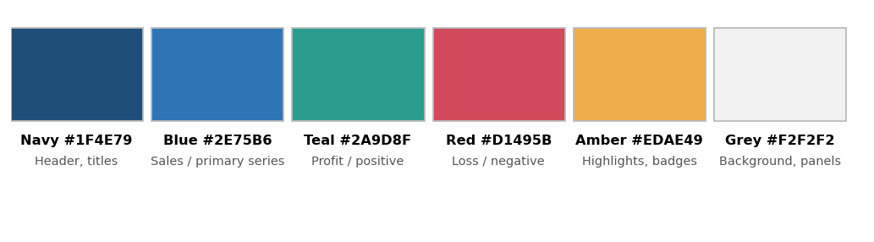
Figure 3: Dashboard colour palette and usage
- Diverging scale on profit: red to light grey to teal, with the midpoint fixed at 0.
- Colour-blind safety: the red/teal pair differs in lightness as well as hue, and every colour-coded value also appears as a label, a sign or a sorted position.

3.5 Typography and spacing
- Font: Tableau Book / Calibri family throughout for consistency.
- Sizes: dashboard title 18 pt bold; chart titles 11 pt bold; axis and labels 9 pt; KPI values 22 pt bold.
- Spacing: 10 px outer padding on every container, light grey (#F2F2F2) background with white tiles to separate charts.
- Remove clutter: hide gridlines, zero lines and unneeded axes; keep data labels where a number needs to be read.

4. Interactivity Design
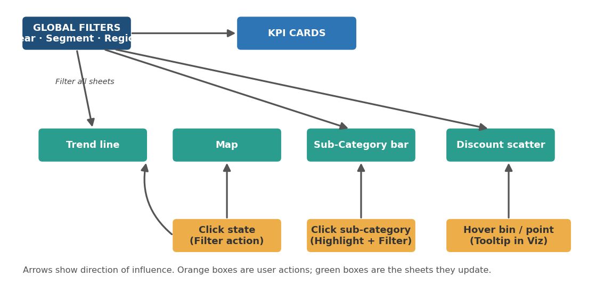
Figure 4: Interaction flow between filters, actions and sheets
Interaction | Trigger | Effect | Purpose
Global filters | Year, Segment, Region, Category dropdowns | All six sheets update (Apply to Worksheets > All Using Related Data Sources) | Lets each audience slice the data for their own question
Map filter action | Click a state | Trend, bars, scatter and KPIs filter to that state | Answer: where is the problem, and what is happening there?
Highlight/filter action | Click a sub-category bar | Scatter and trend filter to that product; map recolours | Connect product to geography and discount behaviour
Tooltips in Viz | Hover a state, bar or discount bin | Small embedded chart (e.g., monthly profit for that item) | Gives detail without adding clutter
Parameter: Measure toggle | Dropdown (Sales / Profit / Profit Ratio) | Switches the metric shown on the map and bars | Offers flexibility with only one chart
Reset | Click an empty area or "Reset" button (navigation object) | Clears all actions | Prevents users getting lost after drilling

Design rules for interactions: use one clear click-action per chart (select), keep filter actions on Select rather than Hover so results do not flicker, and add short on-screen hints such as "Click a state to filter".

5. Integration Rationale

5.1 Why each visualization was chosen
Visual | Chosen over | Reason
KPI cards with YoY | Gauges, pie charts | Gauges waste space and obscure exact values; text with a trend arrow is read instantly
Dual-axis line chart | Bars or stacked area | Lines show continuous change and seasonality best; dual axis compares sales and profit on their own scales
Filled map by profit ratio | Table of states | Reveals geographic clusters at a glance; ratio avoids bias toward large states
Sorted horizontal bar | Treemap or pie | Bars allow precise length comparison; long sub-category names fit; sorting makes ranking obvious; negatives stand out in red
Scatter plus discount bins | Single table | Scatter shows individual orders and the shape of the relationship; bins give a simple summary for non-analysts

5.2 How the elements interrelate
The charts are designed as a chain of questions, not as independent exhibits. The KPIs state the outcome. The trend shows when it changed. The map shows where. The bars show which products. The discount chart offers a possible reason. A click on any one element filters the others, so a user can move from "profit fell" to "in this state, for this product, at these discount levels" in three clicks, without leaving the page.
Example user journey:
- The manager sees the Profit Ratio KPI has fallen year over year.
- The trend chart shows profit lagging sales in later months.
- The map highlights a few red states; the manager clicks one.
- The bar chart refilters and shows which sub-categories lose money in that state.
- The scatter shows those loss-making orders sit at high discounts, confirming the hypothesis.

5.3 How the design supports understanding
- Progressive disclosure: summary first, detail on demand.
- Consistent encoding: the same colours and the same metric definitions throughout, so nothing has to be relearned.
- Low cognitive load: six visuals, one palette, no 3D or decorative elements.
- Direct annotation: titles state the question the chart answers, and short subtitles explain how to read it.

6. Technical and Performance Considerations
- Use an extract rather than a live connection for speed; the dataset is small, so refresh is trivial.
- Build each sheet separately, name sheets clearly (for example "01_KPI_Sales", "03_Trend") and reuse calculated fields.
- Minimise quick filters and use "Apply to worksheets" selectively to keep rendering fast.
- Create a Phone layout: stack KPIs 2×2, then trend, then bars; hide the map and scatter or move them to a second tab.
- Accessibility: sufficient contrast, meaningful alt text on the dashboard, and labels that do not rely on colour alone.

7. Risks and Mitigations
Risk | Mitigation
Dashboard becomes cluttered | Limit to six visuals; move extra detail to tooltips or a second page
Users get lost after filtering | Visible Reset button and filter hints
Map misleads due to small states | Use Profit Ratio, add tooltips with sales totals, allow metric toggle
Correlation mistaken for causation in the scatter | Add a note in the subtitle and describe it as an association
Misreading of colour for colour-blind users | Labels, sorted order and a lightness difference in the palette

8. Implementation Roadmap
Phase | Tasks | Output
A. Prepare | Connect data, create extract, build calculated fields and parameters | Clean data source
B. Build sheets | Create the six sheets from the specification table, apply palette and formatting | Six finished worksheets
C. Assemble | Place containers, set fixed size, add title, filters and KPI cards | Static dashboard
D. Interact | Add filter actions, tooltips in viz, parameter toggle and reset button | Interactive dashboard
E. Test | Check with sample users from each audience; check phone layout | Feedback log
F. Refine | Fix issues, document and publish | Final dashboard

9. Conclusion
This blueprint defines a six-visual dashboard that tells a clear story from overall performance to the specific causes of lost profit. Layout, colour and interaction choices are each tied to a stated audience need or a Week 1 finding. With the component specification, interaction plan and roadmap above, the dashboard can be built in the following weeks with no major design decisions left open.

Appendix: Design checklist
- Every chart has a title that states the question it answers
- Colours mean the same thing on every sheet
- Zero baseline used on bar charts
- No more than six visuals on the page
- All filters tested against all sheets
- Phone layout checked
- Reset path available

