Advanced Chart Techniques & Calculation Insights
Dual-Axis, Heat Map, Pareto and Waterfall Views with Calculated Fields in Tableau
Dataset: Tableau Sample – Superstore
Week 4 Report | Author: [Your Name] | Date: [Date]

Contents

Tip: right-click the table above in Word and choose Update Field to refresh page numbers.

1. Introduction
Weeks 1 to 3 explored the Superstore data, designed a dashboard and planned a data story. Those plans relied mostly on standard charts. This week deepens the toolkit: it selects four advanced chart techniques, defines the calculated fields and table calculations that power them, and plans how they fit into one dashboard. For each calculation the document gives the formula, the reason it exists and the effect it has on the analysis.
✎ This is a planning and technical-design document. Diagrams use placeholder values. Build each view in Tableau, check the formulas against your data using the validation steps in Section 7, and add screenshots where indicated.

2. Research and Technique Selection

2.1 Candidate techniques
Technique | What it shows best | Question it answers | Selected?
Dual-axis combination | Two measures with different scales on one axis pair | Do sales and margin move together? | Yes (A)
Heat map | Intensity across two categorical dimensions | Which sub-category and month combinations are weak? | Yes (B)
Pareto chart | Ranked values with cumulative share | How concentrated is sales among customers? | Yes (C)
Waterfall chart | How parts add up to a total | Which sub-categories build or erode total profit? | Yes (D)
Bullet chart | Actual versus target | Are we meeting targets? | No: Superstore has no target data
Treemap | Part-to-whole of many items | Share of sales by item | No: bars read more precisely (Week 2)
Box plot | Distribution and outliers | Spread of profit | Used in Week 1 already

Four techniques were chosen because each answers a different analytical question and each relies on a different class of calculation, which lets the report demonstrate row-level calculations, aggregates, table calculations and level-of-detail (LOD) expressions.
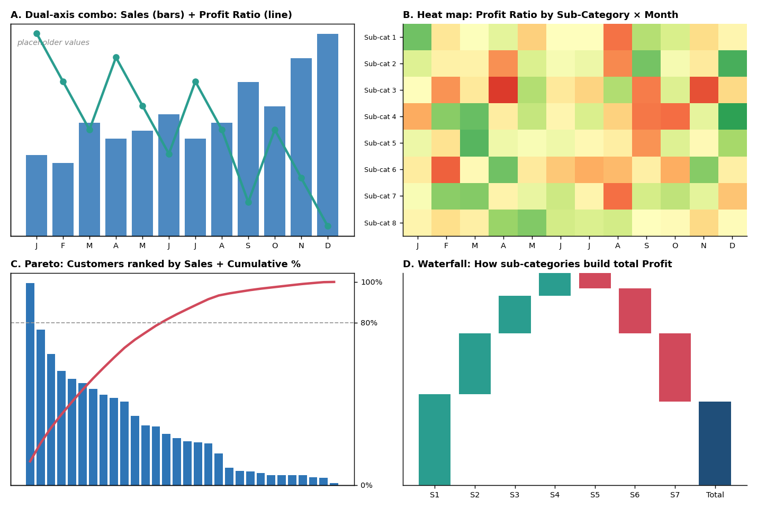
Figure 1: The four advanced techniques (placeholder values)

3. Advanced Visualizations: Build Plans

3.1 Technique A: Dual-axis combination (Sales bars + Profit Ratio line)
Purpose: reveal whether margin rises or falls as sales rise, which was the central tension in the Week 3 story.
Build steps:
- Place continuous MONTH(Order Date) on Columns and SUM(Sales) on Rows; set the mark type to Bar.
- Drag Profit Ratio to Rows beside SUM(Sales), then right-click it and choose Dual Axis.
- Set the Profit Ratio mark type to Line with markers; right-click the right axis and choose Synchronize only if both use the same units (here they do not, so leave unsynchronised).
- Colour bars blue and the line teal; add a constant reference line at the overall Profit Ratio.
- Add tooltips showing sales, profit, ratio and YoY growth.
Design rationale: bars suit volume (a quantity that accumulates), lines suit rates (a quantity that varies). Putting them on separate axes lets each use its own scale, so a 10% margin is not flattened beside six-figure sales.
Reading guide: a line that falls while bars rise signals growth without profitability. A dual axis can mislead if the scales are manipulated, so both axes start at zero and are labelled clearly.

3.2 Technique B: Heat map (Sub-Category × Month)
Purpose: expose specific weak spots that totals hide, such as one sub-category that loses money in particular months.
Build steps:
- Place Sub-Category on Rows and discrete MONTH(Order Date) on Columns.
- Set the mark type to Square; drag Profit Ratio to Color.
- Edit the colour: choose a diverging red-to-green palette, tick Use Full Color Range off, and set the centre to 0 so red always means loss.
- Drag SUM(Sales) to Label or to Tooltip so low-volume cells can be interpreted with caution.
- Sort Sub-Category by overall Profit Ratio so the weakest rows group together.
Design rationale: a heat map packs many cells (for example 17 sub-categories × 12 months) into a small space and uses pre-attentive colour to locate patterns. A diverging palette centred at zero gives red and green a precise meaning.
Reading guide: look for rows that stay red across many months (a structural problem) and columns that are red across many rows (a seasonal problem).

3.3 Technique C: Pareto chart (customer concentration)
Purpose: test whether a small share of customers generates most of the sales (the 80/20 pattern) and therefore where relationship effort and discount policy matter most.
Build steps:
- Place Customer Name on Columns and SUM(Sales) on Rows; sort descending by SUM(Sales).
- Add a second SUM(Sales) to Rows, change it to a table calculation: Running Total, then Percent of Total (compute along Customer Name), or use the Cumulative % calculation in Section 4.
- Set the first as Bar and the second as Line; use Dual Axis and set the right axis to 0–100%.
- Add a reference line at 80% on the right axis.
Design rationale: the combination of ranked bars and a cumulative line shows both the individual contribution and the cumulative effect on a single chart, which neither a bar chart nor a table can do alone.
Reading guide: the steeper the cumulative line rises, the more concentrated the sales. The point where the line crosses the 80% reference marks the number of customers who account for four-fifths of sales.

3.4 Technique D: Waterfall chart (profit build by sub-category)
Purpose: show how each sub-category adds to or subtracts from total profit, making the loss-makers visible as downward steps.
Build steps:
- Place Sub-Category on Columns, sorted descending by SUM(Profit).
- Place SUM(Profit) on Rows, then apply a Running Total quick table calculation (compute along Sub-Category).
- Change the mark type to Gantt Bar.
- Create the calculated field Waterfall Size = -SUM([Profit]) and drag it to Size (a negative size draws the bar from the running total back to the previous value).
- Colour by a calculated field Profit Direction (positive teal, negative red) and add a Total column using Analytics > Totals or a reference line.
Design rationale: a waterfall turns the question "how did we get to this total?" into a visible sequence. It is more informative than a plain bar chart because the viewer sees the cumulative effect at each step.
Reading guide: where the staircase turns down, the sub-category is dragging total profit down. The final bar is the total, so the viewer can see how much of the gain is given back by loss-makers.

4. Calculated Fields and Table Calculations
Tableau offers four kinds of calculation, and each answers a different need. Row-level calculations are evaluated for each record; aggregate calculations are evaluated after grouping; table calculations are evaluated over the results in the view; and LOD expressions evaluate at a level independent of the view.

4.1 Calculation catalogue
Field | Type | Formula | Purpose and impact
Profit Ratio | Aggregate | SUM([Profit]) / SUM([Sales]) | Margin as a fair comparison across groups of different size. Used in A, B and KPI cards; avoids the bias of raw profit towards large groups
Discount Bin | Row-level | IF [Discount]=0 THEN "0%" ELSEIF [Discount]<=0.2 THEN "1-20%" ELSEIF [Discount]<=0.4 THEN "21-40%" ELSE ">40%" END | Groups a continuous measure into readable bands so that the discount effect can be summarised in a bar chart or a filter
Is Loss Line | Row-level | IF [Profit] < 0 THEN 1 ELSE 0 END | Flags loss-making order lines; the building block for Loss Rate
Loss Rate | Aggregate | SUM([Is Loss Line]) / COUNT([Order ID]) | Share of order lines that lose money; shows how widespread losses are, which total profit does not
Sales YoY Growth | Table calc | (ZN(SUM([Sales])) - LOOKUP(ZN(SUM([Sales])), -1)) / ABS(LOOKUP(ZN(SUM([Sales])), -1)) | Year-over-year change (compute along Year of Order Date); gives direction to KPI cards and tooltips
Sales 3-Month Moving Avg | Table calc | WINDOW_AVG(SUM([Sales]), -2, 0) | Smooths month-to-month noise in the trend so the underlying pattern stands out
Cumulative % of Sales | Table calc | RUNNING_SUM(SUM([Sales])) / TOTAL(SUM([Sales])) | Drives the Pareto line; compute along Customer Name, sorted descending
Waterfall Size | Aggregate | -SUM([Profit]) | Gives Gantt bars the right length for the waterfall
Profit Direction | Aggregate | IF SUM([Profit]) >= 0 THEN "Gain" ELSE "Loss" END | Colour driver for the waterfall and bars; keeps red and teal meaning consistent
Customer Lifetime Profit | LOD (FIXED) | { FIXED [Customer Name] : SUM([Profit]) } | Total profit per customer regardless of filters on the view; used to flag unprofitable customers inside the Pareto
Customer Order Count | LOD (FIXED) | { FIXED [Customer Name] : COUNTD([Order ID]) } | Separates frequent from occasional buyers; supports segmentation
Margin vs Company Average | Aggregate + table calc | SUM([Profit])/SUM([Sales]) - TOTAL(SUM([Profit]))/TOTAL(SUM([Sales])) | Shows how far each group is above or below the overall margin; a reference-based view that is easier to interpret than a bare ratio
Days to Ship | Row-level | DATEDIFF("day", [Order Date], [Ship Date]) | Operational measure used in tooltips and shipping analysis
Selected Metric | Aggregate (parameter) | CASE [Metric Selector] WHEN "Sales" THEN SUM([Sales]) WHEN "Profit" THEN SUM([Profit]) ELSE SUM([Profit])/SUM([Sales]) END | Lets one chart display three measures on demand; reduces dashboard clutter
Top N Customer Flag | Table calc | RANK(SUM([Sales]), "desc") <= [Top N] | Controlled by a parameter; focuses the Pareto and tables on the largest customers
Dynamic Title | Aggregate | "Profit Ratio by " + [Selected Dimension] + ", " + STR(MIN(YEAR([Order Date]))) | Keeps chart titles accurate when users change filters or parameters

✎ Parameter prerequisites: Metric Selector (string list: Sales, Profit, Profit Ratio), Top N (integer, 5 to 50, default 20). Create these before the fields that reference them. Names in square brackets must match your workbook exactly.

4.2 Rationale for key computations
- Profit Ratio instead of Profit: a group with high profit may simply be large. The ratio isolates efficiency, which is what a pricing decision should respond to.
- Loss Rate alongside Profit Ratio: a sub-category with a decent margin can still lose money on many orders if a few large profitable orders mask them. The rate exposes this.
- FIXED LOD for customers: filters on the view (for example Region) would otherwise change each customer’s total. FIXED ignores view filters, so the customer’s lifetime figure stays constant unless a context filter is used.
- Table calculations for Pareto and waterfall: running totals depend on the order of marks in the view, so they must be computed in the view, not in the data.
- Parameters: they let the audience change the question without changing the dashboard, which supports exploration.

4.3 How calculations depend on each other
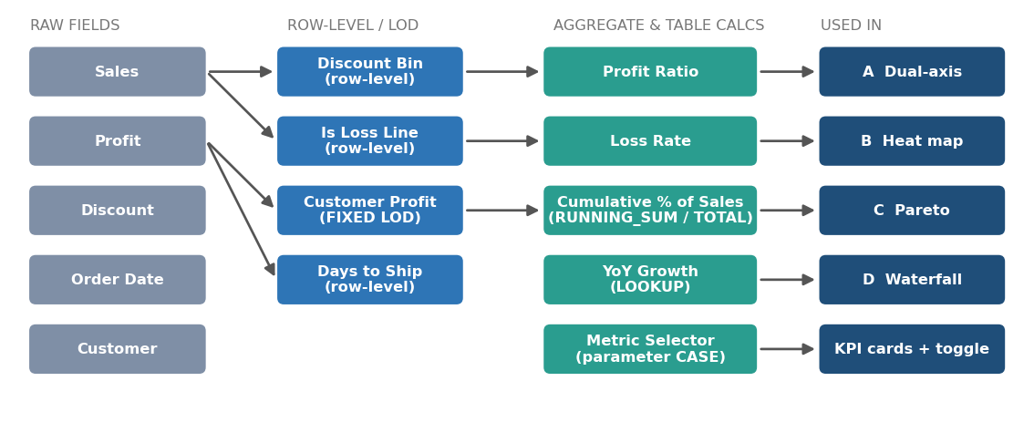
Figure 2: From raw fields to calculations to visualizations
Order of evaluation matters. Row-level fields are computed first, then aggregates, then table calculations and finally what-if or display formatting. Table calculations depend on the layout of the view: changing sort order or the "compute using" setting changes the result, so each table calculation should have its addressing documented (Section 4.4).

4.4 Table calculation settings
Calculation | Compute using | Notes
Sales YoY Growth | Table (across) or Order Date Year | Partition by Region or Segment if they are on the view
Moving Average | Order Date Month | Window of the current and previous two months
Cumulative % of Sales | Customer Name | Sort the dimension descending by SUM(Sales) first
Waterfall running total | Sub-Category | Sort by SUM(Profit) descending
Top N Customer Flag | Customer Name | Use RANK_UNIQUE if ties would produce more than N marks

5. Dashboard Integration Plan

5.1 Layout
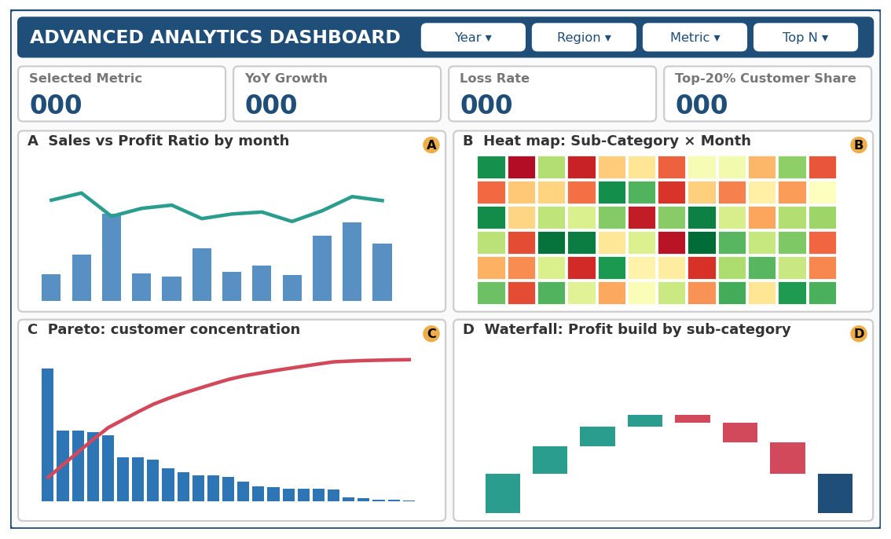
Figure 3: Dashboard layout with the four advanced views (callouts A–D)
View | Position | Role in the dashboard
KPI strip | Top row | Selected Metric, YoY Growth, Loss Rate, Top-20% customer share; all react to the Metric parameter and filters
A: Dual-axis | Row 2 left | Establishes the sales versus margin relationship over time
B: Heat map | Row 2 right | Locates weak sub-category and month combinations
C: Pareto | Row 3 left | Shows customer concentration and links to who matters
D: Waterfall | Row 3 right | Shows how products build total profit

The layout reads in a Z-pattern: the viewer meets summary figures first, then time and pattern views, then structure views (customers and products). This follows the narrative from Week 3, from overview through detail.

5.2 Interactions between views
Action | Source → Targets | Effect and reasoning
Filter action (Select) | Heat map row → Waterfall, Dual-axis | Clicking a sub-category filters the time chart and highlights its step in the waterfall, tying product, time and total together
Filter action (Select) | Heat map column → Dual-axis, Pareto | Clicking a month filters the customer view to that month, showing who drove it
Highlight action | Pareto bar → Heat map | Highlights the chosen customer’s sub-categories
Parameter control | Metric Selector → KPI, A, B | Switches the displayed measure; colour legends and titles update through the Dynamic Title field
Parameter control | Top N → Pareto | Reduces the number of customers shown; the cumulative line recomputes
Tooltip in Viz | Heat map cell, waterfall step | Shows a mini trend and the margin versus company average
Reset button | Dashboard-wide | Clears selections; stops users getting lost after drilling

5.3 Text explanations that accompany the calculations
Each view is paired with a short annotation so that the reader understands how to read the chart and how the number was produced. Planned text elements:
- Subtitle under each chart: one line stating the question (e.g. "Does margin follow sales?").
- "How to read" tooltip on an information icon: one or two sentences, such as "Red cells mean negative profit; darker means larger loss."
- Footnote for calculations: e.g. "Loss Rate = share of order lines with negative profit. Cumulative % computed along customers sorted by sales."
- Dynamic caption: a text object whose content updates with filters (for example the number of customers needed to reach 80% of sales).

5.4 User-centred design considerations
- Progressive disclosure: simple KPIs first, advanced views below, formulas only in tooltips and footnotes.
- Consistent colour meaning (teal gain, red loss, blue neutral) across all four views.
- No reliance on colour alone: heat map cells carry labels or tooltips; waterfall steps carry values.
- Performance: use an extract, minimise nested LODs, and keep the heat map to one measure on colour.

6. Intended Impact on the Analysis
Calculation / view | What it adds to the analysis | Decision it supports
Profit Ratio and Margin vs Average | Fair comparison and a benchmark | Which groups to investigate for pricing or cost problems
Loss Rate | Breadth of loss-making, not just size | Whether to fix specific orders or whole categories
Heat map | Pinpoints sub-category/time weaknesses | Where and when to adjust discounts or stock
Pareto and Customer LOD | Customer concentration and unprofitable customers | Which customers need account management or discount review
Waterfall | Visible contribution of each product to total profit | Which products to promote, reprice or phase out
Parameters | Flexible questions without extra charts | Self-service exploration for different audiences

7. Validation and Quality Checks
- Reconcile totals: the sum of the waterfall steps must equal total profit in the KPI card; the final Pareto point must equal 100%.
- Cross-check Profit Ratio: compare against a manual calculation in a text table for one region and one year.
- Spot-check Loss Rate: filter to one sub-category and compare the count of negative-profit rows with the Tableau result.
- Test table-calculation addressing: change the sort order and confirm the running total still behaves as expected.
- Test filters with LOD fields: confirm Customer Lifetime Profit does not change when the Region filter is applied (FIXED behaviour), and decide whether a context filter is wanted.
- Check nulls and zeros: ZN() is used in YoY growth so missing years do not break the formula; division by zero in ratios should return NULL, not an error.

8. Limitations and Next Steps
- The Pareto assumes sales are the right basis for concentration; profit-based concentration may tell a different story and should be tested.
- Dual-axis charts can be misread; the audience must be given a clear legend and zero-based axes.
- Heat maps with many cells can overwhelm; a limit on the number of sub-categories or a filter by category is available.
- Next steps: build the four views, capture screenshots, validate each formula, and test the dashboard with one user from each audience.

9. Conclusion
This plan selects four advanced techniques, each answering a different question about sales, margin, customers and products, and defines the sixteen calculations that power them. Every formula is documented with its type, purpose and expected effect. The views are arranged in one dashboard whose interactions connect product, time and customer, and whose text elements explain how to read each chart. With the validation checks above, the plan provides a reliable guide for building and testing the advanced dashboard in Tableau.

Appendix: Calculation type reference
Type | Evaluated | Example in this report
Row-level | For each record, before aggregation | Discount Bin, Is Loss Line, Days to Ship
Aggregate | After grouping to the view’s level | Profit Ratio, Waterfall Size
Table calculation | Over the marks in the view, after aggregation | YoY Growth, Cumulative %, Moving Average
LOD (FIXED) | At a stated level, independent of the view | Customer Lifetime Profit, Customer Order Count
Parameter-driven | Depends on a user-set value | Selected Metric, Top N Customer Flag

