Tableau Data Visualization Internship
Final Integration, Evaluation & Reporting
From Exploratory Analysis to an Optimised, Story-Driven Dashboard Blueprint
Dataset: Tableau Sample – Superstore
Final Report (Week 6) | Author: [Your Name] | Date: [Date]

Contents

Tip: right-click the table above in Word and choose Update Field to refresh page numbers.

Executive Summary
This report brings together six weeks of work on a single question: how can the Superstore retail dataset be turned into a Tableau dashboard that is insightful, clear, fast and easy to explore? Each week built on the one before. Week 1 explored the data and produced hypotheses; Week 2 designed the dashboard; Week 3 turned it into a guided data story; Week 4 added advanced charts and calculations; Week 5 planned performance optimisation and richer interactivity; and this final week integrates and critically evaluates the whole.
The central working narrative is that sales may be growing without profit keeping pace, with deep discounting in particular products and regions as a likely cause. The final design traces this narrative from a business question through evidence views, calculated fields, story points and interactive controls to a decision: review or cap discounts where they erode margin.
Key outputs of the project:
- A six-visual dashboard blueprint with defined audiences, layout, colour system and interaction plan.
- A six-point data story with a five-stage narrative arc and a what-if discount tool.
- Four advanced chart techniques (dual-axis, heat map, Pareto, waterfall) supported by a catalogue of sixteen calculated fields.
- A layered performance strategy and a set of usability-focused interactive enhancements.
- A critical evaluation, lessons learned and a roadmap for future work.
✎ Please read this honestly and keep it in your final version: Weeks 2 to 5 are planning and design documents, and the findings in Week 1 and the hypotheses that follow are not yet confirmed by analysis in Tableau. The report is strongest when you add your own screenshots, measured results and personal reflections where marked. Claims about outcomes are stated as expectations to be verified, not as achieved results.

1. Project Overview

1.1 Objectives
- Explore a public dataset and generate business insights (Week 1).
- Plan an interactive, audience-centred dashboard (Week 2).
- Craft a narrative that guides users from question to decision (Week 3).
- Apply advanced charts and calculations with documented rationale (Week 4).
- Optimise performance and enhance interactivity (Week 5).
- Integrate, evaluate and reflect (Week 6).

1.2 Dataset
Sample – Superstore is a public retail dataset that ships with Tableau. It contains order-line transactions with dates, customer segments, geography, product hierarchy, and the measures Sales, Quantity, Discount and Profit. It was chosen for its mix of dimensions and a profit measure that can be negative, which makes discount and margin analysis possible.

1.3 Journey at a glance
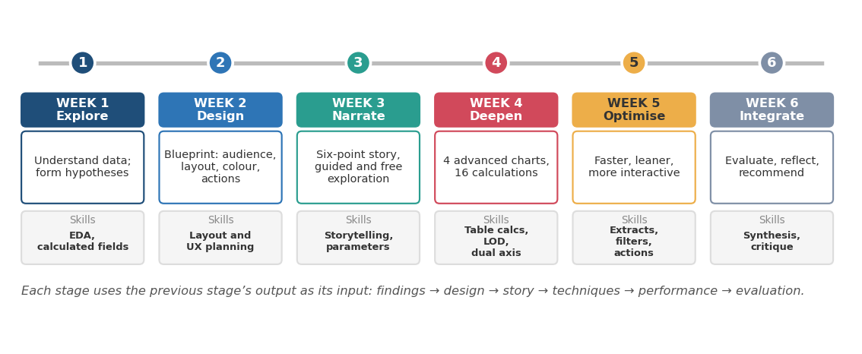
Figure 1: Six-week progression and skills developed
Week | Deliverable | Main outcome | Key Tableau skills
1 | Exploratory analysis report | Dataset description, EDA plan, hypotheses, questions | Calculated fields, EDA views, outlier and trend analysis
2 | Dashboard design plan | Audience, metrics, wireframe, colour, interaction plan | Dashboard layout, actions, colour encoding
3 | Data story plan | Key message, six story points, interactive path | Story points, parameters, what-if
4 | Advanced charts and calculations | Four techniques, sixteen calculated fields | Table calcs, LODs, dual-axis, parameters
5 | Performance and interactivity plan | Bottleneck analysis, optimisation strategy, enhancements | Extracts, filters, dynamic zones, set and parameter actions
6 | Final integration report | Evaluation, lessons, recommendations | Synthesis and critique

2. Exploratory Analysis (Week 1)

2.1 Approach
The exploration followed a repeatable loop: profile the data, ask a question, build the simplest view that answers it, interpret, then refine. Eight analysis areas were defined: overall KPIs, trends over time, category and sub-category performance, geography, discount versus profit, customers and segments, distributions and outliers, and shipping mode.

2.2 Variables used
Variable group | Fields | Purpose
Time | Order Date, Ship Date | Trend, seasonality, shipping speed
Geography | Region, State, City | Map and regional comparison
Product | Category, Sub-Category | Product mix and profitability
People | Segment, Customer Name | Segment comparison, customer concentration
Measures | Sales, Quantity, Discount, Profit | Performance and the discount–profit relationship

2.3 Working hypotheses
- H1: Profit does not grow in step with sales.
- H2: Losses are concentrated in particular sub-categories and states.
- H3: Higher discounts are associated with a higher chance of loss-making orders.
- H4: A minority of customers account for most sales.
✎ YOUR INPUT: For each hypothesis, record whether your Tableau analysis supported, partly supported or rejected it, with the figure that proves it (for example, total profit ratio, loss-making threshold for discount, share of sales from the top 20% of customers).
✎ YOUR INPUT: Insert 2–3 of your best Week 1 screenshots here (trend line, sub-category bars, discount scatter).

3. Dashboard Design (Week 2)

3.1 Design decisions
- Audiences: executives (are we profitable?), regional managers (where is the problem?), analysts (why is it happening?).
- Structure: KPIs first, then trend and map, then product and discount views, so each reader can stop when they have their answer.
- Colour: teal for profit, red for loss, blue for sales and neutral structure, amber for highlights; the same meaning on every sheet.
- Interactions: four global filters, a map-to-bars filter action, bar-to-scatter highlight, tooltips and a reset button.
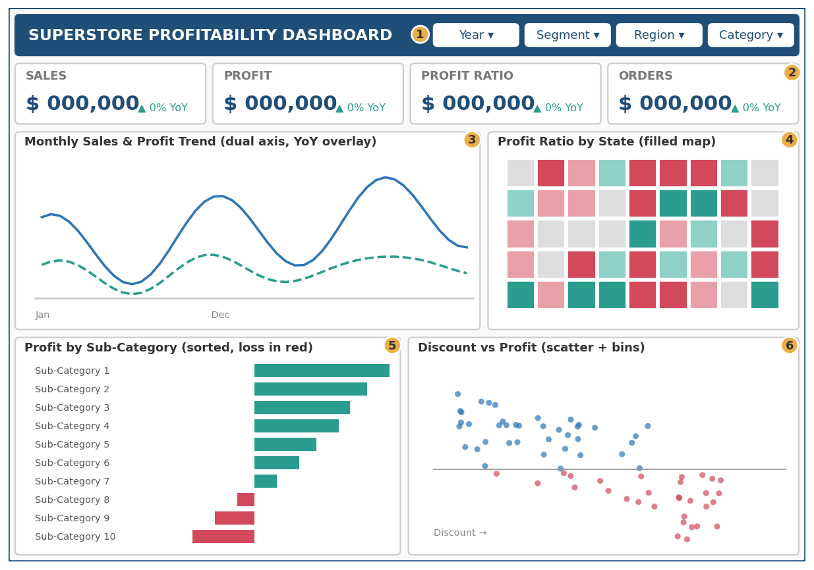
Figure 2: Wireframe from the dashboard design plan (placeholder values)

3.2 Why these choices
Every visual type was chosen for the question it answers: KPI cards for a one-second status, a dual-axis line for two measures with different scales, a filled map for location of weak areas, sorted bars for precise ranking, and a scatter for the relationship between discount and profit. Pie charts and gauges were rejected because they hide exact values and waste space.

4. Data Narrative (Week 3)

4.1 Story concept
Key message: "Superstore’s sales are growing, but profit is not following, and heavy discounting in specific products and places is a likely reason. Targeted discount control could recover margin."
The story follows a five-stage arc (context, trend, tension, climax, resolution), told in six story points: Context, Trend, Tension, Locate, Cause and Act. Each point carries one headline, one primary visual and one interaction, and each caption ends with the question the next point answers.
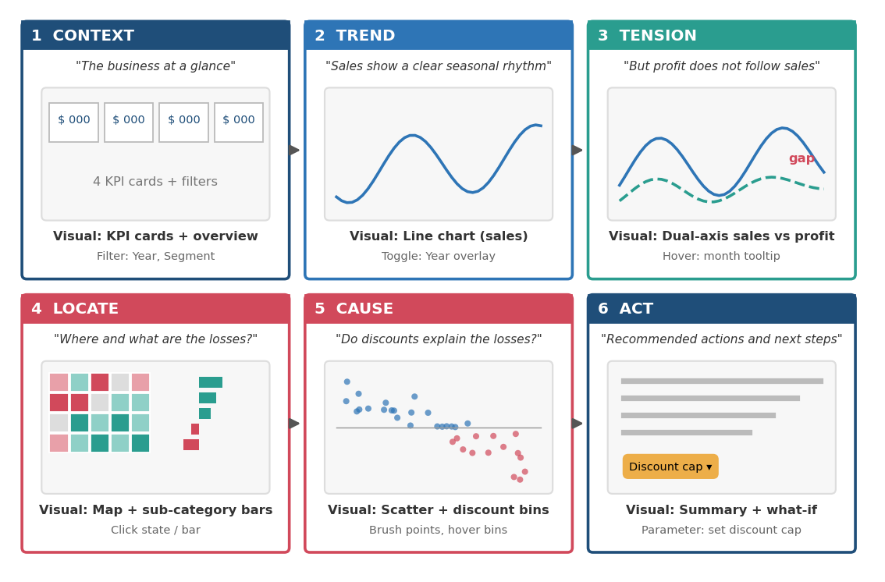
Figure 3: Six-point storyboard (placeholder values)

4.2 Interaction in the story
- Guided mode: Next and Back buttons through the six points.
- Free exploration: filters, filter and highlight actions, tooltips and parameters, with a reset path.
- What-if: a discount-cap parameter that estimates profit if discounts above the cap were reduced, clearly labelled as an estimate that assumes demand and cost stay unchanged.

5. Advanced Techniques (Week 4)

5.1 Selected techniques
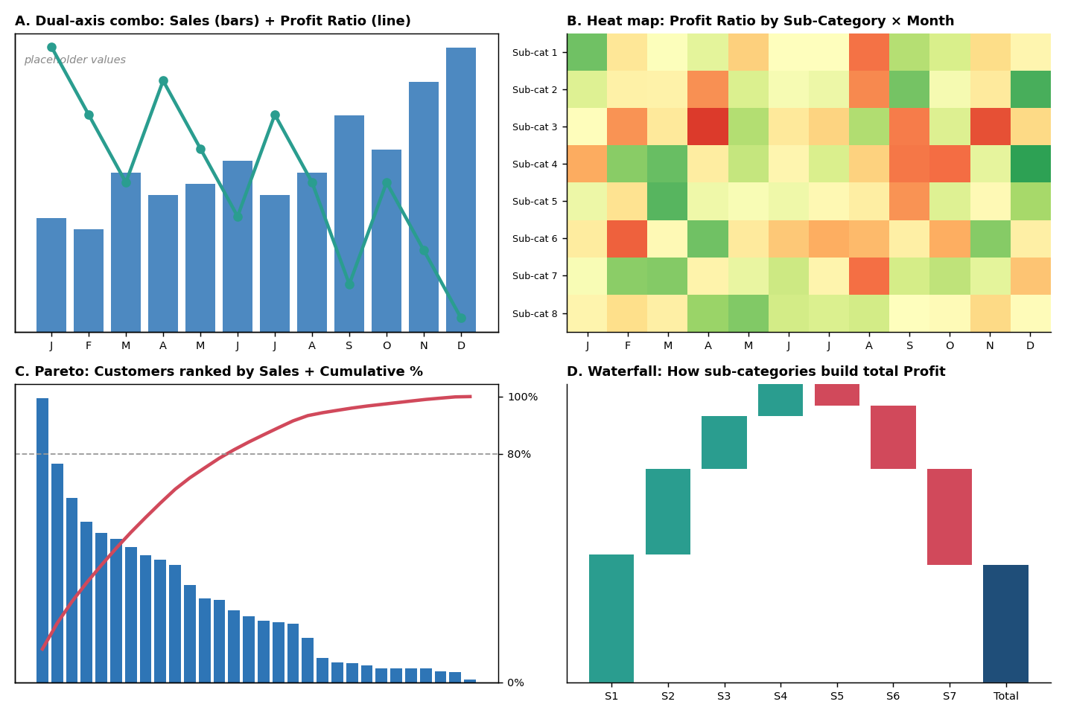
Figure 4: The four advanced techniques (placeholder values)
Technique | Question answered | Key calculation(s)
Dual-axis combo | Does margin follow sales? | Profit Ratio = SUM([Profit]) / SUM([Sales])
Heat map | Which sub-category and month combinations are weak? | Profit Ratio on colour; diverging palette centred at 0
Pareto | How concentrated is customer sales? | Cumulative % = RUNNING_SUM(SUM([Sales])) / TOTAL(SUM([Sales]))
Waterfall | How does each product build total profit? | Running total of profit with Gantt size = -SUM([Profit])

5.2 Calculation highlights
Sixteen calculated fields were catalogued by type. The most important are:
- Profit Ratio (aggregate): fair comparison across groups of different size.
- Loss Rate (row-level flag aggregated): share of order lines that lose money, which reveals breadth of loss that total profit hides.
- Customer Lifetime Profit (FIXED LOD): { FIXED [Customer Name] : SUM([Profit]) } for stable customer-level figures.
- Sales YoY Growth (table calculation) and a three-month moving average to give direction and smooth noise.
- Metric Selector (parameter-driven CASE) to let one chart show Sales, Profit or Profit Ratio.
✎ YOUR INPUT: Confirm that each formula works in your workbook; note any change you had to make (for example, field names or table-calculation settings).

6. Performance Optimisation and Interactivity (Week 5)

6.1 Assessment
Because the Superstore dataset is small, Week 5 analysed a hypothetical scaled-up version of the dashboard with a live connection, twelve quick filters, ten sheets, string-based and nested calculations, and automatic layout size. Bottlenecks were grouped into data volume, joins, filters, calculations, design, marks, tooltips and publishing.

6.2 Strategy
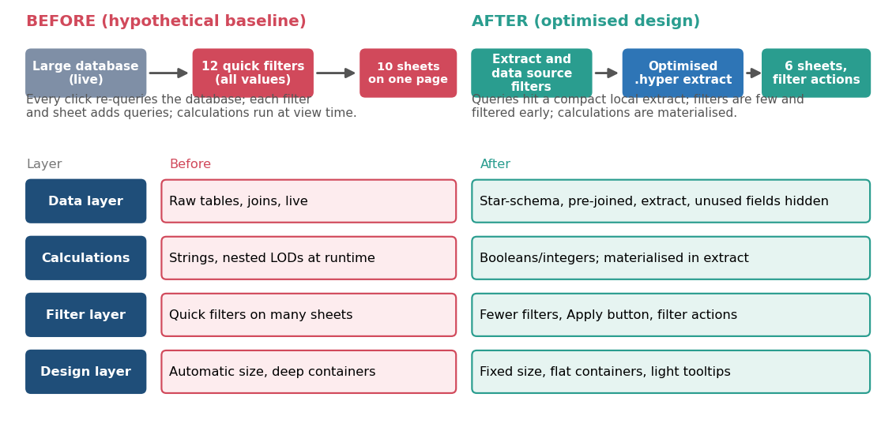
Figure 5: Baseline versus optimised design by layer
- Data: use a filtered, aggregated extract with unused fields hidden and calculations materialised.
- Calculations: prefer numbers and booleans, limit COUNTD, simplify LODs.
- Filters: four to five global filters with an Apply button; use filter actions instead of redundant quick filters.
- Design: about six sheets, fixed dashboard size, flat containers, limited marks.

6.3 Interactive enhancements
Drill-down hierarchies, parameter and set actions, dynamic zone visibility for optional panels, Top N controls, search-enabled dropdowns and navigation buttons were proposed. Several of these replace multiple filters or sheets, so they improve usability and reduce load together.
✎ YOUR INPUT: If you were able to record performance, paste the before and after figures here (initial load time, number of queries, slowest event). If not, state clearly that the optimisation is a plan to be tested.

7. Integration of the Work

7.1 The golden thread
The six weeks are most valuable when they are read as one chain. Each business question should link to an evidence view, the calculations that power it, a story point, an interactive control and a decision, while the performance layer keeps every step responsive.
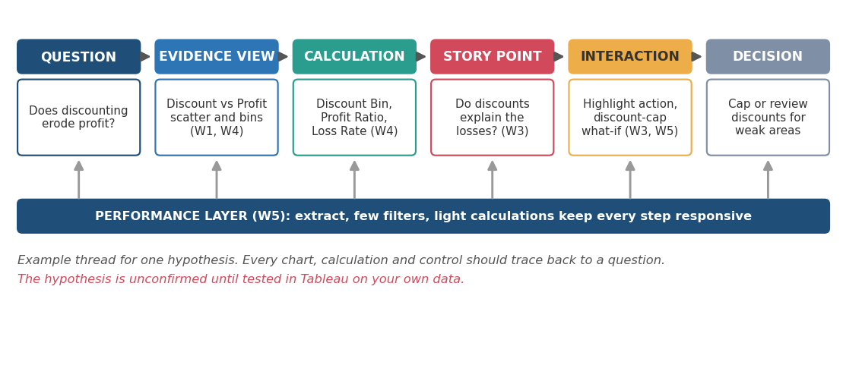
Figure 6: Traceability from business question to decision (example hypothesis)

7.2 Traceability matrix
Hypothesis | Evidence view | Key calculation | Story point | Decision
H1 Profit lags sales | Dual-axis combo | Profit Ratio, YoY Growth | 3 Tension | Investigate margin drivers
H2 Losses concentrate | Heat map, waterfall, map | Loss Rate, Margin vs Average | 4 Locate | Target weak products and states
H3 Discounts erode profit | Discount scatter, bins | Discount Bin, Capped Discount | 5 Cause, 6 Act | Review or cap discounts
H4 Customer concentration | Pareto | Cumulative %, Customer LOD | 1 Context (extension) | Prioritise key accounts

7.3 Consolidated final dashboard specification
Element | Final specification
Audience and purpose | Executives, regional managers, analysts; find where and why profit is lost
Canvas | Fixed 1200 × 840 desktop layout plus Phone layout
Header filters | Year, Segment, Region, Category (Apply button on multi-select)
KPI strip | Selected Metric, YoY Growth, Loss Rate, Top-20% Customer Share
Core views | Dual-axis trend, heat map, Pareto, waterfall; map, discount scatter and sub-category bars on the story path
Interactions | Filter and highlight actions, metric and Top N parameters, drill-down hierarchies, optional panels, Reset and navigation buttons
Data | Published, filtered extract; calculations materialised where possible
Visual language | Teal profit, red loss, blue sales, amber highlight; labels in addition to colour
Narrative | Six story points from Context to Act, with a what-if discount tool

7.4 Consistency checks across weeks
- Definitions: Profit Ratio, Loss Rate and Discount Bin must be the same in every sheet and every document.
- Colour: teal and red keep one meaning throughout; no second use of red for anything but loss.
- Filters: Week 2 listed four filters, Week 5 reduced the set; the final design uses the reduced set.
- Views: the Week 2 six-visual dashboard and the Week 4 four advanced views are merged into one specification (Section 7.3); decide which detail views move to a second dashboard.

8. Critical Evaluation

8.1 What worked well
- A consistent thread: each week used the previous week’s output, which kept decisions justified.
- Audience-first design: separating executive, manager and analyst needs shaped layout and interaction.
- Choosing each chart for a specific question, with the alternatives rejected for stated reasons.
- Documenting formulas with type, purpose and impact, which makes the calculations reviewable.
- Treating performance as a design concern, not an afterthought.

8.2 Limitations
Area | Limitation | How to address it
Evidence | Hypotheses are not yet confirmed; the story could change | Build the views, test each hypothesis, rewrite story points if needed
Implementation | Weeks 2–5 are plans; no finished workbook is included | Build the dashboard and add screenshots and a .twbx file
Dataset | Sample data is small and may not behave like real business data | Test on a larger, real dataset where possible
Performance | Baseline was hypothetical; no measured timings | Use Performance Recorder before and after changes
What-if tool | Assumes demand and unit cost stay unchanged | State assumptions; add elasticity data if available
Data scope | No cost, target, return or customer-demographic data | Add sources to enable deeper analysis
User testing | No real users tested the design | Run usability sessions with each audience

8.3 Effectiveness against the goals
Goal | Evidence of success (to collect) | Current status | Confidence
Insight quality | Hypotheses tested with figures | Planned | Medium after testing
Clarity of story | Users can state the key message after one run-through | Planned | Medium
Usability | Task completion time and errors in testing | Planned | Medium
Calculation correctness | Totals reconcile; spot-checks pass | Planned | High after validation
Performance | Load and interaction times meet targets | Planned | Depends on measurement

8.4 Self-assessment against the internship criteria
Rate yourself honestly from 1 (beginner) to 5 (confident) and add one line of evidence.
Skill | Rating | Evidence
Exploratory analysis in Tableau | [ ] | [example: built 8 EDA views; found …]
Dashboard layout and design | [ ] | [ ]
Data storytelling | [ ] | [ ]
Calculated fields, table calcs and LODs | [ ] | [ ]
Performance optimisation | [ ] | [ ]
Interactivity (actions, parameters) | [ ] | [ ]
Documentation and communication | [ ] | [ ]

9. Lessons Learned

9.1 Analytical lessons
- Ratios reveal what totals hide: a large group can look strong in profit and weak in margin.
- Averages and totals can mask a small number of loss-making items; breadth measures such as Loss Rate help.
- Correlation (discount and profit) is not proof of cause; wording and testing must reflect that.

9.2 Design and storytelling lessons
- One message per screen and action titles make a dashboard easier to follow than a collection of charts.
- Consistent colour meaning is a large part of clarity.
- A good story ends with a decision, not just an observation.

9.3 Technical lessons
- Table calculations depend on view layout and addressing; document the "compute using" setting.
- LOD expressions and filters interact through the order of operations; test after any filter change.
- Performance is mostly decided by data volume, filters and calculations, not by chart colour or fonts.

9.4 Process lessons
- Write assumptions down: they make later evaluation honest.
- Change one variable at a time when optimising.
- Plan validation checks before building, not afterwards.
✎ YOUR INPUT: Add 3–4 lessons from your own experience: what surprised you, what took longer than expected, what you would do differently.

10. Challenges and How to Address Them
Challenge | Why it matters | Approach
Balancing depth and simplicity | Too many advanced views overload users | Limit to six main visuals; move detail to a second page
Hypothetical performance work | Cannot prove improvements without measurement | Scale test data or test on a larger dataset
Keeping calculations consistent | Different definitions create conflicting numbers | Single set of certified calculated fields
Interaction versus speed | Rich interaction can slow dashboards | Prefer actions and parameters to many filters
Explaining correlation carefully | Over-claiming damages credibility | Use "associated with" language and test further

✎ YOUR INPUT: Describe one real challenge you faced during the internship and how you resolved it.

11. Recommendations for Future Enhancements

11.1 Immediate next steps
- Build the dashboard in Tableau from the Week 2–5 specifications and capture screenshots.
- Test each hypothesis, record results and update the story.
- Validate every calculation using the checks in the Week 4 plan.
- Measure performance before and after optimisation (ideally on a larger dataset).
- Run usability tests with one person from each audience and revise.

11.2 Medium-term improvements
- Add richer data: cost, targets, returns, marketing spend and customer demographics, to move from association towards explanation.
- Add forecasting for sales and profit, with clear confidence intervals.
- Build role-based views with row-level security for regional managers.
- Introduce a shared, certified data source and calculation library so definitions stay consistent.
- Prepare data upstream (for example in a data-preparation tool or in the warehouse) to reduce dashboard-time computation.

11.3 Longer-term practice
- Create a team style guide: colour, typography, layout grid, chart choices and annotation conventions.
- Set up usage monitoring and periodic performance reviews.
- Conduct an accessibility audit (contrast, alt text, keyboard use, colour-blind checks).
- Maintain version control and a change log for workbooks and data sources.
- Consider alerts and subscriptions so key changes (for example, a sudden margin drop) reach the right people.

12. Reflective Conclusion
The project shows how a dashboard grows from a question rather than from a set of charts. Exploration produced hypotheses; design gave them a structure; storytelling gave them an order; advanced calculations gave them depth; and performance planning made them practical to use. The strongest lesson is that every element, from a colour to a calculated field to a filter, should earn its place by serving a question and an audience.
The work also shows the limits of planning without building. The next and most important step is to implement the dashboard, test the hypotheses against the data, measure the performance, and let the evidence improve the story. A dashboard that has been tested with real users and verified calculations will be far more persuasive than the plan alone.
✎ YOUR INPUT: Write 3–5 sentences in your own voice: what you learned about Tableau, what you learned about yourself as an analyst, and how you will apply it in future work.

Appendix A: Glossary
Term | Meaning
EDA | Exploratory data analysis: examining data to find patterns, outliers and relationships
Calculated field | A new field defined by a formula in Tableau
Table calculation | A calculation applied to the results shown in the view, such as a running total
LOD expression | Level-of-detail expression, evaluating at a level independent of the view (for example FIXED)
Parameter | A user-controlled value that can drive calculations, filters and titles
Dashboard action | An interaction (filter, highlight, set, parameter, URL) triggered by selecting marks
Extract (.hyper) | Tableau’s optimised local data file used to speed up queries
Pareto chart | Ranked bars with a cumulative percentage line
Waterfall chart | A chart showing how parts add or subtract to reach a total
Dynamic zone visibility | Showing or hiding dashboard objects based on a parameter or field

Appendix B: Portfolio evidence checklist
- Screenshots of Week 1 EDA views (at least five)
- Screenshot of the assembled dashboard with annotations
- Storyboard or story-point screenshots
- Screenshots of each advanced chart and its calculated fields
- Performance Recorder summary before and after (if available)
- Packaged workbook (.twbx) or Tableau Public link
- Your name, date and personal reflections filled in
- Table of contents updated in Word

