Crafting Interactive Data Stories
"Growing Sales, Shrinking Profit": A Tableau Data Story Plan
Dataset: Tableau Sample – Superstore
Week 3 Report | Author: [Your Name] | Date: [Date]

Contents

Tip: right-click the table above in Word and choose Update Field to refresh page numbers.

1. Introduction
Weeks 1 and 2 explored the Superstore data and designed a dashboard. This week turns that work into a story. A dashboard lets people look; a data story guides them from a question to a conclusion and an action. This document defines the story, storyboards each step, assigns every visualization a narrative job, and explains how interactive features let the audience move from following the story to exploring it themselves.
✎ The story below is a working narrative built on the hypotheses from Weeks 1 and 2 (that profit does not keep pace with sales, and that discounting is a likely cause). Before presenting it, confirm each claim with your own Tableau views; if the data points elsewhere, change the story points but keep the structure.

2. Data Story Concept

2.1 Key message
"Superstore’s sales are growing, but profit is not following, and heavy discounting in specific products and places is a likely reason. Targeted discount control could recover margin without hurting demand."

2.2 Target audience
Audience | What they care about | How the story serves them
Executive team | Is the business healthy? What should we decide? | Opens with the headline, closes with a clear recommendation
Regional and sales managers | Where is my region losing money? | Locate step lets them filter to their own region
Pricing / merchandising analysts | Why are products losing money? | Cause step and parameters allow deeper checking

2.3 Supporting insights
- Insight A: Sales follow a recognisable seasonal pattern (to be confirmed from the monthly trend).
- Insight B: Profit and sales diverge: higher sales do not always bring proportionally higher profit.
- Insight C: Losses concentrate in particular sub-categories and states, not across the whole business.
- Insight D: Orders with higher discounts are more likely to be loss-making.
- Insight E: A discount cap on the worst-performing areas would likely recover profit (simulated with a parameter).

2.4 Story structure: narrative arc
The story follows a classic five-stage arc: context, trend, tension, climax and resolution. The audience’s interest builds as the gap between sales and profit appears, peaks when the cause is revealed, and settles when a solution is offered.
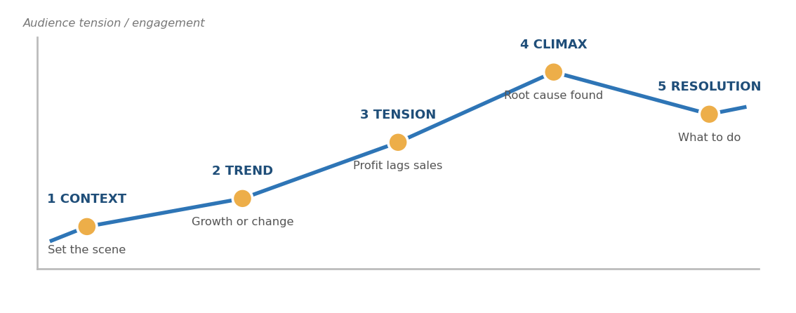
Figure 1: Narrative arc of the data story

3. Visual Narrative Planning

3.1 Storyboard
The story is built as six Tableau Story Points (or six sequential dashboard states). Each point has one headline message, one primary visual and one interaction.
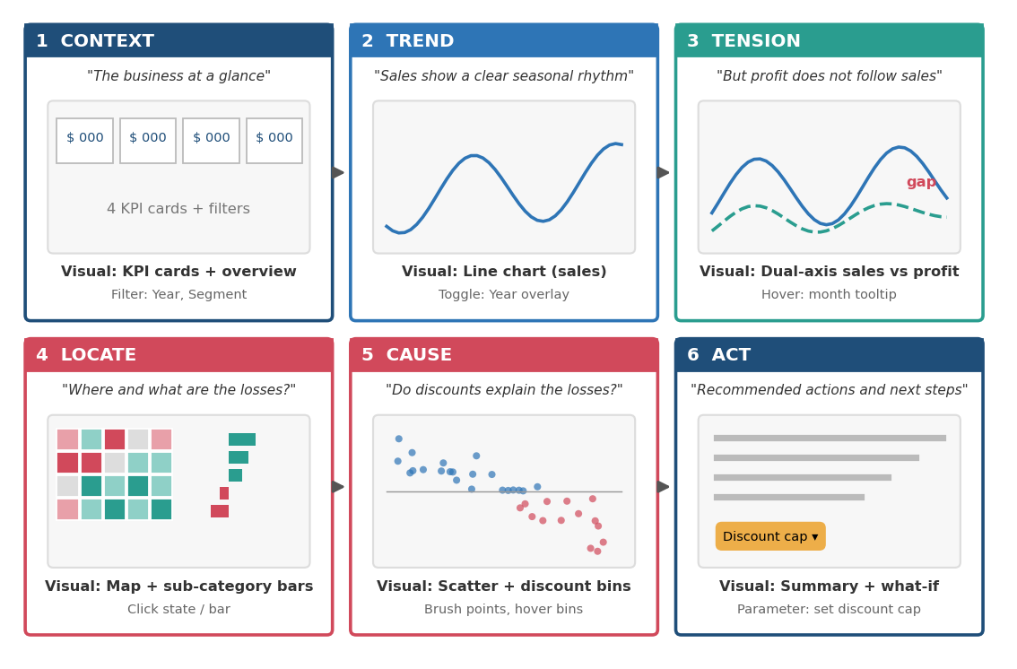
Figure 2: Six-point storyboard (placeholder values only)

3.2 Story point specification
Story point | Headline (caption) | Primary visual | Narrative role
1. Context | The business at a glance | KPI cards for Sales, Profit, Profit Ratio, Orders | Orients the audience with scale and sets the baseline
2. Trend | Sales follow a clear seasonal rhythm | Monthly sales line chart with year overlay | Builds a shared understanding of normal performance
3. Tension | But profit does not follow sales | Dual-axis sales and profit lines | Introduces the problem: the visible gap creates the question "why?"
4. Locate | Where and what are the losses? | Filled map plus sorted sub-category bars | Narrows the problem to places and products
5. Cause | Do discounts explain the losses? | Scatter of discount vs profit, bar by discount bin | Reveals the likely cause with evidence of a relationship
6. Act | Recommended actions | Summary panel with discount-cap what-if | Turns insight into a decision the audience can test

3.3 How each visualization contributes
- KPI cards give the audience the "so what" in a second and anchor every later chart to the same numbers.
- Sales line chart establishes the pattern before it is broken; the audience needs to know normal before they can see abnormal.
- Dual-axis chart is the turning point: placing profit against sales makes divergence visible without any explanation.
- Map answers "where", and bars answer "what"; both use the same red/teal profit encoding so the eye links them instantly.
- Scatter and bins explain "why": individual orders show the pattern, and bins make it simple enough to say aloud.
- Summary and what-if close the loop with an action, so the story ends in a decision and not just observation.

3.4 Transitions between story points
Each caption ends by posing the question that the next point answers. This keeps the sequence logical and prevents the audience from wondering why they are looking at a new chart.
Transition | Bridging question/phrase
1 → 2 | "Now let us see how this has moved over time."
2 → 3 | "Sales look healthy, but does profit move with them?"
3 → 4 | "The gap is real. Where is it coming from?"
4 → 5 | "Which products and states lose money, and what do they have in common?"
5 → 6 | "If discounts are part of the cause, what would a cap change?"

3.5 Design principles applied
- One message per screen: each story point makes a single claim.
- Action titles: captions state the finding ("But profit does not follow sales") instead of describing the chart ("Sales and profit by month").
- Consistent colour: teal = profit, red = loss, blue = sales, amber = highlight, identical in every point.
- Emphasis through annotation: callouts, reference lines at zero and highlighted marks direct attention to the key part of each chart.
- Accessible by design: labels in addition to colour, readable text sizes, and plain-language captions.

4. Interactive Elements

4.1 Interaction architecture
The story offers two modes. In guided mode, users click Next and Back through the story points and receive the intended narrative. In exploration mode, users break out of the path with filters, actions and parameters to ask their own questions, then return to the story. This keeps the story coherent for new viewers while giving experienced users freedom.
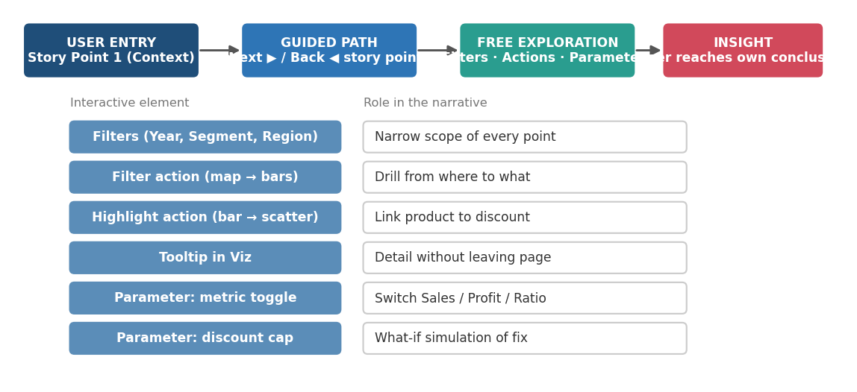
Figure 3: Guided path and free exploration, with the role of each interactive element

4.2 Detailed specification
Feature | How it works | Story points | How it deepens the narrative
Global filters (Year, Segment, Region) | Shown on every point; apply to all sheets | All | Lets managers see the story for their own scope; viewers test whether the pattern holds everywhere
Year overlay toggle | Parameter switches trend between continuous and year-by-year colour | 2, 3 | Confirms the seasonality and divergence are repeating, not a one-off
Map-to-bars filter action | Click a state; bars update to that state | 4 | Moves from where to what in one click
Bar-to-scatter highlight action | Click a sub-category; its orders highlight in the scatter | 4, 5 | Links the product problem to discount behaviour
Tooltips in Viz | Hover a state, bar or bin to see a small trend chart | 3, 4, 5 | Gives context without adding clutter
Metric parameter | Dropdown: Sales / Profit / Profit Ratio | 4 | One chart answers multiple questions; ratio avoids size bias
Discount-cap parameter | Slider (0–50%); calculated field recomputes profit as if discounts above the cap were reduced | 6 | Turns the recommendation into an experiment the audience can test
Navigation buttons | Next / Back / Reset / Go to Start | All | Keeps users oriented and prevents getting lost

4.3 Discount-cap what-if (innovative element)
The final story point includes a what-if tool. A parameter lets the viewer choose a maximum discount; a calculated field estimates profit under that cap. Because a simple recalculation cannot model changes in customer demand, the output is labelled as an estimate, and the assumption is stated on screen.
Planned calculated fields:
- Capped Discount = MIN([Discount], [Discount Cap])
- Estimated Sales at Cap = [Sales] / (1 - [Discount]) * (1 - [Capped Discount])
- Estimated Profit at Cap = [Profit] + ([Estimated Sales at Cap] - [Sales]) (assumes unit cost unchanged and demand unchanged)
✎ Check the formula against your data and state its assumptions in the dashboard footnote. This is a scenario tool, not a forecast.

4.4 Interaction guidelines
- Use Select, not Hover, for filter actions so charts do not flicker.
- Add short hints such as "Click a state to see its products".
- Always give a visible way back: a Reset button on every point.
- Pre-set filters to "All" so the guided story starts identically for every viewer.

5. Narrative Walkthrough (Presenter Script)
A short script showing how the story would be told live. Replace bracketed items with your actual findings.
- Context: "This is Superstore at a glance: [total sales], [total profit], [margin]."
- Trend: "Sales are seasonal, peaking in [months]."
- Tension: "But look at profit: it [does / does not] rise with sales. In [period], sales rose while profit [fell]."
- Locate: "The problem is not everywhere. [States] and [sub-categories] lose money."
- Cause: "These orders share heavy discounting. Above roughly [X]% discount, most orders lose money."
- Act: "If we capped discounts at [Y]%, the model suggests profit would change by about [Z]. Try the slider."

6. Testing the Story
Check | Method
Is the message clear? | Ask a colleague to state the key message after one run-through; compare to Section 2.1
Is the order logical? | Ask whether any story point raised a question that was answered too late
Can users explore without getting lost? | Observe someone using filters and actions; confirm the Reset button is found
Are claims supported? | Check every caption against a view and a number in the workbook
Is it accessible? | Review in grayscale, check contrast and text size

7. Risks and Limitations
- The story assumes the Week 1 hypotheses hold; if the data shows a different cause, the Cause and Act points must be rewritten.
- Correlation between discount and profit does not prove causation; the wording should say "coincide" or "are associated with".
- The what-if tool cannot account for changes in customer demand, so results are estimates.
- Sample data does not represent a real company; conclusions illustrate method.

8. Conclusion
This plan turns a dashboard into a guided story with one message, a five-stage arc, six story points and a set of interactive elements that support both guided viewing and free exploration. Each visualization has a defined narrative job, each transition is justified, and the final what-if tool lets the audience test the recommendation themselves. The result is a story that is clear to follow, easy to explore and ends in a decision.

