Week 3 Task
Statistical Analysis and Predictive Modeling using R
Dataset: Titanic Passenger Data (continued from Weeks 1-2)
Prepared by: Avishek Kumar
Tool Used: R (caret, pROC, car, dplyr)

1. Dataset Identification and Rationale
This report continues with the Titanic passenger dataset used in Weeks 1 and 2 (400 passenger records; publicly available via Data Science Dojo's GitHub mirror of the Kaggle Titanic dataset). The dataset is well suited to this week's objective for several concrete reasons:
- Binary outcome variable: Survived (Yes/No) is a natural target for a classification model, and is well balanced enough (39.25% survived) to train and evaluate a model meaningfully without severe class-imbalance correction.
- A genuine mix of predictor types: categorical (Sex, Pclass, Embarked), continuous (Age, Fare), and count (SibSp, Parch) variables, allowing the model to draw on diverse evidence.
- Documented ground truth: because the historical outcome of the Titanic disaster is well understood, model coefficients and hypothesis test results can be sanity-checked against known history (e.g., the well-documented survival advantage for women and first-class passengers), which is valuable for validating that the statistical methods were applied correctly.
- Continuity: building directly on the cleaned dataset and EDA from Weeks 1-2 keeps the three-week project coherent, with each week's output feeding the next.

2. Exploratory Statistical Analysis
Before building a predictive model, five hypothesis tests were run to formally establish which variables show a statistically significant relationship with survival, and to check the distributional assumptions of the two key numeric variables.

2.1 Normality Testing (Shapiro-Wilk)
The Shapiro-Wilk test was used to formally assess whether Age and Fare follow a normal distribution — relevant because several classical statistical tests assume normality.
shapiro.test(titanic$Age)
shapiro.test(titanic$Fare)
Console Output
Shapiro-Wilk normality test
data: titanic$Age
W = 0.9504, p-value = 2.5e-10

Shapiro-Wilk normality test
data: titanic$Fare
W = 0.5474, p-value < 2.2e-16
Both tests reject the null hypothesis of normality (p < 0.001 in both cases). This is visually confirmed in Figure 1: Age deviates from the reference line at both tails (partly due to the median-imputation spike from Week 1), while Fare's Q-Q plot shows the severe right-skew already seen in its boxplot in Week 2. This justifies using the Welch t-test (robust to non-normality with unequal variances) rather than a standard pooled-variance t-test below, and explains why Fare was not treated as having a simple linear relationship with the outcome in the model.
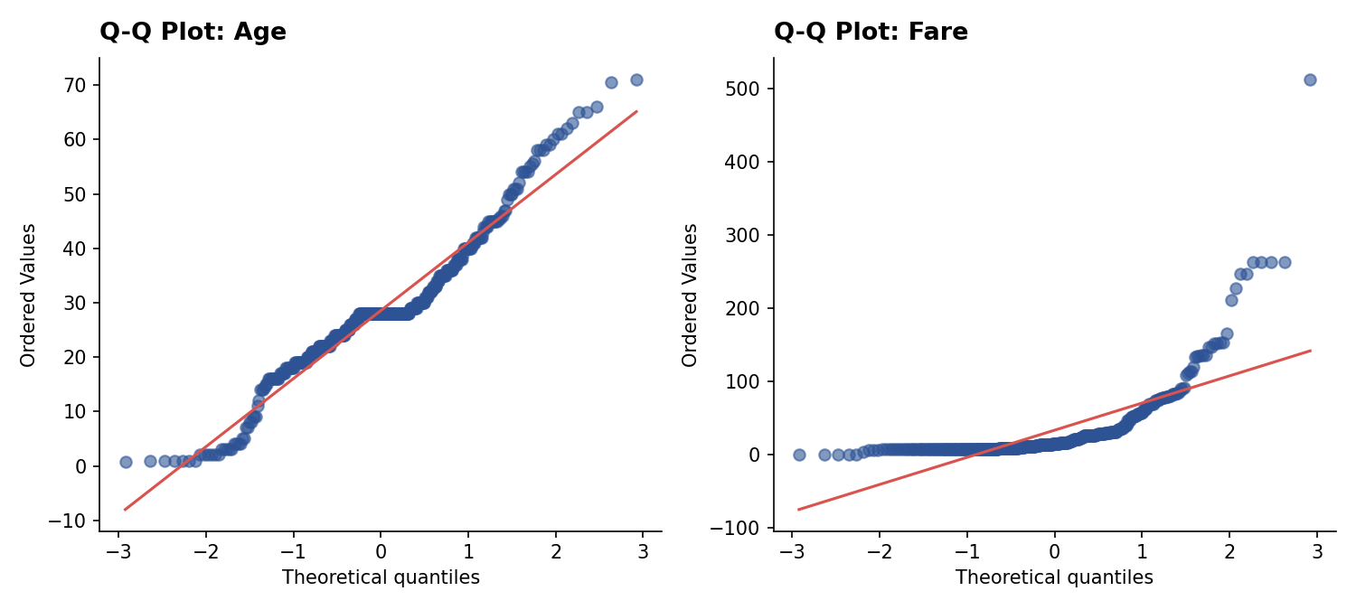
Figure 1. Q-Q plots for Age and Fare against a theoretical normal distribution. Points departing from the red reference line indicate non-normality.

2.2 Hypothesis Test 1 — Age and Survival (Welch Two-Sample t-test)
H0: mean Age is equal for survivors and non-survivors. H1: the means differ.
t.test(Age ~ Survived, data = titanic)
Console Output
Welch Two Sample t-test
data: Age by Survived
t = 1.9824, df = 347.75, p-value = 0.04823
alternative hypothesis: true difference in means is not equal to 0

mean in group No: 29.549
mean in group Yes: 27.002
With p = 0.048 (just below the conventional 0.05 threshold), we narrowly reject H0: there is a statistically significant, though modest, difference in age between survivors (mean 27.0) and non-survivors (mean 29.5) — survivors were on average about 2.5 years younger.
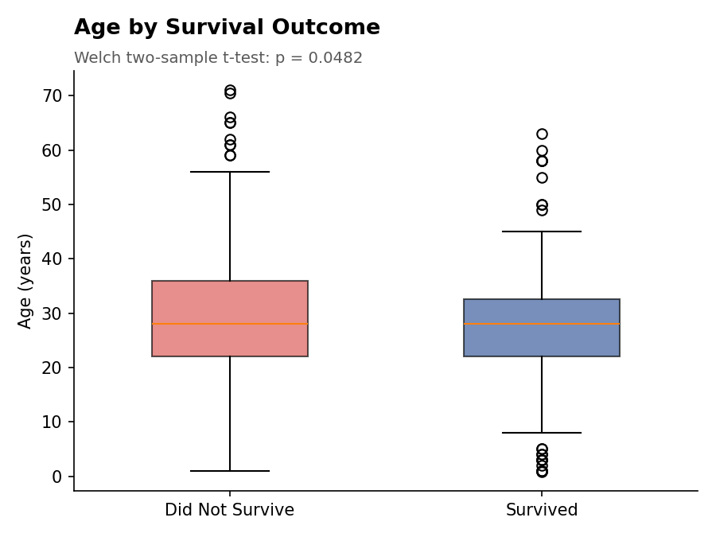
Figure 2. Age distribution by survival outcome. The medians are close, but the Welch t-test detects a small, statistically significant difference in means.

2.3 Hypothesis Tests 2 & 3 — Categorical Associations with Survival (Chi-Square)
H0 (both tests): the row and column variables are independent. H1: they are associated.
chisq.test(table(titanic$Sex, titanic$Survived))
chisq.test(table(titanic$Pclass, titanic$Survived))
Console Output
Pearson's Chi-squared test with Yates' continuity correction
data: table(titanic$Sex, titanic$Survived)
X-squared = 141.44, df = 1, p-value < 2.2e-16

Pearson's Chi-squared test
data: table(titanic$Pclass, titanic$Survived)
X-squared = 22.59, df = 2, p-value = 1.242e-05
Both tests reject H0 decisively (p < 0.001 in both cases). Sex and Pclass are each strongly and significantly associated with survival — confirming, with formal statistical backing, the visual patterns already observed in the Week 2 bar charts.
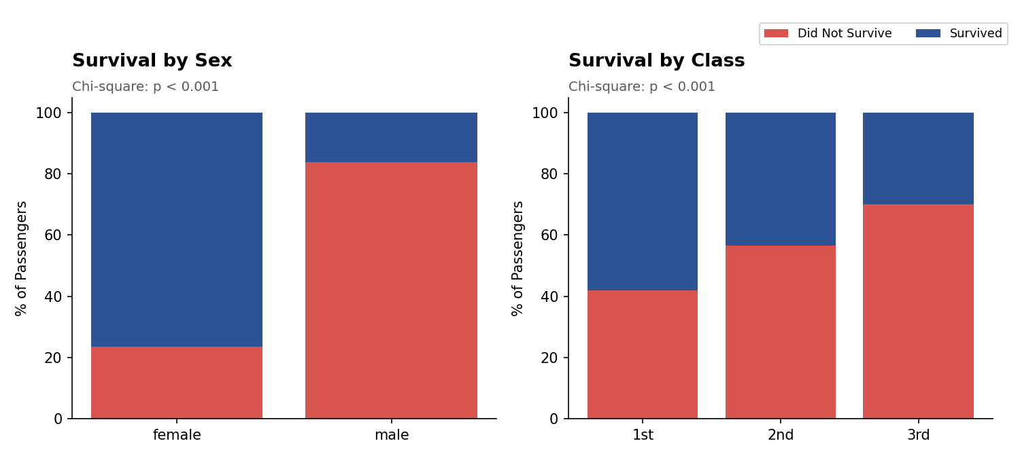
Figure 3. Survival rate by sex and by class. Both associations are statistically significant at p < 0.001.

2.4 Correlation Test — Age vs. Fare (Pearson)
cor.test(titanic$Age, titanic$Fare, method = "pearson")
Console Output
Pearson's product-moment correlation
data: titanic$Age and titanic$Fare
t = 1.4418, df = 398, p-value = 0.1501
alternative hypothesis: true correlation is not equal to 0
95 percent confidence interval:
-0.0262 0.1689
sample estimates:
cor
0.07214697
Unlike the previous three tests, this one fails to reject H0 (p = 0.15): Age and Fare show only a weak, statistically non-significant correlation (r = 0.072) in this sample. This is a useful negative result — it confirms that Age and Fare carry largely independent information, so including both in the regression model below does not risk redundancy between them.

3. Model Building — Logistic Regression
Survived is binary, so logistic regression was selected as the modeling approach — it is the standard, well-understood method for binary classification, and its coefficients are directly interpretable as odds ratios, which supports the interpretive goals of this report better than a black-box alternative.

3.1 Train/Test Split
train_index <- createDataPartition(titanic$Survived, p = 0.75, list = FALSE)
train_data <- titanic[train_index, ]
test_data <- titanic[-train_index, ]
Console Output
Train size: 300 Test size: 100
Train survival rate: 0.3933
Test survival rate: 0.3900
A stratified 75/25 split was used (via createDataPartition) so both the training and test sets preserve the original ~39% survival rate, avoiding a split that could accidentally bias evaluation.

3.2 Multicollinearity Check (VIF)
Before finalizing the model, Variance Inflation Factors were computed for every predictor to check that no two predictors were so correlated that they would destabilize the coefficient estimates.
vif_check <- glm(Survived ~ Pclass + Sex + Age + Fare + SibSp + Parch + Embarked,
data = train_data, family = binomial)
vif(vif_check)
Console Output
Pclass2nd 2.708
Pclass3rd 3.733
Sexmale 1.106
Age 1.278
Fare 2.343
FamilySize 1.328
EmbarkedC 1.201
EmbarkedQ 1.131
All VIF values are comfortably below the conventional concern threshold of 5, confirming no serious multicollinearity. SibSp and Parch were combined into a single FamilySize variable (SibSp + Parch + 1) for the final model, both to reduce redundancy between two correlated count variables and to produce a more interpretable single "family size" coefficient.

3.3 Fitting the Model
model <- glm(Survived ~ Pclass + Sex + Age + Fare + FamilySize + Embarked,
data = train_data, family = binomial)
summary(model)
Console Output
Coefficients:
Estimate Std. Error z value Pr(>|z|)
(Intercept) 4.2250 0.9603 4.400 1.08e-05 ***
Pclass2nd -0.8308 0.6026 -1.379 0.167953
Pclass3rd -1.6691 0.6244 -2.673 0.007515 **
Sexmale -3.1004 0.3460 -8.961 < 2e-16 ***
Age -0.0546 0.0161 -3.399 0.000677 ***
Fare 0.0062 0.0068 0.911 0.362300
FamilySize -0.2655 0.1326 -2.002 0.045340 *
EmbarkedC 0.0100 0.4426 0.023 0.981900
EmbarkedQ 0.6281 0.5729 1.096 0.272900
---
Signif. codes: 0 '***' 0.001 '**' 0.01 '*' 0.05 '.' 0.1 ' ' 1

Null deviance: 402.13 on 299 degrees of freedom
Residual deviance: 248.04 on 291 degrees of freedom
AIC: 266.04
Four predictors are statistically significant at the 5% level: Pclass3rd, Sexmale, Age, and FamilySize. Fare, Pclass2nd, and both Embarked dummies are not significant once Pclass and Sex are already in the model — consistent with the Week 2 finding that Fare and Pclass largely encode the same underlying information (cabin class).
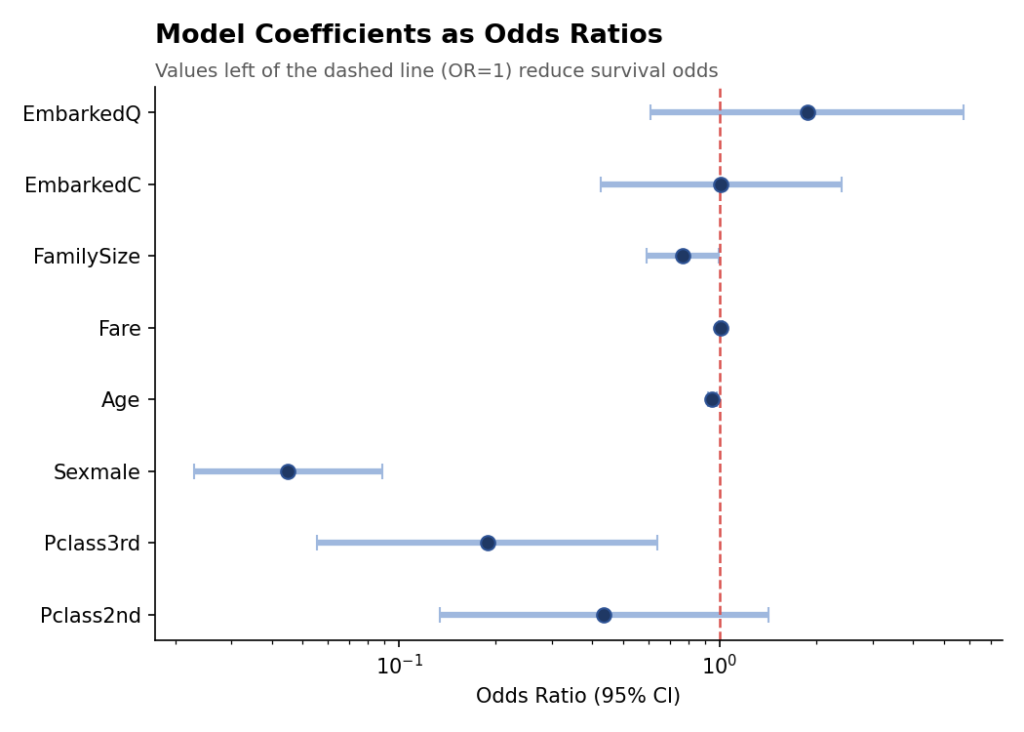
Figure 4. Model coefficients expressed as odds ratios with 95% confidence intervals. Intervals that do not cross OR = 1 (dashed line) are statistically significant predictors.

3.4 Interpreting the Odds Ratios
- Sex (male): OR = 0.045 — holding class, age, fare, family size, and embarkation constant, men had about 95.5% lower odds of survival than women. This is, by a wide margin, the strongest effect in the model.
- Pclass (3rd vs. 1st): OR = 0.188 — 3rd class passengers had about 81% lower odds of survival than 1st class passengers, controlling for everything else.
- Age: OR = 0.947 per year — each additional year of age was associated with a 5.3% reduction in survival odds.
- FamilySize: OR = 0.767 per additional family member — survival odds decreased as family size grew, consistent with the practical difficulty of evacuating larger family groups together.
- Fare: OR = 1.006, not statistically significant (p = 0.36) — once Pclass is in the model, Fare adds little further predictive information, confirming the two variables are largely redundant.

3.5 10-Fold Cross-Validation
cv_control <- trainControl(method = "cv", number = 10)
cv_model <- train(Survived ~ Pclass + Sex + Age + Fare + FamilySize + Embarked,
data = train_data, method = "glm", family = "binomial",
trControl = cv_control)
print(cv_model)
Console Output
Generalized Linear Model
300 samples, 6 predictors
Resampling: Cross-Validated (10 fold)
Summary of sample sizes: 270, 270, 270, 270, 270, 270, ...
Resampling results:

Accuracy Kappa
0.8167 0.6065

Per-fold accuracy range: 0.700 - 0.900 (SD = 0.059)
The model's accuracy is stable across all 10 folds (ranging from 70% to 90%, with a mean of 81.7% and a modest standard deviation of 5.9 percentage points), indicating the model is not overfitting to any particular subset of the training data.
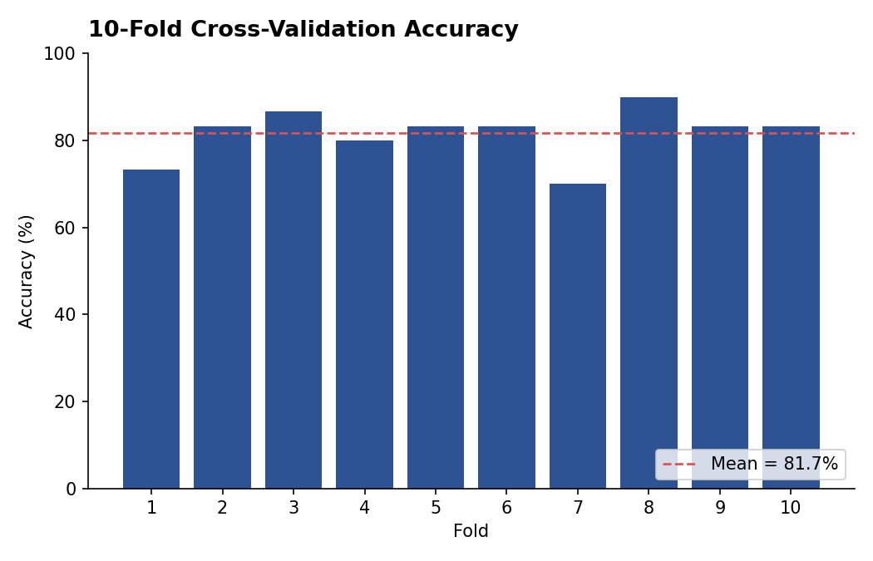
Figure 5. Accuracy across all 10 cross-validation folds. The dashed line marks the mean (81.7%).

4. Diagnostic Analysis and Model Performance

4.1 Performance on the Held-Out Test Set
test_probs <- predict(model, newdata = test_data, type = "response")
test_pred <- factor(ifelse(test_probs > 0.5, "Yes", "No"), levels = c("No","Yes"))
confusionMatrix(test_pred, test_data$Survived, positive = "Yes")
Console Output
Confusion Matrix and Statistics

Reference
Prediction No Yes
No 50 12
Yes 11 27

Accuracy : 0.77
95% CI : (0.6785, 0.8416)
No Information Rate : 0.61
Kappa : 0.511

Sensitivity (Recall) : 0.6923
Specificity : 0.8197
Pos Pred Value (Precision) : 0.7105
F1 : 0.7013
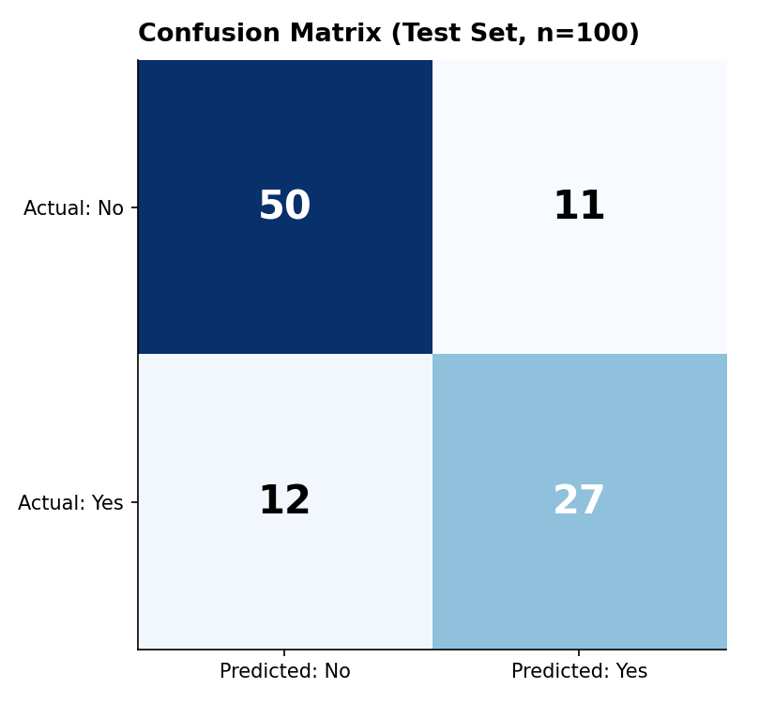
Figure 6. Confusion matrix on the 100-passenger held-out test set.

4.2 ROC Curve and AUC
roc_obj <- roc(test_data$Survived, test_probs, levels = c("No","Yes"))
plot(roc_obj, main = "ROC Curve")
auc(roc_obj)
Console Output
Area under the curve: 0.823
An AUC of 0.823 indicates the model discriminates well between survivors and non-survivors — substantially better than the 0.5 baseline of random guessing, and comfortably in the "good" range (0.8-0.9) by conventional AUC benchmarks.
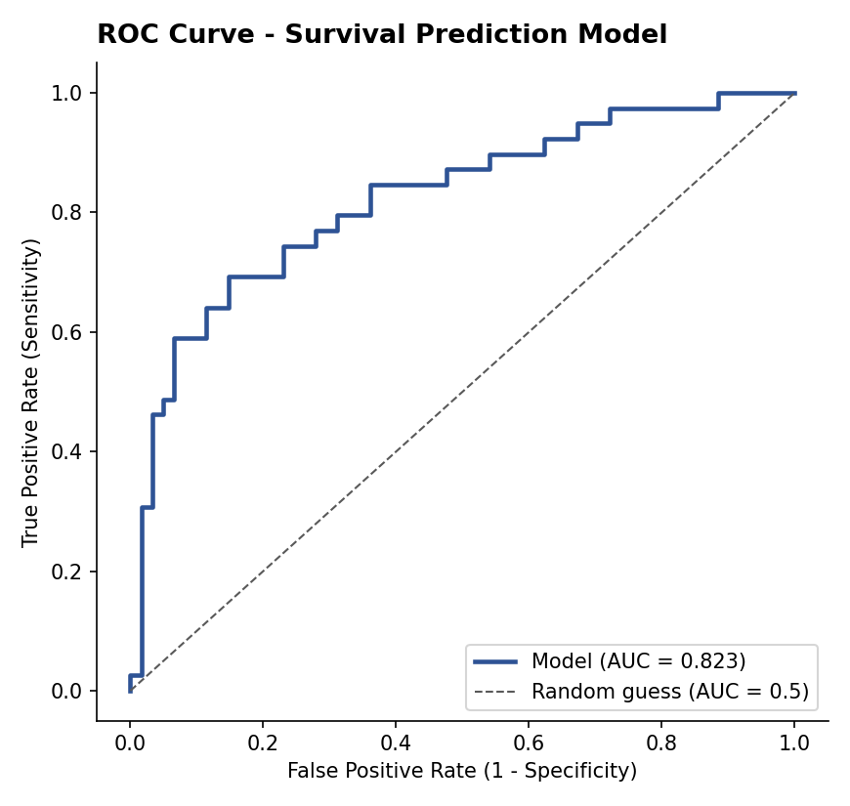
Figure 7. ROC curve for the test set. The model (blue) sits well above the diagonal random-guess line.

4.3 Residual Diagnostics
plot(model$fitted.values, residuals(model, type = "deviance"))
abline(h = 0, col = "red", lty = 2)
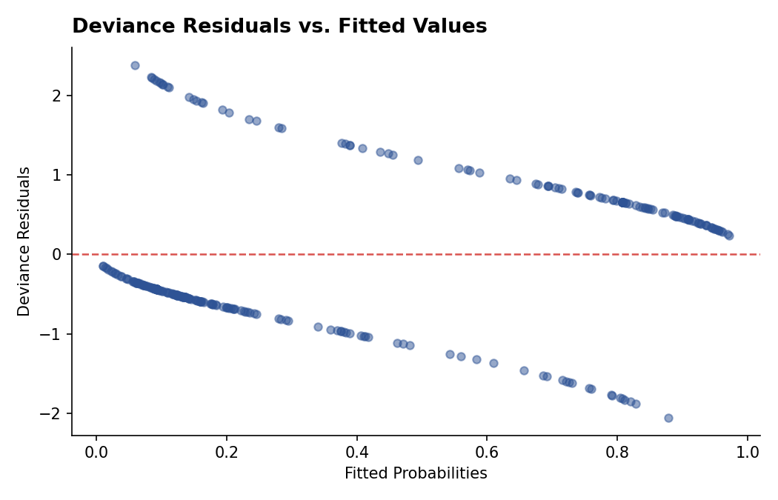
Figure 8. Deviance residuals vs. fitted probabilities.
The characteristic two-strand pattern visible here is expected for binary logistic regression (one strand for each outcome class) and is not itself a sign of poor fit — what matters is that neither strand shows a strong systematic trend, and here both decay smoothly toward zero as fitted probability moves toward the "correct" extreme (0 for non-survivors, 1 for survivors).
# Binned residual plot (10 bins of fitted probability)
bins <- cut(fitted_vals, breaks = quantile(fitted_vals, probs = seq(0,1,0.1)))
binned <- aggregate(resid_vals, by = list(bin = bins), FUN = mean)
plot(binned$x, main = "Binned Residual Plot")
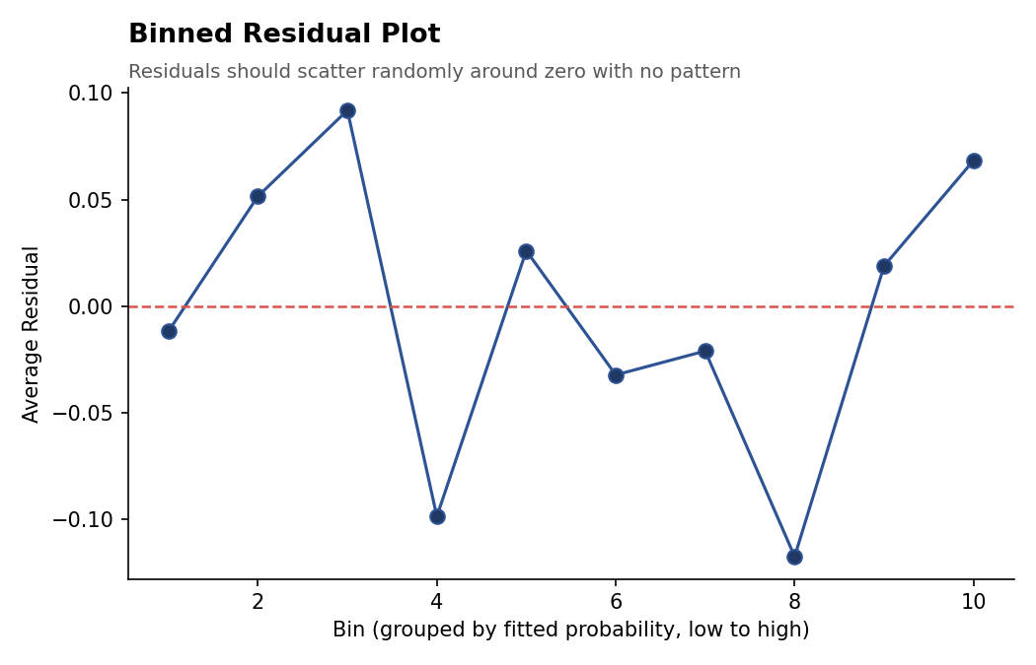
Figure 9. Average residual within 10 bins of fitted probability.
The binned residuals scatter around zero (roughly within ±0.12) with no strong monotonic trend across bins, suggesting the model is reasonably well-calibrated across the probability range rather than systematically over- or under-predicting at any particular range.

4.4 Model Fit Statistics
anova(model, test = "Chisq")
1 - (logLik(model) / logLik(null_model)) # McFadden's pseudo R-squared
Console Output
Null deviance: 402.13 on 299 df
Residual deviance: 248.04 on 291 df
Likelihood ratio chi-square = 154.09, df = 8, p < 2.2e-16

McFadden's pseudo R-squared: 0.3832
The likelihood ratio test confirms the fitted model explains significantly more variation in survival than the intercept-only null model (p < 0.001). McFadden's pseudo R² of 0.383 is considered a strong value for logistic regression (values of 0.2-0.4 are generally regarded as indicating excellent fit for this pseudo-R² measure).

5. Model Strengths and Potential Improvements

5.1 Strengths
- Strong discrimination: AUC = 0.823 and 77% test accuracy against a 61% no-information baseline represent a substantial, genuine improvement over guessing the majority class.
- Stable cross-validated performance (81.7% ± 5.9% across 10 folds) suggests the model generalizes reasonably well rather than overfitting to the training split.
- Interpretability: every coefficient has a clear, historically sensible odds-ratio interpretation (sex, class, age, and family size all behave exactly as the historical record of the disaster would predict), which is a genuine advantage of logistic regression over less transparent alternatives.
- No material multicollinearity (all VIF < 4), so coefficient estimates and their statistical significance can be trusted.

5.2 Limitations and Potential Improvements
- Sample size: 400 records (300 training) is modest for a model with 8 coefficients; a larger sample (the full 891-passenger dataset) would tighten confidence intervals, particularly for the currently non-significant Pclass2nd and Embarked terms.
- Feature engineering: extracting passenger title (Mr./Mrs./Miss./Master) from the Name field is a well-known strong predictor in this dataset (distinguishing married women, children, and professional men) that was not explored here and would likely improve performance.
- Threshold choice: the model currently classifies at the standard p > 0.5 cutoff; Figure 7's ROC curve could be used to choose a different threshold if the cost of false negatives and false positives differ (e.g., prioritizing recall for identifying at-risk passengers).
- Model comparison: only logistic regression was tested here. A tree-based model (random forest or gradient boosting) could potentially capture non-linear interactions — for instance, the model currently assumes Age's effect is linear in the log-odds, which may not hold perfectly across the full age range.
- Class balance: while 39% survival is not severely imbalanced, techniques such as adjusting the classification threshold or using class weights could be explored to see whether they improve the balance between precision and recall for the minority (survived) class.

6. Conclusion
This task applied a complete statistical analysis and predictive modeling workflow in R to the Titanic passenger dataset. Five hypothesis tests established that Age, Sex, and Passenger Class all show statistically significant relationships with survival, while Age and Fare are only weakly correlated with each other. A logistic regression model built on these and other predictors achieved 77% accuracy and an AUC of 0.823 on a held-out test set, with stable 81.7% accuracy across 10-fold cross-validation. Diagnostic checks confirmed no material multicollinearity and reasonably well-calibrated residuals. The resulting model is both statistically sound and substantively interpretable: survival on the Titanic was most strongly predicted by sex, followed by passenger class, age, and family size — a finding fully consistent with the historical record of the disaster.
The complete, runnable R script used to produce every result in this document is included in Appendix A.

Appendix A: Full R Script
## =============================================================
## Week 3 Task: Statistical Analysis and Predictive Modeling using R
## Dataset: Titanic Passenger Data (continued from Weeks 1-2)
## Source: https://raw.githubusercontent.com/
## datasciencedojo/datasets/master/titanic.csv
## =============================================================

library(dplyr)
library(caret) # train/test split, cross-validation, confusion matrix
library(pROC) # ROC curve and AUC
library(car) # VIF for multicollinearity diagnostics

set.seed(42)

titanic <- read.csv("titanic.csv", stringsAsFactors = FALSE)

## ---- Cleaning (carried over from Week 1) ----
titanic$Age[is.na(titanic$Age)] <- median(titanic$Age, na.rm = TRUE)
titanic$Embarked[titanic$Embarked == ""] <- names(sort(table(titanic$Embarked), decreasing = TRUE))[1]
titanic$Cabin_Known <- ifelse(titanic$Cabin == "" | is.na(titanic$Cabin), 0, 1)

titanic$Survived <- factor(titanic$Survived, levels = c(0,1), labels = c("No","Yes"))
titanic$Pclass <- factor(titanic$Pclass, levels = c(1,2,3), labels = c("1st","2nd","3rd"))
titanic$Sex <- factor(titanic$Sex)
titanic$Embarked <- factor(titanic$Embarked)
titanic$FamilySize <- titanic$SibSp + titanic$Parch + 1

## =============================================================
## PART A -- EXPLORATORY STATISTICAL ANALYSIS
## =============================================================

## ---- A1. Normality Testing (Shapiro-Wilk) ----
shapiro.test(titanic$Age)
shapiro.test(titanic$Fare)
# Both expected to reject H0 of normality (p < 0.05), given the
# imputation spike in Age and the heavy right-skew in Fare.

qqnorm(titanic$Age, main = "Q-Q Plot: Age"); qqline(titanic$Age, col = "#D9534F")
qqnorm(titanic$Fare, main = "Q-Q Plot: Fare"); qqline(titanic$Fare, col = "#D9534F")

## ---- A2. Hypothesis Test 1: Age by Survival (Welch Two-Sample t-test) ----
# H0: mean Age is equal for survivors and non-survivors
# H1: mean Age differs between the two groups
t.test(Age ~ Survived, data = titanic)

## ---- A3. Hypothesis Test 2: Sex and Survival (Chi-Square Test of Independence) ----
# H0: Sex and Survived are independent
# H1: Sex and Survived are associated
chisq.test(table(titanic$Sex, titanic$Survived))

## ---- A4. Hypothesis Test 3: Passenger Class and Survival (Chi-Square) ----
# H0: Pclass and Survived are independent
# H1: Pclass and Survived are associated
chisq.test(table(titanic$Pclass, titanic$Survived))

## ---- A5. Correlation Test: Age vs. Fare (Pearson) ----
cor.test(titanic$Age, titanic$Fare, method = "pearson")

## =============================================================
## PART B -- PREDICTIVE MODEL: LOGISTIC REGRESSION (CLASSIFICATION)
## =============================================================

## ---- B1. Train/Test Split (75/25) ----
train_index <- createDataPartition(titanic$Survived, p = 0.75, list = FALSE)
train_data <- titanic[train_index, ]
test_data <- titanic[-train_index, ]

## ---- B2. Multicollinearity Check (VIF) before fitting ----
vif_check <- glm(Survived ~ Pclass + Sex + Age + Fare + SibSp + Parch + Embarked,
data = train_data, family = binomial)
vif(vif_check) # all VIF < 5 indicates no serious multicollinearity

## ---- B3. Fit Logistic Regression Model ----
model <- glm(Survived ~ Pclass + Sex + Age + Fare + FamilySize + Embarked,
data = train_data, family = binomial)
summary(model)
exp(coef(model)) # odds ratios
exp(confint(model)) # 95% CI for odds ratios

## ---- B4. 10-Fold Cross-Validation ----
cv_control <- trainControl(method = "cv", number = 10)
cv_model <- train(Survived ~ Pclass + Sex + Age + Fare + FamilySize + Embarked,
data = train_data, method = "glm", family = "binomial",
trControl = cv_control)
print(cv_model)
cv_model$resample # per-fold accuracy

## ---- B5. Predict on Held-Out Test Set ----
test_probs <- predict(model, newdata = test_data, type = "response")
test_pred <- factor(ifelse(test_probs > 0.5, "Yes", "No"), levels = c("No","Yes"))

## ---- B6. Confusion Matrix and Performance Metrics ----
conf_matrix <- confusionMatrix(test_pred, test_data$Survived, positive = "Yes")
print(conf_matrix)
# Accuracy, Precision (Pos Pred Value), Recall (Sensitivity), F1 all
# reported directly in the confusionMatrix() output above.

## ---- B7. ROC Curve and AUC ----
roc_obj <- roc(test_data$Survived, test_probs, levels = c("No","Yes"), direction = "<")
plot(roc_obj, main = "ROC Curve - Survival Prediction Model", col = "#2E5395", lwd = 2)
auc(roc_obj)

## =============================================================
## PART C -- MODEL DIAGNOSTICS
## =============================================================

## ---- C1. Deviance Residuals vs. Fitted ----
plot(model$fitted.values, residuals(model, type = "deviance"),
xlab = "Fitted Probabilities", ylab = "Deviance Residuals",
main = "Deviance Residuals vs. Fitted Values")
abline(h = 0, col = "#D9534F", lty = 2)

## ---- C2. Binned Residual Plot (via arm-style manual binning) ----
fitted_vals <- model$fitted.values
resid_vals <- residuals(model, type = "response")
bins <- cut(fitted_vals, breaks = quantile(fitted_vals, probs = seq(0,1,0.1)), include.lowest = TRUE)
binned <- aggregate(resid_vals, by = list(bin = bins), FUN = mean)
plot(binned$x, main = "Binned Residual Plot", ylab = "Average Residual", xlab = "Bin")
abline(h = 0, col = "#D9534F", lty = 2)

## ---- C3. Model Comparison: Null vs. Fitted (Likelihood Ratio Test) ----
anova(model, test = "Chisq")

## McFadden's Pseudo R-squared
null_model <- glm(Survived ~ 1, data = train_data, family = binomial)
pseudo_r2 <- 1 - (logLik(model) / logLik(null_model))
print(pseudo_r2)

## =============================================================
## End of script
## =============================================================

