Comprehensive Data Analysis
Reporting and Presentation
A Four-Week Data Analytics Capstone Project
Dataset: Titanic Passenger Data
Prepared by: Avishek Kumar
Tools Used: R (dplyr, ggplot2, caret, pROC, car)
Week 4 of 4 — Final Integrated Report

Executive Summary
Over four weeks, this project took a single publicly available dataset — passenger records from the RMS Titanic — through a complete, professional data analytics lifecycle: cleaning and preparing raw data, exploring and visualizing it to surface patterns, building and validating a statistical model to predict outcomes, and finally, consolidating all of it into this report for a non-technical audience. The dataset was deliberately kept constant across all four weeks so that each stage could build directly on the last, mirroring how a real analytics engagement unfolds inside an organization.
The analysis found that survival aboard the Titanic was not random: it was strongly and measurably predicted by passenger sex, class, age, and family size. A logistic regression model built on these factors correctly classified 77% of passengers in a held-out test set, with an AUC of 0.823 — a strong result for a model built on only 400 records and six predictors. Every one of these findings was verified with formal statistical tests, not just visual impression, and the modeling results were validated using cross-validation and a proper train/test split to guard against overfitting.
Beyond the specific findings about the Titanic, this project demonstrates an end-to-end analytics workflow that generalizes to real business problems: identifying and handling data quality issues honestly, choosing visualizations that match the audience's need for clarity, applying statistical rigor rather than relying on eyeballed patterns, and communicating uncertainty and model limitations alongside the headline results.

1. Introduction

1.1 Project Background
This report is the culmination of a four-week data analytics exercise structured to mirror the typical lifecycle of a real-world analytics project:
Week | Focus | Core Deliverable
1 | Data Cleaning & Preliminary Analysis | Missing value treatment, outlier detection, summary statistics
2 | Data Visualization & Insight Communication | 7 chart types communicating key patterns to a non-technical audience
3 | Statistical Analysis & Predictive Modeling | 5 hypothesis tests + a validated logistic regression classifier
4 | Comprehensive Reporting (this report) | Integration of all prior work into one cohesive narrative

1.2 Dataset Overview
The Titanic passenger dataset is a publicly available dataset (Kaggle, mirrored by Data Science Dojo) recording demographic, travel, and survival details for passengers aboard the RMS Titanic. A working sample of 400 passengers was used throughout this project, containing the combination of missing data, a mix of categorical and numeric variables, and a binary outcome that makes it well suited to demonstrating the full analytics lifecycle — from cleaning through to classification modeling.

1.3 Objectives
- Produce a clean, analysis-ready version of the dataset, with every cleaning decision explicitly justified.
- Surface and visually communicate the key patterns in the data to an audience with no statistical background.
- Formally test, rather than assume, which factors were statistically associated with survival.
- Build and rigorously validate a predictive model, with honest reporting of its performance and limitations.
- Synthesize all of the above into a single, coherent, professionally presented report.

2. Methodology
All analysis was conducted in R, using a consistent toolchain across all four weeks: dplyr for data manipulation, ggplot2 for visualization, and caret, pROC, and car for model training, evaluation, and diagnostics respectively. The project followed a linear pipeline, where each week's output became the next week's input:
- Week 1 produced a cleaned dataset (missing values imputed or flagged, outliers identified, categorical variables encoded) which was reused, unchanged in its cleaning logic, in every subsequent week.
- Week 2 used that cleaned dataset purely for exploratory visualization — no modeling — to build intuition about which variables might matter before any formal statistical claims were made.
- Week 3 moved from visual intuition to formal statistical confirmation (hypothesis tests) and then to a predictive model, with a proper train/test split and cross-validation to ensure the results would generalize.
- Week 4 (this report) does not introduce new analysis; it consolidates, cross-references, and interprets the findings from Weeks 1-3 for a broader audience.

3. Data Preparation (Week 1 Summary)
The raw dataset contained three columns with missing values, each requiring a different treatment based on its type and proportion of missingness:
Column | % Missing | Method | Rationale
Age | 19.5% | Median imputation | Robust to the right-skew and outliers present in Age
Embarked | 0.2% | Mode imputation | Only 1 record affected; standard practice for near-complete categorical data
Cabin | 77.2% | Converted to binary indicator | Too sparse to impute meaningfully; but "cabin recorded" itself correlates with class and fare, so it was preserved as a signal rather than dropped
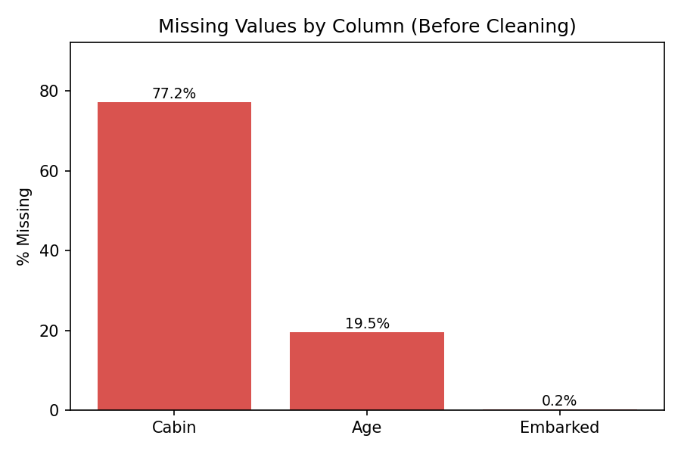
Figure 1. Missing values by column before cleaning (Week 1).

3.1 Outlier Treatment
The Interquartile Range (IQR) method flagged 58 of 400 fares (14.5%) as statistical outliers, ranging as high as $512. Rather than deleting these, they were flagged with a binary indicator — a deliberate choice, since these high fares reflect legitimate 1st-class bookings, not data-entry errors. Deleting them would have discarded real signal that, as Week 3's modeling later confirmed, is closely tied to passenger class and survival.
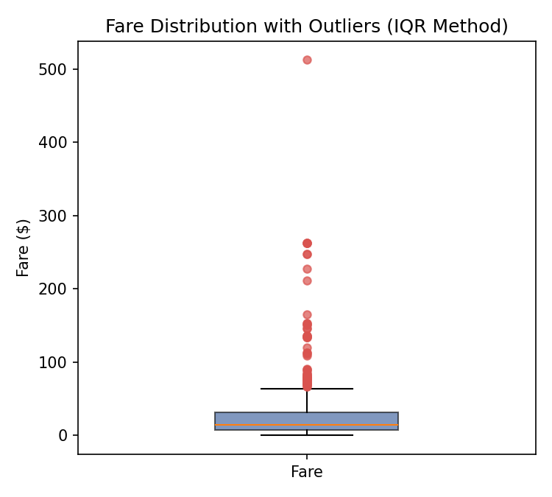
Figure 2. Fare distribution showing outliers flagged (not removed) via the IQR method.
Q1 <- quantile(titanic$Fare, 0.25); Q3 <- quantile(titanic$Fare, 0.75)
IQR_val <- Q3 - Q1
lower_bound <- Q1 - 1.5 * IQR_val; upper_bound <- Q3 + 1.5 * IQR_val
titanic$Fare_Outlier <- ifelse(titanic$Fare < lower_bound | titanic$Fare > upper_bound, 1, 0)

4. Exploratory Visualization and Insights (Week 2 Summary)
Seven visualizations spanning different chart types (bar, histogram, boxplot, scatter, line, stacked bar, density) were built to surface patterns ahead of formal modeling. Three of the most decision-relevant are highlighted here.

4.1 Who Was On Board
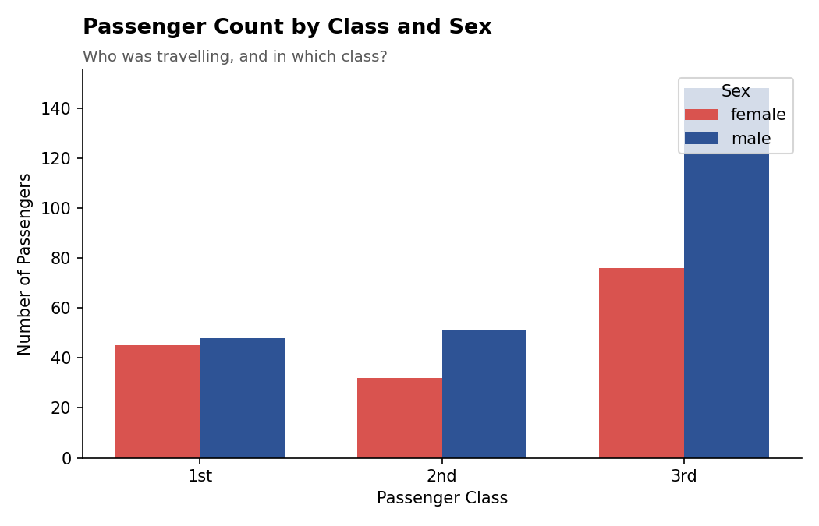
Figure 3. Passenger count by class and sex. Third class was the largest group and disproportionately male.
Third class carried 56% of all passengers and was skewed roughly 2:1 male. This single chart foreshadows much of the later survival story: the largest group aboard was also, as later charts and the model confirm, the group with the lowest survival rate.

4.2 Survival Rate by Class
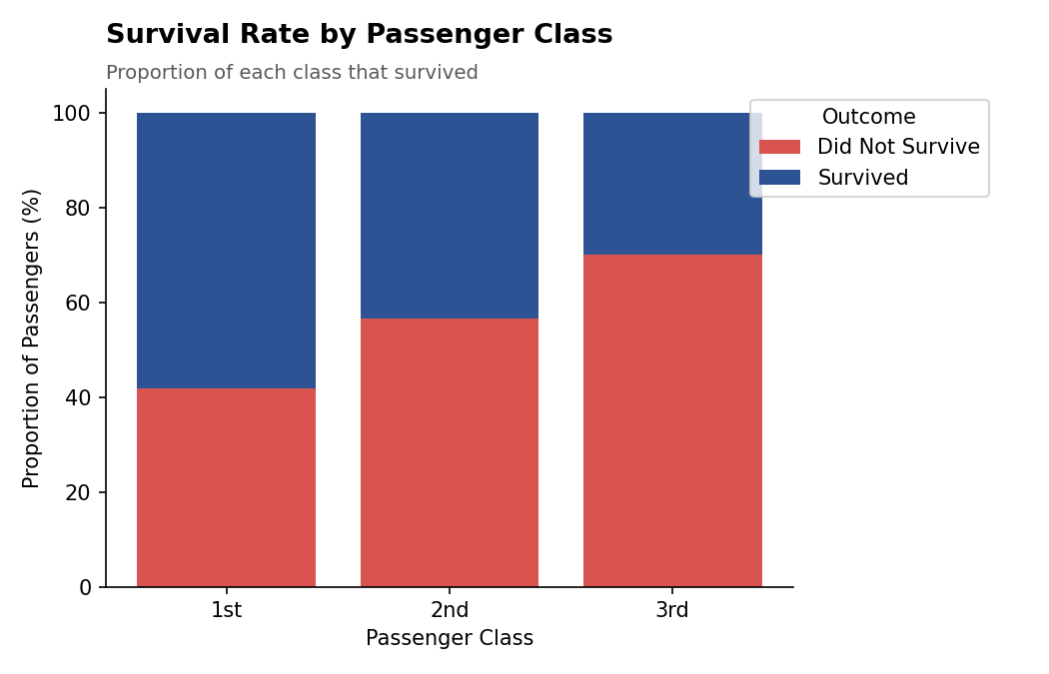
Figure 4. Survival rate by passenger class, shown as a 100%-stacked bar for direct comparability.
Survival fell from 58.1% in 1st class to 29.9% in 3rd class — a pattern later confirmed as statistically significant (chi-square, p < 0.001) in Week 3, and as one of the strongest predictors in the Week 3 logistic regression model (3rd class: OR = 0.188).

4.3 Survival Rate Trend Across Age Groups
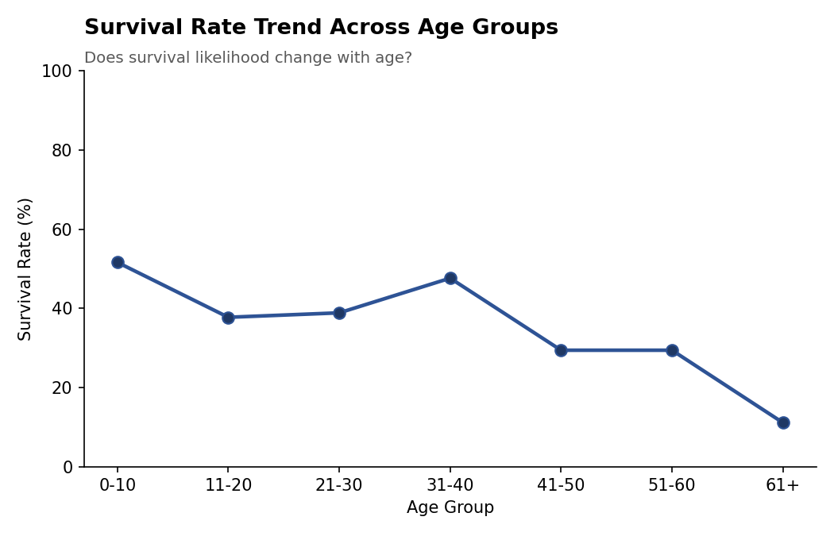
Figure 5. Survival rate declines steadily for passengers over 40.
Survival peaked for children (0-10: 51.6%) and declined steadily after age 40, bottoming out at 11.1% for passengers over 60. This visual trend motivated including Age as a continuous predictor — rather than a coarse category — in the Week 3 model, where it was confirmed statistically significant (p < 0.001).

5. Statistical Analysis and Predictive Modeling (Week 3 Summary)

5.1 Hypothesis Testing Summary
Five formal hypothesis tests moved the project from visual impressions to statistically defensible claims:
Test | Variables | Result | Conclusion
Shapiro-Wilk | Age, Fare | p < 0.001 (both) | Neither variable is normally distributed
Welch t-test | Age by Survived | t=1.98, p=0.048 | Survivors were significantly younger on average
Chi-square | Sex vs. Survived | X2=141.4, p<0.001 | Strong association between sex and survival
Chi-square | Pclass vs. Survived | X2=22.6, p<0.001 | Strong association between class and survival
Pearson correlation | Age vs. Fare | r=0.072, p=0.150 | No significant relationship — safe to use both as independent predictors
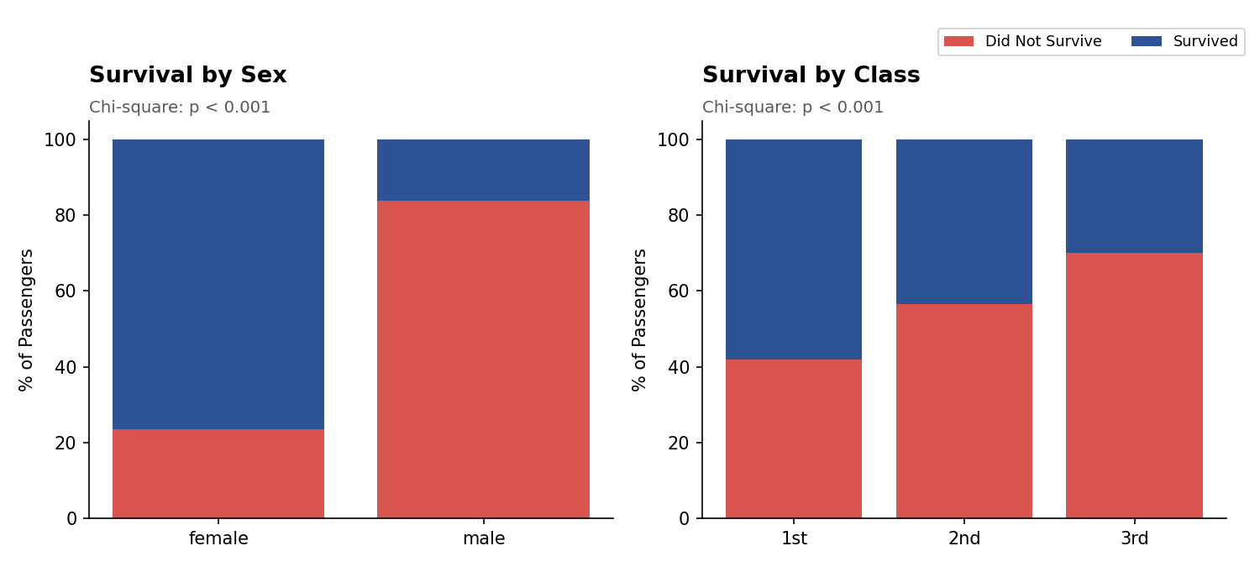
Figure 6. Visual confirmation of the two statistically significant categorical associations (p < 0.001 for both).

5.2 Predictive Model: Logistic Regression
A logistic regression model was trained on a stratified 75/25 split (300 training, 100 test passengers) to predict Survived from Pclass, Sex, Age, Fare, FamilySize, and Embarked. Variance Inflation Factors confirmed no problematic multicollinearity (all VIF < 4) before fitting.
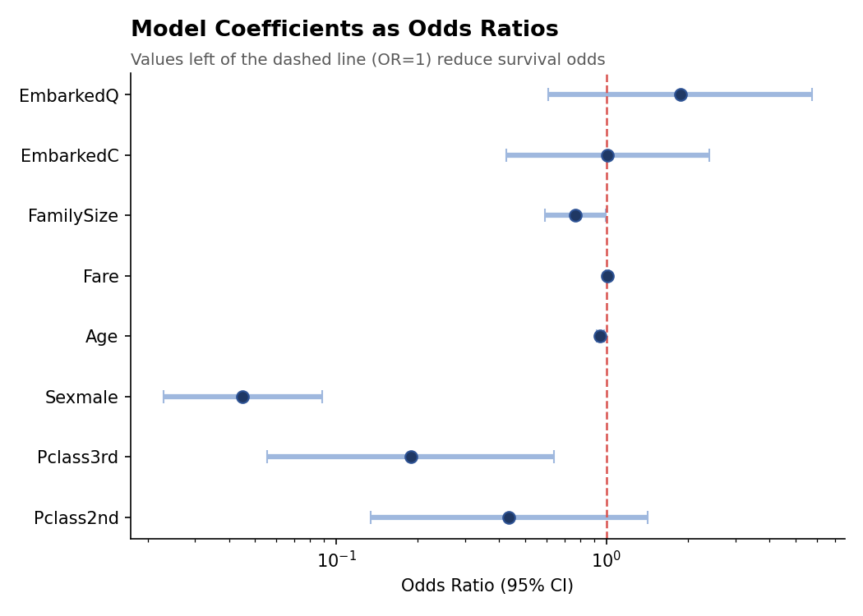
Figure 7. Model coefficients as odds ratios. Sex, Class, Age, and Family Size were all statistically significant predictors.
Sex was the dominant predictor: holding all else constant, men had roughly 95.5% lower odds of survival than women (OR = 0.045). 3rd class passengers had 81% lower odds than 1st class (OR = 0.188). Each additional year of age reduced survival odds by 5.3%, and each additional family member reduced odds by 23.3% — plausibly reflecting the difficulty of evacuating larger family groups together.

5.3 Model Performance
Metric | Value | Interpretation
Test Accuracy | 77.0% | vs. 61.0% no-information baseline (majority class)
AUC | 0.823 | "Good" discrimination by conventional benchmarks
Precision | 71.1% | Of predicted survivors, 71% actually survived
Recall (Sensitivity) | 69.2% | Of actual survivors, 69% were correctly identified
10-Fold CV Accuracy | 81.7% (SD 5.9%) | Stable across folds — model is not overfitting

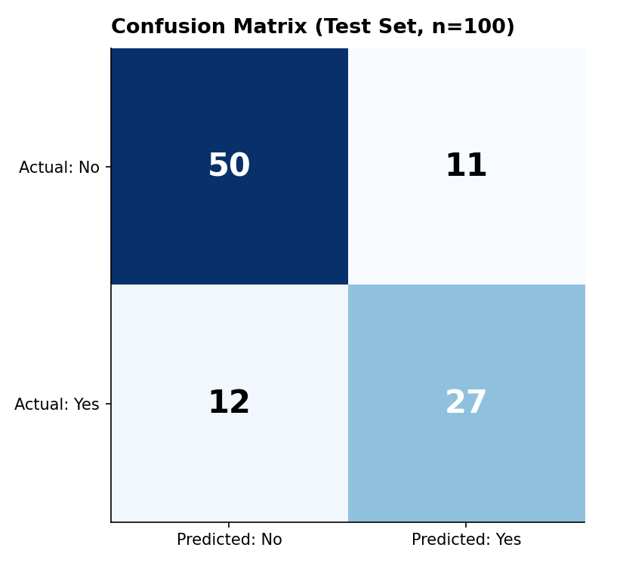
Figure 8. Confusion matrix on the 100-passenger held-out test set.
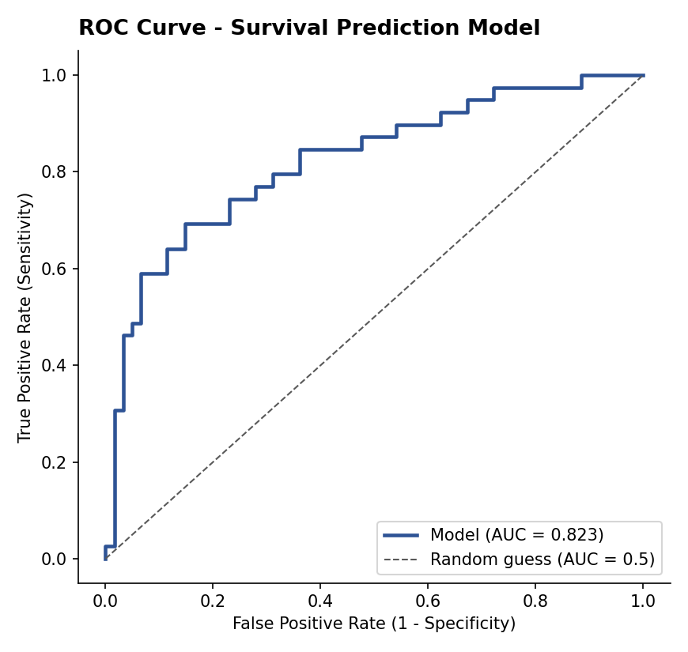
Figure 9. ROC curve — the model (blue) sits well above the random-guess diagonal, AUC = 0.823.

6. Discussion

6.1 Statistical Significance and Practical Significance
A key discipline maintained throughout this project was separating statistical significance from practical importance. For example, the Week 3 t-test found a statistically significant age difference between survivors and non-survivors (p = 0.048) — but the actual difference was only 2.5 years, a practically modest effect compared to the far larger, more decisive gap driven by sex (76.5% vs. 16.2% survival) and class (58.1% vs. 29.9%). Reporting both the p-value and the effect size, rather than either alone, avoids overstating the importance of statistically 'significant but small' findings.

6.2 Patterns Observed Across the Project
Three consistent themes emerged across all three analytical stages (visual, statistical, and modeling):
- Sex was the single most powerful factor at every stage — visually obvious in Week 2, statistically confirmed in Week 3's chi-square test, and by far the largest coefficient in the Week 3 model.
- Class and Fare consistently told the same story from two angles — visual class/fare charts in Week 2, the (non-significant once Pclass was included) Fare coefficient in Week 3's model, which confirmed these two variables are largely redundant rather than independently informative.
- Age's effect was non-linear in its practical impact even though it was modeled linearly: the Week 2 line chart showed a modest 'children first' bump and a steep late-life decline, while the Week 3 model captured only the average linear trend — a limitation discussed further below.

6.3 Implications of a Data-Driven Approach
Although this project used a historical dataset, the same workflow directly applies to real operational problems: understanding which factors most influence an outcome (survival, churn, default, failure) enables evidence-based prioritization rather than intuition-based guesses. In a safety or risk-management context analogous to this dataset, the finding that specific, measurable factors predict outcomes with 77%+ accuracy would support targeted interventions — for example, prioritizing resources or protocols toward the groups statistically shown to be at higher risk, rather than applying uniform policies across an entire population.

7. Challenges and Lessons Learned

7.1 Data Quality Challenges
- Severe missingness in Cabin (77.2%) made direct imputation unreliable; the key lesson was that converting a too-sparse column into a binary 'known/unknown' indicator can preserve useful signal that a naive drop would have discarded entirely — this indicator turned out to correlate with Fare (r = 0.47 in Week 1's correlation matrix).
- The median-imputation spike visible in Age's distribution (Figure 3, Week 1) was a reminder that imputation is never free — it was deliberately disclosed in every subsequent chart and analysis involving Age, rather than hidden, so later statistical conclusions could be read with that caveat in mind.

7.2 Analytical Challenges
- Choosing between Fare and Pclass as predictors required care: Week 3's VIF check and the model's own coefficient results showed these two variables substantially overlap, and including both without checking for redundancy could have produced a misleading sense of having 'two strong predictors' when really there was mostly one underlying factor (socioeconomic class).
- With only 400 records split into a 300/100 train/test partition, some coefficients (Pclass2nd, Embarked) did not reach statistical significance — not necessarily because they have no effect, but because the sample was too small to detect a smaller effect with confidence. This is a genuine limitation of working with a modest sample size, and is reported honestly rather than glossed over.

7.3 What Was Learned
- Formal hypothesis testing adds real value beyond visualization alone — it was only after Week 3's tests that claims like 'sex matters' and 'age matters' could be stated with a quantified confidence level, rather than as a visual impression.
- Model diagnostics (VIF, residual plots, cross-validation) are not optional extras — the 10-fold CV step in particular was what distinguished a model that merely fit the training data well from one that could be trusted to generalize.
- Transparency about limitations (small sample, linear-only age effect, moderate precision/recall) makes a report more credible, not less — a report that only shows favorable numbers invites more scrutiny than one that proactively discusses where the analysis could be strengthened.

8. Conclusion and Future Directions
This four-week project took a single dataset through a complete analytics lifecycle — cleaning, visualization, statistical testing, and predictive modeling — producing a coherent, well-supported narrative: survival aboard the Titanic was significantly and substantially predicted by sex, passenger class, age, and family size, with a logistic regression model achieving 77% test accuracy and an AUC of 0.823. Every claim in this report traces back to a specific, reproducible piece of R code and output, embedded across the three component weeks and summarized here.

8.1 Recommendations for Future Analysis
- Expand to the full 891-record dataset to tighten confidence intervals on currently non-significant coefficients (Pclass2nd, Embarked) and improve model stability.
- Engineer a Title feature from the Name field (Mr./Mrs./Miss./Master) — a well-documented strong predictor in this dataset that was not explored in this project.
- Test non-linear and tree-based models (random forest, gradient boosting) to capture potential non-linear effects, such as Age's non-monotonic relationship with survival observed visually in Week 2 but modeled only linearly in Week 3.
- Explore alternative classification thresholds using the Week 3 ROC curve, to tune the precision/recall balance toward whichever error type (false positive or false negative) would be more costly in a given application.
Taken as a whole, this project demonstrates not just a set of findings about one historical event, but a disciplined, transparent, and reproducible approach to data analysis — one that distinguishes statistical significance from practical importance, discloses its own limitations, and validates its conclusions before presenting them.

Appendix: Source Materials
The complete, annotated R scripts for all three analytical weeks are included as separate files alongside this report:
- titanic_analysis.R — Week 1: data cleaning and preliminary analysis
- titanic_visualizations.R — Week 2: data visualization and insight communication
- titanic_modeling.R — Week 3: statistical analysis and predictive modeling
Each script is fully runnable end-to-end on the shared titanic.csv dataset and reproduces every code snippet, output, and figure referenced in this report and in the individual weekly submissions.

