Week 2 Task
Data Visualization and Insight Communication using R
Dataset: Titanic Passenger Data (continued from Week 1)
Prepared by: Avishek Kumar
Tool Used: R (ggplot2, dplyr, scales)

1. Data Overview
This week's task continues with the Titanic passenger dataset introduced in Week 1 — a publicly available dataset recording demographic, travel, and survival details for 400 passengers aboard the RMS Titanic. Continuing with the same dataset allows this report to focus entirely on the goal of this task: choosing the right chart for each question, and communicating what each one reveals to a reader who may have no background in statistics or R.

1.1 Key Variables Used in This Report
Variable | Type | Role in This Report
Survived | Categorical (Yes/No) | Primary outcome of interest throughout
Pclass | Categorical (1st/2nd/3rd) | Proxy for socioeconomic status
Sex | Categorical | Compared against survival and class
Age | Numeric | Distribution, and relationship to survival
Fare | Numeric | Compared across class; related to Age
Minimal cleaning was carried over from Week 1 (median imputation for missing Age values, mode imputation for Embarked) so that every chart below is built on a complete, analysis-ready dataset.

1.2 Visualization Design Approach
Rather than producing charts for their own sake, each visualization below was chosen to answer a specific question a non-technical stakeholder would plausibly ask about the Titanic disaster. The seven visualizations deliberately span different chart families — bar, histogram, boxplot, scatter, line, stacked bar, and density — because each is suited to a different kind of question:
- Bar charts — comparing counts or proportions across categories (who was on board, who survived)
- Histogram & density — understanding the shape and spread of a single numeric variable
- Boxplot — spotting spread, skew, and outliers at a glance
- Scatter plot — looking for a relationship between two numeric variables
- Line chart — tracking how a rate changes across an ordered sequence of groups
All charts were built in R using ggplot2, with a consistent colour scheme (navy/blue for favourable or '1st class' categories, red for unfavourable or 'did not survive' categories) so that colour means the same thing throughout the report.

2. Who Was On Board? — Passenger Count by Class and Sex
Chart type: Grouped Bar Chart
Question this chart answers: "How were passengers distributed across class and sex?"
ggplot(titanic, aes(x = Pclass, fill = Sex)) +
geom_bar(position = "dodge") +
scale_fill_manual(values = c("female" = "#D9534F", "male" = "#2E5395")) +
labs(title = "Passenger Count by Class and Sex",
subtitle = "Who was travelling, and in which class?",
x = "Passenger Class", y = "Number of Passengers", fill = "Sex") +
theme_report
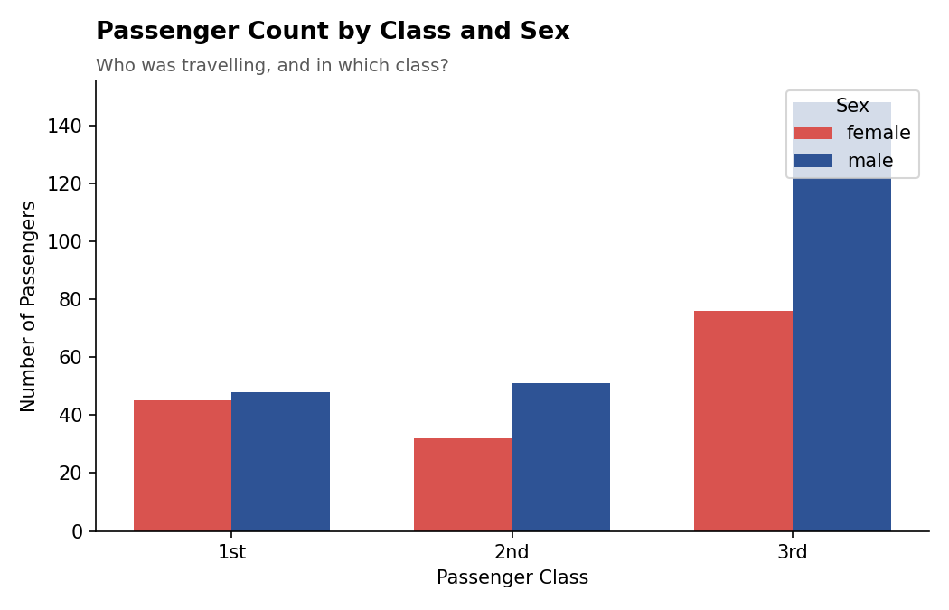
Figure 1. Passenger count by class and sex. A grouped bar chart was chosen because it lets a reader compare both the overall size of each class and its male/female split in a single glance.
Third class was by far the largest group (224 of 400 passengers, 56%), and within it men outnumbered women by roughly 2 to 1 (148 vs. 76). First and second class, by contrast, were close to an even split between men and women.
This matters for everything that follows: because 3rd class was both the largest group and disproportionately male, and because (as later charts show) survival was lowest for men and for 3rd class, this single chart foreshadows much of the survival story before a single survival number is shown.

3. How Old Were the Passengers? — Age Distribution
Chart type: Histogram
Question this chart answers: "What did the age profile of the passengers look like?"
ggplot(titanic, aes(x = Age)) +
geom_histogram(binwidth = 5, fill = "#2E5395", color = "white") +
geom_vline(aes(xintercept = median(Age)), color = "#D9534F", linetype = "dashed") +
labs(title = "Age Distribution of Passengers",
subtitle = "Dashed line marks the median age",
x = "Age (years)", y = "Number of Passengers") +
theme_report
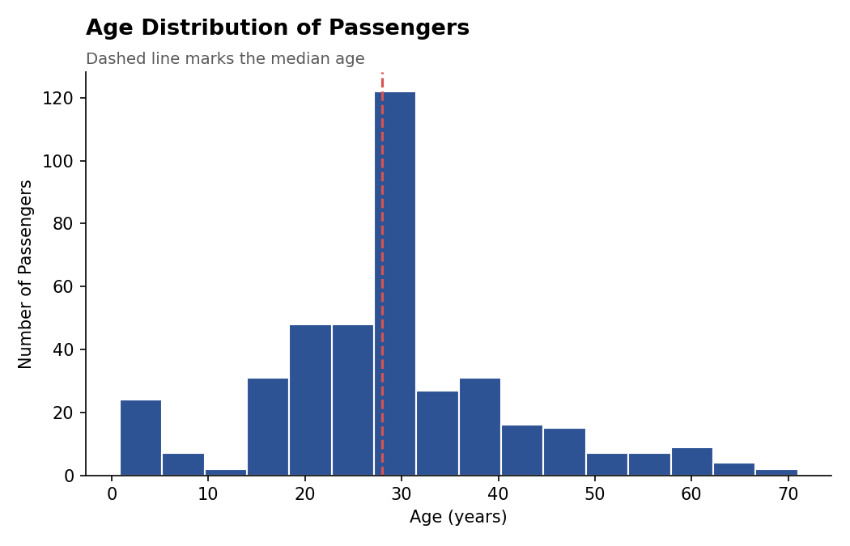
Figure 2. Age distribution of all 400 passengers, with the median (28 years) marked. A histogram was chosen because it is the standard, most intuitive way to show the shape of a single numeric variable.
The majority of passengers were young adults between 20 and 35, with a visible spike exactly at the median (28) — this spike is a direct, transparent result of the median-imputation method used in Week 1 to fill missing Age values, and is worth disclosing to any reader of this chart.
There is also a smaller cluster of children under 10 and a long tail of older passengers up to age 71, meaning the ship carried a genuinely wide range of ages, not just young adults.

4. Who Paid More? — Fare Distribution by Class
Chart type: Boxplot
Question this chart answers: "How much did passengers in each class actually pay, and how much did that vary?"
ggplot(titanic, aes(x = Pclass, y = Fare, fill = Pclass)) +
geom_boxplot(outlier.color = "#D9534F", outlier.alpha = 0.6) +
labs(title = "Fare Distribution by Passenger Class",
subtitle = "Dots above the whiskers are statistical outliers",
x = "Passenger Class", y = "Fare ($)") +
theme_report + theme(legend.position = "none")
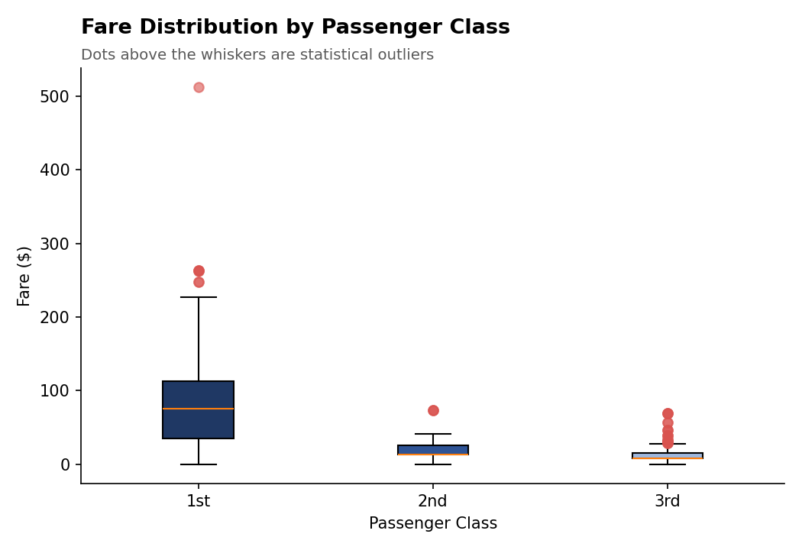
Figure 3. Fare distribution by class. A boxplot was chosen over a bar chart of averages because it also reveals spread and outliers, both of which turn out to be important here.
1st class fares (median $75.25) were roughly 6x higher than 3rd class fares (median $8.05), which is expected — but the 1st class box is also far taller, meaning fares within 1st class varied enormously, from modest berths to the $512 fare visible as an extreme outlier at the top of the chart.
2nd and 3rd class fares, by comparison, were far more tightly clustered — most 3rd class passengers paid within a narrow band close to the class median, suggesting much more standardized pricing at the lower end of the ship.

5. Did Age and Fare Together Relate to Survival? — Age vs. Fare Scatter Plot
Chart type: Scatter Plot
Question this chart answers: "Is there a visible relationship between age, fare, and whether a passenger survived?"
ggplot(titanic, aes(x = Age, y = Fare, color = Survived_Label)) +
geom_point(alpha = 0.6, size = 2) +
scale_color_manual(values = c("Did Not Survive" = "#D9534F", "Survived" = "#2E5395")) +
labs(title = "Age vs. Fare, Coloured by Survival Outcome",
x = "Age (years)", y = "Fare ($)", color = "Outcome") +
theme_report
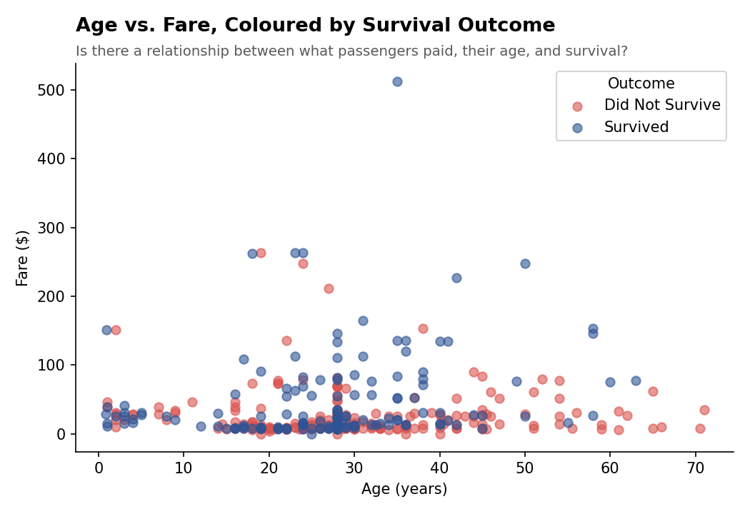
Figure 4. Each point is one passenger, positioned by age and fare and coloured by outcome. A scatter plot was chosen because it is the only chart type that can show the joint relationship between two numeric variables and a third categorical outcome at once.
Blue points (survived) are visibly concentrated in the upper portion of the chart — higher fares — while red points (did not survive) dominate the dense cluster of low fares below $50, regardless of age.
No clear diagonal pattern exists between Age and Fare themselves (older passengers did not systematically pay more or less), which tells us Fare's relationship with survival in this dataset is really a stand-in for passenger class, not a separate age-driven effect.

6. Did Survival Odds Change With Age? — Survival Rate Trend
Chart type: Line Chart
Question this chart answers: "As passengers get older, does their chance of survival rise or fall?"
survival_by_age <- titanic %>%
group_by(AgeGroup) %>%
summarise(SurvivalRate = mean(Survived), Count = n())

ggplot(survival_by_age, aes(x = AgeGroup, y = SurvivalRate, group = 1)) +
geom_line(color = "#2E5395", linewidth = 1.2) +
geom_point(color = "#1F3864", size = 3) +
scale_y_continuous(labels = percent_format()) +
labs(title = "Survival Rate Trend Across Age Groups",
x = "Age Group", y = "Survival Rate") +
theme_report
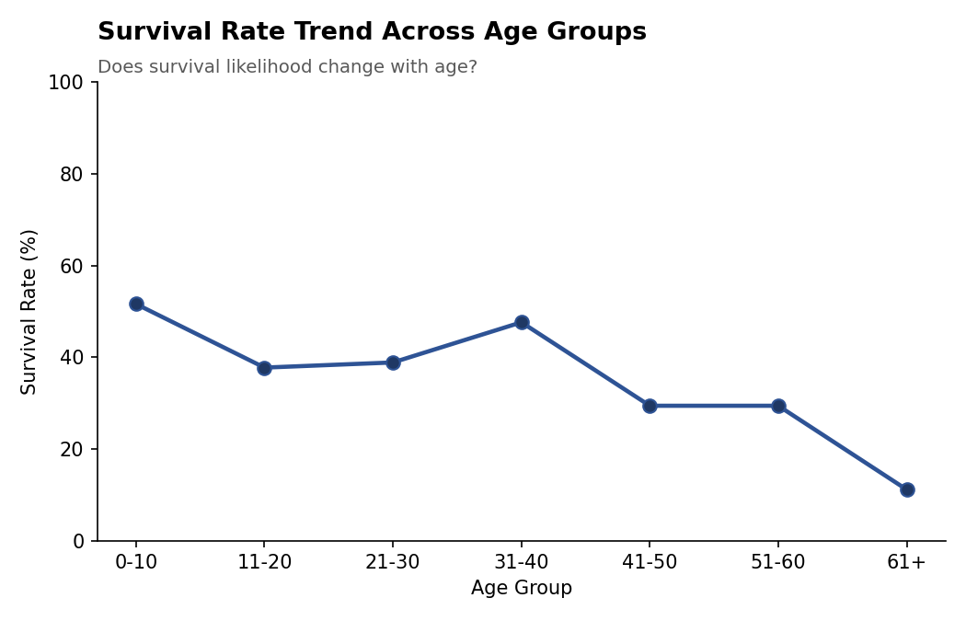
Figure 5. Survival rate by age group. A line chart was chosen because the age groups are naturally ordered, making a line the clearest way to show a trend across that sequence — which a bar chart would not emphasize as well.
Survival rate is highest for the youngest group (0-10 years, 51.6%) — consistent with the 'children first' evacuation priority — dips through the young-adult years, recovers slightly for 31-40 year-olds (47.6%), then declines steadily to just 11.1% for passengers over 60.
The clear downward trend after age 40 is the chart's main takeaway: older passengers were substantially less likely to survive, even though the overall average survival rate across the whole dataset was 39.25%.

7. The Headline Finding — Survival Rate by Passenger Class
Chart type: Stacked Bar Chart (100%)
Question this chart answers: "How much did a passenger's class affect their chance of survival?"
ggplot(titanic, aes(x = Pclass, fill = Survived_Label)) +
geom_bar(position = "fill") +
scale_y_continuous(labels = percent_format()) +
labs(title = "Survival Rate by Passenger Class",
subtitle = "Proportion of each class that survived",
x = "Passenger Class", y = "Proportion of Passengers", fill = "Outcome") +
theme_report
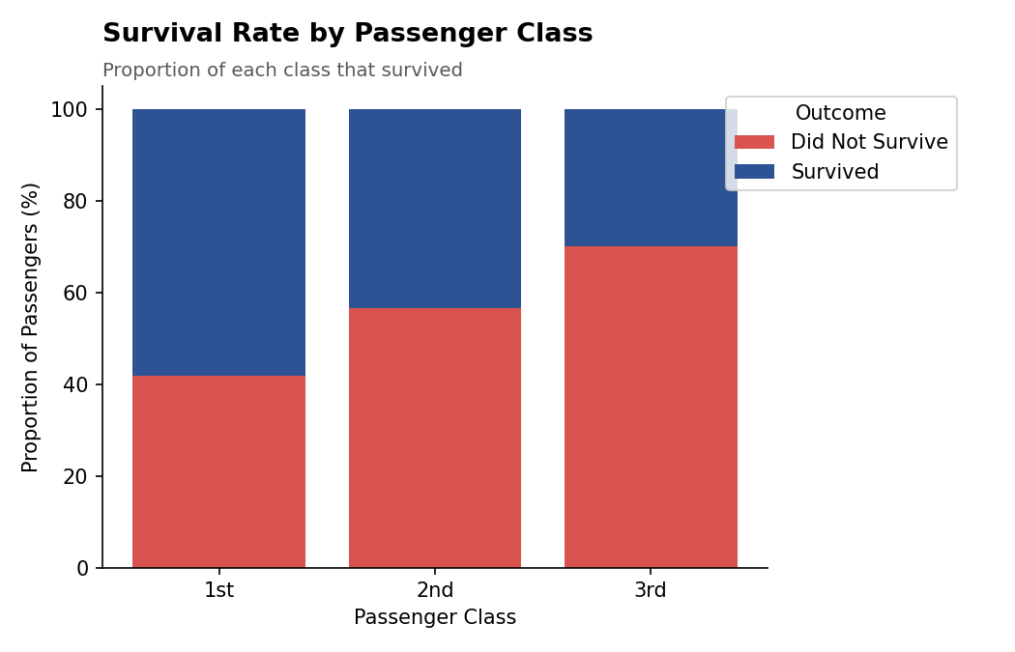
Figure 6. Survival rate by class, shown as a 100%-stacked bar so every bar is directly comparable regardless of how many passengers were in each class. This is deliberately the most "headline-ready" chart in the report.
The pattern is stark and monotonic: 58.1% of 1st class passengers survived, compared to 43.4% of 2nd class and just 29.9% of 3rd class — a nearly 2x gap between the top and bottom of the ship.
Combined with Figure 1 (which showed 3rd class was both the largest group and disproportionately male) and Figure 5 (which showed older passengers fared worse), this chart completes the picture: survival on the Titanic was shaped by where — and who — you were, more than by chance.

8. A Closer Look at Age and Survival — Density Comparison
Chart type: Overlaid Density Plot
Question this chart answers: "Beyond the single median, how do the full age profiles of survivors and non-survivors compare?"
ggplot(titanic, aes(x = Age, fill = Survived_Label)) +
geom_density(alpha = 0.5) +
scale_fill_manual(values = c("Did Not Survive" = "#D9534F", "Survived" = "#2E5395")) +
labs(title = "Age Distribution by Survival Outcome",
x = "Age (years)", y = "Density", fill = "Outcome") +
theme_report
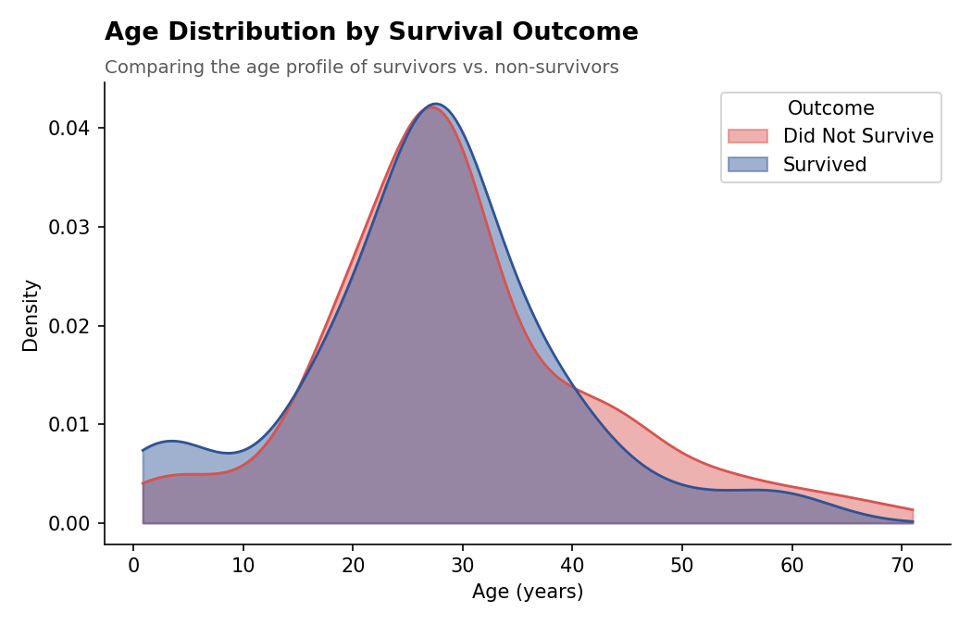
Figure 7. Overlaid density curves comparing the age distribution of survivors vs. non-survivors. A density plot was chosen over two separate histograms because overlaying smooth curves makes the two groups' shapes directly comparable without the visual clutter of overlapping bars.
The two curves are nearly identical through the 20-35 age range, where most passengers of both outcomes are concentrated — but they diverge past age 40, where the 'Did Not Survive' curve sits consistently above the 'Survived' curve, visually confirming the decline already seen in Figure 5.
There is also a small, slightly elevated bump for survivors under age 10, reflecting the modestly higher survival rate for young children noted earlier.

9. Key Insights Summary
Taken together, these seven visualizations tell a coherent story about the Titanic disaster using nothing more than the passenger manifest:
- Who was on board shaped who survived: 3rd class carried the most passengers and skewed male — both factors independently associated with lower survival.
- Fare and class are two views of the same underlying factor — wealth and cabin location — and both tracked closely with survival.
- Age mattered at the extremes: young children had a modest survival advantage, while passengers over 40, and especially over 60, fared markedly worse.
- No single variable tells the whole story on its own — it is the combination of class, sex, and age, visible only by looking across all seven charts together, that best explains who survived.
Each chart type was deliberately matched to the question it answers — bar charts for group comparisons, a histogram and density plot for distribution shape, a boxplot for spread and outliers, a scatter plot for a two-variable relationship, and a line chart for a trend across ordered groups — so that a reader with no statistical background can follow the analysis from simple counts through to the final, class-driven survival story.

Appendix A: Full R Script
## =============================================================
## Week 2 Task: Data Visualization and Insight Communication using R
## Dataset: Titanic Passenger Data (continued from Week 1)
## Source: https://raw.githubusercontent.com/
## datasciencedojo/datasets/master/titanic.csv
## =============================================================

library(dplyr)
library(ggplot2)
library(scales)

titanic <- read.csv("titanic.csv", stringsAsFactors = FALSE)

## ---- Minimal cleaning carried over from Week 1 ----
titanic$Age[is.na(titanic$Age)] <- median(titanic$Age, na.rm = TRUE)
titanic$Embarked[titanic$Embarked == ""] <- names(sort(table(titanic$Embarked), decreasing = TRUE))[1]
titanic$Cabin_Known <- ifelse(titanic$Cabin == "" | is.na(titanic$Cabin), 0, 1)

titanic$Pclass <- factor(titanic$Pclass, levels = c(1,2,3), labels = c("1st","2nd","3rd"))
titanic$Survived_Label <- factor(titanic$Survived, levels = c(0,1), labels = c("Did Not Survive","Survived"))

theme_report <- theme_minimal(base_size = 13) +
theme(plot.title = element_text(face = "bold", size = 15),
plot.subtitle = element_text(color = "grey40"),
legend.position = "bottom")

## =============================================================
## VISUAL 1 -- Bar Chart: Passenger Count by Class and Sex
## =============================================================
ggplot(titanic, aes(x = Pclass, fill = Sex)) +
geom_bar(position = "dodge") +
scale_fill_manual(values = c("female" = "#D9534F", "male" = "#2E5395")) +
labs(title = "Passenger Count by Class and Sex",
subtitle = "Who was travelling, and in which class?",
x = "Passenger Class", y = "Number of Passengers", fill = "Sex") +
theme_report

## =============================================================
## VISUAL 2 -- Histogram: Age Distribution
## =============================================================
ggplot(titanic, aes(x = Age)) +
geom_histogram(binwidth = 5, fill = "#2E5395", color = "white") +
geom_vline(aes(xintercept = median(Age)), color = "#D9534F", linetype = "dashed", linewidth = 1) +
labs(title = "Age Distribution of Passengers",
subtitle = "Dashed line marks the median age",
x = "Age (years)", y = "Number of Passengers") +
theme_report

## =============================================================
## VISUAL 3 -- Boxplot: Fare by Passenger Class
## =============================================================
ggplot(titanic, aes(x = Pclass, y = Fare, fill = Pclass)) +
geom_boxplot(outlier.color = "#D9534F", outlier.alpha = 0.6) +
scale_fill_manual(values = c("1st" = "#1F3864", "2nd" = "#2E5395", "3rd" = "#9FB8DE")) +
labs(title = "Fare Distribution by Passenger Class",
subtitle = "Dots above the whiskers are statistical outliers",
x = "Passenger Class", y = "Fare ($)") +
theme_report + theme(legend.position = "none")

## =============================================================
## VISUAL 4 -- Scatter Plot: Age vs Fare, coloured by Survival
## =============================================================
ggplot(titanic, aes(x = Age, y = Fare, color = Survived_Label)) +
geom_point(alpha = 0.6, size = 2) +
scale_color_manual(values = c("Did Not Survive" = "#D9534F", "Survived" = "#2E5395")) +
labs(title = "Age vs. Fare, Coloured by Survival Outcome",
subtitle = "Is there a relationship between what passengers paid, their age, and survival?",
x = "Age (years)", y = "Fare ($)", color = "Outcome") +
theme_report

## =============================================================
## VISUAL 5 -- Line Chart: Survival Rate Trend Across Age Groups
## =============================================================
age_breaks <- c(0, 10, 20, 30, 40, 50, 60, 80)
age_labels <- c("0-10","11-20","21-30","31-40","41-50","51-60","61+")
titanic$AgeGroup <- cut(titanic$Age, breaks = age_breaks, labels = age_labels, include.lowest = TRUE)

survival_by_age <- titanic %>%
group_by(AgeGroup) %>%
summarise(SurvivalRate = mean(Survived), Count = n())

ggplot(survival_by_age, aes(x = AgeGroup, y = SurvivalRate, group = 1)) +
geom_line(color = "#2E5395", linewidth = 1.2) +
geom_point(color = "#1F3864", size = 3) +
scale_y_continuous(labels = percent_format()) +
labs(title = "Survival Rate Trend Across Age Groups",
subtitle = "Does survival likelihood change with age?",
x = "Age Group", y = "Survival Rate") +
theme_report

## =============================================================
## VISUAL 6 -- Stacked Bar: Survival Proportion by Class
## =============================================================
ggplot(titanic, aes(x = Pclass, fill = Survived_Label)) +
geom_bar(position = "fill") +
scale_y_continuous(labels = percent_format()) +
scale_fill_manual(values = c("Did Not Survive" = "#D9534F", "Survived" = "#2E5395")) +
labs(title = "Survival Rate by Passenger Class",
subtitle = "Proportion of each class that survived",
x = "Passenger Class", y = "Proportion of Passengers", fill = "Outcome") +
theme_report

## =============================================================
## VISUAL 7 -- Overlaid Density: Age Distribution by Survival
## =============================================================
ggplot(titanic, aes(x = Age, fill = Survived_Label)) +
geom_density(alpha = 0.5) +
scale_fill_manual(values = c("Did Not Survive" = "#D9534F", "Survived" = "#2E5395")) +
labs(title = "Age Distribution by Survival Outcome",
subtitle = "Comparing the age profile of survivors vs. non-survivors",
x = "Age (years)", y = "Density", fill = "Outcome") +
theme_report

## =============================================================
## End of script
## =============================================================

