**Experiment 1**

Design a LED Flasher

**Circuit Diagram:-**

**Theory:-**

**Concept used:-**

The concepts used for realization and implementation of the task are:-

* The arduino board supply a power of 5V which we call as HIGH and 0V which we call as LOW digital output signals through the 14 pins present on the Arduino board.
* The GND pin on arduino is the ground.
* And the concept of breadboard where there are two rows each on top and bottom of it, connected to each other :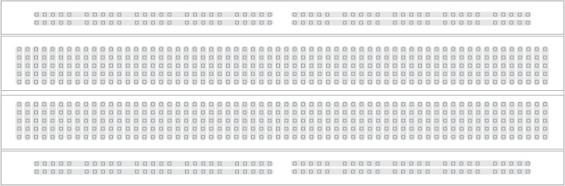

**Learning and Observations:-**

**Leanings:**

* I have learned about breadboard working and about connections on it(LEDs and wires).
* I have learned about how an arduino works and how coding is done on software for the hardware to run.

**Observations:**

* When we upload our code, electrical signals are passed to the Arduino(because we have connected our hardware to the PC) and the LEDs glows and works accordingly.

**Problems and Troubleshooting:-**

The problems I faced while doing task are:

* LED was not glowing once for our wrong connection so I checked my ‘p’ and ‘n’ side of the LED and second for not choosing tools option from the Arduino software so I corrected that before uploading the code.
* The circuit was not getting closed because some wires used were short and not at place so I tried to change the position.

**Precautions**

The precautions that we need to keep in mind while doing this experiment are:-

* The wires and the LEDs used should be inserted properly in the breadboard for the hardware to work properly.
* The pins of the LED should be connected properly. The ‘p’ and ‘n’ side of the LED is something which is to be checked properly.
* We should take care that the circuit is closed .

**Learning Outcomes**

* I have gained knowledge about certain projects and circuits using Arduino board and breadboard hardware.
* I have got to know about glowing LEDs by running codes on Arduino software and various other connections.