How to Back up MQM Database

Part I

Why do we need to back and restore ?
In course of time due to downloading and uploading lots of data the
MQM DB increases in size .
This can affect the operation of the DB in means of speed .
In order to keep the DB in a small size we recommend that you make a backup
and restore of the DB from time to time.

Part II - Backup
How to backup :
1. Open the IB console
2. logon to your server
3. right click on the "backup" and select backup - see picure:

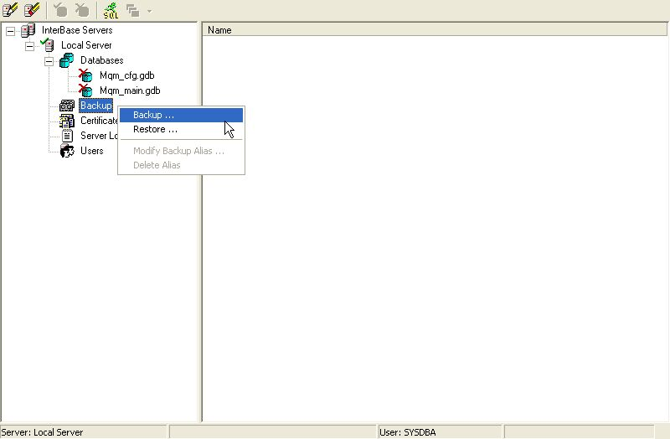

4. select your db to backup - see picture

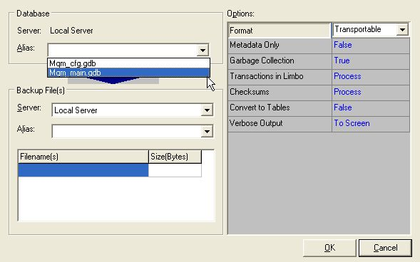
5. Fill in the name you wish to give for the backup file in both places:
1. the alias field
2. the file name if you don't give a full path (like c:\Interbase backup\mqmbackup.gbk )
then the backup file shall be created in:( c:\program files\borland\bin)
- see picture
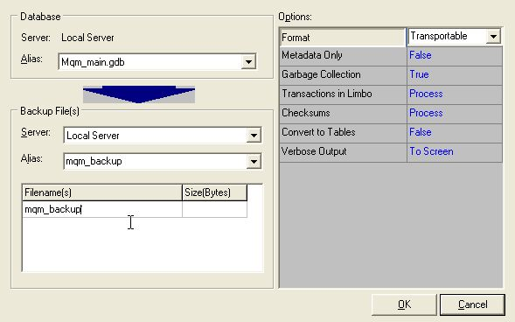

6. press OK and then you get this - see picture
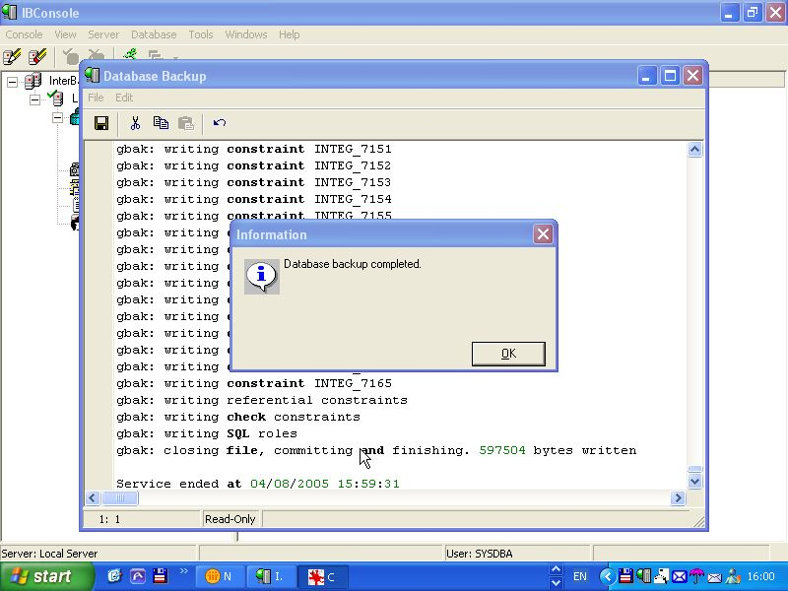
7. Now you should have a backup file - see picture
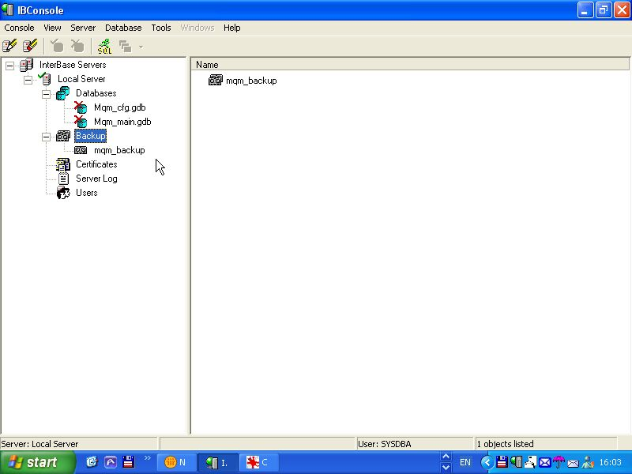
Part III - Restore:

And now to restore:
8. right click on the "backup" and select restore - see picture
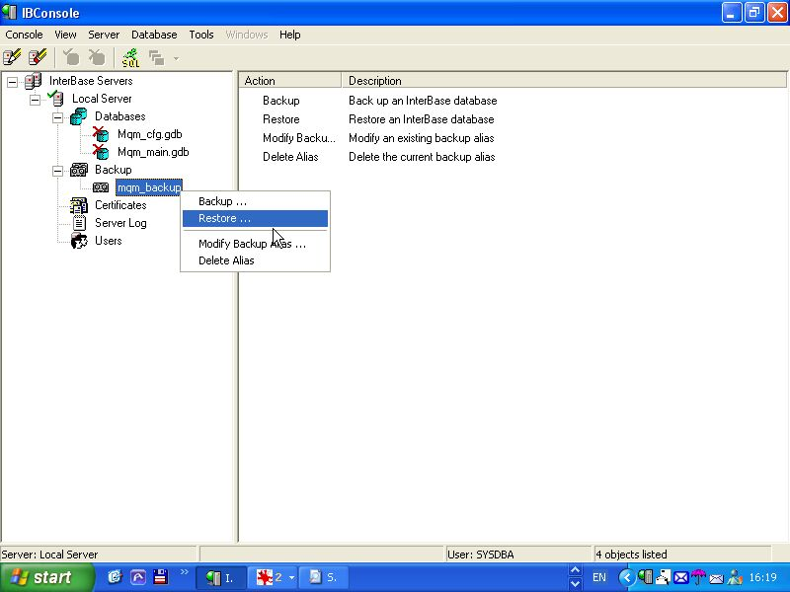
9. The form should have already the correct details - see picture
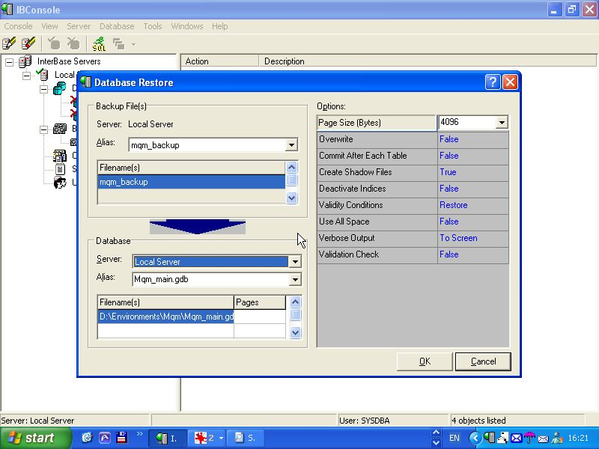

10. Change to overwrite : true (to overwrite the current DB ) - see picture
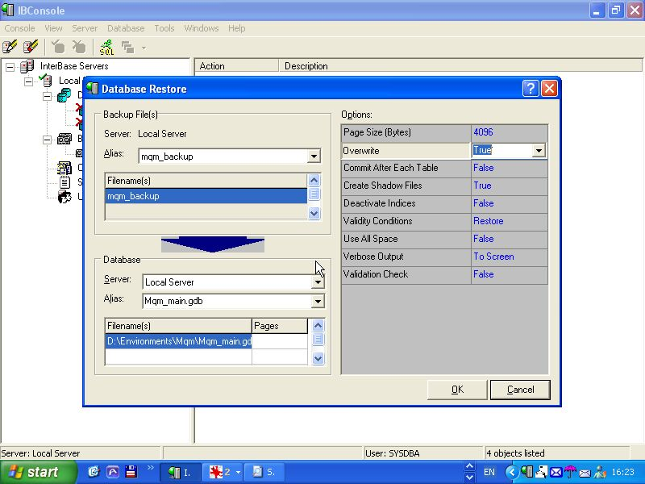
11. Press OK .
12. Close the form - press cancel
13. That's it now you should be after restore with a much smaller DB file.

