
DEPARTMENT OF MANAGEMENT OF TECHNOLOGY
FACULTY OF BUSINESS
UNIVERSITY OF MORATUWA
TM3221 – Data Science for BPM
Group Assignment
Customer Churn Prediction and Analysis Using Machine Learning
A Data-Driven Approach for Customer Retention
Group name: [Group name]
Name | Index number
[Member name] | [Index no.]
[Member name] | [Index no.]
[Member name] | [Index no.]
[Member name] | [Index no.]
[Member name] | [Index no.]
Semester 06 · [Submission date]

Table of Contents
1. Introduction
1.1 Dataset overview
1.2 Context and relevance
1.3 Objective of the study
2. Data Cleaning
2.1 Handling missing and invalid values
2.2 Handling outliers
2.3 Feature engineering and encoding
2.4 Multicollinearity
3. Exploratory Data Analysis (EDA)
3.1 Summary statistics
3.2 Distribution of numeric variables
3.3 Target variable analysis
3.4 Categorical variable analysis
3.5 Correlation analysis
3.5.1 Correlation heatmap
3.5.2 Relationship plots
3.6 Statistical tests of association
4. Model Fitting
4.1 Logistic regression model
4.1.1 Logistic regression model equation
4.2 Decision tree model
4.3 Random forest model
4.4 Model comparison
4.4.1 Performance results
4.4.2 Interpretation of results
4.4.3 Actual vs predicted values
5. Conclusion
5.1 Recommendations
5.2 Limitations and responsible use
References
Table of Figures
Figure 1: Missing and invalid values per column before cleaning (raw file)
Figure 2: Boxplots of the numeric variables before and after cleaning
Figure 3: Variance inflation factors before and after removing the collinear charge columns
Figure 4: Histograms of tenure, monthly charges and total charges by churn status
Figure 5: Distribution of the target variable (churn)
Figure 6: Churn rate by contract, internet service, payment method and tenure group
Figure 7: Churn rate by demographic and billing attributes
Figure 8: Spearman correlation heatmap of all variables (categories one-hot encoded)
Figure 9: Relationship plots: churn rate against tenure, monthly charges and total charges
Figure 10: Effect sizes of the associations with churn
Figure 11: Logistic regression odds ratios with 95% bootstrap confidence intervals
Figure 12: Permutation importance of the input variables
Figure 13: Model comparison on the test set
Figure 14: Actual vs predicted classes: confusion matrices on the test set
Table of Tables
Table 1: Missing and invalid values found in the raw file and their treatment
Table 2: Imputation values learned from the training data
Table 3: Summary statistics of the numeric variables
Table 4: Profile of customers who stayed and customers who churned
Table 5: Interpretation of the histograms
Table 6: Logistic regression coefficient summary (training data)
Table 7: Decision rules of the simplified decision tree (training data)
Table 8: Cross-validated and test-set performance of the models
Table 9: Actual vs predicted values: comparison of the two strongest models
Table 10: Retention recommendations and supporting evidence

1. Introduction

1.1 Dataset overview
This study uses the Telco Customer Churn dataset, an IBM sample dataset describing the home phone and internet customers of a telecom provider (BlastChar, 2018). The file supplied for the assignment contains 7,073 records and 21 variables; after removing 30 duplicate records it describes 7,043 unique customers, each row representing one customer. The variables cover demographics (gender, senior citizen, partner, dependents), the account (tenure in months, contract type, paperless billing, payment method, monthly and total charges) and the subscribed services (phone, multiple lines, internet type and six internet add-ons). The target variable, Churn (Yes/No), records whether the customer left within the last month; 26.5% of customers churned.

1.2 Context and relevance
Customer churn – customers ending their subscription – is a central concern for telecommunications companies, whose markets are mature and highly competitive. Because keeping an existing customer is commonly regarded as cheaper than winning a new one, operators use data mining to identify customers at risk of leaving so that retention actions can be targeted where they matter most (Verbeke et al., 2012). This study applies data analysis and machine learning to identify which customer and service characteristics are most strongly associated with churn, to measure how strong these relationships are, and to build models that predict churn and support retention decisions. Because the data are observational, the findings describe associations and predictions rather than causal effects.

1.3 Objective of the study
The main goal is to predict which customers will churn and to identify the most influential predictors, answering the research question: “Which customer characteristics and service-related factors are most strongly associated with customer churn, and how effectively can machine learning models predict churn?” Through data cleaning, exploratory data analysis (EDA), statistical testing and model fitting, the study addresses four key questions:
- Which contract, service, billing and demographic factors are associated with higher churn?
- How well do logistic regression, decision tree and random forest models predict churn?
- Which model is most suitable for targeting retention actions, and why?
- What practical retention actions do the findings support?

2. Data Cleaning
The analysis was carried out in Python with pandas (McKinney, 2010), scikit-learn (Pedregosa et al., 2011), SciPy (Virtanen et al., 2020), statsmodels (Seabold & Perktold, 2010) and Matplotlib (Hunter, 2007). The raw file was never modified: it was audited with every value read as text, so that blanks, text tokens and codes such as −99 were visible, and every cleaning step is documented and reproducible.

2.1 Handling missing and invalid values
Table 1: Missing and invalid values found in the raw file and their treatment
Column | Blank | Invalid text | Impossible | Total | % of rows | Treatment
MonthlyCharges | 80 | 0 | 10 | 90 | 1.27% | Set to missing, then rebuilt as TotalCharges ÷ tenure
tenure | 40 | 0 | 20 | 60 | 0.85% | Set to missing, then rebuilt as round(TotalCharges ÷ MonthlyCharges)
Contract | 35 | 0 | 0 | 35 | 0.49% | Imputed with the most frequent value (training data)
TotalCharges | 11 | 12 | 0 | 23 | 0.33% | Blank (tenure 0) set to 0; invalid rebuilt as tenure × MonthlyCharges
gender | 0 | 15 | 0 | 15 | 0.21% | Imputed with the most frequent value (training data)

The audit found problems in 5 of the 21 columns (Table 1, Figure 1): 223 affected values in total, 0.15% of all 148,533 data points. A default pandas import would have missed most of them: it reports no missing values in TotalCharges, although that column contains 11 blank strings and 12 “INVALID_VAL” entries, and it does not recognise gender labels such as “Unknown” or “OtherXYZ”. In addition, 30 records were exact duplicates (every repeated customerID was an identical copy) and were removed.
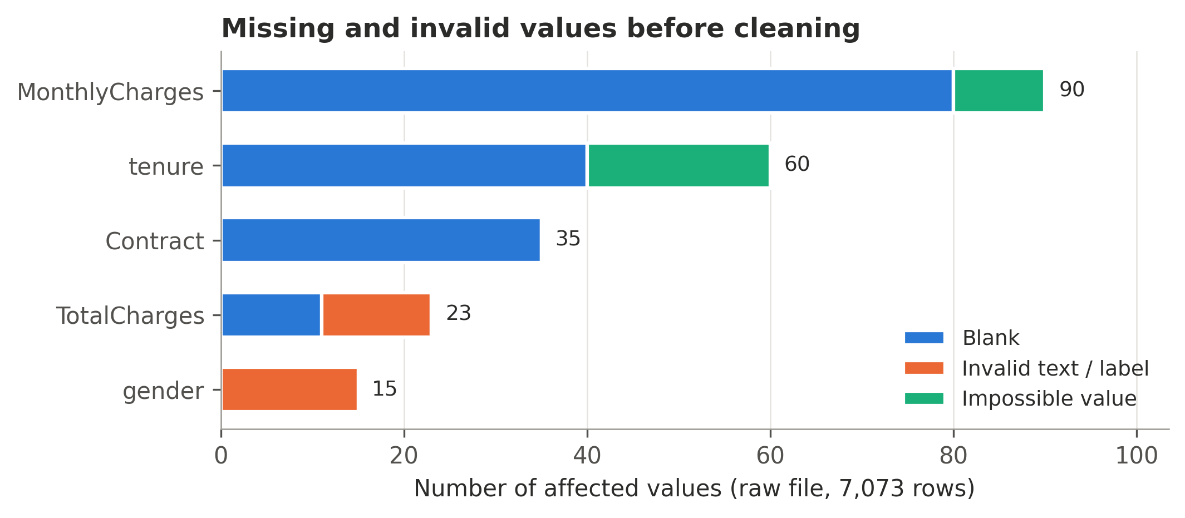
Figure 1: Missing and invalid values per column before cleaning (raw file)
Instead of deleting customers or filling numeric gaps with an average, the three billing variables were repaired using the relationship TotalCharges ≈ tenure × MonthlyCharges. Tested on 6,900 complete records, this rebuilt TotalCharges with a median error of 2.0% (median imputation: 74%) and tenure with a mean error of 0.67 months (median imputation: 21.7 months). No customer had more than one corrupted billing value, so all 132 were repaired; blank TotalCharges belonged to customers with zero tenure and were set to 0. Only 15 gender and 35 contract values remained missing; they were imputed with the most frequent category, learned from the training data only (Table 2). Customers with repaired values churned at 31.7% against 26.4% for the rest, a difference that is not statistically significant (χ² p = 0.14).
Table 2: Imputation values learned from the training data
Column | Type | Strategy | Value learned (training data) | Missing after repair
tenure | numeric | median | 29.0 | 0
MonthlyCharges | numeric | median | 70.47 | 0
TotalCharges | numeric | median | 1394.0 | 0
gender | categorical | most frequent | Male | 15
Contract | categorical | most frequent | Month-to-month | 35

2.2 Handling outliers
Outliers were detected with the interquartile range (IQR) rule (below Q1 − 1.5 × IQR or above Q3 + 1.5 × IQR) and boxplots (Figure 2). The extreme raw values – tenures of −99 and 545.8 to 988.5 months, and monthly charges of 5,765 to 9,960 USD against a normal range of about 18–119 USD – are impossible, so they were treated as data-entry errors and repaired (Section 2.1).
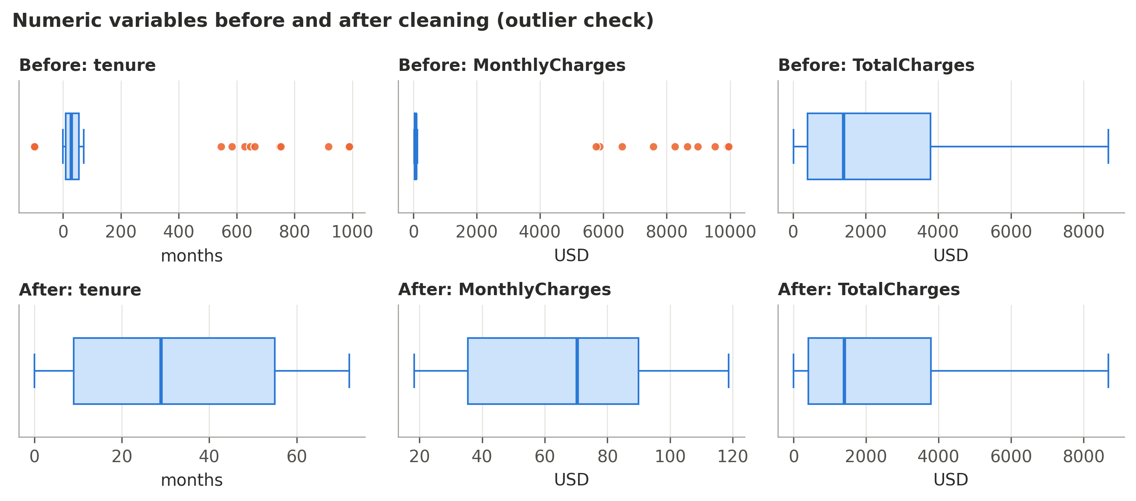
Figure 2: Boxplots of the numeric variables before and after cleaning
After repair, 0 values lie outside the IQR fences. TotalCharges is right-skewed (skewness 0.96) but plausible, so no further treatment was applied; winsorisation was not used, because capping values would alter genuine records such as long-standing, high-spending customers.

2.3 Feature engineering and encoding
The customerID was removed because it is only an identifier. SeniorCitizen was recoded from 0/1 to No/Yes, and “No internet service” / “No phone service” were recoded to “No” for modelling, as InternetService and PhoneService already hold that information. Categorical variables were converted with one-hot encoding (a separate 0/1 column for each category) rather than label encoding, because integer codes such as 0, 1, 2, 3 for payment methods would impose an order that does not exist. Numeric variables were standardised for logistic regression. Two helper variables – tenure groups and the number of add-on services – were created for EDA only.
The data were split 80/20 with stratification on churn (5,634 training and 1,409 test customers, both with 26.5% churners). To prevent data leakage (Kaufman et al., 2012), every step that learns from data – imputation, scaling and encoding – was placed inside a scikit-learn Pipeline with a ColumnTransformer, so it is fitted on the training data only and re-fitted within every cross-validation fold. Class imbalance was handled with class_weight = "balanced" rather than synthetic oversampling.

2.4 Multicollinearity
Multicollinearity was checked with variance inflation factors (VIF) on the training data, because strongly related predictors make regression coefficients unstable and hard to interpret. Figure 3(a) shows that MonthlyCharges has a VIF of 836: the service variables explain almost all of it, since the monthly bill is essentially the sum of the service prices. TotalCharges is also strongly related to tenure (VIF 9.7; Spearman ρ = 0.89).
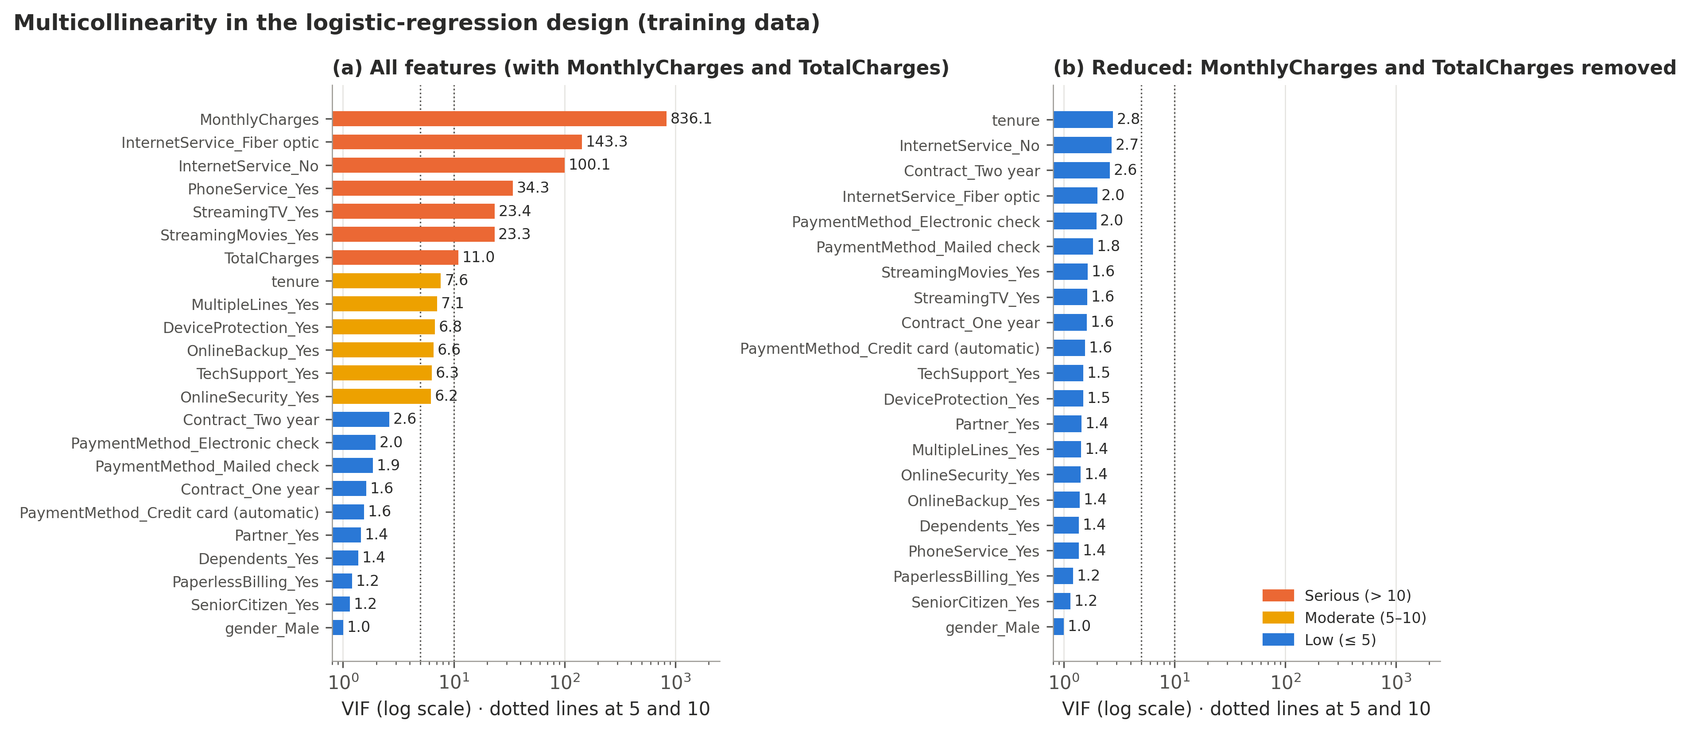
Figure 3: Variance inflation factors before and after removing the collinear charge columns
Standardising the variables does not reduce VIF, because VIF depends only on the correlations between predictors (raw and standardised variables gave identical VIFs). Removing the redundant MonthlyCharges and TotalCharges lowers the largest VIF to 2.78 (Figure 3(b)), so they were excluded from the logistic regression at almost no cost (CV ROC-AUC 0.8448 vs 0.8462 with all features); the tree models kept all variables.

3. Exploratory Data Analysis (EDA)

3.1 Summary statistics
Table 3: Summary statistics of the numeric variables
Variable | Count | Mean | SD | Min | Q1 | Median | Q3 | Max
tenure (months) | 7,043 | 32.4 | 24.6 | 0.0 | 9.0 | 29.0 | 55.0 | 72.0
MonthlyCharges (USD) | 7,043 | 64.8 | 30.1 | 18.2 | 35.5 | 70.3 | 89.9 | 118.8
TotalCharges (USD) | 7,043 | 2,279.8 | 2,266.9 | 0.0 | 398.6 | 1,394.4 | 3,786.6 | 8,684.8

Table 3 summarises the three numeric variables after cleaning. The mean of total charges (2,280 USD) lies far above its median (1,394 USD), a first sign of right skew. Table 4 adds the categorical profile: churners are newer (median tenure 10 vs 38 months) and far more often on month-to-month contracts, fiber-optic internet and electronic-check payment.
Table 4: Profile of customers who stayed and customers who churned
Characteristic | All customers | Stayed | Churned
Customers | 7,043 | 5,174 | 1,869
Median tenure (months) | 29 | 38 | 10
Mean monthly charge (USD) | 64.8 | 61.3 | 74.4
Month-to-month contract (%) | 55.1 | 42.9 | 88.7
Fiber optic internet (%) | 44.0 | 34.8 | 69.4
Pays by electronic check (%) | 33.6 | 25.0 | 57.3
Has tech support (%) | 29.0 | 33.5 | 16.6

3.2 Distribution of numeric variables
Figure 4 shows the shape, spread and concentration of each numeric variable as histograms, with customers who stayed and churned stacked in each bar. Table 5 interprets each histogram; the distribution type is computed from the data (number of peaks and skewness), not judged by eye.
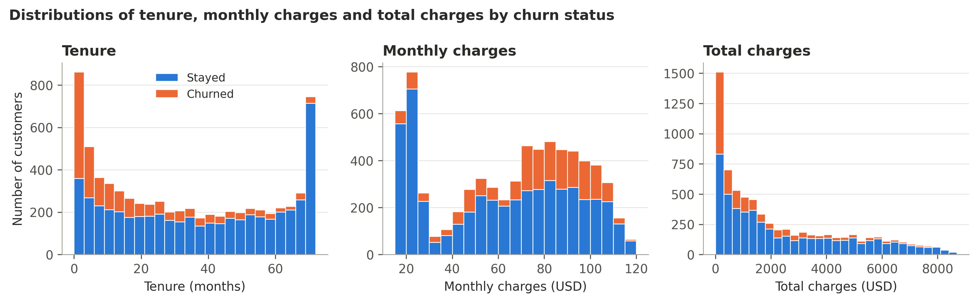
Figure 4: Histograms of tenure, monthly charges and total charges by churn status
Table 5: Interpretation of the histograms
Variable | Observation | Distribution type | Insight (churned vs stayed)
tenure | Mean 32.4, median 29.0; range 0–72 months | U-shaped (peaks at both ends); skewness 0.24 | Churners lower (median 10.0 vs 38.0 months)
MonthlyCharges | Mean 64.8, median 70.3; range 18–119 USD | Bimodal (two peaks); skewness −0.22 | Churners higher (median 79.6 vs 64.4 USD)
TotalCharges | Mean 2,279.8, median 1,394.4; range 0–8,685 USD | Right-skewed; skewness 0.96 | Churners lower (median 703.5 vs 1,679.5 USD)

Because none of the numeric variables is normally distributed, rank-based methods (Spearman correlation, Mann-Whitney U) were used in the analysis.

3.3 Target variable analysis
The target variable, Churn, records whether a customer left within the last month. Figure 5 shows that 1,869 of 7,043 customers (26.5%) churned and 5,174 (73.5%) stayed. The classes are therefore imbalanced, about 2.8 customers who stay for every churner. A model that always predicts “no churn” would already be 73.5% accurate while catching no churners, which is why models are judged with recall, precision, F1 and ROC-AUC rather than accuracy alone, and why class weighting is used.
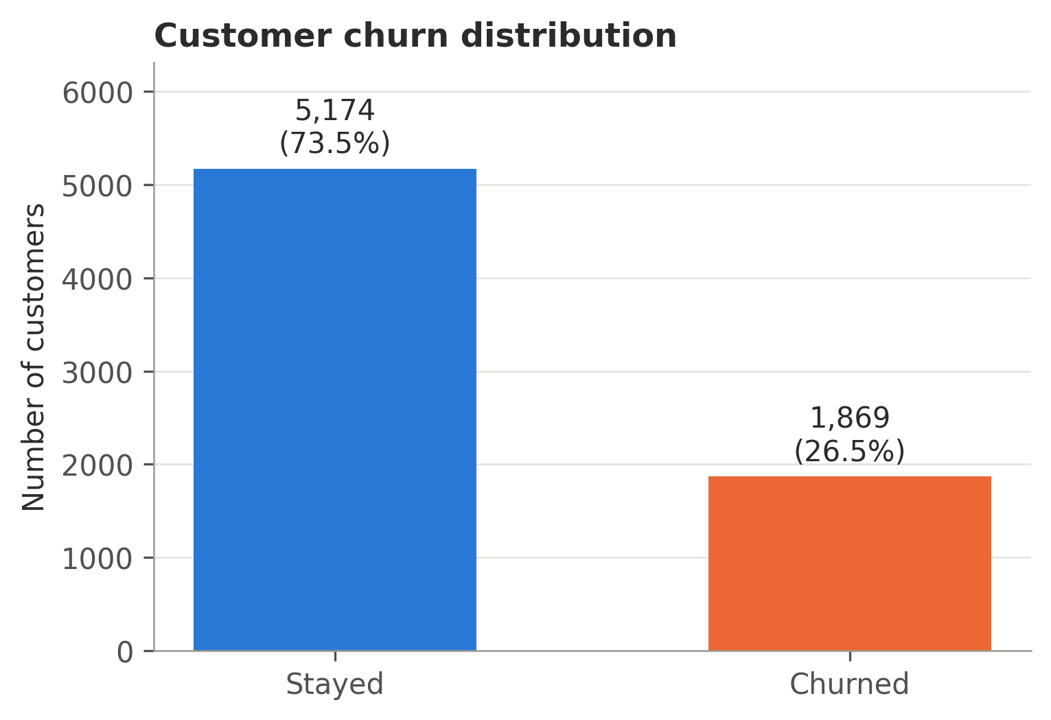
Figure 5: Distribution of the target variable (churn)

3.4 Categorical variable analysis
Figure 6 compares churn rates across the account and service variables. Month-to-month customers churn at 42.7%, compared with 11.2% on one-year and 2.8% on two-year contracts. Fiber-optic customers churn at 41.9%, more than twice the DSL rate (19.0%). Electronic-check payers churn at 45.3%, against 15.2%–19.1% for other methods, and churn falls from 47.5% in the first year to 9.5% after four years.
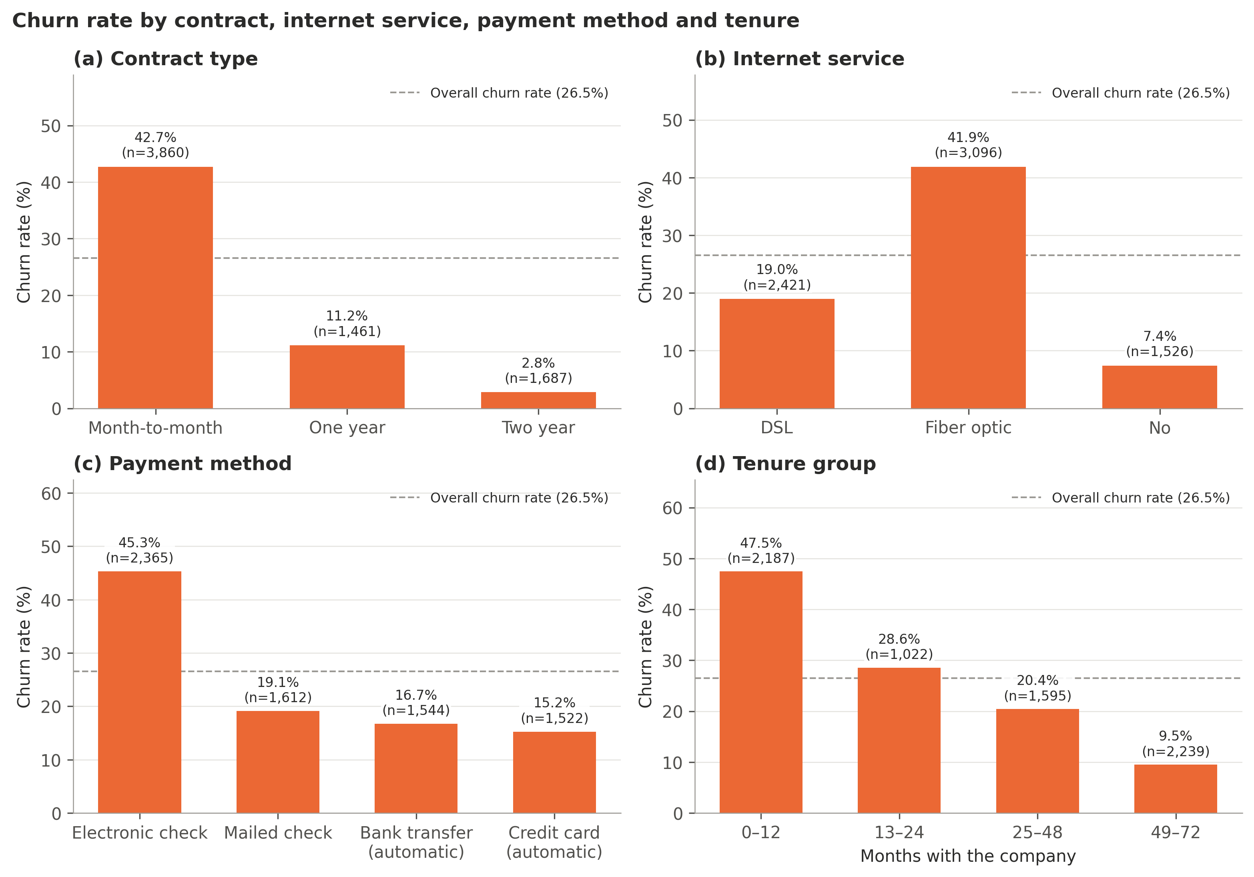
Figure 6: Churn rate by contract, internet service, payment method and tenure group
Figure 7 covers the demographic and billing variables. Senior citizens churn at 41.7% vs 23.6%; customers without a partner (33.0%) or dependents (31.3%) churn more, as do customers with paperless billing (33.6%). Gender shows no meaningful difference (26.9% vs 26.2%), nor does phone service. Among internet customers, churn is 41.8% without online security vs 14.6% with it, and 41.6% vs 15.2% for tech support, whereas streaming add-ons make little difference. Because month-to-month customers also tend to be newer, contracts were compared within tenure groups: month-to-month churn falls from 51.4% to 25.8% with tenure but stays far above two-year contracts (at most 3.3%), so contract and tenure each carry information.
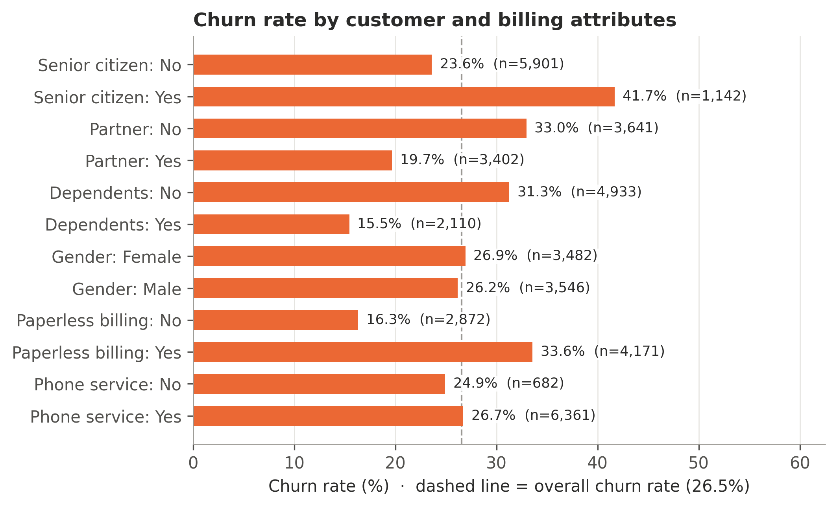
Figure 7: Churn rate by demographic and billing attributes

3.5 Correlation analysis

3.5.1 Correlation heatmap
To include the categorical variables, each was converted to 0/1 columns with the same one-hot encoding used by the models: one column for each Yes/No variable (1 = Yes, with "No internet service" and "No phone service" counted as No) and one column per level for InternetService, Contract and PaymentMethod. Label codes such as 0/1/2/3 were avoided because they would impose a false order on the categories. A correlation with a 0/1 column is a standard measure (the phi coefficient between two 0/1 columns, a point-biserial correlation with a numeric one). Figure 8 shows the resulting 28 × 28 Spearman correlation matrix; Spearman's coefficient ranges from −1 to +1, with values near 0 indicating no monotonic relationship, and was used instead of Pearson's because the numeric variables are skewed and bimodal.
- Higher churn: month-to-month contracts (ρ = +0.41), fiber optic internet (+0.31) and electronic-check payment (+0.30).
- Lower churn: tenure (−0.37), two-year contracts (−0.30), no internet service (−0.23), OnlineSecurity (−0.17) and TechSupport (−0.16). Gender (−0.01) and PhoneService (+0.01) are practically unrelated to churn.
- Related predictors: tenure and total charges (ρ = 0.89) and monthly charges and fiber optic internet (0.80) move together – the multicollinearity that led to removing the charge columns from the logistic regression (Section 2.4). Levels of the same variable are negatively correlated by construction (e.g. month-to-month vs two-year, −0.62).
- The add-on count barely correlates with churn overall (−0.06) because customers without internet have no add-ons yet rarely churn – an overall correlation can hide strong subgroup patterns.
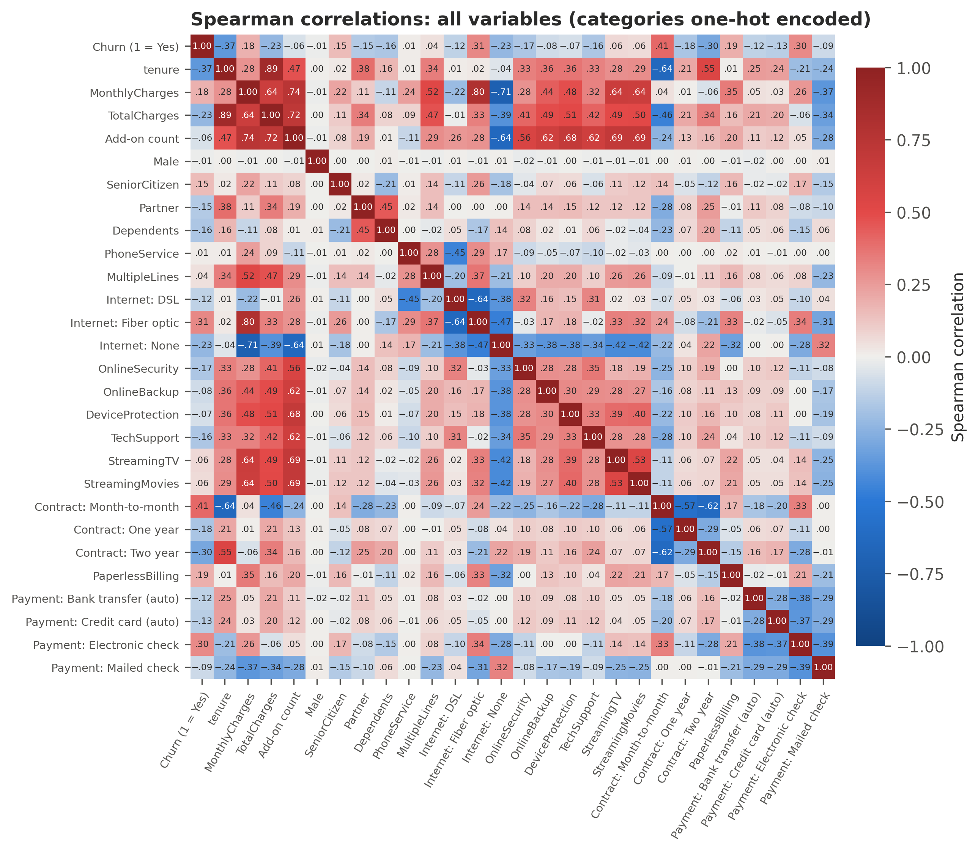
Figure 8: Spearman correlation heatmap of all variables (categories one-hot encoded)

3.5.2 Relationship plots
Because churn is a yes/no variable, a plain scatter plot against it would show only two lines of dots. Figure 9 therefore plots the churn rate of groups of customers with the same tenure or a similar charge level, with a smoothed LOWESS trend line. Churn is 62% among customers in their first month and falls steadily with tenure. For monthly charges the relationship is not linear: churn rises from the cheapest plans (mostly no internet) to a peak of 41% around 70–75 USD (mostly fiber optic) and then eases, which is why its correlation is weak (ρ = +0.18) even though price matters. Total charges largely mirror tenure.
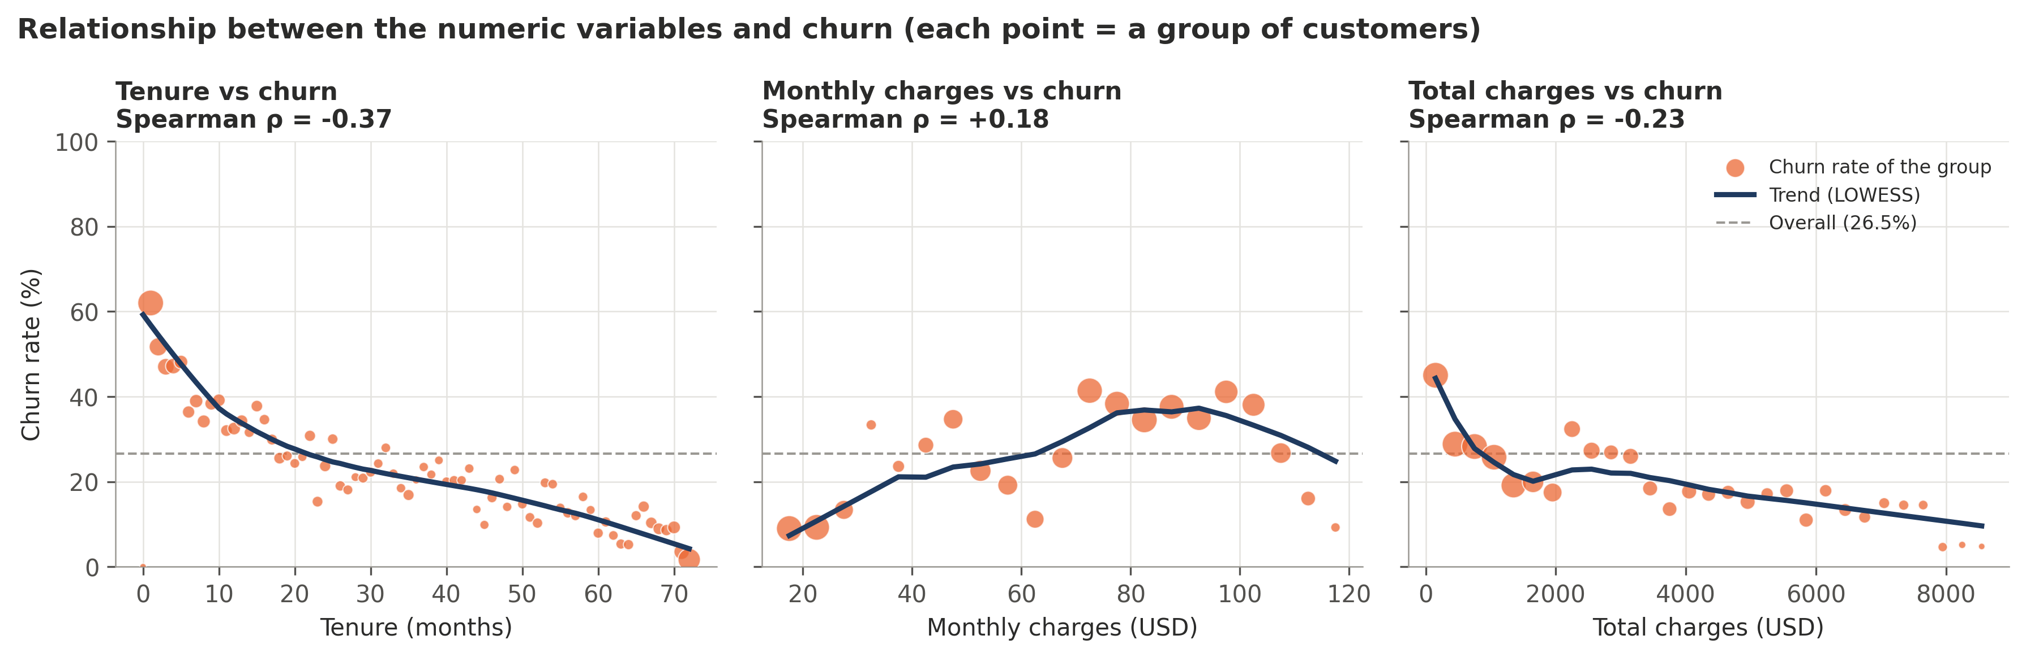
Figure 9: Relationship plots: churn rate against tenure, monthly charges and total charges

3.6 Statistical tests of association
The patterns above, including the correlations in Figure 8, were tested formally. Categorical variables were tested with chi-square tests of independence (all expected cell counts ≥ 5) and Cramér's V as effect size; numeric variables with the Mann-Whitney U test (Mann & Whitney, 1947) and the rank-biserial correlation, because they are not normally distributed. A Bonferroni correction was applied to the 19 tests, and effect sizes (Cohen, 1988: 0.10 small, 0.30 medium, 0.50 large) were used to judge practical importance, since almost any difference is significant with about 7,000 customers.
13 of 16 categorical variables were significantly associated with churn; gender (p = 0.47), phone service and multiple lines were not, matching their near-zero correlations with churn in Figure 8. Figure 10 shows that contract type has the largest effect (V = 0.41, medium), followed by online security, tech support, internet service and payment method, while demographic variables have small effects (V ≈ 0.15). Among the numeric variables, tenure differs most between churners and non-churners (r = −0.48). Re-testing the add-ons among internet customers only showed that the streaming services' apparent association (V = 0.23) came from the shared “No internet service” level (V = 0.04). Overall, the hypotheses that contract, tenure, internet type, payment method and protective add-ons are associated with churn were supported; monthly charges showed only a small, non-linear association (r = 0.24), and gender showed none.
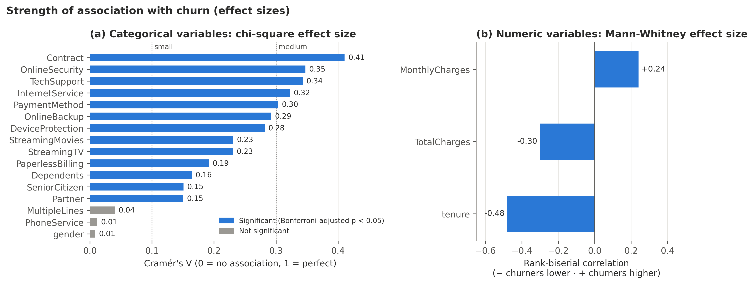
Figure 10: Effect sizes of the associations with churn

4. Model Fitting
Churn is a yes/no outcome, so this is a binary classification problem; linear regression, which can predict values outside 0–1, is not appropriate. Three classifiers were compared with a DummyClassifier that always predicts “no churn”: logistic regression, an interpretable model of the log-odds of churn (Hosmer et al., 2013); a decision tree of readable if/then rules (Breiman et al., 1984); and a random forest of 300 trees that captures non-linear patterns (Breiman, 2001).
Each model was tuned by grid search with stratified 5-fold cross-validation (CV) on the training set only, and all used class_weight = "balanced", which left ranking ability unchanged (CV ROC-AUC 0.845) but raised recall from 0.54 to 0.79. The selection rule was fixed in advance: highest mean CV ROC-AUC, preferring the more interpretable model if another was within 0.01. ROC-AUC measures how well a model ranks churners above non-churners; because only 26.5% of customers churn, accuracy alone would be misleading, so precision, recall, F1 and PR-AUC (Saito & Rehmsmeier, 2015) are also reported. The test set (1,409 customers) was used once, at the end.

4.1 Logistic regression model
Logistic regression was fitted without MonthlyCharges and TotalCharges (Section 2.4). The best regularisation strength was C = 1, giving a CV ROC-AUC of 0.845 and a test ROC-AUC of 0.839. To report standard errors and p-values, an unpenalised statsmodels Logit was fitted to the same training data (Table 6); its odds ratios agree with the final model (largest difference 0.07), 14 of 21 terms are significant at p < 0.05, and McFadden's pseudo-R² is 0.285. Table 6 lists the 12 largest of the 21 terms (full table in the notebook).
Table 6: Logistic regression coefficient summary (training data)
Term | Coef. | Std. err. | z | p-value | Odds ratio
Intercept | -1.411 | 0.181 | -7.80 | < 0.001 | 0.24
Contract: Two year | -1.354 | 0.193 | -7.01 | < 0.001 | 0.26
InternetService: Fiber optic | 0.918 | 0.103 | 8.91 | < 0.001 | 2.50
InternetService: No | -0.835 | 0.156 | -5.37 | < 0.001 | 0.43
tenure (standardised) | -0.804 | 0.065 | -12.42 | < 0.001 | 0.45
Contract: One year | -0.711 | 0.121 | -5.88 | < 0.001 | 0.49
PhoneService: Yes | -0.467 | 0.142 | -3.29 | < 0.001 | 0.63
OnlineSecurity: Yes | -0.395 | 0.095 | -4.17 | < 0.001 | 0.67
PaymentMethod: Electronic check | 0.387 | 0.106 | 3.64 | < 0.001 | 1.47
PaperlessBilling: Yes | 0.369 | 0.083 | 4.44 | < 0.001 | 1.45
TechSupport: Yes | -0.341 | 0.096 | -3.57 | < 0.001 | 0.71
MultipleLines: Yes | 0.324 | 0.088 | 3.67 | < 0.001 | 1.38
StreamingMovies: Yes | 0.282 | 0.089 | 3.16 | 0.002 | 1.33

Figure 11 shows the odds ratios (OR) with bootstrap confidence intervals. For otherwise identical customers, a two-year contract has about a quarter of the churn odds of a month-to-month contract (OR = 0.25); each additional 25 months of tenure roughly halves the odds (OR = 0.47); fiber-optic service has 2.5 times the odds of DSL; and electronic-check payment 1.50 times the odds of automatic bank transfer. Online security (OR = 0.68) and tech support (OR = 0.72) are associated with lower odds, whereas gender (OR = 1.04) and senior status show no clear effect once other factors are included.
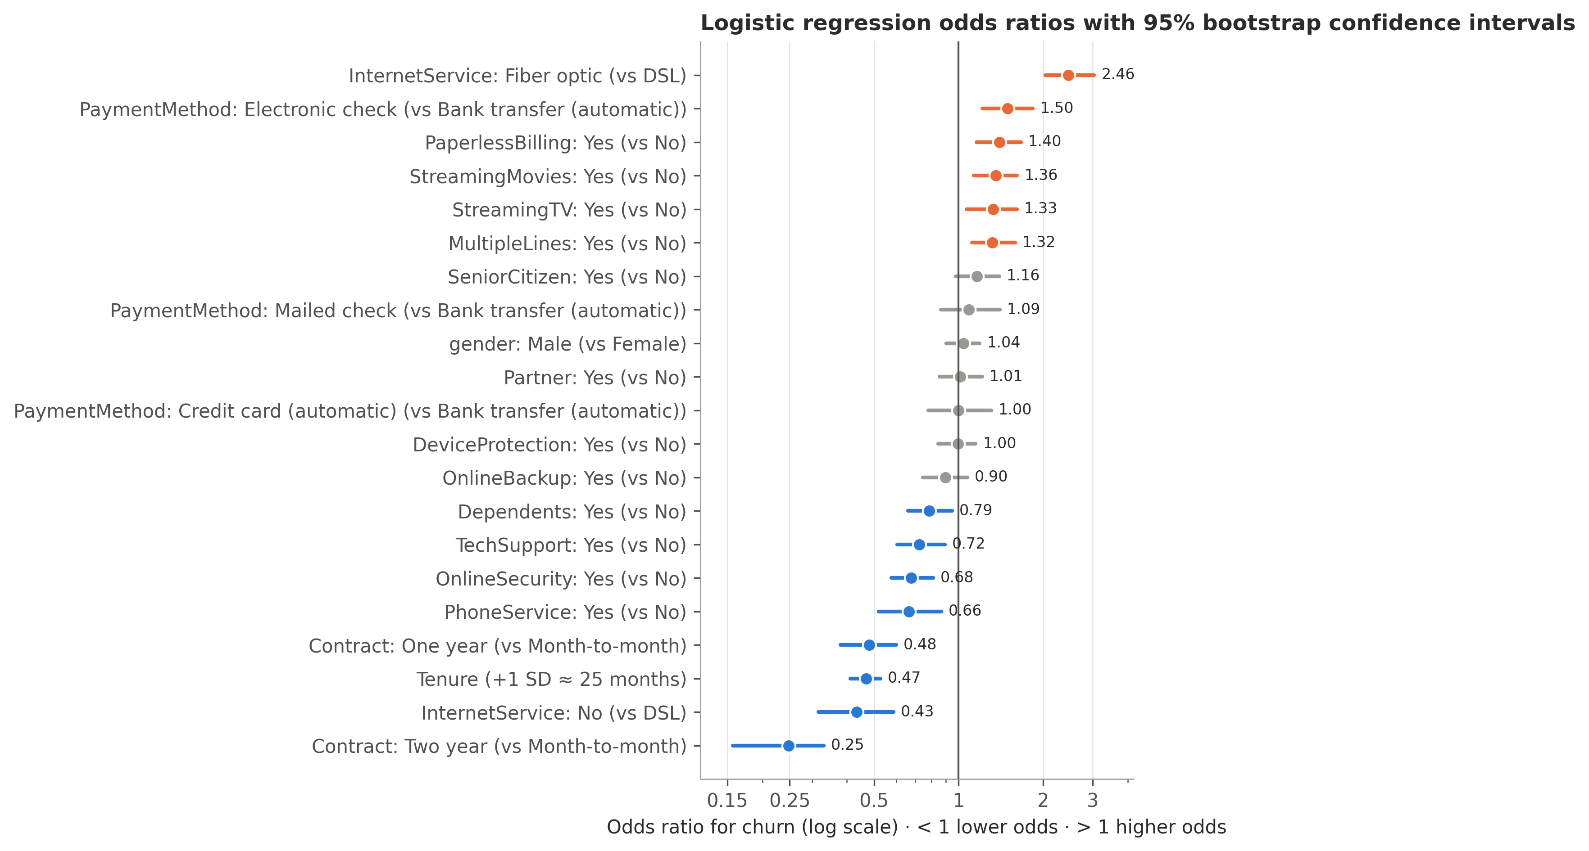
Figure 11: Logistic regression odds ratios with 95% bootstrap confidence intervals

4.1.1 Logistic regression model equation
The fitted model, with its eight largest terms, is:
log-odds(churn) = −0.40 − 1.39·[two-year contract] + 0.90·[fiber optic] − 0.84·[no internet] − 0.76·[z_tenure] − 0.73·[one-year contract] − 0.41·[phone service] + 0.40·[electronic check] − 0.39·[online security] + …
where z_tenure = (tenure − 32.5) / 24.6, each bracket is 1 for customers in that category and 0 otherwise, and the predicted probability is p(churn) = 1 / (1 + e^(−log-odds)); the remaining 13 smaller terms are listed in the notebook. A negative coefficient lowers the predicted churn risk and a positive one raises it. Because balanced class weights shift the intercept, the model is used to rank customers by risk rather than as a calibrated probability.

4.2 Decision tree model
The tuned decision tree has a maximum depth of 5 and at least 50 customers per final group, which limits overfitting (training-to-validation AUC gap 0.021). It reached a CV ROC-AUC of 0.831 and a test ROC-AUC of 0.836. To show how its decisions work, a simplified depth-3 tree (test ROC-AUC 0.815) was also fitted; Table 7 lists its rules. The tree splits first on contract type, then on internet service or monthly charges, then on tenure – the same drivers identified in the EDA.
Table 7: Decision rules of the simplified decision tree (training data)
Rule (path through the tree) | Customers | Churn rate
Contract = Month-to-month and InternetService = Fiber optic and tenure ≤ 13.5 | 762 | 71%
Contract = Month-to-month and InternetService = Fiber optic and tenure > 13.5 | 954 | 42%
Contract = Month-to-month and InternetService is not Fiber optic and tenure ≤ 5.5 | 595 | 40%
Contract is not Month-to-month and MonthlyCharges > 93.7 and Contract is not Two year | 320 | 21%
Contract = Month-to-month and InternetService is not Fiber optic and tenure > 5.5 | 806 | 18%
Contract is not Month-to-month and MonthlyCharges > 93.7 and Contract = Two year | 301 | 8%
Contract is not Month-to-month and MonthlyCharges ≤ 93.7 and Contract is not Two year | 842 | 7%
Contract is not Month-to-month and MonthlyCharges ≤ 93.7 and Contract = Two year | 1,054 | 1%

4.3 Random forest model
The random forest combines 300 trees (maximum depth 8, at least 10 customers per leaf). Its ROC-AUC was 0.890 on the training folds, 0.849 in CV and 0.845 on the test set: moderate overfitting, but the test score matches the CV estimate, so the model generalises well.
Feature importance was measured by permutation importance: how much the test ROC-AUC drops when one variable is randomly shuffled (Figure 12). This was preferred to the forest's built-in impurity importance, which is biased towards continuous variables (Strobl et al., 2007). Contract is the forest's most important input (0.094), followed by internet service and tenure; for the logistic regression, tenure (0.080) leads. Both models rely mainly on the same three variables, and gender has no importance in either.
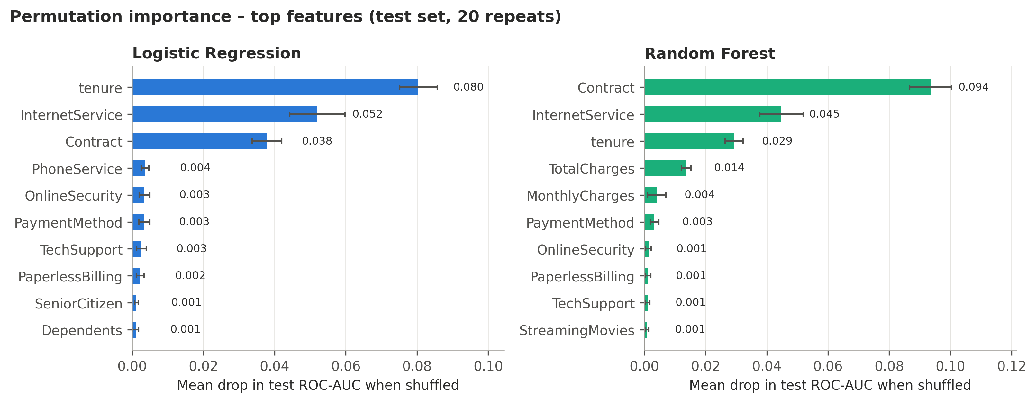
Figure 12: Permutation importance of the input variables

4.4 Model comparison

4.4.1 Performance results
Table 8 and Figure 13 compare the models on the test set. All three clearly outperform the baseline, which is 73.5% accurate but catches no churners. The random forest scores highest on every metric (ROC-AUC 0.845), closely followed by the logistic regression (0.839) and the decision tree (0.836); all catch about 78%–79% of churners.
Table 8: Cross-validated and test-set performance of the models
Model | CV ROC-AUC | ROC-AUC | PR-AUC | Accuracy | Precision | Recall | F1
Dummy baseline | 0.500 ± 0.000 | 0.500 | 0.265 | 0.735 | 0.000 | 0.000 | 0.000
Logistic Regression (selected) | 0.845 ± 0.012 | 0.839 | 0.629 | 0.742 | 0.510 | 0.778 | 0.616
Decision Tree | 0.831 ± 0.013 | 0.836 | 0.620 | 0.755 | 0.526 | 0.794 | 0.633
Random Forest | 0.849 ± 0.011 | 0.845 | 0.657 | 0.762 | 0.534 | 0.791 | 0.638

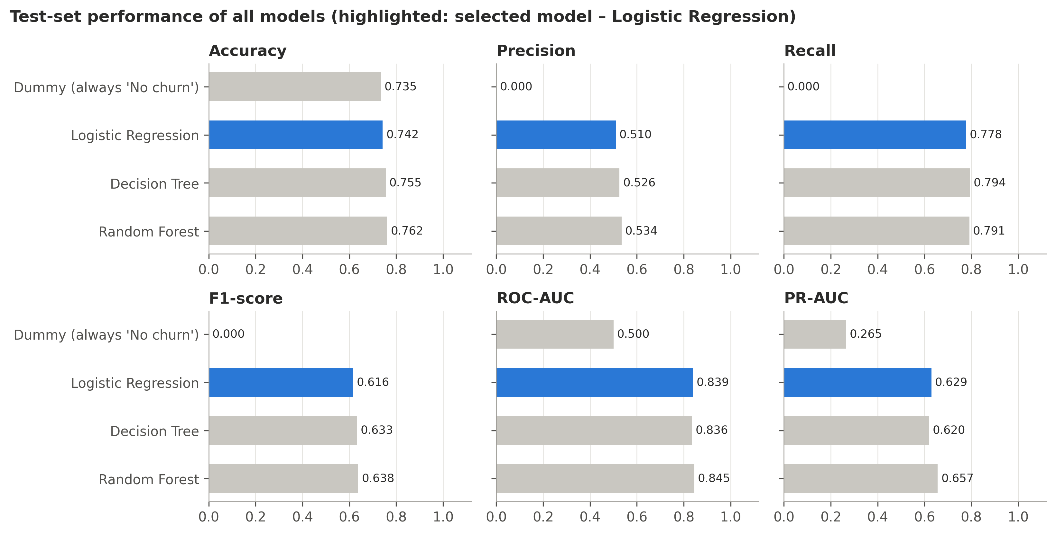
Figure 13: Model comparison on the test set

4.4.2 Interpretation of results
Although the random forest scored slightly higher, the logistic regression was selected: its CV ROC-AUC (0.845) was within the 0.01 tolerance of the forest's (0.849), and the forest's test advantage is not statistically reliable – the paired bootstrap ROC-AUC difference is +0.006 (95% CI −0.001 to 0.014), which includes zero (Efron & Tibshirani, 1993). The logistic regression (test ROC-AUC 0.839, 95% CI 0.815–0.859) also overfits least (gap 0.003 vs 0.041) and is easier to explain. The 0.50 threshold was kept, as the F1-optimal threshold (0.55) performed almost identically; in practice it should follow the retention budget.

4.4.3 Actual vs predicted values
Figure 14 compares actual and predicted classes for every model. The logistic regression correctly identifies 291 of 374 churners; 83 are missed (false negatives – customers lost without a retention attempt) and 280 loyal customers are flagged (false positives – retention offers that were not needed). Ranking customers by predicted risk is also effective: the 20% with the highest scores contain 50% of all churners. Table 9 compares the two strongest models.
Table 9: Actual vs predicted values: comparison of the two strongest models
 | Logistic regression (selected) | Random forest
Churners correctly predicted (TP) | 291 of 374 (77.8%) | 296 of 374 (79.1%)
Churners missed (FN) | 83 | 78
Loyal customers wrongly flagged (FP) | 280 | 258
Loyal customers correctly predicted (TN) | 755 | 777
Share of flagged customers who churn | 51.0% | 53.4%
Overall assessment | Slightly more false alarms; transparent coefficients; least overfitting (gap 0.003). Missed churners resemble loyal customers (median tenure 30 vs 6 months for caught churners). | Marginally better on every count, but the difference is not statistically reliable; harder to explain and more overfitting (gap 0.041).

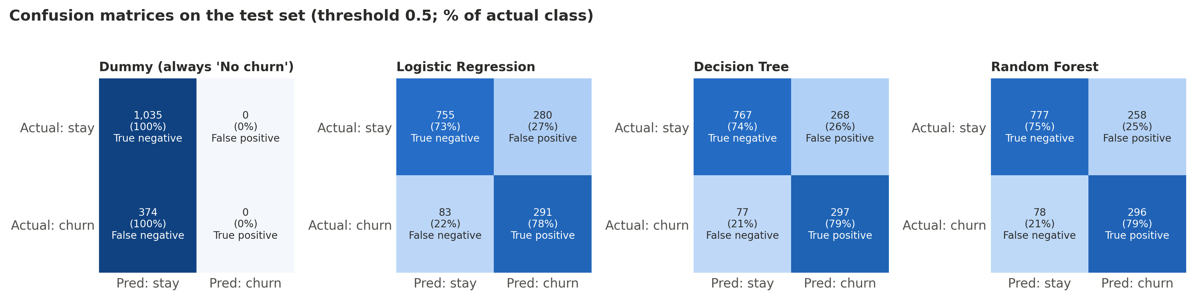
Figure 14: Actual vs predicted classes: confusion matrices on the test set

5. Conclusion
A documented cleaning process repaired a deliberately corrupted dataset without deleting customers or leaking test information, and the EDA and statistical tests showed clear differences between churners and other customers. The selected logistic regression predicts churn with a test ROC-AUC of 0.84 and catches 78% of churners, matching a random forest within statistical uncertainty. The most influential predictors were:
- Contract type, with month-to-month customers churning at 42.7% against 2.8% on two-year contracts (negative impact of short contracts);
- Tenure, with churn highest in the first year (47.5%) (protective effect of longer tenure);
- Internet service, with fiber-optic customers churning at 41.9% (higher risk);
- Payment method and add-ons, with electronic-check payment linked to higher churn and online security or tech support to lower churn.
These are also the variables most strongly correlated with churn in the full correlation matrix (Figure 8). Gender showed no association with churn, and all findings are associations, not proof of cause.

5.1 Recommendations
Table 10 links each recommendation to the evidence that supports it.
Table 10: Retention recommendations and supporting evidence
Recommendation | Evidence | Suggested action
Move month-to-month customers onto longer contracts | Churn 42.7% vs 2.8% (two-year); OR two-year vs month-to-month = 0.25 | Offer loyalty discounts or added benefits for switching to 1- or 2-year plans, especially in the first year
Strengthen onboarding in the first 12 months | Churn 47.5% in the first year vs 9.5% after 4 years; OR per +1 SD tenure = 0.47 | Welcome calls, early check-ins and service-quality follow-ups for new customers
Investigate the fiber-optic experience | Churn 41.9% vs 19.0% (DSL); OR fiber vs DSL = 2.46 even after controlling for other factors | Review fiber pricing, reliability and support; survey departing fiber customers
Encourage automatic payment | Churn 45.3% for electronic check vs 15.2% for automatic credit card; OR = 1.50 vs bank transfer | Small incentives to switch from electronic check to automatic bank or card payment
Promote security and support add-ons | Internet customers: churn with/without OnlineSecurity 14.6% / 41.8%; TechSupport 15.2% / 41.6%; ORs 0.68 and 0.72 | Bundle or offer free trials of online security and tech support, prioritising high-risk customers
Use the model to prioritise, not to decide alone | Contacting the top 20% riskiest customers reaches 50% of churners (top 30%: 64%) | Score customers monthly, contact the highest-risk group first, and size the group to the retention budget
Measure impact with a controlled trial | The data are observational, so the effect of interventions is unknown | Randomly assign retention offers within the high-risk group (A/B test) to measure their real effect before scaling

5.2 Limitations and responsible use
- Association, not causation: the effect of retention actions should be tested with randomised trials.
- Limited information: complaints, service quality and competitor offers are not in the data, so some churners who look loyal are missed.
- Generalisability: the data are an IBM sample for one provider; re-validate on local data before use.
- Responsible use: use the model to support staff decisions, never to give worse terms based on gender or age, and monitor and retrain it regularly.

References
BlastChar. (2018). Telco customer churn [Data set]. Kaggle. https://www.kaggle.com/datasets/blastchar/telco-customer-churn
Breiman, L. (2001). Random forests. Machine Learning, 45(1), 5–32.
Breiman, L., Friedman, J. H., Olshen, R. A., & Stone, C. J. (1984). Classification and regression trees. Wadsworth.
Cohen, J. (1988). Statistical power analysis for the behavioral sciences (2nd ed.). Lawrence Erlbaum Associates.
Efron, B., & Tibshirani, R. J. (1993). An introduction to the bootstrap. Chapman & Hall.
Hosmer, D. W., Lemeshow, S., & Sturdivant, R. X. (2013). Applied logistic regression (3rd ed.). Wiley.
Hunter, J. D. (2007). Matplotlib: A 2D graphics environment. Computing in Science & Engineering, 9(3), 90–95.
Kaufman, S., Rosset, S., Perlich, C., & Stitelman, O. (2012). Leakage in data mining: Formulation, detection, and avoidance. ACM Transactions on Knowledge Discovery from Data, 6(4), Article 15.
Mann, H. B., & Whitney, D. R. (1947). On a test of whether one of two random variables is stochastically larger than the other. The Annals of Mathematical Statistics, 18(1), 50–60.
McKinney, W. (2010). Data structures for statistical computing in Python. Proceedings of the 9th Python in Science Conference, 56–61.
Pedregosa, F., Varoquaux, G., Gramfort, A., Michel, V., Thirion, B., Grisel, O., Blondel, M., Prettenhofer, P., Weiss, R., Dubourg, V., Vanderplas, J., Passos, A., Cournapeau, D., Brucher, M., Perrot, M., & Duchesnay, É. (2011). Scikit-learn: Machine learning in Python. Journal of Machine Learning Research, 12, 2825–2830.
Saito, T., & Rehmsmeier, M. (2015). The precision-recall plot is more informative than the ROC plot when evaluating binary classifiers on imbalanced datasets. PLOS ONE, 10(3), e0118432.
Seabold, S., & Perktold, J. (2010). Statsmodels: Econometric and statistical modeling with Python. Proceedings of the 9th Python in Science Conference, 92–96.
Strobl, C., Boulesteix, A.-L., Zeileis, A., & Hothorn, T. (2007). Bias in random forest variable importance measures: Illustrations, sources and a solution. BMC Bioinformatics, 8, 25.
Verbeke, W., Dejaeger, K., Martens, D., Hur, J., & Baesens, B. (2012). New insights into churn prediction in the telecommunication sector: A profit driven data mining approach. European Journal of Operational Research, 218(1), 211–229.
Virtanen, P., Gommers, R., Oliphant, T. E., et al. (2020). SciPy 1.0: Fundamental algorithms for scientific computing in Python. Nature Methods, 17, 261–272.

