**Sri Lanka Institute of Information Technology**

**Data warehousing and Business Intelligence**

**Assignment 2**

**Student Registration No: IT20186142**

**Student Name: Wijesooriya H.M.A.H.**

**Step 1 – Data Source for the Assignment**

I used data warehouse database (GlobalSuperStore_DW) as the data source which I created in Assignment 1.In there , the fact table and the dimensions as follows,

FactOrder

DimDate

DimCustomer

DimShipmentDetails

DimOrderPriorityDetails

DimMarketDetails

DimSubCategory

DimCategory

DimProduct

Also, I used snowflake schema to integrate them. I used these data to create OLAP cubes and to generate OLAP operations in Excel and to prepare reports in Report Builder.

**Step 2 – SSAS Cube Implementation**

Used Tools:-

SQL Server Analysis Services

SQL Server Management Studio

SQL Server Data Tools

When creating the OLAP cubes first I created Analysis Services Multidimensional and Data Mining Project on SSDT.

Then I renamed it as “DWBI Assignment 02”.Then the folder structure is as follow.

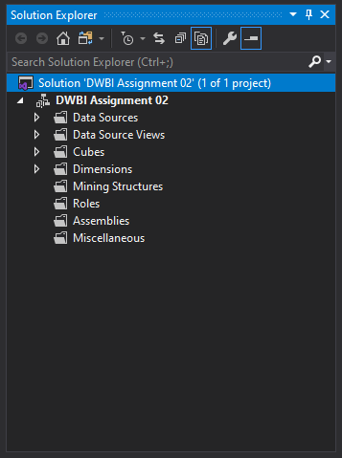

Then the following steps are done ,

1. **Create a Data source**

Under the Data Sources folder in above folder structure, and a new Data Source to create connection with my GlobalSuperStore_DW is added and renamed as DS_Global_Super_Store_DW. I used the service account option to connect it.

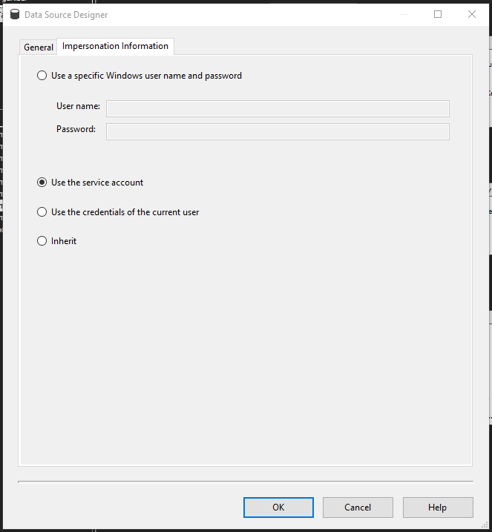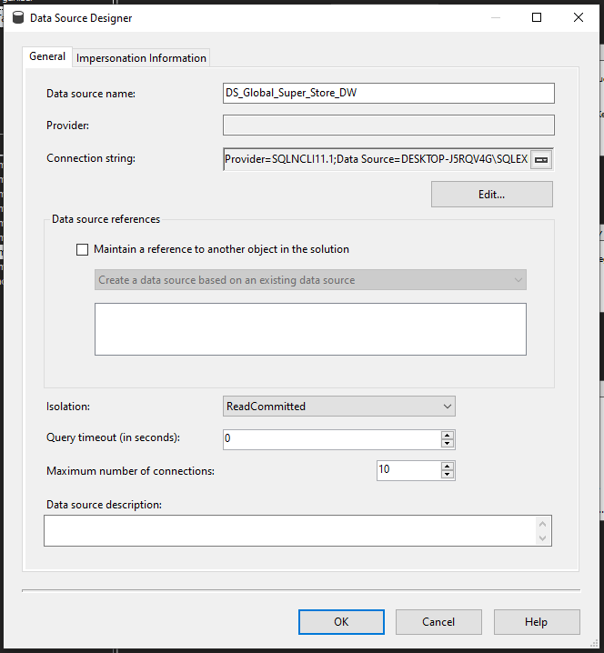

1. **Create a Data Source View**

Under the Data Source Views folder, I added new data source view called DSV_Global_Super_Store_DW.

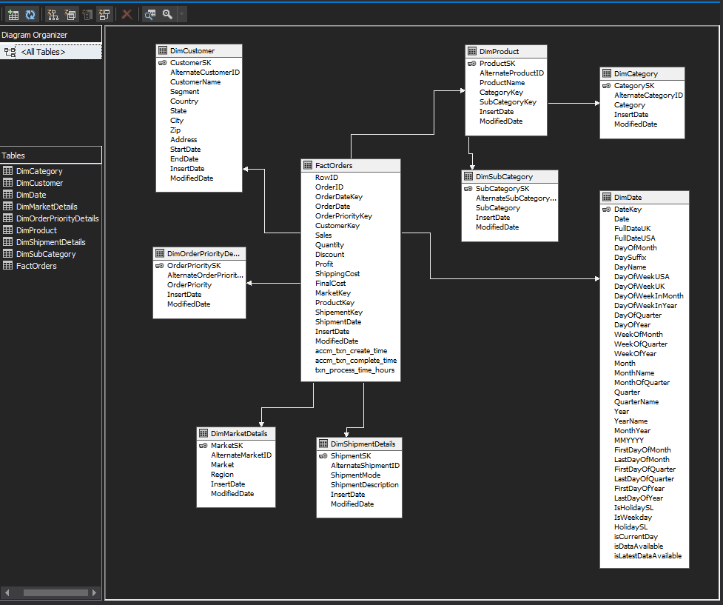

1. **Create a Cube**

Under the Cubes folder I created new cube using above data source view called Cube_Global_Super_Store _DW.

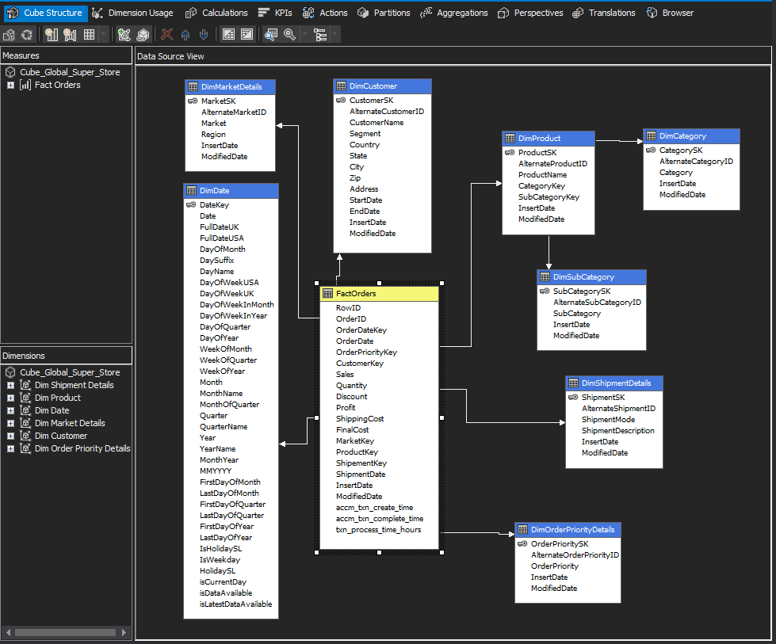

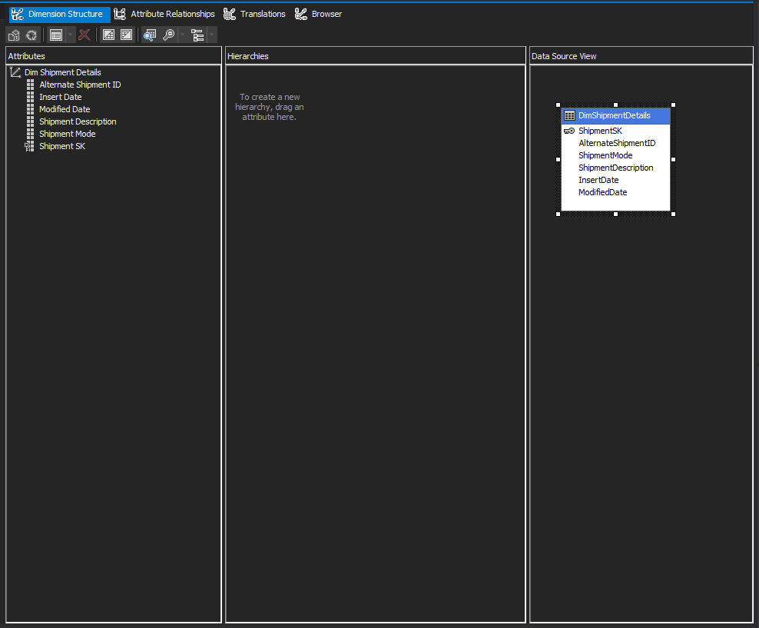Then, I added attributes to all dimensions and created hierarchy to relevant dimensions.

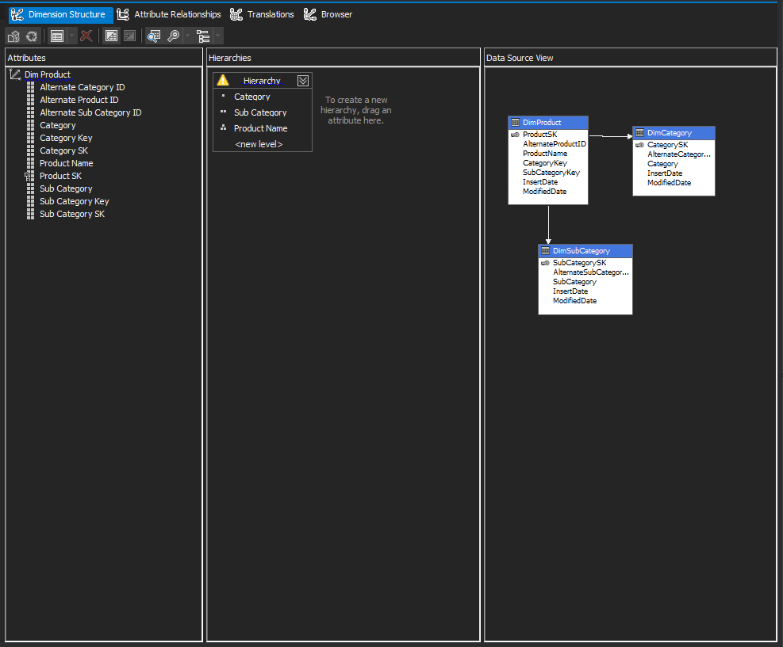

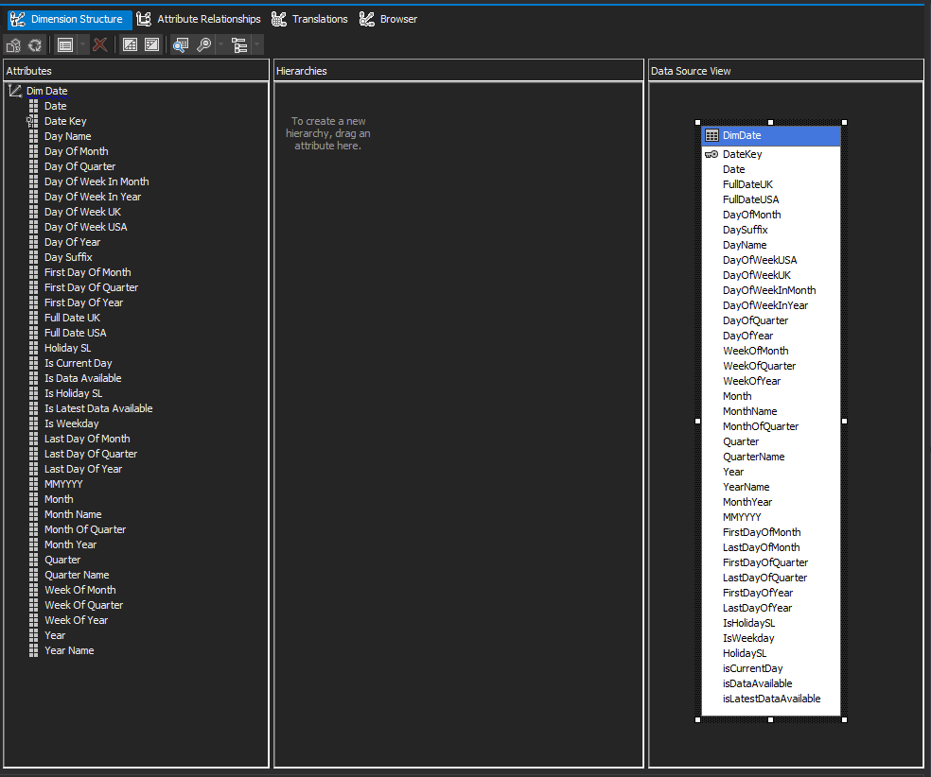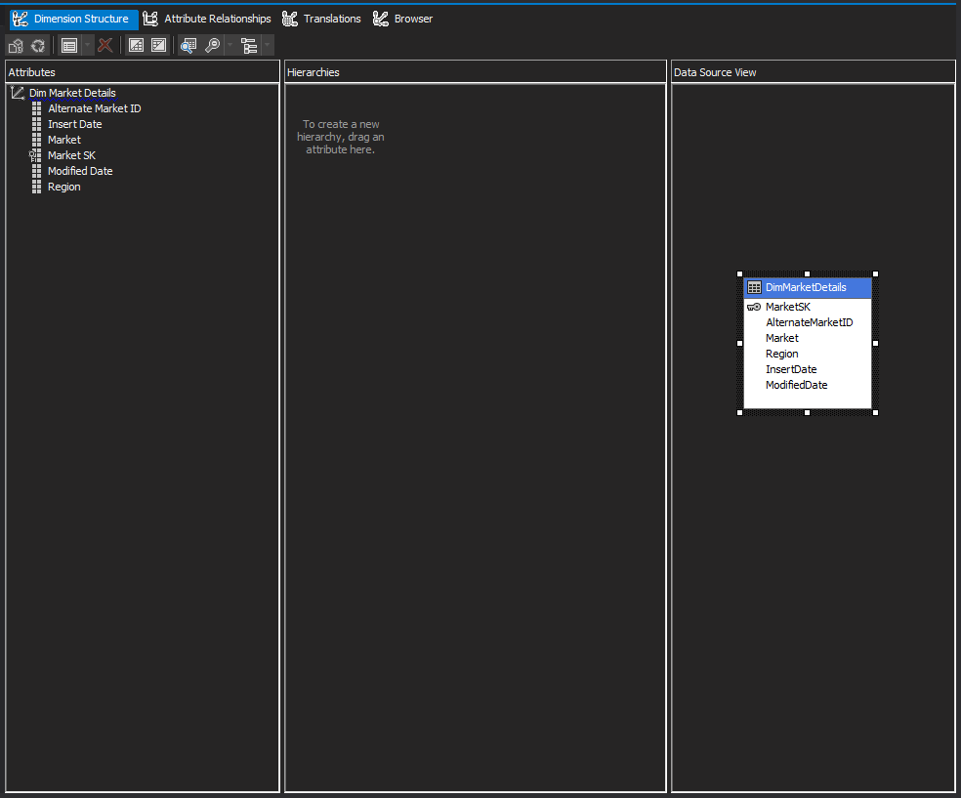

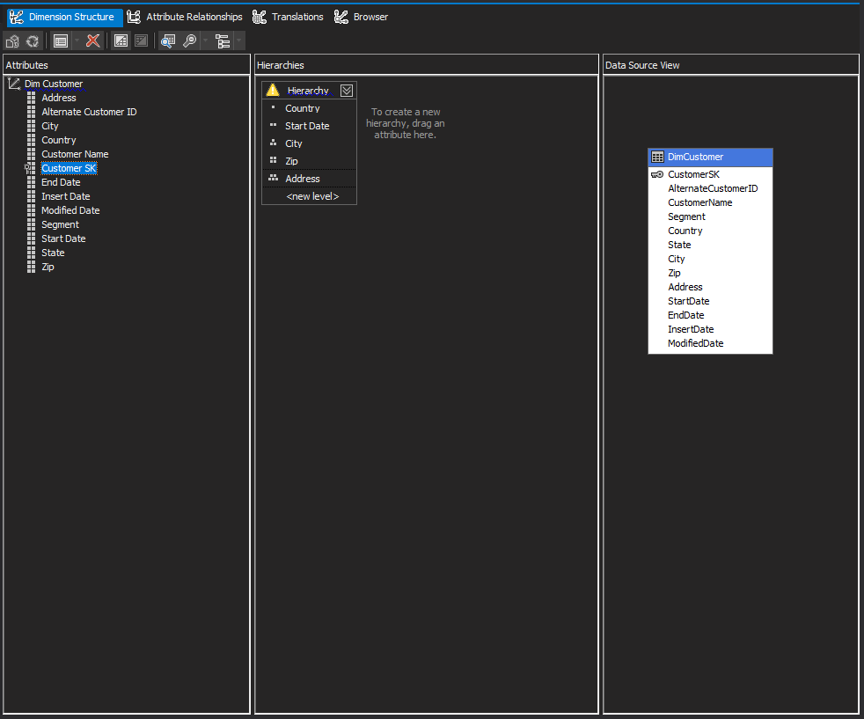

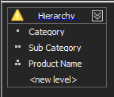These are the 2 hierarchies that was created,

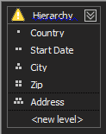

After been deployed folder structure is shown as below,

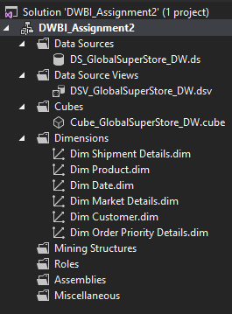

1. **Deploy the Cube**

After finishing all the above steps, the cube is deployed. If it is successfully deployed a message is displayed signifying deployment’s success as shown below.

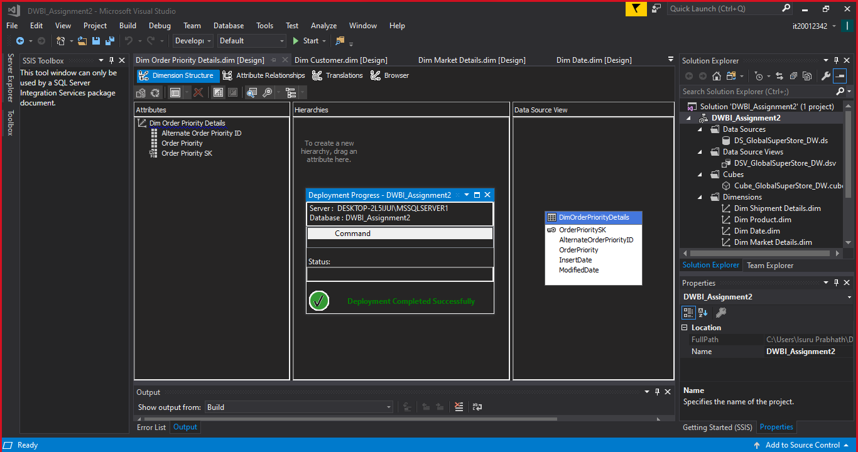

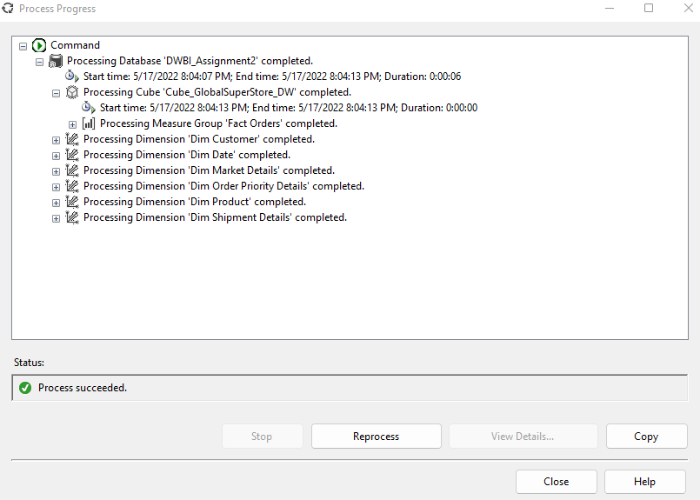

1. **Create KPI**

KPIs are developed based on the needs of the SuperStore. KPIs are used by businesses to assess their progress toward achieving their objectives.

Following Figure shows the KPI which I created after the deploying cube. These are the KPI values which created for GlobalSuperStore. It can be used for determining how much of customers have paid final cost per order more than $30000.

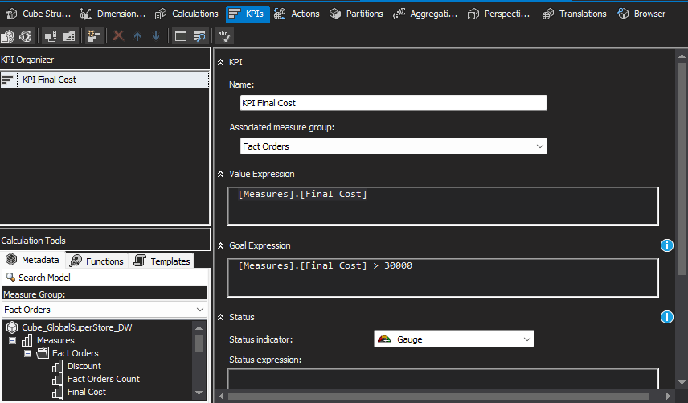

1. **Browse Cube Data**

Browsing data is done via using SSMS. By connecting SSAS to SSMS using instance and MDX queries can generated by selecting the relevant fields from the dimensions.

When browsing cube data, a KPI value or measurement value is compulsory. Otherwise, it will not be executed.

Below figure shows how to browse data in SSMS,

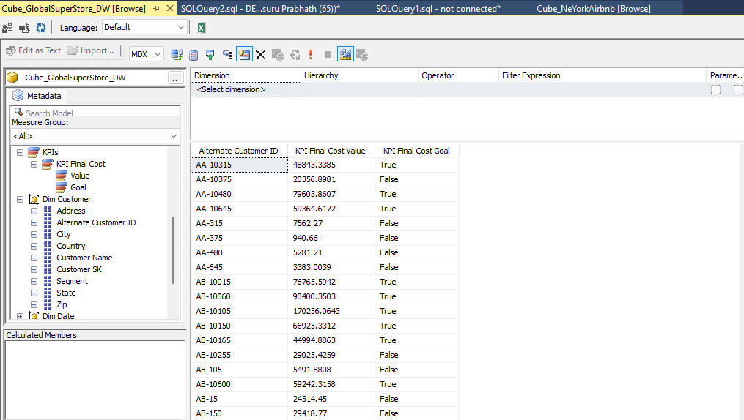

**Step 3 – Demonstration of OLAP Operations**

Used Tools :-

Excel

SQL Server Management Studio

SQL Server Analysis Service

OLAP operation first, the Excel is connected to SSAS cube using MDX query. MDX query is created using above process. And below picture show how to connect the Excel to SSAS Cube successfully.

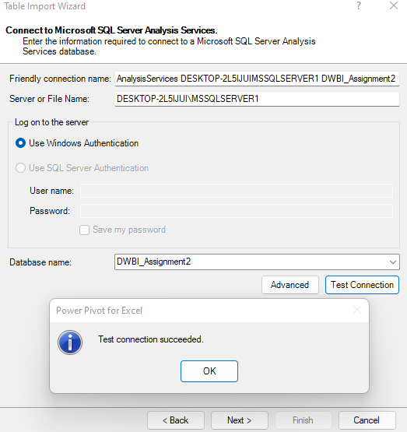

Then, this shows how to successfully insert MDX query for generating data to create OLAP operations.

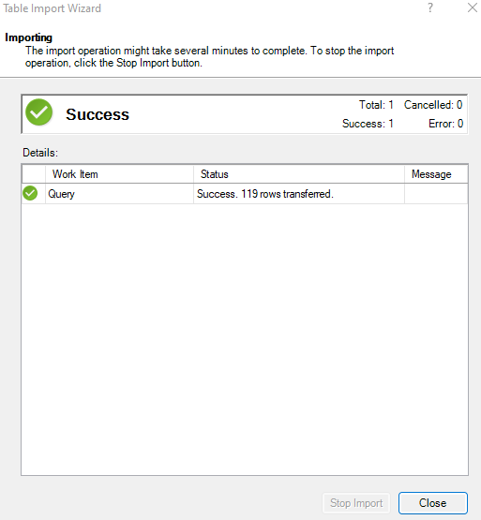

1. **Slice**

Slices are visual filters that can be used to filter data in a pivot table or chart.

The slices I used to filter my pivot table and pivot chart are shown in the diagram below.

In this excel sheet I added the slicers on Customer State, when I clicked the State, I can get the Sum of Final Costs, Sum of Shipping Costs and sum of sale amount of orders according to the selected state of customer.

And the chart showed state-wise Sum of Final Costs, Sum of Shipping Costs and sum of sale amount of orders 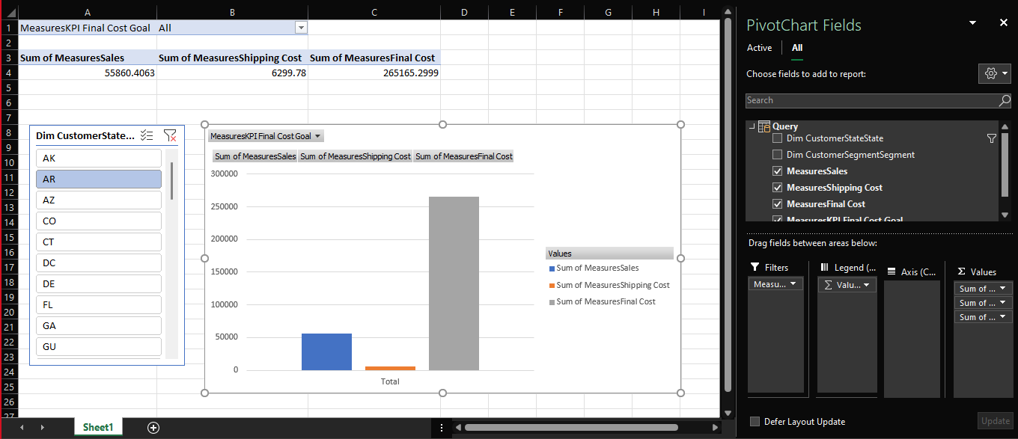

1. **Dice**

Selecting appropriate qualities to group the data by is referred to as dicing the data.

To analyze the data in the pivot table and pivot chart, I utilized two slicers. Those are CustomerState slicer and CustomerSegment slicer.Then I grouped data according to State of customers and types of customers

After that, I can get state-wise result sum of sales according to state.

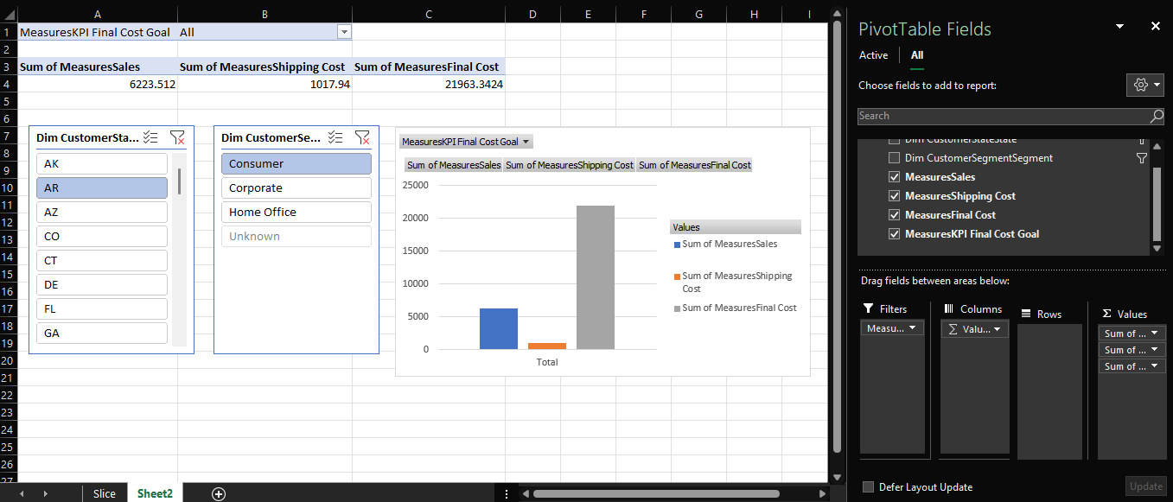

1. **Roll-up**

Climbing up a hierarchy of a dimension to aggregate data is what the Roll up OLAP function in cubes signifies.

In this following excel sheet shows State and Sales amounts

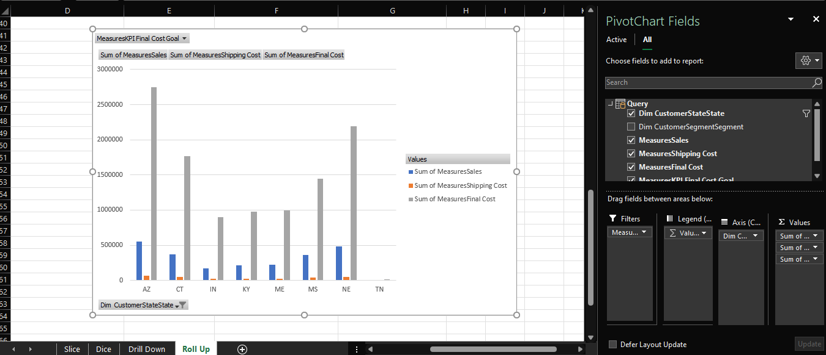

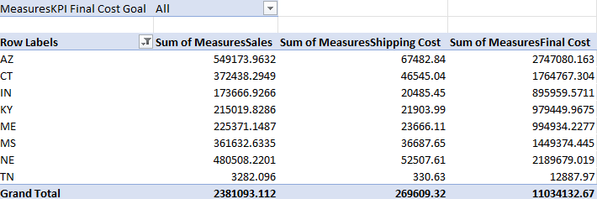

1. **Drill-down**

In cubes, the drill down OLAP function entails navigating through details by moving down a hierarchy of a dimension.

Following Figure shows state can be drilled down to the customer segement

So, we can view the sales amounts state wise. This process is the opposite of the roll up operation.

And the graph shows state wise sum of final costs and the sum of sales.

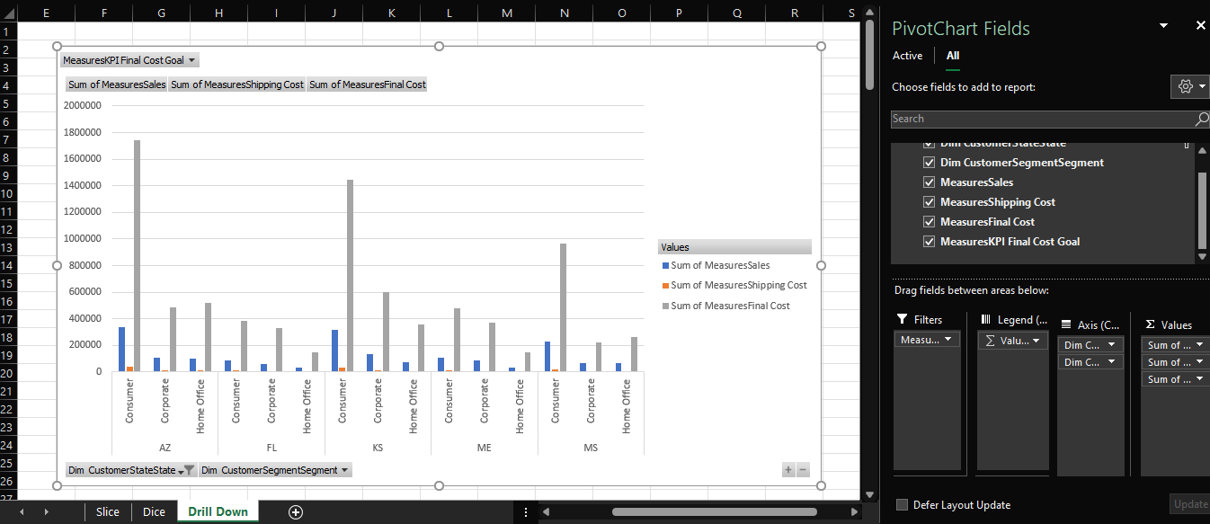

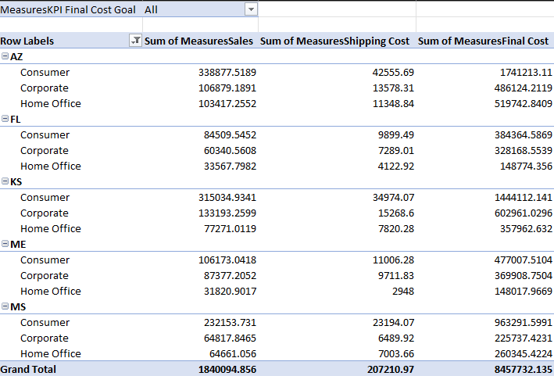

**Step 4 – SSRS Reports**

Used Tools:-

Report server

SSRS web portal

Report Server Configuration Manager

Report Server database

Below figure show the web portal view . In there, the created paginated reports and SSRS folder is displayed.

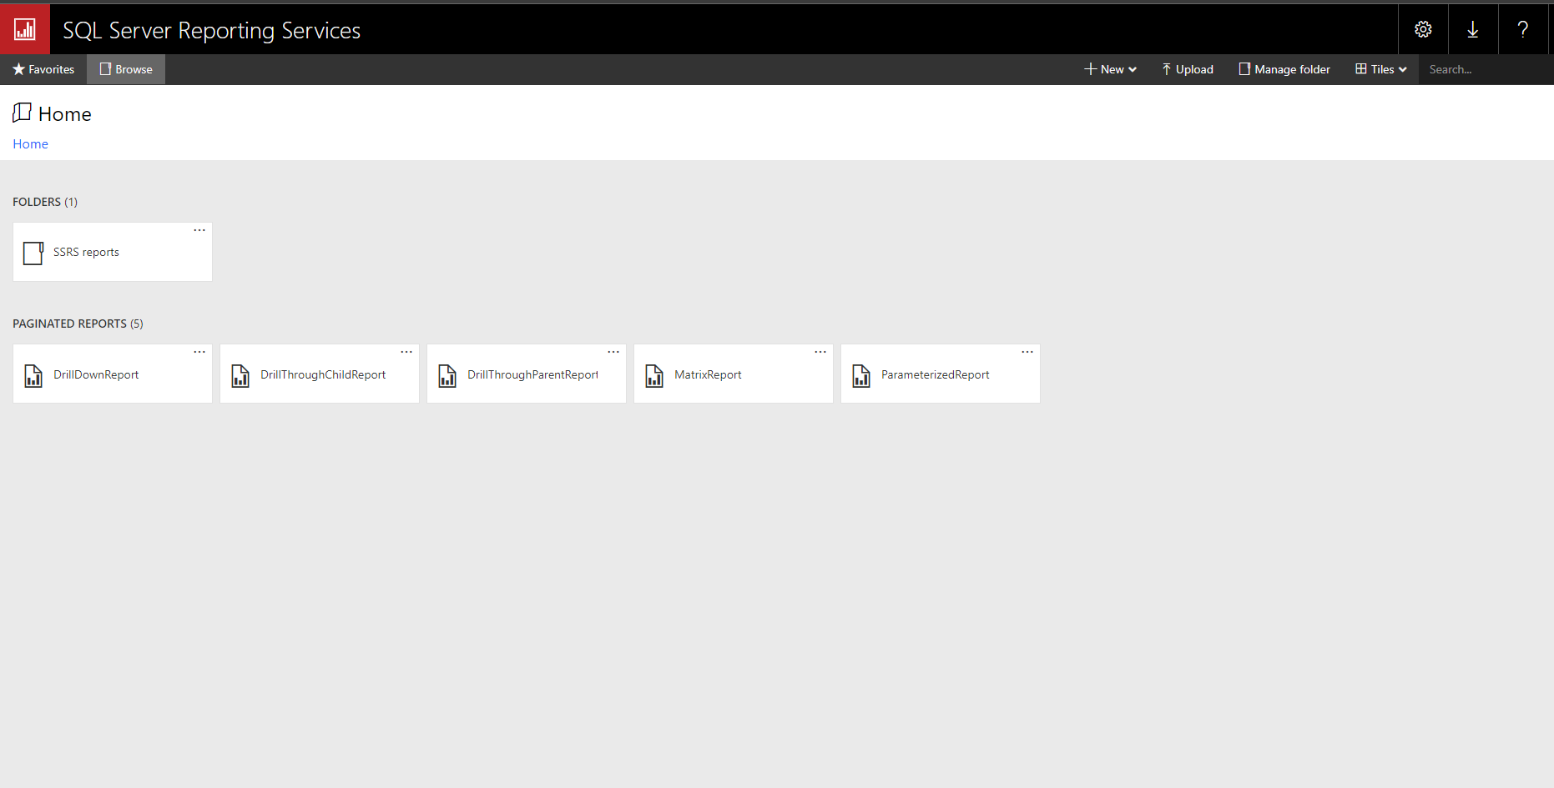

1. **Report 1: Report with a matrix**

Below figure shows how to add rows, columns and data according to the report,

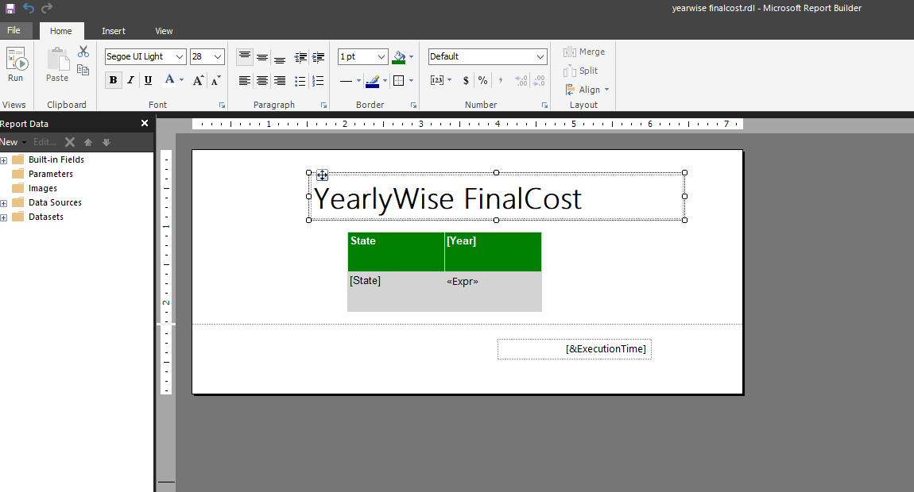

Below report shows year wise total final costs for each sales according to the states of customers .

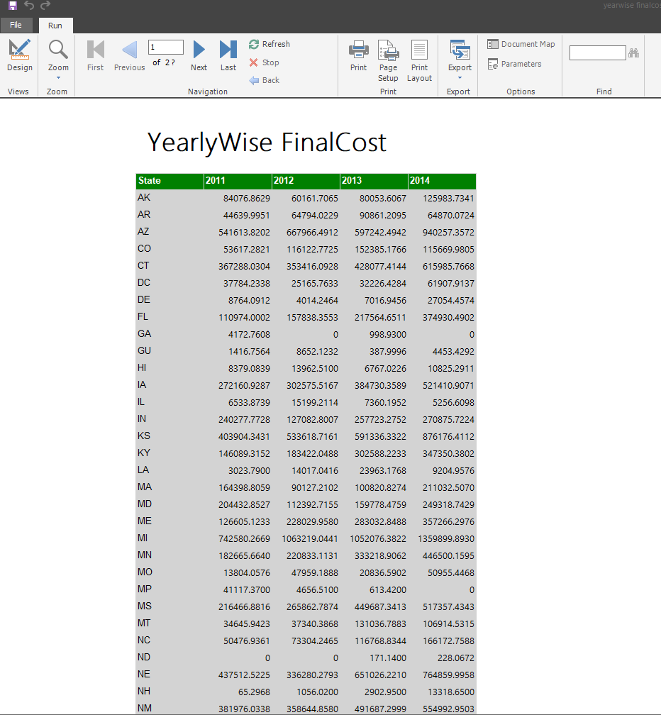

1. **Report 2: Report with more than one parameter**

In this report I used two parameters of Category and SubCategory. There is a dropdown to select the options.

Then, it can select values from category drop down and subcategory drop down and then relevant details related to parameter values is displayed.

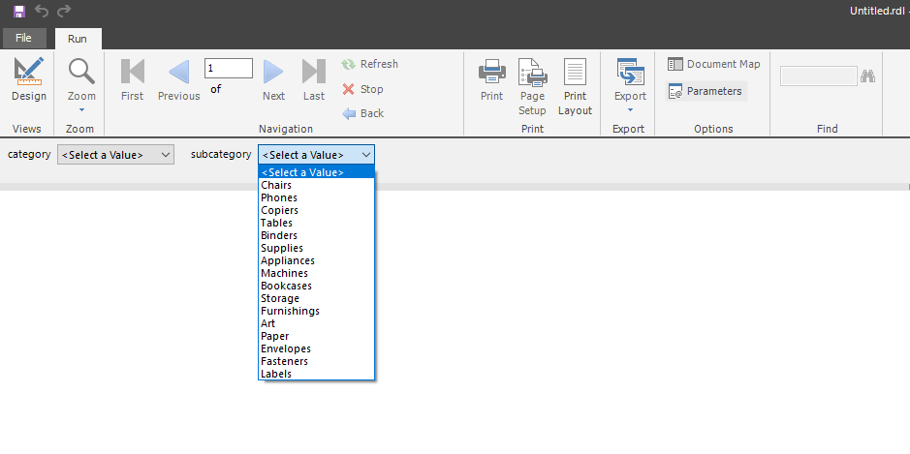Below figures shows two parameters and the result reports of them.

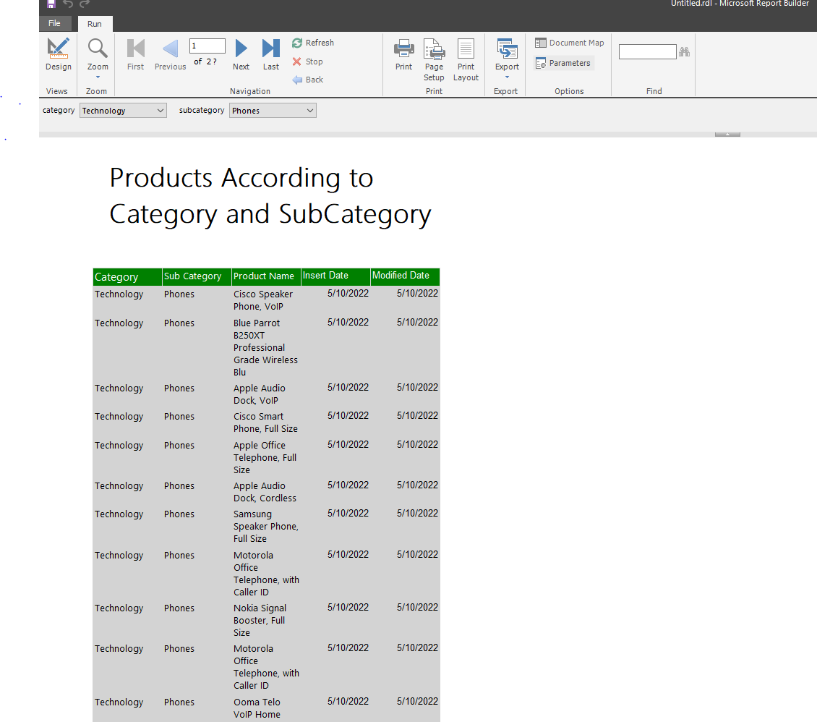

1. **Report 3 : Create an SSRS drill-down report.**

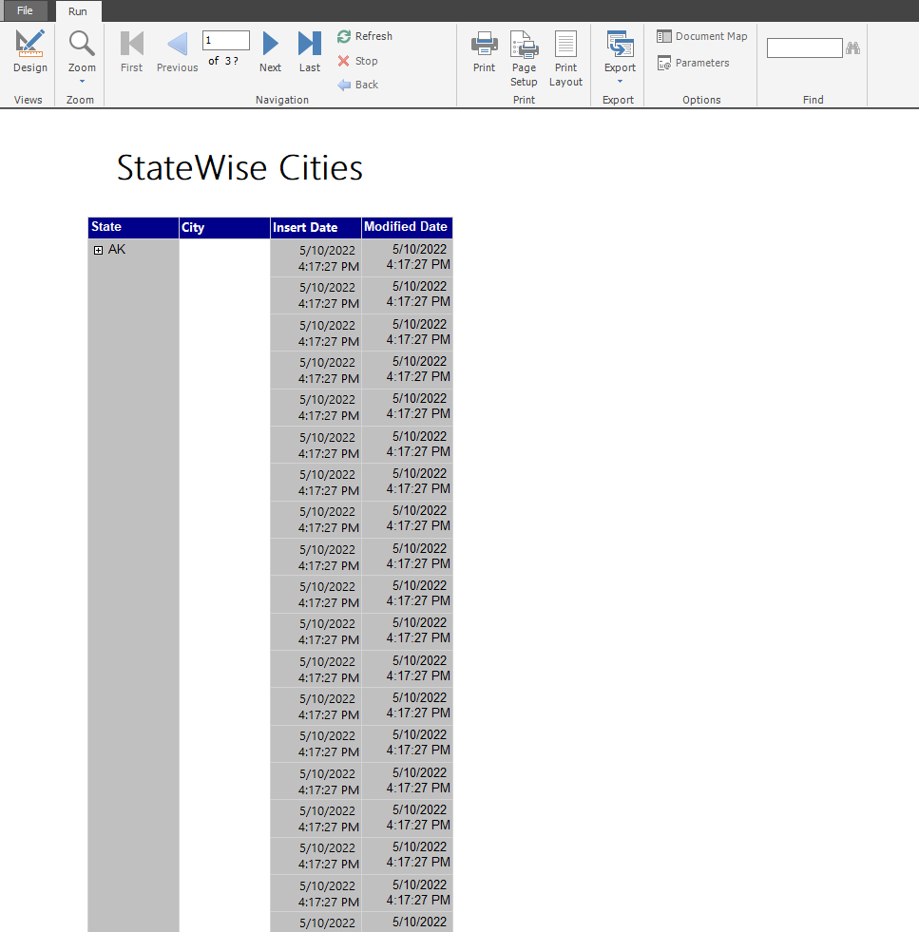

Drill Down Reports allow users to Show or Hide Column Data by using plus and minus symbols.

In here we can view customer’s cities are hidden by providing a plus sign. It can be expanded by clicking plus sign to see other hidden fields.

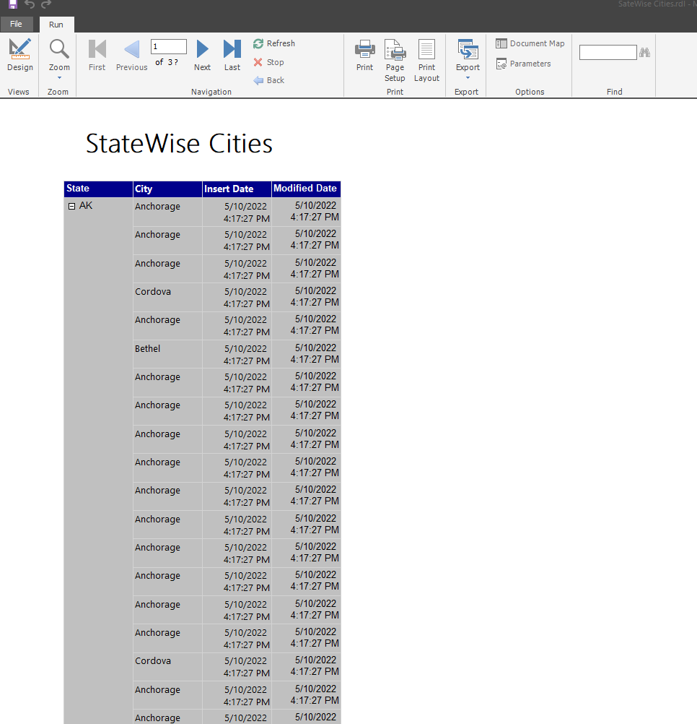

1. **Report 4 : Create an SSRS drill-through report**

A drill-through report is one that a user accesses by following a link from another report. Drilling down through a report opens a new window with an entirely different visualization or report.

In this report is visualized orders according to markets. In parent drill through report there are markets. By clicking a relevant market, it would navigate to a separate report which contains all orders happened in that market

Below figures shows that detailed reports of market and orders.

