**BSc (Hons) in Information Technology**

**Specializing in Software Engineering**

**Year 4 - 2022**

**IT4010 – Research Project**

**Status Document**

**Agrox**

Elevating Cinnamon Industry through Expert Guidance and Support

2023-156

Student Name: Ravishan S.A.A.

Student ID: IT20241032

## Group Details

**Supervisor** – Prof. Koliya Pulasinghe

**Co-Supervisor** – Dr. Dharshana Kasthurirathna

# Screenshots of MS Teams Meetings

## Weekly Meetings

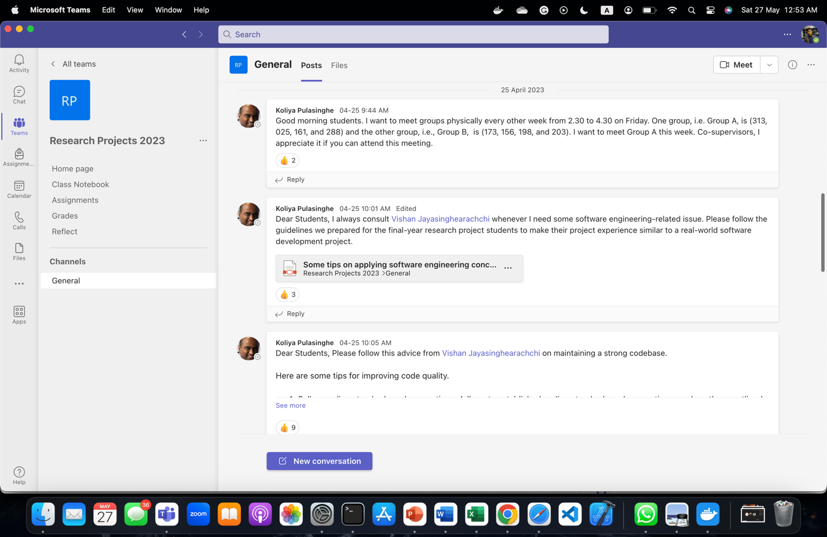

Teams Calls

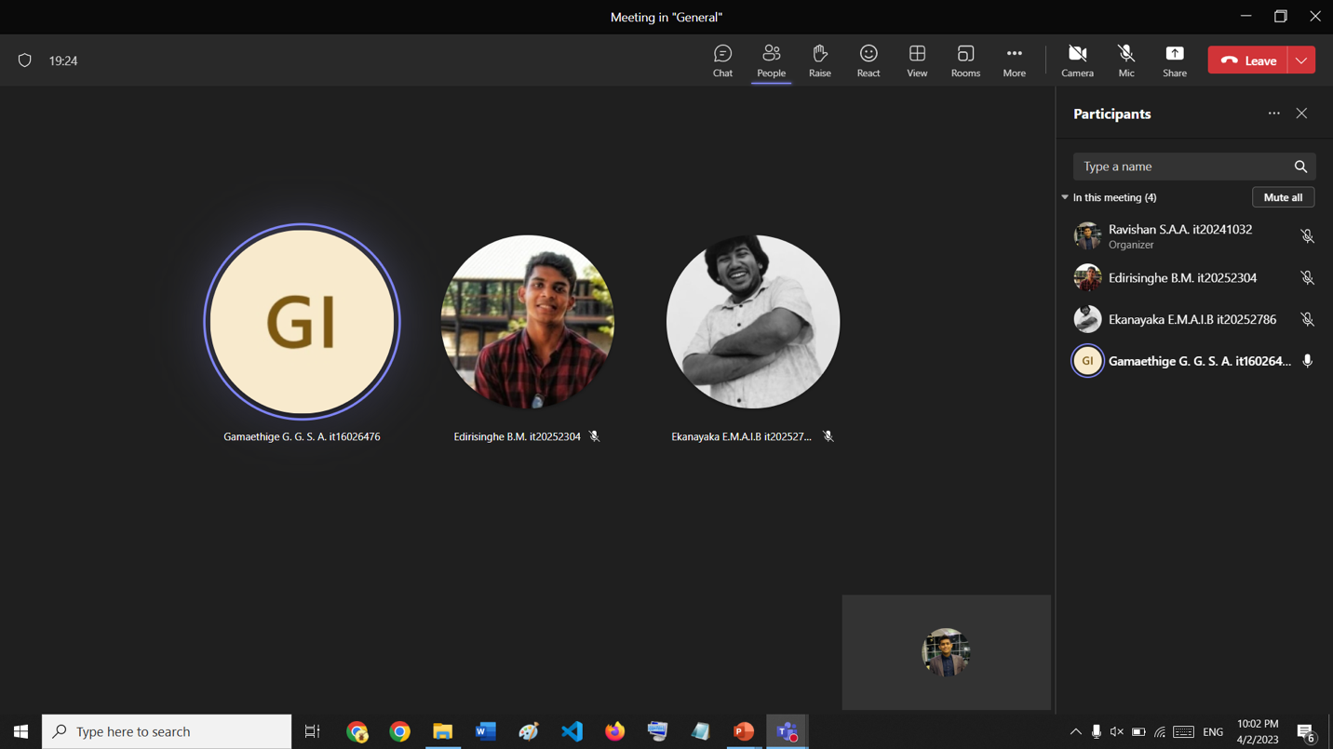

## Group Members

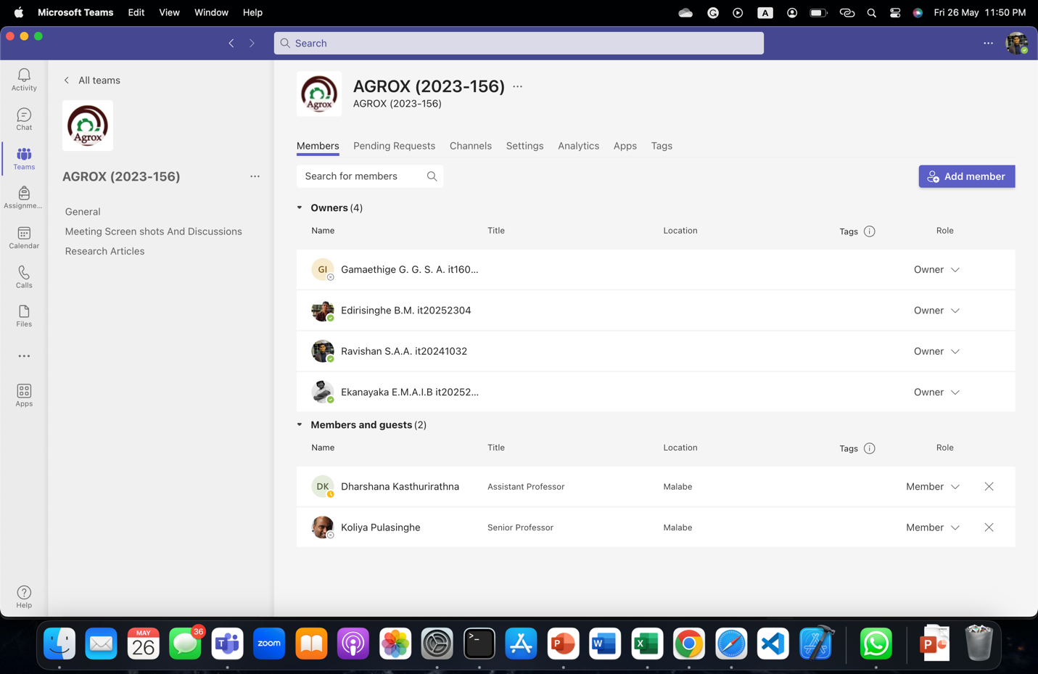

Screenshots of MS Planner

## Bucket List – IT20241032

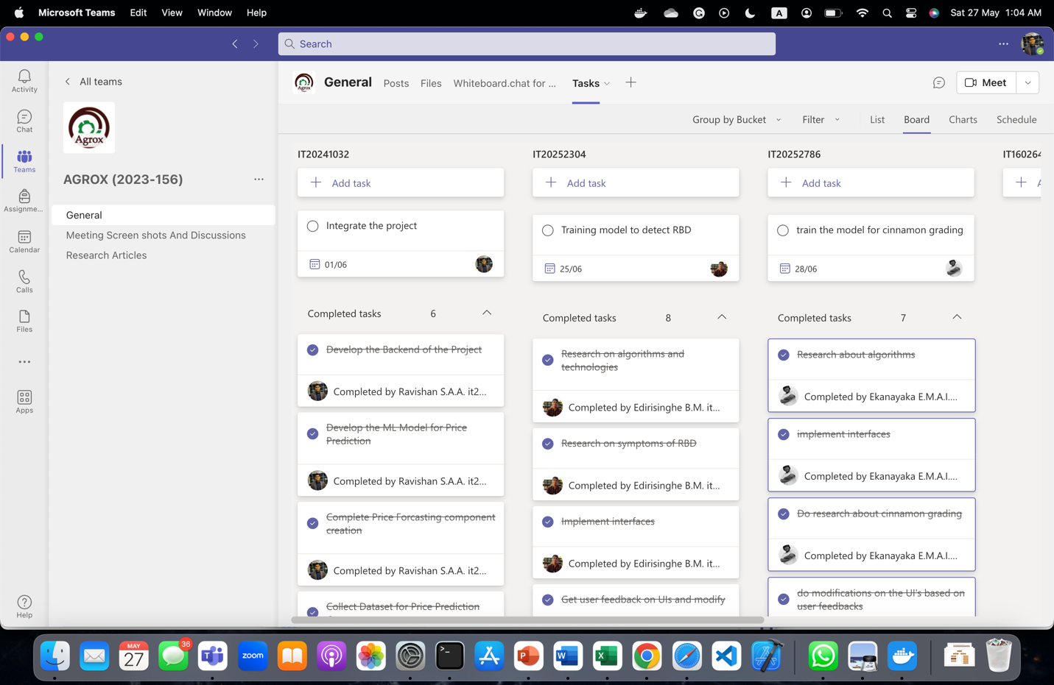

# Screenshots of GitLab

## Group Members

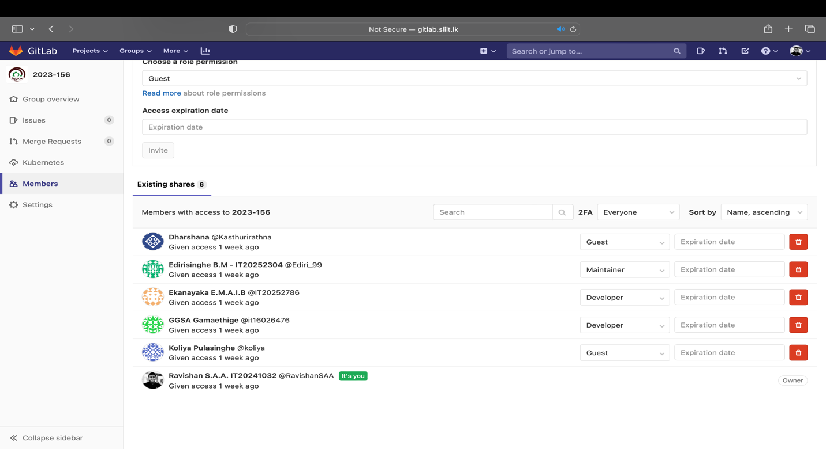

## Git Master View

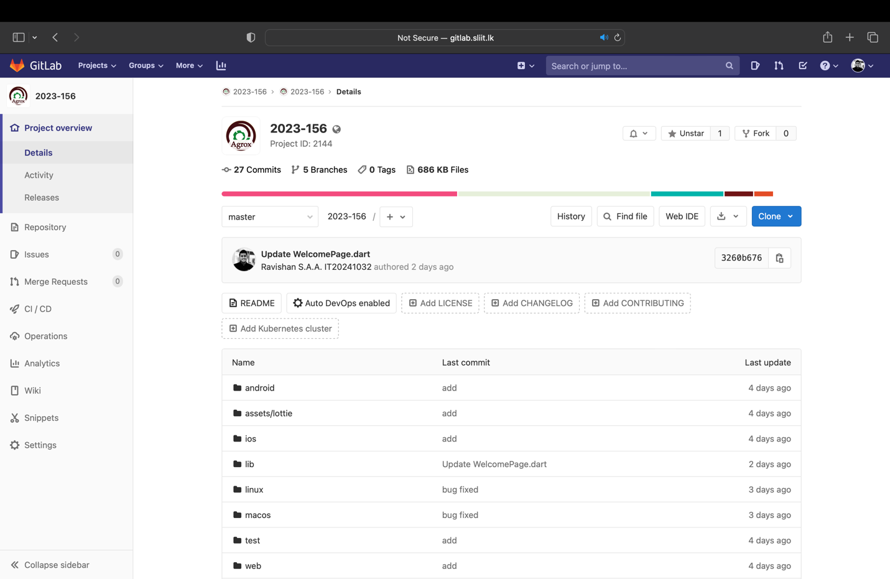

## Git ReadMe.md

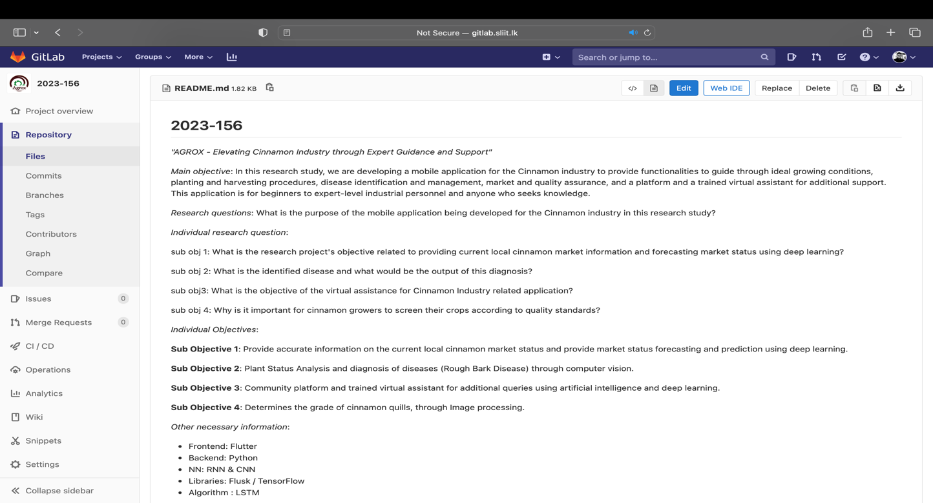

## Git Merged

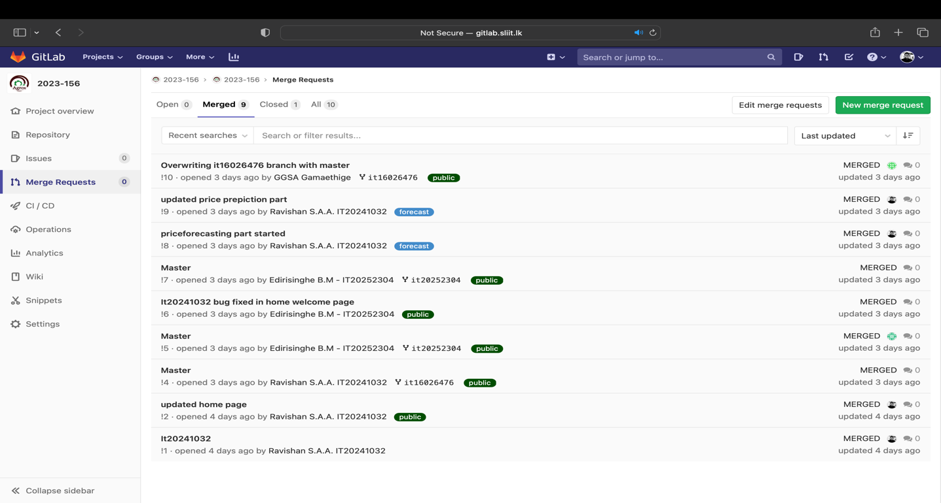

## Git Branches

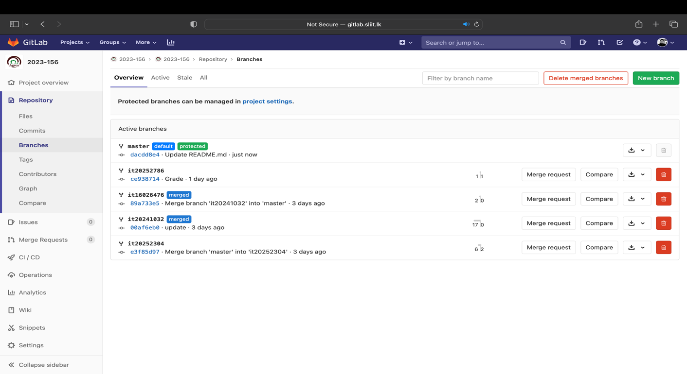

## Git Commits – IT20241032

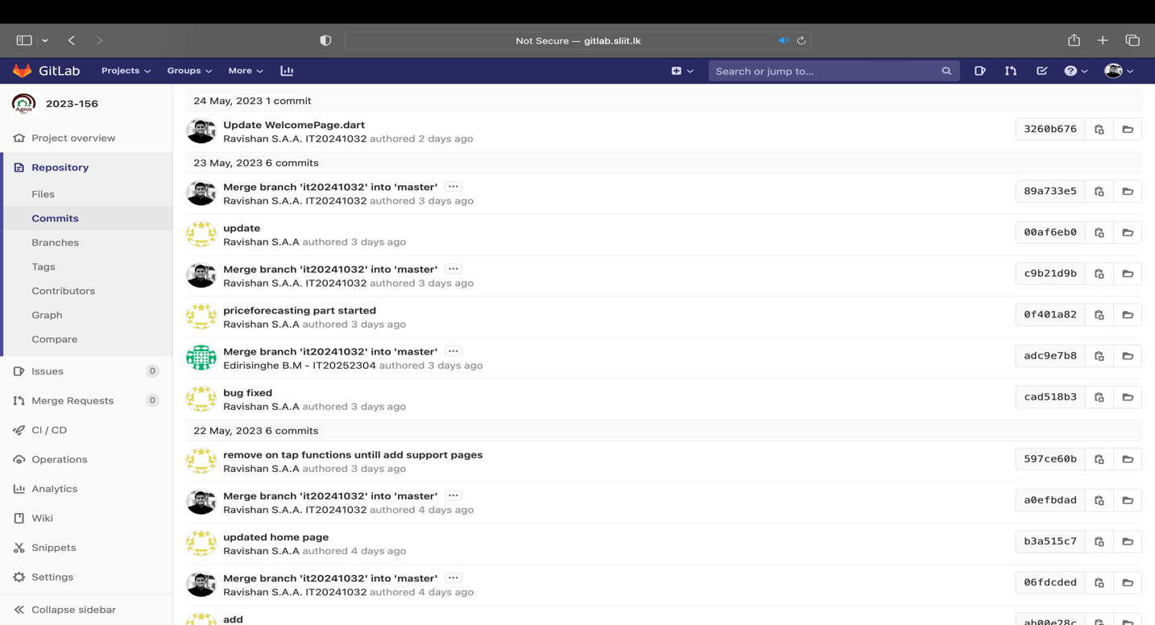

## GitLab Profile

## 

# Gantt Chart

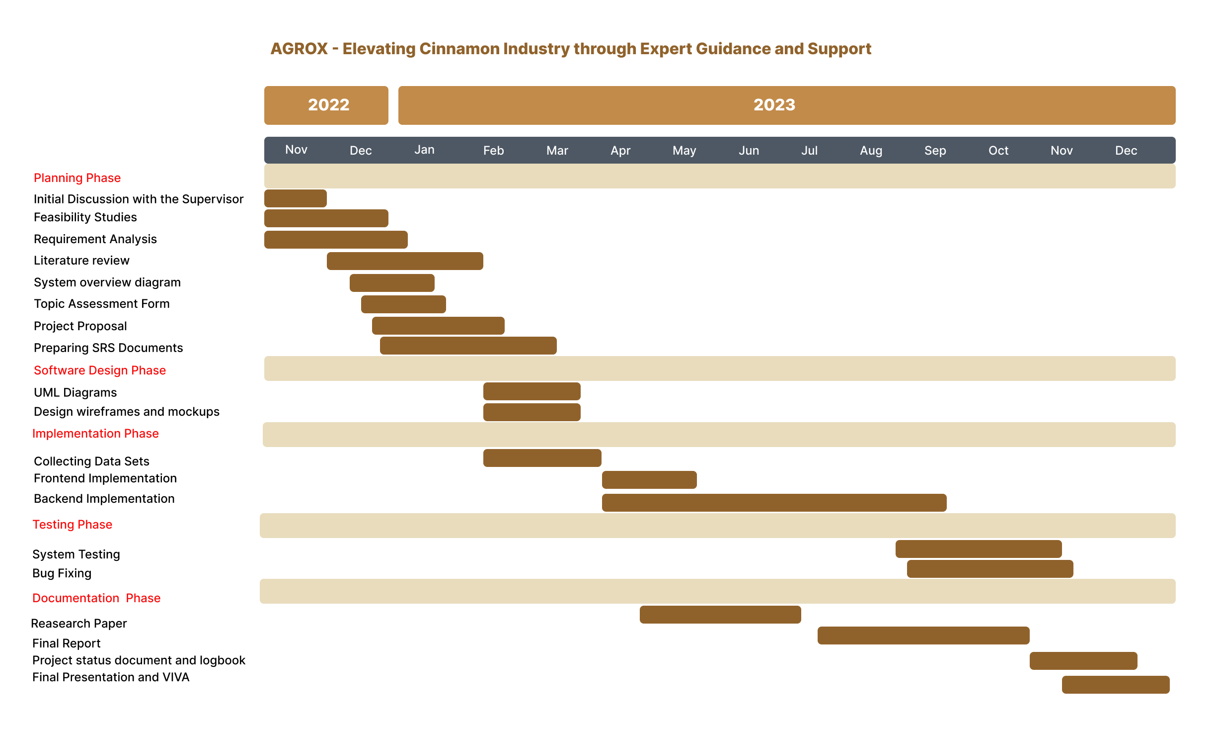

# Work Breakdown Structure

