|  |
| --- |
| <PROJECT NAME> Executive Summary |
| Group Member Names2810ICT Software TechnologiesDate |

# Abstract

Due to the rapid increase in the world population and high population densities in urban and suburban areas, the number of street accidents has been increased. Since the data available related to street accidents is bulky and unstructured, most people are not interested in analyzing data to get a better understanding of the reasons for these accidents to minimize street accidents.

In our project, we have developed a Machine Learning model to analyze a given set of data.

The user can set a period that needs to be analyzed as the starting date and ending date of the period. The data can be further analyzed according to the time of a day by giving the starting time and the ending time of time duration as inputs to the model.

# Introduction

The focus of this project is to represent data in an effective manner to the user, in such a way that the user can easily make decisions relying on these results. The covered period is from the year 2013-2019

In our model, we offer 5 main features

1. For a user-selected period, display the information of all accidents that happened in the period
2. For a user-selected period, produce a chart to show the number of accidents in each hour of the day (on average).
3. For a user-selected period, retrieve all accidents caused by an accident type that contains a keyword (user entered)
4. Allow the user to analyze the impact of alcohol in accidents according to the following criteria
   1. Tends over time
   2. Accident types involving alcohol
5. For a user given period, the number of accidents in each speed zone

# **Analysis 1 – Displaying accidents happened in a user given period**

Resulted HTML files folder : <https://drive.google.com/drive/folders/1SvcDo2aYnBBIEH_rYD5CWH8vT_B_wp_A?usp=sharing>

# **Analysis 2 – Displaying number of average accidents happened in each hour of the day for a user given period**

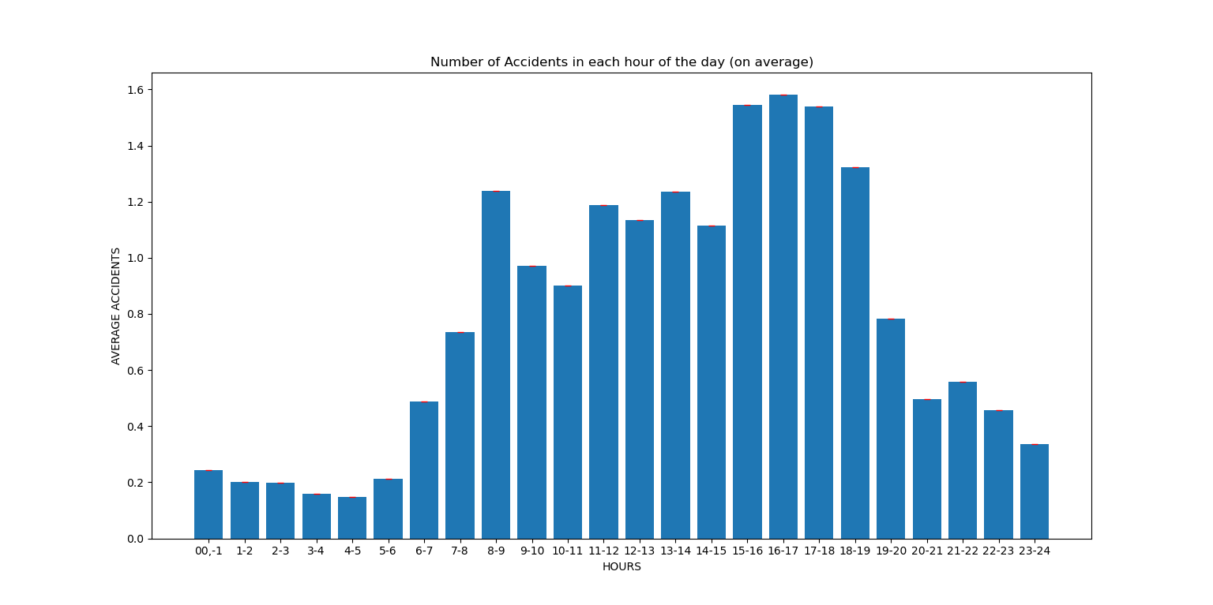

2013 - 2014

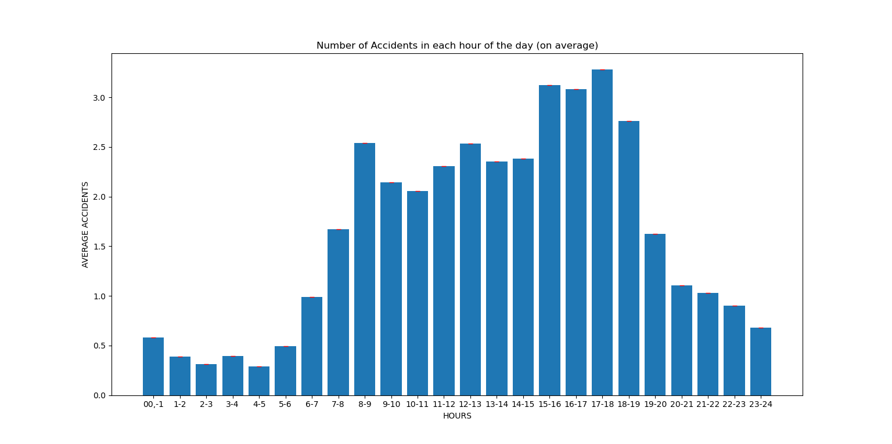

2014-2015

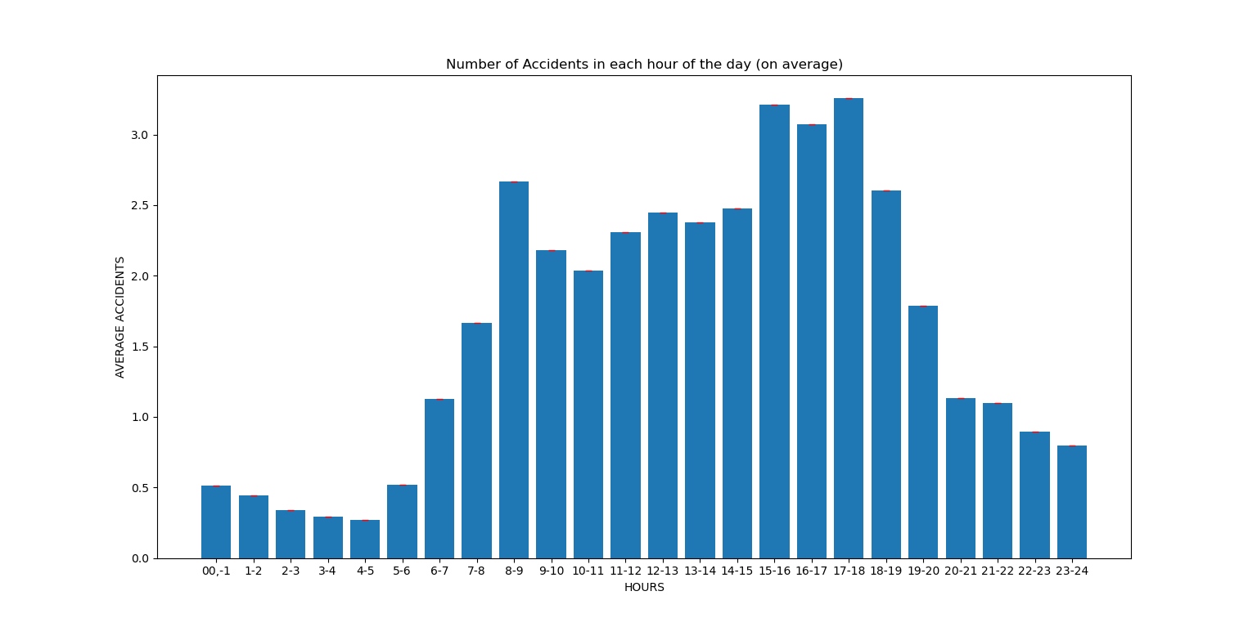

2015-2016

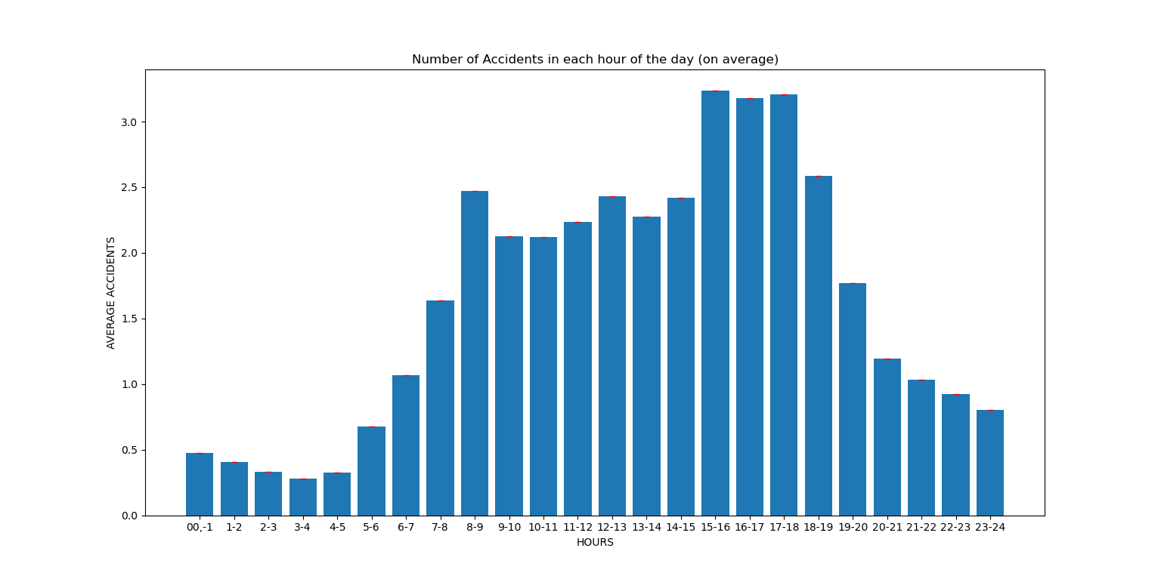

2016-2017

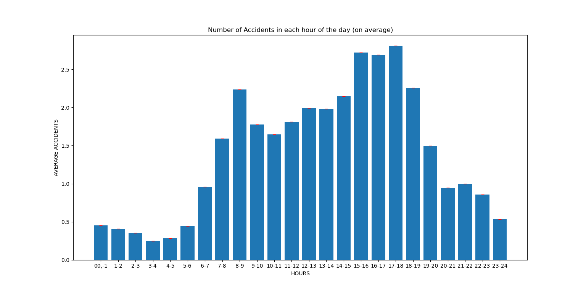

2017-2018

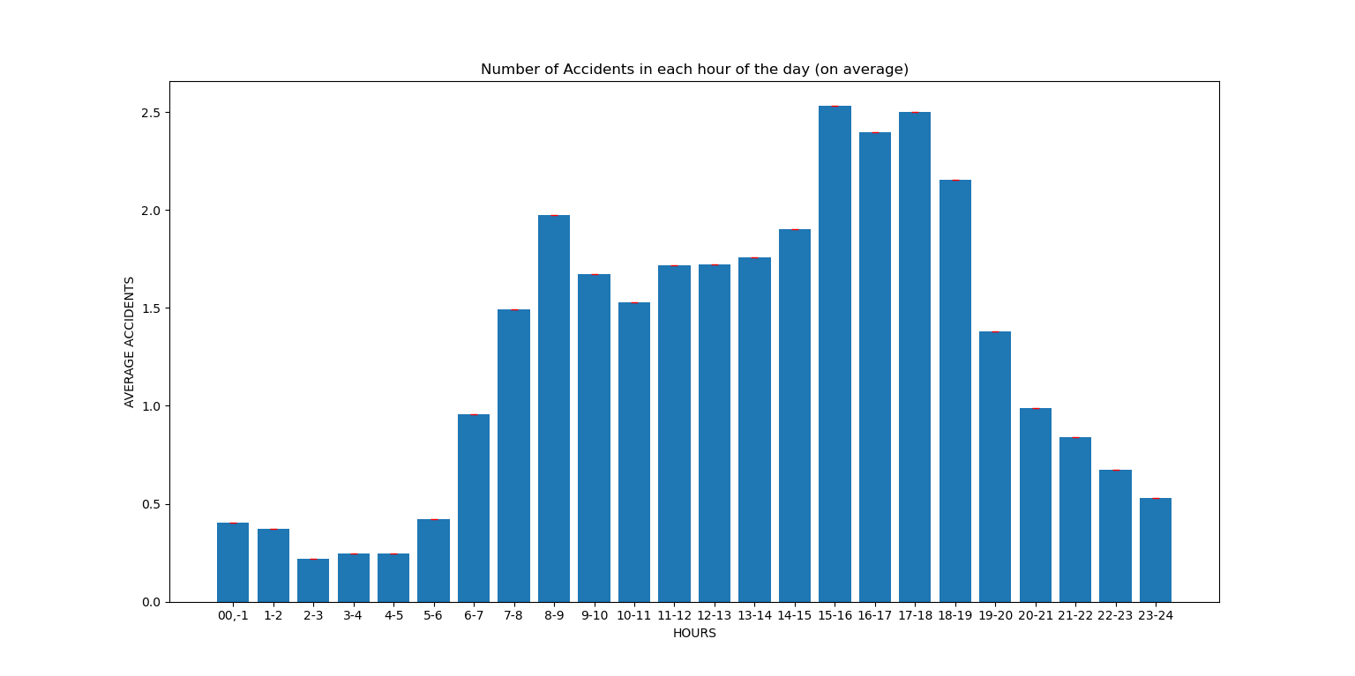

2018 - 2019

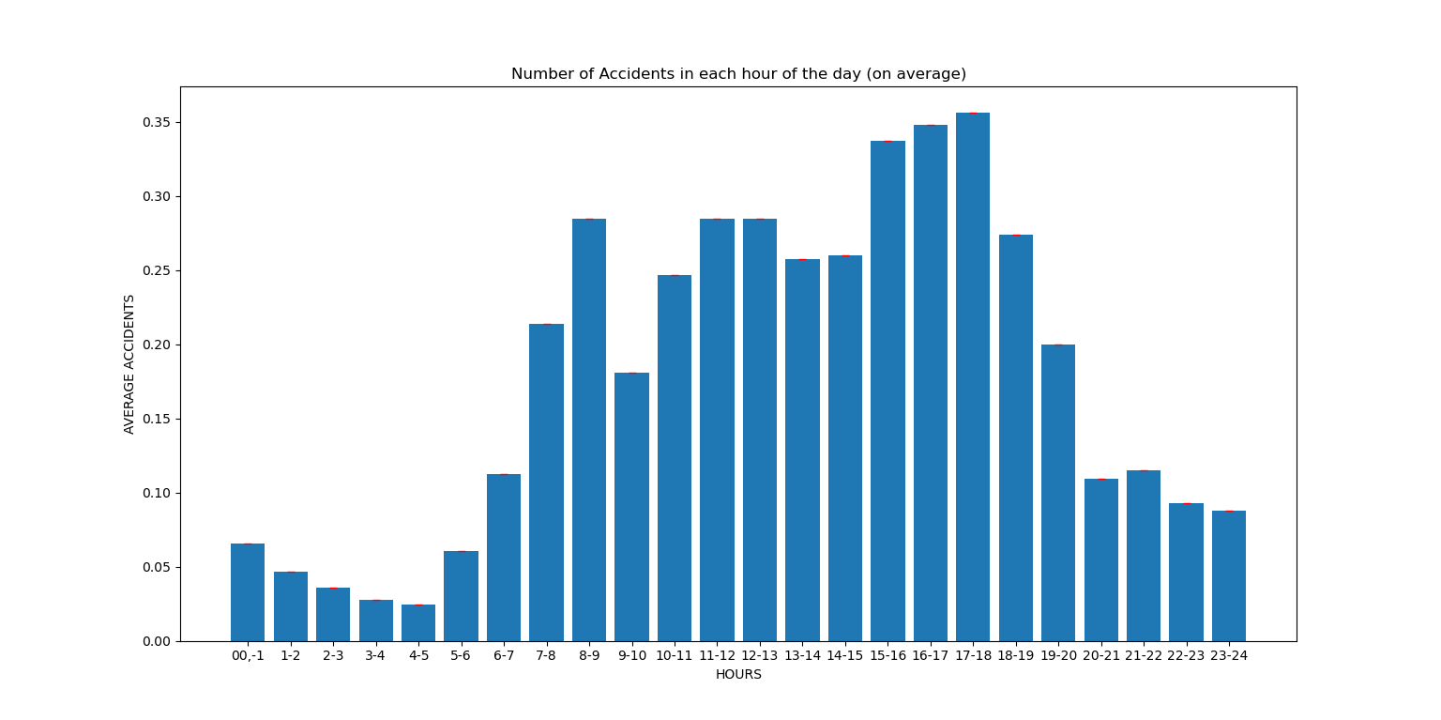

2019-2020

# **Analysis 3 –** Retrieving all accidents caused by an accident type that contains a user-given keyword for a user given period

Resulted HTML files folder : <https://drive.google.com/drive/folders/1I897BZ6PQjc7wlaKuPYxaZuqRFlOq9VM?usp=sharing>

# keyword **Analysis 4 – Analysis of the impact of alcohol in accidents**

The average number of accidents in each hour of the day

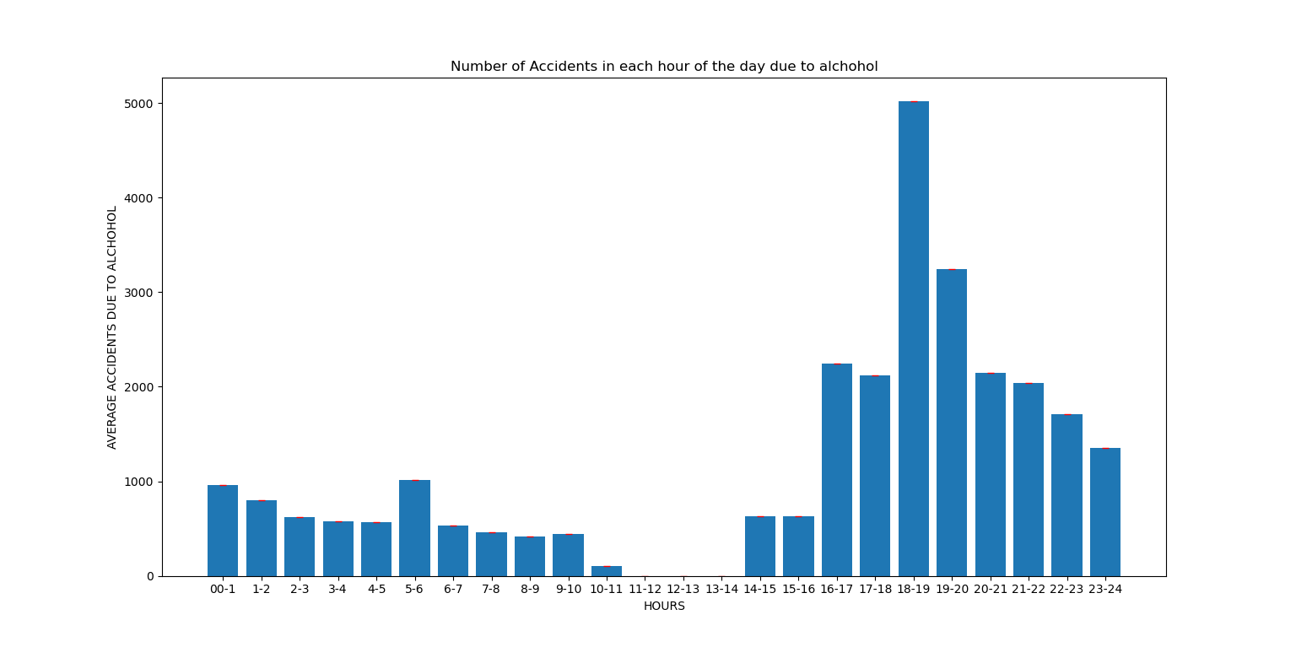

For whole data set

Accident type involving alcohol analysis (image)

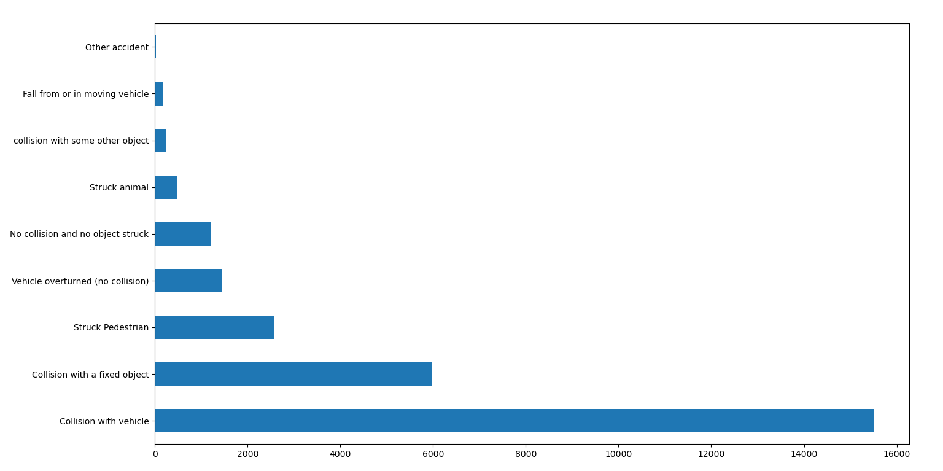

For whole data set

# **Analysis 5 – number of accidents in speed zone for a user given period**

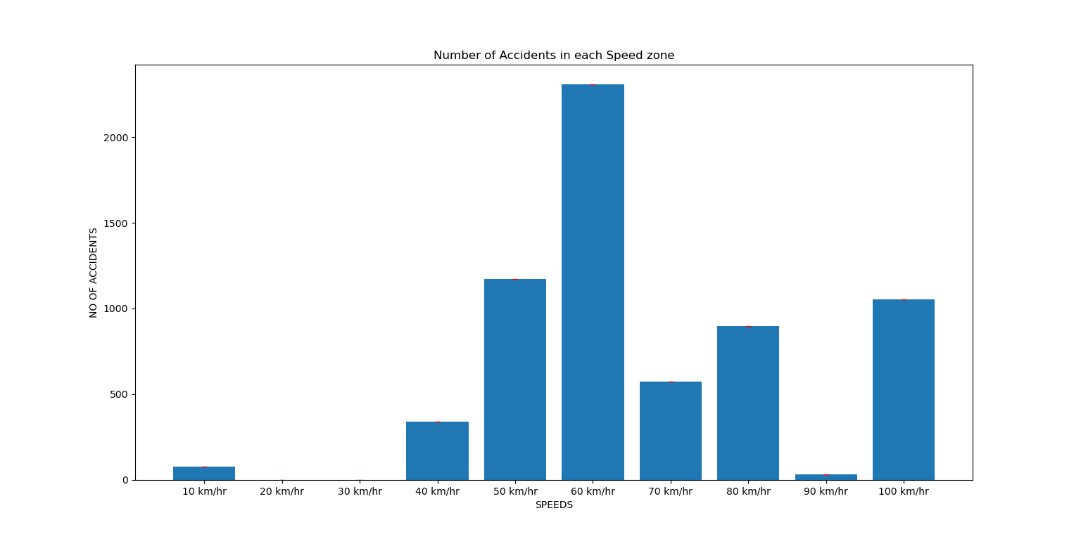Resulted Graph

2013 - 2014

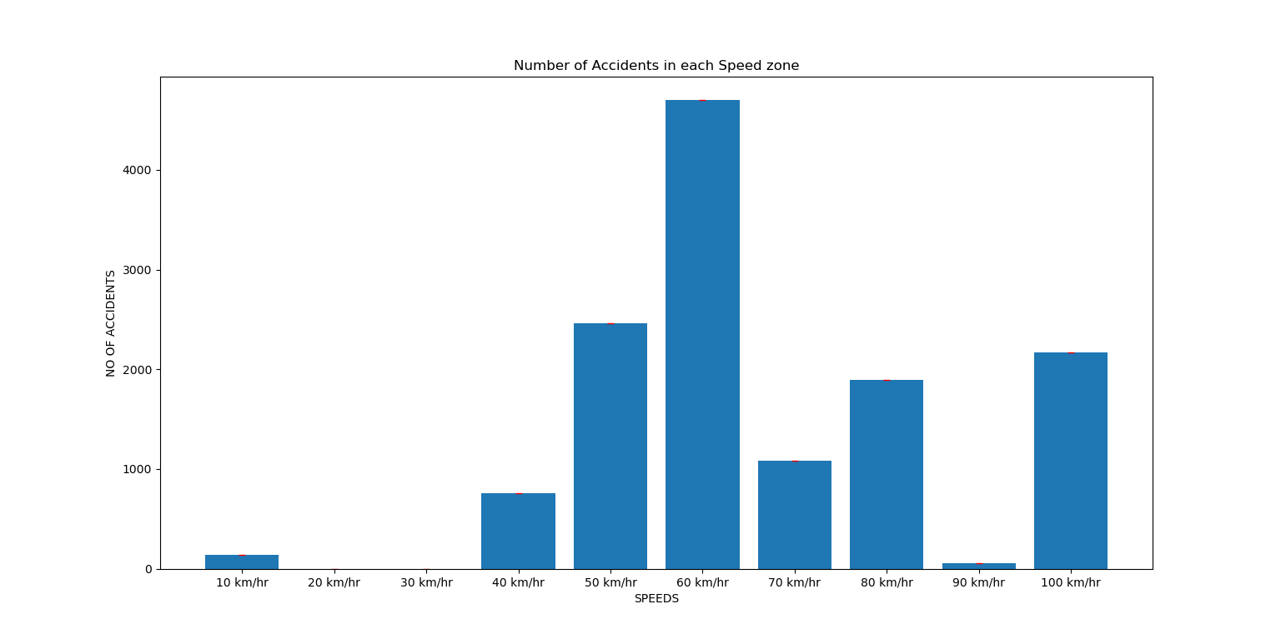

2014-2015

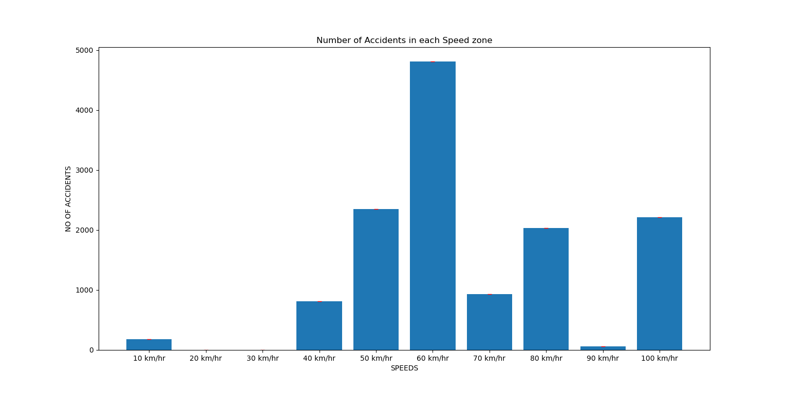

2015-2016

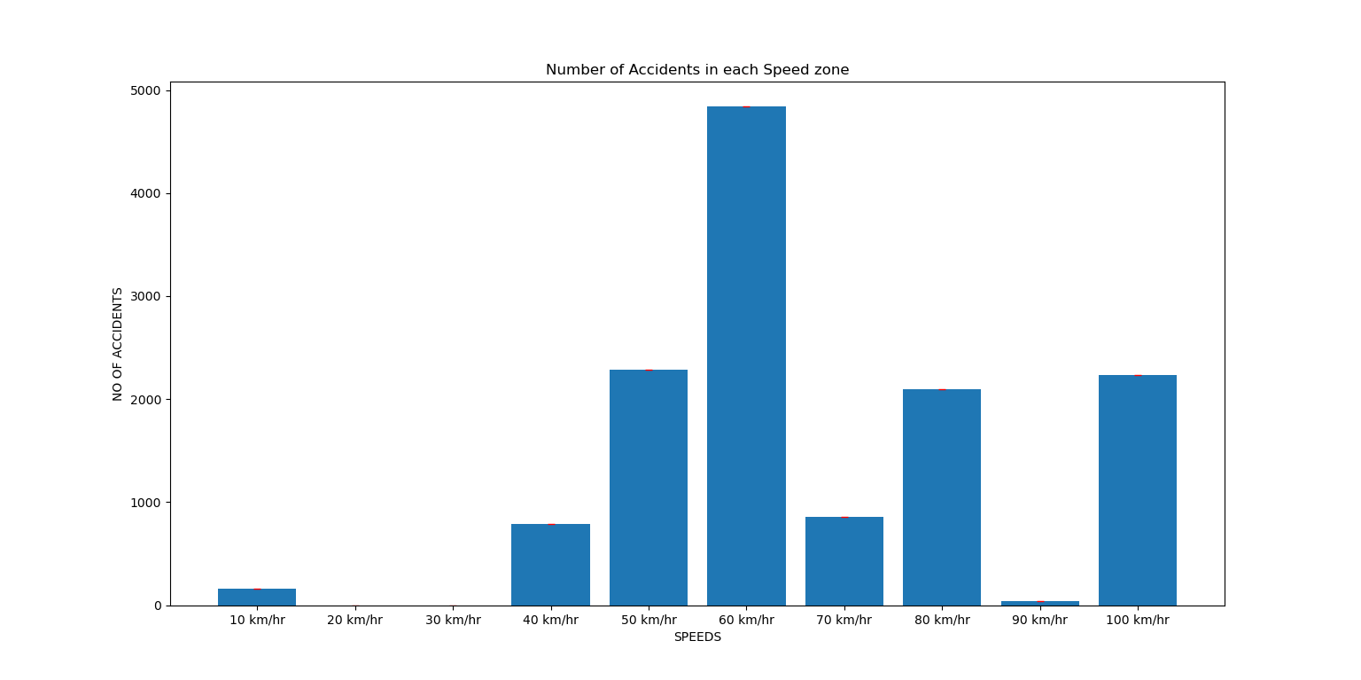

2016-2017

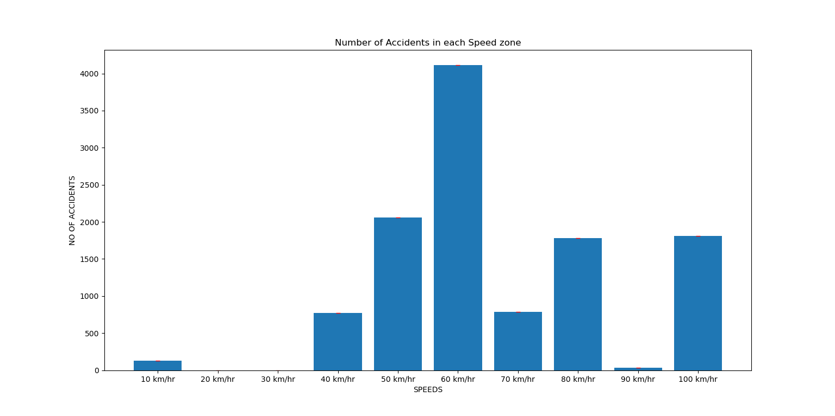

2017-2018

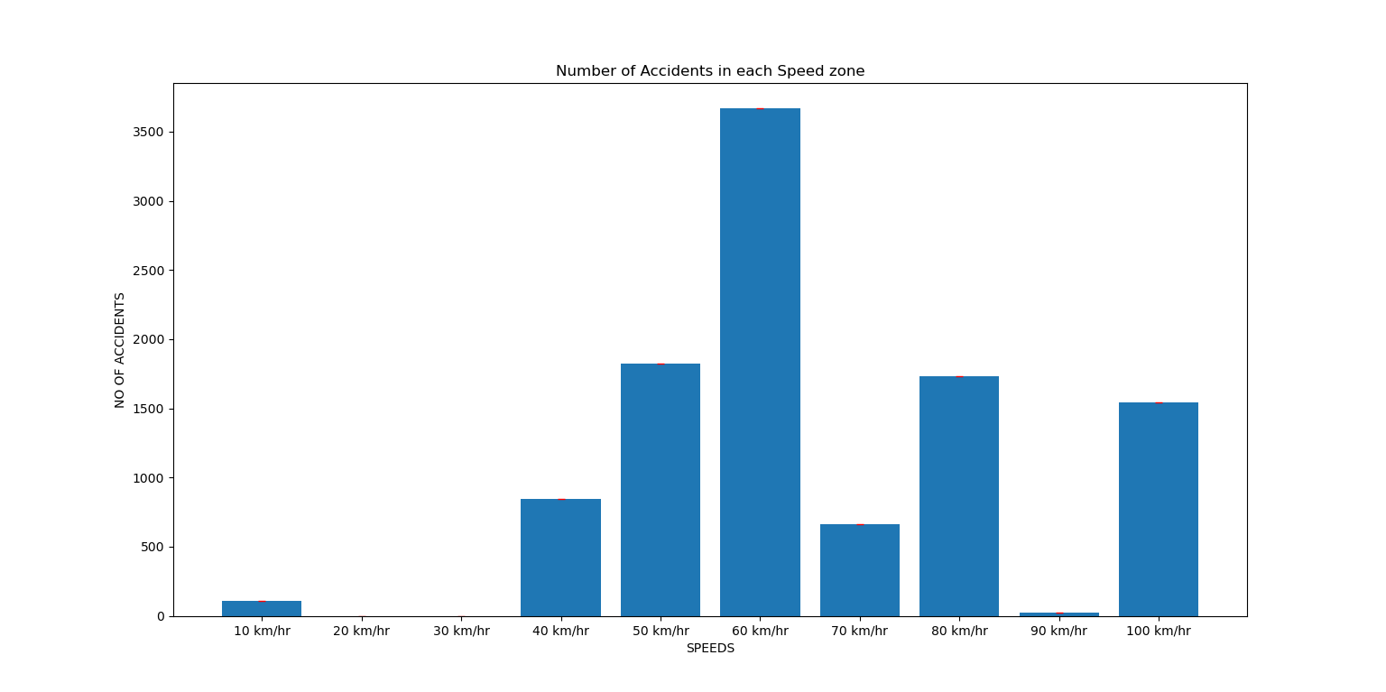

2018-2019

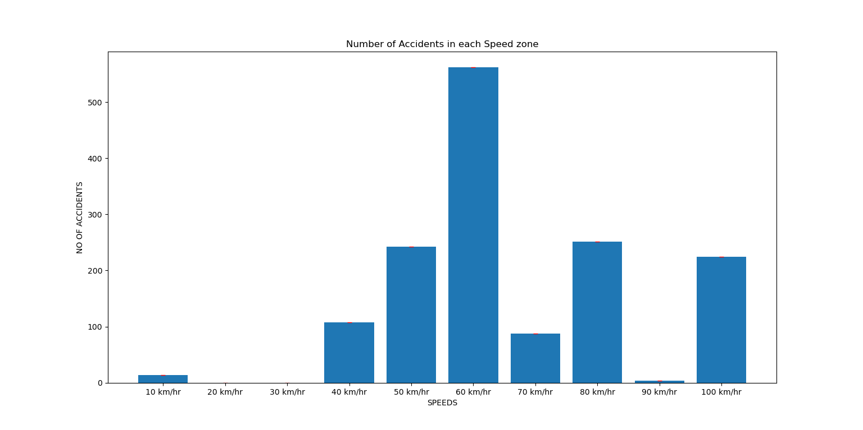

2019-2020