//LAB Exercise 4

import java.lang.Exception;

import java.util.Scanner;

class UnderAge extends Exception{

int age;

UnderAge(int age){

this.age=age;

}

public String toString(){

String temp="Under Age: "+age;

return temp;

}

}

public class Demo{

static void test(int age){

try {

if (age<18){

throw new UnderAge(age);

}

else{

System.out.println("age is above 18");

}

}

catch (UnderAge a){

System.out.println(a.toString());

}

}

public static void main(String []args ){

Scanner sc=new Scanner(System.in);

System.out.println("Enter the age: ");

int age=sc.nextInt();

test(age);

}

}

\*OUTPUT\*

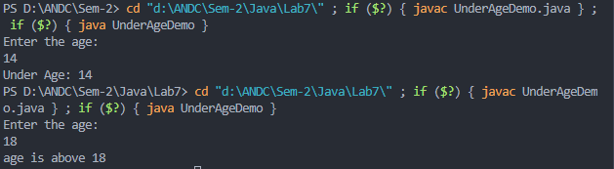

//Lab Exercise 5

import java.util.Scanner;

import java.lang.Exception;

class stackException extends Exception{

public String overflow()

{

return ("@@@@@ Stack Overflow:Could not add more @@@@");

}

public String empty()

{

return ("@@@@@ Stack Underflow:No element in stack@@@@ ");

}

}

class StackD{

int arr[];

int t=-1;

int size;

Scanner sc=new Scanner(System.in);

public StackD(int size){

this.size=size;

arr=new int[size];

}

public void push(int x) throws stackException{

if(t==size-1){

throw new stackException();

}

if(t==-1)

t=0;

else

{

t++;

arr[t]=x;

}

}

public int pop() throws stackException{

if(t==-1)

{

throw new stackException();

}

else

{

return t--;

}

}

public void Display(){

int i;

if(t==-1)

System.out.println("Stack is Empty");

for(i=t;i>=0;i--){

System.out.println("Stack is "+arr[i]+"\t");

}

}

}

class StackLabs{

public static void main(String[] args){

Scanner sc=new Scanner(System.in);

char ch='y';

int e, size;

System.out.print("Enter the size of the Stack : ");

size=sc.nextInt();

StackD s=new StackD(size);

int opt;

do{

System.out.println("\n1.Push\n2.Pop\n3.Display\nEnter The Choice : ");

opt=sc.nextInt();

switch(opt){

case 1:

try{

System.out.print("\nEnter the Elements : ");

e=sc.nextInt();

s.push(e);

}

catch(stackException x){

System.out.println(x.overflow());

}

break;

case 2:

try{

s.pop();

}

catch(stackException x){

System.out.println(x.empty());

}

break;

case 3:

s.Display();

break;

default:

System.out.print("Wrong Choice");

break;

}

System.out.print("Do you Wish to Continue(y/n)?");

ch=sc.next().charAt(0);

}while(ch=='y'||ch=='Y');

}

}

\*OUTPUT\*

