**Lab0**

**Avishkaar Pawar AD-1224 B.Sc CS (H)**

//Practise Set Number 1

public class Student{

public static void main(String args[]){

* Name,RollNo,Course,college Student stu1 = new Student(args); stu1.display();

}

public void display(){

System.out.println("Name : "+this.name);

System.out.println("Roll NO is "+this.rollno);

System.out.println("Marks Scored : "+this.course);

System.out.println("College : "+this.college);

}

public String name;

public String course;

public int rollno;

public String college;

public Student(String args[]){

name=args[0];

rollno=Integer.parseInt(args[1]);

course=args[2];

college=args[3];

}

}

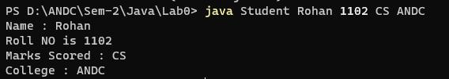

-------------------------------------------------------------------------------------------------------------------------------

//Practise Set 2

import java.util.Scanner;

public class Leap_Year {

public static void main(String[] args){

Scanner sc= new Scanner(System.in);

System.out.print("Enter Year : ");

int year=sc.nextInt();

if ((year%400!=0)&& (year%100==0)){

System.out.println("Not a leap year ");

}

else if (year%400==0){

System.out.println("Leap Year");

}

else if (year%4==0){

System.out.println("Leap Year");

}

else { System.out.println("Not a leap year ");}

sc.close();

}

}

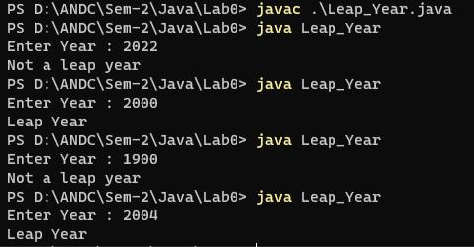

-----------------------------------------------------------------------------------------------------------

* Practise Set 3
* Sum of N Command Line Arguement

public class SumOfN{

// Command Line Arguement

public static void main(String [] args){

int sum=0;

for (int i=0;i<args.length;i++){

sum+=Integer.parseInt(args[i]);

}

System.out.print("\nThe sum is : "+sum+"\n");

}

}

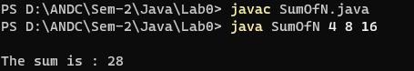

-----------------------------------------------------------------------------------------------------

//Practise Set 4

public class Factorial {

public static void main(String [] args){

int num=Integer.parseInt(args[0]);

int fact=1;

for(int i=1;i<=num;i++){

fact*=i;

}

System.out.println("Factorial of "+args[0]+" : "+fact);

}

}

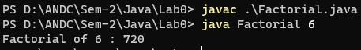

* Practise Set 5 public class Pattern {

public static void main(String [] args){ int x=1;

for(int i=0;i<4;i++){ for(int j=0;j<i+1;j++){

System.out.print(x+" "); x++;

}

System.out.println();

}

}

}

