**AVISHKAAR PAWAR AD-1224**

**CS – Summer 2022**

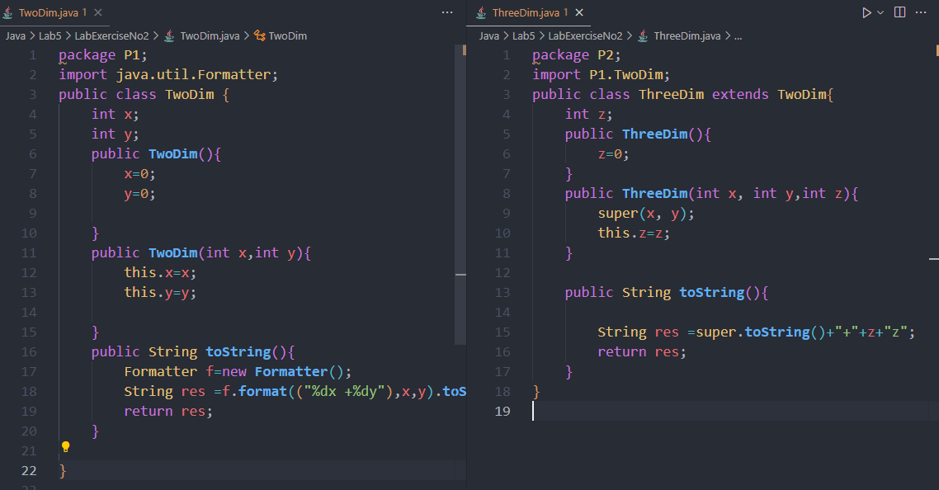Lab Exercise 2

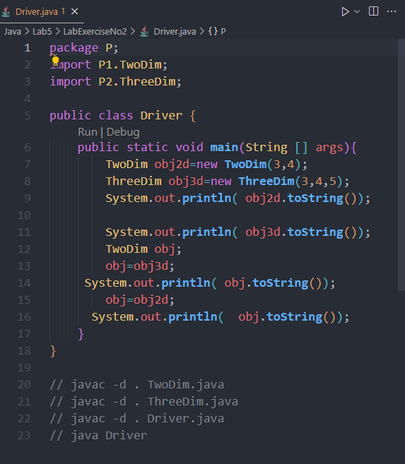

OUTPUT

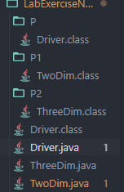

FILE STRUCTURE CREATED

