NAME: AVISHKAAR

Course: B.Sc (Hons) CS

Roll No: AD-1224

LAB EXERCISE 6

import java.io.*;

public class CopyFileExample {

    public static void **main**(String [] args){

        int i;

        FileInputStream fin;

        FileOutputStream fout;

        if(args.length==2){

            System.out.**println**("Input Filename: "+args[0]);

            System.out.**println**("Output Filename: "+args[1]);

        }

        try {

            fin=new **FileInputStream**(args[0]);

            fout=new **FileOutputStream**(args[1]);

            do{

                i=fin.**read**();

                if(i!=-1){

                fout.**write**(i);

                }

            }while(i!=-1);

        }

        catch(FileNotFoundException e){

            System.out.**println**("File Not Found");

        }

        catch(IOException e){

            System.out.**println**("Reading or Writing not possible");

        }

        System.out.**println**("File Copy Successful");

    }

}

CONTENT OF FILES (BEFORE)

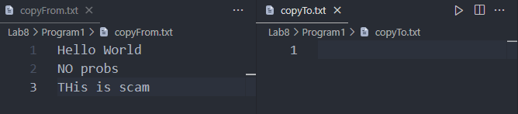

OUTPUT

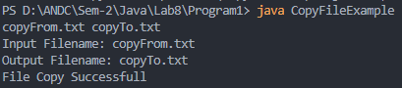

CONTENT OF FILES (AFTER)

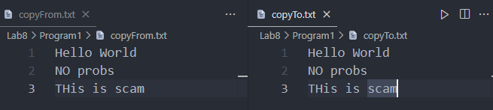

LAB EXERCISE 7

import java.io.*;

public class SpecificLine {

    public static void **main**(String[] args) {

        String str;

        int i;

        if (args.length == 1) {

            System.out.**println**("Input Filename: " + "Text.txt");

        }

        try {

            FileReader fr = new **FileReader**("Text.txt");

            BufferedReader br = new **BufferedReader**(fr);

            str = br.**readLine**();

            while (str != null) {

                if ((str.**charAt**(0) == '/') && (str.**charAt**(1) == '/')) {

                    System.out.**println**(str.**substring**(2,str.**length**()));

                }

                str = br.**readLine**();

            }

        } catch (FileNotFoundException e) {

            System.out.**println**("File Not Found");

        } catch (IOException e) {

            System.out.**println**("Reading not possible");

        }

    }

}

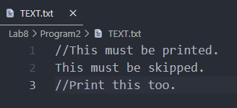

OUTPUT

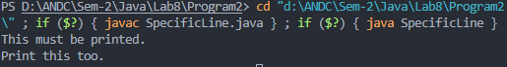

Lab EXERCISE 8

// Write a program to handle mouse events(Clicked, Entered, Exited, Presses, and Released).

// Lab Exercise 8

import java.awt.*;

import java.awt.event.*;

public class MouseExample extends Frame implements MouseListener{

    Label l;

**MouseExample**(){

**addMouseListener**(this);

        l=new **Label**();

        l.**setBounds**(20,50,100,20);

**add**(l);

**setSize**(300,300);

**setLayout**(null);

**setVisible**(true);

    }

    public void **mouseClicked**(MouseEvent e) {

        l.**setText**("Mouse Clicked");

    }

    public void **mouseEntered**(MouseEvent e) {

        l.**setText**("Mouse Entered");

    }

    public void **mouseExited**(MouseEvent e) {

        l.**setText**("Mouse Exited");

    }

    public void **mousePressed**(MouseEvent e) {

        l.**setText**("Mouse Pressed");

    }

    public void **mouseReleased**(MouseEvent e) {

        l.**setText**("Mouse Released");

    }

public static void **main**(String[] args) {

    new **MouseExample**();

}

}

OUTPUT

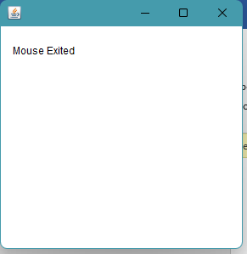

LAB EXERCISE 9

import java.awt.*;

import java.awt.event.*;

public class KeyExample extends Frame implements KeyListener {

    Label l;

    TextArea area;

**KeyExample**() {

        l = new **Label**();

        l.**setBounds**(20, 50, 100, 20);

        area = new **TextArea**();

        area.**setBounds**(20, 80, 300, 300);

        area.**addKeyListener**(this);

**add**(l);

**add**(area);

**setSize**(400, 400);

**setLayout**(null);

**setVisible**(true);

    }

    public void **keyPressed**(KeyEvent e) {

        l.**setText**("Key Pressed");

    }

    public void **keyReleased**(KeyEvent e) {

        l.**setText**("Key Released");

    }

    public void **keyTyped**(KeyEvent e) {

        l.**setText**("Key Typed");

    }

    public static void **main**(String[] args) {

        new **KeyExample**();

    }

}

