NAME: AVISHKAAR

Course: B.Sc (Hons) CS

Roll No: AD-1224

LAB EXERCISE 10

import java.awt.*;

import java.awt.event.*;

public class Pink extends Frame {

    Label l;

**Pink**() {

        super("Pink Screen Example");

        l = new **Label**("Hello World");

        l.**setBounds**(25, 50, 250, 30);

        l.**setAlignment**(Label.CENTER);

        this.**setBackground**(Color.PINK);

        this.**add**(l);

        this.**setSize**(300, 400);

        this.**setVisible**(true);

    }

    public static void **main**(String[] args) {

        new **Pink**();

    }

}

OUTPUT

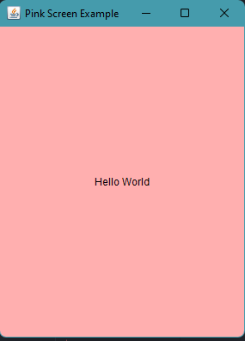

LAB EXERCISE 11

import java.awt.*;

 import java.awt.event.*;

 public class Main extends Frame implements ActionListener {

    Button btnRed, btnBlue;

**Main**() {

        super("AWT Buttons");

        btnRed = new **Button**("Red");

        btnRed.**setBounds**(25, 50, 250, 30);

        btnRed.**addActionListener**(this);

        this.**add**(btnRed);

        btnBlue = new **Button**("Blue");

        btnBlue.**setBounds**(25, 100, 250, 30);

        btnBlue.**addActionListener**(this);

        this.**add**(btnBlue);

        this.**setSize**(300, 160);

        this.**setLayout**(null);

        this.**setVisible**(true);

        this.**addWindowListener**(new **WindowAdapter**() {

            public void **windowClosing**(WindowEvent e) {

**dispose**();

            }

        });

    }

    public static void **main**(String[] args) {

                 new **Main**();

    }

    @Override public void **actionPerformed**(ActionEvent e) {

        if (e.**getSource**() == btnRed) { this.**setBackground**(Color.RED); }

        else if (e.**getSource**() == btnBlue) { this.**setBackground**(Color.BLUE); }

    }

}

OUTPUT

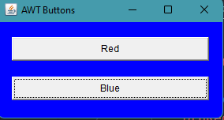 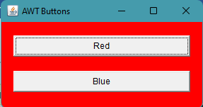

LAB EXERCISE 12

import java.awt.*;

import java.awt.event.*;

class KbdAdapter extends KeyAdapter {

    Label l;

**KbdAdapter**(Label l) {

         this.l = l;

    }

    @Override public void **keyTyped**(KeyEvent e) {

        l.**setText**("Typed character is: " + e.**getKeyChar**());

    }

    @Override public void **keyPressed**(KeyEvent e) {

        System.out.**println**("Pressed character is: " + e.**getKeyChar**());

    } @Override public void **keyReleased**(KeyEvent e) {

        System.out.**println**("Released character is: " + e.**getKeyChar**());

    }

}

public class Main extends Frame {

        Label l;

**Main**() {

        super("AWT Keyboard"); l = new **Label**("");

        l.**setBounds**(25, 50, 250, 30);

        l.**setAlignment**(Label.CENTER);

        this.**addKeyListener**(new **KbdAdapter**(l));

        this.**add**(l); this.**setSize**(300, 110);

        this.**setLayout**(null);

        this.**setVisible**(true);

        this.**addWindowListener**(new **WindowAdapter**() {

        public void **windowClosing**(WindowEvent e) {

**dispose**(); }

        }

        );

    }

    public static void **main**(String[] args) {

        new **Main**();

    }

}

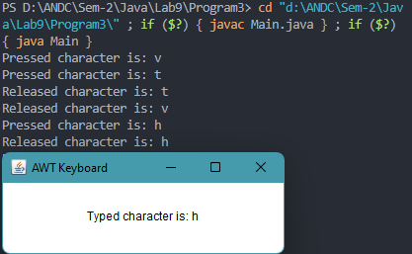

LAB EXERCISE 13

import java.awt.*;

import java.awt.event.*;

 public class Main extends Frame implements ActionListener {

    Button btnA, btnB;

    Label la,lb;

**Main**() {

        super("Student Data");

        la=new **Label**("Name:James, Course :B.A. , Roll No : 1234 , College : Alien College ");

        lb= new **Label**("CGPA : 7.4");

        la.**setBounds**(25,250 ,1000,100);

        lb.**setBounds**(25,350,100,100);

        btnA = new **Button**("A");

        btnA.**setBounds**(25, 50, 100, 100);

        btnA.**addActionListener**(this);

        this.**add**(btnA);

        btnB = new **Button**("B");

        btnB.**setBounds**(25, 150, 100, 100);

        btnB.**addActionListener**(this);

        this.**add**(btnB);

        this.**setSize**(500, 500);

        this.**setLayout**(null);

        this.**addWindowListener**(new **WindowAdapter**() {

            public void **windowClosing**(WindowEvent e) {

**dispose**();

            }

        });

        this.**setVisible**(true);

    }

    public static void **main**(String[] args) {

                 new **Main**();

    }

    @Override public void **actionPerformed**(ActionEvent e) {

        if (e.**getSource**() == btnA) { this.**add**(la); }

        else if (e.**getSource**() == btnB) {

            this.**add**(lb);

            //this.setVisible(true);

        }

    }

}

