ASSIGNMENT -2

Submitted By : Avishkaar Pawar

Roll No : AD-1224

Course : B.Sc. Hons Computer Science

Semester : 4

Date of Submission : 21-Nov-2023

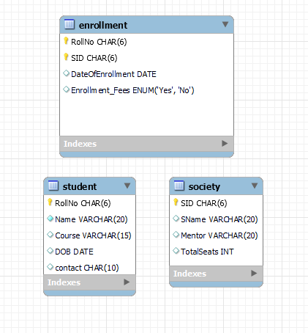

CREATE TABLE studentsociety.student (

`RollNo` CHAR(6) NOT NULL,

`Name` VARCHAR(20) NOT NULL,

`Course` VARCHAR(15) NULL DEFAULT NULL,

`DOB` DATE NULL DEFAULT NULL,

`contact` CHAR(10) NULL DEFAULT NULL,

PRIMARY KEY (`RollNo`)

)

CREATE TABLE IF NOT EXISTS `studentsociety`.`society` (

`SID` CHAR(6) NOT NULL,

`SName` VARCHAR(20) NULL DEFAULT NULL,

`Mentor` VARCHAR(20) NULL DEFAULT NULL,

`TotalSeats` INT UNSIGNED NULL DEFAULT NULL,

PRIMARY KEY (`SID`)

)

CREATE TABLE IF NOT EXISTS `studentsociety`.`enrollment` (

`RollNo` CHAR(6) NOT NULL,

`SID` CHAR(6) NOT NULL,

`DateOfEnrollment` DATE NULL DEFAULT '2023-01-01',

`Enrollment_Fees` ENUM('Yes', 'No') NULL DEFAULT 'No',

PRIMARY KEY (`RollNo`, `SID`)

)

1. Retrieve students name enrolled in any society.

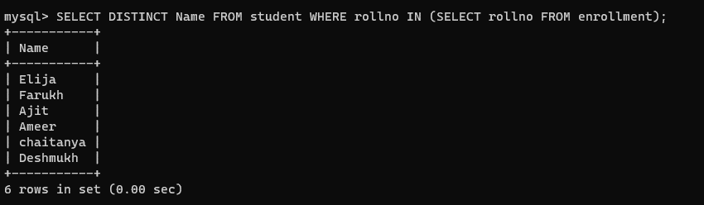

1. Retrieve all society names.

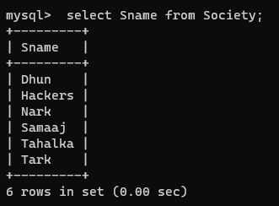

1. Retrieve Student Name whose name starts with letter "A".

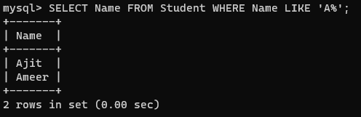

1. Retrieve Students studying in course CS(H) or LS

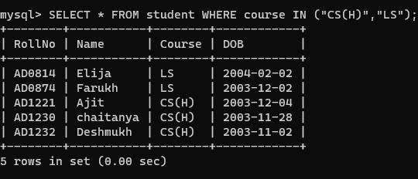

1. Retrieve Students whose roll no starts with letter "C" or "A".

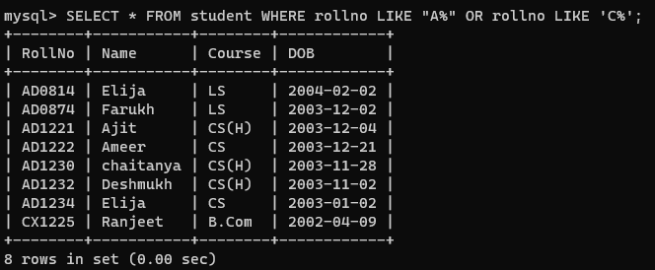

1. Retrieve Society whose capacity is more than 15.

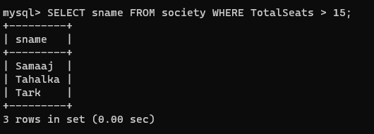

1. Update Society Table for mentor name for a specific society.

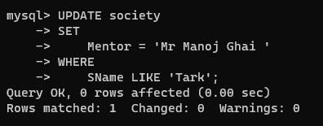

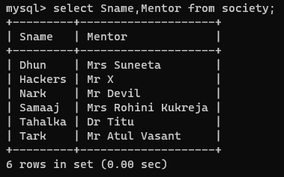

8) Remove details for a student who is not enrolled in any society.

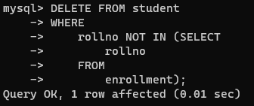

1. Increment Capacity of society by 10%.

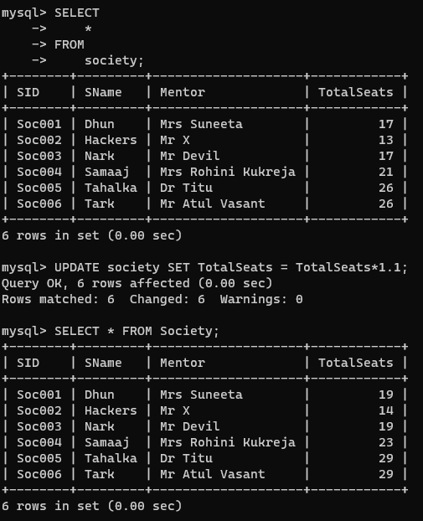

1. Find the students name who are not enrolled in any society.

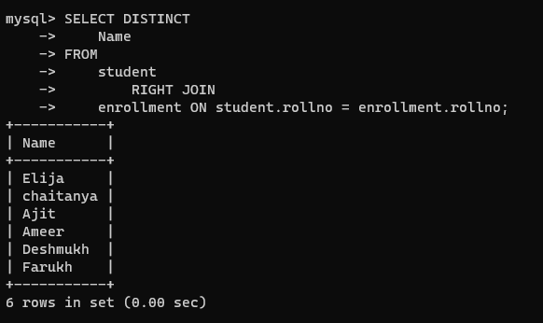

11)Find total number of Students whose age is greater than 19

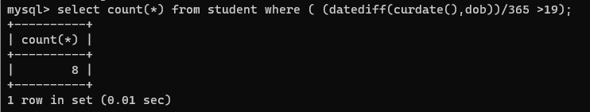

12)Find the student names enrolled in atleast two societies

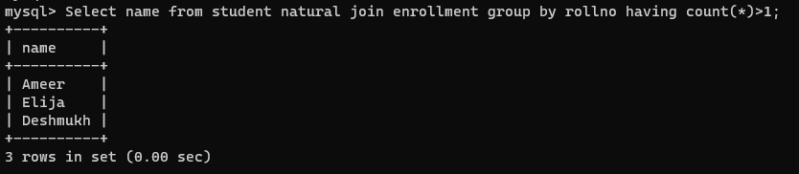

13) Find society names in which any student is enrolled

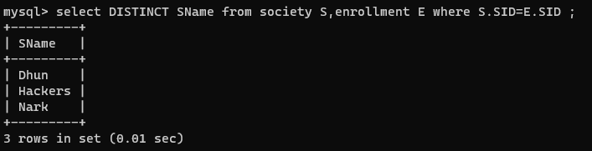

14) Find names of all students enrolled in any society and society names in which any student is enrolled

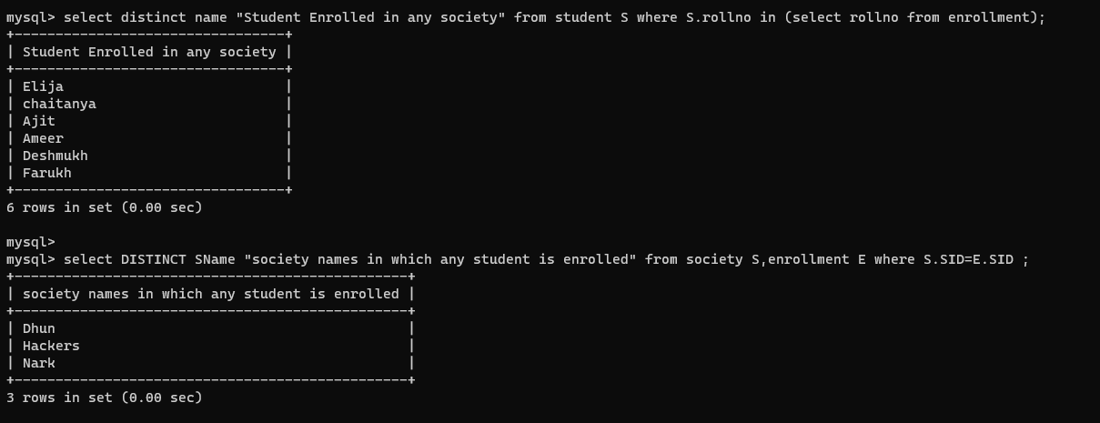

15) Find names of students who are enrolled in all three societies "Dhun","Hackers"and"Nark".

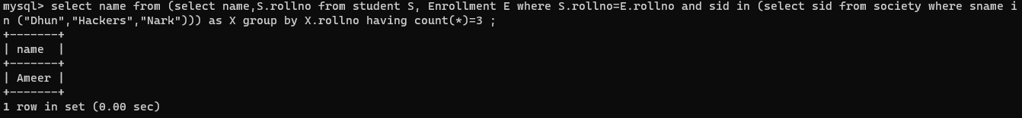

16) Find society names that has ‘abc’ as mentor or ‘abc’ as the name of enrolled student.

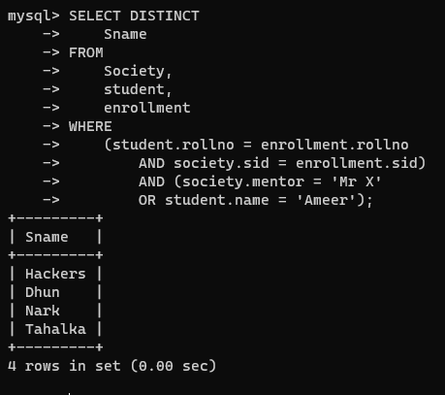

17) Find society names whose mentor name is same as that of any enrolled student in it.

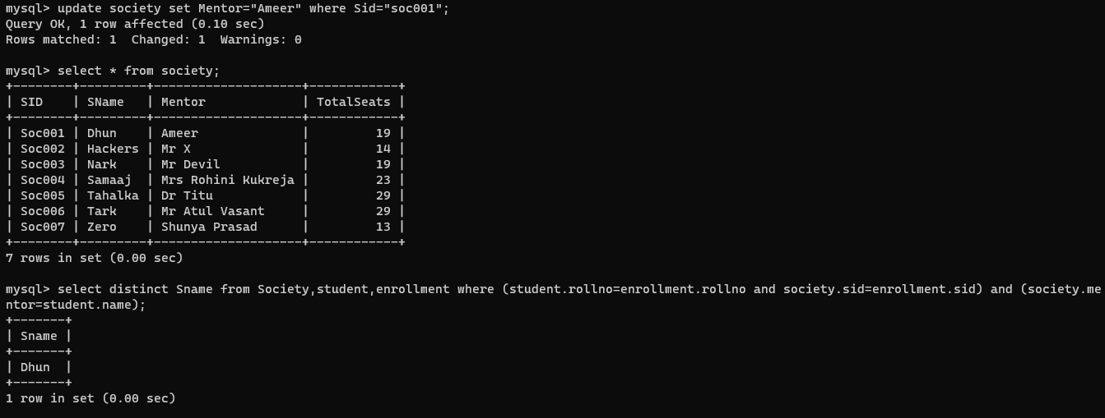

18) Find the society names in which number of enrolled students are less than its capacity.

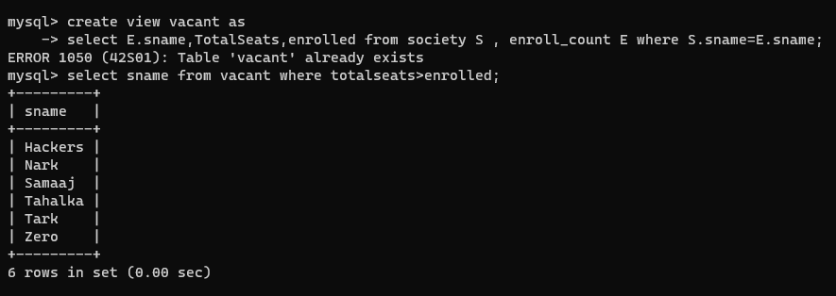

19) Display the vacant seats for each society.

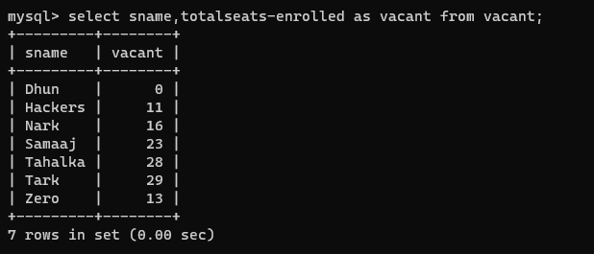

20) Find society names in which more than one students have enrolled in the given year.

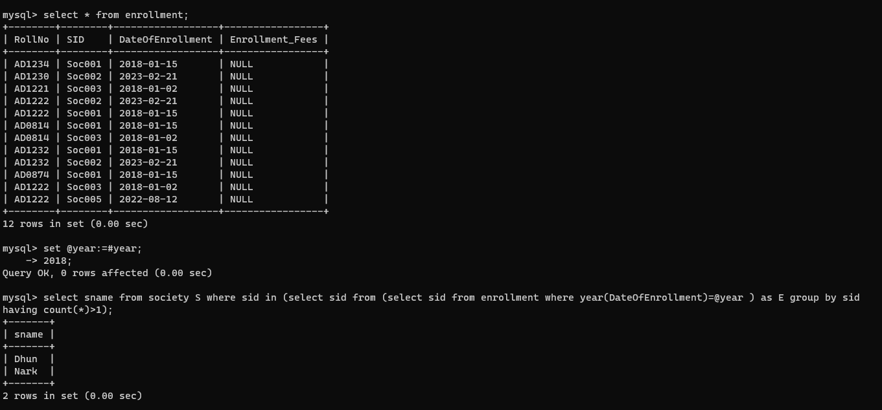

21) Add enrolment fees paid (‘yes’/’No’) field in the enrollment table.

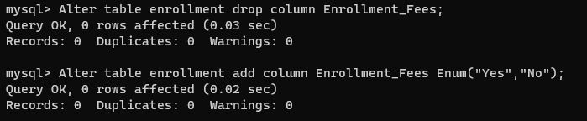

22) Update date of enrolment of society s1 to ‘2018-01-15’, s2 to current date

and s3 to ‘2018-01-02’.

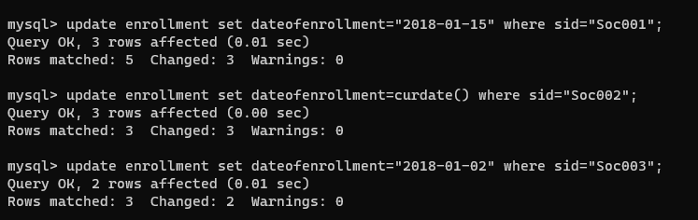

23) Find society names whose enrolment is over.

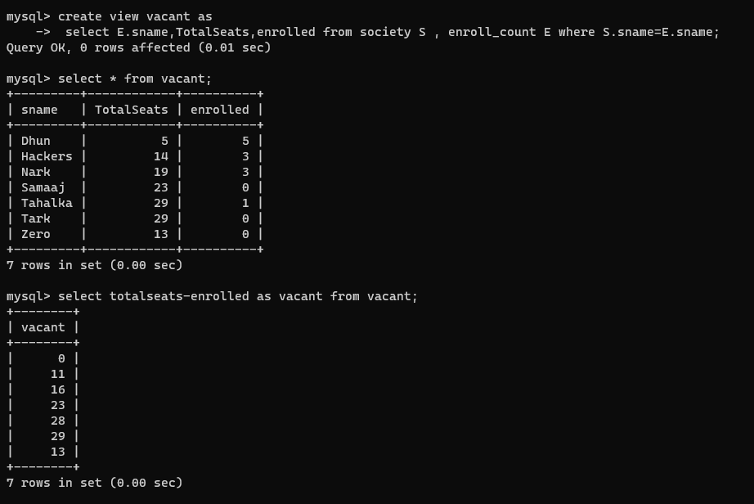

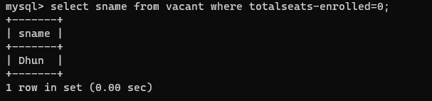

24) Find common societies of students of courses ‘cs(h)’ and ‘cs’

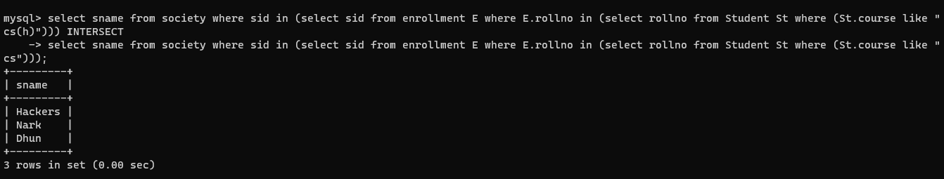

25) Create a view to keep track of society names with total number of students enrolled in it.



26) Find student names enrolled in all societies.

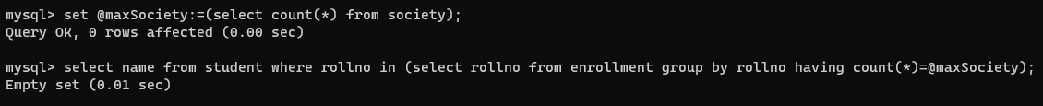

27) Count societies with student enrolled > 3.

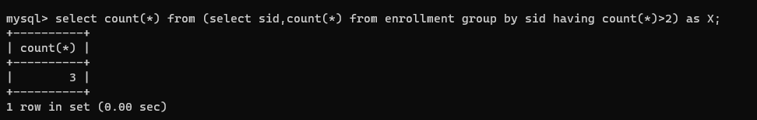

28) add column contact in student with default value.

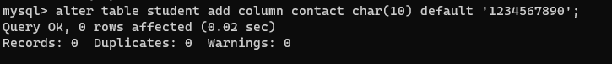

29) Find the name of oldest and youngest student in class along with their age and DOB

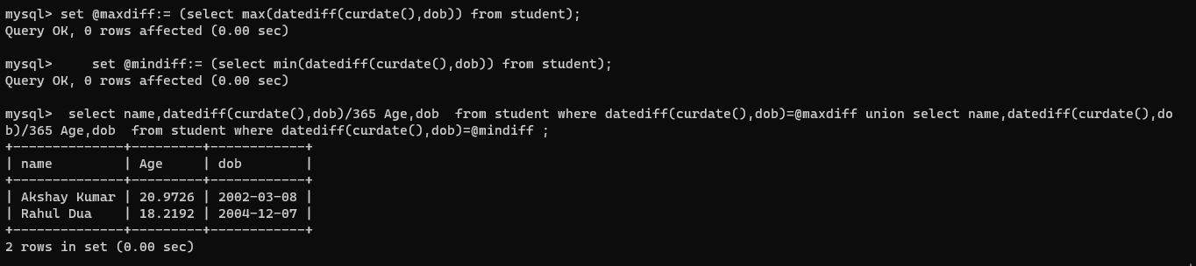

30) Find the most popular and least popular society name (on the basis of enrolled students)

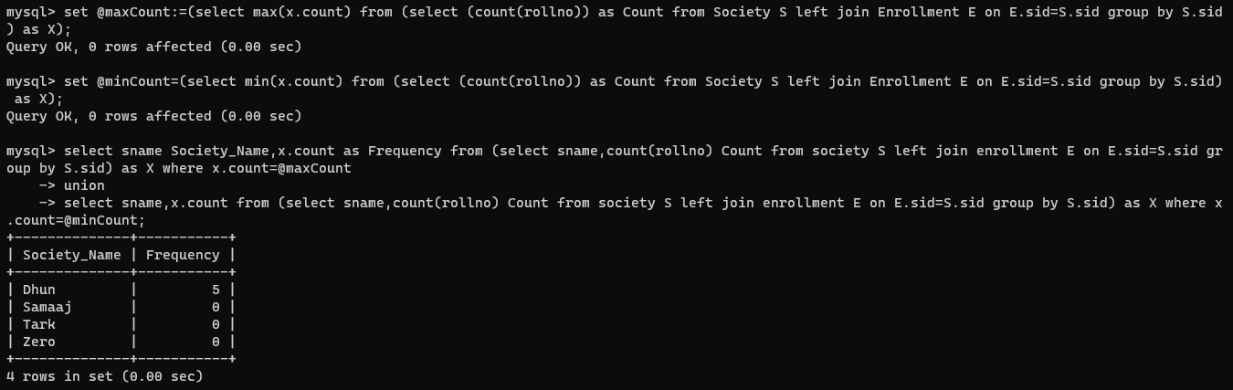

31) Find names of students born in year 2003 and enrolled in atleast one society

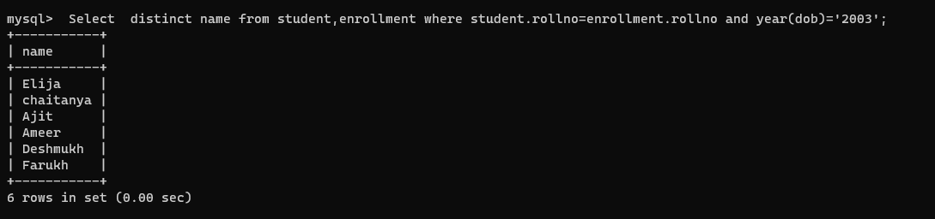

32) Remove default value of any field.

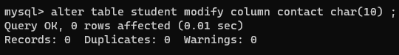

33) Find society names where students have enrolled in month Jan/Feb

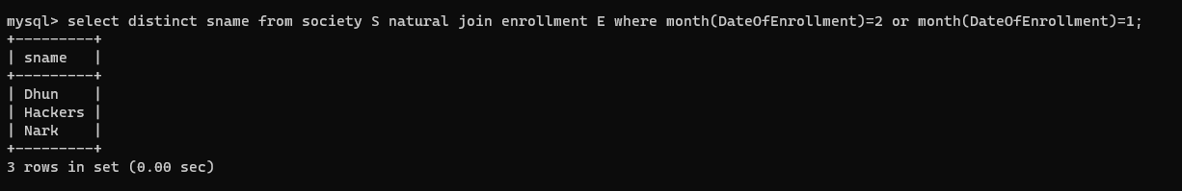

34) Display all students details alongwith society name if they are enrolled in any society

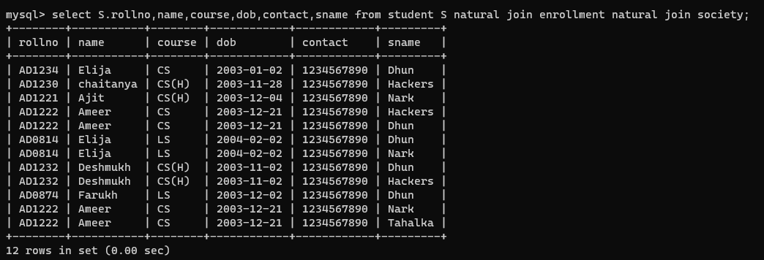

35) Display society names in uppercase and padded with character * to get a

length of 10 characters which are mentored by mentors whose names start with

‘S’ and ends with ‘d’ and capacity is between 10 to 20. 