# JCEI’S JAIHIND COLLEGE OF ENGINEERING, KURAN

**DEPARTMENT OF ARTIFICIAL INTELLIGENCE AND DATA SCIENCE**

**A.Y. 2024-25**



**REPORT ON**

**“LEADERSHIP AND PERSONALITY DEVELOPEMENT”**

**UNDER**

**“AUDIT COURSE-6[317537C]”**

TE-AI & DS ENGINEERING SEM – VI

## SUBMITTED BY

**Thorve Avishkar Shrikrushna**

**EXAM SEAT NO: T400840394**

## JCEI’S JAIHIND COLLEGE OF ENGINEERING, KURAN DEPARTMENT OF ARTIFICIAL INTELLIGENCE AND DATA SCIENCE



**CERTIFICATE**

This is to certify that the Audit course Report Entitled

## “LEADERSHIP AND PERSONALITY DEVELOPEMENT”

SUBMITTED BY

**Mr. Thorve Avishkar Shrikrushna**

Is a Bonafide work carried out by students under the supervision of Prof. S.P. Jadhav and it is submitted towards the partial fulfillment of the requirement of third year of Engineering in Artificial intelligence and data science under the Savitribai Phule Pune University during the academic year 2024-2025.

|  |  |
| --- | --- |
| **Prof. S. P. Jadhav**  (Subject Teacher) | **Prof. S. K. Said**  (HOD Dept of AI &DS Engineering) |
| **Dr. D. J. Garkal**  (Principal)  JCEI’s JAIHIND COLLEGE ENGINEERING, KURAN | |

## ACKNOWLEDGEMENT

I would like to thank my Audit Course guide **Prof. S. P. Jadhav,** Head of the Artificial Intelligence & Data Science Engineering Department **Prof. S. K. Said** for their valuable guidance and continual encouragement throughout the seminar work. I am heartily thankful for their time to time suggestion and guidance which helped me lot during this work. I would like to thank **Prof. S. P. Jadhav** Subject Teacher of Audit course and **Dr. D. J. Garkal**, Principal, Jaihind College of Engineering, for their co-operation and suggestions throughout the work.

I am giving gratitude to my all staff of AI&DS Department for their help and guidance. I would like to thank my all classmates to motivate me throughout this work.

Yours Faithfully,

**Mr. Thorve Avishkar Shrikrushna**

## ABSTRACT

In today's dynamic and competitive world, effective leadership and robust personality development are pivotal for personal and organizational success. This abstract delves into the intricate relationship between leadership and personality development, shedding light on how they intersect and influence one another. Leadership is not merely a position of authority but a multifaceted trait encompassing the ability to inspire, motivate, and guide others towards a common goal. Effective leaders often exhibit adiverse range of personality traits that contribute to their success, including but not limited to emotional intelligence, resilience, adaptability, and authenticity.

Personality development, on the other hand, is a lifelong process shaped by various internal and external factors, such as genetics, upbringing, experiences, and cultural influences. While certain personality traits may be innate, individuals possess the capacity to cultivate and refine their personalities over time through self-awareness, reflection, and intentional efforts. The relationship between leadership and personality development is symbiotic, with each influencing and shaping the other. Leaders who invest in their own personal growth and development often cultivate traits that are conducive to effective leadership, such as empathy, integrity, and decisiveness. Conversely, the challenges and responsibilities inherent inleadership roles can serve as catalysts for personal growth, prompting individuals to confront their strengths, weaknesses, and areas for improvement.

# TABLE OF CONTENTS

|  |  |  |
| --- | --- | --- |
| **Sr. No.** | **Contents** | **Page No**. |
| 1 | INTRODUCTION | 01 |
| 2 | PERSONALITYDEVELPOEMENT | 04 |
| 3 | SOFT SKILLS | 12 |
| 4 | COMMUNICATION SKILL | 17 |
| 5 | GROUPDISCUSSION | 21 |
| 6 | JOB INTERWIEW | 25 |
| 7 | BODYLANGUAGE | 29 |
| 8 | CONCLUSION | 31 |
| 9 | REFERENCES | 32 |

1. **Chapter 1.INTRODUCTION**

Leadership and personality development are foundational pillars for personal and professional success, influencing every aspect of an individual's life. While leadership revolves around guiding and influencing others towards a shared vision or goal, personality development encompasses the process of enhancing one's traits, behaviors, and attitudes to become more effective in interpersonal relationships, decision-making, and overall self-management.

In the dynamic landscape of today's world, where change is constant and challenges are multifaceted, the demand for effective leadership is ever-present. Effective leaders possess a diverse set of skills, including communication, empathy, strategic thinking, and adaptability, allowing them to navigate complexities and inspire others to achieve collective objectives. Leadership is not confined to hierarchical positions; it manifests in various forms, from leading teams in the workplace to spearheading community initiatives or driving societal change.

Personality development complements leadership by focusing on the individual's inner growth and self-awareness. It involves understanding one's strengths and weaknesses, embracing continuous learning and self-improvement, and cultivating resilience in the face of adversity. Through personality development, individuals enhance their emotional intelligence, communication abilities, and conflict resolution skills, which are essential for effective leadership and meaningful interpersonal connections.

The relationship between leadership and personality development is symbiotic. Effective leadership often stems from a solid foundation of self-awareness and personal growth. Conversely, leadership experiences contribute to the refinement and evolution of one's personality traits and behaviors. As individuals progress on their journey of leadership and personality development, they cultivate a deeper understanding of themselves and their impact on others, fostering authentic leadership grounded in integrity, empathy, and purpose. In summary, leadership and personality development are interconnected processes that empower individuals to unleash their full potential, inspire positive change, and make enduring contributions to their organizations, communities, and the world at large. Through continuous learning, self-reflection, and intentional growth.

* 1. **Purpose-**

The purpose of leadership and personality development is multifaceted, encompassing personal growth, professional success, and societal impact. Some key purposes include:

1. **Enhancing Effectiveness**: Both leadership and personality development aim to enhance individual effectiveness. Leadership development focuses on equipping individuals with the skills, knowledge, and behaviors necessary to lead others effectively, while personality development aims to improve personal traits, behaviors, and attitudes to become more adaptable, resilient, and influential.
2. **Maximizing Potential**: The primary purpose of these processes is to help individuals realize their full potential. Through leadership development, individuals can unlock their leadership capabilities and leverage their strengths to achieve personal and organizational goals. Personality development enables individuals to understand themselves better, capitalize on their strengths, and work on areas for improvement, thus maximizing their overall potential.
3. **Facilitating Growth**: Leadership and personality development foster continuous growth and learning. They encourage individuals to engage in self-reflection, seek feedback, and pursue opportunities for development. By embracing growth-oriented mindsets, individuals can evolve as leaders and as individuals, constantly striving for improvement and excellence.
4. **Promoting Self-awareness**: A central purpose of personality development is to promote self- awareness. By understanding their personality traits, emotions, and behaviors, individuals can better manage themselves and their interactions with others. Self-awareness is essential for effective leadership, as it enables leaders to understand their impact on others and make informed decisions.
5. **Fostering Positive Relationships**: Leadership and personality development contribute to the cultivation of positive relationships. Effective leaders build trust, foster collaboration, and inspire others through their actions and behaviors.
   1. **Scope**
6. **Individual Growth**: Leadership and personality development focus on enhancing the capabilities and attributes of individuals. This includes improving leadership skills such as communication, decision-making, and conflict resolution, as well as cultivating personality traits such as self-awareness, emotional intelligence, and resilience.
7. **Professional Developmen**t: These processes extend to professional settings, including workplaces, organizations, and industries. Leadership development programs help individuals advance their careers by preparing them for leadership roles and increasing their effectiveness as leaders. Personality development enhances professional relationships, promotes teamwork, and improves performance and productivity.
8. **Organizational Effectiveness**: Leadership development contributes to organizational success by fostering effective leadership at all levels. Strong leadership drives strategic direction, fosters innovation, and creates a positive organizational culture. Personality development programs can also benefit organizations by promoting employee engagement, reducing turnover, and enhancing team dynamics.
9. **Community Impact**: The scope of leadership and personality development extends beyond the workplace to communities and society at large. Effective leaders play critical roles in addressing social issues, driving positive change, and inspiring others to contribute to their communities. Personality development empowers individuals to become responsible citizens, empathetic leaders, and advocates for social justice.
10. **Global Perspective**: In today's interconnected world, leadership and personality development have a global scope. Leaders need to navigate cultural differences, collaborate across borders, and address global challenges such as climate change, poverty, and inequality. Personality development fosters intercultural competence, adaptability, and open-mindedness, enabling individuals to thrive in diverse environments.

**Chapter 2**

## PERSONALITY DEVELPOEMENT

Personality development involves enhancing various aspects of oneself, including behavior, thoughts, and emotions, to become a better version of oneself. It encompasses self-awareness, self- confidence, communication skills, emotional intelligence, adaptability, and continuous learning and growth. Personality development is a multifaceted process that involves the enhancement and refinement of various aspects of an individual's character, behavior, thoughts, and emotions. Understanding one's strengths, weaknesses, values, beliefs, and emotions. Self-awareness forms the foundation of personality development as it enables individuals to recognize areas for improvement and make informed decisions about personal growth. Believing in oneself and one's abilities. Building self-confidence involves setting realistic goals, celebrating achievements, and embracing failures as learning opportunities. It also involves developing a positive self-image and overcoming self-doubt. Effective communication is essential for personal and professional success. This includes verbal and nonverbal communication, active listening, empathy, assertiveness, and the ability to convey ideas clearly and persuasively. The ability to recognize, understand, and manage one's own emotions as well as the emotions of others. Emotional intelligence involves self- regulation, empathy, social skills, and handling interpersonal relationships effectively.

Flexibility and openness to change are vital traits in today's dynamic world. Being adaptable means being able to adjust to new situations, challenges, and environments, as well as learning from experiences and embracing opportunities for growth. Personality development is a lifelong process that requires a commitment to ongoing learning and self-improvement. This includes seeking new experiences, acquiring new knowledge and skills, challenging oneself, and striving for personal and professional development. The ability to bounce back from setbacks, adversity, and challenges is crucial for personal development. Resilience involves developing coping strategies, maintaining a positive outlook, and building a support network to navigate through difficult times. Being true to oneself and living in alignment with one's values, beliefs, and principles. Authenticity fosters self-acceptance, confidence, and meaningful connections with others.

### Importance

Personality development is important for several reasons:

1. **Personal Growth**: It enables individuals to become the best version of themselves by enhancing their strengths, improving their weaknesses, and realizing their full potential.
2. **Career Success**: Strong communication skills, emotional intelligence, adaptability, and resilience are highly valued in the workplace and can lead to career advancement and professional success.
3. **Interpersonal Relationships**: Developing empathy, effective communication, and interpersonal skills fosters healthier and more meaningful relationships with family, friends, colleagues, and peers.
4. **Self-Confidence**: Building self-confidence and self-esteem empowers individuals to pursue their goals, take on challenges, and overcome obstacles with a positive mindset.
5. **Emotional Being**: Increased self-awareness, emotional intelligence, and resilience contribute to better mental and emotional health, leading to greater happiness and fulfillment.
6. **Leadership Development**: Effective leadership requires strong interpersonal skills, emotional intelligence, and the ability to inspire and motivate others, all of which are developed through personality development.
7. **Adaptability**: In today's fast-paced and ever-changing world, the ability to adapt to new situations, challenges, and environments is essential for personal and professional success.
8. **Conflict Resolution**: Developing conflict resolution skills enables individuals to navigate disagreements and disputes constructively, leading to better outcomes and stronger relationships.

### Key Components of Personality Development:

Key points in personality development include:

1. **Self-awareness:** Understanding one's strengths, weaknesses, values, and emotions is essential for personal growth.
2. **Self-confidence:** Believing in oneself and one's abilities is crucial for pursuing goals and overcoming challenges.
3. **Communication skills:** Effective communication, including listening, speaking, and nonverbal cues, is vital for building relationships and achieving success.
4. **Emotional intelligence:** Recognizing, understanding, and managing one's own emotions, as well as empathizing with others, is important for interpersonal relationships and leadership**.**
5. **Adaptability:** Being flexible and open to change allows individuals to thrive in diverse situations and environments.

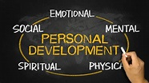

Fig. Personal Development

### Basic Personality Traits

The goal of personality development theories is to explain how we each develop our own unique characteristics and traits. While the list of options could be almost endless, most of these personality traits fall into five basic categories:

**Openness**: Level of creativeness and responsiveness to change. **Conscientiousness:** Level of organization and attention to detail. **Extraversion**: Level of socialness and emotional expressiveness. **Agreeableness**: Level of interest in others and cooperativeness.

**Neuroticism:** Level of emotional stability and moodiness.

The "Big 5" is one of the most recognized models of personality and also the most widely used, though some suggest that it isn't comprehensive enough to cover the huge variety of personality traits that one can grow and develop.

Every human being should spend five days in his life in five different places.

### Jail

For compassion

You all should spend one day in jail. With all those who have been condemned as criminals. Talk to them. Your life will be transformed. You will have compassion for them. There is nobody to sit and talk to them and heal their wounds to transform them. One day in prison will open up your vision, your prejudice will go and your tendency to condemn people will disappear.

### School

For patience

One day in school, maybe with children who have special needs and you have to teach them something. How many times do they make mistakes, with the challenge you have to make them repeat the poems and you have to teach them? Do you know how much patience you need to have? Primary school teachers are much more evolved than professors of colleges as they need a lot of patience to deal with them. So, someone who is impatient, you send them to primary school.

### Farmer

For faith

One day with the farmer in the garden. Just be with the mud, sowing seed and watching how the seed sprouts. You need to have patience to see that seed sprouting and that caring for trees. One day may not be enough. When you prune the trees, you are not pruning to drop roots. Pruning is so that the trees can grow better.

### Hospital

For recognizing transiency

One day in a hospital, maybe even hospice and see life is so impermanent. Of course, those who are working in hospitals, become sort of insensitive towards this. They are used to it. When you are used to something, you no longer learn from it but when you have never done something for a change when you go and do something like that you learn a lot.

### Mental Hospital

For an open mind

One day in the mental hospital and see what they all speak. Do you take it seriously? If you take the word seriously then you are part of the patients there. You should be counted. We take people’s words too seriously. Things are going to happen or even anyway happening from another law, from another level of existence. But we take too seriously what this guy said, what that lady said, who said what and all those things. We take it to our hearts and boil. It makes our minds negative; it gets so thick and the thick head is the bother for you. Whoever said something and they went but those words got into your head and it boiled your head. It made you so hard and insensitive in yourself. You don’t know how you behave. You’re not at all aware of your own reactions, your own perception and your expression gets totally messed up or becomes so gross.

Determinants of Personality

Following are the factors which help in shaping one’s personality:

**Heredity** - Heredity refers to factors that are determined once an individual is born. An individual’s physique, attractiveness, body type, complexion, body weight depends on his/her parents’ biological makeup.

**Environment** - The environment to which an individual is subjected to during his growing years plays an important role in determining his/her personality. The varied cultures in which we are brought up and our family backgrounds have a crucial role in shaping our personalities.

**Situation** - An individual’s personality also changes with current circumstances and situations. An individual would behave in a different way when he/she has enough savings with him and his behavior would automatically change when he is bankrupt.

It is essential to understand that, pleasing personality is admiring, but this thought is not readily accepted by most of the individuals. Personality development is perceived only as training towards improving ones’ outlooks. This is a void statement and it is must to realize that personality development is a quite broader topic and it includes how one-self can educate them to have clean and neat social personality with grace and groom. It also instructs them to enhance one’s communication and interpersonal skills. Objectives of life without these important skills will be futile to head towards success. Benefits of personality development include the following keys:

* Self Confidence
* Credibility
* Leadership qualities
* Interpersonal skills

Self-Confidence

Self-confidence is an important trait required to face success in our lives. Although many of us still find it difficult to hold the trait within and this vicious cycle of lacking confidence may lead to keep us distant from our desires. Confident people admire the characters in others: their chiefs, their friends, their family and their peers. Admiring confidence from others will also enhance our idea towards raising the self-confidence in us. The level of confidence shows in many ways of your behaviour: the way you speak, the way you handle others, the way you solve the problems and so on. Confidence also deals with two major factors: Self-esteem and Self-efficacy. We develop a sense of self-efficacy in ourselves by acquiring skills and knowledge. This will increase our confidence levels to learn and work hard on our vision, and we will succeed. The level of confidence will always boost us to face the risks and crisis and better manage and persists with the setbacks. Self-esteem is breaking down the negative forces and fear of facing failures and raising the hope towards win-win situation.

Credibility

Credibility in the current modern era is one of the noticeable personas. Most of us decide an individual by their outlooks and their attire. A book cannot be judged from its outer cover, in similar way, an individual cannot be judged from their outlooks. A best personality will be covered by their shabby looks and inexpensive dresses. So, it is always good to show up a credible outlook by enhancing your physical features. Do not show up a poor professional image Over- aggressiveness simply doesn't work in most of the official environments other-way, Passiveness too will not work, always find the middle ground to show credibility to your peers.

Interpersonal skills

Interpersonal skills are skills performed everyday which includes interaction with other people, both individually and in groups. People with strong interpersonal skills are successful in their professional and personal lives. Interpersonal skills are more centered on communication, listening, questioning and understanding body language. It also includes the skills and attributes related to the emotional intelligence or being able to understand and manage your own and others' emotions.

People with good interpersonal skills will be able to work well in a team or group without any hesitation. They will be a good communicator with effective skills and it is therefore important in diverse areas of life with the society. We should be able to discover our own strengths and weaknesses. We are developing our interpersonal skills since childhood usually subconsciously.

Leadership qualities

Personality development encourages leading and motivating others towards achievement. A good leader will motivate their group in a positive way to reach success. This quality is a goal-oriented one which helps a person to achieve their ambitions. It will make them work hard lumps in achieving their goals. A leader should keep a vision and equal perspective on all humans. We can be an employee or a manager or a higher official, but we must possess both leadership and motivational character in us. An efficient leader must have a fulfilled knowledge of motivation factors over others. Leaders should ensure following the moral and ethics and also to harmonies the subordinate needs. A word of appreciation is always rewarding to motivate and influence a person to succeed in his/her vision. Good reward or exceptional behavior with a token of appreciation, certification or letter can be motivating to the peer groups. Problem solving capacity is a major character required for a leader to make his/her peers stronger-mentally and emotionally. A major take-away point on leadership is "To be an efficient leader, you must be self-ruling yourself and self-motivating yourself". We must have our own identity, needs and vision to do anything to achieve our ambitions. If you can motivate and rule yourself to achieve your own ambition, you will master in harmonizing the common goals of the organization.

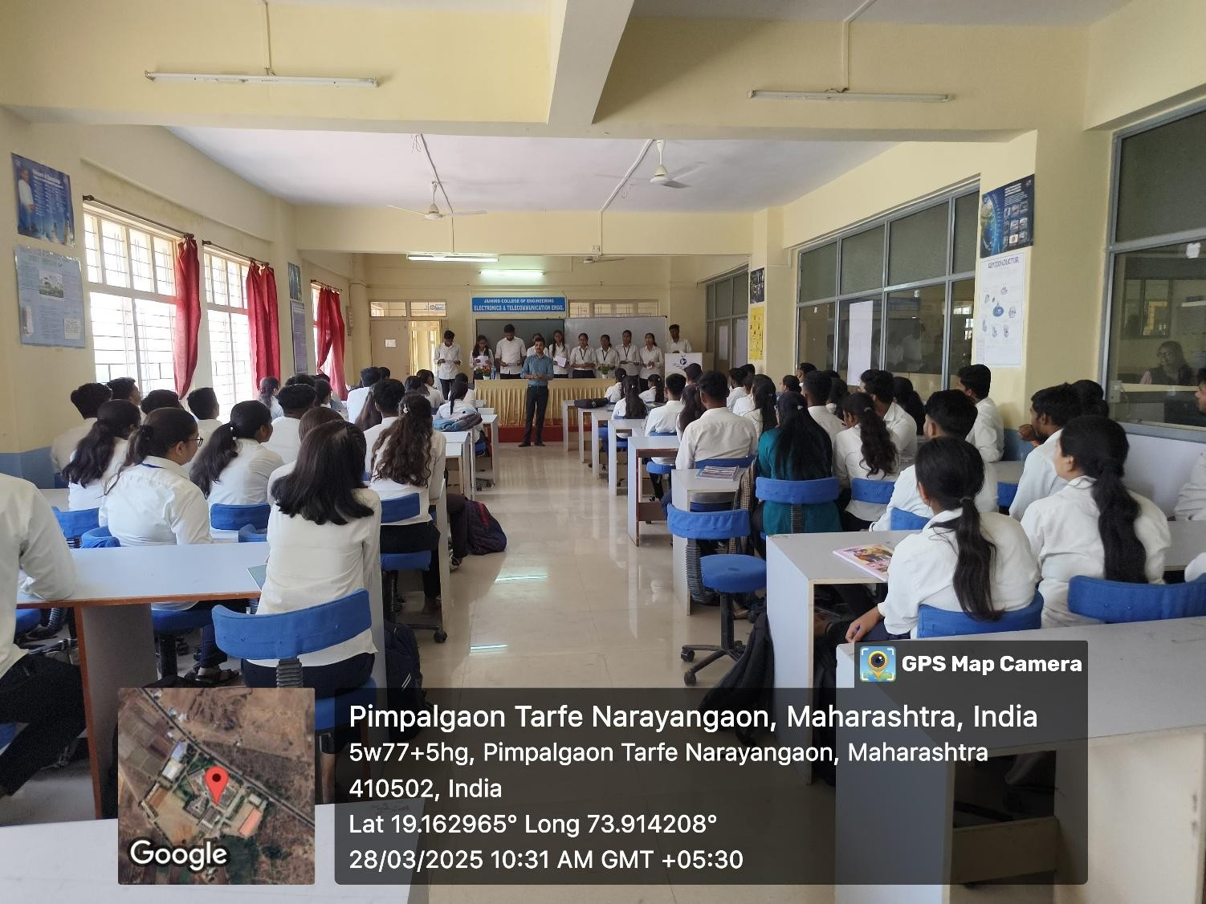

Fig. Personal Development session

**Chapter 3**

## SOFT SKILL

Soft skills are personal attributes that enable individuals to interact effectively with others and succeed in the workplace and beyond. Unlike hard skills, which are job-specific and technical in nature, soft skills are transferable and apply to a wide range of roles and industries. Here's a detailed overview of various soft skills**.** The ability to convey information clearly and effectively through verbal, written, and nonverbal means. Strong communication skills include active listening, articulating ideas, and adapting communication style to different audiences. The ability to build and maintain positive relationships with others. Interpersonal skills include empathy, teamwork, collaboration, conflict resolution, and networking. The capacity to recognize, understand, and manage one's own emotions as well as the emotions of others. Emotional intelligence encompasses self-awareness, self-regulation, empathy, and social skills. The flexibility to adjust to new situations, challenges, and environments.

Adaptability involves being open-minded, resilient, and willing to embrace change. The ability to analyze complex situations, identify solutions, and make sound decisions. Problem- solving skills involve critical thinking, creativity, resourcefulness, and decision-making. The ability to inspire, motivate, and guide others towards achieving common goals. Leadership skills include vision-setting, delegation, coaching, and conflict management. The skill of effectively managing one's time and priorities to maximize productivity and achieve goals. Time management involves setting goals, prioritizing tasks, scheduling, and overcoming procrastination. The ability to cope with pressure, setbacks, and challenges in a healthy and productive manner. Stress management techniques include relaxation, mindfulness, time management, and seeking support. The willingness to adapt to changing circumstances and approaches. Flexibility involves being open to new ideas, feedback, and ways of working.

The ability to think innovatively and generate new ideas or solutions. Creativity involves lateral thinking, problem-solving, and exploring unconventional approaches. The capacity to bounce back from setbacks, failures, and adversity. Resilience involves maintaining a positive outlook, learning from experiences, and persevering in the face of challenges. The ability to address and resolve conflicts or disagreements constructively. Conflict resolution skills include active listening, empathy, negotiation, and finding mutually beneficial solutions. Soft skills are essential for personal and professional success in today's dynamic and interconnected world.

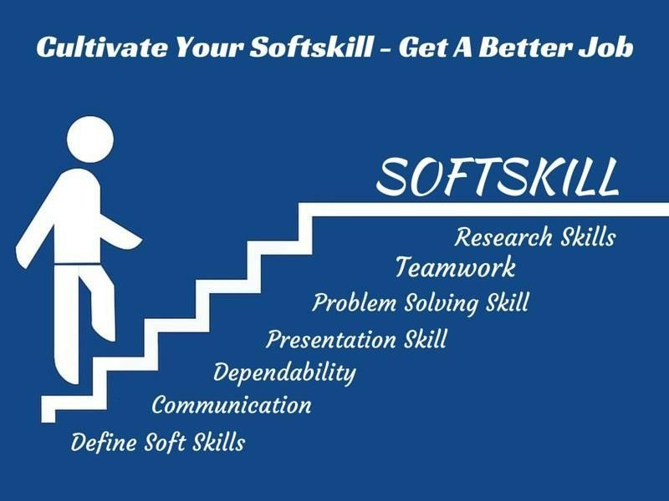.

Fig. Soft skill Management

Workers acquire hard skills through formal education, training programs, and concentrated effort. Hard skills are the quantifiable skills that workers need to successfully perform a specific job. Employers often test or evaluate a candidate's hard skills before hiring. Examples of hard skills include computer programming, writing, web development, and graphic design. Some hard skills are more in demand than others, and employers may need to hire recruiting agencies or headhunters to fill jobs that require specialized, high-level hard skills.

Hard skills can be learned and perfected over time, but soft skills are more difficult to acquire and change. For example, the soft skills a doctor might need are empathy, understanding, active listening, and a good bedside manner. Alternatively, the hard skills a doctor requires include a vast comprehension of illnesses, the ability to interpret test results and symptoms, and a thorough understanding of anatomy and physiology.

### Valuable Soft Skills for Employees

Soft skills benefit businesses when they are practiced on a company-wide basis. For example, a collaborative spirit among workers is important. Team members who are able to work well with people of different generations and backgrounds are generally more productive and better able to focus on common priorities. Efficiency and output improve when workers collaborate by sharing knowledge and tools to get jobs done. The ability to learn new methods and technologies is also a desired soft skill for all workers. Companies that value learning as a soft skill recognize various learning styles and encourage workers to pursue the methods that work best for them. Good troubleshooting is another soft skill that companies value. For example, companies can operate more efficiently and increase productivity when all workers know how to troubleshoot software problems instead of relying on the information technology (IT) department for every fix.Soft skills

can also be thought of as people skills. These can include good communication and interpersonal skills, leadership, problem solving, work ethic, time management, and teamwork. These are characteristics that can be carried over to any position.

### Soft Skills List and Examples:

Because these are often innate personality traits, you already possess several marketable soft skills that might help you get and be successful in a job. Though many are formed with your personality, soft skills can also be learned and developed with practice and experience. Here are few examples of key soft skills and how those can enhance your performance during and after the job search process.

### Communication

Effective communication skills might be helpful through the interview process and in your career. The ability to communicate involves knowing how you are required to speak to others in different situations or settings. For example, when working with a team on a project, you may be required to communicate when you believe that an idea or process is ineffective. Finding a way to tactfully and skillfully disagree with others on the job without creating conflict is an important skill that employers value.

Related communication skills:

* Active listening
* Confidence
* Conflict resolution
* Organization

### Problem-solving

Employers highly value people who can resolve issues quickly and effectively. That may involve calling on industry knowledge to fix an issue immediately, as it occurs, or taking time to research and consult with colleagues to find a scalable, long-term solution.

Related problem-solving skills:

* Creativity
* Research
* Risk management
* Teamwork

### Creativity

Creativity is a broad ability incorporating many different skill sets including other soft skills and

technical skills. Employees with creativity can find new ways to perform tasks, improve processes or even develop new and exciting avenues for the business to explore. Creativity can be used in any role at any level.

Related creativity skills:

* Curiosity
* Learning from others
* Open-mindedness
* Taking calculated risks

### Adaptability

How easily do you adapt to changes? If you are working in a technology-driven field or start-up, adaptability is especially important. Changes in processes, tools or clients you work with can happen quickly. Employees who are capable of adapting to new situations and ways of working are valuable in many jobs and industries.

Related adaptability skills:

* Consistency
* Organization
* Optimism
* Flexibility

### Work ethic

Work ethic is the ability to follow through on tasks and duties in a timely, quality manner. A strong work ethic helps ensure you develop a positive relationship with your employer and colleagues even when you are still developing technical skills in a new job. Many employers would rather work with someone who has a strong work ethic and is eager to learn than a skilled worker who seems unmotivated.

Related work ethic skills:

* Attention to detail
* Integrity
* Persistence
* Time management

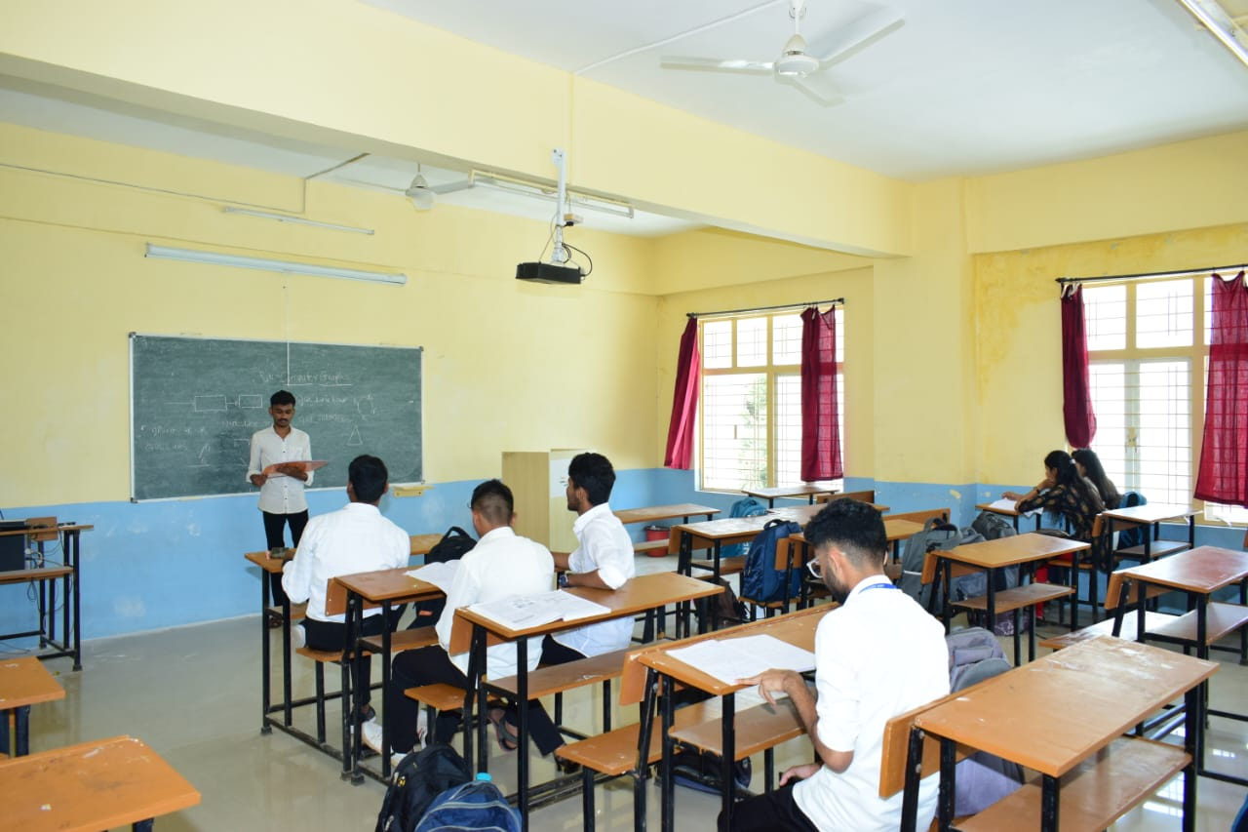

Fig. Soft skill

**Chapter 4**

1. **COMMUNICATION SKILL**

Communication skills are fundamental abilities that enable individuals to convey information effectively, exchange ideas, and build relationships. The use of spoken words to convey messages, ideas, and information. Verbal communication involves clarity, articulation, tone of voice, and the ability to engage and persuade an audience. Communication through gestures, facial expressions, body language, and other nonverbal communication. Nonverbal communication can convey emotions, attitudes, and intentions, and it often complements verbal communication. The ability to actively listen and understand what others are saying. Effective listening involves giving full attention, showing empathy, asking clarifying questions, and providing feedback to ensure understanding. The ability to convey information clearly and effectively through written text. Written communication includes emails, reports, memos, letters, and other written documents. Strong writing skills involve organization, clarity, conciseness, and appropriate tone.

The ability to deliver information or ideas to an audience in a clear, engaging, and persuasive manner. Presentation skills include structuring content, using visual aids effectively, managing nerves, and engaging with the audience. Communication between individuals or within small groups. Interpersonal communication skills involve building rapport, active listening, empathy, conflict resolution, and assertiveness. The ability to communicate effectively with people from different cultural backgrounds. Cross-cultural communication skills involve understanding cultural norms, customs, and communication styles, and adapting one's communication accordingly. The ability to recognize, understand, and manage one's own emotions as well as the emotions of others. Emotional intelligence enhances communication by fostering empathy, self- awareness, and effective conflict resolution. The ability to give and receive feedback constructively.

Effective feedback involves being specific, timely, and actionable, while receiving feedback requires openness, humility, and a willingness to learn and improve. The ability to influence others, reach agreements, and achieve desired outcomes. Negotiation and persuasion skills involve understanding stakeholders' needs and interests, building trust, and presenting compelling arguments. The ability to establish and maintain professional relationships for mutual benefit. Networking involves effective communication skills, active listening, building rapport, and following up with contacts. The ability to address and resolve conflicts or disagreements in a

constructive manner. Conflict resolution skills involve active listening, empathy, finding common ground, and seeking win-win solutions. Developing strong communication skills is essential for success in various aspects of life, including personal relationships, academic pursuits.

Types of Communication

We will share these forms with you as they have a vital role in the communication process.

### Written Communication

Written communication relies on written words and includes emails, letters, and reports, offering a tangible record of information exchange.

### Verbal Communication

Verbal communication involves using spoken words to convey messages, allowing for immediate interaction. Verbal communication is the art of expressing thoughts, ideas, and emotions through the power of speech.

### Non-Verbal Communication

Non-verbal communication involves gestures, body language, and facial expressions, adding depth and nuance to verbal messages.

### Visual Communication

Visual communication utilizes images, charts, and graphs, and serves as a powerful tool for conveying complex information.

### Examples of Communication Skills

If you are wondering how to improve your communication skills, here’s the full guide. We will now look at important skills that can greatly affect personal and professional development.

### Active Listening

Paying attention to both words and non-verbal signals like body language and tone is crucial for effective communication. It helps you truly understand others' perspectives and encourages meaningful conversations.

### Clarity and Conciseness

Being clear and to the point prevents confusion. Strong communicators express their thoughts directly, avoiding unnecessary complexity or jargon.

### Empathy

Empathy is understanding and sharing others' feelings. Being empathetic helps build strong connections in communication, showing care for others and creating a cooperative atmosphere.

### Flexibility

Adapting communication styles to different situations and audiences is key. Adaptable communicators can navigate various social and professional settings easily, enhancing their overall effectiveness.

### Conflict Resolution

Conflicts are a part of life, but individuals with strong communication skills stand out by skillfully resolving them. This not only promotes harmony but also demonstrates leadership and an adept handling of challenging situations.

### Feedback Delivery

Providing constructive feedback is an art. Strong communicators deliver feedback in a helpful and motivating way, fostering a culture of continuous improvement and collaboration within a team or organization.

### Non-verbal Communication

Besides words, non-verbal cues like gestures and facial expressions play a significant role in effective communication. Skilled communicators use non-verbal signals to enhance their spoken messages, making their interactions more meaningful.



Fig. Effective Communication

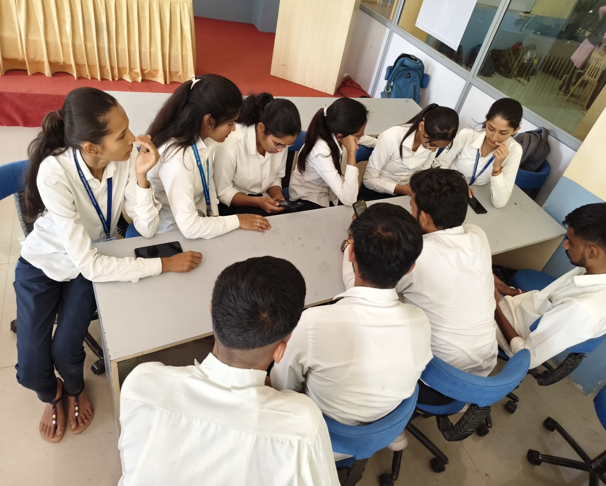

Fig. Effective Communication

**Chapter 5**

## GROUP DISCUSSION

Group discussions are structured conversations among a group of individuals to explore and exchange ideas on a particular topic. They often begin with an introduction of the topic followed by participants sharing their perspectives, insights, and experiences related to the subject matter. Facilitators may guide the discussion to ensure everyone has an opportunity to contribute and that the conversation remains focused. Participants may offer arguments, ask questions, or present evidence to support their viewpoints. Active listening and respectful communication are essential to foster a productive dialogue. The goal of a group discussion is typically to generate new ideas, reach consensus, or gain deeper understanding of the topic at hand.

A group discussion is a conversational format where a small or large group of individuals come together to discuss a specific topic or issue. It typically involves a facilitator or moderator who guides the discussion and ensures that everyone has the opportunity to contribute. Participants share their thoughts, ideas, experiences, and perspectives on the topic at hand, often engaging in active listening and respectful dialogue. The goal of a group discussion may vary depending on the context, but it generally aims to exchange information, explore different viewpoints, brainstorm solutions, make decisions, or reach consensus on a particular issue. Effective group discussions require good communication skills, including the ability to express oneself clearly, listen attentively, ask questions, and build upon others' ideas. They also rely on mutual respect, openness to diverse opinions, and a willingness to collaborate towards common objectives. Group discussions can take place in various settings, such as classrooms, boardrooms, community meetings, or online forums, and they can be instrumental in fostering creativity, problem-solving, teamwork, and critical thinking skills among participants.

A Group Discussion, often abbreviated as GD, is a popular evaluation technique used by employers during the recruitment process. It is a structured conversation involving a group of individuals, usually between 6 to 15 participants, who gather to discuss a specific topic or problem. The primary goal of a group discussion is to assess a candidate's ability to communicate, collaborate, and present their ideas effectively within a group setting. Group discussions play a crucial role in assessing not just an individual's knowledge but also their interpersonal skills, teamwork, and ability to think on their feet.

What is a Group Discussion About?

### Testing Communication Skills

One of the key objectives of a group discussion is to evaluate a candidate's communication abilities. Participants are expected to express their thoughts clearly, concisely, and logically. Effective verbal communication, including listening to others and responding thoughtfully, is a critical skill that employers seek in potential employees.

### Teamwork and Leadership

Group discussions help employers identify how well candidates can work in a team. It's not just about presenting your views but also about listening to others, acknowledging their perspectives, and fostering a collaborative environment. Additionally, it offers a chance for employers to observe emerging leaders who can guide the discussion and maintain order within the group.

### Problem-Solving and Decision-Making

In many group discussions, participants are presented with a problem or a case study to discuss. This assesses their problem-solving and decision-making skills under pressure.Employers are keen to identify candidates who can analyze situations, think critically, and propose effective solutions in real time.

### Knowledge and Awareness

Group discussions often revolve around current affairs, social issues, or industry-related topics. Being well-informed and having a good understanding of these subjects can give candidates an advantage. Employers look for candidates who can contribute meaningful insights and stay updated with relevant information.

### Time Management

Group discussions are typically time-bound, so time management is another skill being tested. Candidates must make their points and engage in the discussion while adhering to time constraints. **Convincing and Persuasive Skills**

Participants may need to persuade others to accept their point of view during a group discussion. Being persuasive, yet respectful, is a valuable skill in a professional setting.

### Handling Pressure

Group discussions can be challenging, especially when participants have differing opinions and the clock is ticking. How candidates handle stress, maintain composure, and continue to contribute constructively is closely observed.

### Types Of Group Discussions

Group discussions come in various formats, each designed to assess specific skills and qualities in participants. Different types of group discussions include:

### Topic-based Group Discussion

In a topic-based GD, participants are given a specific subject or theme to discuss. This type is often used in academic settings, where students are asked to share their views on a given topic. It can also be used in job interviews to evaluate the candidate's knowledge and ability to articulate their thoughts.

### Case Study Group Discussion

In this type of GD, participants are presented with a real or hypothetical scenario or case study. They must analyze the situation, identify issues, and propose solutions. Employers use this format to assess problem-solving abilities and decision-making skills.

### Role-Play Group Discussion

Role-play GDs involve participants assuming specific roles or characters and discussing a scenario or problem as if they were the people they're representing. It's an effective way to evaluate empathy, creativity, and the ability to think from different perspectives.

Structured Group Discussion

Structured GDs are more formal and controlled. Participants may take turns speaking, and the discussion follows a predetermined agenda or set of questions. This format is common in academic settings and research-related discussions.

### Debate Group Discussion

A debate-style GD involves participants taking opposing sides on a given topic and presenting arguments to support their position. This type assesses participants' ability to construct logical arguments, counter opposing viewpoints, and communicate persuasively.

### Fishbowl Group Discussion

In a fishbowl discussion, a smaller group of participants sits in the center and discusses a topic while the larger group observes. This format is often used for training and development purposes, allowing observers to learn from the discussion in progress.

### Group Problem-Solving Discussion

Participants work together to solve a complex problem or challenge. This type assesses teamwork, collaboration, and the ability to collectively find solutions.

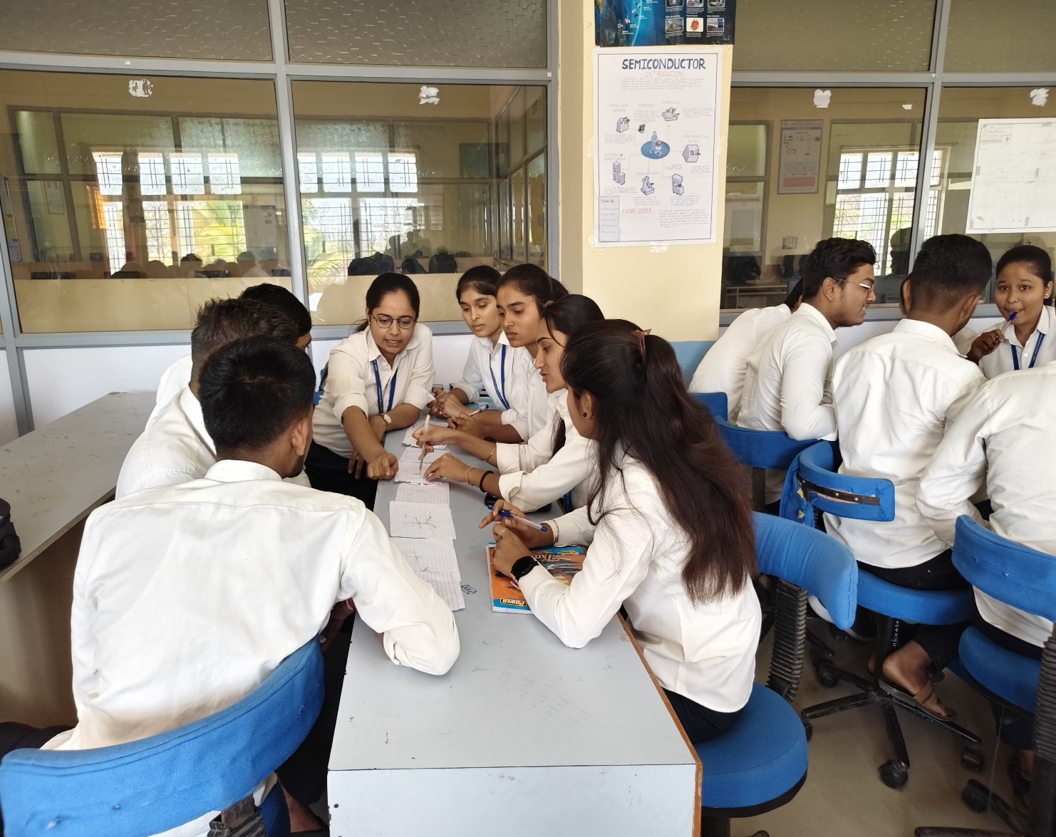

Fig. Group Discussion

Chapter 6

## JOB INTERVIEW

When preparing for a job interview, it's crucial to research the company thoroughly, understand the job description, and prepare examples that showcase your relevant skills and experiences. Dress professionally, arrive on time, and maintain good body language throughout the interview. Listen carefully to questions and provide concise, relevant answers. Prepare thoughtful questions to ask the interviewer. After the interview, send a thank-you email to express gratitude and reiterate your interest in the position. Remember, the interview is an opportunity for both you and the employer to assess mutual fit.

A job interview is an interview consisting of a conversation between a job applicant and a representative of an employer which is conducted to assess whether the applicant should be hired. Interviews are one of the most common methods of employee selection. Interviews vary in the extent to which the questions are structured, from an unstructured and informal conversation to a structured interview in which an applicant is asked a predetermined list of questions in a specified order structured interviews are usually more accurate predictors of which applicants will make suitable employees, according to research studies. A job interview typically precedes the hiring decision. The interview is usually preceded by the evaluation of submitted résumés from interested candidates, possibly by examining job applications or reading many resumes. Next, after this screening, a small number of candidates for interviews is selected. Potential job interview opportunities also include networking events and career fairs.

The job interview is considered one of the most useful tools for evaluating potential employees. It also demands significant resources from the employer, yet has been demonstrated to be notoriously unreliable in identifying the optimal person for the job. An interview also allows the candidate to assess the corporate culture and the job requirements. Multiple rounds of job interviews and/or other candidate selection methods may be used where there are many candidates or the job is particularly challenging or desirable. Earlier rounds sometimes called 'screening interviews' may involve less staff from the employers and will typically be much shorter and less in-depth. An increasingly common initial interview approach is the telephone interview. This is especially common when the candidates do not live near the employer and has the advantage of keeping costs low for both sides.

One way to think about the interview process is as three separate, albeit related, phases: the pre- interview phase which occurs before the interviewer and candidate meet, the interview phase where the interview is conducted, and the post-interview phase where the interviewer forms judgments of candidate qualifications and makes final decisions. Although separate, these three phases are related. That is, impressions interviewers form early on may affect how they view the person in a later phase.

**Pre-interview phase**: The pre-interview phase encompasses the information available to the interviewer beforehand (e.g., resumes, test scores, social networking site information) and the perceptions interviewers form about applicants from this information prior to the actual face-to- face interaction between the two individuals. In this phase, interviewers are likely to already have ideas about the characteristics that would make a person ideal or qualified for the position. Interviewers also have information about the applicant usually in the form of a resume, test scores, or prior contacts with the applicant. Interviewers then often integrate information that they have on an applicant with their ideas about the ideal employee to form a pre-interview evaluation of the candidate. In this way, interviewers typically have an impression even before the actual face-to- face interview interaction. Nowadays with recent technological advancements, interviewers have an even larger amount of information available on some candidates. For example, interviewers can obtain information from search engines (e.g. Google, Bing, Yahoo), blogs, and even social networks (e.g. Linkedin, Facebook, Twitter). While some of this information may be job-related, some of it may not be. In some cases, a review of Facebook may reveal undesirable behaviors such as drunkenness or drug use. Despite the relevance of the information, any information interviewers obtain about the applicant before the interview is likely to influence their impression of the candidate. Furthermore, researchers have found that what interviewers think about the applicant before the interview (pre-interview phase) is related to how they evaluate the candidate after the interview, despite how the candidate may have performed during the interview.

* **Interview phase**: The interview phase entails the actual conduct of the interview, the interaction between the interviewer and the applicant. Initial interviewer impressions about the applicant before the interview may influence the amount of time an interviewer spends in the interview with the applicant, the interviewer's behavior and questioning of the applicant, and the interviewer's post-interview evaluations. Pre-interview impressions also can affect what the interviewer notices about the interviewee, recalls from the interview, and how an interviewer interprets what the applicant says and does in the interview.

As interviews are typically conducted face-to-face, over the phone, or through video conferencing (e.g. Skype), they are a social interaction between at least two individuals. Thus, the behavior of the interviewer during the interview likely "leaks" information to the interviewee. That is, you can sometimes tell during the interview whether the interviewer thinks positively or negatively about you. Knowing this information can actually affect how the applicant behaves, resulting in a self-fulfilling prophecy effect. For example, interviewees who feel the interviewer does not think they are qualified may be more anxious and feel they need to prove they are qualified. Such anxiety may hamper how well they actually perform and present themselves during the interview, fulfilling the original thoughts of the interviewer. Alternatively, interviewees who perceive an interviewer believes they are qualified for the job may feel more at ease and comfortable during the exchange, and consequently, actually perform better in the interview. Because of the dynamic nature of the interview, the interaction between the behaviors and thoughts of both parties is a continuous process whereby information is processed and informs subsequent behavior, thoughts, and evaluations.

* **Post-interview phase**: After the interview is conducted, the interviewer must form an evaluation of the interviewee's qualifications for the position. The interviewer most likely takes into consideration all the information, even from the pre-interview phase, and integrates it to form a post-interview evaluation of the applicant. In the final stage of the interview process, the interviewer uses his/her evaluation of the candidate (i.e., in the interview form ratings or judgment) to make a final decision. Sometimes other selection tools (e.g., work samples, cognitive ability tests, personality tests) are used in combination with the interview to make final hiring decisions; however, interviews remain the most commonly used selection device in North America.
* **For interviewees**: Although the description of the interview process above focuses on the perspective of the interviewer, job applicants also gather information on the job and/or organization and form impressions prior to the interview. The interview is a two-way exchange and applicants are also making decisions about whether the company is a good fit for them. Essentially, the process model illustrates that the interview is not an isolated interaction, but rather a complex process that begins with two parties forming judgments and gathering information, and ends with a final interviewer decision.

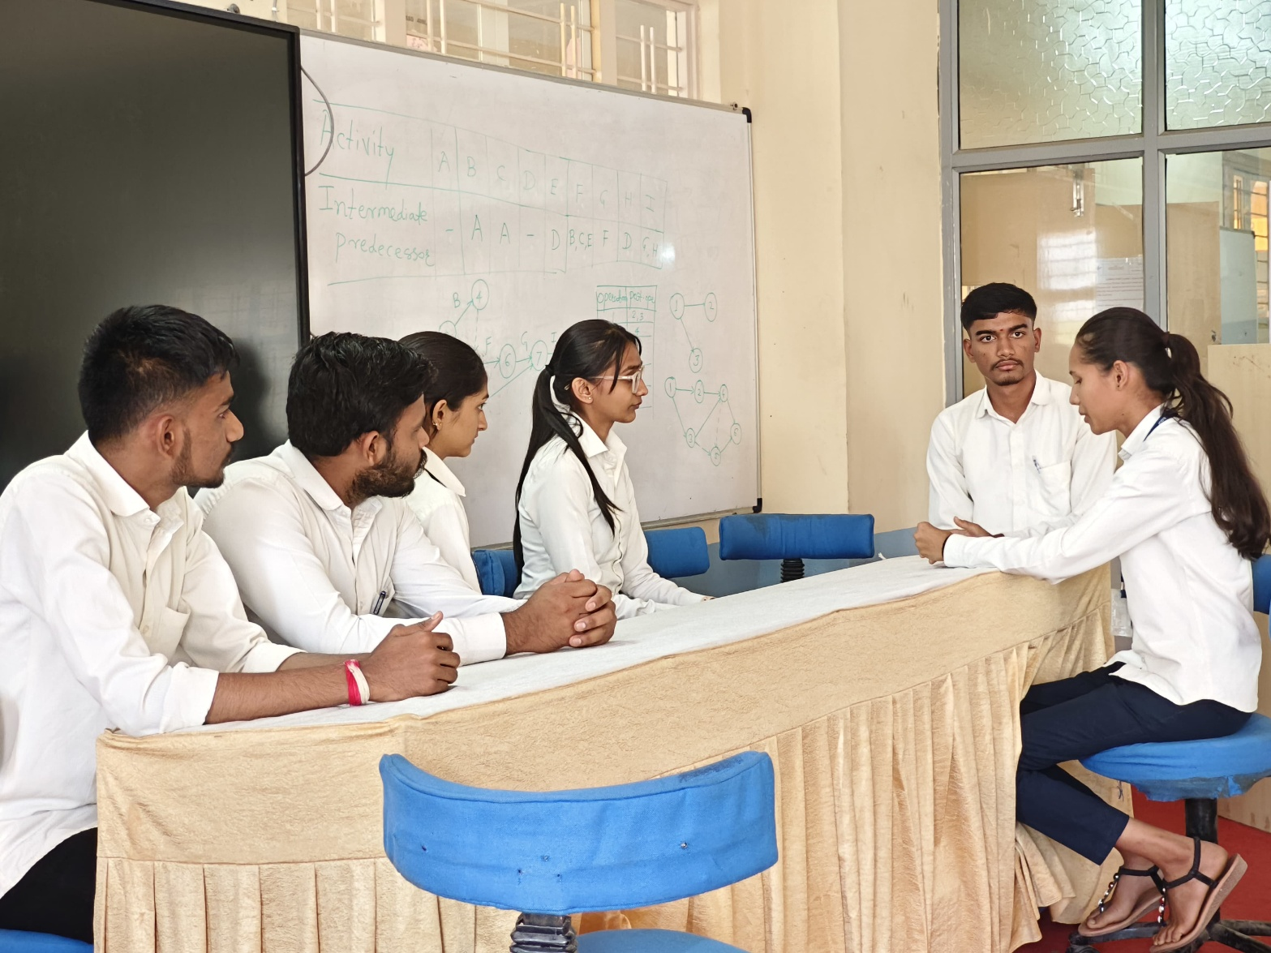

Fig. Interview

**Chapter 7**

## BODY LANGUAGE

Body language encompasses non-verbal cues like posture, eye contact, facial expressions, gestures, and overall demeanor. It's crucial in conveying confidence, interest, and professionalism. Body language plays a significant role in job interviews. It includes maintaining good posture, making eye contact, offering a firm handshake, and smiling appropriately. These gestures convey confidence, interest, and professionalism. Additionally, avoiding fidgeting, crossing arms, or slouching can help you appear more engaged and attentive during the interview. Paying attention to your body language can enhance the overall impression you make on the interviewer.

Body language encompasses various non-verbal cues that can influence how you are perceived during a job interview. Some aspects to consider include, maintain an upright posture to appear confident and attentive. Establish and maintain eye contact to demonstrate interest and engagement. Offer a firm handshake to convey confidence and professionalism. Facial expressions: Smile naturally and appropriately to appear friendly and approachable. Use gestures sparingly to emphasize points, but avoid excessive or distracting movements. Respect personal space boundaries and maintain an appropriate distance from the interviewer. Subtly mirroring the interviewer's body language can help build rapport and establish a connection. Avoid fidgeting, tapping, or other nervous habits that may distract from your message. Keep your arms relaxed and uncrossed to appear open and approachable. Project confidence, enthusiasm, and positivity through your body language to make a strong impression.

Body language differs from sign language, which are languages with complex grammar systems and exhibiting the fundamental properties considered to exist in all true languages. Body language, on the other hand, does not have a grammar system and must be interpreted broadly, instead of having an absolute meaning corresponding with a certain movement. It is, technically, not a language. Body language more so refers to the often unconscious reactions we tend to have in relation to observed stimuli. Within a society, consensus exists regarding the accepted understandings and interpretations of specific behaviors. There also is controversy on whether body language is universal. Body language, a subset of nonverbal communication, complements verbal communication in social interaction. In fact, some researchers conclude that nonverbal communication accounts for the majority of information transmitted during interpersonal.

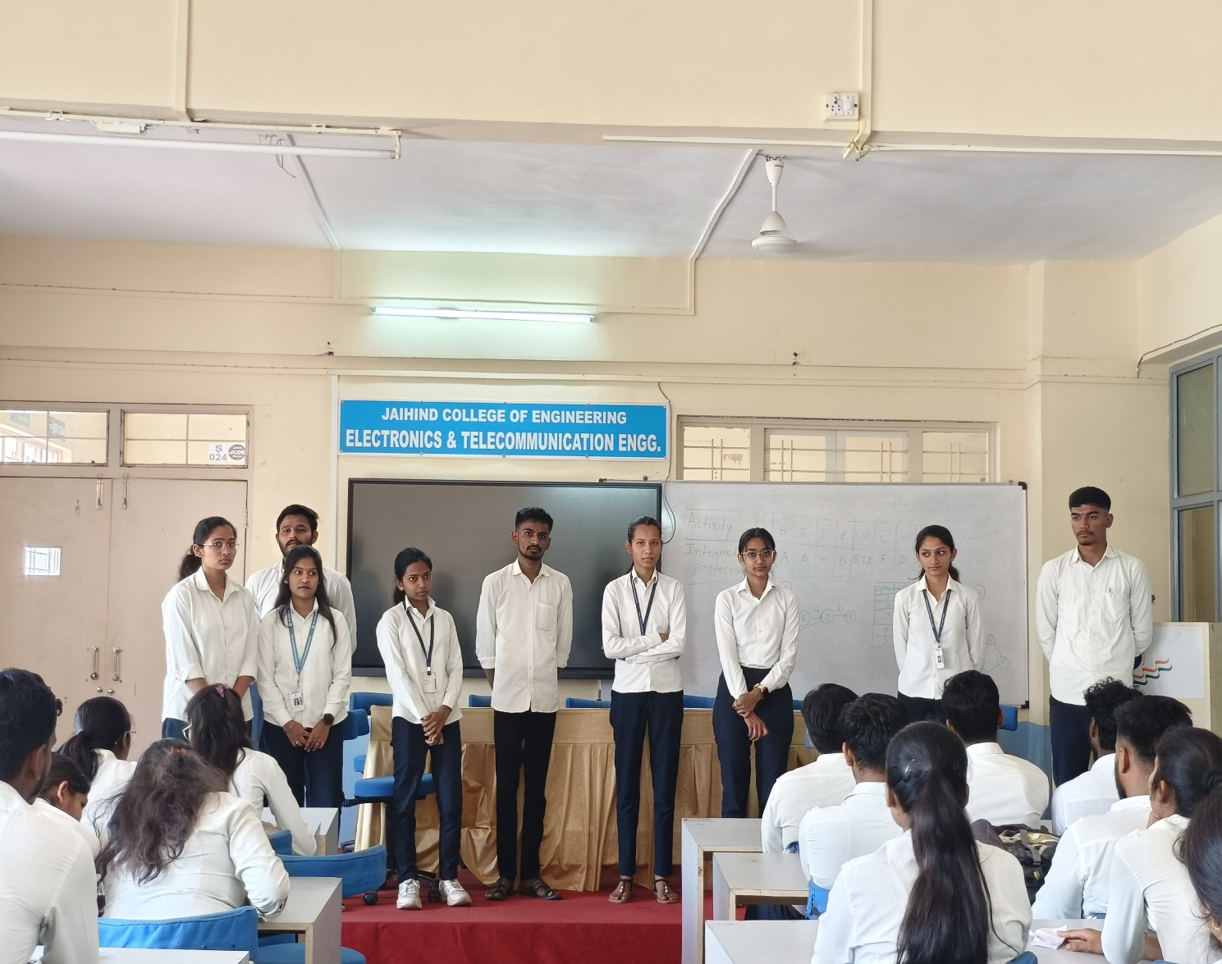

Fig. Body Language

## CONCLUSION

Personality development is essential for effective leadership. By understanding oneself, honing communication skills, and cultivating empathy, leaders can inspire and motivate their teams. Leadership is not just about authority; it's about influence, vision, and the ability to bring out the best in others. Effective leaders continuously work on their personal growth while also nurturing the growth of those around them. Personality development and leadership are intricately linked, forming the backbone of successful individuals and organizations. Personality development encompasses a range of attributes, including self-awareness, emotional intelligence, communication skills, adaptability, and resilience. Leaders who prioritize their personal growth not only enhance their own effectiveness but also create an environment conducive to growth and success for their teams.Self-awareness is the cornerstone of personality development and leadership. It involves understanding one's strengths, weaknesses, values, and motivations. Leaders who are self-aware can leverage their strengths to lead effectively while acknowledging and addressing their weaknesses

1. **REFERENCES**
2. "Emotional Intelligence" by Daniel Goleman
3. “Leaders Eat Last" by Simon Sinek
4. “The 7 Habits of Highly Effective People" by Stephen R. Covey
5. “Dare to Lead" by Brené Brown
6. “Primal Leadership" by Daniel Goleman, Richard Boyatzis, and Annie McKee.