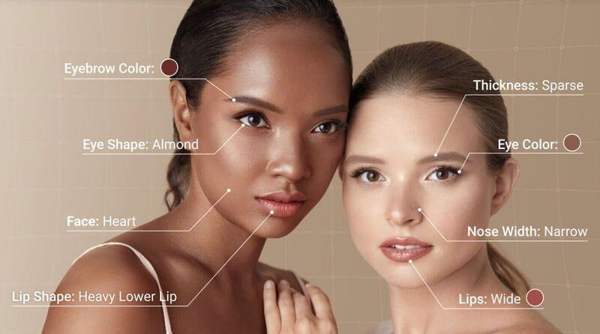

Project Objective
To build a system that can analyze facial images and classify key features such as eyebrow color, eye shape, lip shape, face shape, and other attributes. The output will be similar to the annotations in the provided image.

Technologies
- Programming Language: Python
- Frameworks:
  - Deep Learning: TensorFlow or PyTorch
  - Image Processing: OpenCV
- Pre-trained Models:
  - Face Detection: MediaPipe Face Detection or OpenCV Haar Cascades
  - Facial Feature Extraction: Dlib or DeepFace
- Cloud Platforms (Optional):
  - Google Cloud AI, AWS Rekognition, or Azure Face API for advanced image analysis
- Visualization Tools:
  - Matplotlib or Plotly for result visualization
  - Streamlit for building an interactive web app

Steps to Implement

1. Data Collection
- Source: Use publicly available datasets like CelebA, Kaggle's facial attribute datasets, or Flickr-Faces-HQ (FFHQ).
- Annotations: Ensure datasets have labels for features like eye shape, face shape, nose width, etc., or annotate them manually using tools like LabelImg.

2. Preprocessing
- Face Detection: Detect faces using a pre-trained model (e.g., Dlib or MediaPipe).
- Facial Landmark Detection: Extract key points such as eyes, nose, lips, and jawline for feature-specific cropping and alignment.
- Image Augmentation: Perform transformations (e.g., rotations, flips) to enhance dataset diversity.

3. Model Selection

Facial Feature Classification Models
- Base Models:
  - ResNet, EfficientNet, or MobileNet for feature classification.
- Custom CNN: Build a lightweight convolutional neural network for specific feature detection.
- Transformer Models:
  - Vision Transformers (ViT) for global feature extraction.

Pre-trained Models for Transfer Learning
- FaceNet: To extract embeddings and classify features.
- DeepFace: For facial attribute analysis.

4. Training
- Train separate models for each feature category (e.g., eye shape, lip shape).
- Loss Function: Use categorical cross-entropy for multi-class classification tasks.
- Metrics: Use accuracy, precision, and recall to evaluate performance.

5. Inference Pipeline
- Step 1: Detect and crop the face.
- Step 2: Apply the trained models to classify individual features.
- Step 3: Map predictions back to the image for visualization.

6. Deployment
- Build an interactive web application using Streamlit or Flask.
- Allow users to upload images and display predictions on facial features.

Example Technologies/Models for Each Feature
Feature | Suggested Model/Technology
Face Shape | CNN or MediaPipe
Eye Shape | Vision Transformer or ResNet
Lip Shape | Custom CNN with cropped lip regions
Nose Width | Mask R-CNN for segmentation + custom CNN
Eyebrow Color | Histogram-based classifier or CNN

Challenges and Solutions
- Challenge: Inconsistent lighting or angles in images.
  - Solution: Data augmentation and using robust pre-trained models.
- Challenge: Lack of labeled data.
  - Solution: Semi-supervised learning or leveraging transfer learning.
- Challenge: Detecting fine-grained differences (e.g., almond vs. round eyes).
  - Solution: Use high-resolution datasets and fine-tune transformer models.

Expected Outcome
- A model capable of detecting and labeling facial features as shown in the image.
- Interactive app for real-time predictions on uploaded images.

