CPU SCHEDULING SIMULATOR
A Project Report Submitted in the partial fulfillment of the requirements for the award of the degree of

BACHELOR OF TECHNOLOGY
In
DEPARTMENT OF COMPUTER SCIENCE ENGINEERING

By

G. VARSHINI | 2520030017
K. PRAGNYA | 2520030430
M. AVISHYA | 2520030482

Under the Esteemed Guidance of
Dr. D. Bheekya

Faculty, Operating Systems and Systems Programming
Department of Computer Science and Engineering



K L (Deemed to be) University DEPARTMENT OF COMPUTER SCIENCE ENGINEERING
&

DEPARTMENT OF COMPUTER SCIENCE AND INFORMATION TECHNOLOGY

Declaration

The Project Report entitled “CPU SCHEDULING SIMULATOR” is a record of Bonafide work of G. VARSHINI– 2520030017, K. PRAGNYA– 2520030430, M. AVISHYA – 2520030482 submitted in partial fulfillment for the award of B. Tech in Computer Science and Engineering (or) Computer Science and Information Technology to the K L University. The results embodied in this report have not been copied from any other departments/University/Institute.

G.VARSHINI | 2520030017
K. PRAGNYA | 2520030430
M. AVISHYA | 2520030482

K L (Deemed to be) University
DEPARTMENT OF COMPUTER SCIENCE ENGINEERING

CERTIFICATE

This is to certify that the mini project based report entitled “CPU SCHEDULING SIMULATOR” is a bonafide work done and submitted by G. VARSHINI– 2520030017, K. PRAGNYA– 2520030430, M. AVISHYA – 2520030482 in partial fulfillment of the requirements for the award of the degree of BACHELOR OF TECHNOLOGY in Department of Computer Science Engineering, K L (Deemed to be University), during the academic year 2026-2027.

Signature of the Guide

Signature of the Course Coordinator Signature of the HOD

ACKNOWLEDGEMENT

The success in this project would not have been possible but for the timely help and guidance rendered by many people. Our wish is to express our sincere thanks to all those who have assisted us in one way or the other for the completion of our project.
Our greatest appreciation goes to our Course Coordinator Dr. D. Bheekya and our guide Dr.
D. Bheekya, Department of Computer Science and Engineering, whose tremendous support, encouragement and guidance for this project cannot be expressed in words.
We express our gratitude to Dr. P Venkateshwara Rao (CSE), Head of the Department of Computer Science Engineering, for providing us with adequate facilities, ways and means by which we were able to complete this project-based lab.
We thank all the members of the teaching and non-teaching staff, and also those who have assisted us directly or indirectly in the successful completion of this project. Finally, we sincerely thank our parents, friends and classmates for their kind help and cooperation during our work.

G.VARSHINI | 2520030017
K. PRAGNYA | 2520030430
M. AVISHYA | 2520030482

Abstract

The CPU Scheduling Simulator is an Operating Systems project designed to demonstrate how a CPU schedules multiple processes for execution. In a multitasking operating system, several processes may compete for CPU time, so scheduling algorithms determine which ready process executes next. The proposed simulator covers First Come First Serve (FCFS), Shortest Job First (SJF), Priority Scheduling, and Round Robin. Users enter process identifiers, arrival times, burst times, priorities when required, and a time quantum for Round Robin. The simulator determines an execution sequence, represents the schedule using a Gantt chart, and calculates completion time, turnaround time, waiting time, response time and average performance measures. It is intended as an educational tool for understanding and comparing CPU scheduling methods. The project proposal identifies C/C++, Linux/Ubuntu, GCC, VS Code and Git/GitHub as the intended development environment

Index

S.  No. | Chapter | Topics / Subtopics | Page No.
 | Acknowledgement |  | 4
 | Abstract |  | 5
1 | Introduction |  | 8–9
 |  | 1.1 Background of the Project | 8
 |  | 1.2 Problem Statement | 8
 |  | 1.3 Scope of the Project | 8
 |  | 1.4 Objectives of the Project | 9
 |  | 1.5 Importance of the Application | 9
 |  | 1.6 Target Users / Audience | 9
2 | OS Concepts and Background Study |  | 10–11
 |  | 2.1 Operating System Concepts Related to the Project | 10
 |  | 2.2 Existing Methods / Algorithms | 11
 |  | 2.3 Proposed Approach | 11
 |  | 2.4 Advantages of the Proposed Approach | 11
3 | System Requirements |  | 12
 |  | 3.1 Hardware Requirements | 12
 |  | 3.2 Software Requirements | 12
 |  | 3.3 Operating System Environment – Ubuntu / WSL | 12
 |  | 3.4 Development Tools and Compilers | 12
4 | Technology and Tools Used |  | 13–14
 |  | 4.1 C / C++ Programming | 13
 |  | 4.2 GCC Compiler | 13
 |  | 4.3 Linux System Calls | 13
 |  | 4.4 POSIX Threads / Synchronization | 13
 |  | 4.5 Linux Commands and Utilities | 13
 |  | 4.6 Other Tools / Libraries Used | 14
5 | System Architecture and Design |  | 15–17
 |  | 5.1 Overall System Architecture | 15
 |  | 5.2 System Workflow | 15
 |  | 5.3 Flowchart / Data Flow | 16
 |  | 5.4 Module Description | 17

S.  No. | Chapter | Topics / Subtopics | Page No.
 |  | 5.5 Input and Output Design | 17
6 | Implementation |  | 18–22
 |  | 6.1 Module-wise Implementation | 18
 |  | 6.2 Algorithm / Pseudocode | 18
 |  | 6.3 Core C / C++ Implementation | 19
 |  | 6.4 Linux System Calls / APIs Used | 21
 |  | 6.5 Process / Thread Implementation | 21
 |  | 6.6 IPC / Synchronization Implementation | 22
 |  | 6.7 Memory Management Implementation | 22
 |  | 6.8 Optional User Interface Implementation | 22
7 | Execution and Demonstration |  | 23–26
 |  | 7.1 Compilation in Ubuntu | 23
 |  | 7.2 Execution Commands | 23
 |  | 7.3 Sample Inputs and Outputs | 23
 |  | 7.4 Screenshots of Execution | 24
 |  | 7.5 Demonstration of OS Concepts | 26
8 | Conclusion |  | 27
 |  | 8.1 Summary of the Project | 27
 |  | 8.2 Objectives Achieved | 27
 |  | 8.3 Results Achieved | 27
 |  | 8.4 Skills and Learning Outcomes | 27
9 | References |  | 28
 |  | 9.1 Books | 28
 |  | 9.2 Research Papers | 28
 |  | 9.3 Linux / GNU Documentation | 28
 |  | 9.4 Online Resources | 28

CHAPTER - 1 INTRODUCTION

Background of the Project

CPU scheduling is the operating-system function that selects a process from the ready queue for execution on the processor. When several processes are ready, the selected policy influences waiting time, turnaround time, responsiveness and fairness. Scheduling can be non-preemptive, where a running process retains the CPU until it finishes or blocks, or preemptive, where execution may be interrupted and resumed later.

Problem Statement
Scheduling algorithms can be difficult to compare through theory alone. The proposed CPU Scheduling Simulator accepts process data, simulates FCFS, SJF, Priority Scheduling and Round Robin, and displays execution order, a Gantt chart and performance metrics so users can observe differences between policies without launching actual operating-system processes.

Scope of the Project
The scope includes process input, algorithm selection, ready-queue scheduling, simulated CPU allocation, timeline visualization, per-process metrics and algorithm comparison. The uploaded proposal describes a simulator rather than a replacement for the Linux kernel scheduler.

Objectives of the Project
    - To understand the working of CPU scheduling in operating systems.
    - To implement different CPU scheduling algorithms.
    - To simulate process execution and CPU allocation.
    - To calculate waiting time, turnaround time, response time, and average values.
    - To generate a Gantt chart for visualizing process execution.
    - To compare the performance of different scheduling algorithms.
    - To provide a simple and interactive learning tool for OS concepts.

Importance of the Application
The CPU Scheduling Simulator is important because it helps students understand how an operating system manages multiple processes and allocates CPU time efficiently. It converts theoretical concepts of CPU scheduling into a practical and interactive simulation.
The application is useful in the following ways:
- Better Understanding: Helps students understand how different CPU scheduling algorithms work, such as FCFS, SJF, Priority Scheduling, and Round Robin.
- Performance Analysis: Calculates waiting time, turnaround time, response time, and completion time for different processes.
- Visual Representation: Generates Gantt charts to clearly display the order and duration of process execution.

Target Users / Audience
- The CPU Scheduling Simulator is designed for users who want to understand and learn how CPU scheduling works in an operating system. The main target users are:
- Computer Science Students: Students can learn and understand different CPU scheduling algorithms through practical simulation.
- Operating System Learners: Helps learners understand how processes are selected and executed by the CPU.
- Teachers and Lecturers: Can use the simulator as a teaching tool to explain scheduling algorithms and demonstrate their working.
- Programming Beginners: Helps beginners understand process execution, CPU allocation, and scheduling concepts.
- Researchers and Developers: Can use the simulator to study and compare the performance of different scheduling algorithms.

CHAPTER - 2 OS CONCEPTS AND BACKGROUND STUDY

Operating System Concepts Related to the Project

Process and Process Control Block (PCB)
A Process Control Block (PCB) is a data structure maintained by the operating system to store important information about a process. It helps the operating system manage and track processes during execution.

Process States
A process state represents the current condition of a process during its execution. In an operating system, a process moves through different states from the time it is created until it finishes execution.

Process Creation – fork()
The fork() system call is used in the Linux operating system to create a new process. It creates a child process from an existing parent process.

Program Execution – the exec() family

The exec() family of functions is used in Linux operating systems to execute a new program within an existing process. It replaces the current process's program with a new program. Unlike fork(), the exec() family does not create a new process. It replaces the existing process with a different program while keeping the same Process ID (PID).

Synchronization – wait() / waitpid()
The wait() and waitpid() system calls are used in Linux operating systems to synchronize parent and child processes. They allow the parent process to wait until a child process finishes its execution.
These system calls help maintain proper execution order and prevent the creation of zombie processes.

Process Termination and Exit Status

Process Termination refers to the process of ending a program's execution. When a process completes its task or encounters an error, it is terminated by the operating system.

Process Identifiers – PID and PPID
Every process has a unique PID. Every process also records the PID of its parent (PPID). Displaying both values for the child and the parent makes the process tree visible. In the sample output of Chapter

7, the parent (ForgeOS) has PID 768 and each child created for a command has a different PID (772, 773) but the same PPID, 768.

Existing Methods / Algorithms

1. First Come First Serve (FCFS)
- FCFS is the simplest CPU scheduling algorithm.
- Processes are executed in the order in which they arrive.
- The process that arrives first gets the CPU first.
- It follows the FIFO (First In, First Out) principle.
- It is easy to implement but may cause long waiting times.

2. Shortest Job First (SJF)
- SJF selects the process with the smallest burst time.
- The process requiring the least CPU execution time is executed first.
- It helps reduce the average waiting time.
- However, longer processes may experience starvation.
- It is suitable when burst times are known in advance.

3. Priority Scheduling
- Each process is assigned a priority value.
- The CPU is allocated to the process with the highest priority.
- If two processes have the same priority, FCFS can be used.
- It can be implemented as preemptive or non-preemptive scheduling.
- Low-priority processes may suffer from starvation.

4. Round Robin (RR)
- Round Robin is a preemptive CPU scheduling algorithm.
- Each process receives a fixed amount of CPU time called a time quantum.
- If a process is not completed within its time quantum, it is moved to the end of the ready queue.
- It provides fair CPU allocation among processes.
- It is commonly used in time-sharing systems.

Proposed Approach
The simulator implements four CPU scheduling algorithms:
- FCFS: Executes processes according to their arrival time.
- SJF: Selects the process with the shortest burst time.
- Priority Scheduling: Executes processes according to their priority.
- Round Robin: Allocates a fixed time quantum to each process.
3. Process Scheduling and Execution
- The simulator processes the user-provided input.
- Selects processes based on the chosen scheduling algorithm.
- Determines the execution order of processes.
- Calculates the start and completion times of processes.
4. Gantt Chart Visualization
- Displays the execution sequence of processes.
- Shows the time duration allocated to each process.
- Helps users understand how CPU time is distributed.
5. Performance Calculation
The simulator calculates important performance metrics:
- Waiting Time
- Turnaround Time
- Response Time
- Completion Time
- Average Waiting Time
- Average Turnaround Time
6. Algorithm Comparison
- Allows users to compare the performance of different scheduling algorithms.
- Identifies which algorithm provides better results for the given process inputs.
- Helps users understand the advantages and limitations of each algorithm.

Advantages of the Proposed Approach
    - Easy to Understand: Helps students understand different CPU scheduling algorithms through practical simulations.
    - Multiple Algorithms: Supports FCFS, SJF, Priority Scheduling, and Round Robin algorithms in a single application.
    - Visual Representation: Generates Gantt charts to display the execution order and time allocation of processes clearly.
    - Performance Analysis: Calculates waiting time, turnaround time, response time, and completion time for each process.
    - Algorithm Comparison: Allows users to compare different scheduling algorithms and identify their performance.

CHAPTER - 3 SYSTEM REQUIREMENTS

Hardware Requirements
The program is very light-weight, so any modern computer is sufficient. The recommended minimum configuration is listed below.
S.No. | Hardware Component | Minimum Requirements
1 | Processor | Intel Core i3 or equivalent
2 | RAM | 4 GB
3 | Hard Disk | 500 GB HDD or 128 GB SSD
4 | Monitor | 14-inch display or above
5 | Keyboard | Standard keyboard
6 | Mouse | Standard mouse
7 | System Type | 64-bit computer
8 | Power Supply | Standard laptop or desktop power supply

Software Requirements

Software | Requirements
Linux / Ubuntu | Intended development and execution environment
C / C++ | Proposed implementation language
GCC | Compilation
VS Code | Editing source code
Git / Github | Source control and collaboration

Operating System Environment – Ubuntu / WSL
The CPU Scheduling Simulator uses Ubuntu, a Linux-based open-source operating system, as its development and execution environment. Ubuntu provides a command-line terminal and essential development tools required for compiling, running, and testing programs. Windows Subsystem for Linux (WSL) allows users to run Ubuntu directly on Windows without installing a separate virtual machine. It provides access to Linux commands, utilities, and system calls such as fork(), exec(), wait(), and waitpid(). Tools like GCC are used to compile and execute programs. This environment helps in understanding operating system concepts and provides a suitable platform for developing, testing, and executing the CPU Scheduling Simulator.

Development Tools and Compilers
The CPU Scheduling Simulator is developed using programming tools and compilers that help in writing, compiling, debugging, and executing the program. Ubuntu / WSL is used as the development environment, while the GCC (GNU Compiler Collection) is used to compile C programs into executable files. A text editor such as Visual Studio Code (VS Code) can be used to write and modify the source code. The Linux terminal is used to execute commands, compile programs, and test the implementation of CPU scheduling algorithms such as FCFS, SJF, Priority Scheduling, and Round Robin. These development tools provide a simple and efficient environment for building, testing, and running the CPU Scheduling Simulator.

CHAPTER - 4 TECHNOLOGY AND TOOLS USED
  - C / C++ Programming
C / C++ programming languages are used for developing the CPU Scheduling Simulator. They provide efficient execution, structured programming, and support for implementing different CPU scheduling algorithms. The program uses concepts such as arrays, functions, loops, conditional statements, and structures to store process details like Process ID, Arrival Time, Burst Time, and Priority. These languages help implement scheduling algorithms such as First Come First Serve (FCFS), Shortest Job First (SJF), Priority Scheduling, and Round Robin. They are also used to calculate waiting time, turnaround time, response time, and completion time, and to generate Gantt chart representations. Overall, C / C++ provides a suitable programming environment for implementing and testing CPU scheduling techniques efficiently.

GCC Compiler
GCC (GNU Compiler Collection) is an open-source compiler used to compile C and C++ programs. It converts the source code into machine-executable code, allowing the CPU Scheduling Simulator to run in the Ubuntu / WSL environment. GCC helps identify compilation errors and warnings, making it easier to develop, test, and debug the program. It supports the implementation of CPU scheduling algorithms such as FCFS, SJF, Priority Scheduling, and Round Robin. The following command is used to compile a C program using GCC:
gcc program.c -o program

Linux System Calls
System calls are the entry points through which a user program requests services from the kernel. The calls used in this project are summarised below.

System call | Header | Purpose in the project
fork() | <unistd.h> | Creates a new child process that is a copy of the parent
execvp() | <unistd.h> | Replaces the child’s process image with the requested program
waitpid() | <sys/wait.h> | Suspends the parent until the child terminates and collects its status
getpid() | <unistd.h> | Returns the PID of the calling process
getppid() | <unistd.h> | Returns the PID of the parent of the calling process
exit() | <stdlib.h> | Terminates the child if exec fails, returning an error status
getcwd() | <unistd.h> | Obtains the current directory to show in the ForgeOS prompt

POSIX Threads / Synchronization
POSIX threads (pthreads) provide multiple flows of control inside one process, together with mutexes and semaphores for synchronizing them. This project does not use threads, because its subject is multiple processes rather than multiple threads. The synchronization used here is process-level: the parent is synchronized with the child through waitpid(), which blocks the parent until the child changes state. This is the simplest and most important form of synchronization in the fork–exec–wait model.

Linux Commands and Utilities

Command | Use in the project
mkdir -p, mkdir | Creating the project directory structure (ForgeOS, Shellforge, NanoKernel)

Command | Use in the project
cd, pwd | Moving between directories and confirming the current location
ls, ls -a | Listing files; also used as sample commands to test ForgeOS
nano | Writing process.h, process.c and shell.c
gcc | Compiling and linking the source files
./forgeos | Running the compiled program

Other Tools / Libraries Used
    - Standard C library: stdio.h (printf, fgets, perror), stdlib.h (exit) and string.h (strcmp, strtok, strcspn).
    - POSIX headers: unistd.h, sys/types.h and sys/wait.h for the process-related calls and status macros.
    - VS Code: used for organising and editing the project source code.
    - Git and GitHub: used to maintain the SystemForge_OSSP repository shared among the team members.

CHAPTER - 5 SYSTEM ARCHITECTURE AND DESIGN

Overall System Architecture
The overall system architecture of the CPU Scheduling Simulator describes how the application accepts process details, applies different CPU scheduling algorithms, performs calculations, and displays the results. The system begins by accepting user inputs such as Process ID (PID), Arrival Time, Burst Time, and Priority. The user then selects a scheduling algorithm such as First Come First Serve (FCFS), Shortest Job First (SJF), Priority Scheduling, or Round Robin. The scheduling module processes the input data and determines the execution order of processes. Based on the selected algorithm, the system calculates Completion Time, Waiting Time, Turnaround Time, and Response Time. Finally, the results are displayed using a Gantt chart and performance metrics, allowing users to understand and compare the working of different scheduling algorithms.
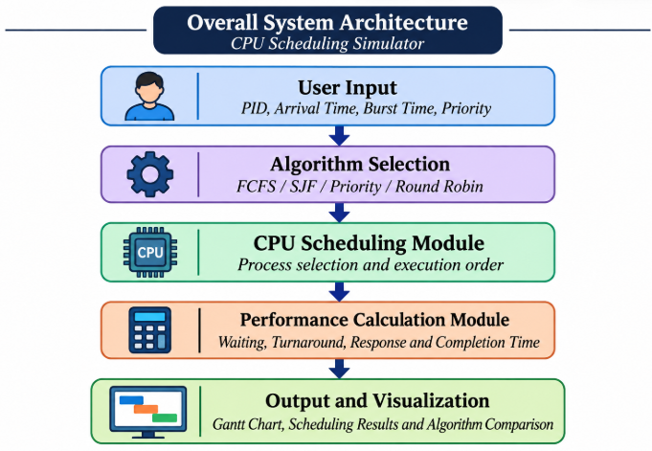

System Workflow
1.Starting ForgeOS: The user executes ./forgeos in the Ubuntu terminal. The ForgeOS banner and command prompt are displayed.
2. Entering a Command: The user enters a Linux command, such as ls, pwd, or ls -a, at the ForgeOS prompt.
3. Command Processing: The ShellForge module receives the command, separates it into arguments, and passes it to the NanoKernel module.
4. Process Creation: NanoKernel calls the fork() system call to create a child process. Linux creates a new child process from the parent process.
5. Parent Process Synchronization: The parent process displays its PID and the child's PID, then calls waitpid() to wait until the child process finishes execution.
6. Program Execution: The child process calls execvp() to execute the requested Linux command. The command runs and displays its output in the terminal.
7. Process Termination: After the command finishes, the child process terminates, and the parent process resumes execution.
8. Status Checking: The parent checks the termination status using WIFEXITED and WEXITSTATUS to identify whether the process terminated normally and retrieve its exit status.
9. Displaying Results: NanoKernel displays the process information, termination status, exit status, and final result as SUCCESS or FAILED. Control returns to ShellForge, which displays the next prompt.
10. Exiting ForgeOS: When the user enters the exit command, the ForgeOS application shuts down.

Flowchart / Data Flow
- ----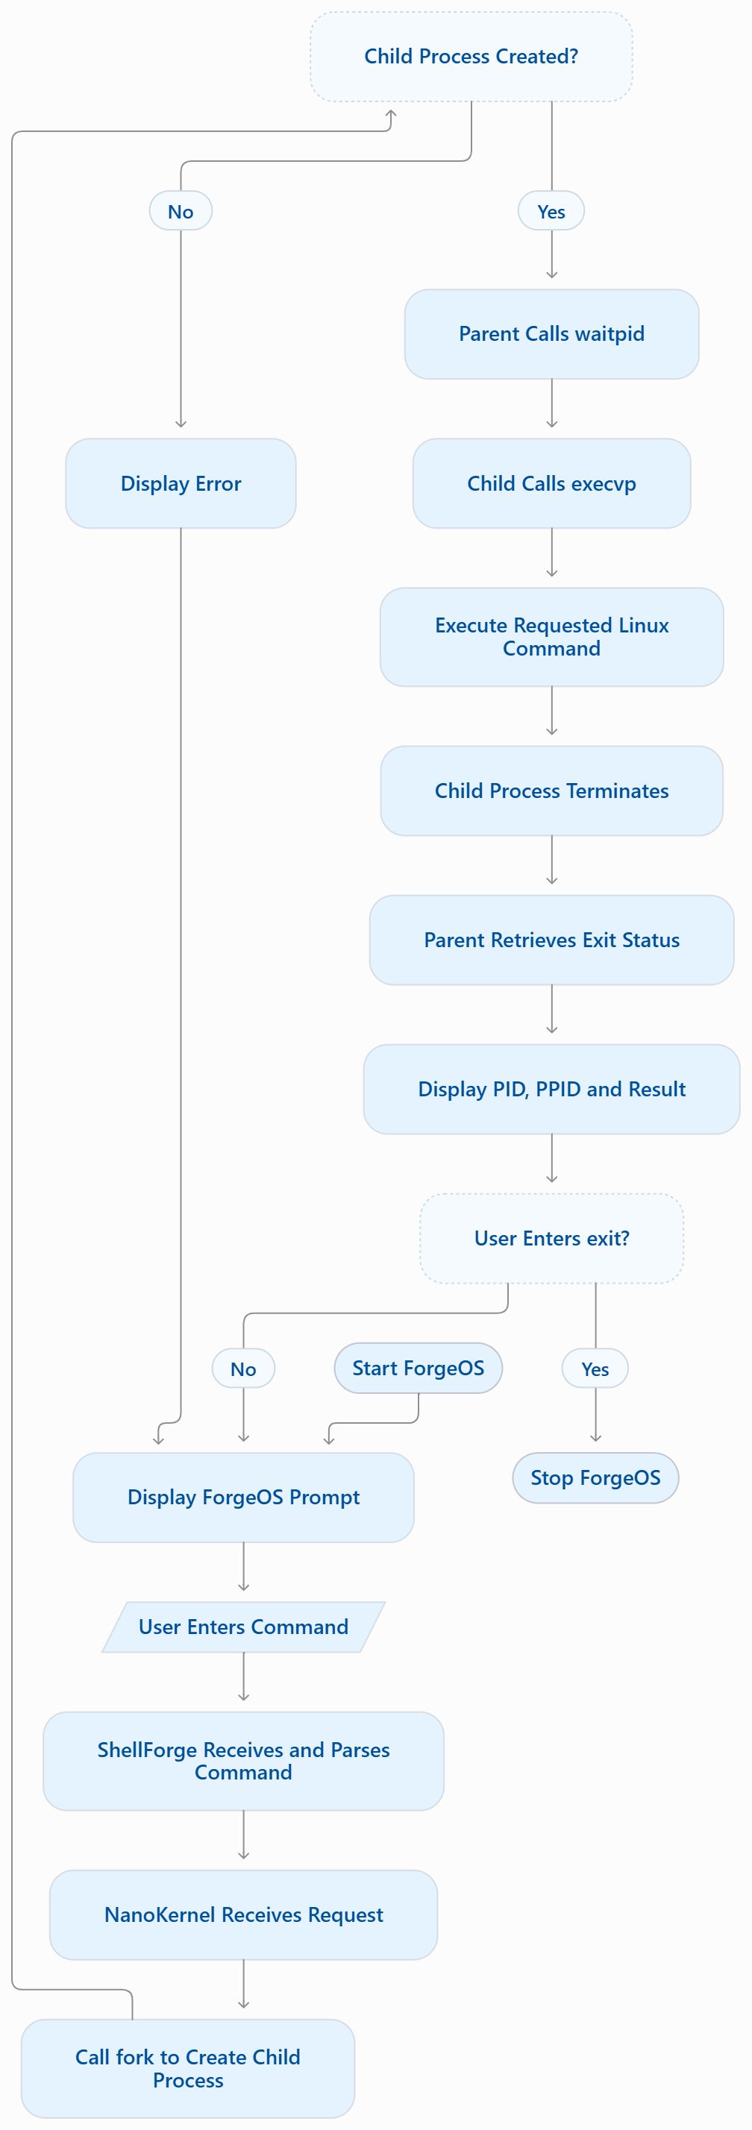

Figure 5.2: Flowchart of the process creation, execution and termination system

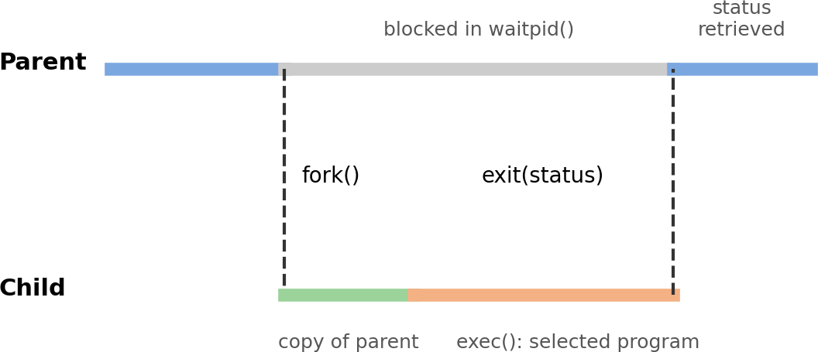

Figure 5.3: Parent and child timeline

Module Description

Module 1 – ShellForge (User Command Interface)
ShellForge is implemented in shell.c. It prints the ForgeOS banner, then repeatedly shows the prompt, reads a line with fgets(), removes the trailing newline, splits the line into an argument array with strtok(), and calls NanoKernel. It also recognises the words help (to list command categories) and exit (to shut ForgeOS down).

Module 2 – NanoKernel (Process Management Module)
NanoKernel is implemented in process.c with its interface in process.h. Its single entry function, execute_command(), carries out the whole life cycle: creation with fork(), execution with execvp(), synchronization with waitpid(), and termination handling with WIFEXITED and WEXITSTATUS. It prints a message at each stage.

Module 3 – Linux Kernel Services
This is not code written by the team, but it is an essential part of the design. The kernel implements fork, exec and wait, maintains the process table (the PCBs), schedules the processes and loads the new program image.

Input and Output Design

Input
- A command line typed at the prompt: a program name followed by optional arguments, for example pwd, ls or ls -a.
- The words help and exit, which are handled by ShellForge itself.

Output
- ShellForge message: “[ShellForge] Command received: <command>”.
- NanoKernel trace messages: request received, creating child process, parent and child PIDs, parent waiting, child created, executing using execvp(), and the command name.
- The output of the executed program itself.
- Termination report: child process terminated, normal termination (YES/NO), exit status, and result (SUCCESS/FAILED).

CHAPTER - 6 IMPLEMENTATION

Module-wise Implementation
The project directory is organised as follows:
SystemForge_OSSP/
└── ForgeOS/
├── NanoKernel/
│ ├── process.h
│ └── process.c
└── Shellforge/
└── shell.c
(interface of the process module) (fork / exec / wait / status)
(command interface and main loop)
The work was divided among the team members according to the stages of the process life cycle, as shown below.

Roll Number | Student Name | Individual Responsibility
2520030607 | Ili Harshika | Process creation using fork() and handling of the parent–child process relationship.
2520030512 | Gurrapu Nikshitha | Program execution using exec() and process synchronization using wait().
2520030365 | Angela Jose | Process termination, exit-status handling, and testing of the system.

Algorithm / Pseudocode

Algorithm for ShellForge
- Display the ForgeOS banner
- Repeat:
  - Display the prompt "forgeos:<cwd>$"
  - Read a line of input; if end-of-input, stop
  - If the line is empty, go to step 2
  - If the line is "exit", display shutdown message and stop
  - If the line is "help", display the help text and go to step 2
  - Print "[ShellForge] Command received: <line>"
  - Split the line into arguments args[0..n-1]; set args[n] = NULL
  - Call execute_command(args)
Algorithm for NanoKernel – execute_command(args)
- Print "Request received" and "Creating child process..."
- pid = fork()
- If pid < 0:
report the error and return
- If pid == 0: /* CHILD */
print "Child process created", own PID and PPID print "Executing using execvp()..." and the command execvp(args[0], args)
if execvp returns: report error and exit(127)
- Else: /* PARENT */
print parent PID, child PID, "Parent waiting for child..."

8.
waitpid(pid, &status, 0) Print "Child process terminated" If WIFEXITED(status):
print "Normal termination : YES" code = WEXITSTATUS(status) print "Exit status : code"
print "Result : SUCCESS" if code == 0 else "FAILED" Else if WIFSIGNALED(status):
print "Normal termination : NO" and the signal number Return to ShellForge

  - Core C / C++ Implementation
The two core files of the project are given below. process.h declares the interface of the NanoKernel module:
/* process.h – NanoKernel interface */ #ifndef PROCESS_H
#define PROCESS_H

/* Creates a child, runs args[0] with args[], waits for it, and displays the termination status. Returns the raw wait status, or -1 if the process could not be created. */
int execute_command(char *args[]);

#endif
process.c contains the process life-cycle logic:
/* process.c – NanoKernel: process management module */ #include <stdio.h>
#include <stdlib.h> #include <unistd.h> #include <sys/types.h> #include <sys/wait.h> #include "process.h"

int execute_command(char *args[])
{
pid_t pid; int status;

printf("\n[NanoKernel] Request received.\n"); printf("[NanoKernel] Creating child process...\n");
pid = fork();
/* create child */
if (pid < 0) {
perror("[NanoKernel] fork failed"); return -1;
}
else if (pid == 0) {
/* fork failed */
/* ---- CHILD */
printf("[NanoKernel] Child process created.\n"); printf("[NanoKernel] Child PID : %d\n", getpid()); printf("[NanoKernel] Parent PID : %d\n", getppid()); printf("[NanoKernel] Executing using execvp() \n");
printf("[NanoKernel] Command : %s\n\n", args[0]); fflush(stdout);
execvp(args[0], args);
/* replace image */
perror("[NanoKernel] execvp failed"); /* only if exec fails */ exit(127);
}
else { /* ---- PARENT */
printf("[NanoKernel] Parent PID : %d\n", getpid()); printf("[NanoKernel] Child PID : %d\n", pid); printf("[NanoKernel] Parent waiting for child \n");
fflush(stdout);
waitpid(pid, &status, 0);
/* synchronize */
printf("\n[NanoKernel] Child process terminated.\n"); if (WIFEXITED(status)) {
int code = WEXITSTATUS(status); printf("[NanoKernel] Normal termination : YES\n");
printf("[NanoKernel] Exit status : %d\n", code); printf("[NanoKernel] Result : %s\n",
code == 0 ? "SUCCESS" : "FAILED");

} else if (WIFSIGNALED(status)) { printf("[NanoKernel] Normal termination : NO\n");
printf("[NanoKernel] Killed by signal : %d\n", WTERMSIG(status)); printf("[NanoKernel] Result : FAILED\n");
}
}
return status;
}
shell.c contains the ShellForge command interface:
/* shell.c – ShellForge: user command interface */ #include <stdio.h>
#include <stdlib.h> #include <string.h> #include <unistd.h>
#include "../NanoKernel/process.h"

#define MAX_INPUT 256
#define MAX_ARGS 32

static void print_banner(void)
{
printf("\n====================================================\n");
printf(" FORGE OS\n");
printf(" PROCESS MANAGEMENT SYSTEM\n"); printf("====================================================\n");
printf(" ShellForge : User Command Interface\n"); printf(" NanoKernel : Process Management Module\n"); printf(" Linux Kernel : Operating System Services\n");
printf("====================================================\n\n");
printf("Type 'help' to see the available command categories.\n"); printf("Type 'exit' to shut down ForgeOS.\n\n");
}

int main(void)
{
char input[MAX_INPUT]; char *args[MAX_ARGS]; char cwd[512];

print_banner();

while (1) {
getcwd(cwd, sizeof(cwd)); printf("forgeos:%s$ ", cwd);

if (fgets(input, sizeof(input), stdin) == NULL) break;
input[strcspn(input, "\n")] = '\0';

if (strlen(input) == 0) continue;
if (strcmp(input, "exit") == 0) { printf("Shutting down ForgeOS...\n"); break;
}

printf("\n[ShellForge] Command received: %s\n", input);

int n = 0;
char *tok = strtok(input, " ");
while (tok != NULL && n < MAX_ARGS - 1) { args[n++] = tok;
tok = strtok(NULL, " ");
}
args[n] = NULL;

execute_command(args);
}
return 0;
}

Linux System Calls / APIs Used

System call / API | How it is used | Concept demonstrated
fork() | Called by NanoKernel to create the child; its return value (<0, 0, >0) selects the failure, child or parent branch | Process creation, parent–child relationship
execvp(file, argv) | Called in the child with the command name and argument array; searches PATH | Program execution, replacing the process image
waitpid(pid, &status, 0) | Called in the parent to block until the child terminates and to collect the status | Synchronization, zombie prevention
WIFEXITED / WEXITSTATUS | Tests for normal termination and extracts the exit code | Termination status
WIFSIGNALED / WTERMSIG | Detects and reports termination by a signal | Abnormal termination
getpid() / getppid() | Prints the PID and PPID of the processes | Process identifiers
exit(127) | Ends the child if execvp fails | Error handling

Process / Thread Implementation
Every command typed by the user is executed in a new child process created by fork(). The ForgeOS shell process is the parent and remains alive between commands; each child lives only for the duration of one command. Immediately after fork(), the parent and child are two separate processes with separate PIDs; they run the same code but follow different branches because of the value returned by fork(). The child then calls execvp(), after which it is no longer a copy of ForgeOS but the requested program.
In the sample run, the ForgeOS parent had PID 768, and the children created for pwd and ls -a had PIDs 772 and 773. All children report the same PPID (768), which confirms that they were all created by the same parent. No threads are created; the project is single-threaded and the concurrency demonstrated is between processes.

IPC / Synchronization Implementation
Synchronization between the parent and child is achieved with waitpid(). Without it, the parent would print the next prompt while the child was still running and the outputs would be interleaved. With waitpid(), the parent is blocked until the child terminates, and the child’s exit status is passed back to the parent through the kernel as the status value.
The only inter-process communication in this project is this exit-status return value. Other IPC mechanisms such as pipes, shared memory, message queues and sockets are not needed, and are noted as possible future extensions (for example, implementing the shell pipe operator).

Memory Management Implementation
The project does not allocate memory dynamically; it uses fixed-size arrays for the input line and the argument list. Memory management is nevertheless involved in the process life cycle. On fork(), Linux gives the child a copy of the parent’s address space, implemented efficiently with copy-on-write: the pages are shared until either process modifies them. On execvp(), the child’s old address space is discarded and a new one is built for the loaded program. When the child terminates, the kernel frees its memory, and the parent’s waitpid() releases the remaining process-table entry.

Optional User Interface Implementation
ShellForge provides a text-based user interface. It displays a banner describing the three layers of ForgeOS, shows a prompt that includes the current working directory (for example forgeos:/home/nikshitha/SystemForge_OSSP/ForgeOS/Shellforge$), prints a clear label before each message so that the origin of the output ([ShellForge] or [NanoKernel]) is always known, and accepts the commands help and exit. No graphical interface was developed, because the goal of the project is to expose the process life cycle rather than to provide a graphical environment.

CHAPTER - 7 EXECUTION AND DEMONSTRATION

Compilation in Ubuntu
The project directories were created and the source files written in the Ubuntu terminal. The commands used were:
cd SystemForge_OSSP cd ForgeOS
mkdir -p Shellforge mkdir NanoKernel cd NanoKernel
nano process.h nano process.c cd ..
cd Shellforge nano shell.c
gcc -Wall -Wextra shell.c ../NanoKernel/process.c -o forgeos
The compilation completed without errors, and the executable forgeos was created in the Shellforge directory.

Execution Commands
cd ~/SystemForge_OSSP/ForgeOS/Shellforge
./forgeos
After the ForgeOS banner appears, commands such as ls, pwd and ls -a are typed at the forgeos prompt. The command exit shuts ForgeOS down.

Sample Inputs and Outputs

Sample Input 1: pwd
forgeos:/home/nikshitha/SystemForge_OSSP/ForgeOS/Shellforge$ pwd [ShellForge] Command received: pwd
[NanoKernel] Request received. [NanoKernel] Creating child process... [NanoKernel] Parent PID : 768 [NanoKernel] Child PID : 772 [NanoKernel] Parent waiting for child... [NanoKernel] Child process created. [NanoKernel] Child PID : 772 [NanoKernel] Parent PID : 768 [NanoKernel] Executing using execvp()... [NanoKernel] Command : pwd

/home/nikshitha/SystemForge_OSSP/ForgeOS/Shellforge

[NanoKernel] Child process terminated. [NanoKernel] Normal termination : YES [NanoKernel] Exit status : 0
[NanoKernel] Result : SUCCESS

Sample Input 2: ls -a
forgeos:/home/nikshitha/SystemForge_OSSP/ForgeOS/Shellforge$ ls -a [ShellForge] Command received: ls -a
[NanoKernel] Request received. [NanoKernel] Creating child process... [NanoKernel] Parent PID : 768 [NanoKernel] Child PID : 773

[NanoKernel] Parent waiting for child... [NanoKernel] Child process created. [NanoKernel] Child PID : 773 [NanoKernel] Parent PID : 768 [NanoKernel] Executing using execvp()... [NanoKernel] Command : ls

. .. forgeos shell.c

[NanoKernel] Child process terminated. [NanoKernel] Normal termination : YES [NanoKernel] Exit status : 0
[NanoKernel] Result : SUCCESS
In both runs the parent PID is the same (768), the child PIDs are different (772 and 773), the program output appears between the “Executing” message and the “terminated” message, and the exit status 0 gives the result SUCCESS.

Test cases

ID | Function tested | Expected result | Result
TC01 | Process creation | Child process is created successfully. | PASS
TC02 | Program execution | Selected program executes through the child process. | PASS
TC03 | Synchronization | Parent waits for the child to terminate. | PASS
TC04 | Normal termination | Child terminates and status is retrieved. | PASS
TC05 | Exit status | Termination status is retrieved and displayed. | PASS

Screenshots of Execution
Figure 7.1 shows the creation of the project directories, the compilation with GCC and the start of ForgeOS, with the ForgeOS banner and the first command (ls) received by ShellForge.
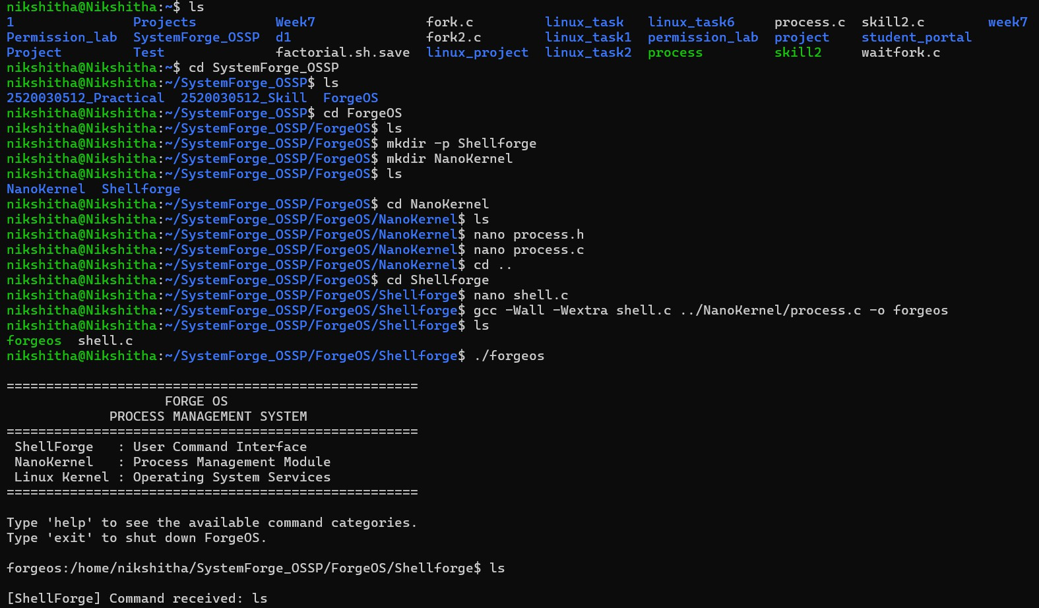
Figure 7.1: Directory setup, compilation and start of ForgeOS

Figure 7.2 shows the NanoKernel trace for the commands pwd and ls -a, including the parent and child PIDs, the execution of the program and the termination report.
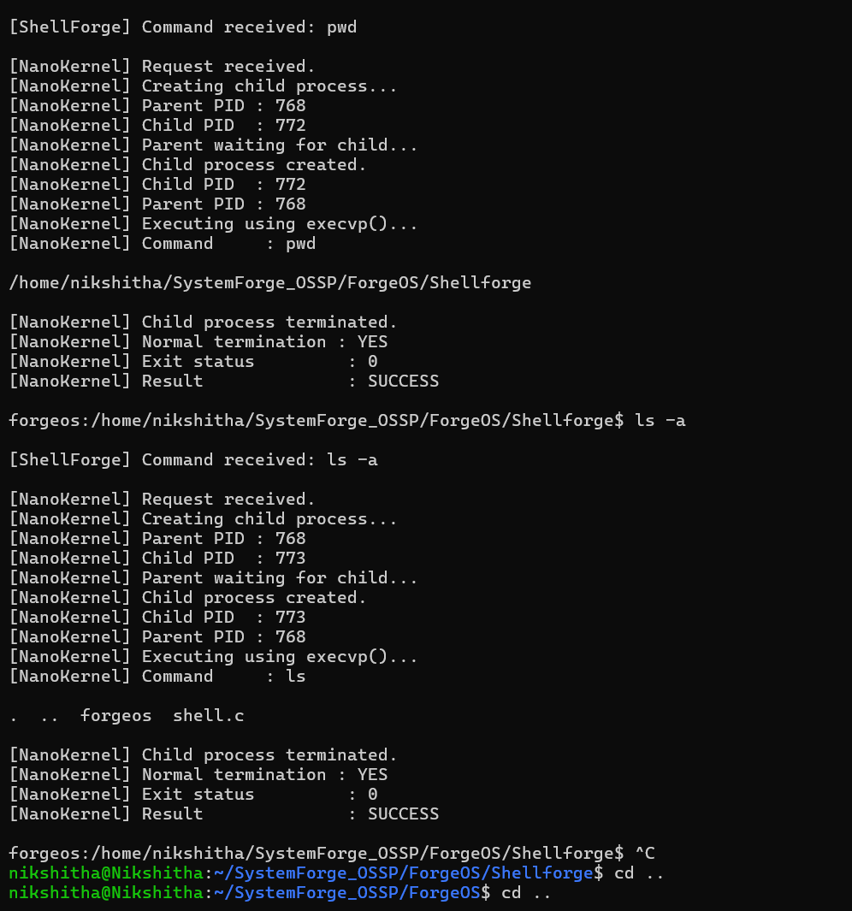
Figure 7.2: NanoKernel output for pwd and ls -a

Demonstration of OS Concepts

OS concept | Where it is visible in the output
Process creation (fork) | “Creating child process…” followed by two different PIDs (parent 768, child 772/773).
Parent–child relationship | The child reports Parent PID 768, which equals the parent’s own PID.
Program execution (exec) | “Executing using execvp()…” and the output of pwd / ls appears from the child.
Synchronization (wait) | “Parent waiting for child…” is printed, and the next prompt appears only after the child has terminated.
Process termination | “Child process terminated.” is printed after the program’s output.
Exit status | “Normal termination : YES”, “Exit status : 0” and “Result : SUCCESS”.

CHAPTER - 8 CONCLUSION

Summary of the Project
The Linux Process Creation, Execution and Termination System (ForgeOS) was designed, implemented and tested successfully. The system uses a layered design in which ShellForge accepts the user’s command, NanoKernel creates and manages the process, and the Linux kernel provides the underlying services. For every command, a child is created with fork(), the program is executed with execvp(), the parent is synchronized with waitpid(), and the termination status is retrieved and displayed.

Objectives Achieved

Objective | Concept used | Status
Implement process creation using fork() and understand the parent–child relationship | fork(), PID, PPID | Achieved
Execute a selected program in the child using the exec() family | execvp() | Achieved
Synchronize parent and child using wait() | waitpid() | Achieved
Demonstrate process termination and display the child’s termination status | WIFEXITED, WEXITSTATUS | Achieved

Results Achieved
    - A working two-module system (ShellForge and NanoKernel) was compiled with GCC without errors and executed on Ubuntu.
    - Commands such as pwd and ls -a were launched through child processes, and their output was displayed correctly.
    - The parent and child PIDs were shown, proving that each command runs in a separate process created by the same parent.
    - The parent waited for each child and reported normal termination, exit status 0 and the result SUCCESS.
    - All five test cases (TC01–TC05) passed.

Skills and Learning Outcomes
    - Practical understanding of the fork–exec–wait model and the life cycle of a Linux process.
    - Experience using POSIX system calls and interpreting exit status with WIFEXITED and WEXITSTATUS.
    - Modular C programming with header files and separate compilation of multiple source files.
    - Use of the Linux terminal, nano, GCC and Git/GitHub for development and teamwork.
    - Skills in testing, documenting and presenting a systems project as a team.
Future scope. The system can be extended with background execution (&), input/output redirection, pipes between commands, built-in commands such as cd, signal handling (for example Ctrl+C), and the use of threads or other IPC mechanisms.

CHAPTER - 9 REFERENCES

Books
- A. Silberschatz, P. B. Galvin and G. Gagne, Operating System Concepts, Wiley.
- W. R. Stevens and S. A. Rago, Advanced Programming in the UNIX Environment, Addison-Wesley.
- M. Kerrisk, The Linux Programming Interface, No Starch Press, 2010.
- A. S. Tanenbaum and H. Bos, Modern Operating Systems, Pearson.
- B. W. Kernighan and D. M. Ritchie, The C Programming Language, Prentice Hall.

Research Papers
- A. Baumann, J. Appavoo, O. Krieger and T. Roscoe, “A fork() in the road,” Proceedings of the Workshop on Hot Topics in Operating Systems (HotOS), 2019.
- D. M. Ritchie and K. Thompson, “The UNIX Time-Sharing System,” Communications of the ACM, vol. 17, no. 7, 1974.

Linux / GNU Documentation
- Linux manual pages: fork(2), execve(2), exec(3), wait(2), getpid(2).
- The GNU C Library Reference Manual – Processes.
- GCC, the GNU Compiler Collection – Online Documentation.

Online Resources
- Linux man-pages project: https://man7.org/linux/man-pages/
- GNU Project documentation: https://www.gnu.org/software/libc/manual/
- Project repositories: https://github.com/iliharshika/SystemForge_OSSP, https://github.com/gurrapunikshitha/SystemForge_OSSP and https://github.com/angelapvjose92/SystemForge_OSSP

