Network analysis

Nir Shchori && Avital Glazer

9 במאי 2016

## Network analysis of Grey anatomy

plot(g)

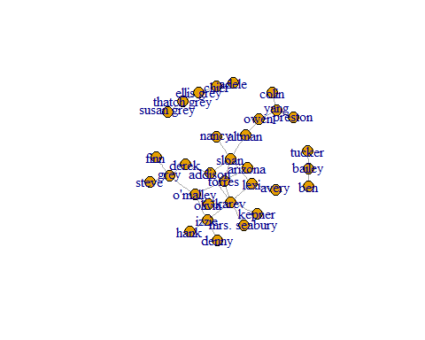

b=betweenness(g)  
c=closeness(g)  
d=degree(g)  
e=evcent(g)   
#max betweenness  
which.max(b)

## sloan   
## 3

#max closeness  
which.max(c)

## torres   
## 4

barplot(c)

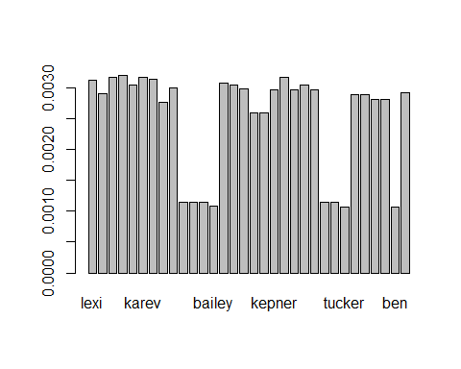

#max degree  
which.max(d)

## karev   
## 6

barplot(d)

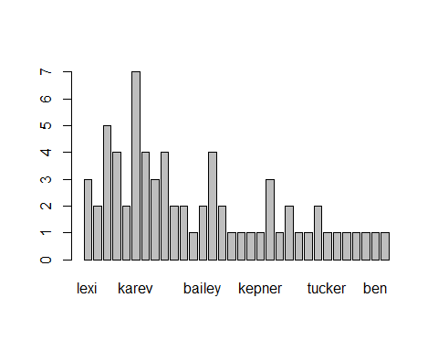

#max Eigencetor  
which.max(e$vector)

## karev   
## 6

# edge betweennes algoritem  
fc=edge.betweenness.community(g)  
plot(g,vertex.size=6,vertex.color=fc$membership+1,asp=FALSE)

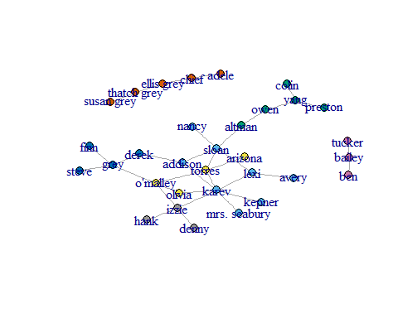

sizes(fc)

## Community sizes  
## 1 2 3 4 5 6 7   
## 8 5 4 4 5 3 3

#walktrap algoritem  
ff=walktrap.community(g)  
plot(g,vertex.size=6,vertex.color=ff$membership+1,asp=FALSE)

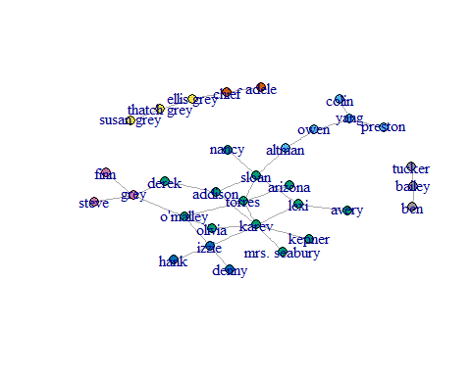

sizes(ff)

## Community sizes  
## 1 2 3 4 5 6 7   
## 5 13 3 3 2 3 3