Network analysis part 2

Nir Shchori & Avital Glazer

9 במאי 2016

## Network analysis of twitter

tkplot(g)

## [1] 1

plot(g)

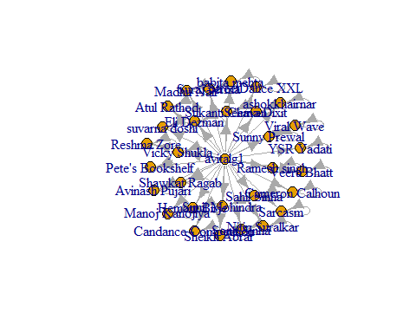

b=betweenness(g)  
c=closeness(g)  
d=degree(g)  
e=evcent(g)   
#max betweenness  
which.max(b)

## avitalg1   
## 1

#max closeness  
which.max(c)

## avitalg1   
## 1

barplot(c)

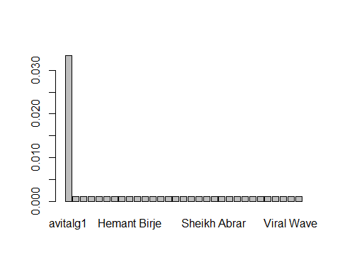

#max degree  
which.max(d)

## avitalg1   
## 1

barplot(d)

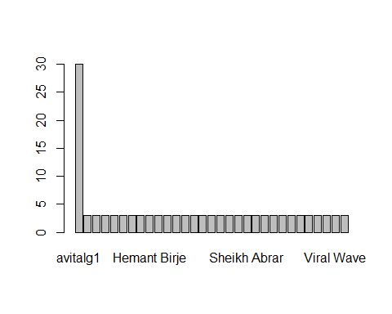

#max Eigencetor  
which.max(e$vector)

## avitalg1   
## 1

# edge betweennes algoritem  
fc=edge.betweenness.community(g)  
plot(g,vertex.size=6,vertex.color=fc$membership+1,asp=FALSE)

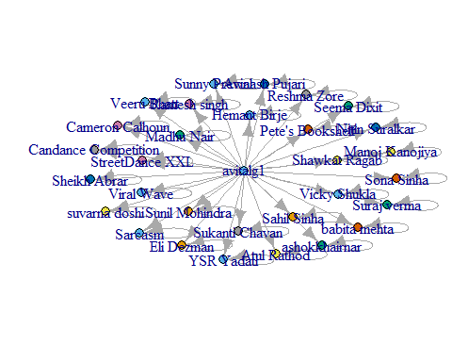

sizes(fc)

## Community sizes  
## 1 2 3 4 5 6 7 8 9 10 11 12 13 14 15 16 17 18 19 20 21 22 23 24 25   
## 5 1 1 1 1 1 1 1 1 1 1 1 1 1 1 1 1 1 1 1 1 1 1 1 1   
## 26 27   
## 1 1

#walktrap algoritem  
ff=walktrap.community(g)  
plot(g,vertex.size=6,vertex.color=ff$membership+1,asp=FALSE)

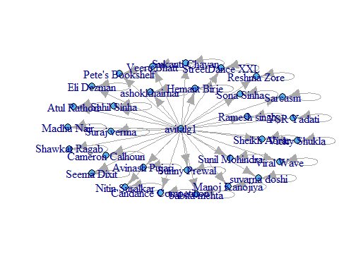

sizes(ff)

## Community sizes  
## 1   
## 31