**Resolve Namespaces of Code Snippets**

There are many great resources on the web for getting help and finding solutions to our development problems. The most popular and useful resource is undoubtedly [StackOverflow.com](http://stackoverflow.com).

According to StackOverflow's rules, code samples should be complete. That is, they should work by anyone who copy them as is. Unfortunately, there are some code samples that are partial and need extra code, such as using directives, in order to execute or even build successfully. When trying to run the code, we usually get the following error:

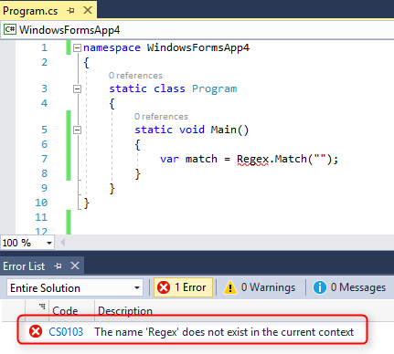

2017 05 01 23H14 31

In this article we will demo a few cases of code snippets that contain unidentified classes and see how to resolve the missing namespaces.

## Missing using directive

The most simple and common case is when the code snippet was copied without the using directives, or contain a class that requires adding a missing using directive. In this case, Visual Studio can help us resolve the missing namespace. When you see the yellow bulb, click CTRL+. to open the Quick Actions menu and there you will have an option to add the missing using directive.

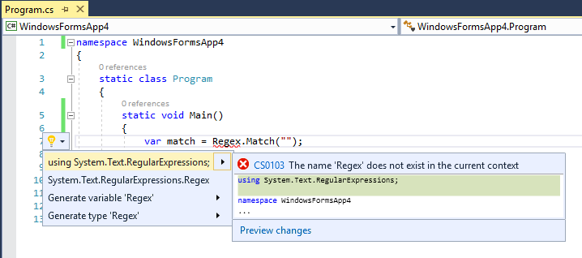

2017 05 01 23H15 35

Notice that if the class name has wrong casing, Visual Studio can still guess the correct class name and suggest to fix the class name and add the using directive for its namespace.

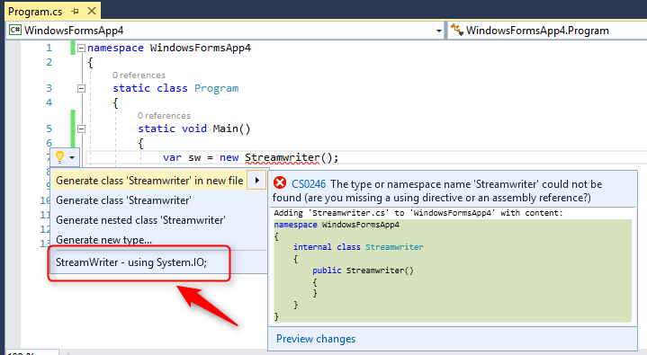

2017 05 01 23H22 45

## Missing assembly reference

Another common problem is when the code contains classes from a .NET assembly which we don't have a reference for in our application. Let's see an example:

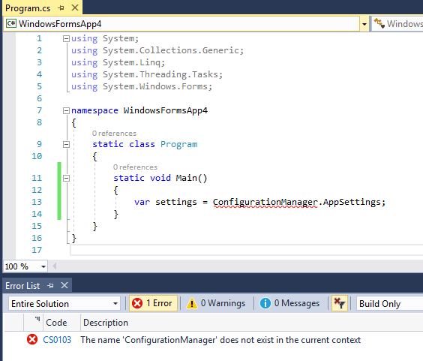

2017 05 01 23H30 54

The ConfigurationManger class is part of the namespace (and dll) System.Configuration, which is not referenced by default in windows forms application. This time, the yellow bulb does not help too much:

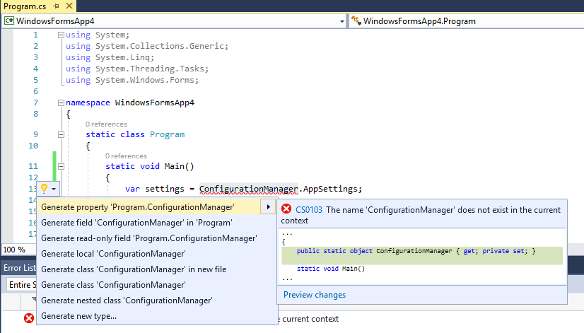

2017 05 01 23H33 38

If you have Resharper, it can help and suggest to add the missing reference and the using directive:

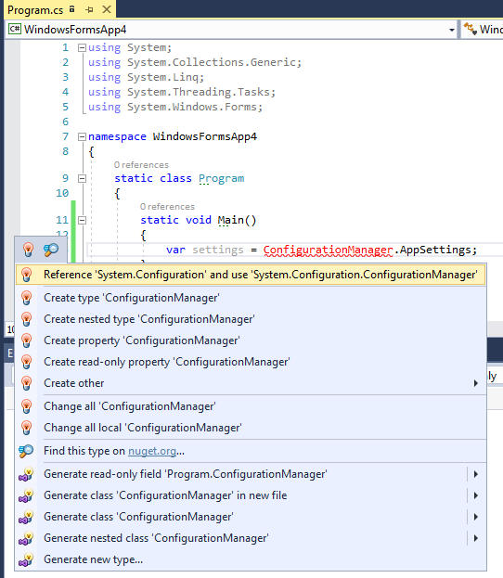

2017 05 01 23H35 57

If you don't have Resharper, you can still easily resolve this, by Googling the class name. If the class is part of the .NET framework, you will usually get the first result from the MSDN.

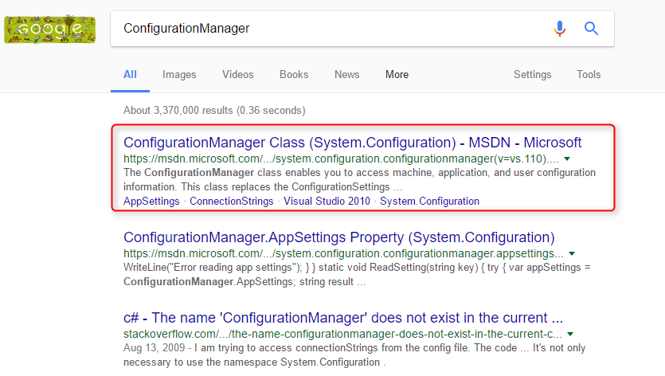

2017 05 01 23H37 44

Go to the class page on MSDN and find at the beginning of the page the assembly name that you need to add reference for and the namespace that you need to add in the using directives.

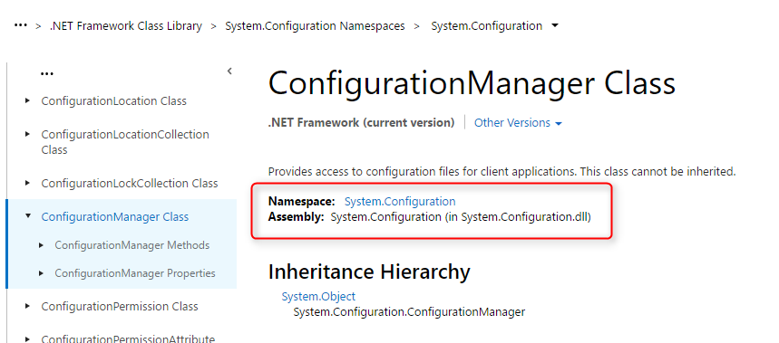

2017 05 01 23H39 37

## Missing a reference to a third party dll

In some cases the code contains classes from a third party library such as DevExpress or some Nuget Package that is not part of our application.

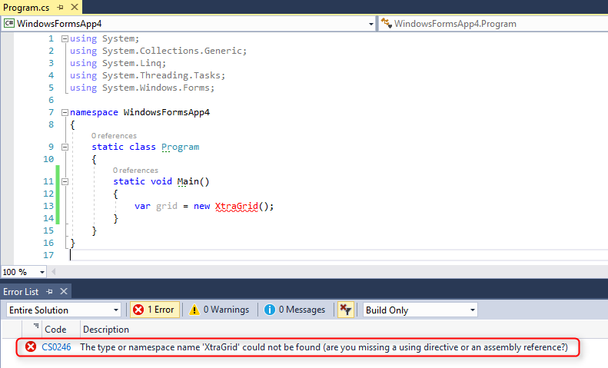

2017 05 01 23H54 38

Visual Studio or Resharper will not be able to guess the missing assembly and will only suggest to create a new type (class) with that name for us.

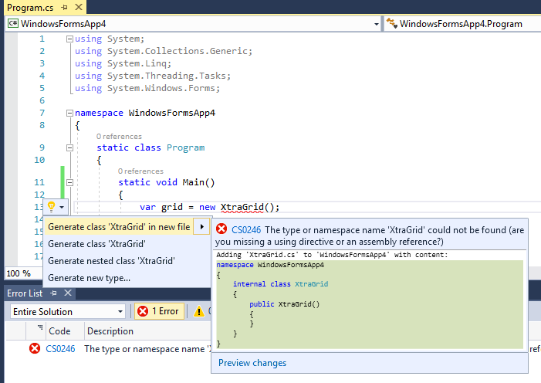

2017 05 01 23H58 30

In order to find out where this class is coming from, it is best to know the context of the code writer. Try Goggling the class name; if the class is popular you should easily find the framework used in the code sample:

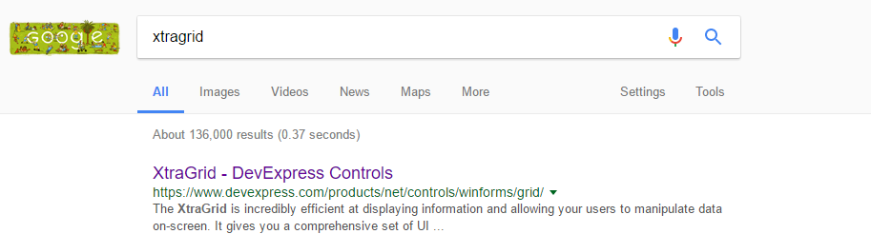

2017 05 02 00H00 29

If you can't find the class using Google, it is probably part of the application, which the writer of the code has not included. If this is the case, which is fairly rare, you have no choice but to ask the writer to provide the missing code, or the continue searching for a working example.