**Appendices**

All the questionnaires completed by the users for evaluating the system and visualizations are attached in the following pages.

The average SUS score for the entire system is 81, calculated as follows:

((73.5 + 78.1 + 89.4 + 87.5 + 94.6 + 76 + 83.6 + 74.7 + 80.5) / 9 = 81).

Under each user's questionnaire, we included their individual SUS score, name, age, and whether they are a student or have any background in reading graphs.  
For example, *Zohar Almog*, a 26-year-old Geology student with graph-reading experience, received a SUS score of 87.5.

**How the SUS Score is Calculated:**

The System Usability Scale (SUS) score is calculated by converting each response to a value between 0 and 6. For positively worded questions, we subtract 1 from the user's rating. For negatively worded questions, we subtract the rating from 7 or 5- depending on the chart type. The adjusted scores are then summed. Since the maximum total score is 48, the final SUS score is calculated by dividing the sum by 48 and multiplying by 100, resulting in a score from 0 to 100, where higher scores indicate better usability.

Example:

If a user rates a positively worded question as 1, the adjusted score is 6 − 1 = 5. If a user rates a negatively worded question as 2, the adjusted score is 7 − 2 = 5. All adjusted scores are summed, divided by 48, and multiplied by 100 to produce the final SUS score.

***User Feedback Questionnaire – Visualizations in the Parkinson’s Project- Zohar almog***

Name: zohar almog

age: 26

Occupation: Geology Student

knowledge in reading graphs: yes

average sus score: 87.5

*Please fill out this questionnaire to help us evaluate the usability and clarity of our project's visualizations.*

***Health& mood insights (line chart):***

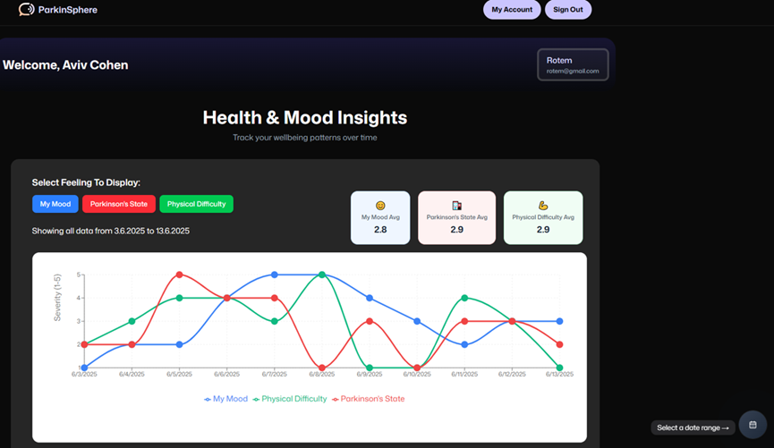

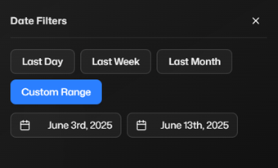

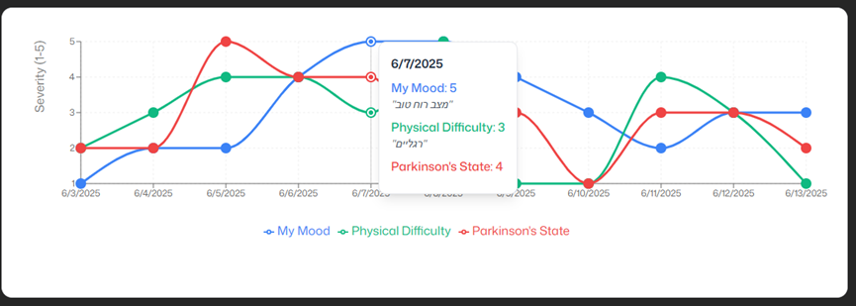

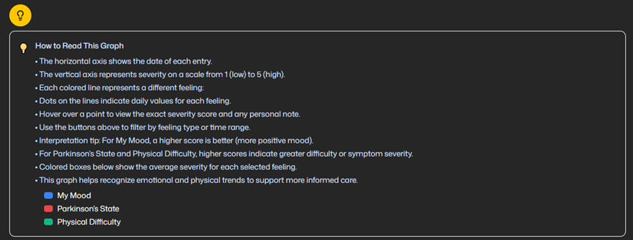

Please answer the following questions for the **health & mood insights Line Chart** visualization:

|  |  |  |  |  |  |  |  |
| --- | --- | --- | --- | --- | --- | --- | --- |
| Strongly agree |  |  |  |  |  | Strongly disagree |  |
| 7 | 6 | 5 | 4 | 3 | 2 | 1 |  |
| x |  |  |  |  |  |  | I thought the visualization was enjoyable |
|  |  |  |  |  | x |  | I found the visualization unnecessarily complex |
|  | x |  |  |  |  |  | I thought the visualization was easy to use |
|  | x |  |  |  |  |  | The use of visualization required considerable mental effort |
|  | x |  |  |  |  |  | The use of visualization was clear and understandable |
|  |  |  |  |  |  | x | The use of visualization was often frustrating |
|  | x |  |  |  |  |  | I thought the visualization was effective |
|  | x |  |  |  |  |  | I would imagine that most people would easily learn how to use this visualization. |

Please indicate what the advantages and/or disadvantages of the **line chart** visualization are in your opinion?

Advantages: it's good to see the average of the 3 different types

Disadvantages: its not always clear how to read this chart

SUS score: 87.5

**A dashboard screen that contains different graphs for every user type**

1. Activity Impact Analysis
2. Macronutrient Timeline
3. Medicine Intake Summary
4. Parkinson's Symptom Tracker

***Activity Impact Analysis (rectangles graph):***

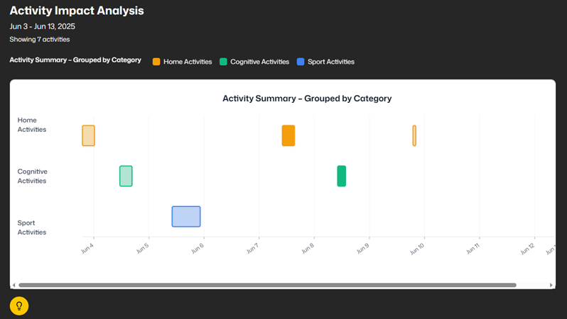

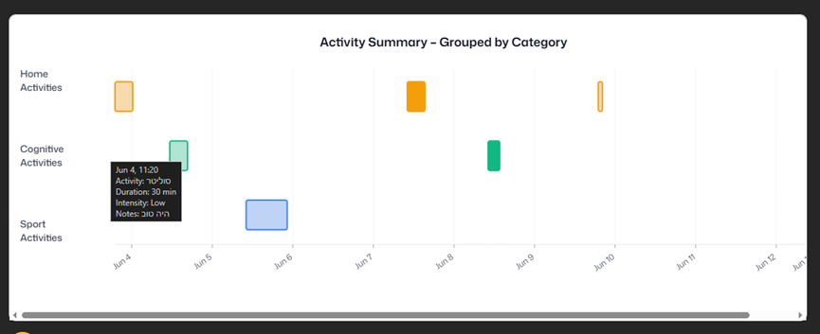

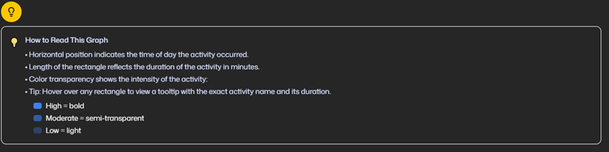

Please answer the following questions for the ***Activity Impact Analysis graph*** visualization:

|  |  |  |  |  |  |  |  |
| --- | --- | --- | --- | --- | --- | --- | --- |
| Strongly agree |  |  |  |  |  | Strongly disagree |  |
| 7 | 6 | 5 | 4 | 3 | 2 | 1 |  |
|  |  | x |  |  |  |  | I thought the visualization was enjoyable |
|  |  |  |  |  |  | x | I found the visualization unnecessarily complex |
|  | x |  |  |  |  |  | I thought the visualization was easy to use |
|  | x |  |  |  |  |  | The use of visualization required considerable mental effort |
|  | x |  |  |  |  |  | The use of visualization was clear and understandable |
|  |  |  |  |  |  | x | The use of visualization was often frustrating |
|  | x |  |  |  |  |  | I thought the visualization was effective |
|  | x |  |  |  |  |  | I would imagine that most people would easily learn how to use this visualization. |

Please indicate what the advantages and/or disadvantages of ***Activity Impact Analysis Graph*** visualization are in your opinion?

Advantages: The size of the rectangles shows the length of the activity

Disadvantages: Not useful for nutritionists or physiotherapists

SUS score: 84

**Parkinson's Symptom Tracker**

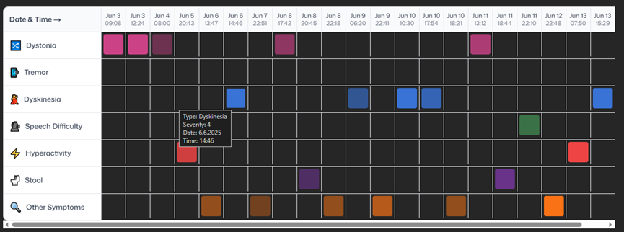

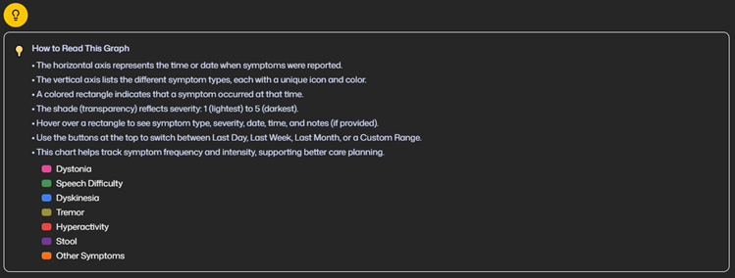

Please answer the following questions for the **Parkinson's Symptom Tracker** visualization:

|  |  |  |  |  |  |  |  |
| --- | --- | --- | --- | --- | --- | --- | --- |
| Strongly agree |  |  |  |  |  | Strongly disagree |  |
| 7 | 6 | 5 | 4 | 3 | 2 | 1 |  |
|  |  | x |  |  |  |  | I thought the visualization was enjoyable |
|  |  |  |  |  |  | x | I found the visualization unnecessarily complex |
| x |  |  |  |  |  |  | I thought the visualization was easy to use |
| x |  |  |  |  |  |  | The use of visualization required considerable mental effort |
| x |  |  |  |  |  |  | The use of visualization was clear and understandable |
|  |  |  |  |  |  | x | The use of visualization was often frustrating |
| x |  |  |  |  |  |  | I thought the visualization was effective |
| x |  |  |  |  |  |  | I would imagine that most people would easily learn how to use this visualization. |

Please indicate what the advantages and/or disadvantages of **Parkinson's Symptom Tracker** visualization are in your opinion?

Advantages: a very organized way to show all the symptoms -like a table

Disadvantages: a lot of information and colors

SUS score: 89

**Macronutrient Timeline:**

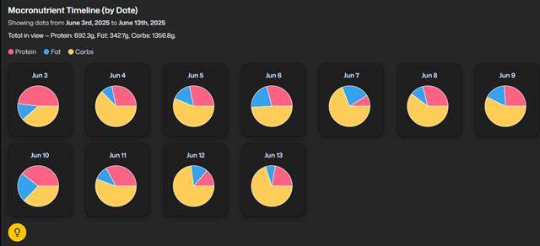

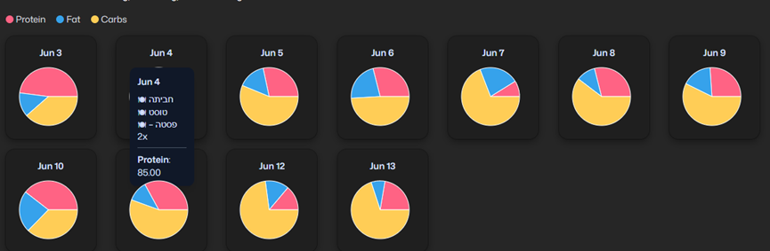

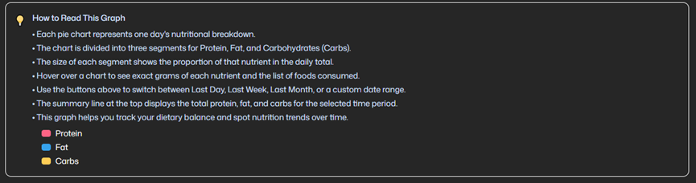

Please answer the following questions for the **Macronutrient Timeline graph (pie Chart)** visualization:

|  |  |  |  |  |  |  |  |
| --- | --- | --- | --- | --- | --- | --- | --- |
| Strongly agree |  |  |  |  |  | Strongly disagree |  |
| 7 | 6 | 5 | 4 | 3 | 2 | 1 |  |
| x |  |  |  |  |  |  | I thought the visualization was enjoyable |
|  |  |  |  |  |  | x | I found the visualization unnecessarily complex |
| x |  |  |  |  |  |  | I thought the visualization was easy to use |
| x |  |  |  |  |  |  | The use of visualization required considerable mental effort |
| x |  |  |  |  |  |  | The use of visualization was clear and understandable |
|  |  |  |  |  |  | x | The use of visualization was often frustrating |
| x |  |  |  |  |  |  | I thought the visualization was effective |
| x |  |  |  |  |  |  | I would imagine that most people would easily learn how to use this visualization. |

Please indicate what the advantages and/or disadvantages of Pie **Chart** visualization are in your opinion?

Advantages: it looks good, and very easy to understand how to read it

Disadvantages: the tooltip is not always clear

SUS score:91

**Medicine Intake Summary:**

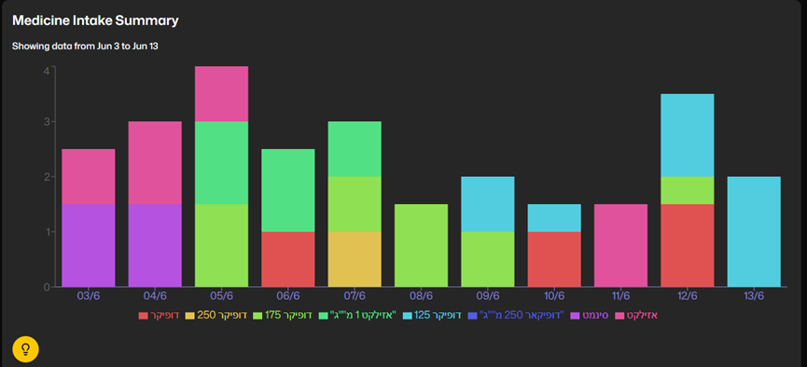

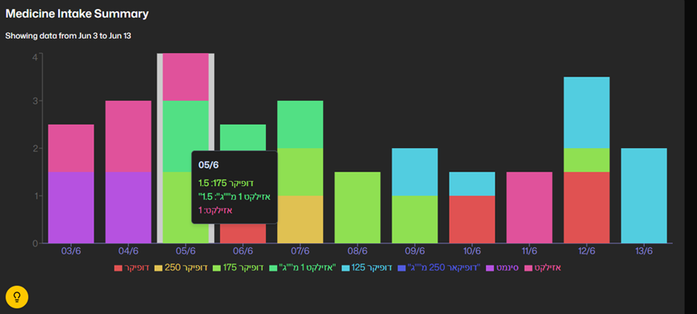

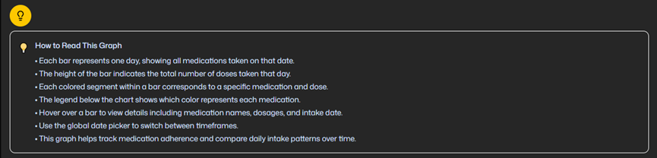

Please answer the following questions for the **Medicine Intake Summary graph** visualization:

|  |  |  |  |  |  |  |  |
| --- | --- | --- | --- | --- | --- | --- | --- |
| Strongly agree |  |  |  |  |  | Strongly disagree |  |
| 7 | 6 | 5 | 4 | 3 | 2 | 1 |  |
|  | x |  |  |  |  |  | I thought the visualization was enjoyable |
|  |  |  |  |  |  | x | I found the visualization unnecessarily complex |
|  | x |  |  |  |  |  | I thought the visualization was easy to use |
| x |  |  |  |  |  |  | The use of visualization required considerable mental effort |
| x |  |  |  |  |  |  | The use of visualization was clear and understandable |
|  |  |  |  |  |  | x | The use of visualization was often frustrating |
| x |  |  |  |  |  |  | I thought the visualization was effective |
|  | x |  |  |  |  |  | I would imagine that most people would easily learn how to use this visualization. |

Please indicate what the advantages and/or disadvantages of ***Medicine Intake Summary Graph*** visualization are in your opinion?

Advantages:

Disadvantages:

SUS score:82

Please answer the following questions to evaluate the **entire** system:

sus score:90

|  |  |  |  |  |  |
| --- | --- | --- | --- | --- | --- |
| Strongly agree |  |  |  | Strongly disagree |  |
| 5 | 4 | 3 | 2 | 1 |  |
| x |  |  |  |  | I think that I would like to use the system frequently |
|  |  |  |  | x | I found the system unnecessarily complex |
|  | x |  |  |  | I thought the system was easy to use |
|  |  |  |  | x | I think that I would need the support of a technical person to be able to use the system |
|  | x |  |  |  | I found that the various functions in the system were well integrated |
|  |  |  |  | x | I thought there was too much inconsistency in the system |
|  | x |  |  |  | I would imagine that most people would learn to use the system very quickly |
|  |  |  |  | x | I found the system very cumbersome to use |
|  | x |  |  |  | I felt very confident using the system |
|  |  |  |  | x | I needed to learn a lot of things before I could get going with the system. |

Comments: ______________________________________________________________________________________________________________________________________

***User Feedback Questionnaire – Visualizations in the Parkinson’s Project- Eden koren***

Name: eden koren

age: 27

Occupation: hr Student

knowledge in reading graphs: yes

average sus score: 94.6

*Please fill out this questionnaire to help us evaluate the usability and clarity of our project's visualizations.*

***Health& mood insights (line chart):***

Please answer the following questions for the **health & mood insights Line Chart** visualization:

|  |  |  |  |  |  |  |  |
| --- | --- | --- | --- | --- | --- | --- | --- |
| Strongly agree |  |  |  |  |  | Strongly disagree |  |
| 7 | 6 | 5 | 4 | 3 | 2 | 1 |  |
| x |  |  |  |  |  |  | I thought the visualization was enjoyable |
|  |  |  |  |  |  | x | I found the visualization unnecessarily complex |
| x |  |  |  |  |  |  | I thought the visualization was easy to use |
|  | x |  |  |  |  |  | The use of visualization required considerable mental effort |
| x |  |  |  |  |  |  | The use of visualization was clear and understandable |
|  |  |  |  |  |  | x | The use of visualization was often frustrating |
| x |  |  |  |  |  |  | I thought the visualization was effective |
| x |  |  |  |  |  |  | I would imagine that most people would easily learn how to use this visualization. |

Please indicate what the advantages and/or disadvantages of the **line chart** visualization are in your opinion?

Advantages: Useful for identifying symptom patterns before/after events

Disadvantages: doesn't isolate *why* symptoms improved

SUS score: 97.9

**A dashboard screen that contains different graphs for every user type**

1. Activity Impact Analysis
2. Macronutrient Timeline
3. Medicine Intake Summary
4. Parkinson's Symptom Tracker

***Activity Impact Analysis (rectangles graph):***

Please answer the following questions for the ***Activity Impact Analysis graph*** visualization:

|  |  |  |  |  |  |  |  |
| --- | --- | --- | --- | --- | --- | --- | --- |
| Strongly agree |  |  |  |  |  | Strongly disagree |  |
| 7 | 6 | 5 | 4 | 3 | 2 | 1 |  |
|  | x |  |  |  |  |  | I thought the visualization was enjoyable |
|  |  |  |  |  |  | x | I found the visualization unnecessarily complex |
| x |  |  |  |  |  |  | I thought the visualization was easy to use |
| x |  |  |  |  |  |  | The use of visualization required considerable mental effort |
| x |  |  |  |  |  |  | The use of visualization was clear and understandable |
|  |  |  |  |  |  | x | The use of visualization was often frustrating |
| x |  |  |  |  |  |  | I thought the visualization was effective |
| x |  |  |  |  |  |  | I would imagine that most people would easily learn how to use this visualization. |

Please indicate what the advantages and/or disadvantages of ***Activity Impact Analysis Graph*** visualization are in your opinion?

Advantages: Quickly identifies dominant types of physical activity

Disadvantages: Doesn’t show *how* the patient responded

SUS score:97.9

**Parkinson's Symptom Tracker**

Please answer the following questions for the **Parkinson's Symptom Tracker** visualization:

|  |  |  |  |  |  |  |  |
| --- | --- | --- | --- | --- | --- | --- | --- |
| Strongly agree |  |  |  |  |  | Strongly disagree |  |
| 7 | 6 | 5 | 4 | 3 | 2 | 1 |  |
|  |  | x |  |  |  |  | I thought the visualization was enjoyable |
|  |  |  |  |  |  | x | I found the visualization unnecessarily complex |
| x |  |  |  |  |  |  | I thought the visualization was easy to use |
| x |  |  |  |  |  |  | The use of visualization required considerable mental effort |
| x |  |  |  |  |  |  | The use of visualization was clear and understandable |
|  |  |  |  |  |  | x | The use of visualization was often frustrating |
| x |  |  |  |  |  |  | I thought the visualization was effective |
| x |  |  |  |  |  |  | I would imagine that most people would easily learn how to use this visualization. |

Please indicate what the advantages and/or disadvantages of **Parkinson's Symptom Tracker** visualization are in your opinion?

Advantages: Lets physiotherapists notice which symptoms are improving,

Disadvantages: it might look like a lot of information and colors

SUS score:92

**Macronutrient Timeline:**

Please answer the following questions for the **Macronutrient Timeline graph (pie Chart)** visualization:

|  |  |  |  |  |  |  |  |
| --- | --- | --- | --- | --- | --- | --- | --- |
| Strongly agree |  |  |  |  |  | Strongly disagree |  |
| 7 | 6 | 5 | 4 | 3 | 2 | 1 |  |
| x |  |  |  |  |  |  | I thought the visualization was enjoyable |
|  |  |  |  |  |  | x | I found the visualization unnecessarily complex |
| x |  |  |  |  |  |  | I thought the visualization was easy to use |
| x |  |  |  |  |  |  | The use of visualization required considerable mental effort |
| x |  |  |  |  |  |  | The use of visualization was clear and understandable |
|  |  |  |  |  |  | x | The use of visualization was often frustrating |
| x |  |  |  |  |  |  | I thought the visualization was effective |
| x |  |  |  |  |  |  | I would imagine that most people would easily learn how to use this visualization. |

Please indicate what the advantages and/or disadvantages of the **pie Chart** visualization are in your opinion?

Advantages: Let nutritionists check each meal’s nutritional balance

Disadvantages: hard to compare meal to meal.

SUS score:97.9

**Medicine Intake Summary:**

Please answer the following questions for the **Medicine Intake Summary graph** visualization:

|  |  |  |  |  |  |  |  |
| --- | --- | --- | --- | --- | --- | --- | --- |
| Strongly agree |  |  |  |  |  | Strongly disagree |  |
| 7 | 6 | 5 | 4 | 3 | 2 | 1 |  |
|  |  | x |  |  |  |  | I thought the visualization was enjoyable |
|  |  |  |  |  |  | x | I found the visualization unnecessarily complex |
| x |  |  |  |  |  |  | I thought the visualization was easy to use |
| x |  |  |  |  |  |  | The use of visualization required considerable mental effort |
| x |  |  |  |  |  |  | The use of visualization was clear and understandable |
|  |  |  |  |  | x |  | The use of visualization was often frustrating |
|  | x |  |  |  |  |  | I thought the visualization was effective |
|  | x |  |  |  |  |  | I would imagine that most people would easily learn how to use this visualization. |

Please indicate what the advantages and/or disadvantages of ***Medicine Intake Summary Graph*** visualization are in your opinion?

Advantages: Physiotherapists can link dosage timing with symptom changes in the line chart

Disadvantages:

SUS score:92

Please answer the following questions to evaluate the **entire** system:

SUS score:90

|  |  |  |  |  |  |
| --- | --- | --- | --- | --- | --- |
| Strongly agree |  |  |  | Strongly disagree |  |
| 5 | 4 | 3 | 2 | 1 |  |
| x |  |  |  |  | I think that I would like to use the system frequently |
|  |  |  | x |  | I found the system unnecessarily complex |
|  | x |  |  |  | I thought the system was easy to use |
|  |  |  |  | x | I think that I would need the support of a technical person to be able to use the system |
| x |  |  |  |  | I found that the various functions in the system were well integrated |
|  |  |  |  | x | I thought there was too much inconsistency in the system |
|  | x |  |  |  | I would imagine that most people would learn to use the system very quickly |
|  |  |  |  | x | I found the system very cumbersome to use |
|  | x |  |  |  | I felt very confident using the system |
|  |  |  |  | x | I needed to learn a lot of things before I could get going with the system. |

Comments: ______________________________________________________________________________________________________________________________________

***User Feedback Questionnaire – Visualizations in the Parkinson’s Project- Nelly kogan***

*Please fill out this questionnaire to help us evaluate the usability and clarity of our project's visualizations.*

Name: nelly kogan

age: 28

Occupation: med Student

knowledge in reading graphs: yes

average sus score: 76

***Health& mood insights (line chart):***

Please answer the following questions for the **health & mood insights Line Chart** visualization:

|  |  |  |  |  |  |  |  |
| --- | --- | --- | --- | --- | --- | --- | --- |
| Strongly agree |  |  |  |  |  | Strongly disagree |  |
| 7 | 6 | 5 | 4 | 3 | 2 | 1 |  |
|  | x |  |  |  |  |  | I thought the visualization was enjoyable |
|  |  |  |  |  |  | x | I found the visualization unnecessarily complex |
| x |  |  |  |  |  |  | I thought the visualization was easy to use |
| xx |  |  |  |  |  |  | The use of visualization required considerable mental effort |
| x |  |  |  |  |  |  | The use of visualization was clear and understandable |
|  |  |  |  |  |  | x | The use of visualization was often frustrating |
| x |  |  |  |  |  |  | I thought the visualization was effective |
| x |  |  |  |  |  |  | I would imagine that most people would easily learn how to use this visualization. |

Please indicate what the advantages and/or disadvantages of the **line chart** visualization are in your opinion?

Advantages: Shows patterns over time

Disadvantages: Might require some explanation for less tech users

SUS score:97.9

**A dashboard screen that contains different graphs for every user type**

1. Activity Impact Analysis
2. Macronutrient Timeline
3. Medicine Intake Summary
4. Parkinson's Symptom Tracker

***Activity Impact Analysis (rectangles graph):***

Please answer the following questions for the ***Activity Impact Analysis graph*** visualization:

|  |  |  |  |  |  |  |  |
| --- | --- | --- | --- | --- | --- | --- | --- |
| Strongly agree |  |  |  |  |  | Strongly disagree |  |
| 7 | 6 | 5 | 4 | 3 | 2 | 1 |  |
|  |  | x |  |  |  |  | I thought the visualization was enjoyable |
|  |  |  |  |  |  | x | I found the visualization unnecessarily complex |
|  |  | x |  |  |  |  | I thought the visualization was easy to use |
|  |  |  |  |  |  | x | The use of visualization required considerable mental effort |
|  |  | x |  |  |  |  | The use of visualization was clear and understandable |
|  |  |  |  |  | x |  | The use of visualization was often frustrating |
|  |  | x |  |  |  |  | I thought the visualization was effective |
|  |  | x |  |  |  |  | I would imagine that most people would easily learn how to use this visualization. |

Please indicate what the advantages and/or disadvantages of ***Activity Impact Analysis Graph*** visualization are in your opinion?

Advantages: Great for seeing what activities were performed and how often

Disadvantages: Doesn’t show how the patient responded

SUS score:81.25

**Parkinson's Symptom Tracker**

Please answer the following questions for the **Parkinson's Symptom Tracker** visualization:

|  |  |  |  |  |  |  |  |
| --- | --- | --- | --- | --- | --- | --- | --- |
| Strongly agree |  |  |  |  |  | Strongly disagree |  |
| 7 | 6 | 5 | 4 | 3 | 2 | 1 |  |
|  | x |  |  |  |  |  | I thought the visualization was enjoyable |
|  |  |  |  |  |  | x | I found the visualization unnecessarily complex |
|  | x |  |  |  |  |  | I thought the visualization was easy to use |
|  | x |  |  |  |  |  | The use of visualization required considerable mental effort |
|  | x |  |  |  |  |  | The use of visualization was clear and understandable |
|  |  |  |  |  |  | x | The use of visualization was often frustrating |
|  | x |  |  |  |  |  | I thought the visualization was effective |
|  | x |  |  |  |  |  | I would imagine that most people would easily learn how to use this visualization. |

Please indicate what the advantages and/or disadvantages of **Parkinson's Symptom Tracker** visualization are in your opinion?

Advantages: Very clear

Disadvantages: Doesn’t include context

SUS score:85.3

**Macronutrient Timeline:**

Please answer the following questions for the **Macronutrient Timeline graph (pie Chart)** visualization:

|  |  |  |  |  |  |  |  |
| --- | --- | --- | --- | --- | --- | --- | --- |
| Strongly agree |  |  |  |  |  | Strongly disagree |  |
| 7 | 6 | 5 | 4 | 3 | 2 | 1 |  |
| x |  |  |  |  |  |  | I thought the visualization was enjoyable |
|  |  |  |  |  |  | x | I found the visualization unnecessarily complex |
| x |  |  |  |  |  |  | I thought the visualization was easy to use |
| x |  |  |  |  |  |  | The use of visualization required considerable mental effort |
| x |  |  |  |  |  |  | The use of visualization was clear and understandable |
|  |  |  |  |  |  | x | The use of visualization was often frustrating |
| x |  |  |  |  |  |  | I thought the visualization was effective |
| x |  |  |  |  |  |  | I would imagine that most people would easily learn how to use this visualization. |

Please indicate what the advantages and/or disadvantages of the **pie Chart** visualization are in your opinion?

Advantages: The visual pie slices are intuitive

Disadvantages: Doesn't show day totals or patterns over time

SUS score:97.9

**Medicine Intake Summary:**

Please answer the following questions for the **Medicine Intake Summary graph** visualization:

|  |  |  |  |  |  |  |  |
| --- | --- | --- | --- | --- | --- | --- | --- |
| Strongly agree |  |  |  |  |  | Strongly disagree |  |
| 7 | 6 | 5 | 4 | 3 | 2 | 1 |  |
|  | x |  |  |  |  |  | I thought the visualization was enjoyable |
|  |  |  |  |  |  | x | I found the visualization unnecessarily complex |
| x |  |  |  |  |  |  | I thought the visualization was easy to use |
|  |  |  |  |  |  | x | The use of visualization required considerable mental effort |
| x |  |  |  |  |  |  | The use of visualization was clear and understandable |
|  |  |  |  |  |  | x | The use of visualization was often frustrating |
| x |  |  |  |  |  |  | I thought the visualization was effective |
| x |  |  |  |  |  |  | I would imagine that most people would easily learn how to use this visualization. |

Please indicate what the advantages and/or disadvantages of ***Medicine Intake Summary Graph*** visualization are in your opinion?

Advantages: bars make it easy to see medication timing and type.

Disadvantages: Can be confusing if a patient takes many meds

Please answer the following questions to evaluate the **entire** system:

SUS score: 93.7

|  |  |  |  |  |  |
| --- | --- | --- | --- | --- | --- |
| Strongly agree |  |  |  | Strongly disagree |  |
| 5 | 4 | 3 | 2 | 1 |  |
|  |  | x |  |  | I think that I would like to use the system frequently |
|  |  |  |  | x | I found the system unnecessarily complex |
|  | x |  |  |  | I thought the system was easy to use |
|  |  |  |  | x | I think that I would need the support of a technical person to be able to use the system |
|  | x |  |  |  | I found that the various functions in the system were well integrated |
|  |  |  |  | x | I thought there was too much inconsistency in the system |
| x |  |  |  |  | I would imagine that most people would learn to use the system very quickly |
|  |  |  |  | x | I found the system very cumbersome to use |
|  | x |  |  |  | I felt very confident using the system |
|  |  |  |  | x | I needed to learn a lot of things before I could get going with the system. |

Comments: ______________________________________________________________________________________________________________________________________

***User Feedback Questionnaire – Visualizations in the Parkinson’s Project- tal gur***

*Please fill out this questionnaire to help us evaluate the usability and clarity of our project's visualizations.*

Name: tal gur

age: 25

Occupation: designer

knowledge in reading graphs: no

average sus score: 83.6

***Health& mood insights (line chart):***

Please answer the following questions for the **health & mood insights Line Chart** visualization:

|  |  |  |  |  |  |  |  |
| --- | --- | --- | --- | --- | --- | --- | --- |
| Strongly agree |  |  |  |  |  | Strongly disagree |  |
| 7 | 6 | 5 | 4 | 3 | 2 | 1 |  |
|  |  | x |  |  |  |  | I thought the visualization was enjoyable |
|  |  |  |  |  |  | x | I found the visualization unnecessarily complex |
|  | x |  |  |  |  |  | I thought the visualization was easy to use |
|  | x |  |  |  |  |  | The use of visualization required considerable mental effort |
|  | x |  |  |  |  |  | The use of visualization was clear and understandable |
|  |  |  |  |  |  | x | The use of visualization was often frustrating |
|  |  | xx |  |  |  |  | I thought the visualization was effective |
|  |  | x |  |  |  |  | I would imagine that most people would easily learn how to use this visualization. |

Please indicate what the advantages and/or disadvantages of the **line chart** visualization are in your opinion?

Advantages: The use of tooltips is great

Disadvantages: Sometimes the tooltip appears too fast or blocks other parts of the graph

sus score: 81.25.

**A dashboard screen that contains different graphs for every user type**

1. Activity Impact Analysis
2. Macronutrient Timeline
3. Medicine Intake Summary
4. Parkinson's Symptom Tracker

***Activity Impact Analysis (rectangles graph):***

Please answer the following questions for the ***Activity Impact Analysis graph*** visualization:

|  |  |  |  |  |  |  |  |
| --- | --- | --- | --- | --- | --- | --- | --- |
| Strongly agree |  |  |  |  |  | Strongly disagree |  |
| 7 | 6 | 5 | 4 | 3 | 2 | 1 |  |
|  |  | x |  |  |  |  | I thought the visualization was enjoyable |
|  |  |  |  |  | x |  | I found the visualization unnecessarily complex |
|  |  | x |  |  |  |  | I thought the visualization was easy to use |
|  | x |  |  |  |  |  | The use of visualization required considerable mental effort |
|  | x |  |  |  |  |  | The use of visualization was clear and understandable |
|  |  |  |  |  | x |  | The use of visualization was often frustrating |
|  | x |  |  |  |  |  | I thought the visualization was effective |
|  | x |  |  |  |  |  | I would imagine that most people would easily learn how to use this visualization. |

Please indicate what the advantages and/or disadvantages of ***Activity Impact Analysis Graph*** visualization are in your opinion?

Advantages: Helps to plan balanced activity schedules

Disadvantages: hard to see if the activity levels are increasing over time

sus score: 79.17

**Parkinson's Symptom Tracker**

Please answer the following questions for the **Parkinson's Symptom Tracker** visualization:

|  |  |  |  |  |  |  |  |
| --- | --- | --- | --- | --- | --- | --- | --- |
| Strongly agree |  |  |  |  |  | Strongly disagree |  |
| 7 | 6 | 5 | 4 | 3 | 2 | 1 |  |
|  |  | x |  |  |  |  | I thought the visualization was enjoyable |
|  |  |  |  |  | x |  | I found the visualization unnecessarily complex |
|  | x |  |  |  |  |  | I thought the visualization was easy to use |
|  | x |  |  |  |  |  | The use of visualization required considerable mental effort |
|  | x |  |  |  |  |  | The use of visualization was clear and understandable |
|  |  |  |  |  | x |  | The use of visualization was often frustrating |
|  | x |  |  |  |  |  | I thought the visualization was effective |
|  | x |  |  |  |  |  | I would imagine that most people would easily learn how to use this visualization. |

Please indicate what the advantages and/or disadvantages of **Parkinson's Symptom Tracker** visualization are in your opinion?

Advantages: Good at showing long term symptoms

Disadvantages: Needs more interactivity

sus score: 81.25

**Macronutrient Timeline:**

Please answer the following questions for the **Macronutrient Timeline graph (pie Chart)** visualization:

|  |  |  |  |  |  |  |  |
| --- | --- | --- | --- | --- | --- | --- | --- |
| Strongly agree |  |  |  |  |  | Strongly disagree |  |
| 7 | 6 | 5 | 4 | 3 | 2 | 1 |  |
| x |  |  |  |  |  |  | I thought the visualization was enjoyable |
|  |  |  |  |  |  | x | I found the visualization unnecessarily complex |
| x |  |  |  |  |  |  | I thought the visualization was easy to use |
| x |  |  |  |  |  |  | The use of visualization required considerable mental effort |
| x |  |  |  |  |  |  | The use of visualization was clear and understandable |
|  |  |  |  |  |  | x | The use of visualization was often frustrating |
| x |  |  |  |  |  |  | I thought the visualization was effective |
| x |  |  |  |  |  |  | I would imagine that most people would easily learn how to use this visualization. |

Please indicate what the advantages and/or disadvantages of the **pieChart** visualization are in your opinion?

Advantages: Attractive design and intuitive

Disadvantages: might be clustered

sus score: 100

**Medicine Intake Summary:**

Please answer the following questions for the **Medicine Intake Summary graph** visualization:

|  |  |  |  |  |  |  |  |
| --- | --- | --- | --- | --- | --- | --- | --- |
| Strongly agree |  |  |  |  |  | Strongly disagree |  |
| 7 | 6 | 5 | 4 | 3 | 2 | 1 |  |
|  |  |  | x |  |  |  | I thought the visualization was enjoyable |
|  |  |  |  |  | x |  | I found the visualization unnecessarily complex |
|  | x |  |  |  |  |  | I thought the visualization was easy to use |
|  | x |  |  |  |  |  | The use of visualization required considerable mental effort |
|  | x |  |  |  |  |  | The use of visualization was clear and understandable |
|  |  |  |  |  | x |  | The use of visualization was often frustrating |
|  | x |  |  |  |  |  | I thought the visualization was effective |
|  |  |  | x |  |  |  | I would imagine that most people would easily learn how to use this visualization. |

Please indicate what the advantages and/or disadvantages of ***Medicine Intake Summary Graph*** visualization are in your opinion?

Advantages: Effective in showing increasing or decreasing usage

Disadvantages: maybe too much colors

SUS score: 75

Please answer the following questions to evaluate the **entire** system:

SUS score: 85

|  |  |  |  |  |  |
| --- | --- | --- | --- | --- | --- |
| Strongly agree |  |  |  | Strongly disagree |  |
| 5 | 4 | 3 | 2 | 1 |  |
|  | x |  |  |  | I think that I would like to use the system frequently |
|  |  |  |  | x | I found the system unnecessarily complex |
|  | x |  |  |  | I thought the system was easy to use |
|  |  |  |  | x | I think that I would need the support of a technical person to be able to use the system |
| x |  |  |  |  | I found that the various functions in the system were well integrated |
|  |  |  |  | x | I thought there was too much inconsistency in the system |
|  |  |  | X |  | I would imagine that most people would learn to use the system very quickly |
|  |  |  |  | x | I found the system very cumbersome to use |
|  | x |  |  |  | I felt very confident using the system |
|  |  |  |  | x | I needed to learn a lot of things before I could get going with the system. |

Comments: ______________________________________________________________________________________________________________________________________

***User Feedback Questionnaire – Visualizations in the Parkinson’s Project- keren yaacoby***

*Please fill out this questionnaire to help us evaluate the usability and clarity of our project's visualizations.*

Name: keren yaacoby

age: 30

Occupation: recruiter

knowledge in reading graphs: no

average sus score: 74.7

***Health& mood insights (line chart):***

Please answer the following questions for the **health & mood insights Line Chart** visualization:

|  |  |  |  |  |  |  |  |
| --- | --- | --- | --- | --- | --- | --- | --- |
| Strongly agree |  |  |  |  |  | Strongly disagree |  |
| 7 | 6 | 5 | 4 | 3 | 2 | 1 |  |
|  | x |  |  |  |  |  | I thought the visualization was enjoyable |
|  |  |  |  |  |  | x | I found the visualization unnecessarily complex |
|  |  | x |  |  |  |  | I thought the visualization was easy to use |
|  | x |  |  |  |  |  | The use of visualization required considerable mental effort |
|  | x |  |  |  |  |  | The use of visualization was clear and understandable |
|  |  |  |  |  |  | x | The use of visualization was often frustrating |
|  |  | xx |  |  |  |  | I thought the visualization was effective |
|  |  | x |  |  |  |  | I would imagine that most people would easily learn how to use this visualization. |

Please indicate what the advantages and/or disadvantages of the **line chart** visualization are in your opinion?

Advantages: The time filter is very helpful

Disadvantages: at first is not so easy to understand

sus score:81.25

**A dashboard screen that contains different graphs for every user type**

1. Activity Impact Analysis
2. Macronutrient Timeline
3. Medicine Intake Summary
4. Parkinson's Symptom Tracker

***Activity Impact Analysis (rectangles graph):***

Please answer the following questions for the ***Activity Impact Analysis graph*** visualization:

|  |  |  |  |  |  |  |  |
| --- | --- | --- | --- | --- | --- | --- | --- |
| Strongly agree |  |  |  |  |  | Strongly disagree |  |
| 7 | 6 | 5 | 4 | 3 | 2 | 1 |  |
|  |  |  | x |  |  |  | I thought the visualization was enjoyable |
|  |  | x |  |  |  |  | I found the visualization unnecessarily complex |
|  |  | x |  |  |  |  | I thought the visualization was easy to use |
|  |  | x |  |  |  |  | The use of visualization required considerable mental effort |
|  |  |  | x |  |  |  | The use of visualization was clear and understandable |
|  |  |  |  |  | x |  | The use of visualization was often frustrating |
|  |  | x |  |  |  |  | I thought the visualization was effective |
|  |  |  | x |  |  |  | I would imagine that most people would easily learn how to use this visualization. |

Please indicate what the advantages and/or disadvantages of ***Activity Impact Analysis Graph*** visualization are in your opinion?

Advantages: Great summary

Disadvantages: Doesn’t include rest periods or inactivity days—could give an incomplete picture

sus score: 58.3

**Parkinson's Symptom Tracker**

Please answer the following questions for the **Parkinson's Symptom Tracker** visualization:

|  |  |  |  |  |  |  |  |
| --- | --- | --- | --- | --- | --- | --- | --- |
| Strongly agree |  |  |  |  |  | Strongly disagree |  |
| 7 | 6 | 5 | 4 | 3 | 2 | 1 |  |
|  |  | x |  |  |  |  | I thought the visualization was enjoyable |
|  |  | x |  |  |  |  | I found the visualization unnecessarily complex |
|  |  | x |  |  |  |  | I thought the visualization was easy to use |
|  |  | x |  |  |  |  | The use of visualization required considerable mental effort |
|  |  |  | x |  |  |  | The use of visualization was clear and understandable |
|  |  |  |  |  |  | x | The use of visualization was often frustrating |
|  |  | x |  |  |  |  | I thought the visualization was effective |
|  |  |  | x |  |  |  | I would imagine that most people would easily learn how to use this visualization. |

Please indicate what the advantages and/or disadvantages of **Parkinson's Symptom Tracker** visualization are in your opinion?

Advantages: easy to use and to understand

Disadvantages: maybe too much colors

sus score:62.5

**Macronutrient Timeline:**

Please answer the following questions for the **Macronutrient Timeline graph (pie Chart)** visualization:

|  |  |  |  |  |  |  |  |
| --- | --- | --- | --- | --- | --- | --- | --- |
| Strongly agree |  |  |  |  |  | Strongly disagree |  |
| 7 | 6 | 5 | 4 | 3 | 2 | 1 |  |
|  | x |  |  |  |  |  | I thought the visualization was enjoyable |
|  |  |  |  |  |  | x | I found the visualization unnecessarily complex |
|  | x |  |  |  |  |  | I thought the visualization was easy to use |
|  | x |  |  |  |  |  | The use of visualization required considerable mental effort |
|  | x |  |  |  |  |  | The use of visualization was clear and understandable |
|  |  |  |  |  |  | x | The use of visualization was often frustrating |
|  | x |  |  |  |  |  | I thought the visualization was effective |
|  |  | x |  |  |  |  | I would imagine that most people would easily learn how to use this visualization. |

Please indicate what the advantages and/or disadvantages of the **pie Chart** visualization are in your opinion?

Advantages: everybody knows how to read this graph

Disadvantages: a lot of information in one pie chart

sus score: 85

**Medicine Intake Summary:**

Please answer the following questions for the **Medicine Intake Summary graph** visualization:

|  |  |  |  |  |  |  |  |
| --- | --- | --- | --- | --- | --- | --- | --- |
| Strongly agree |  |  |  |  |  | Strongly disagree |  |
| 7 | 6 | 5 | 4 | 3 | 2 | 1 |  |
|  | x |  |  |  |  |  | I thought the visualization was enjoyable |
|  |  |  |  |  |  | x | I found the visualization unnecessarily complex |
|  | x |  |  |  |  |  | I thought the visualization was easy to use |
|  | x |  |  |  |  |  | The use of visualization required considerable mental effort |
|  | x |  |  |  |  |  | The use of visualization was clear and understandable |
|  |  |  |  | x |  |  | The use of visualization was often frustrating |
|  | x |  |  |  |  |  | I thought the visualization was effective |
|  |  | x |  |  |  |  | I would imagine that most people would easily learn how to use this visualization. |

Please indicate what the advantages and/or disadvantages of ***Medicine Intake Summary Graph*** visualization are in your opinion?

Advantages: Useful for spotting missed doses across days

Disadvantages: Bar stacking order might be confusing

sus score:81.25

Please answer the following questions to evaluate the **entire** system:

sus score:80

|  |  |  |  |  |  |
| --- | --- | --- | --- | --- | --- |
| Strongly agree |  |  |  | Strongly disagree |  |
| 5 | 4 | 3 | 2 | 1 |  |
|  | x |  |  |  | I think that I would like to use the system frequently |
|  |  |  |  | x | I found the system unnecessarily complex |
|  |  | x |  |  | I thought the system was easy to use |
|  |  |  | x |  | I think that I would need the support of a technical person to be able to use the system |
| x |  |  |  |  | I found that the various functions in the system were well integrated |
|  |  |  |  | x | I thought there was too much inconsistency in the system |
|  |  |  | X |  | I would imagine that most people would learn to use the system very quickly |
|  |  |  |  | x | I found the system very cumbersome to use |
|  | x |  |  |  | I felt very confident using the system |
|  |  |  |  | x | I needed to learn a lot of things before I could get going with the system. |

Comments: ______________________________________________________________________________________________________________________________________

***User Feedback Questionnaire – Visualizations in the Parkinson’s Project- Nitsan kitner***

*Please fill out this questionnaire to help us evaluate the usability and clarity of our project's visualizations.*

Name:nitsan kitner

age: 29

Occupation: teacher

knowledge in reading graphs: yes

average sus score: 80.5

***Health& mood insights (line chart):***

**Screenshot showing the user clicking the explanation button in the health& mood insights line chart:**

Please answer the following questions for the **health & mood insights Line Chart** visualization:

|  |  |  |  |  |  |  |  |
| --- | --- | --- | --- | --- | --- | --- | --- |
| Strongly agree |  |  |  |  |  | Strongly disagree |  |
| 7 | 6 | 5 | 4 | 3 | 2 | 1 |  |
|  | x |  |  |  |  |  | I thought the visualization was enjoyable |
|  |  |  |  |  |  | x | I found the visualization unnecessarily complex |
|  | x |  |  |  |  |  | I thought the visualization was easy to use |
|  | x |  |  |  |  |  | The use of visualization required considerable mental effort |
|  | x |  |  |  |  |  | The use of visualization was clear and understandable |
|  |  |  |  | x |  |  | The use of visualization was often frustrating |
|  | x |  |  |  |  |  | I thought the visualization was effective |
|  |  | x |  |  |  |  | I would imagine that most people would easily learn how to use this visualization. |

Please indicate what the advantages and/or disadvantages of the **line chart** visualization are in your opinion?

Advantages: Smooth transitions and animations

Disadvantages: On mobile, it's harder to interact with specific points

sus score: 81.25

**A dashboard screen that contains different graphs for every user type**

1. Activity Impact Analysis
2. Macronutrient Timeline
3. Medicine Intake Summary
4. Parkinson's Symptom Tracker

***Activity Impact Analysis (rectangles graph)***

**Screenshot showing the user clicking the explanation button in the Activity Impact Analysis graph:**

Please answer the following questions for the ***Activity Impact Analysis graph*** visualization:

|  |  |  |  |  |  |  |  |
| --- | --- | --- | --- | --- | --- | --- | --- |
| Strongly agree |  |  |  |  |  | Strongly disagree |  |
| 7 | 6 | 5 | 4 | 3 | 2 | 1 |  |
|  | x |  |  |  |  |  | I thought the visualization was enjoyable |
|  |  |  |  |  |  | x | I found the visualization unnecessarily complex |
|  | x |  |  |  |  |  | I thought the visualization was easy to use |
|  | x |  |  |  |  |  | The use of visualization required considerable mental effort |
|  | x |  |  |  |  |  | The use of visualization was clear and understandable |
|  |  |  |  |  |  | x | The use of visualization was often frustrating |
|  | x |  |  |  |  |  | I thought the visualization was effective |
|  |  | x |  |  |  |  | I would imagine that most people would easily learn how to use this visualization. |

Please indicate what the advantages and/or disadvantages of ***Activity Impact Analysis Graph*** visualization are in your opinion?

Advantages: Clearly shows which types of activities the patient is most engaged in over time.

Disadvantages: Doesn’t show the emotional or physical impact of the activity

sus score:85

**Parkinson's Symptom Tracker**

Please answer the following questions for the **Parkinson's Symptom Tracker** visualization:

|  |  |  |  |  |  |  |  |
| --- | --- | --- | --- | --- | --- | --- | --- |
| Strongly agree |  |  |  |  |  | Strongly disagree |  |
| 7 | 6 | 5 | 4 | 3 | 2 | 1 |  |
|  |  |  | x |  |  |  | I thought the visualization was enjoyable |
|  |  |  |  |  | x |  | I found the visualization unnecessarily complex |
|  |  | x |  |  |  |  | I thought the visualization was easy to use |
|  | x |  |  |  |  |  | The use of visualization required considerable mental effort |
|  | x |  |  |  |  |  | The use of visualization was clear and understandable |
|  |  |  |  |  | x |  | The use of visualization was often frustrating |
|  |  | x |  |  |  |  | I thought the visualization was effective |
|  |  | x |  |  |  |  | I would imagine that most people would easily learn how to use this visualization. |

Please indicate what the advantages and/or disadvantages of **Parkinson's Symptom Tracker** visualization are in your opinion?

Advantages: easy to read even when filled with data.

Disadvantages: Needs a way to highlight critical symptom spikes

sus score:72.9

**Macronutrient Timeline:**

Please answer the following questions for the **Macronutrient Timeline graph (pie Chart)** visualization:

|  |  |  |  |  |  |  |  |
| --- | --- | --- | --- | --- | --- | --- | --- |
| Strongly agree |  |  |  |  |  | Strongly disagree |  |
| 7 | 6 | 5 | 4 | 3 | 2 | 1 |  |
|  | x |  |  |  |  |  | I thought the visualization was enjoyable |
|  |  |  |  |  |  | x | I found the visualization unnecessarily complex |
|  | x |  |  |  |  |  | I thought the visualization was easy to use |
|  | x |  |  |  |  |  | The use of visualization required considerable mental effort |
|  | x |  |  |  |  |  | The use of visualization was clear and understandable |
|  |  |  |  |  |  | x | The use of visualization was often frustrating |
|  | x |  |  |  |  |  | I thought the visualization was effective |
|  | x |  |  |  |  |  | I would imagine that most people would easily learn how to use this visualization. |

Please indicate what the advantages and/or disadvantages of the **PIE Chart** visualization are in your opinion?

Advantages: Simple to understand

Disadvantages: Not easy to see progress or changes over time.

sus score: 87.5

**Medicine Intake Summary:**

Please answer the following questions for the **Medicine Intake Summary graph** visualization:

|  |  |  |  |  |  |  |  |
| --- | --- | --- | --- | --- | --- | --- | --- |
| Strongly agree |  |  |  |  |  | Strongly disagree |  |
| 7 | 6 | 5 | 4 | 3 | 2 | 1 |  |
|  |  |  |  |  | x |  | I thought the visualization was enjoyable |
|  |  |  |  |  |  | x | I found the visualization unnecessarily complex |
|  | x |  |  |  |  |  | I thought the visualization was easy to use |
|  | x |  |  |  |  |  | The use of visualization required considerable mental effort |
|  | x |  |  |  |  |  | The use of visualization was clear and understandable |
|  |  |  |  |  |  | x | The use of visualization was often frustrating |
|  | x |  |  |  |  |  | I thought the visualization was effective |
|  | x |  |  |  |  |  | I would imagine that most people would easily learn how to use this visualization. |

Please indicate what the advantages and/or disadvantages of ***Medicine Intake Summary Graph*** visualization are in your opinion?

Advantages: Easy to use

Disadvantages: Would be helpful to display medicine names more clearly

sus score:79.2

Please answer the following questions to evaluate the **entire** system:

sus score:77.5

|  |  |  |  |  |  |
| --- | --- | --- | --- | --- | --- |
| Strongly agree |  |  |  | Strongly disagree |  |
| 5 | 4 | 3 | 2 | 1 |  |
|  | x |  |  |  | I think that I would like to use the system frequently |
|  |  |  | x |  | I found the system unnecessarily complex |
|  | x |  |  |  | I thought the system was easy to use |
|  |  |  |  | x | I think that I would need the support of a technical person to be able to use the system |
|  | x |  |  |  | I found that the various functions in the system were well integrated |
|  |  |  |  | x | I thought there was too much inconsistency in the system |
|  |  | x |  |  | I would imagine that most people would learn to use the system very quickly |
|  |  |  | x |  | I found the system very cumbersome to use |
|  |  | x |  |  | I felt very confident using the system |
|  |  |  |  | x | I needed to learn a lot of things before I could get going with the system. |

Comments: ______________________________________________________________________________________________________________________________________

***User Feedback Questionnaire – Visualizations in the Parkinson’s Project- michal amit***

*Please fill out this questionnaire to help us evaluate the usability and clarity of our project's visualizations.*

Name: michal amit

age: 27

Occupation: project manager

knowledge in reading graphs: yes

average sus score: 89.4

***Health& mood insights (line chart):***

Please answer the following questions for the **health & mood insights Line Chart** visualization:

|  |  |  |  |  |  |  |  |
| --- | --- | --- | --- | --- | --- | --- | --- |
| Strongly agree |  |  |  |  |  | Strongly disagree |  |
| 7 | 6 | 5 | 4 | 3 | 2 | 1 |  |
| x |  |  |  |  |  |  | I thought the visualization was enjoyable |
|  |  |  |  |  |  | x | I found the visualization unnecessarily complex |
| x |  |  |  |  |  |  | I thought the visualization was easy to use |
| x |  |  |  |  |  |  | The use of visualization required considerable mental effort |
|  | x |  |  |  |  |  | The use of visualization was clear and understandable |
|  |  |  |  |  | x |  | The use of visualization was often frustrating |
|  | x |  |  |  |  |  | I thought the visualization was effective |
|  | x |  |  |  |  |  | I would imagine that most people would easily learn how to use this visualization. |

Please indicate what the advantages and/or disadvantages of the **line chart** visualization are in your opinion?

Advantages: Simple interface,looks good

Disadvantages: Might be overwhelming for users who are not familiar with line graphs.

sus score:91.7

**A dashboard screen that contains different graphs for every user type**

1. Activity Impact Analysis
2. Macronutrient Timeline
3. Medicine Intake Summary
4. Parkinson's Symptom Tracker

***Activity Impact Analysis (rectangles graph):***

Please answer the following questions for the ***Activity Impact Analysis graph*** visualization:

|  |  |  |  |  |  |  |  |
| --- | --- | --- | --- | --- | --- | --- | --- |
| Strongly agree |  |  |  |  |  | Strongly disagree |  |
| 7 | 6 | 5 | 4 | 3 | 2 | 1 |  |
|  | X |  |  |  |  |  | I thought the visualization was enjoyable |
|  |  |  |  |  |  | X | I found the visualization unnecessarily complex |
|  | X |  |  |  |  |  | I thought the visualization was easy to use |
|  | X |  |  |  |  |  | The use of visualization required considerable mental effort |
| X |  |  |  |  |  |  | The use of visualization was clear and understandable |
|  |  |  |  |  | X |  | The use of visualization was often frustrating |
|  |  | X |  |  |  |  | I thought the visualization was effective |
|  | X |  |  |  |  |  | I would imagine that most people would easily learn how to use this visualization. |

Please indicate what the advantages and/or disadvantages of ***Activity Impact Analysis Graph*** visualization are in your opinion?

Advantages: Fast to understand

Disadvantages: Could be confusing at first glance without reading the explanation button.

sus score:85

**Parkinson's Symptom Tracker**

Please answer the following questions for the **Parkinson's Symptom Tracker** visualization:

|  |  |  |  |  |  |  |  |
| --- | --- | --- | --- | --- | --- | --- | --- |
| Strongly agree |  |  |  |  |  | Strongly disagree |  |
| 7 | 6 | 5 | 4 | 3 | 2 | 1 |  |
|  | X |  |  |  |  |  | I thought the visualization was enjoyable |
|  |  |  |  |  |  | X | I found the visualization unnecessarily complex |
| X |  |  |  |  |  |  | I thought the visualization was easy to use |
| X |  |  |  |  |  |  | The use of visualization required considerable mental effort |
| X |  |  |  |  |  |  | The use of visualization was clear and understandable |
|  |  |  |  |  |  | X | The use of visualization was often frustrating |
|  |  | X |  |  |  |  | I thought the visualization was effective |
| X |  |  |  |  |  |  | I would imagine that most people would easily learn how to use this visualization. |

Please indicate what the advantages and/or disadvantages of **Parkinson's Symptom Tracker** visualization are in your opinion?

Advantages: Helps spot patterns

Disadvantages: Doesn’t show correlation with medications or activities directly

sus score: 93.8

**Macronutrient Timeline:**

Please answer the following questions for the **Macronutrient Timeline graph (pie Chart)** visualization:

|  |  |  |  |  |  |  |  |
| --- | --- | --- | --- | --- | --- | --- | --- |
| Strongly agree |  |  |  |  |  | Strongly disagree |  |
| 7 | 6 | 5 | 4 | 3 | 2 | 1 |  |
|  | X |  |  |  |  |  | I thought the visualization was enjoyable |
|  |  |  |  |  | x |  | I found the visualization unnecessarily complex |
|  | x |  |  |  |  |  | I thought the visualization was easy to use |
|  | x |  |  |  |  |  | The use of visualization required considerable mental effort |
|  | x |  |  |  |  |  | The use of visualization was clear and understandable |
|  |  |  |  |  |  | X | The use of visualization was often frustrating |
|  | x |  |  |  |  |  | I thought the visualization was effective |
|  | x |  |  |  |  |  | I would imagine that most people would easily learn how to use this visualization. |

Please indicate what the advantages and/or disadvantages of the **PIE Chart** visualization are in your opinion?

Advantages: Hover tooltips make it easy to understand portions

Disadvantages: Small slices are difficult to notice

sus score: 85

**Medicine Intake Summary:**

Please answer the following questions for the **Medicine Intake Summary graph** visualization:

|  |  |  |  |  |  |  |  |
| --- | --- | --- | --- | --- | --- | --- | --- |
| Strongly agree |  |  |  |  |  | Strongly disagree |  |
| 7 | 6 | 5 | 4 | 3 | 2 | 1 |  |
|  |  |  | X |  |  |  | I thought the visualization was enjoyable |
|  |  |  |  |  |  | X | I found the visualization unnecessarily complex |
| X |  |  |  |  |  |  | I thought the visualization was easy to use |
| X |  |  |  |  |  |  | The use of visualization required considerable mental effort |
| X |  |  |  |  |  |  | The use of visualization was clear and understandable |
|  |  |  |  |  |  | X | The use of visualization was often frustrating |
| X |  |  |  |  |  |  | I thought the visualization was effective |
| x |  |  |  |  |  |  | I would imagine that most people would easily learn how to use this visualization. |

Please indicate what the advantages and/or disadvantages of ***Medicine Intake Summary Graph*** visualization are in your opinion?

Advantages: Clearly shows which medicines are used most frequently.

Disadvantages: not very organized

sus score:93.8

Please answer the following questions to evaluate the **entire** system:

score:87.5

|  |  |  |  |  |  |
| --- | --- | --- | --- | --- | --- |
| Strongly agree |  |  |  | Strongly disagree |  |
| 5 | 4 | 3 | 2 | 1 |  |
|  | x |  |  |  | I think that I would like to use the system frequently |
|  |  |  |  | x | I found the system unnecessarily complex |
|  | x |  |  |  | I thought the system was easy to use |
|  |  |  |  | x | I think that I would need the support of a technical person to be able to use the system |
|  | x |  |  |  | I found that the various functions in the system were well integrated |
|  |  |  |  | x | I thought there was too much inconsistency in the system |
| x |  |  |  |  | I would imagine that most people would learn to use the system very quickly |
|  |  |  |  | x | I found the system very cumbersome to use |
|  | x |  |  |  | I felt very confident using the system |
|  |  |  | x |  | I needed to learn a lot of things before I could get going with the system. |

Comments: ______________________________________________________________________________________________________________________________________

***User Feedback Questionnaire – Visualizations in the Parkinson’s Project- Sharon dikarev***

*Please fill out this questionnaire to help us evaluate the usability and clarity of our project's visualizations.*

Name: sharon dikarev

age: 27

Occupation: payroll accountant

knowledge in reading graphs: no

average sus score: 78.1

***Health& mood insights (line chart):***

Please answer the following questions for the **health & mood insights Line Chart** visualization:

|  |  |  |  |  |  |  |  |
| --- | --- | --- | --- | --- | --- | --- | --- |
| Strongly agree |  |  |  |  |  | Strongly disagree |  |
| 7 | 6 | 5 | 4 | 3 | 2 | 1 |  |
|  | x |  |  |  |  |  | I thought the visualization was enjoyable |
|  |  |  |  |  |  | x | I found the visualization unnecessarily complex |
| x |  |  |  |  |  |  | I thought the visualization was easy to use |
|  |  |  |  |  |  | x | The use of visualization required considerable mental effort |
| x |  |  |  |  |  |  | The use of visualization was clear and understandable |
|  |  |  |  |  |  | x | The use of visualization was often frustrating |
|  | x |  |  |  |  |  | I thought the visualization was effective |
|  |  | x |  |  |  |  | I would imagine that most people would easily learn how to use this visualization. |

Please indicate what the advantages and/or disadvantages of the **line chart** visualization are in your opinion?

Advantages: The ability to hover and see specific values makes it very informative

Disadvantages: Hard to interpret exact differences when lines are close together

sus score:79.2

**A dashboard screen that contains different graphs for every user type**

1. Activity Impact Analysis
2. Macronutrient Timeline
3. Medicine Intake Summary
4. Parkinson's Symptom Tracker

***Activity Impact Analysis (rectangles graph):***

Please answer the following questions for the ***Activity Impact Analysis graph*** visualization:

|  |  |  |  |  |  |  |  |
| --- | --- | --- | --- | --- | --- | --- | --- |
| Strongly agree |  |  |  |  |  | Strongly disagree |  |
| 7 | 6 | 5 | 4 | 3 | 2 | 1 |  |
|  |  |  | X |  |  |  | I thought the visualization was enjoyable |
|  |  |  |  |  | x |  | I found the visualization unnecessarily complex |
|  | x |  |  |  |  |  | I thought the visualization was easy to use |
|  |  |  |  |  |  | X | The use of visualization required considerable mental effort |
| X |  |  |  |  |  |  | The use of visualization was clear and understandable |
|  |  |  |  |  |  | X | The use of visualization was often frustrating |
| X |  |  |  |  |  |  | I thought the visualization was effective |
|  |  |  | x |  |  |  | I would imagine that most people would easily learn how to use this visualization. |

Please indicate what the advantages and/or disadvantages of ***Activity Impact Analysis Graph*** visualization are in your opinion?

Advantages: Fast to scan and understand

Disadvantages: Could be confusing at first glance without reading the explanation button.

sus score: 70.8

**Parkinson's Symptom Tracker**

Please answer the following questions for the **Parkinson's Symptom Tracker** visualization:

|  |  |  |  |  |  |  |  |
| --- | --- | --- | --- | --- | --- | --- | --- |
| Strongly agree |  |  |  |  |  | Strongly disagree |  |
| 7 | 6 | 5 | 4 | 3 | 2 | 1 |  |
|  |  | x |  |  |  |  | I thought the visualization was enjoyable |
|  |  |  |  |  |  | x | I found the visualization unnecessarily complex |
| x |  |  |  |  |  |  | I thought the visualization was easy to use |
|  |  |  |  |  |  | x | The use of visualization required considerable mental effort |
| x |  |  |  |  |  |  | The use of visualization was clear and understandable |
|  |  |  |  |  |  | x | The use of visualization was often frustrating |
|  | x |  |  |  |  |  | I thought the visualization was effective |
|  | x |  |  |  |  |  | I would imagine that most people would easily learn how to use this visualization. |

Please indicate what the advantages and/or disadvantages of **Parkinson's Symptom Tracker** visualization are in your opinion?

Advantages: Color-coded severity makes it easy to track changes visually

Disadvantages: Could be difficult for colorblind users

sus score: 79.2

**Macronutrient Timeline:**

Please answer the following questions for the **Macronutrient Timeline graph (pie Chart)** visualization:

|  |  |  |  |  |  |  |  |
| --- | --- | --- | --- | --- | --- | --- | --- |
| Strongly agree |  |  |  |  |  | Strongly disagree |  |
| 7 | 6 | 5 | 4 | 3 | 2 | 1 |  |
|  | X |  |  |  |  |  | I thought the visualization was enjoyable |
|  |  |  |  |  |  | X | I found the visualization unnecessarily complex |
|  | X |  |  |  |  |  | I thought the visualization was easy to use |
|  |  |  |  |  |  | X | The use of visualization required considerable mental effort |
| X |  |  |  |  |  |  | The use of visualization was clear and understandable |
|  |  |  |  |  |  | X | The use of visualization was often frustrating |
|  | X |  |  |  |  |  | I thought the visualization was effective |
|  | X |  |  |  |  |  | I would imagine that most people would easily learn how to use this visualization. |

Please indicate what the advantages and/or disadvantages of the **Macronutrient Timeline (PIE Chart)** visualization are in your opinion?

Advantages: Very helpful for nutritionists

Disadvantages: Doesn’t show total daily intake unless calculated separately.

sus score:79.2

**Medicine Intake Summary:**

Please answer the following questions for the **Medicine Intake Summary graph** visualization:

|  |  |  |  |  |  |  |  |
| --- | --- | --- | --- | --- | --- | --- | --- |
| Strongly agree |  |  |  |  |  | Strongly disagree |  |
| 7 | 6 | 5 | 4 | 3 | 2 | 1 |  |
|  |  |  |  | x |  |  | I thought the visualization was enjoyable |
|  |  |  |  |  |  | x | I found the visualization unnecessarily complex |
| x |  |  |  |  |  |  | I thought the visualization was easy to use |
|  |  |  |  |  |  | x | The use of visualization required considerable mental effort |
|  | x |  |  |  |  |  | The use of visualization was clear and understandable |
|  |  |  |  |  |  | x | The use of visualization was often frustrating |
|  | x |  |  |  |  |  | I thought the visualization was effective |
|  | x |  |  |  |  |  | I would imagine that most people would easily learn how to use this visualization. |

Please indicate what the advantages and/or disadvantages of ***Medicine Intake Summary Graph*** visualization are in your opinion?

Advantages: Very efficient for summarizing medication habits

Disadvantages:Tooltip sometimes hides part of the chart when hovering

sus score: 72.9

Please answer the following questions to evaluate the **entire** system:

sus score: 87.5

|  |  |  |  |  |  |
| --- | --- | --- | --- | --- | --- |
| Strongly agree |  |  |  | Strongly disagree |  |
| 5 | 4 | 3 | 2 | 1 |  |
|  | x |  |  |  | I think that I would like to use the system frequently |
|  |  |  |  | x | I found the system unnecessarily complex |
|  | x |  |  |  | I thought the system was easy to use |
|  |  |  |  | x | I think that I would need the support of a technical person to be able to use the system |
|  | x |  |  |  | I found that the various functions in the system were well integrated |
|  |  |  |  | x | I thought there was too much inconsistency in the system |
|  | x |  |  |  | I would imagine that most people would learn to use the system very quickly |
|  |  |  |  | x | I found the system very cumbersome to use |
|  | x |  |  |  | I felt very confident using the system |
|  |  |  |  | x | I needed to learn a lot of things before I could get going with the system. |

Comments: ______________________________________________________________________________________________________________________________________

***User Feedback Questionnaire – Visualizations in the Parkinson’s Project- ethan butorsky***

*Please fill out this questionnaire to help us evaluate the usability and clarity of our project's visualizations.*

Name: ethan butorsky

age: 32

Occupation: software engineer

knowledge in reading graphs: yes

average sus score: 73.5

***Health& mood insights (line chart):***

**Screenshot of the user clicking on the date range selector:**

Please answer the following questions for the **health & mood insights Line Chart** visualization:

|  |  |  |  |  |  |  |  |
| --- | --- | --- | --- | --- | --- | --- | --- |
| Strongly agree |  |  |  |  |  | Strongly disagree |  |
| 7 | 6 | 5 | 4 | 3 | 2 | 1 |  |
|  |  |  |  |  | X |  | I thought the visualization was enjoyable |
|  |  |  |  |  |  | X | I found the visualization unnecessarily complex |
| X |  |  |  |  |  |  | I thought the visualization was easy to use |
|  |  |  |  |  |  | X | The use of visualization required considerable mental effort |
| X |  |  |  |  |  |  | The use of visualization was clear and understandable |
|  |  |  |  |  |  | X | The use of visualization was often frustrating |
| X |  |  |  |  |  |  | I thought the visualization was effective |
|  | X |  |  |  |  |  | I would imagine that most people would easily learn how to use this visualization. |

Please indicate what the advantages and/or disadvantages of the **line chart** visualization are in your opinion?

Advantages: Clear and easy to understand

Disadvantages: Can feel a bit crowded when multiple lines overlap,

sus score:75

**A dashboard screen that contains different graphs for every user type**

1. Activity Impact Analysis
2. Macronutrient Timeline
3. Medicine Intake Summary
4. Parkinson's Symptom Tracker

***Activity Impact Analysis (rectangles graph):***

Please answer the following questions for the ***Activity Impact Analysis graph*** visualization:

|  |  |  |  |  |  |  |  |
| --- | --- | --- | --- | --- | --- | --- | --- |
| Strongly agree |  |  |  |  |  | Strongly disagree |  |
| 7 | 6 | 5 | 4 | 3 | 2 | 1 |  |
|  |  |  |  |  | X |  | I thought the visualization was enjoyable |
|  |  |  |  |  | X |  | I found the visualization unnecessarily complex |
|  | X |  |  |  |  |  | I thought the visualization was easy to use |
|  |  |  |  |  | X |  | The use of visualization required considerable mental effort |
|  |  |  |  |  | X |  | The use of visualization was clear and understandable |
|  |  |  |  |  |  | X | The use of visualization was often frustrating |
|  | X |  |  |  |  |  | I thought the visualization was effective |
|  |  |  | X |  |  |  | I would imagine that most people would easily learn how to use this visualization. |

Please indicate what the advantages and/or disadvantages of ***Activity Impact Analysis Graph*** visualization are in your opinion?

Advantages: Creative way to show activities

Disadvantages: Some rectangles are very small, so it’s hard to hover

sus score:56.2

**Parkinson's Symptom Tracker**

Please answer the following questions for the **Parkinson's Symptom Tracker** visualization:

|  |  |  |  |  |  |  |  |
| --- | --- | --- | --- | --- | --- | --- | --- |
| Strongly agree |  |  |  |  |  | Strongly disagree |  |
| 7 | 6 | 5 | 4 | 3 | 2 | 1 |  |
|  |  |  |  |  |  | X | I thought the visualization was enjoyable |
|  |  |  |  |  |  | X | I found the visualization unnecessarily complex |
|  | X |  |  |  |  |  | I thought the visualization was easy to use |
|  |  |  |  |  |  | X | The use of visualization required considerable mental effort |
|  | X |  |  |  |  |  | The use of visualization was clear and understandable |
|  |  |  |  |  |  | X | The use of visualization was often frustrating |
| X |  |  |  |  |  |  | I thought the visualization was effective |
|  | X |  |  |  |  |  | I would imagine that most people would easily learn how to use this visualization. |

Please indicate what the advantages and/or disadvantages of **Parkinson's Symptom Tracker** visualization are in your opinion?

Advantages: Excellent way to monitor symptoms

Disadvantages: Might look repetitive if the patient logs the same symptoms daily

sus score:68.7

**Macronutrient Timeline:**

Please answer the following questions for the **Macronutrient Timeline graph (pie Chart)** visualization:

|  |  |  |  |  |  |  |  |
| --- | --- | --- | --- | --- | --- | --- | --- |
| Strongly agree |  |  |  |  |  | Strongly disagree |  |
| 7 | 6 | 5 | 4 | 3 | 2 | 1 |  |
|  |  |  |  | X |  |  | I thought the visualization was enjoyable |
|  |  |  |  |  |  | X | I found the visualization unnecessarily complex |
| X |  |  |  |  |  |  | I thought the visualization was easy to use |
|  |  |  |  |  |  | X | The use of visualization required considerable mental effort |
| X |  |  |  |  |  |  | The use of visualization was clear and understandable |
|  |  |  |  |  |  | X | The use of visualization was often frustrating |
| X |  |  |  |  |  |  | I thought the visualization was effective |
| X |  |  |  |  |  |  | I would imagine that most people would easily learn how to use this visualization. |

Please indicate what the advantages and/or disadvantages of the **Macronutrient Timeline (Pie Chart)** visualization are in your opinion?

Advantages: Visualizes nutrition in a clean and familiar pie chart

Disadvantages: Hard to compare values between different meals at a glance

sus score: 79.1

**Medicine Intake Summary:**

Please answer the following questions for the **Medicine Intake Summary graph** visualization:

|  |  |  |  |  |  |  |  |
| --- | --- | --- | --- | --- | --- | --- | --- |
| Strongly agree |  |  |  |  |  | Strongly disagree |  |
| 7 | 6 | 5 | 4 | 3 | 2 | 1 |  |
|  |  |  |  |  |  | X | I thought the visualization was enjoyable |
|  |  |  |  |  |  | X | I found the visualization unnecessarily complex |
| X |  |  |  |  |  |  | I thought the visualization was easy to use |
|  |  |  |  |  |  | X | The use of visualization required considerable mental effort |
| X |  |  |  |  |  |  | The use of visualization was clear and understandable |
|  |  |  |  |  |  | X | The use of visualization was often frustrating |
| X |  |  |  |  |  |  | I thought the visualization was effective |
| X |  |  |  |  |  |  | I would imagine that most people would easily learn how to use this visualization. |

Please indicate what the advantages and/or disadvantages of ***Medicine Intake Summary Graph*** visualization are in your opinion?

Advantages: stacked format shows quantity

Disadvantages: Hard to distinguish colors if multiple medicines are taken in a single day

sus score:75

Please answer the following questions to evaluate the **entire** system:

sus score: 87.5

|  |  |  |  |  |  |
| --- | --- | --- | --- | --- | --- |
| Strongly agree |  |  |  | Strongly disagree |  |
| 5 | 4 | 3 | 2 | 1 |  |
|  | x |  |  |  | I think that I would like to use the system frequently |
|  |  |  |  | x | I found the system unnecessarily complex |
|  | x |  |  |  | I thought the system was easy to use |
|  |  |  |  | x | I think that I would need the support of a technical person to be able to use the system |
| x |  |  |  |  | I found that the various functions in the system were well integrated |
|  |  |  |  | x | I thought there was too much inconsistency in the system |
|  |  | x |  |  | I would imagine that most people would learn to use the system very quickly |
|  |  |  |  | X | I found the system very cumbersome to use |
|  | X |  |  |  | I felt very confident using the system |
|  |  |  |  | X | I needed to learn a lot of things before I could get going with the system. |

Comments: ______________________________________________________________________________________________________________________________________