### 

Capstone Project Phase B

25-1-D-5

**ParkinSphere**

Development of an Application for Multidisciplinary Care Management and Support for Parkinson's Disease

**Supervisors: Ph.D. Julia Sheidin and Ph.D. Avital Shulner Tal**

**Rotem Sher -** [**rotemsh37@gmail.com**](mailto:rotemsh37@gmail.com)

**Aviv cohen -** [**avivcohen22@icloud.com**](mailto:avivcohen22@icloud.com)

**GitHub:** [**https://github.com/AvivFairfield/finalproject**](https://github.com/AvivFairfield/finalproject)

Table of Contents:

1. Introduction 4

2. Background and Related Work 5

2.1 The Role of Care Providers in PD Management 5

2.2 Challenges in Current Care Provider Communication 6

2.3 Supporting the Need for Software Solutions for Care Providers 6

2.4 Summary 7

3. Solution Description 7

4. Development Process 8

4.1 Application Features and User Roles 8

4.2 Initial Prototype 9

4.3 Code Implementation 10

5. Faced Challenges and Solutions 12

5.1 Planning and Functional Challenges 12

5.2 Design and Aesthetics Challenges 13

6. Results and Conclusions 14

6.1 Goals and Achievements 14

6.2 Conclusions 15

6.3 Future Work 16

7. Evaluation / Verification Plan 17

7.1 User Evaluation Methodology 17

7.2 Summary of User Feedback and Findings 18

8. User Documentation 18

8.1 User Guide 18

8.1.1 General Description 18

8.1.2 Operating Instructions 19

8.2 Maintenance Guide 31

8.2.1 Web Application Maintenance Guide 31

8.2.2 Data Content Overview 33

8.2.3 Database Structure 35

8.2.4 Backend Structure (Firebase Serverless Architecture) 36

References: 37

Abstract

Parkinson's disease is a neurodegenerative disorder that significantly impacts motor abilities, causing symptoms such as tremors, stiffness, and slowness of movement. Patients experience fluctuating "ON" and "OFF" states that dramatically affect their ability to perform daily activities. While no cure exists, effective multidisciplinary care coordination through physical therapy, nutrition management, exercise programs, and systematic symptom tracking can substantially improve patient quality of life.

This project successfully developed and implemented a comprehensive web-based platform designed to bridge the communication gap between Parkinson's patients and their multidisciplinary care teams. The system was built upon real patient data provided by Michael Jackont, a Parkinson's patient who had been using the existing patient application to log his daily health and lifestyle information, including symptoms, physical training activities, nutrition intake, and medication adherence.

The developed platform transforms this collected patient data into intuitive, role-specific dashboards tailored for different care providers, including physiotherapists, nutritionists, and fitness trainers. Each dashboard presents structured visualizations that enable care providers to quickly assess patient progress, identify patterns in symptom fluctuations, and make informed decisions about treatment adjustments. The system implements secure, role-based access controls while allowing patients to maintain control over their data-sharing permissions.

Through the integration of user-centered design principles and healthcare data visualization best practices, the platform successfully addresses critical challenges in multidisciplinary care coordination. Implementation with Michael's actual patient data validated the system's ability to present multi-domain health information in clear, accessible formats for care providers. The developed solution enhances technology-assisted Parkinson's disease management by enabling effective communication between patients and their care teams while maintaining patient privacy and data control.

**Keywords:** Parkinson's Disease, Multidisciplinary Care, Healthcare Technology, Data Visualization, Care Provider Dashboards, Symptom Tracking, Role-Based Access, Patient Data Integration.

# 1. Introduction

Parkinson's disease (PD) is a growing global health concern, with cases increasing from 2.5 million in 1990 to 6.1 million in 2016 [1]. Research suggests this number will continue to rise, with projections estimating 8.7 million cases by 2030 in the world's most populous nations [2]. The disease primarily affects people over 60 years of age, and men are approximately 1.5 times more likely to develop it than women [3]. PD patients can experience motor fluctuations where their response to medication varies throughout the day. During 'ON' periods, patients respond well to medication and can better manage their daily activities, while during 'OFF' periods, they experience a deterioration in mobility and motor symptoms [4].

Research has demonstrated that PD management benefits significantly from a multidisciplinary approach, where different care providers work together to provide comprehensive care [5]. This team typically includes neurologists, physiotherapists, occupational therapists, nutritionists, and fitness trainers who coordinate their efforts to improve patient outcomes [5]. Studies show that multidisciplinary team approaches lead to better results for PD patients [6]. However, research also reveals that care providers often work in isolation without effective communication channels, which can compromise the quality of patient care [7]. While technological developments have enabled better monitoring of PD symptoms and patient activities, there remains a significant gap in tools that effectively support clinical decision-making and care coordination [8].

Studies demonstrate that effective data visualization tools enable care providers to better understand complex patient information and identify critical patterns that support clinical decision-making [10].

Our implementation specifically addresses the needs of key stakeholders in PD management:

* Physiotherapists: Who utilize evidence-based physical therapy interventions to improve mobility and function in PD patients [11]
* Nutritionists: Who address the documented impact of nutritional status on PD symptoms and quality of life through targeted dietary management [12]
* Fitness trainers: Who provide supervised exercise programs that help maintain mobility in people with PD [13,14]
* Patients: Who maintain complete control over their data access permissions and can selectively grant viewing rights to their care providers

This project aimed to address this critical gap by developing a comprehensive web-based platform that facilitates communication between PD patients and their multidisciplinary care teams. Our platform builds upon CareHub, an existing application that allows PD patients to log their daily activities, medication schedules, nutrition intake, and symptom fluctuations. By transforming this collected data into actionable insights, our platform enhances the ability of care providers to support their patients effectively.

The developed system imports patient data from CareHub and shows it through easy-to-use dashboards made for different care providers. Physiotherapists can track various patient symptoms, nutritionists can analyze dietary patterns in relation to medication timing, and fitness trainers can monitor different activities, including home activities, cognitive tasks, and sport activities. All care providers can also view mood changes, reports on Parkinson's condition, and physical difficulty levels. The platform uses secure access controls, allowing patients to manage who can view their data.

The platform's effectiveness was validated through implementation with real patient data, demonstrating how comprehensive, accessible patient information can improve coordinated care delivery. This aligns with documented evidence showing that patient outcomes improve significantly when care providers have access to relevant, transparent, and well-organized patient data [15].

# 2. Background and Related Work

PD has been documented in medical literature for over two centuries, with the first comprehensive medical description published by James Parkinson in 1817 [16]. While significant advances have been made in understanding and treating the disease, the role of healthcare providers in managing PD has changed greatly over time, especially with the rise of digital healthcare solutions [8]. Modern research emphasizes the importance of a coordinated, multi-disciplinary approach to PD care, involving various care providers working together to manage patient symptoms and improve quality of life [15].

## 2.1 The Role of Care Providers in PD Management

Care providers face unique challenges in managing PD patients due to the condition's complex and progressive nature [3]. Each type of provider requires specific information to make informed decisions about patient care: Physiotherapists need detailed data about movement patterns and symptom progression to effectively plan and adjust treatment programs [11]. Research shows that physiotherapists who have access to comprehensive movement data can better tailor their interventions and achieve improved patient outcomes [9]. Nutritionists require information about patients' nutritional status, including personalized dietary patterns and their impact on motor and non-motor symptoms, to optimize care and improve quality of life for individuals with Parkinson's disease [12]. Studies indicate that proper nutrition management can significantly impact medication effectiveness and overall symptom control [17]. Fitness trainers must understand the patient's current physical capabilities, medication schedule, and symptom patterns to design safe and effective exercise programs. Research demonstrates that appropriately structured exercise programs can help maintain mobility and reduce the rate of physical decline in PD patients [18].

## 2.2 Challenges in Current Care Provider Communication

Today's care providers struggle with several major challenges when caring for PD patients [19]. When a patient visits different providers, their health information gets spread across many different systems - some on paper, some in various digital formats, making it hard to get a complete picture of the patient's condition [20]. This scattered information creates a chain of problems [21]. For example, when physiotherapists need to plan a therapy session, they often have to make decisions without knowing how the patient responded to their last nutrition change or exercise routine. providers waste valuable time searching through large amounts of patient data to find the specific information they need for their specialty. A nutritionist, for instance, might need to look through pages of general health records to find relevant information about the patient's diet and medication schedule [22]. While protecting patient information is crucial, current systems make it unnecessarily complicated for patients to control who sees their information. As a result, patients struggle to easily share their data with new care providers while keeping their information secure [20].

## 2.3 Supporting the Need for Software Solutions for Care Providers

Before the digital age, care providers relied heavily on paper records and verbal communication with their patients to track PD progression and treatment effectiveness. This traditional approach created significant challenges, particularly when trying to identify patterns in patient symptoms or treatment responses across different aspects of care. The emergence of digital technology has opened new possibilities for care providers to better serve their PD patients [23]. However, current digital solutions often focus primarily on patient needs rather than supporting the specific requirements of different care providers [24]. Software solutions are particularly crucial for PD care because they can automatically process large amounts of patient data and present it in meaningful ways [25]. Unlike manual methods, software can quickly identify patterns, generate customized reports, and share relevant information instantly among different care providers [9]. This automated processing is especially important given the complex, long-term nature of PD treatment and the need to track multiple health indicators over time [23].

Studies have demonstrated that various care providers have distinct data requirements when managing patients, particularly those with chronic conditions like PD:

* Physiotherapists need to track movement patterns and symptom progression over time [26]
* Nutritionists require clear views of dietary patterns and their correlation with medication effectiveness [27]
* Fitness trainers benefit from seeing exercise performance data alongside symptom reports [28]

## 2.4 Summary

Care providers managing PD patients require specialized software solutions that address the unique challenges of coordinated care delivery. These platforms should feature role-specific dashboards that present relevant patient data through customized visualizations tailored to each care provider's specialty, whether physiotherapy, nutrition, or fitness training. The software should seamlessly integrate with existing patient data collection methods, transforming raw health information into actionable insights through automated pattern recognition and trend analysis. Care provider platforms must include intuitive patient-controlled access permissions that allow selective data sharing while maintaining security and privacy. The system should centralize patient information from different sources, saving providers time by eliminating the need to search through multiple systems. The platform should analyze patient data to identify patterns and correlations, helping care providers make better treatment decisions and optimize medication and therapy timing.

# 3. Solution Description

This project builds on an earlier initiative that helped Michael Jackont, a 57-year-old Parkinson’s patient, track his symptoms, medication, meals, and physical activity in a structured digital format. Our current focus is turning that data into a practical tool for his care team through a user-friendly dashboard platform.

Each care provider initially sees only the visualizations that are most relevant to their role. However, after presenting these graphs to the team, they expressed interest in seeing the complete picture. As a result, the platform now allows each user to access all available visualizations if they choose, while still starting with their personalized view by default. This approach supports both role-specific focus and broader context when needed. The dashboards are designed with non-technical users in mind. Every graph includes clear text that explains how to read it and what it means. Users can explore the data across different time periods, such as the last day, week, month, or a custom date range, and view calculated averages for key indicators like mood and the severity of Parkinson’s state. The platform integrates smoothly into existing clinical workflows, requiring no technical training. Patients maintain control over their data and can manage access permissions for each provider. Overall, the platform enables faster decision-making, better care coordination, and a more comprehensive understanding of the patient’s condition, enabling providers to deliver more personalized and effective care.

The main requirements for our system:

Functional Requirements:

1. The system shall allow care providers to create accounts.
2. The system shall allow care providers to view patient data in visual formats.
3. The system shall allow tooltips within visualizations.
4. The system shall allow users to compare trends.
5. The system shall allow secure data sharing.
6. The system shall allow the display of text explanations.
7. The system shall allow role-based views.
8. The system shall allow care providers to view historical patient data.

Non-Functional Requirements:

1. The interface should be user-friendly and intuitive, ensuring that care providers with varying technical expertise can easily navigate the platform.
2. The system should load data visualizations quickly, even with large datasets, to avoid delays during clinical workflows.
3. The system should support future additions of new data types and visualizations without significant redesigns.
4. The system should support interactive elements like filtering and toggling to enable detailed data exploration.
5. The system should ensure that patient data is accurately imported and displayed without errors or loss of information.
6. The system should provide secure role-based access controls to restrict user permissions based on their role.

# 4. Development Process

The project started with a literature review to study the domain (phase A of the capstone project). It then proceeded with stakeholder analysis, user requirements gathering through interviews with Michael and his care team, iterative prototyping and interface design, technical implementation using modern web development tools, and user-centered testing with the patient data.

## 4.1 Application Features and User Roles

Our solution, a web-based platform, was specifically designed for Michael Jackont, a 57-year-old individual living with Parkinson’s disease and his caregiver team.

As shown in the Use Case diagram (Figure 1), the system supports two main roles:

1. PD Patient
2. Care Provider, with sub-roles: *Physiotherapist*, *Fitness Trainer*, and *Nutritionist*

The system allows providers to explore trend graphs across various timeframes (day/week/month/custom) and includes plain-text explanations for each visualization, making it especially approachable for non-technical users. As a fully web-based platform, it requires no special installation and is accessible through any modern browser.

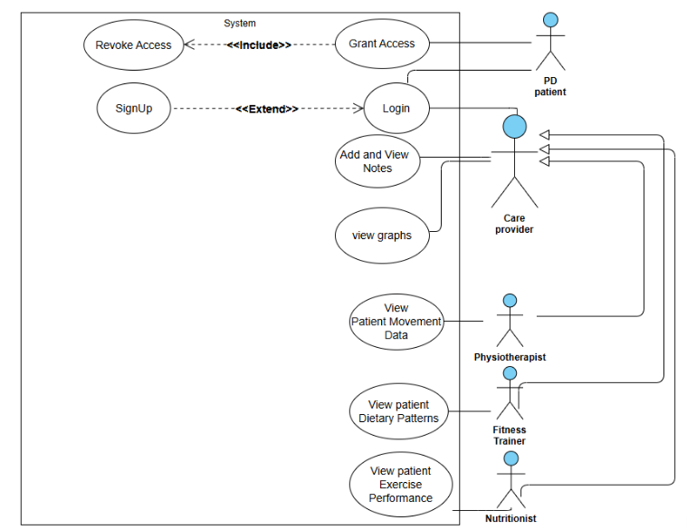

**Figure 1:** Use-Case Diagram

## 4.2 Initial Prototype

As part of our development process, we created a prototype of the application's user interface using Figma, a collaborative web-based design tool. Figma enabled our team to work together efficiently, with real-time editing and feedback loops that helped shape a user-centered design focused on the needs of Parkinson’s caregivers. The prototype featured a clean and intuitive interface designed to simplify the viewing of patient data, such as physical training sessions, medication intake, meals, symptoms, and mood, through role-specific dashboards and accessible visualizations. The prototyping phase proved essential not only for identifying usability issues early but also for validating the system’s real-world relevance and potential impact. The feedback guided several design decisions that ultimately enhanced usability, cross-disciplinary collaboration, and the application’s value in daily caregiving.

Once the initial prototype was ready, we presented it to Michael’s care team to gather their impressions. During this session, we asked whether the system met their expectations, what additional features they would find helpful, and whether they would actually use such a tool in their day-to-day work. Our goal was to ensure that the platform would be practical, beneficial, and seamlessly integrated into their routines.

Their feedback was crucial in shaping the final direction of the project. For example, they emphasized how valuable and easy to understand the visualizations were, which validated our design approach. However, they also highlighted the importance of allowing users to select a custom date range, something we hadn’t initially considered. In addition, while our original concept limited each professional to viewing only their role-specific charts, the feedback made it clear that cross-professional visibility was important. As a result, we adapted the system to give all users access to other professionals' graphs, promoting better collaboration. They also noted the need to prominently display key indicators, Parkinson’s state, mood, and physical difficulty, at the top of the dashboard. This change allows caregivers to quickly understand whether certain activities, meals, or medications had a significant impact on the patient's overall condition.

## 4.3 Code Implementation

During the code implementation phase, we developed the ParkinSphere web application using a modern, serverless architecture based on React, Firebase, and Tailwind CSS (see Figure 2). 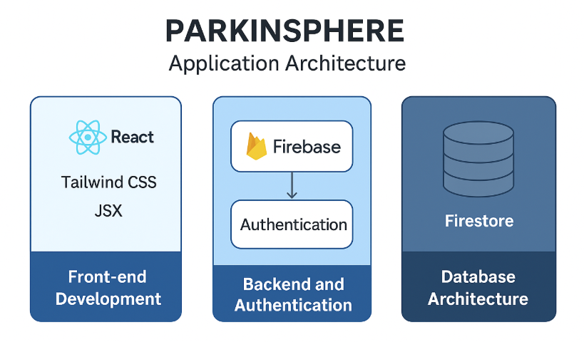

**Figure 2:** Application Architecture

#### Frontend Development

The frontend was built using **React** and styled with **Tailwind CSS**, providing a clean and responsive user experience. We used .tsx components and media queries to ensure accessibility across desktops, tablets, and smartphones. The UI was further enhanced using **Material UI** and **shadcn/ui** for consistent styling, accessibility, and usability.

Key frontend features include:

* **Responsive Design**: Implemented with Tailwind CSS to ensure optimal display across devices.
* **Reusable Components**: Modular components were created to handle data visualization, user selection, and role-based dashboards.
* **State Management**: Leveraged React’s Context API and hooks to maintain global state, including the unified floating date picker used across charts.
* **Data Visualization**: Integrated **Recharts** to render interactive graphs that visualize symptoms, medication adherence, nutrition, and activity trends over time.

Backend and Authentication (via Firebase)

All backend functionality is handled through **Firebase**, eliminating the need for a custom server:

* **Firestore**: Used as the primary database to store real-time user-generated data, including symptoms, medications, nutrition logs, and care provider connections.
* **Authentication**: Firebase Authentication was implemented to manage secure login for both patients and care providers, with role-based access control to ensure appropriate data visibility.
* **Real-time Updates**: Firestore’s real-time syncing keeps user dashboards up-to-date without requiring manual refreshes.
* **Security Rules**: Custom Firestore rules enforce access permissions and protect sensitive data based on user roles and relationships.

#### Database Architecture

ParkinSphere uses Firestore, a flexible and scalable NoSQL database, to manage its dynamic data needs:

* **Schema-less Flexibility**: Collections and documents were structured to reflect entities such as users, symptoms, medications, and caregiver relationships, allowing flexibility in data representation.
* **Relational Modeling**: Modeled care provider-patient relationships to support pending requests, confirmed connections, and shared data access.
* **Data Security**: Sensitive fields like passwords are encrypted and protected using Firebase’s built-in security and role-based rules.

Together, this stack enabled the creation of a responsive, secure, and scalable application tailored to the unique needs of Parkinson’s patients and their care teams.

# 5. Faced Challenges and Solutions

## 5.1 Planning and Functional Challenges

**1. Choosing Platform and Designing for Visual Clarity**

**Challenge:**Early in the project, we debated whether to build a native mobile app or a web application. While mobile apps seemed convenient, we recognized that showing detailed data visualizations, especially over long time ranges, on small screens like smartphones would be difficult for users. Caregivers also requested the ability to view data between two specific dates, which made mobile use even more complex. At the same time, developing and maintaining two native apps (iOS and Android) would have been time-consuming and resource-heavy for our team.

**Solution:**We decided to focus on building a responsive web application, optimized primarily for use on tablets and desktops. This approach ensured that users could comfortably view and interact with graphs that span several days or weeks, without the layout feeling cramped or unclear. While the app is still accessible on mobile devices, we prioritized readability and functionality, especially for caregivers who rely on seeing trends and patterns over time.

**2. Presenting the Data Effectively  
Challenge:**

We had several ideas for how to visualize the patient’s health data - line charts, bar graphs, averages, comparisons over time, and it wasn’t immediately clear which approach would best suit each care provider’s needs.

**Solution:**To resolve this, we consulted our project supervisors for guidance and then presented multiple visualization options to Michael’s care team. Their feedback helped us decide on a simple, clear approach that included line charts with text explanations and average values. This ensured that even non-technical users could easily interpret the information.

**3. Incomplete Patient Data  
Challenge:**

Since Michael was sometimes too tired or unwell to log daily data, we encountered gaps in the dataset. These gaps affected the clarity and usefulness of the graphs, especially when trying to demonstrate long-term patterns or trends.

**Solution:**To address this, we expanded on the real data by adding artificial entries that followed Michael’s natural patterns. This filled in the visual gaps, allowing us to properly test the system and showcase how the dashboard would look with more consistent data, without compromising the realism or integrity of the design.

**4. Data Visualization with Recharts  
Challenge:**

We had no prior experience with Recharts, the library we chose for building our interactive visualizations. Understanding how to structure the data correctly, configure the charts, and add advanced features like tooltips, averages, and custom explanations required significant learning and trial and error.

**Solution:**We invested time in reading Recharts documentation, exploring community examples, and testing different configurations within our app. Through hands-on experimentation and teamwork, we gradually built a strong understanding of how to create clear, interactive, and responsive graphs. This allowed us to deliver visualizations that matched caregiver needs while maintaining usability across devices.

## 5.2 Design and Aesthetics Challenges

**1.Managing Conflicting Needs Across Multiple Caregiver Roles  
 Challenge:**One of the biggest challenges we encountered was designing an interface that could serve the different needs of various caregivers, like physiotherapists, nutritionists, and fitness trainers, without making the platform feel cluttered or overwhelming. Initially, we tried showing all graphs by default, but this quickly became confusing and hard to navigate. On the other hand, limiting access only to role-specific views caused frustration, as some users needed a broader picture of the patient’s condition.

**Solution:**After several design iterations, we developed role-based dashboards that prioritize the most relevant data for each caregiver type. We added a toggle that allows users to explore additional graphs when needed, creating a flexible design that supports both simplicity and comprehensive access.

**2.Balancing Visual Richness with Mobile Accessibility  
 Challenge:**  
Our visualizations are data-rich, often spanning days or weeks, which works well on desktops and tablets. However, caregivers also need to quickly check patient status on the go. Designing a layout that maintains clarity and impact on smaller screens without overwhelming users remains a key aesthetic challenge. The current mobile experience, while functional, lacks simplified summaries and visuals that are truly optimized for fast mobile review.

**Solution:**To address this, future iterations could explore streamlined mobile views with concise visual summaries and adaptive layouts. These would highlight only the most critical insights, such as recent symptom trends or medication adherence, using minimalistic design principles. If we had more time, we could also explore adding data-driven features, such as alerts or care suggestions, that turn long-term trends into simple, actionable summaries, helping caregivers stay informed and make timely decisions, even on mobile devices.

# 6. Results and Conclusions

## 6.1 Goals and Achievements

The primary goal of our project was to create a web-based dashboard that allows Parkinson’s care providers to easily access and interpret relevant patient data, such as mood, physical condition, symptoms, medications, and meals, in order to better understand the patient’s condition and support more coordinated care. We built the system using real patient data from Michael Jackont, a Parkinson’s patient who had already been logging his daily health information through an existing application.

One of the key achievements was the creation of role-specific, easy-to-read dashboards that visualize health data over time using interactive graphs. Each provider sees a customized view by default but can opt to explore other views for additional clinical context. We included filters for viewing data across different timeframes (last day, week, month, or a selected range), along with average severity ratings and textual explanations to help users interpret the graphs.

During the early stages of the project, we considered using Tableau to generate the data visualizations. However, we found that Tableau offered limited flexibility for fully customizing the look and behavior of the charts within our application. As a result, we decided to use Recharts, which gave us more precise control over the design, responsiveness, and integration with our React-based frontend. This allowed us to tailor the visualizations to the specific needs of each caregiver while maintaining a consistent and accessible user experience.

Another important success was the use of Firebase (Firestore and Authentication) as our backend solution. While we initially considered using the MERN stack, we ultimately chose Firebase for its ease of use, real-time syncing, and integrated security features, allowing us to focus more on usability and less on infrastructure.

To test the usability of the platform, we designed a survey inspired by usability scales and presented the app to peers. The questionnaire included statements such as:

* “I thought the visualization was enjoyable”
* “The use of visualization was clear and understandable”
* “I found the visualization unnecessarily complex.”
* “I would imagine that most people would easily learn how to use this visualization”

9 participants interacted with the dashboard and provided structured feedback based on predefined evaluation questions. Their responses indicated that the interface was generally clear, easy to navigate, and informative. The calculated System Usability Scale (SUS) average score was 81, which reflects a good level of usability and suggests that users found the system effective and user-friendly.

Users highlighted several strengths of the platform, including its intuitive layout, the ability to easily recognize trends, and the tailored dashboards for each care provider role. They particularly appreciated the use of colors, tooltips, and filters, which made the visualizations more accessible and engaging. One of the most positively received elements was the pie chart in the nutritionist’s graph, which helped users understand nutritional balance in a clear and familiar way.

In terms of improvement, several users noted that some visualizations, such as the Symptom Tracker and Activity Analysis, were initially overwhelming or could benefit from additional textual explanations. Others suggested making it easier to identify connections between symptoms, medication, and activity patterns, as well as simplifying the display for smaller screens. These insights provide valuable input for refining future versions of the system.

## 6.2 Conclusions

Looking back, we can confidently say that the project met its key goals of delivering a role-based, data-driven web application that enables Parkinson’s care providers to easily interpret a patient’s daily health data in order to support more personalized, informed care.

Our main targets included:

* Designing a clear and intuitive interface tailored to different types of caregivers (physiotherapists, nutritionists, and fitness trainers)
* Enabling easy tracking and interpretation of symptoms, mood, medication, and nutrition over time
* Creating a system that is accessible, responsive, and usable, especially on tablets and desktops

Our decision to build a responsive web application, optimized for desktops and tablets, proved essential for displaying detailed health data across long time ranges, especially after caregivers expressed a need to view custom date intervals.

Although the initial plan involved using the MERN stack, our switch to Firebase proved advantageous. It simplified authentication, supported real-time updates, and aligned with our need for quick development cycles and secure data handling.

The use of Recharts, despite being unfamiliar to us at the start, enabled us to create interactive and dynamic data visualizations that fit the specific needs of our users. Compared to solutions like Tableau, Recharts gave us the design freedom and code-level control necessary to deliver a tailored and responsive dashboard experience.

While the system in its current form fulfills its core purpose, we see potential for future improvements, such as:

* Adding support for new symptom categories, allowing patients and caregivers to track a broader range of experiences
* Offering data-driven recommendations, such as alerts or insights based on trends in the patient’s data  
  Enhancing mobile compatibility by designing tailored visualizations specifically optimized for small screens, making it easier for caregivers to access key insights on the go without compromising readability or usability

These enhancements could further expand the platform’s value, making it more flexible, accessible, and supportive of personalized Parkinson’s care across different devices and settings.

Ultimately, the project demonstrates the real-world impact of well-designed, patient-centered health technology, transforming isolated data points into meaningful insights that empower both patients and their care teams.

## 6.3 Future Work

Looking ahead, there are several directions in which the platform can be expanded and improved. While our current project focused on the specific needs of one Parkinson’s patient, Michael Jackont, and his care team, the system has been designed with future scalability in mind and already includes the technical foundation to support multiple patients. In the current version, the "My Account" window allows care providers to switch between a list of patients, and within the dashboard itself, it is also possible to select a specific patient to view their data. This built-in flexibility lays the groundwork for future expansion of the system to accommodate a broader range of patients, each potentially requiring different types of care and data visualizations. As the platform evolves to include more patients, it will also need to support a wider range of caregiver roles, such as occupational therapists, neurologists, or speech therapists, each with their own unique data needs. This will require adapting the system’s logic for role-based views and developing new types of visualizations to match those professional requirements. In addition, the system will need to handle more varied health data and offer more advanced customization of dashboards and summaries. The visual design and interaction model should continue evolving to support complex data exploration while remaining user-friendly for non-technical users.

Another area for improvement is enhancing mobile experience. While the system is optimized for desktop and tablet usage, especially given the need to display wide time ranges and detailed charts, future versions could include simplified mobile views with concise summaries and graphs tailored to smaller screens, enabling caregivers to quickly review patient status on the go. There is also an opportunity to implement data-driven insights, such as personalized alerts, summaries, or treatment suggestions based on long-term patterns in the data. These features could help caregivers intervene earlier or adjust care plans more effectively.

Lastly, expanding the user testing process to include a wider and more diverse group of patients and caregivers will be essential. Feedback from additional users can help guide design decisions and improve accessibility, inclusiveness, and real-world applicability. Supporting multiple languages, voice commands, and adjustable interfaces could also extend the platform’s reach globally. With these enhancements, the platform can grow and empower not only Michael’s care team, but potentially many other patients and professionals managing Parkinson’s disease or similar chronic conditions.

# 7. Evaluation / Verification Plan

## 7.1 User Evaluation Methodology

To evaluate the usability and clarity of the system, we gathered feedback from 9 peer participants using a detailed user feedback questionnaire. Each participant interacted with the application and rated their experience through Likert-scale questions (1-7 or 1-5), covering each visualization component individually: Health & Mood Insights, Activity Impact Analysis, Parkinson’s Symptom Tracker, Macronutrient Timeline, and Medicine Intake Summary. The questionnaire also included a final section assessing the overall experience with the system.

The results reflect user perceptions of clarity, usability, and effectiveness for each visualization, as well as the platform as a whole. The data collected offers both quantitative insights, such as usability scores, and qualitative feedback that highlights areas of strength (the intuitive design of the pie charts) and opportunities for improvement (simplifying complex visual elements for first-time users). The original responses are provided in the Appendices to support transparency and deeper analysis.

## 7.2 Summary of User Feedback and Findings

To assess the usability and effectiveness of the ParkinSphere system and its visualizations, we conducted a structured user evaluation with 9 peers who interacted with the platform and responded to a detailed questionnaire. The evaluation form included Likert-scale questions (1-7 or 1-5) for each individual visualization and the system as a whole, focusing on aspects such as clarity, ease of use, and perceived complexity.

The participants included a mix of individuals, 3 were students, while 6 were not, all with varying levels of familiarity with data visualizations and health applications. The group consisted of 3 men and 6 women, all within the age range of 25 to 32 years old. Their diverse backgrounds provided a balanced perspective on the system’s usability and overall user experience

Key findings from the user feedback:

* The most favored visualization was the Macronutrient Timeline (Pie Chart). Participants appreciated its clarity and intuitive design for representing nutritional data.
* The least favored visualization was the Activity Impact Analysis (Gantt Chart). While visually clean, users found it less informative due to the lack of contextual or symptomatic connection.
* Across all visualizations, users consistently rated positive statements with high scores, typically 6 or 7 out of 7, such as "The visualization was clear and understandable" and "I thought the visualization was effective."
* In contrast, statements that evaluated frustration or perceived complexity (“The visualization was unnecessarily complex”) were mostly rated 1 or 2, indicating low levels of difficulty or negative experience.

Overall, the evaluation confirmed that the application is both accessible and effective for non-technical users. Feedback gathered will help guide future iterations, with particular focus on improving clarity in less popular visualizations and expanding personalization options.

# 8. User Documentation

## 8.1 User Guide

### 8.1.1 General Description

Our platform is a web-based dashboard that helps Parkinson’s care providers access and understand patient health data, such as symptoms, mood, medications, meals, and physical activity, through clear visualizations and trend tracking. It is based on real data from the patient but designed to support broader use. The app is accessible via any modern browser on desktop or tablet, with a responsive design. It includes two main user roles:

* **Patients** – Can log their data using an external system and manage access permissions.
* **Care Providers** – Can view personalized dashboards with relevant graphs and trends to support clinical decisions.

While the current version focuses on Michael and his care team, the system already supports multiple patient profiles, which care providers can switch between. Each graph includes a text explanation to ensure even non-technical users can understand the data easily. The interface is simple and intuitive, prioritizing clarity and ease of use. This guide helps users navigate the platform and make the most of its features to improve care coordination and decision-making.

### 8.1.2 Operating Instructions

Parkin Sphere is a web application accessible from any device with an internet connection and a modern web browser. Follow the steps below to start using the app and explore its features:

Accessing the Application:

Open a web browser on your device and navigate to the ParkinSphere website by entering the app’s URL (https://parkinsphere.vercel.app/) in the address bar. Ensure you have a stable internet connection for smooth operation.

Important Notes:

•Ensure your browser is up to date to avoid compatibility issues.

•For security, never share your login details with anyone.

By following these instructions, users can easily access and operate ParkinSphere to manage daily health routines and gain valuable insights into their well-being.

Each screen of the ParkinSphere application is described in detail on the following pages, along with its intended functionality.

**1. Login/Signup Screen:**

New Users:

1. Click the "Register now! Sign up" button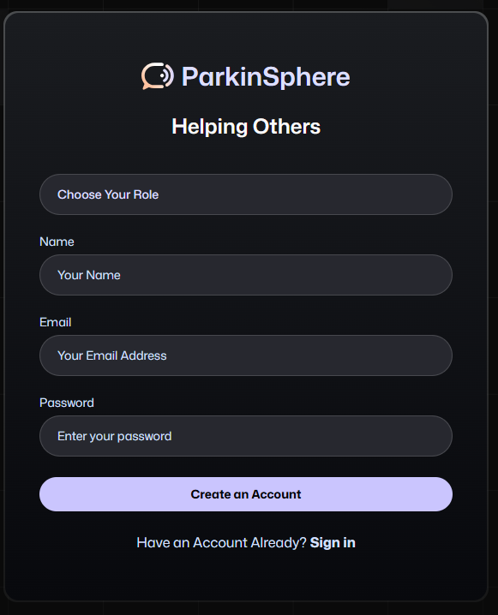

2. Click on the field “Choose your role” and select the type of user. (Fitness Trainer, Physiotherapist, Nutritionist, Patient)

3. Type your name in the “Name” field.

4. Enter your email address in the "Email" field

5. Create a secure password in the "Password" field (At least 6 characters)

6. Click "Create an Account" to create your account

7. Clicking "Have an Account Already? Sign in" cancels account creation

8. After signing up, sign in with your new credentials on the login screen

•Existing Users: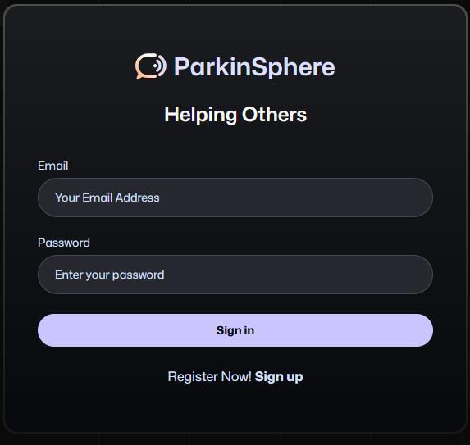

1. Enter your registered email address

2. Input your password

3. Click "Sign in" to access your account

**2. Home Screen (for Caregivers):**

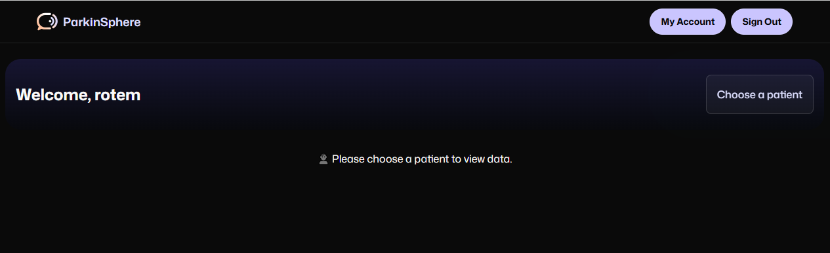

After logging in, you will be directed to the Home Screen.

Here’s how to navigate it:

1. Welcome Message

At the top of the screen, you’ll see a personalized welcome message (“Welcome, rotem”).

2. Navigation Buttons

* My Account – Click this button to manage your profile and view the list of patients you’re connected to.
* Sign Out – Click this button to safely log out of the application.

3. Choose a Patient

* To begin viewing data, click the “Choose a patient” button on the right side of the welcome banner.
* A dropdown list will appear with the patients you have access to. Select a patient to enter their dashboard.

4. Patient Prompt

* If no patient is selected, a prompt will appear: “Please choose a patient to view data.”
* You must select a patient before accessing any graphs or data.

Once a patient is selected, you’ll be redirected to their personalized dashboard with visualizations and health information tailored to your role.

**3. Caregiver Dashboard**

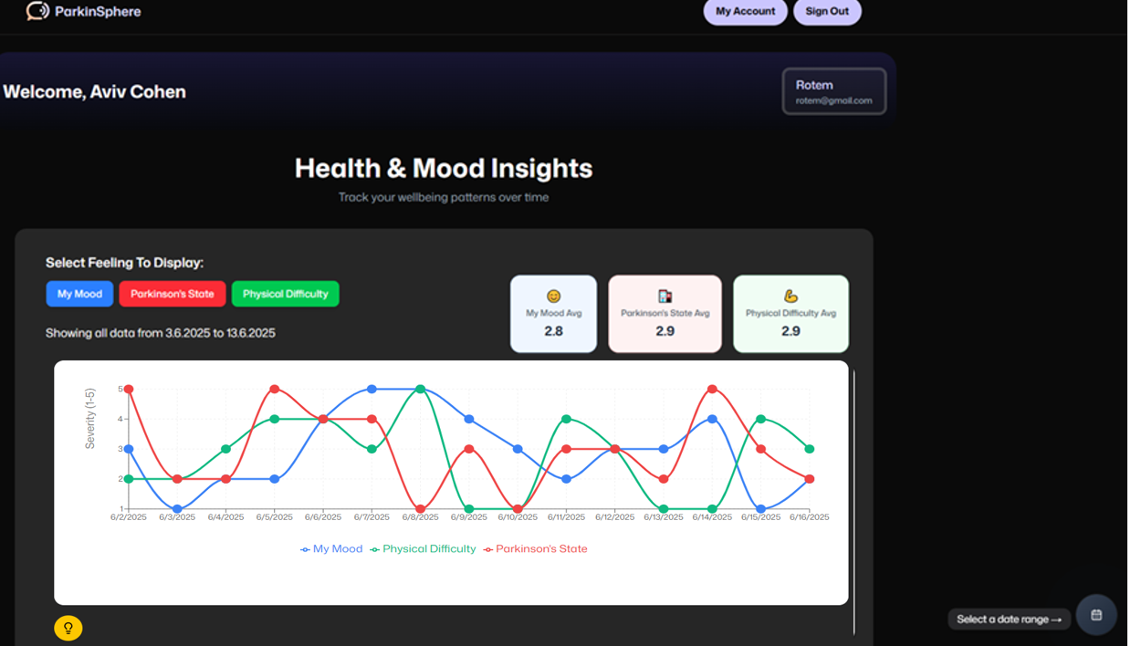

After selecting a patient, caregivers are directed to the **Health & Mood Insights** dashboard. This page allows you to monitor the patient's well-being through visualized symptom data over time.

#### 1. Dashboard Overview

* The name and email of the selected patient appear in the upper right box (Rotem – rotem@gmail.com).
* A personalized welcome message shows your name at the top (Welcome, Aviv Cohen).

#### 2. Feelings Selector

* Use the buttons labeled My Mood, Parkinson’s State, and Physical Difficulty to toggle which data lines appear in the chart below.
* You can select one, two, or all three to compare how the patient feels in different areas over time.

#### 3. Average Indicators

* Just above the graph, you will see average severity values for each selected feeling:
  + My Mood Avg
  + Parkinson’s State Avg
  + Physical Difficulty Avg
* These numbers summarize the overall trend for the selected date range.

#### 4. Interactive Line Graph

* The main graph displays the severity (y-axis) of each feeling over time (x-axis).
* Each line is color-coded:  
  + Blue: My Mood
  + Red: Parkinson’s State
  + Green: Physical Difficulty
* Use this graph to identify symptom trends, fluctuations, or improvements over specific days.

#### 5. Date Range Picker

In the bottom right corner, click “Select a date range” to choose a custom time period. The graph and averages will update automatically to reflect your selected dates.

6. Graph Explanation button

At the bottom-left corner of the dashboard, you’ll see a yellow lightbulb icon. This icon serves as an Explanation button for the graphs.

#### What it does:

* When clicked, it opens a short text explanation of how to interpret the chart above.
* The explanation includes:  
  + What each colored line represents
  + The severity scale (1–5)
  + Tips for identifying trends and patterns over time

This feature is designed especially for non-technical users, ensuring that caregivers can understand and use the data effectively without needing prior experience with graphs or charts.

Tip: Use this feature when you’re unsure how to read the visualized data.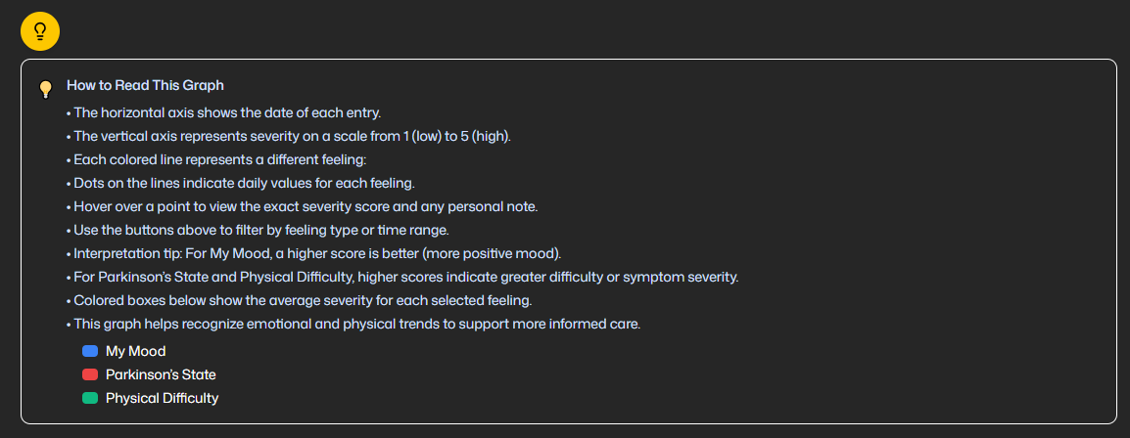

#### 7. Navigation Buttons

* Use the “My Account” button (top right) to return to your caregiver account overview.
* Use “Sign Out” to securely exit the application.

**4. Fitness Trainer Dashboard- Activity Analysis Section (Scroll Down View)**

When you scroll down below the line chart in the caregiver dashboard, you reach the Activity Impact Analysis section. This part of the dashboard visualizes the patient's logged activities and allows you to explore how different types of activities are distributed over time.

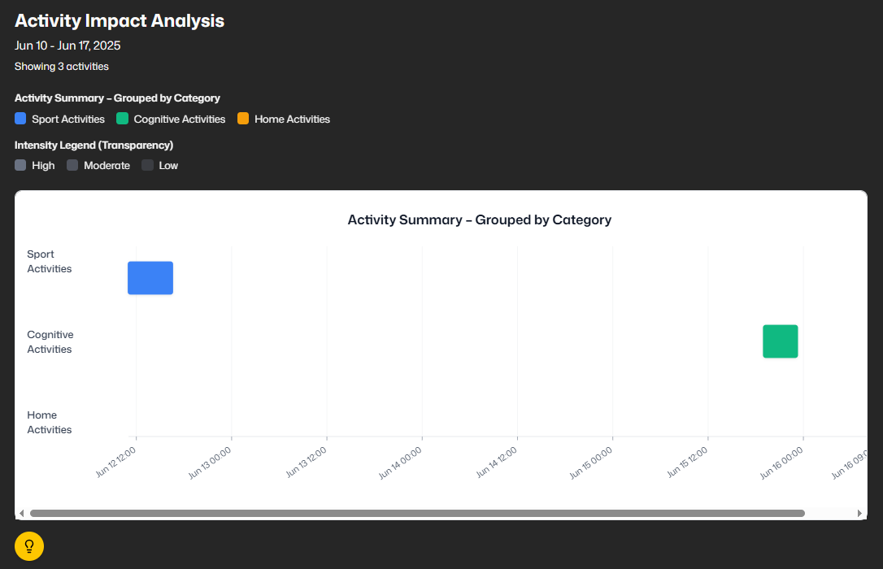

When you scroll down below the line chart in the caregiver dashboard, you reach the Activity Impact Analysis section. This part of the dashboard visualizes the patient's logged activities and allows you to explore how different types of activities are distributed over time.

#### 1. Role-Based Default View

* The first chart displayed matches the caregiver’s role:
  + A Fitness Trainer will see activity data related to Sport, Home, and Cognitive Activities.
  + A Nutritionist will see data related to the patient's meals and medication intake, with a focus on nutritional balance and treatment timing.
  + A Physiotherapist will see information related to the patient's physical symptoms and severity levels, helping to assess functional condition over time.

#### 2. Switching Between Views

* At the top of this section, you’ll see role filter buttons (Nutritionist, Fitness Trainer, Physiotherapist).
* You can click any of these buttons to switch between different caregivers' views and explore other domains of patient activity data.

#### 3. Activity Graph

* The graph shows activities grouped by category and plotted over time.
* Categories include:
  + Sport Activities
  + Home Activities
  + Cognitive Activities
* Each colored bar represents the duration and timing of the activity.

Each colored rectangle represents the duration and timing of a logged activity.  
 The transparency level of each rectangle indicates activity intensity:

* High intensity = fully opaque
* Medium intensity = semi-transparent
* Low intensity = more transparent

#### 4. Tooltip Explanation

* A yellow light bulb icon at the bottom-left opens a tooltip with explanations about how to interpret the graph, useful for non-technical users or first-time visitors.

### **5. Nutritionist Dashboard- Macronutrient Timeline and Medicine Intake Summary**

### The Nutritionist Dashboard provides insights into the patient’s dietary patterns and medication intake over time. This dashboard helps nutritionists analyze how macronutrient balance and medication schedules may relate to the patient’s symptoms and physical condition.

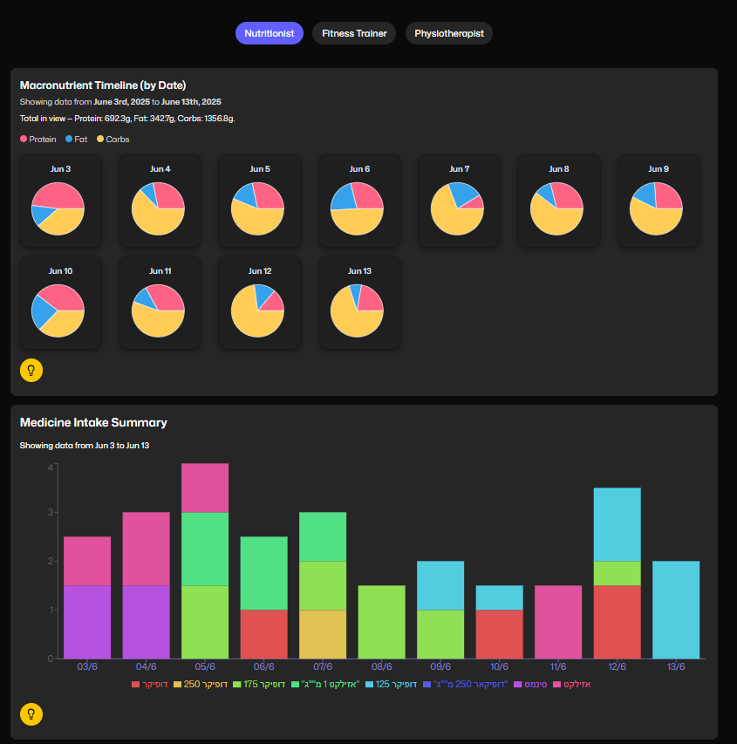

#### 1. Macronutrient Timeline

* Displays daily pie charts for each day in the selected date range.
* Macronutrients are shown in color-coded segments:
  + pink: Protein
  + blue: Fat
  + yellow: Carbohydrates
* Above the pie charts, you can see the total amount of each macronutrient consumed in grams over the selected time period.
* Hovering over each pie chart provides a clearer breakdown of that day’s intake.
* Click the yellow lightbulb icon to view a tooltip explaining how to read and interpret the charts.

2. Medicine Intake Summary

* This stacked bar chart shows daily medication usage by type.
* Each color represents a different medication.
* The y-axis represents the number of doses or scheduled intakes.
* This visualization helps identify trends in medication consistency, timing, and combinations.
* Use this chart to evaluate possible interactions or timing issues between
* meals and medication intake.  
  A tooltip icon is also available here to provide interpretation guidance for non-technical users.

3. Role Toggle Buttons

* Use the buttons at the top of the screen (Nutritionist, Fitness Trainer, Physiotherapist) to switch to other caregiver dashboards if needed.

**6. Physiotherapist Dashboard – Parkinson’s Symptom Tracker**

The Physiotherapist Dashboard is focused on monitoring Parkinson’s-related symptoms over time. This view helps physiotherapists understand how symptoms vary in frequency and severity, supporting better physical therapy planning and adjustments.

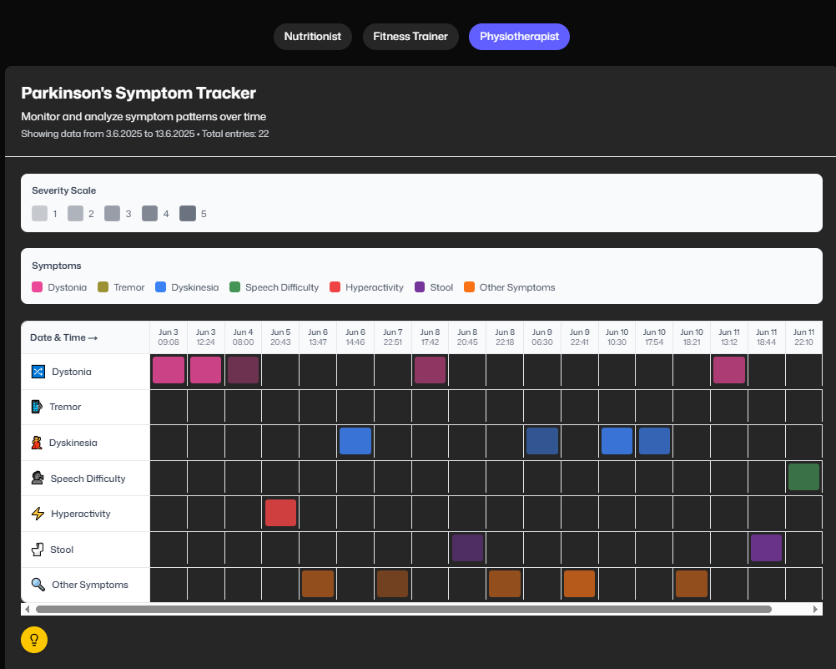

#### 1. Symptom Tracker Overview

* The main chart shows a grid of symptom occurrences, grouped by type and timestamp.
* Each row represents a different symptom.
* Each column represents a date and time the patient logged a symptom.
* Colored blocks indicate symptom entries, with darker shades representing higher severity levels (from 1 to 5).

#### 2. Severity Scale

* A legend at the top shows the meaning of each color intensity:
  + 1 = Mild (lightest)
  + 5 = Severe (darkest)

This scale applies to all symptom categories, each symptom has its own unique color, and the intensity of that color represents the severity level reported by the patient.

#### 3. Symptom Categories

* Each symptom is color-coded

The color key helps caregivers quickly identify which symptoms occurred and their relative severity.

#### 4. Time Navigation

* The chart includes a horizontal scrollbar, allowing you to view symptom data across multiple days.
* Each entry also displays the exact timestamp for better temporal analysis.

#### 5. Role Switch

* Buttons at the top allow switching to the Nutritionist or Fitness Trainer dashboards to compare symptom trends with other logged activities like meals or exercise.

#### 6. Tooltip Explanation

* A yellow light bulb icon at the bottom-left opens a tooltip that explains how to read the symptom grid, what each color means, and how to interpret symptom patterns.

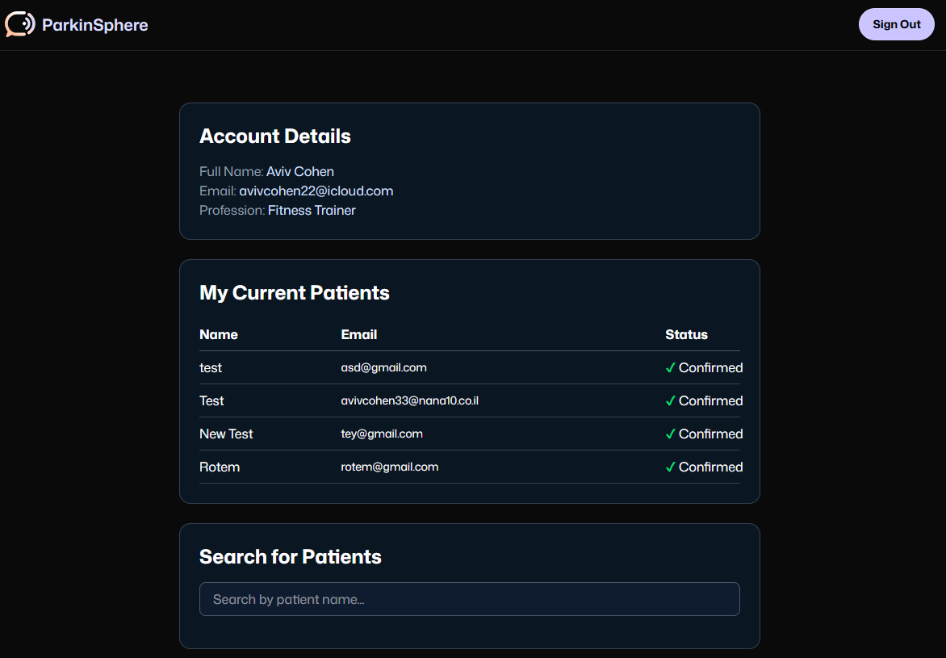

### **7. My Account Page (for Caregivers)**

The “My Account” page allows caregivers to view their account information and manage the patients they are connected to. This page helps caregivers easily track which patients they have access to and provides a way to search for additional patients.

#### 

#### 1. Account Details

This section displays your personal information:

* + Full Name
  + Email Address
  + Profession (Physiotherapist, Nutritionist, Fitness Trainer)

#### 2. My Current Patients

* A table showing all patients you are currently connected to.
* Each entry includes:  
  + Name – The patient’s display name in the system
  + Email – The patient’s registered email address
  + Status – Shows "✔ Confirmed" once the patient has approved your access

#### 3. Search for Patients

* Use the Search bar to find and request access to other patients by typing their name.
* This is useful if you’ve been given permission to work with a new patient and need to connect with them in the system.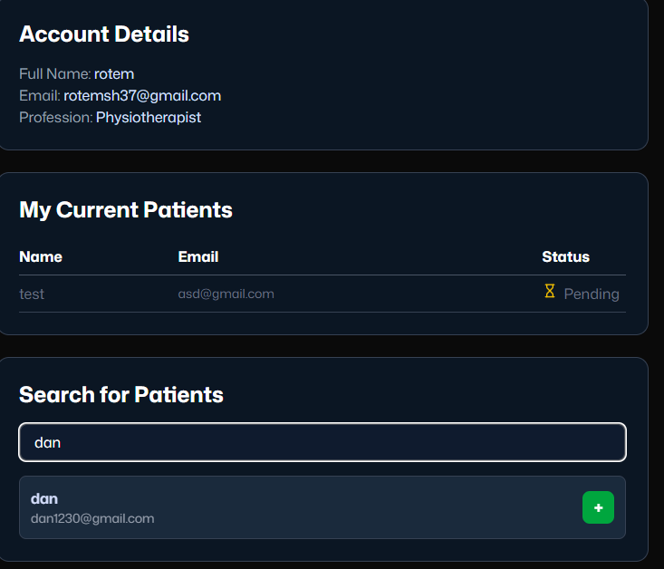

#### 4. Sign Out

* Click the Sign Out button in the top-right corner to securely log out of your caregiver account.

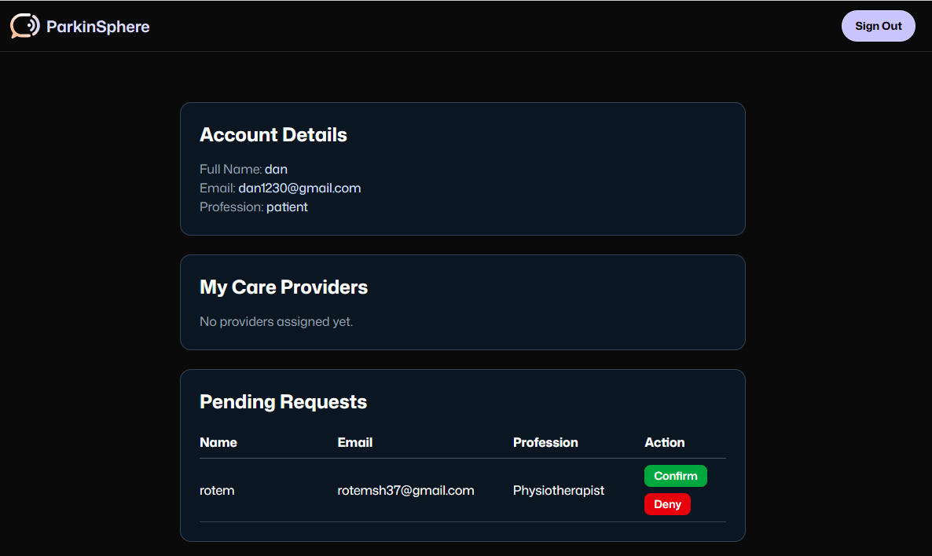

**4. Patient View: Managing Care Provider Access**

When a patient logs into the application, they are taken to a screen where they can review and manage caregiver access requests. This ensures that patients retain full control over who can view their personal health data.

#### 1.Confirming or Denying New Requests

As shown in the first screenshot: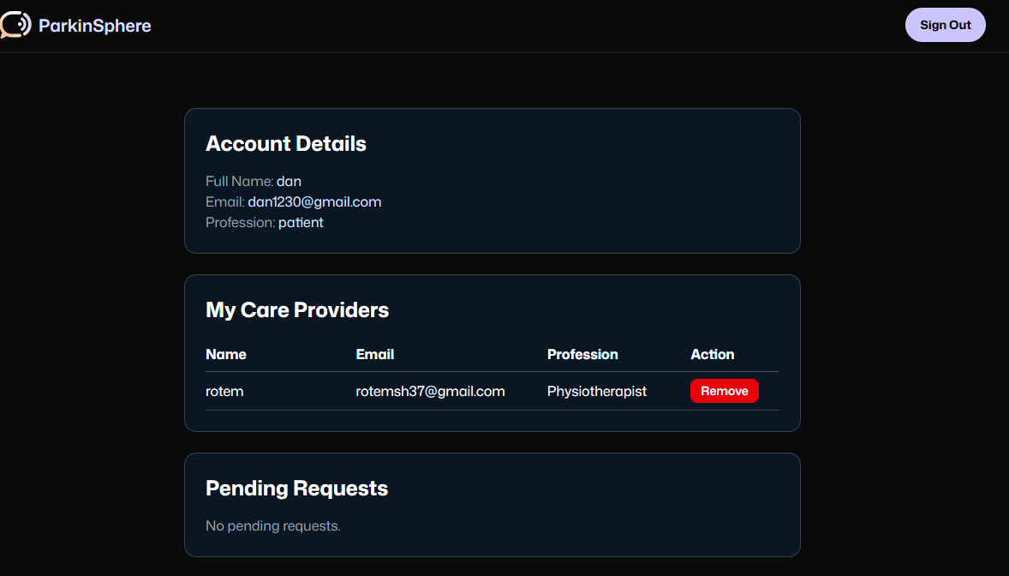

* Under “Pending Requests”, the patient sees a list of caregivers who have requested access to their data.
* Each request includes the caregiver’s name, email, and profession.
* The patient can:  
  + Click "Confirm" to approve access and allow the caregiver to view their dashboard and data.
  + Click "Deny" to reject the request and prevent access.

Once confirmed, the caregiver will move to the “My Care Providers” list.

#### 2. Removing an Existing Caregiver

As shown in the second screenshot:

* After confirming, the caregiver appears in the “My Care Providers” section.
* The patient can click the red "Remove" button at any time to revoke access.
* Once removed, the caregiver can no longer view the patient’s data unless access is requested and granted again.

## 8.2 Maintenance Guide

### 8.2.1 Web Application Maintenance Guide

Development Tools:

1. Code Editor or Integrated Development Environment (IDE)

•Tool: Visual Studio Code (VS Code)

•Link: https://code.visualstudio.com/

•Purpose: A powerful and popular code editor with features like syntax highlighting, debugging, and different extensions.

2. Firebase

•Tool: Firebase Console (cloud-hosted)

•Link:<https://firebase.google.com/>

•Purpose: A cloud-based platform by Google used to manage authentication, real-time data storage (Firestore), and secure access control. Firebase Authentication handles user sign-in and role management, while Firestore serves as a NoSQL database for storing patient logs, caregiver access, and app data with real-time sync across users.

3. Git and GitHub

•Tool: Git and GitHub or other version control platforms.

•Link (Git): https://git-scm.com/

•Link (GitHub): <https://github.com/AvivFairfield/finalproject>

•Purpose: For version control, collaboration, and source code management.

•Installation Tip: Install Git on your local machine and configure a GitHub repository for your project.

4. Browser

•Tool: Google Chrome (preferred).

•Purpose: For testing the web application and debugging using Chrome Developer Tools.

•Optional Extension: Install React Developer Tools for easier debugging of React components.

### 5. React

•Tool: React (with TypeScript support via .tsx components)

• Link:<https://reactjs.org/>

• Purpose: A JavaScript library used for building interactive user interfaces. In this project, React was used to create modular, reusable components and to render role-based dashboards for care providers.

### 6. Tailwind CSS

•Tool: Tailwind CSS

• Link:<https://tailwindcss.com/>

•Purpose: A utility-first CSS framework used to design responsive layouts and clean, consistent styling across the application. Tailwind allowed rapid UI development while ensuring accessibility and mobile responsiveness.

### 7. Recharts

•Tool: Recharts – A charting library for React

•Link:<https://recharts.org/>

•Purpose: Used for data visualization in the application. Recharts enabled the rendering of interactive line charts, bar graphs, and pie charts to display trends in symptoms, nutrition, medications, and activity levels.

### 8. Vercel

•Tool: Vercel (Cloud Deployment Platform)

•Link:<https://vercel.com/>

•Purpose: Used to deploy the frontend React application. Vercel offers fast, serverless hosting with automatic integration for GitHub and continuous deployment workflows. The platform allowed quick iteration and sharing of new builds during development.

### 9. shadchan/ui

•Tool: shadcn/ui component library

•Link: <https://ui.shadcn.com/>

•Purpose: A modern, accessible component library used to streamline frontend development and maintain visual consistency across the application. It helped speed up development of buttons, modals, and form elements while ensuring WCAG-compliant design.

### 8.2.2 Data Content Overview

As part of this project, we received structured patient data that had been previously collected through daily logs maintained by a Parkinson’s patient. These logs included information about symptoms, medication intake, meals, physical activity, and subjective health ratings. Our role was to organize, process, and visualize this data within the system to support care providers.

However, due to technical difficulties in the patient’s ability to consistently provide their data logs, the visualizations are currently connected to static CSV files rather than a live data source. As a result, the system does not support real-time synchronization. This limitation stems from communication challenges and data transfer issues on the patient's side.

Below is a summary of the main data categories and the fields included in each:

#### **1. Symptoms Data**

Self-reported logs of Parkinson’s-related symptoms tracked over time.

**Fields:**

* symptom (String): The specific symptom reported.
* severity (Number): A rating from 1 (mild) to 5 (severe).
* timestamp (Date & Time): The exact moment the symptom was logged.
* notes (String): Optional comments added by the patient.

#### **2. Medication Intake**

Entries documenting the medications taken by the patient throughout the day.

**Fields:**

* Name (String): Name of the medication.
* type (String): The form of the medication.
* quantity (Number): The dosage or amount taken.
* timestamp (Date & Time): When the medication was taken.
* notes (String): Optional text where the patient adds context or remarks.

#### **3. Nutrition Data**

Detailed meal logs used to evaluate dietary habits and macronutrient distribution.

**Fields:**

* foodName (String): Name or description of the food item.
* timestamp (Date & Time): When the food was consumed.
* proteins / fats / carbohydrates (Number): Macronutrient values in grams.

#### **4. Activities**

Recorded physical, home, and cognitive activities performed by the patient.

**Fields:**

* activityName (String): Description of the activity.
* activityCategory (String): Type of activity.
* duration (Number): Time spent on the activity (in minutes).
* intensity (String): Level of physical effort ("Low", "Moderate", "High").
* timestamp (Date & Time): Start time of the activity.
* notes (String): Optional text where the patient adds context or remarks.

#### **5. Mood and Parkinson’s State Ratings**

Daily self-assessments used to capture subjective health experiences.

**Fields:**

* feeling (String): The category rated: "My Mood", "Parkinson’s State", or "Physical Difficulty".
* severity (Number): Rating scale from 1 (good/low difficulty) to 5 (bad/high difficulty).
* timestamp (Date & Time): When the rating was logged.
* notes (String): Optional personal reflections or context.

**Installation Instructions**

**Follow these steps to set up and run the project locally:**

#### 1. Clone the Repository

* Copy the project’s GitHub URL (<https://github.com/AvivFairfield/finalproject>)
* Open Visual Studio Code
* Open the terminal and run:

git clone <https://github.com/AvivFairfield/finalproject>.git

* Move into the project directory:

cd final project

2. Add the .env.local File

* Locate the .env.local file provided with the submission (separate from the repository).
* Manually copy this file into the root of the project folder (same level as package.json and next.config.ts).

#### 3. Install Dependencies

* In the terminal, run:

npm install

4. Start the Development Server

* To launch the app locally, run:

npm run dev

#### 5. Open the Application

* Once the server is running, open your browser and go to:

http://localhost:3000

You’ll now be able to use the application locally.

### 8.2.3 Database Structure

The ParkinSphere application uses Firebase Firestore, a NoSQL cloud database, to store data in a flexible and scalable way. It organizes data into collections with documents that hold key-value pairs. Below is an explanation of the key collections and their fields:

#### **1. users Collection**

This collection stores the basic profile information of all users, including both patients and caregivers.

**Fields:** • email (String): The unique email address used for login and identification.  
 • name (String): The full name of the user.  
 • profession (String): The role of the user, such as "patient", "physiotherapist", or "fitness trainer".

#### **2. accessRequests Collection**

This collection tracks caregiver requests to access patient data. Each document represents a request made by a caregiver to a specific patient.

**Fields:** • patientId (String): The email of the patient the caregiver wants access to.  
 • providerId (String): The email of the caregiver requesting access.  
 • confirmed (Boolean): Indicates whether the patient has approved the caregiver’s access (true) or not (false).  
 • createdAt (Timestamp): The date and time the request was created.

### **Key Points:**

1. **Role-Based Access**Access between caregivers and patients is managed through the accessRequests collection. A request must be confirmed by the patient before the caregiver is granted data access.
2. **Scalable NoSQL Design** Firestore’s document-based structure allows for easy expansion by adding new fields or collections without schema migration. This ensures flexibility as new user types or data features are introduced.
3. **Security and Permissions**Access to these collections is protected through Firestore security rules, which enforce role-based permissions and restrict data access based on authentication status and user role.

### 8.2.4 Backend Structure (Firebase Serverless Architecture)

Unlike traditional server-based applications, this project does not include a dedicated backend folder or server logic written in Express or Node.js. Instead, it uses Firebase’s serverless architecture, which handles backend operations such as authentication, database management, and data access directly from the frontend.

All backend functionality is achieved using:

#### **2. Firebase Authentication**

Handles secure login for both patients and caregivers. Authentication is managed in real-time using Firebase Auth, with role-based access enforced through Firestore security rules.

#### **3. Firestore Security Rules**

These rules act as the logic layer of the backend, defining exactly which users can read or write specific data based on their role and relationships. This eliminates the need for custom route handlers or controllers.

#### **4. Environment Configuration**

The .env.local file in the root directory securely stores Firebase credentials such as the API key, project ID, and database URL. These values are injected into the frontend and used to initialize the Firebase connection.

### **Summary**

The backend responsibilities, such as user access control, data validation, and secure storage, are handled by Firebase services instead of a traditional backend folder structure. This simplifies development, reduces infrastructure complexity, and ensures real-time sync and scalability without maintaining server code.

# References:

[1] GBD 2016 Parkinson's Disease Collaborators. (2018). Global, regional, and national burden of Parkinson's disease, 1990-2016: a systematic analysis for the Global Burden of Disease Study 2016. The Lancet Neurology, 17(11), 939-953.

[2] Dorsey, E. R., Constantinescu, R., Thompson, J. P., Biglan, K. M., Holloway, R. G., Kieburtz, K., Marshall, F., Ravina, B., Schifitto, G., Siderowf, A., & Tanner, C. M. (2007). Projected number of people with Parkinson disease in the most populous nations, 2005 through 2030. Neurology, 68(5), 384-386.

[3] Kalia, L. V., & Lang, A. E. (2015). Parkinson's disease: A comprehensive analysis of pathophysiology, clinical features, and management. The Lancet, 386(9996), 896-912.

[4] Jankovic, J. (2008). Parkinson's disease: clinical features and diagnosis. Journal of Neurology, Neurosurgery & Psychiatry, 79(4), 368-376.

[5] van der Marck, M. A., Bloem, B. R., Borm, G. F., Overeem, S., Munneke, M., & Guttman, M. (2013). Effectiveness of multidisciplinary care for Parkinson's disease: a randomized, controlled trial. Movement Disorders, 28(5), 605-611.

[6] van der Marck, M. A., Kalf, J. G., Sturkenboom, I. H., Nijkrake, M. J., Munneke, M., & Bloem, B. R. (2009). Multidisciplinary care for patients with Parkinson's disease. Parkinsonism & Related Disorders, 15, S219-S223.

[7] Bloem, B. R., Henderson, E. J., Dorsey, E. R., Okun, M. S., Okubadejo, N., Chan, P., Andrejack, J., & Munneke, M. (2020). Integrated and patient-centred management of Parkinson's disease: a network model for reshaping chronic neurological care. The Lancet Neurology, 19(7), 623-634.

[8] Espay, A. J., Bonato, P., Nahab, F. B., Maetzler, W., Dean, J. M., Klucken, J., Eskofier, B. M., Merola, A., Horak, F., Lang, A. E., & Reilmann, R. (2016). Technology in Parkinson's disease: Challenges and opportunities. Movement Disorders, 31(9), 1272-1282.

[9] Espay, A. J., Hausdorff, J. M., Sánchez‐Ferro, Á., Klucken, J., Merola, A., Bonato, P., Bloem, B. R., Evers, L. J. W., Maetzler, W., Mer, J. E., Mirelman, A., Poli, L., Rochester, L., & the Movement Disorder Society Task Force on Technology. (2019). A roadmap for implementation of patient‐centered digital outcome measures in Parkinson's disease obtained using mobile health technologies. Movement Disorders, 34(5), 657-663.

[10] West, V. L., Borland, D., & Hammond, W. E. (2015). Innovative information visualization of electronic health record data: a systematic review. Journal of the American Medical Informatics Association, 22(2), 330-339.

[11] Mak, M. K., Wong-Yu, I. S., Shen, X., & Chung, C. L. (2017). Long-term effects of exercise and physical therapy in people with Parkinson disease. Nature Reviews Neurology, 13(11), 689-703.

[12] Ongun, N. (2018). Does nutritional status affect Parkinson's Disease features and quality of life?. PLoS One, 13(10), e0205100.

[13] van der Kolk, N. M., & King, L. A. (2013). Effects of exercise on mobility in people with Parkinson's disease. Movement Disorders, 28(11), 1386-1396.

[14] Goodwin, V. A., Richards, S. H., Taylor, R. S., Taylor, A. H., & Campbell, J. L. (2008). The effectiveness of exercise interventions for people with Parkinson's disease: A systematic review and meta-analysis. Movement Disorders, 23(5), 631-640.

[15] Radder, D. L., de Vries, N. M., Riksen, N. P., Diamond, S. J., Gross, D., Gold, D. R., Heesakkers, J., Henderson, E., Hommel, A. L., Lennaerts, H. H., Busch, J., Dorsey, R. E., Andrejack, J., & Bloem, B. R. (2020). Multidisciplinary care for people with Parkinson's disease: the new kids on the block! Journal of Parkinson's Disease, 10(2), 443-454.

[16] Goetz, C. G. (2011). The History of Parkinson's Disease: Early Clinical Descriptions and Neurological Therapies. Cold Spring Harbor Perspectives in Medicine, 1(1), a008862-a008875.

[17] Barichella, M., Cereda, E., & Pezzoli, G. (2019). Nutritional Management of Parkinson's Disease. Movement Disorders Clinical Practice, 6(1), 17-27.

[18] Mak, M. K., Wong-Yu, I. S., Shen, X., & Chung, C. L. (2017). Long-term effects of exercise and physical therapy in people with Parkinson disease. Nature Reviews Neurology, 13(11), 689-703.

[19] Jones, S., Patel, J. P., Twigg, M. J., & Chaudhuri, K. R. (2024). What is known about the challenges people with Parkinson’s disease experience with their medicines and what solutions have been explored to overcome them? A scoping review. *International Journal of Pharmacy Practice, 32*(6), 431–445.

[20] Kern, L. M., Bynum, J. P. W., & Pincus, H. A. (2024). Care fragmentation, care continuity, and care coordination—How they differ and why it matters. *JAMA Internal Medicine, 184*(3), 236–237.

[21] Kerkemeyer, L., Claus, I., Kutscher, M., von Stülpnagel, V., Zur Nieden, P., Huchtemann, T., Warnecke, T., & PNM+ Steering Committee. (2022). Strengthening communication and collaboration in the fragmented German healthcare system: A mixed-method evaluation of an interdisciplinary network for Parkinson's disease. *Journal of Parkinson's Disease, 12*(4), 1307–1317.

[22] HelloHealth. (2024). What data fragmentation means for the patient: Learn how fragmented healthcare data impacts diagnoses, costs, care coordination, and outcomes. *HelloHealth Blog.*

[23] Luis-Martínez, R., Monje, M. H. G., Antonini, A., Sánchez-Ferro, Á., & Mestre, T. A. (2020). Technology-Enabled Care: Integrating Multidisciplinary Care in Parkinson's Disease Through Digital Technology. Frontiers in Neurology, 11, 575975.<https://doi.org/10.3389/fneur.2020.575975>

[24] HealthManagement.org (2024). Digital Technologies in Health Care: Challenges and Opportunities. HealthManagement.org. <https://healthmanagement.org/c/enterprise/news/digital-technologies-in-health-care-challenges-and-opportunities>.

[25] Adams, J., Mammen, J., & Critical Path Institute (C-Path). (2023). Using digital health technologies for assessment of people with Parkinson's. Journal of Parkinson's Disease.

[26] American Physical Therapy Association (APTA). (2016). The Movement System: Physical Therapist Practice and the Movement System. APTA White Paper.

[27] Boullata, J. I., & Hudson, L. M. (2012). Drug–Nutrient Interactions: A Broad View with Implications for Practice. Journal of the Academy of Nutrition and Dietetics, 112(4), 506–517. <https://doi.org/10.1016/j.jand.2011.11.004>

[28] MedFit Network. (n.d.). *The roles of a medical fitness specialist: Scope of practice, prevention, and interprofessional collaboration.* [MedFit Network](https://medfitnetwork.org/public/all-mfn/the-roles-of-a-medical-fitness-specialist-scope-of-practice-prevention-and-interprofessional-collaboration/).