### 

### 

### Capstone Project Phase A

25-1-D-5

**ParkinSphere**

Development of an Application for Multidisciplinary Care Management and Support for Parkinson's Disease

**Supervisors: Ph.D. Julia Sheidin and Ph.D. Avital Shulner Tal**

**Rotem Sher -** [**rotemsh37@gmail.com**](mailto:rotemsh37@gmail.com)

**Aviv Cohen -** [**avivcohen22@icloud.com**](mailto:avivcohen22@icloud.com)

[**https://github.com/rotemsher37/FinalProject**](https://github.com/rotemsher37/FinalProject)

**Table of Content:**

1. Abstract ....................................................................................................................... 3

2. Introduction .................................................................................................................. 3

3. Related Work and Background .....................................................................................5

3.1 The Role of Care Providers in PD Management..............................................5

3.2 Challenges in Current Care Provider Communication…………………….…….5

3.3 Supporting the Need for Software Solutions for Care Providers…….…………6

3.4 Existing Solutions………………………………………………………..…………..6

3.5 Summary ........................................................................................................13

4. Expected Achievements ...............................................................................................13

5. Research and Engineering Process..................................................................14

5.1 Process.................................................................................................14

5.1.1 Visualizing the Data………………………………………………………14

5.1.2. Data that Needs to be Visualized………………………………………18

5.1.3 The Main Requirements for our System………………………...……..19

5.1.4 System Architecture and Technology Overview……………………….20

5.1.5 Expected Challenges………………………………………….………….21

5.2 Product………………………………………………………………….……22

6. Diagrams………………………………………………………………………………22

6.1 Use Case…………………………………………………….………………22

6.2 GUI Prototype………………...……………………………………………..23

7. Evaluation / Verification Plan………………………………………………………..36

7.1 Testing Plan………………………………………………………….………36

7.2 Evaluation by Users…………………………………………………………38

7.3 Metrics for Success………………………………………………………….39

8. References .........................................................................................................40

**1.Abstract**

Parkinson's disease (PD) is a chronic and progressive neurodegenerative disorder. It mainly affects movement, causing symptoms like tremors, stiff muscles, and slow movements. Patients experience "ON" and "OFF" states, characterized by fluctuations in their ability to perform daily activities, which are influenced by medication and lifestyle factors. Multidisciplinary care, including physical therapy, nutrition, and exercise, has been shown to improve the quality of life for individuals with PD. However, current technological solutions often fall short in addressing the unique needs of care providers responsible for managing these patients. This project focuses on developing a web-based platform tailored to the needs of multidisciplinary care providers, including physiotherapists, nutritionists, and fitness trainers, who support Parkinson’s patients. The platform will present structured data collected from a PD patient in intuitive visual formats, such as role-specific dashboards, enabling Care providers to make informed decisions and coordinate care effectively. The system prioritizes secure, role-based access to ensure patient privacy while allowing the patient to control data-sharing permissions

By leveraging user-centered design principles and incorporating best practices in data visualization and healthcare technology, this solution aims to bridge the communication gap between Care providers and improve overall patient outcomes. The project addresses critical challenges in integrating and presenting data from multiple domains, setting a new standard for multidisciplinary care coordination in Parkinson’s disease management.

**Keywords:** Parkinson’s Disease, Multidisciplinary Care, Healthcare Technology, Data Visualization, Care Provider Dashboards, Symptom Tracking, Role-Based Access**.**

**2. Introduction**

Parkinson's disease (PD) is a growing global health concern, with cases increasing from 2.5 million in 1990 to 6.1 million in 2016 [1]. Research suggests this number will continue to rise, with projections estimating 8.7 million cases by 2030 in the world's most populous nations [2]. The disease primarily affects people over 60 years of age, and men are approximately 1.5 times more likely to develop it than women [3]. PD patients can experience motor fluctuations where their response to medication varies throughout the day. During 'ON' periods, patients respond well to medication and can better manage their daily activities, while during 'OFF' periods they experience a deterioration in mobility and motor symptoms [4]. Research has shown that PD management benefits from a multidisciplinary approach, where different care providers work together to provide comprehensive care [5]. This team typically includes neurologists, physiotherapists, occupational therapists, and other specialists who coordinate their efforts to improve patient outcomes [5]. Studies show that a multidisciplinary team approach, where different care professionals coordinate their care efforts, leads to better outcomes for PD patients [6]. However, research shows that care providers often work separately and don't communicate well with each other, which can lead to worse care for PD patients [7]. While recent technological developments have enabled better monitoring of PD symptoms and patient activities, there remains a need for tools that effectively support clinical decision-making and care delivery. Current technological solutions in PD face challenges in data integration and sharing between different care providers [8].

To address this gap, our project builds upon an existing initiative that developed a system for collecting and organizing patient data related to daily activities, medication, nutrition, and exercise patterns. This work is a continuation of a previous project that focused on collecting and categorizing PD patients' daily logs, including data on meals, medication intake, exercise routines, and symptom fluctuations. While the prior project emphasized raw data collection and organization, our project aims to develop a web-based platform that imports this structured data and presents it in a user-friendly, visual format tailored to the specific needs of different care providers. By leveraging the foundation established in the previous project, we aim to create a comprehensive solution that supports clinical decision-making and multidisciplinary care coordination. Our platform will enable care providers to view relevant patient information in an intuitive, role-based dashboard. For example, physiotherapists will be able to track movement patterns and motor fluctuations, nutritionists will see dietary patterns and their correlation with medication times, and fitness trainers will monitor exercise performance and pre/post-exercise conditions.

This approach aligns with research showing that objective digital measures can help care providers make more informed treatment decisions for PD patients [9]. Research shows that data visualization tools can help care providers better understand complex patient data and identify important patterns, supporting more informed clinical decisions [10].

Research has identified several important roles in PD management:

* Physiotherapists: Studies show that physical therapy interventions help improve mobility and function in PD patients [11]
* Nutritionists: Research demonstrates that nutritional status affects PD symptoms and quality of life, making dietary management important [12]
* Fitness trainers: Evidence shows that exercise, especially when properly supervised, can help maintain mobility in people with PD [13,14]
* and Patients: Who have control over their data access permissions and information and can manage which care providers can view their information.

The effectiveness of involving multiple specialists in PD care has been well-documented [14], with studies showing that patient’s outcomes are improved when providers have access to comprehensive, relevant and transparent data [15].

**3. Related Work and Background**

PD has been documented in medical literature for over two centuries, with the first comprehensive medical description published by James Parkinson in 1817 [16]. While significant advances have been made in understanding and treating the disease, the role of healthcare providers in managing PD has changed greatly over time, especially with the rise of digital healthcare solutions [8]. Modern research emphasizes the importance of a coordinated, multi-disciplinary approach to PD care, involving various care providers working together to manage patient symptoms and improve quality of life [15].

**3.1 The Role of Care Providers in PD Management**

Care providers face unique challenges in managing PD patients due to the condition's complex and progressive nature [3]. Each type of provider requires specific information to make informed decisions about patient care: Physiotherapists need detailed data about movement patterns and symptom progression to effectively plan and adjust treatment programs [11]. Research shows that physiotherapists who have access to comprehensive movement data can better tailor their interventions and achieve improved patient outcomes [9]. Nutritionists require information about patients' nutritional status, including personalized dietary patterns and their impact on motor and non-motor symptoms, to optimize care and improve quality of life for individuals with Parkinson's disease.[12]. Studies indicate that proper nutrition management can significantly impact medication effectiveness and overall symptom control [17]. Fitness trainers must understand the patient's current physical capabilities, medication schedule, and symptom patterns to design safe and effective exercise programs. Research demonstrates that appropriately structured exercise programs can help maintain mobility and reduce the rate of physical decline in PD patients [18].

**3.2 Challenges in Current Care Provider Communication**

Today's care providers struggle with several major challenges when caring for PD patients [19]. When a patient visits different providers, their health information gets spread across many different systems - some on paper, some in various digital formats, making it hard to get a complete picture of the patient's condition [20]. This scattered information creates a chain of problems [21]. For example, when physiotherapists need to plan a therapy session, they often have to make decisions without knowing how the patient responded to their last nutrition change or exercise routine. providers waste valuable time searching through large amounts of patient data to find the specific information they need for their specialty. A nutritionist, for instance, might need to look through pages of general health records to find relevant information about the patient's diet and medication schedule [22]. While protecting patient information is crucial, current systems make it unnecessarily complicated for patients to control who sees their information. As a result, patients struggle to easily share their data with new care providers while keeping their information secure [20].

**3.3 Supporting the Need for Software Solutions for Care Providers**

Before the digital age, care providers relied heavily on paper records and verbal communication with their patients to track PD progression and treatment effectiveness. This traditional approach created significant challenges, particularly when trying to identify patterns in patient symptoms or treatment responses across different aspects of care. The emergence of digital technology has opened new possibilities for care providers to better serve their PD patients [23]. However, current digital solutions often focus primarily on patient needs rather than supporting the specific requirements of different care providers [24]. Software solutions are particularly crucial for PD care because they can automatically process large amounts of patient data and present it in meaningful ways [25]. Unlike manual methods, software can quickly identify patterns, generate customized reports, and share relevant information instantly among different care providers [9]. This automated processing is especially important given the complex, long-term nature of PD treatment and the need to track multiple health indicators over time [23].

Studies have demonstrated that various care providers have distinct data requirements when managing patients, particularly those with chronic conditions like PD:

* Physiotherapists need to track movement patterns and symptom progression over time [26]
* Nutritionists require clear views of dietary patterns and their correlation with medication effectiveness [27]
* Fitness trainers benefit from seeing exercise performance data alongside symptom reports [28]

Our proposed solution addresses these needs by creating specialized visualizations for each type of care provider, ensuring they can easily access and interpret the specific patient data most relevant to their role. This approach is supported by research showing that well-organized, visually presented patient data leads to more informed healthcare decisions [23]. In contrast to systems that collect data directly from patients, our platform focuses on transforming this data into actionable insights for care providers. While the previous project focused on collecting raw data from PD patients, our project focuses on importing, processing, and presenting this data to support care providers in their decision-making process.

**3.4 Existing Solutions**

Several healthcare systems have attempted to address the challenge of presenting patient data to different types of care providers. For example, Epic's Care Everywhere Network allows care providers to access and share patient information across different institutions [29]. However, this system focuses on general medical data rather than specialized visualization for different types of providers (Figure 1). Additionally, Figure 2 demonstrates the "Plan of Care" panel, which organizes detailed patient information, such as allergies and medications, while offering clinical decision support options and enabling data reconciliation from external sources.

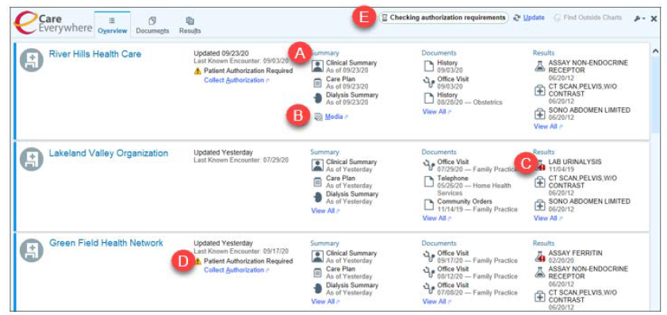

**Figure 1.** Overview interface of Epic's Care Everywhere shows connected health organizations and access to clinical summaries, documents, and results.

A. Each organization's section shows the patient's most recent summaries, documents, and results.

B. If a patient has media (such as images), links to the Media tab.

C. Red exclamation points indicate that a result is abnormal.

D. The column next to each organization's name shows when updated information was last received.

E. Any general notifications appear next to the Update button.

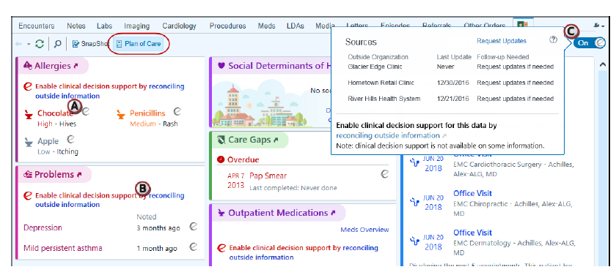

**Figure 2.** "Plan of Care" panel displays detailed patient data, including allergies, medications, and clinical decision support options.

In diabetes care, the T1D Exchange Clinic Registry is an example of using data visualization for different specialists. Their platform helps endocrinologists, nutritionists, and diabetes educators view patient data in ways that fit their needs [30]. The T1D Exchange QI Portal makes it easier to see trends, compare results, and make informed decisions to improve patient care [31]. The dashboard highlights rankings for various health metrics, such as HbA1c and depression screening, allowing specialists to monitor patient outcomes and track improvement over time (see Figure 3). Although this approach works well for diabetes, it hasn't been widely used for neurological conditions.

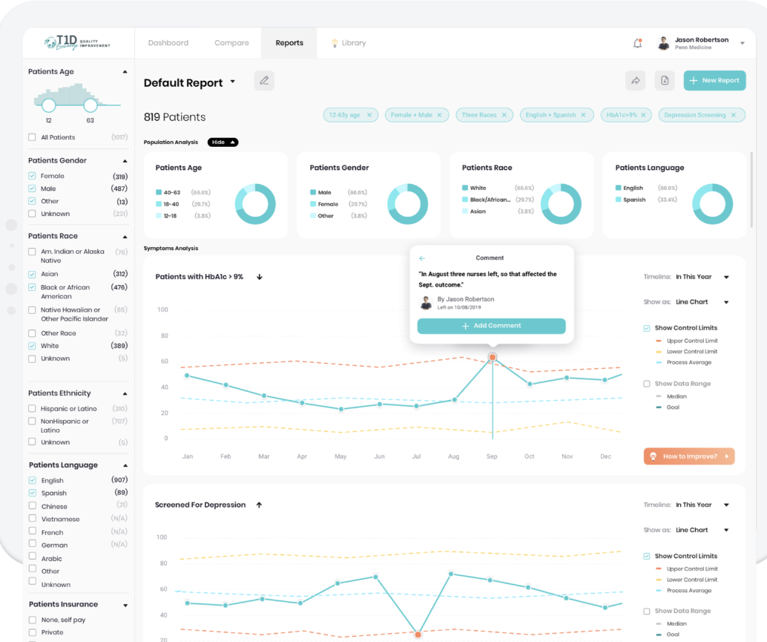

**Figure 3:** T1D Exchange QI Portal Dashboard Overview

Winnow is a visual analytics tool designed for tracking disease progression in Parkinson's patients [32]. It uses parallel coordinate line plots to display changes across multiple clinical measures over time, with each line representing a patient’s progression. The lines are color-coded to differentiate subgroups, such as gender, while histograms below the plots summarize the distribution of changes, showing how many patients improved or worsened in each measure. The tool’s interactive filtering allows users to select specific subgroups, such as rapidly progressing patients, and view updated statistics across all panels [32]. However, the parallel coordinate plots can become cluttered when visualizing large datasets, making it necessary to apply filters to interpret the data effectively (see Figure 4).

Line Plot Visualization of Patient Outcome Changes in Winnow:

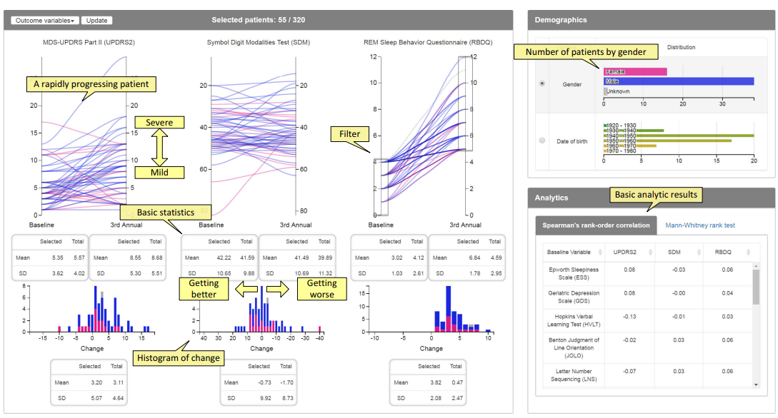

**Figure 4:** Winnow’s interface displays parallel line plots for multiple clinical assessments with demographic data, summary statistics, and histograms of changes.

OnPoint Visualization Tool supports personalized care for cancer patients with multiple chronic conditions by integrating self-reported and clinical data into an interactive dashboard [33]. It presents a 4-week calendar view showing daily readings for medication adherence, blood pressure, weight, and blood glucose using color-coded indicators for normal or abnormal values and icons for missed doses (Figure 5). Line graphs show trends over time, highlighting spikes and drops for abnormal readings (Figure 6). The calendar view provides quick pattern recognition, while line graphs offer detailed insights. However, some users found blank cells or alternate circular visualizations unclear, highlighting the need for a refined design. OnPoint illustrates the value of combining familiar formats with interactive elements to enhance personalized care [33].

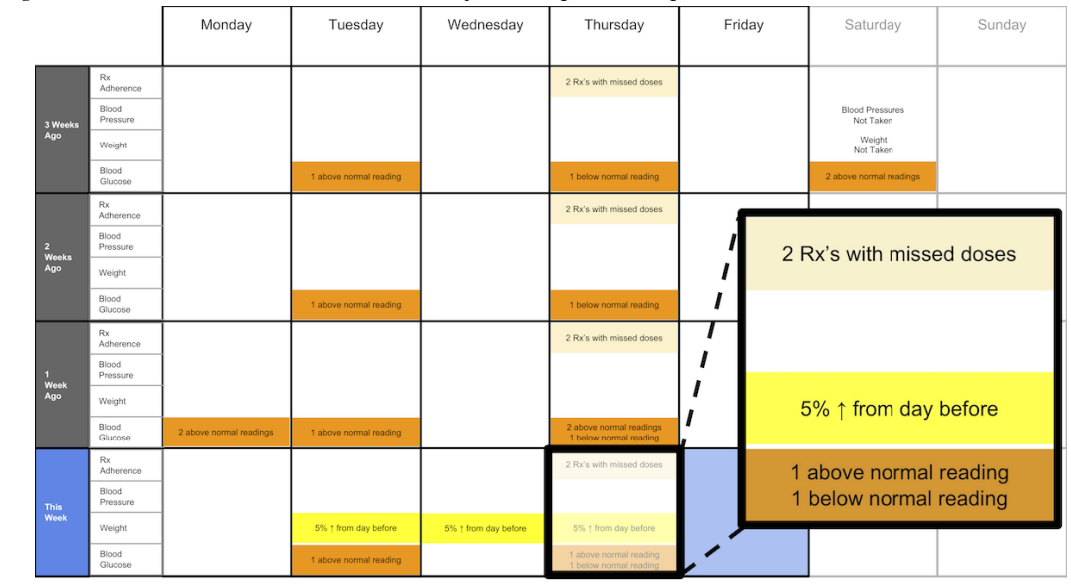

**Figure 5:** A 4-week overview of medication adherence, blood pressure, weight, and blood glucose.

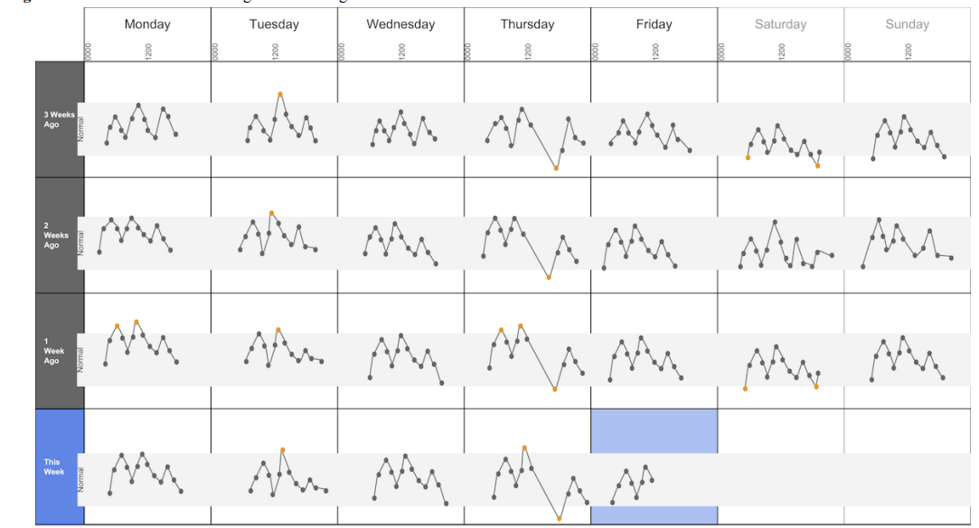

**Figure 6:** A 4-week view of blood glucose readings alone.

These existing solutions highlight the gap in specialized data visualization tools that balance customization, data integration, and ease of use for different types of care providers managing PD patients. Our proposed solution builds upon these experiences by addressing the specific needs of PD care providers through interactive, scalable visualizations that support personalized care without overwhelming users.

A summary of the presented solutions:

|  |  |  |
| --- | --- | --- |
| **System** | **Advantages** | **Disadvantages** |
| Epic's Care Everywhere Network | 1. Wide network of connected care institutions  2. Icons and symbols help to visually signal important actions or warnings.  3.” View All” links and expandable sections reduce information overload, letting users view more detailed data only when needed.  4. The data is clearly categorized into sections such as Allergies, Problems, Medications, and Care Gaps, making it easier for the user to navigate and focus on relevant information. | 1. Same interface for all providers regardless of specialty  2. The interface displays a significant amount of information at once, which can overwhelm users, especially when they need to quickly find specific data.  3. The data is presented largely in text form with lists and tables rather than using graphical summaries. |
| T1D Exchange Registry | 1. Specialized Data Views  2. Custom Views for different providers  3. Line charts for tracking trends help visualize progression.  4. The dashboard provides clear segmentation by patient demographics | 1. Limited to diabetes care  2. Having too many filter categories can overwhelm users and complicate navigation.  3. Displaying many lines (upper/lower control limits, median, goals) on the same chart can cause visual clutter, making it hard to focus on key insights. |
| Winnow | 1. Interactive visualizations for tracking data over time  2. Highlights temporal changes and progression patterns  3. Allows comparison of subgroups via filtering and linked views  4. Intuitive interface developed with clinical feedback | 1. Line plots can become cluttered with large datasets  2. Requires filtering to avoid overwhelming visuals |
| OnPoint Visualization Tool | 1. Integrates self-reported and clinical data into interactive dashboards  2. Calendar view displays 4-week overviews of key health metrics  3. Supports personalized care by allowing quick pattern recognition | 1. Some users found blank cells and alternate visualizations unclear  2. Users may find it difficult to interpret patterns in the calendar views without adequate context or training. |

After reviewing these existing care systems, we identified several important patterns. While some systems excel in data sharing or specialty-specific views, they often fall short in supporting diverse healthcare roles or managing complex, progressive conditions like Parkinson's disease. This review shows a clear need for systems that can handle specific medical conditions and present information in ways tailored to the varying needs of care providers, facilitating better collaboration and personalized care.

**3.5 Summary**

Based on our review of existing solutions and care provider needs, any system designed for PD care providers should meet several key requirements. The platform should allow each type of care provider to customize their dashboard according to their specialty's needs. The system should provide clear data visualization and explanations that may help providers quickly understand patient trends and patterns. Care providers should have easy access to relevant patient data without having to search through unrelated information [34]. The interface should enable communication between different types of providers while maintaining patient privacy [35]. Most importantly, the system should be easy for care providers to use as part of their regular daily work, without needing to spend a lot of extra time learning or using new tools.

**4. Expected Achievements**

The primary goal of this project is to develop a web-based platform that organizes and displays Parkinson's patients' daily activities for different care providers. The system will import structured data processed by the previous project and present it in formats that support care providers in making informed decisions. This includes displaying data related to daily routines, such as meals, exercise, medications, and symptoms, in ways that align with each provider’s specific needs.

While each care provider wants to view data specific to their role, all of the care providers also require access to data that reflects the patient’s general condition and Parkinson’s progression over time. This ensures a comprehensive understanding of the patient's overall health and supports collaboration between care providers.

Our platform will focus on presenting this data through visual and textual formats. For example, nutritionists will see details related to meal timing and composition alongside medication schedules, while fitness trainers will view data on pre- and post-exercise conditions. Physiotherapists will have access to information about movement patterns, symptom trends, and general physical state changes throughout the day.

The technical implementation will prioritize efficient data retrieval, user-friendly interfaces, and secure data access management. Each provider will have login credentials with appropriate access permissions, while the patient will retain control over who can view their information.

Our success criteria include three main goals:

1. Ensuring the system retrieves and presents structured data entries accurately.
2. Providing care providers with intuitive visualizations and textual explanations relevant to their role, alongside general condition data.
3. Validating the system with real stakeholders to ensure it meets their needs.

To assess user satisfaction, we will conduct surveys and aim for a System Usability Scale (SUS) score above 85, reflecting high user satisfaction and usability.

**5. Research and Engineering Process**

**5.1 Process**

To begin our work, we reviewed the structured data generated by the previous project, which collects detailed daily logs from a Parkinson’s patient. Our role is to transform this pre-processed data into meaningful visualizations for care providers. These care providers, such as physiotherapists, nutritionists, and fitness trainers, need specific insights to make informed decisions about the patient’s care.

We studied interviews and feedback from earlier students' projects to understand challenges related to data presentation and communication between care providers. This allowed us to better identify how our visualization system could enhance the existing workflows of the multidisciplinary team.

### **5.1.1 Visualizing the Data**

We provided a literature review and researched best practices in data visualization and the importance of multidisciplinary care for Parkinson’s disease. Studies highlighted how clear visual representations can help care providers quickly understand complex data, spot trends, and identify areas requiring intervention. This research also helped us understand the specific types of information that each type of care provider finds most valuable:

* **Physiotherapists** need data about physical activity patterns, symptom progression, and motor fluctuations.
* **Nutritionists** require insights into the patient’s dietary habits and how they correlate with medication times and symptom changes.
* **Fitness trainers** need to track exercise performance, pre-training conditions, and recovery data.

**Additional Shared Need:**

All stakeholders also want to see data on the patient’s general condition and Parkinson’s progression level.

Below, we detail the visualizations chosen for each type of care provider and justify our decisions based on user needs, research findings, and feedback from previous studies.

**Physiotherapists:**

**Selected visualizations Types:**

* **Text Line Graph:** Annotated line graph to display physical activity patterns, symptom fluctuations, and motor progression over time (Fig. 7).
* **Bar Graph:** Comparison of symptom intensity across different time periods (morning vs. evening sessions).
* **Scatter Plot:** A scatter plot to visualize the relationship between physical activity levels and symptom intensity across different sessions or time periods.

**Justification:** Studies show that physiotherapists need clear, time-based visualizations to monitor day-to-day trends in mobility and motor symptoms. Text annotations help highlight significant changes, making it easier to track the effects of therapy. Text graphs combine the benefits of line graphs (for showing trends over time) and text (for context and explanation), making it a familiar format for users like care providers who are accustomed to reading patient notes. Scatter plots are particularly useful for identifying correlations or patterns between two variables, such as activity levels and symptom severity. For example, they might reveal that higher activity levels correlate with reduced symptom intensity, providing valuable insights into the effectiveness of specific interventions. The results of a study by Tanvir (2021) [36] highlight the perceived usefulness of different visualizations by care providers. The findings indicate that text summaries and text-based graphs received the highest "Very Useful" ratings, supporting our choice to include these formats. In contrast, line graphs without annotations were rated as less effective, emphasizing the importance of adding text-based context for improved clarity. Similarly, scatter plots offer an additional layer of analysis, reinforcing their value in providing actionable insights for physiotherapists.

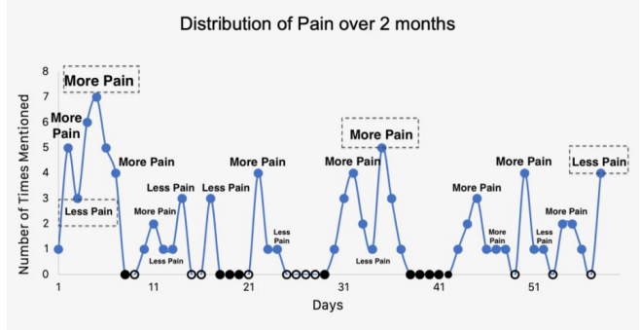

**Figure 7:** Text Line Graph example used in the MHMR data visualization study [36].

Bar graphs are particularly effective for comparing discrete values, such as symptom intensity across different times of day or therapy sessions. Their straightforward format allows physiotherapists to easily identify patterns, such as higher pain levels during evening sessions or improved strength after morning exercises. Research indicates that bar graphs excel in presenting categorical comparisons, making them ideal for visualizing changes in symptom severity and facilitating data-driven adjustments to treatment plans.

This preference for bar graphs is supported by findings from a systematic review, where bar graphs emerged as the most frequently utilized format for visualizing PROMs data (Patient-Reported Outcome Measure) [37].

**Nutritionists:**

**Visualization Types:**

* + **Pie Chart/Stacked Bar Chart:** Proportion of macronutrients in daily meals and comparison of nutrient intake across days.
  + **Text Line Graph:** A time-series graph that emphasizes key points or trends using markers, shaded areas, or annotations to make changes in dietary patterns and their correlation with symptoms more noticeable at a glance.

**Justification:** Nutritionists benefit from visualizations that highlight trends in dietary habits and their impact on symptoms. Research indicates that both summary (proportions) and detailed (time-series) visualizations aid in identifying diet-related improvements or issues. Stacked bar charts and pie charts effectively illustrate proportions and discrete comparisons, making it easier to spot imbalances or trends in nutrient intake [36]. These formats allow users to identify patterns, such as daily macronutrient breakdowns, across multiple days without needing to cross-reference external legends or color keys, as recommended for user-friendly design. Annotations within charts can further emphasize important insights, such as days with insufficient protein intake or excess carbohydrates. Text Line Graph provides a detailed, time-based view of dietary patterns [38], emphasizing key events or trends, such as sudden increases in caloric intake or changes following medication adjustments. By incorporating highlights and annotations, they help nutritionists quickly identify significant changes and correlate them with patient-reported symptoms or medical interventions.

**Fitness Trainers:**

**Visualization Types**:

* + **Radar Chart:** Overview of multiple metrics (stamina, recovery, fatigue levels) in one visualization.
  + **Stacked Bar Chart:** Track changes in exercise performance, pre-training conditions, and post-training recovery metrics across sessions.
  + **Area Chart:** Visualize cumulative improvement or setbacks across different training periods.

**Justification**: Fitness trainers need an overview of different performance indicators as well as a detailed timeline of improvements or setbacks. Radar charts offer a comprehensive snapshot of multiple variables, making it easy to identify areas of strength and weakness within a single visual [39]. Research shows that categorical comparison visualizations, such as stacked bar charts, excel at presenting multiple contributing components (strength, fatigue) in an accessible and familiar format. The stacked bar chart effectively illustrates cumulative trends over time by shading the space under the line to emphasize the scale and weight of progress. Studies indicate that color and gradient-filled visualizations like area charts improve pattern recognition and provide more intuitive feedback on overall performance changes [40], which supports fitness trainers in making data-driven adjustments to exercise training plans.

Based on our review of the visualizations and explanations, we have decided to prioritize clarity and user engagement by incorporating a text summary at the top of every dashboard for a quick, high-level overview, similar to the format of clinical notes. Additionally, interactive elements, such as filters for date ranges and symptom types, as well as informative tooltips, will be included to enhance context and minimize cognitive overload.

**5.1.2. Data that Needs to be Visualized**

The data collected represents detailed daily logs of a Parkinson's patient named Michael, documenting his activities, medications, meals, exercise sessions, and symptom levels throughout the day. This data is used to create visualizations and textual explanations tailored to the needs of different care providers. Below is an overview of the data and how it will be presented within the system.

The system is designed to provide each care provider (physiotherapist, nutritionist, and fitness trainer) with relevant data visualizations to their specific role. It presents comparisons between Michel’s current state and past states to help identify trends and changes over time. Additionally, the system highlights whether there may be a correlation between exercise sessions and changes in Michel’s condition. In cases where no data is reported for an entire day, the system assumes that Michel is in an "OFF" state, indicating a potential period of inactivity or symptom severity.

### **Types of Data to Visualize:**

Time-Stamped Events: Log entries documenting when activities, meals, and medications occurred.

Medications: Types of medications (Dopicar, Sinemet) and specific dosage times.

Meals: Details about meals, including ingredients and meal times ("half pita with hummus and pastrami").

Exercise: Exercise types, session times, and perceived physical condition before and after exercise.

Symptoms:

General Condition:

Represents Michel's overall physical state (1 = very weak, 5 = very strong).

Parkinson’s Severity:

Represents the level of Parkinson’s symptoms (1 = minimal symptoms, 5 = severe symptoms).

Rest and Sleep: Rest periods, sleep interruptions, and overall sleep patterns.

### 

### **Sample Data Entry:**

Date: 9/23/2023

Morning: 09:15 – Woke up, took Dopicar and Azilect, and ate homemade cake.

Midday: 12:10 – Took Dopicar.

13:00 – Lunch: challah, tahini, olives, rice, green beans, baked potatoes.

Afternoon: 15:00 – Took Dopicar, had a snack.

18:00 – Skipped exercise, took a quarter dose of Dopicar due to fatigue

The visualizations and textual explanations aim to present Michel's structured data in a clear and accessible way, enabling care providers to interpret the information based on their professional expertise. The system organizes the data to support informed decision-making by each care provider.

**5.1.3 The Main Requirements for our System**

**Functional Requirements:**

1. The system allows care providers to create accounts.
2. The system allows care providers to log in.
3. The system allows care providers to view patient data in visual formats.
4. The system allows annotations within visualizations.
5. The system allows tooltips within visualizations.
6. The system allows care providers to add notes or comments to patient records.
7. The system allows users to compare trends.
8. The system allows secure data sharing.
9. The system allows the display of text summaries.
10. The system allows role-based views.
11. The system allows physiotherapists to view movement-related data, symptom progression, and motor fluctuations over time.
12. The system allows nutritionists to view dietary patterns, meal composition, macronutrient intake, and timing relative to medications.
13. The system allows fitness trainers to monitor exercise performance, recovery patterns, and pre/post-exercise conditions.
14. The system allows care providers to view historical patient data.

**Non-Functional Requirements:**

1. The interface should be user-friendly and intuitive, ensuring that care providers with varying technical expertise can easily navigate the platform.
2. The system should load data visualizations quickly, even with large datasets, to avoid delays during clinical workflows.
3. The system should support future additions of new data types and visualizations without significant redesigns.
4. The system should support interactive elements like zooming, filtering, and toggling to enable detailed data exploration.
5. The system should ensure that patient data is accurately imported and displayed without errors or loss of information.
6. The system should provide informative error messages and logs in case of issues, ensuring users can resolve problems or contact support easily.
7. The system should provide secure role-based access controls to restrict user permissions based on their role
8. The system should support a consistent and responsive user interface across different screen sizes.

**5.1.4 System Architecture and Technology Overview**

After defining the system's requirements, we designed the system’s architecture and identified key components needed for its implementation (see Fig. 8). Following an analysis of existing market solutions (see Section 3.4), we planned the system's functionality and identified the need to build two main modules: Data Processing and Visualization. During this phase, we created a Use-Case diagram to map out the interactions between care providers and the system, ensuring the workflows are clearly defined (see Fig. 9). With the system design outlined, we began creating the initial prototype and preparing the testing framework. As we progressed, several challenges were identified in developing an effective data visualization platform, including learning and implementing specialized tools:

**Data Visualization Libraries:** Using Chart.js to create clear and interactive visual representations tailored for care providers.

**React Framework:** Building the frontend interface using React for a dynamic, modular user experience.

**Backend with Node.js and Express:** Managing server-side data processing.

**Database Management:** Integrating and managing data storage using MongoDB, in alignment with the database structure established by the previous project, ensuring seamless access to existing data for efficient retrieval and updates.

**Understanding User Needs:** Gaining insight into care providers' specific needs and preferences is crucial for tailoring the application to support their workflows and ensure it aligns with their requirements.

In the next phases of development, we will address these challenges and continue coding the system according to the design plans, refining the visualizations and ensuring seamless interactions within the platform.

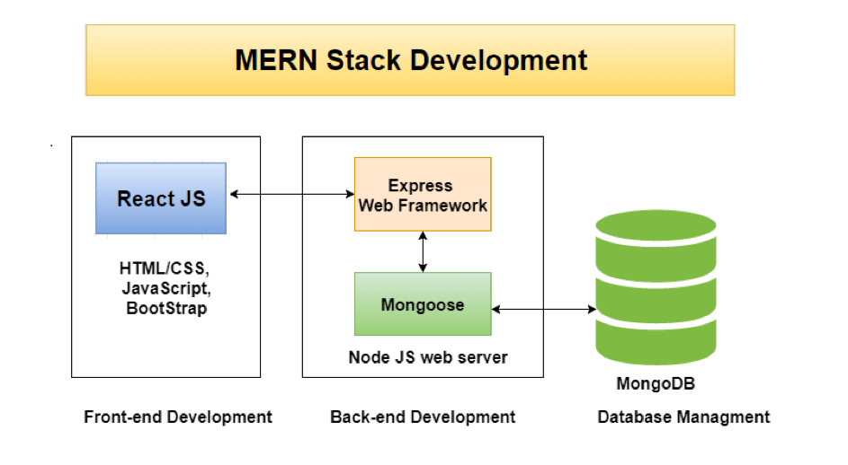

**Figure 8:** Application Architecture.

**5.1.5 Expected Challenges**

Continuing an existing project and integrating with data collected by another team presents several challenges. One major hurdle is the need to use their pre-existing database (MongoDB), limiting our ability to select a database structure that best fits our needs. Instead, we must adapt our approach to align with their system, which may introduce inefficiencies or require additional adjustments.

Another challenge is the potential need to process and clean the data ourselves, as the original team may not have the capacity or resources to handle this step. This could lead to a significant increase in our workload and necessitate the development of new preprocessing routines to ensure the data is usable for our purposes.

Additionally, there is the issue of meeting the specific requirements of care providers. These stakeholders may have expectations that cannot be fulfilled due to gaps or limitations in the available data. Addressing these limitations may require setting realistic expectations or identifying alternative solutions to mitigate the impact of missing information.

Effective communication, careful planning, and flexibility will be critical to overcoming these challenges and ensuring a successful continuation of the project.

**5.2 Product**

Our system is a web-based platform designed to support care providers in accessing and analyzing patient data relevant to their expertise, ultimately improving clinical decision-making and facilitating multidisciplinary care. In the following sections, we will describe the core components of our solution.

**6. Diagrams**

**6.1 Use Case**

The interactions between care providers and the system:

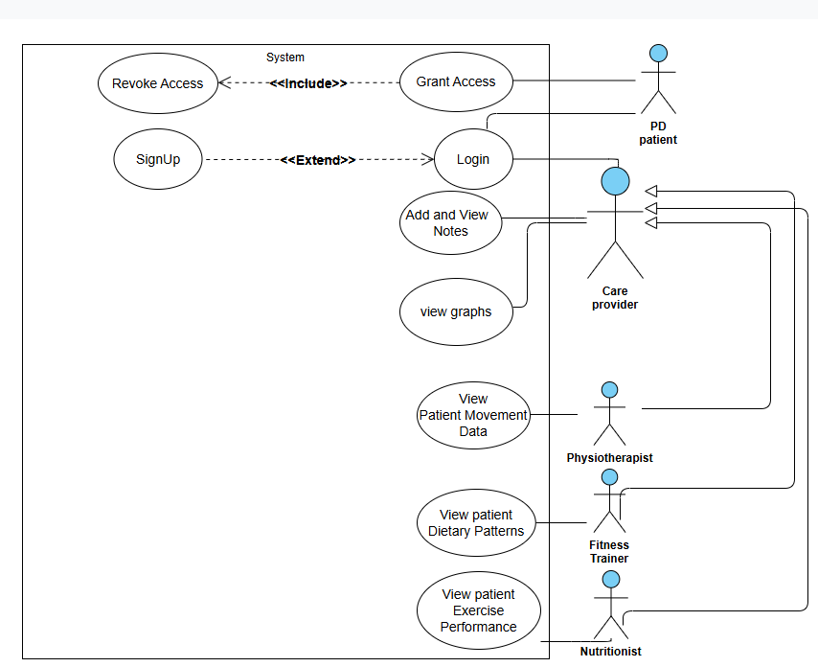

**Figure 9:** Use case.

### 

### 

### **6.2 GUI Prototype**

The GUI flowchart illustrates how care providers interact with the system to analyze patient data and document their observations. The process begins with the care provider logging into the platform. After successful authentication, the care provider navigates to their personalized dashboard, which displays relevant data visualizations, such as patient-reported symptoms, meal details, and exercise sessions. Alongside the visualizations, we will include textual explanations to provide additional context and highlight key insights. We want the textual explanations to enhance understanding, reduce misinterpretation, and ensure that care providers can quickly grasp the most critical information at a glance.

The system ensures that care providers can filter and view specific data according to their role (physiotherapists view movement-related data, nutritionists view dietary insights, and fitness trainers track exercise performance).

Care providers can annotate their dashboards with notes for later use, aiding their analysis and tracking patient progress over time. However, they cannot view notes or dashboards created by other care providers. Collaboration within the system is supported by a messaging feature that allows care providers to communicate directly with each other without accessing each other’s dashboards or patient-specific data.

The session concludes when the care provider finishes their work and logs out. This workflow supports secure data access, personalized analysis, and professional collaboration while ensuring that patient privacy and data segregation are maintained.

**Main screens of the suggested system:**

At the bottom of every dashboard, there is a textual explanation for each visualization, providing clear guidance on how to interpret and understand the graph.

### **The Fitness Trainer Dashboard**

This dashboard provides fitness trainers with detailed visualizations to monitor patient progress, tailor training sessions, and optimize fitness plans. Trainers can select data resolution to focus on a single day, a week, or a month.

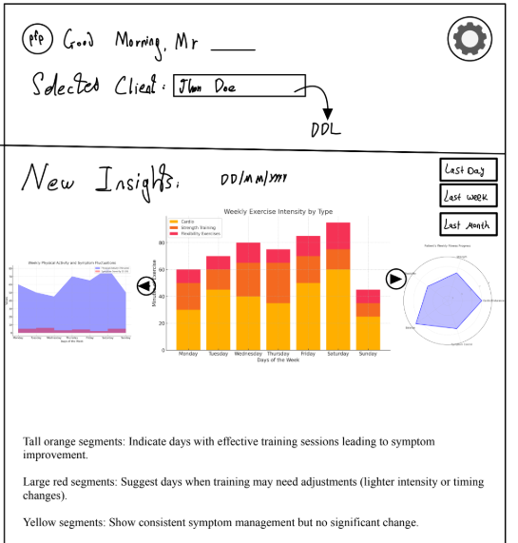

#### 

#### **Radar Chart: "Fitness Session Metrics"**

Purpose:Compares key patient metrics before and after training sessions to assess the impact of exercise on Parkinson’s severity and fitness levels.

Structure:

* Radar chart with 5 metrics, scaled from 1–5.
* Blue for the current session and gray for the previous session.

Metrics:

* Pre-Training PD Level (פ): Parkinson’s severity before exercise.
* Post-Training PD Level (פ): Impact of exercise on symptoms.
* Pre-Training Fitness (כ): Physical capability before the session.
* Post-Training Fitness (כ): Physical state after exercise.
* Time Since Last Meal: Assesses energy levels for the session.

Insights Provided:

* Detect improvements or declines in PD severity and fitness post-training.
* Assess whether time since the last meal affects performance.
* Identify patterns to optimize future training plans.

#### **Area Chart: "Pre-Training Patient Snapshot"**

Purpose:Summarizes the patient’s condition just before training, helping trainers tailor sessions based on real-time data.

Structure:

* Y-axis: Scale 0–5 for all metrics.
* X-axis: Time elapsed (0–6 hours).

Lines Representing Metrics:

* Green Line: Parkinson’s severity (פ).
* Blue Line: Fitness level (כ).
* Yellow Line: Time since last meal.
* Red Line: Time since last pain episode.

Annotations:

* Highlights significant pre-training conditions like pain or skipped meals.
* Tooltip shows meal details, pain type, and severity.

Insights Provided:

* Understand the patient’s immediate condition.
* Prepare for training while avoiding overexertion.
* Adjust session intensity based on recent meals or pain episodes.

#### **Stacked Bar Chart: "Training Session Outcomes"**

Purpose:  
Analyzes weekly training outcomes to identify patterns of improvement, stability, or worsening of Parkinson’s symptoms.

Structure:

* X-axis: Days of the week.
* Y-axis: Number of sessions.

Bar Sections:

* Green (Bottom): PD symptoms improved (פ4.5 → פ4).
* Yellow (Middle): Symptoms stayed the same.
* Red (Top): Symptoms worsened.

Insights Provided:

* Track which days have the best outcomes.
* Optimize session schedules based on patterns of improvement.

**The Nutritionist Dashboard**

This dashboard helps nutritionists monitor dietary patterns and their correlation with Parkinson’s symptoms. Users can view insights for a single day, a week, or a month.

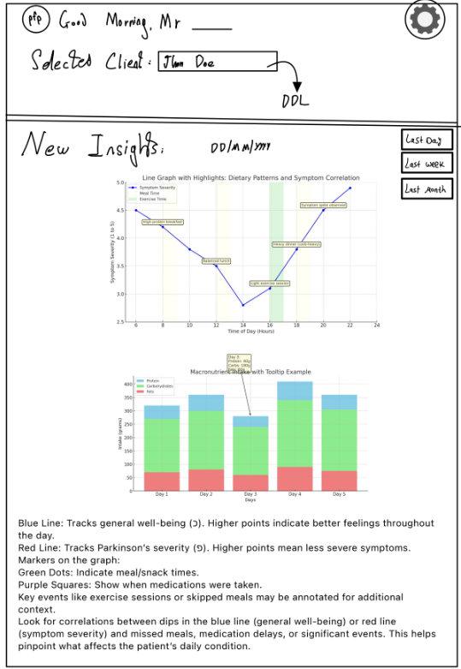

**Bar Chart: "Daily Meal and Medication Overview"**

Purpose:  
Visualizes daily patterns of meals and medication to identify gaps, irregularities, and correlations with health outcomes.

Structure:

* X-axis: Dates (daily bars).
* Y-axis: Number of meals/snacks/medications.

Bar Sections:

* Blue (Bottom): Morning meals/snacks (before 12 PM).
* Green (Middle): Afternoon meals/snacks (12 PM–5 PM).
* Yellow (Top): Evening meals/snacks (after 5 PM).

Annotations:

* Green Dots: Medication times.
* Red Flags: Skipped meals or light food days.
* Yellow Stars: Exercise sessions for pre- and post-exercise nutrition.

Tooltip Information:

* Lists food items and medication details.
* Highlights meal timing, type, and context.

Insights Provided:

* Assess meal consistency and medication timing.
* Detect skipped meals or poor nutrition days.
* Evaluate whether nutrition aligns with exercise needs.

#### **Line Chart: "Daily Well-Being Timeline"**

Purpose:  
Tracks fluctuations in Parkinson’s severity (פ) and general well-being (כ) throughout the day to identify correlations with meals, medications, and other events.

Structure:

* X-axis: Time of day.
* Y-axis:
  + Blue Line: General well-being (כ), scaled 1–5.
  + Red Line: PD severity (פ), scaled 1–5.

Markers:

* Green Dots: Meals/snacks.
* Purple Squares: Medications.

Annotations:

* Highlights key events such as skipped meals, delayed medications, or symptom spikes.
* Tooltip provides meal details and medication timing.

Insights Provided:

* Track time-sensitive symptom patterns.
* Detect meal or medication timing effects on symptoms.
* Monitor daily trends in well-being and severity.

**The Physiotherapist Dashboard:**

Helps physiotherapists monitor symptom severity, general well-being, and physical activity patterns. Data resolution can be adjusted for a day, week, or month.

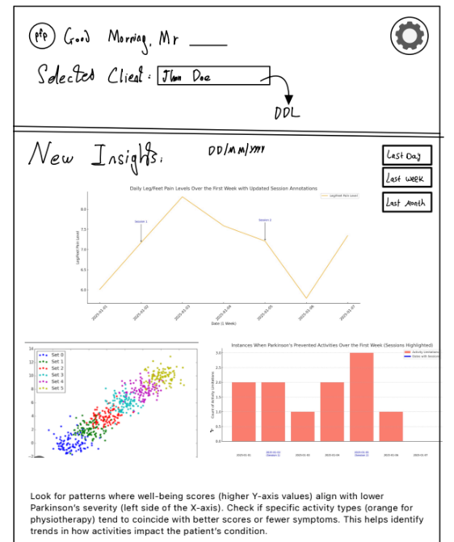

#### **Scatter Plot: "Patient State Overview"**

Purpose:  
Visualizes the relationship between Parkinson’s severity, general well-being, and daily physical activity to detect correlations and trends.

Structure:

* X-axis: Parkinson’s severity level (1–5).
* Y-axis: General well-being score (1–5).

Data Points:

* Orange: Physiotherapy session days.
* Blue: Training days.
* Green: No physical activity.
* Shapes: Different shapes for days with spasms versus symptom-free days.

Insights Provided:

* Correlate activity levels with symptoms and well-being.
* Spot trends in daily severity and overall condition.
* Identify the impact of physical activity on symptoms.

#### **Stacked Bar Chart: "Weekly Health Metrics Overview"**

Purpose:  
Summarizes weekly trends in sleep, pain episodes, and overall health, helping physiotherapists assess how these factors contribute to well-being.

Structure:

* X-axis: Weekly time periods.
* Y-axis: Stacked health metrics.

Bar Sections:

* Blue (Bottom): Average sleep hours.
* Red (Middle): Number of pain episodes.
* Purple (Top): Combined scores of Parkinson’s severity and general well-being.

Tooltip Information:

* Provides sleep hours, pain episodes, and health scores.
* Displays start and end dates for each week.

Insights Provided:

* Compare health metrics across weeks.
* Identify patterns between sleep, pain, and health.
* Monitor long-term trends in patient stability and progress.

### 

### 

### **Line Chart: "Daily Symptom and Well-Being Timeline"**

Purpose:  
This line chart tracks fluctuations in Parkinson’s symptom severity (פ) and general well-being (כ) throughout the day. It helps physiotherapists identify patterns and correlations between symptoms, well-being, and events like physical activity or medications.

Structure:

* X-axis: Time of day (hourly timeline).
* Y-axis: Both metrics use a shared scale of 1–5:
  + General Well-Being (1-5)
  + Parkinson’s Severity (1-5).

Lines and Markers:

* Blue Line: Tracks general well-being (כ) throughout the day.
* Red Line: Tracks Parkinson’s severity (פ) over time.
* Markers:
  + Green Dots: Meals/snacks.
  + Purple Squares: Medications.
  + Orange Stars: Physiotherapy sessions.

Annotations:

* Key events like exercise sessions or skipped meals are highlighted.
* Tooltip displays:
  + Exact times of meals/snacks and medications.
  + Meal details ("Toast with avocado at 9:00 AM").
  + Well-being (כ) and severity (פ) scores at each timestamp.

Insights Provided:

* Correlations between symptoms and daily events like meals or medication timing.
* Identify if physiotherapy, meals, or medications alleviate symptoms.
* Detect times of day when symptoms are consistently better or worse.

**Login Screen**

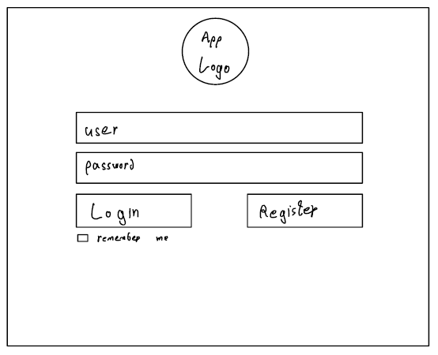

**Account Settings Page of the PD Patient**

The patient's account settings page, where they can manage access permissions for their care team.

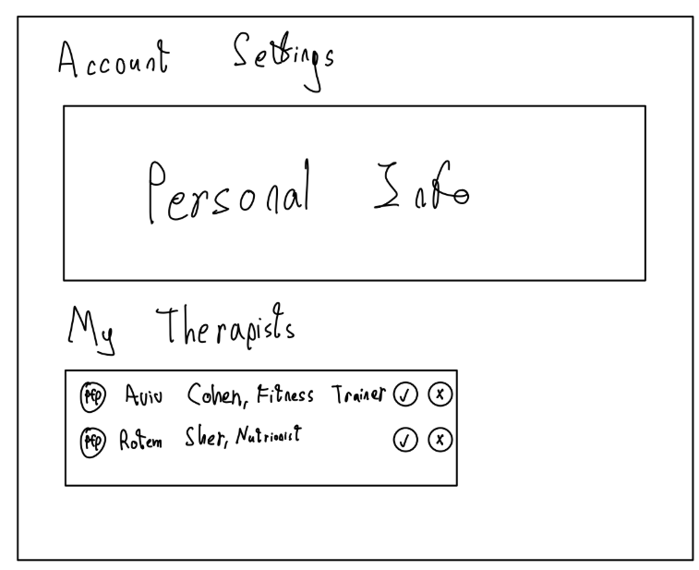

**Account Settings Page of the Care Provider**

The Care Provider account settings page, where they can see their list of patients.

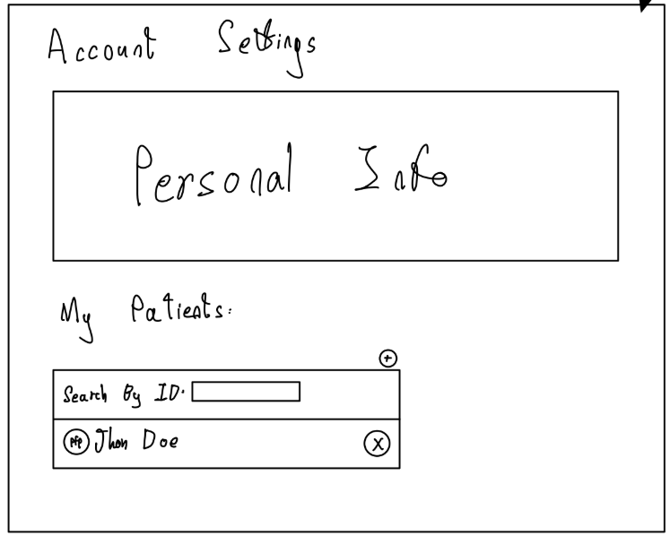

**7. Evaluation / Verification Plan**

To ensure the system operates correctly and as intended, we will evaluate it through the following steps:

1. Execute the testing plan.

2. Have the system used by 3 representative users (different care providers).

### **7.1 Testing Plan**

To ensure the reliability of our final product, we have developed a testing plan detailed in the table below. This plan is based on the Use Case descriptions and GUI screens, allowing us to identify potential problematic scenarios, weaknesses, and processes requiring accuracy verification.

|  |  |  |  |
| --- | --- | --- | --- |
| **#** | **Test Subject** | **Test Headline** | **Expected Result** |
| 1 | User Registration | New care provider signup with valid information | User account is created successfully, and the user is redirected to the login page. |
|  |  | Attempt to sign up with an existing email | System displays an error message indicating the email is already in use. |
| 2 | User Authentication | Existing care provider login with correct information | Users are logged in and directed to their personalized dashboard. |
|  |  | Login with incorrect password | System displays an error message and prevents login. |
| 3 | Role-Based Dashboard Access | Physiotherapist logs in and views their dashboard | Physiotherapist-specific data and general data is displayed. |
|  |  | Nutritionist logs in and views their dashboard | Nutritionist-specific data and general data is displayed. |
|  |  | Fitness trainer logs in and views their dashboard | Fitness trainer-specific data and general data is displayed. |
| 4 | Data Access Control | Patient grants access to care providers | Care providers listed by the patient gain access to relevant patient data as per their roles. |
|  |  | Patient revokes access to a care provider | Care provider lose access to patient data immediately |
| 5 | Data Visualization | Care provider requests to view patient data in graph format | Accurate graphical representation of requested data is displayed based on the care provider role. |
| 6 | Data Entry Validation | Care provider enters invalid data in a form field | Clear error message is displayed, and form is not submitted. |
| 7 | Annotation Feature | Care provider adds a note to a dashboard | Note is saved and visible only to the care provider who created it. |
| 8 | Security | Attempt to access patient data without authorization | Access is denied, and an appropriate error message is displayed. |
| 9 | Responsiveness | Access system on mobile device | Interface adapts to screen size without loss of functionality. |
| 10 | Performance | Load dashboard with large datasets | Dashboard loads within 3 seconds on a standard internet connection. |
| 11 | Text and Visual Synchronization | View textual summary alongside graphical data | Textual explanation matches data visualization accurately. |
| 12 | Multi-User Role Testing | Simultaneous logins by multiple care providers | System maintains role-specific views and handles concurrent usage without errors. |

### **7.2 Evaluation by Users**

We will conduct user evaluations with three care providers (physiotherapist, nutritionist, and fitness trainer) and a patient to assess the system’s effectiveness and usability.

#### **Care Provider Evaluation**

We will ask each care provider to perform key tasks:

* **Physiotherapist**: Analyze weekly motor fluctuation trends and annotate patient progress.
* **Nutritionist**: Review dietary patterns.
* **Fitness Trainer**: Monitor exercise performance and identify patterns in pre/post-training conditions.

Feedback will be collected on:

* Ease of accessing relevant data.
* Clarity and intuitiveness of visualizations.
* Usefulness of textual summaries.
* Satisfaction with the annotation feature.

#### 

#### **Patient Evaluation**

We will ask the patient to:

* Grant and revoke access permissions for care providers.
* Verify that care providers only access data as allowed.

Feedback will be collected on:

* Ease of managing access permissions.
* Clarity of the access control interface.
* Confidence in data security and privacy.

### **7.3 Metrics for Success**

The success of the system will be evaluated based on the following metrics:

1. **System Usability Scale (SUS)**: Achieve a score of 85 or above, indicating high user satisfaction.
2. **Task Completion Rate**: Ensure that 95% of test tasks are completed without errors.
3. **System Performance**: Dashboard loads within 3 seconds for all users.
4. **Security**: Ensure zero unauthorized access incidents during testing.

This evaluation plan ensures the system meets the needs of care providers while maintaining patient privacy and data security.

**References:**

[1] GBD 2016 Parkinson's Disease Collaborators. (2018). Global, regional, and national burden of Parkinson's disease, 1990-2016: a systematic analysis for the Global Burden of Disease Study 2016. The Lancet Neurology, 17(11), 939-953.

[2] Dorsey, E. R., Constantinescu, R., Thompson, J. P., Biglan, K. M., Holloway, R. G., Kieburtz, K., Marshall, F., Ravina, B., Schifitto, G., Siderowf, A., & Tanner, C. M. (2007). Projected number of people with Parkinson disease in the most populous nations, 2005 through 2030. Neurology, 68(5), 384-386.

[3] Kalia, L. V., & Lang, A. E. (2015). Parkinson's disease: A comprehensive analysis of pathophysiology, clinical features, and management. The Lancet, 386(9996), 896-912.

[4] Jankovic, J. (2008). Parkinson's disease: clinical features and diagnosis. Journal of Neurology, Neurosurgery & Psychiatry, 79(4), 368-376.

[5] van der Marck, M. A., Bloem, B. R., Borm, G. F., Overeem, S., Munneke, M., & Guttman, M. (2013). Effectiveness of multidisciplinary care for Parkinson's disease: a randomized, controlled trial. Movement Disorders, 28(5), 605-611.

[6] van der Marck, M. A., Kalf, J. G., Sturkenboom, I. H., Nijkrake, M. J., Munneke, M., & Bloem, B. R. (2009). Multidisciplinary care for patients with Parkinson's disease. Parkinsonism & Related Disorders, 15, S219-S223.

[7] Bloem, B. R., Henderson, E. J., Dorsey, E. R., Okun, M. S., Okubadejo, N., Chan, P., Andrejack, J., & Munneke, M. (2020). Integrated and patient-centred management of Parkinson's disease: a network model for reshaping chronic neurological care. The Lancet Neurology, 19(7), 623-634.

[8] Espay, A. J., Bonato, P., Nahab, F. B., Maetzler, W., Dean, J. M., Klucken, J., Eskofier, B. M., Merola, A., Horak, F., Lang, A. E., & Reilmann, R. (2016). Technology in Parkinson's disease: Challenges and opportunities. Movement Disorders, 31(9), 1272-1282.

[9] Espay, A. J., Hausdorff, J. M., Sánchez‐Ferro, Á., Klucken, J., Merola, A., Bonato, P., Bloem, B. R., Evers, L. J. W., Maetzler, W., Mer, J. E., Mirelman, A., Poli, L., Rochester, L., & the Movement Disorder Society Task Force on Technology. (2019). A roadmap for implementation of patient‐centered digital outcome measures in Parkinson's disease obtained using mobile health technologies. Movement Disorders, 34(5), 657-663.

[10] West, V. L., Borland, D., & Hammond, W. E. (2015). Innovative information visualization of electronic health record data: a systematic review. Journal of the American Medical Informatics Association, 22(2), 330-339.

[11] Mak, M. K., Wong-Yu, I. S., Shen, X., & Chung, C. L. (2017). Long-term effects of exercise and physical therapy in people with Parkinson disease. Nature Reviews Neurology, 13(11), 689-703.

[12] Ongun, N. (2018). Does nutritional status affect Parkinson's Disease features and quality of life?. PLoS One, 13(10), e0205100.

[13] van der Kolk, N. M., & King, L. A. (2013). Effects of exercise on mobility in people with Parkinson's disease. Movement Disorders, 28(11), 1386-1396.

[14] Goodwin, V. A., Richards, S. H., Taylor, R. S., Taylor, A. H., & Campbell, J. L. (2008). The effectiveness of exercise interventions for people with Parkinson's disease: A systematic review and meta-analysis. Movement Disorders, 23(5), 631-640.

[15] Radder, D. L., de Vries, N. M., Riksen, N. P., Diamond, S. J., Gross, D., Gold, D. R., Heesakkers, J., Henderson, E., Hommel, A. L., Lennaerts, H. H., Busch, J., Dorsey, R. E., Andrejack, J., & Bloem, B. R. (2020). Multidisciplinary care for people with Parkinson's disease: the new kids on the block! Journal of Parkinson's Disease, 10(2), 443-454.

[16] Goetz, C. G. (2011). The History of Parkinson's Disease: Early Clinical Descriptions and Neurological Therapies. Cold Spring Harbor Perspectives in Medicine, 1(1), a008862-a008875.

[17] Barichella, M., Cereda, E., & Pezzoli, G. (2019). Nutritional Management of Parkinson's Disease. Movement Disorders Clinical Practice, 6(1), 17-27.

[18] Mak, M. K., Wong-Yu, I. S., Shen, X., & Chung, C. L. (2017). Long-term effects of exercise and physical therapy in people with Parkinson disease. Nature Reviews Neurology, 13(11), 689-703.

[19] Jones, S., Patel, J. P., Twigg, M. J., & Chaudhuri, K. R. (2024). What is known about the challenges people with Parkinson’s disease experience with their medicines and what solutions have been explored to overcome them? A scoping review. *International Journal of Pharmacy Practice, 32*(6), 431–445.

[20] Kern, L. M., Bynum, J. P. W., & Pincus, H. A. (2024). Care fragmentation, care continuity, and care coordination—How they differ and why it matters. *JAMA Internal Medicine, 184*(3), 236–237.

[21] Kerkemeyer, L., Claus, I., Kutscher, M., von Stülpnagel, V., Zur Nieden, P., Huchtemann, T., Warnecke, T., & PNM+ Steering Committee. (2022). Strengthening communication and collaboration in the fragmented German healthcare system: A mixed-method evaluation of an interdisciplinary network for Parkinson's disease. *Journal of Parkinson's Disease, 12*(4), 1307–1317.

[22] HelloHealth. (2024). What data fragmentation means for the patient: Learn how fragmented healthcare data impacts diagnoses, costs, care coordination, and outcomes. *HelloHealth Blog.*

[23] Luis-Martínez, R., Monje, M. H. G., Antonini, A., Sánchez-Ferro, Á., & Mestre, T. A. (2020). Technology-Enabled Care: Integrating Multidisciplinary Care in Parkinson's Disease Through Digital Technology. Frontiers in Neurology, 11, 575975.<https://doi.org/10.3389/fneur.2020.575975>

[24] HealthManagement.org (2024). Digital Technologies in Health Care: Challenges and Opportunities. HealthManagement.org. <https://healthmanagement.org/c/enterprise/news/digital-technologies-in-health-care-challenges-and-opportunities>.

[25] Adams, J., Mammen, J., & Critical Path Institute (C-Path). (2023). Using digital health technologies for assessment of people with Parkinson's. Journal of Parkinson's Disease.

[26] American Physical Therapy Association (APTA). (2016). The Movement System: Physical Therapist Practice and the Movement System. APTA White Paper.

[27] Boullata, J. I., & Hudson, L. M. (2012). Drug–Nutrient Interactions: A Broad View with Implications for Practice. Journal of the Academy of Nutrition and Dietetics, 112(4), 506–517. <https://doi.org/10.1016/j.jand.2011.11.004>

[28] MedFit Network. (n.d.). *The roles of a medical fitness specialist: Scope of practice, prevention, and interprofessional collaboration.* [MedFit Network](https://medfitnetwork.org/public/all-mfn/the-roles-of-a-medical-fitness-specialist-scope-of-practice-prevention-and-interprofessional-collaboration/).

[29] Surety Systems. (2024, November 26). *Epic Care Everywhere: Enhancing Patient Outcomes Through Data Sharing*. <https://www.suretysystems.com/insights/epic-care-everywhere-enhancing-patient-outcomes-through-data-sharing/>

[30] Foster, N. C., Beck, R. W., Miller, K. M., Clements, M. A., Rickels, M. R., DiMeglio, L. A., Olson, B. A., et al. (2019). State of Type 1 Diabetes Management and Outcomes from the T1D Exchange in 2016-2018. Diabetes Technology & Therapeutics, 21(2), 66-72

[31] T1D Exchange. (n.d.). T1D Exchange QI Portal. https://somersetandchurch.com/signifier-medical-copy-1

[32] Hsueh-Chien Cheng, Rainer von Coelln, Ann L. Gruber-Baldini, Lisa M. Shulman, and Amitabh Varshney. "Winnow: Interactive Visualization of Temporal Changes in Multidimensional Clinical Data." Proceedings of the 8th ACM International Conference on Bioinformatics, Computational Biology, and Health Informatics (ACM-BCB), 2017, pp. 124–133.

[33] Stadler, J. G., Donlon, K., Siewert, J. D., Franken, T., & Lewis, N. E. (2016). Improving the Efficiency and Ease of Healthcare Analysis Through Use of Data Visualization Dashboards. Big Data, 4(2), 129-135.

[34] Rabiei, R., & Almasi, S. (2022). Requirements and challenges of hospital dashboards: A systematic literature review. BMC Medical Informatics and Decision Making, 22(287).

[35] D'Souza, M., Steinheimer, S., Dorn, J., Morrison, C., Boisvert, J., Kravitis, K., et al. (2018). Reference documentation for electronic health records in multiple sclerosis care: A consensus of the multiple sclerosis documentation working group. Multiple Sclerosis and Related Disorders, 24, 144-150.

[36] Tanvir, R. (2021). Exploring Alternative Methods of Visualizing Patient Data (Master's thesis). University of Toronto, Department of Mechanical and Industrial Engineering.

[37] Albers, E. A. C., Fraterman, I., Walraven, I., Wilthagen, E., Schagen, S. B., van der Ploeg, I. M., Wouters, M. W. J. M., van de Poll-Franse, L. V., & de Ligt, K. M. (2022). Visualization formats of patient-reported outcome measures in clinical practice: A systematic review about preferences and interpretation accuracy. *Journal of Patient-Reported Outcomes, 6*(1), 18.

[38] Muth, L. C. (2022, September 28). What to consider when using text in data visualizations. Datawrapper Blog. <https://blog.datawrapper.de/text-in-data-visualizations/>

[39] Cloud Software Group, Inc. (2024). *What is a radar chart?* Jaspersoft. https://www.jaspersoft.com/articles/what-is-a-radar-chart

[40] FasterCapital. (2024). *Visualization Techniques: Area Charts: Filling in the Data Landscape*.<https://fastercapital.com/content/Visualization-Techniques--Area-Charts--Filling-in-the-Data-Landscape.html>